

**0113 258 1150**

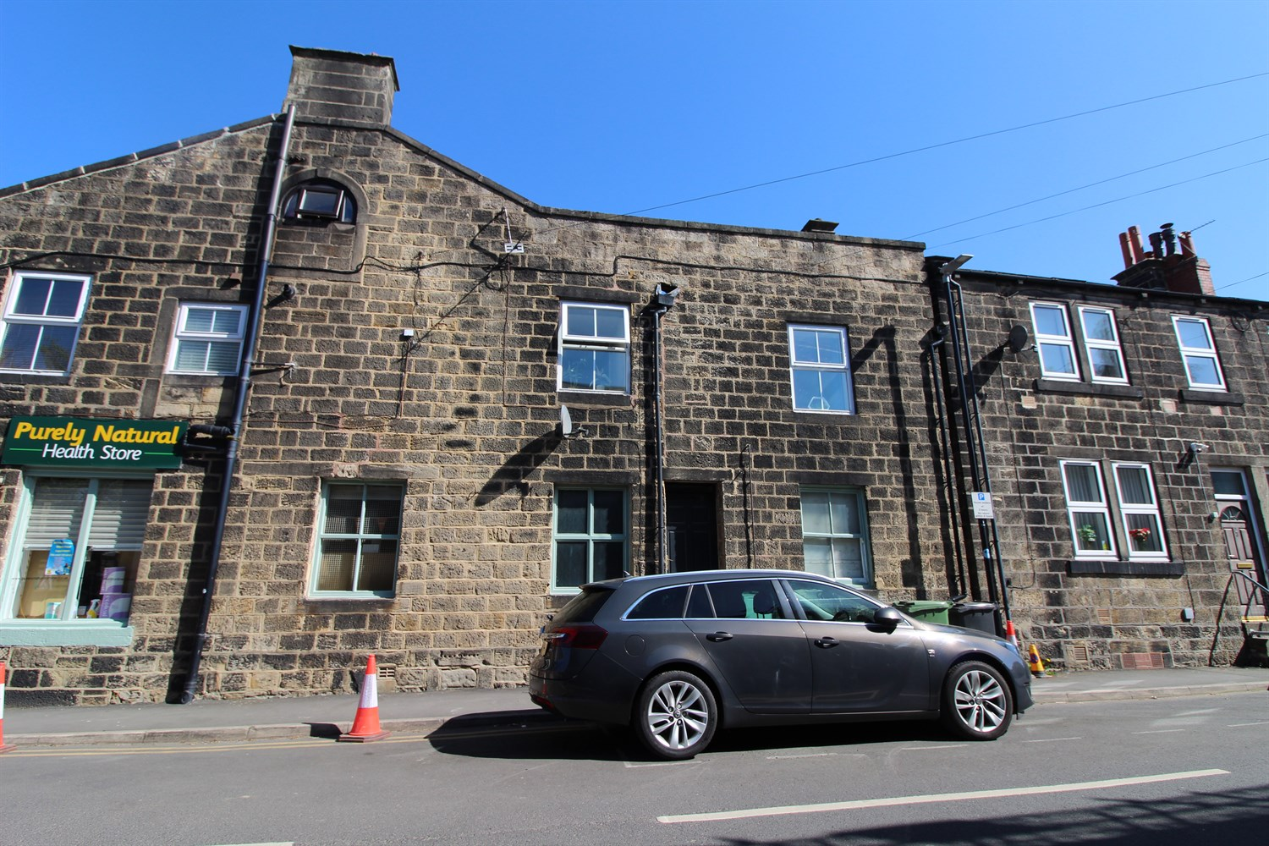



**Available to let £795.00pcm**

**Kerry Street, Horsforth**

**TWO BEDROOM DUPLEX APARTMENT in CENTRAL HORSFORTH** Adair Paxton are pleased to offer to the market this spacious duplex apartment located just off Horsforth Town Street. This unfurnished apartment briefly comprises; stairs to first floor, living room, kitchen, bathroom and bedroom to the first floor. To the second floor is a second bedroom (restricted head height). On street parking is available with a permit. Council tax band B, EPC rating D, Deposit £915

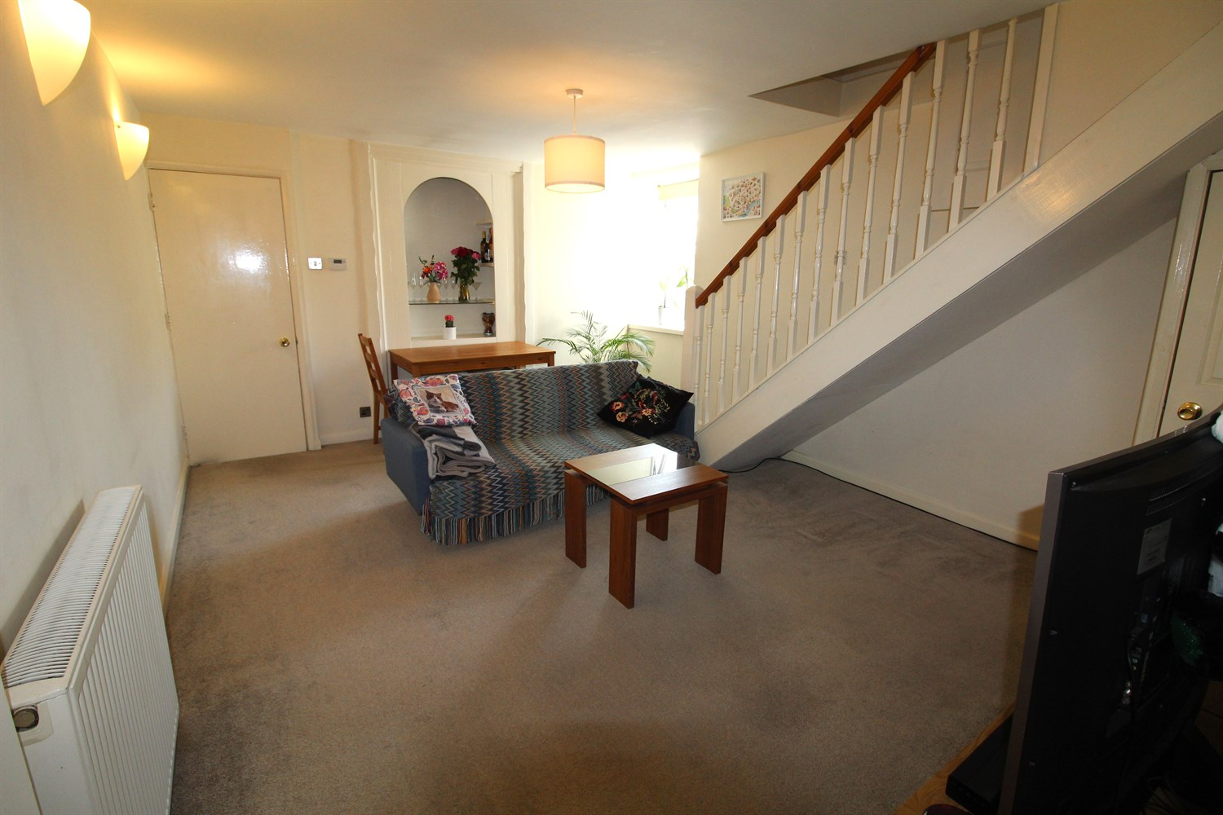

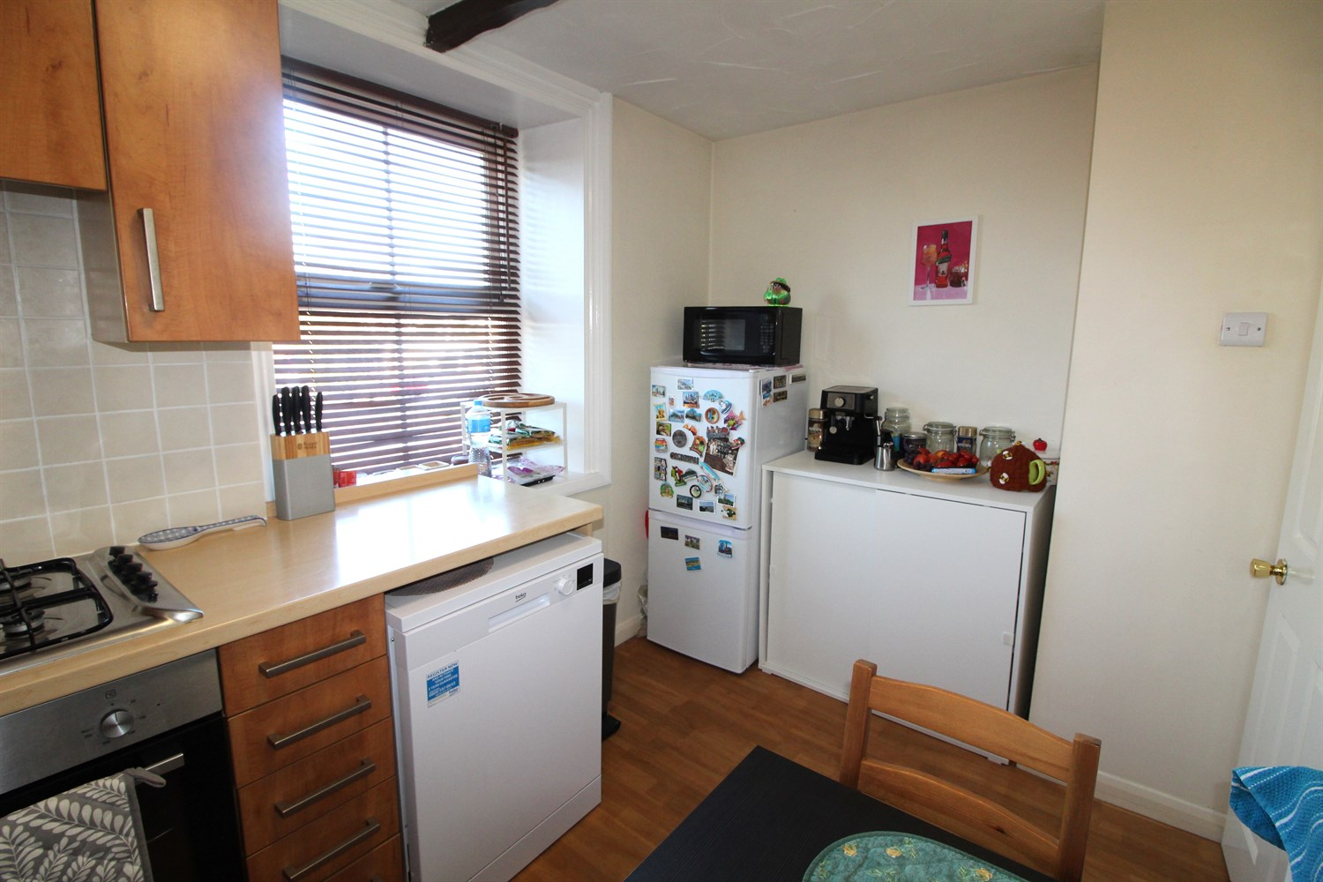

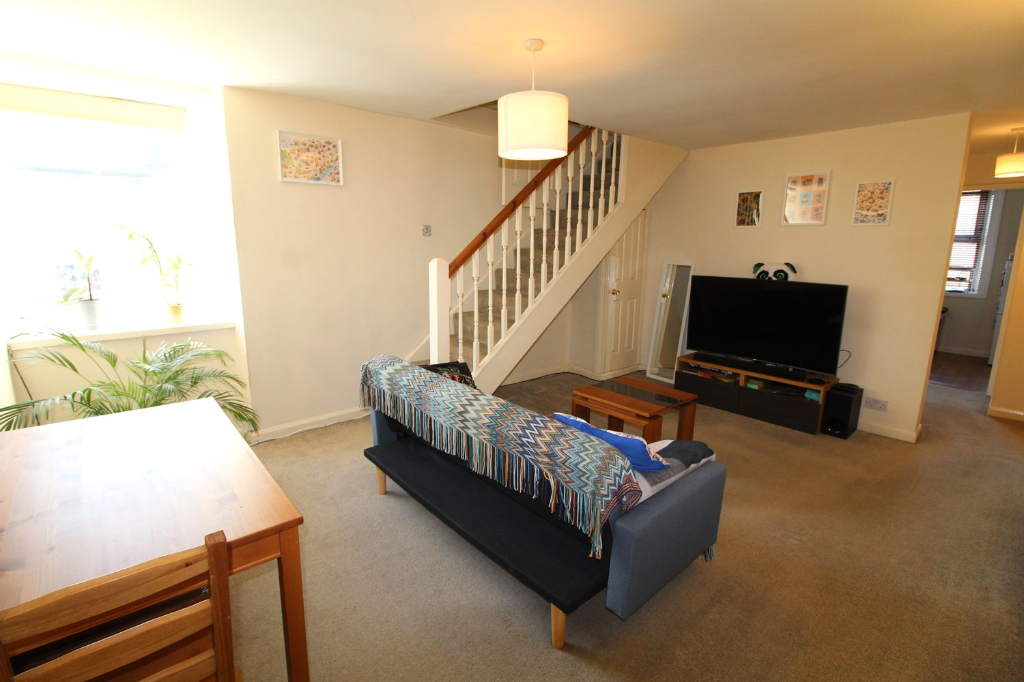

1 Bathroom(s)

1 Reception(s)

2 Bedroom(s)

00

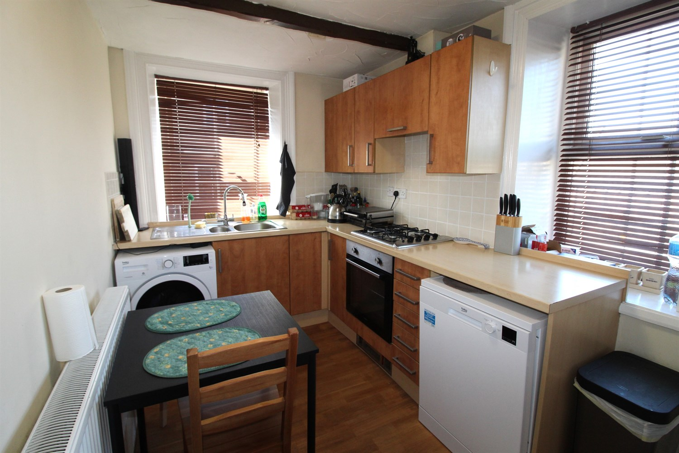

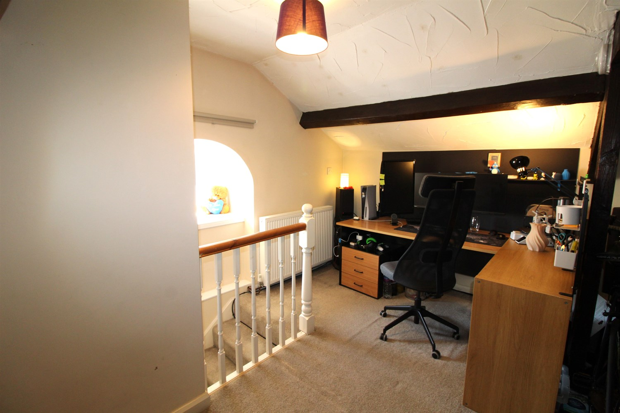

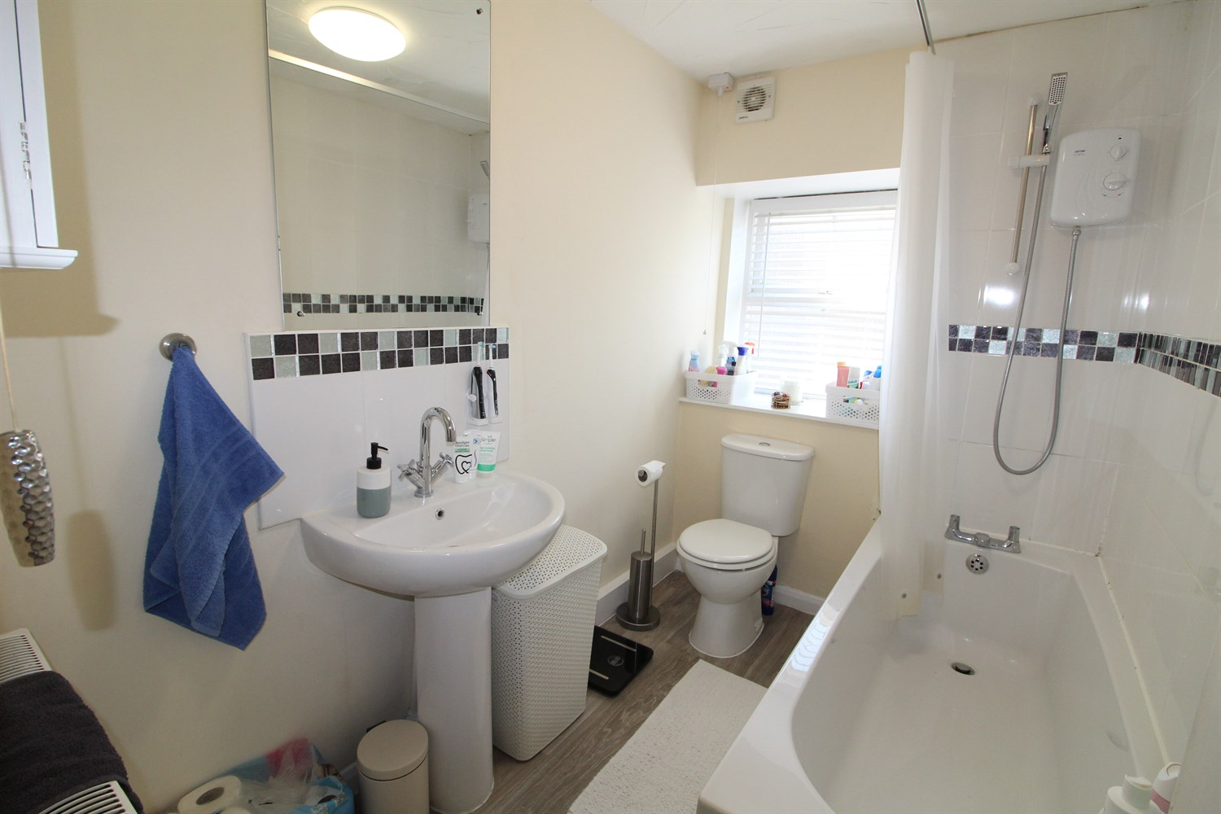

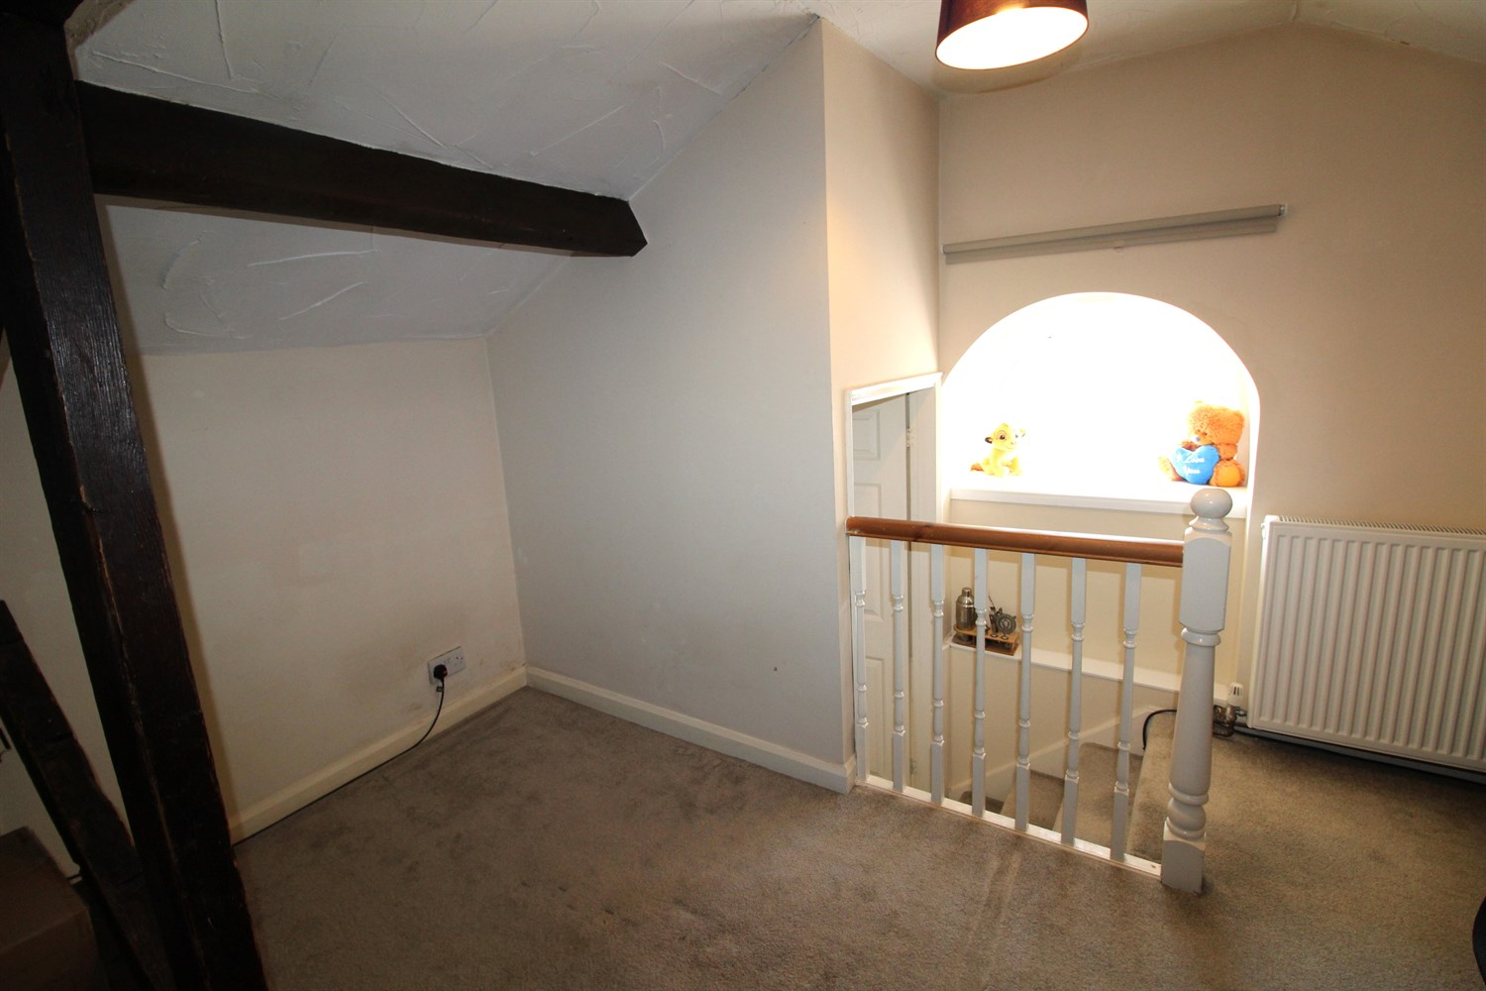

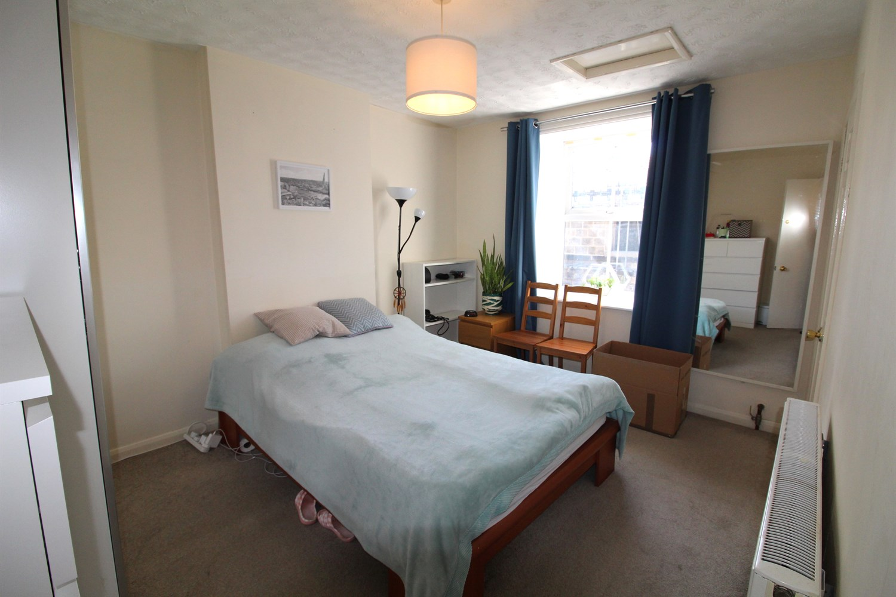

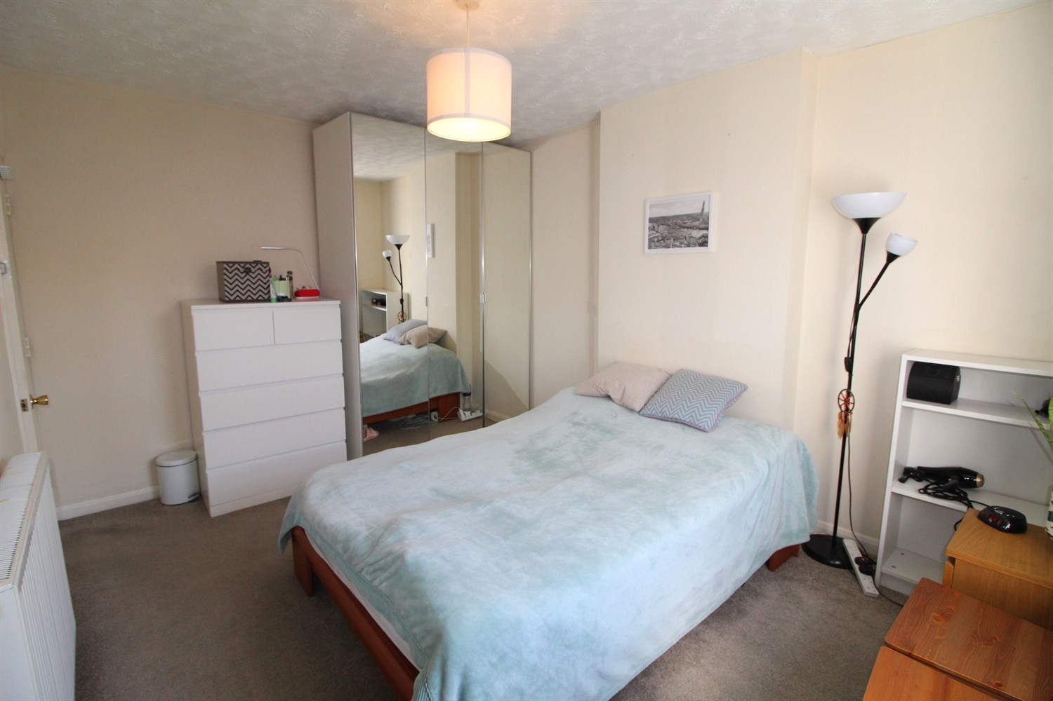

|  |
| --- |
| **Hallway**  Via front entrance door. Stairs to first floor apartment. |
| **Lounge 4.86m (15'11) x 3.35m (11')**  Light and airy living area with uPVC double glazed window to front. Gas central heating radiator. Stairs to first floor bedroom. |
| **Kitchen 3.88m (12'9) x 2.15m (7'1)**  Fitted with a range of wall, base and drawer units with worktops over. Space for dishwasher. Washing machine and fridge/freezer. Integrated oven with gas hob and extractor hood over. uPVC double glazed window to front to front and side. Gas central heating radiator. |
| **Bedroom 1 3.98m (13'1) x 3.07m (10'1)**  Double bedroom with uPVC double glazed window to front. Built in wardrobe. Gas central heating radiator. |
| **Bathroom**  Fitted with three piece suite comprising; bath with shower over, WC and wash hand basin. Part tiled walls. uPVC double glazed window. Gas central heating radiator. |
| **Bedroom 2/Office 4.08m (13'5) x 3.66m (12'0)**  Top Floor bedroom with exposed beams. uPVC double glazed window. Gas central heating radiator. |
| **On Street Parking**  Permit required. |
| **Central Heating**  Gas central heating. |
| **Home Information**  COUNCIL TAX BAND: B EPC Rating: D  Freehold property Street permit Parking  Broadband: Standard 15 Mbps 1 Mbps Good Superfast 80 Mbps 20 Mbps Good Ultrafast 1800 Mbps 220 Mbps Mobile availability: EE limited. Three Limited. O2 likely to have good coverage. Vodafone limited coverage.  Utilities: Water supplied on standard meters. Electric mains supplied on standard meters. Gas mains supplied on standard meters |

|  |  |
| --- | --- |
| These particulars are intended to give a fair description of the property, but their accuracy cannot be guaranteed, and they do not constitute an offer of contract. Intending purchasers must rely on their own inspection of the property. None of the above appliances/services have been tested by ourselves. We recommend purchasers arrange for a qualified person to check all appliances/services before legal commitment.  **Property Ref:** 5823  **For more information, please contact**  0113 258 1150 **|** [lettings@adairpaxton.co.uk](mailto:lettings@adairpaxton.co.uk) **|** www.adairpaxton.co.uk |  |