

**Bouverie Court, Leeds**

**For Sale £159,950.00**

***TWO BEDROOM, TWO BATHROOM GROUND FLOOR APARTMENT WITH ALLOCATED PARKING*** Well presented two double bedrooms, two bathroom apartment situated on this much favoured and convenient development on the outskirts of Leeds city centre, with easy access to the motorway network. The property briefly comprises; Private entrance hall, spacious open plan living/dining room & kitchen, Master bedroom with en-suite shower room, second double bedroom and house bathroom. Externally the property has well maintained communal grounds and an allocated parking space.

**0113 258 1150**

**0800 000 000**

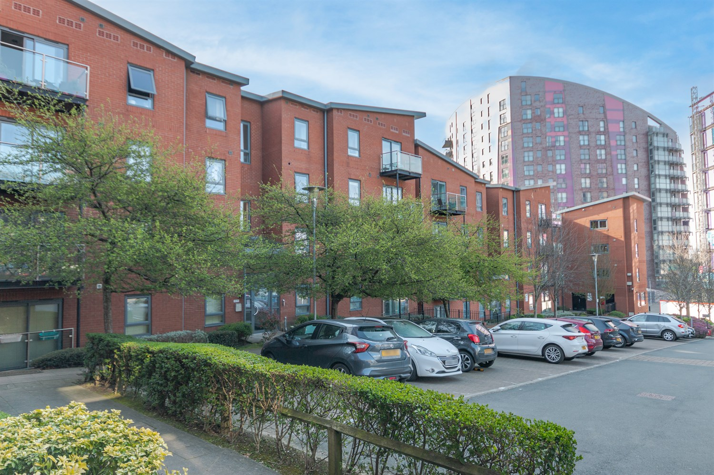



1 Reception(s)

2 Bathroom(s)

2 Bedroom(s)

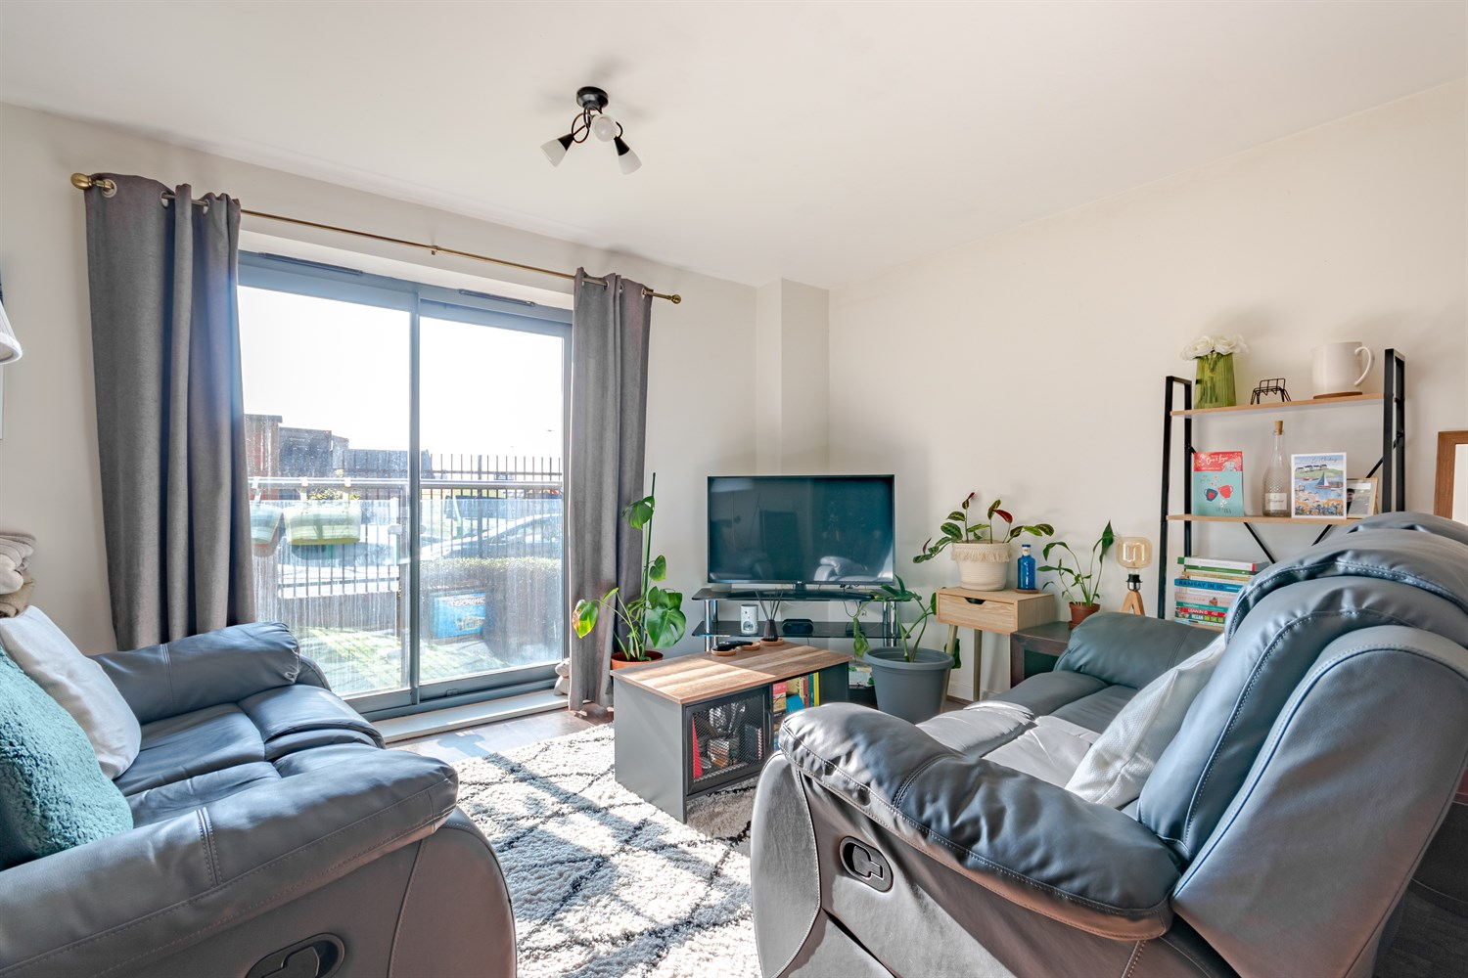

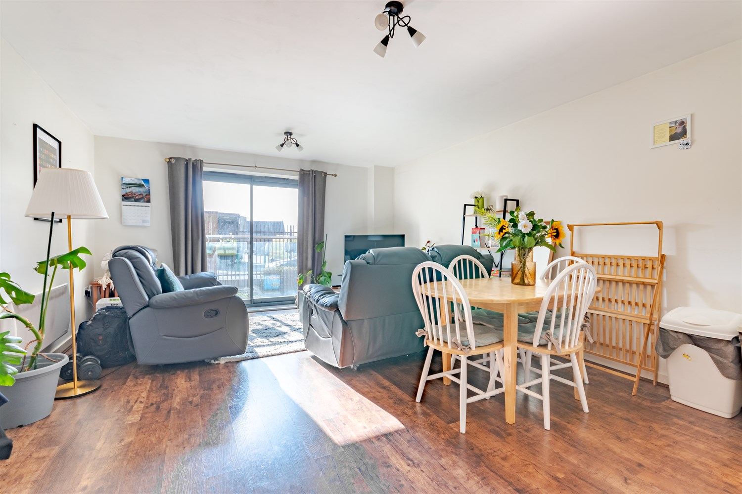

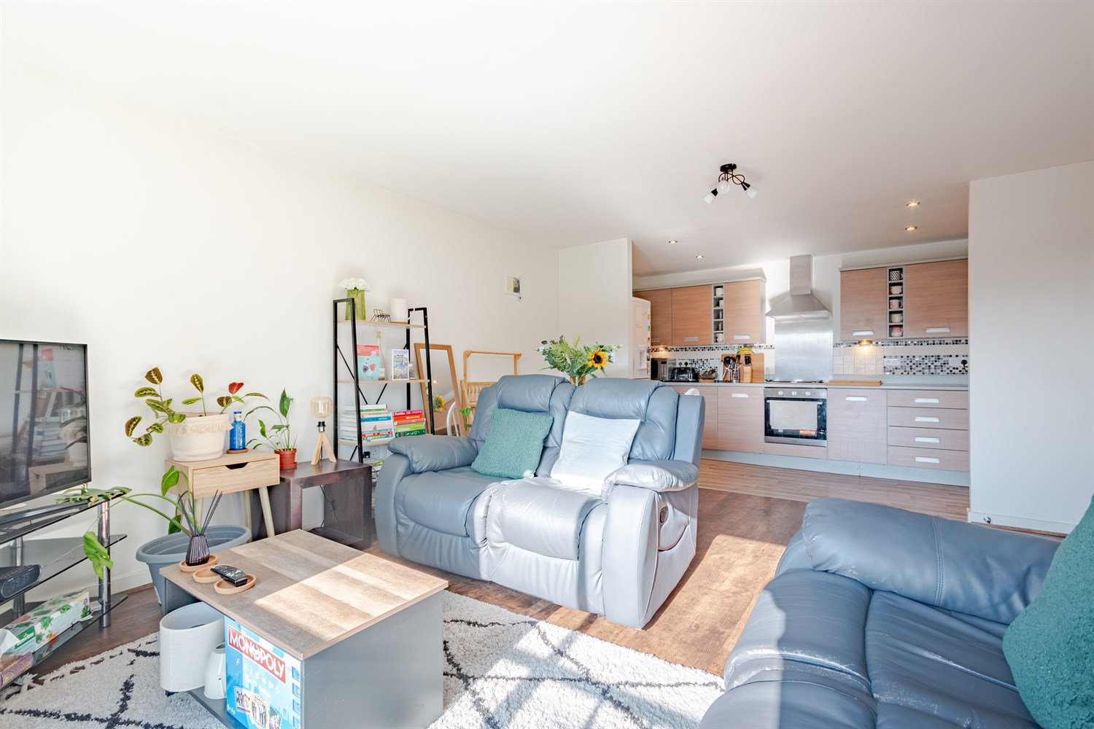

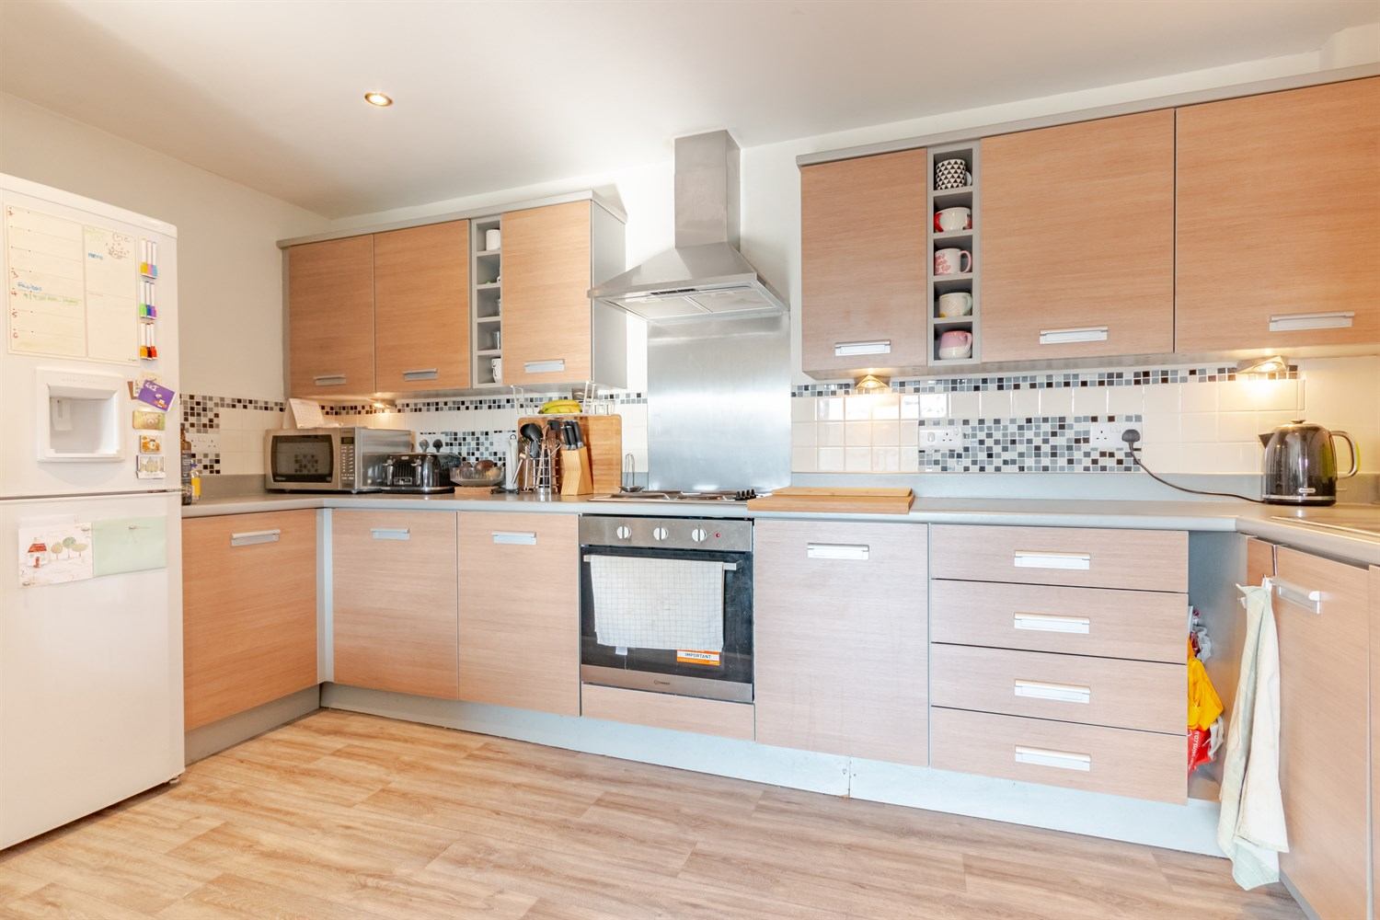

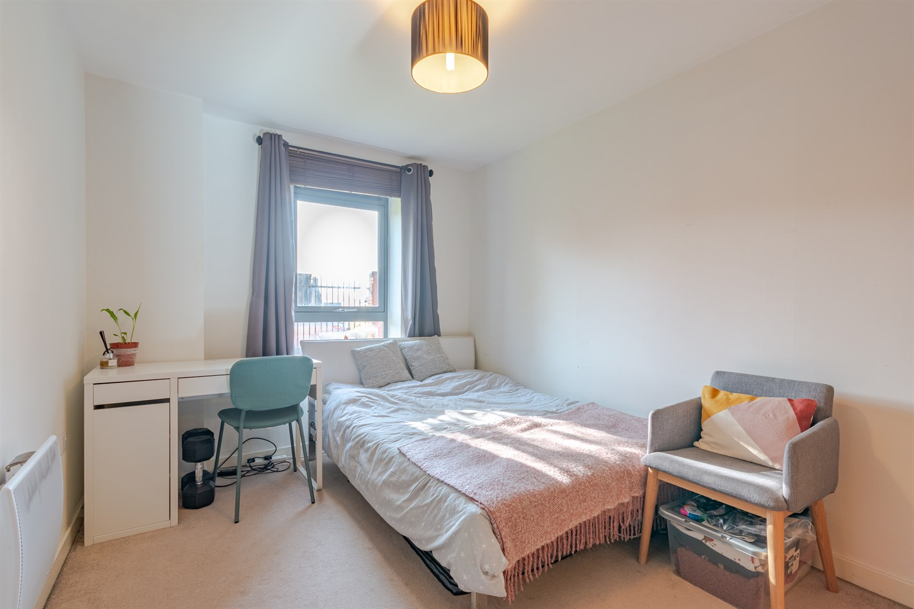

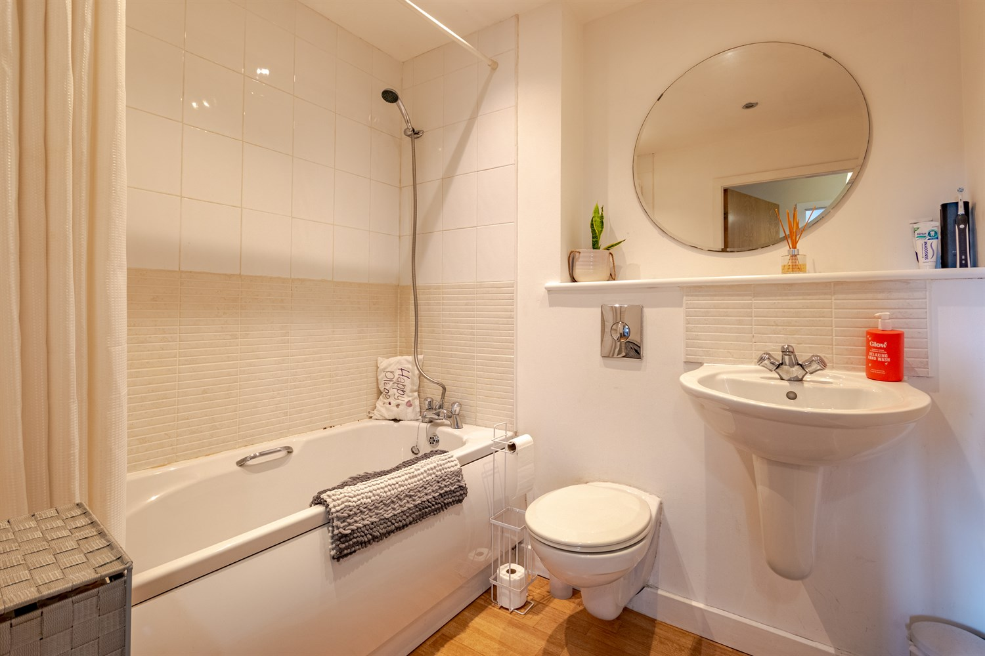

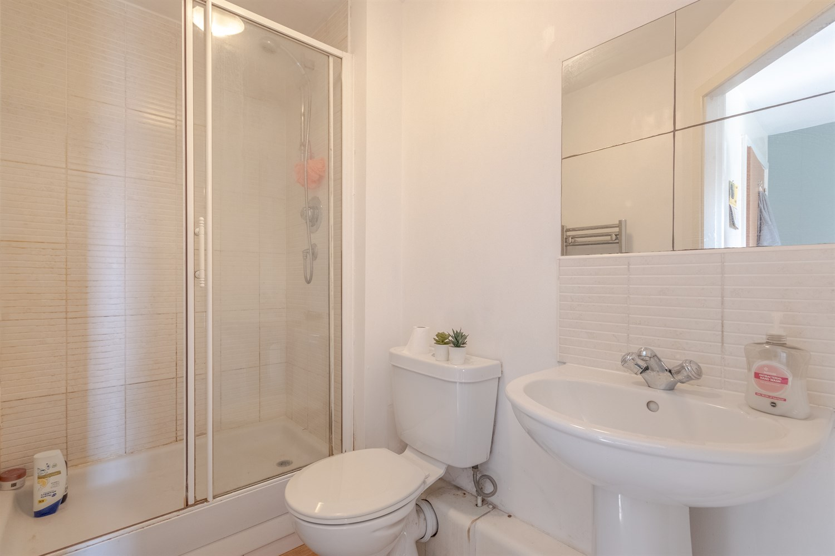

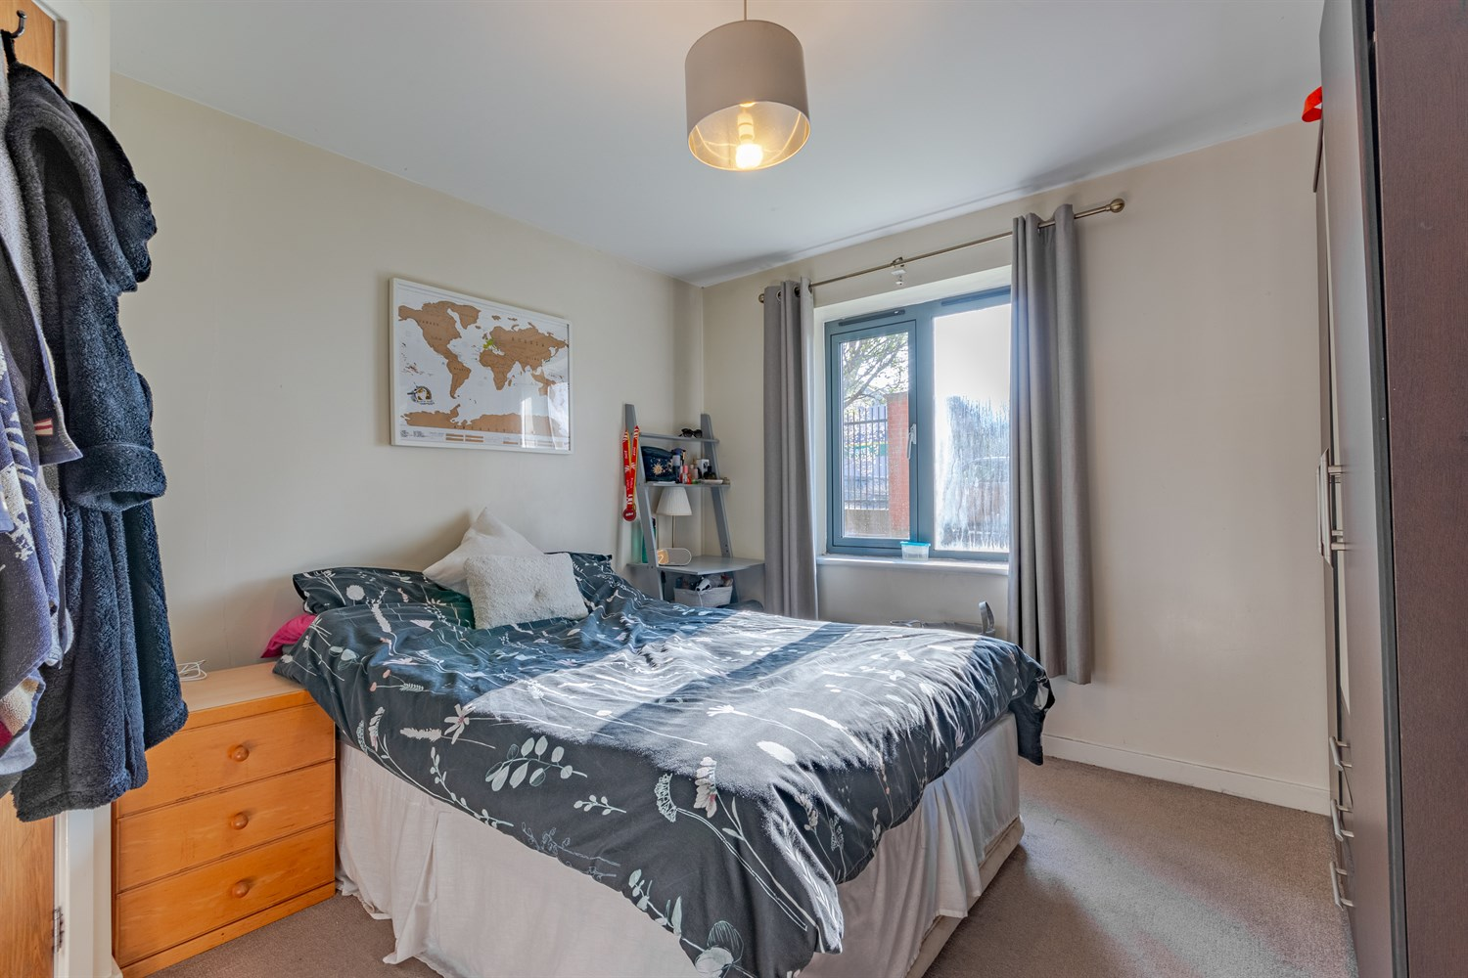

|  |
| --- |
| **Communal Entrance**  Via secure intercom entry system. Stairs to all floors. |
| **Private Entrance**  Useful storage cupboard housing the boiler. Intercom entry system. |
| **Lounge/Dining Area 4.11m (13'6) x 4.77m (15'8)**  Spacious living area with Juliet balcony to rear. Wall mounted electric radiator. Open plan to the kitchen. |
| **Kitchen 4.11m (13'6) x 1.94m (6'4)**  Open plan to the living room/diner. Fitted with a range of wall, base and drawer units with work surfaces over. Stainless steel sink and drainer with mixer tap. Integrated electric oven and hob with extractor hood over. Integrated washing machine. |
| **Bedroom 1 3.33m (10'11) x 3.41m (11'2)**  A spacious double bedroom with double glazed window. Wall mounted electric radiator. |
| **En-suite Bathroom**  Fitted with a three piece white suite comprising low level WC, wash hand basin and shower cubicle. Electric shaver point. Chrome heated ladder towel rail. |
| **Bedroom 2 2.64m (8'8) x 3.63m (11'11)**  A spacious double bedroom with double glazed window. Wall mounted electric radiator. |
| **Bathroom**  Fitted with a three piece white suite comprising bath with shower attachment to taps, low level WC and wash hand basin. Chrome heated ladder towel rail. |
| **Tenure**  Leasehold. 155 years from Jan 2006 Ground rent is £373.40 per annum |
| **Service Charge**  The service charges are £234.21 per quarter |
|  |
|  |

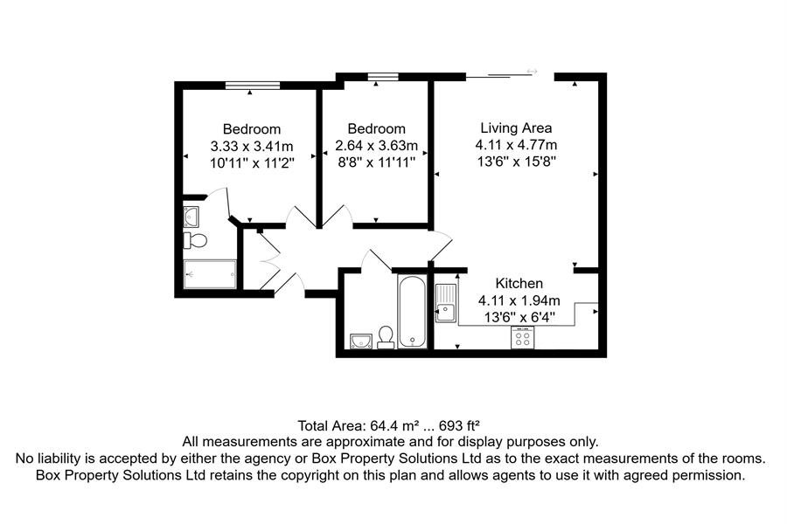

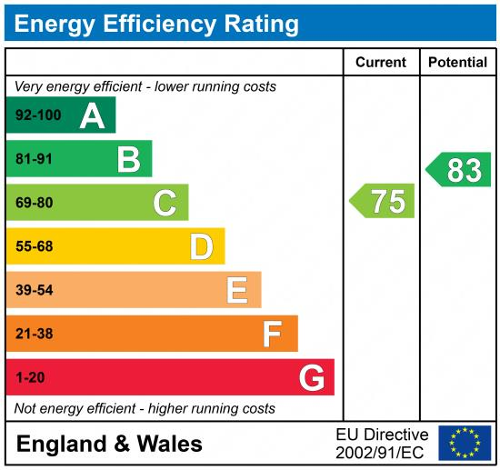

|  |
| --- |
|  |

These particulars are intended to give a fair description of the property, but their accuracy cannot be guaranteed, and they do not constitute an offer of contract. Intending purchasers must rely on their own inspection of the property. None of the above appliances/services have been tested by ourselves. We recommend purchasers arrange for a qualified person to check all appliances/services before legal commitment.

**For more information, please contact**

0113 258 1150 **|** [sales@adairpaxton.co.uk](mailto:sales@adairpaxton.co.uk) **|** www.adairpaxton.co.uk