

Roker Lane, Pudsey
For Sale £280,000.00

***EXTENDED FOUR BEDROOM SEMI-DETACHED HOUSE with NO ONWARD CHAIN*** Adair Paxton are pleased to offer to the market this deceptively spacious family home located in a popular part of Pudsey. The accommodation briefly comprises; hallway, living room, sitting room, ground floor WC/shower room, utility and Kitchen/Diner to the ground floor. To the first floor there is a master bedroom with an en-suite bathroom, two further double bedrooms, a single bedroom and a house bathroom. Externally, the property sits on a corner plot with gardens to the front and rear. To the rear is an off street parking space leading to a detached garage. Pudsey Town Centre offers a range of local facilities including schools, shops, cafes, bars and restaurants. Pudsey Park is centrally located in the town and offers a childrens playground and fabulous gardens. Out-of-town shopping on a larger scale is found at the nearby Owlcotes Shopping Centre which offers both Asda and Marks & Spencer Superstore, with bus links and New Pudsey Railway Station also being close by.
0113 258 1150
0800 000 000
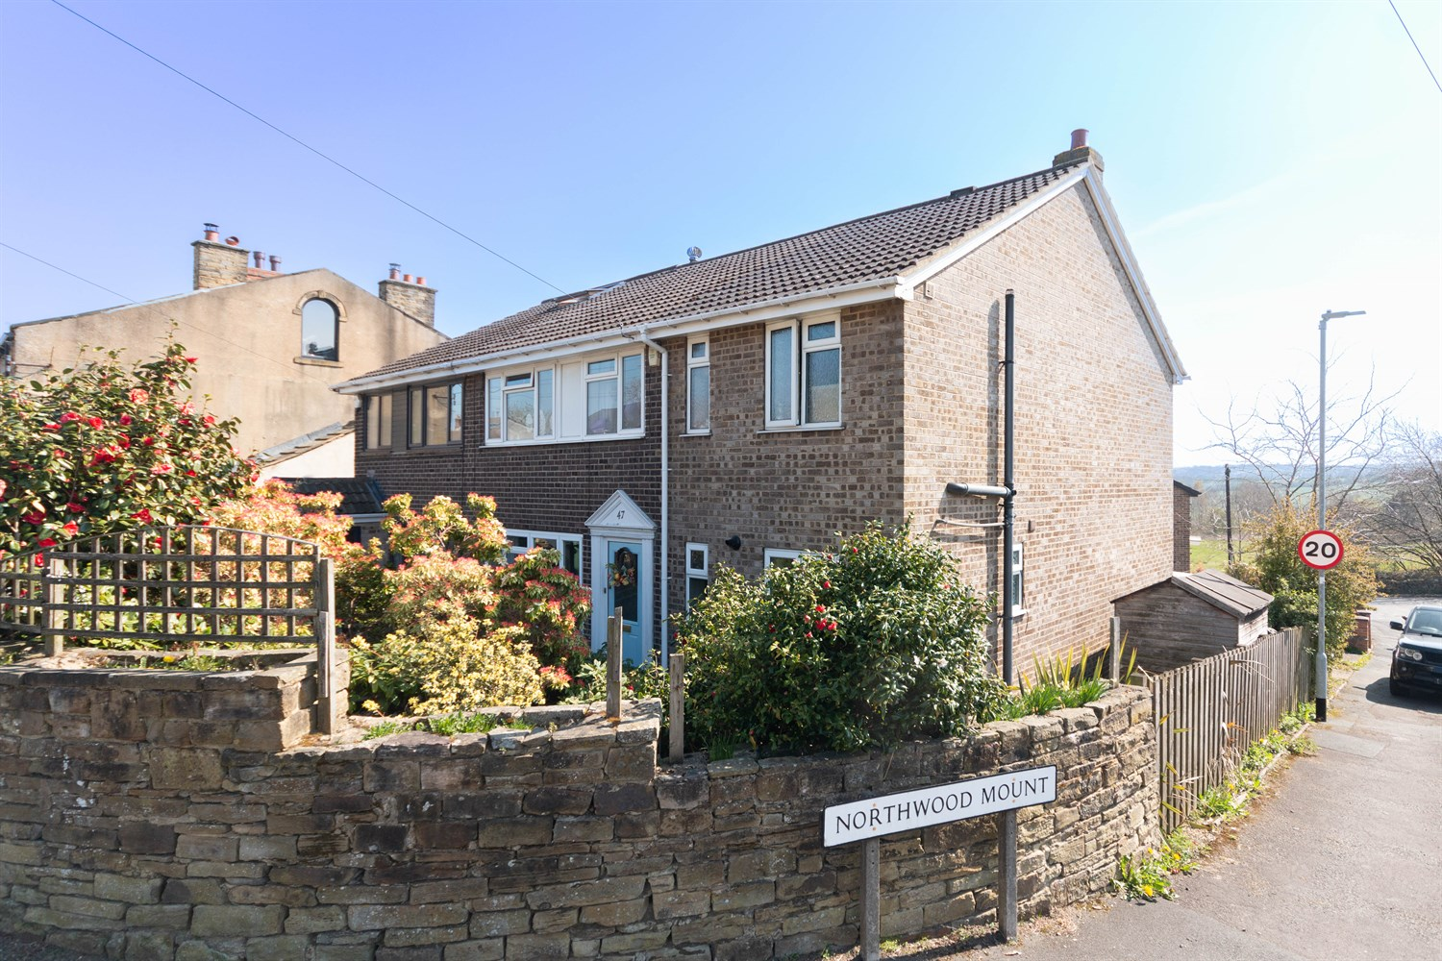
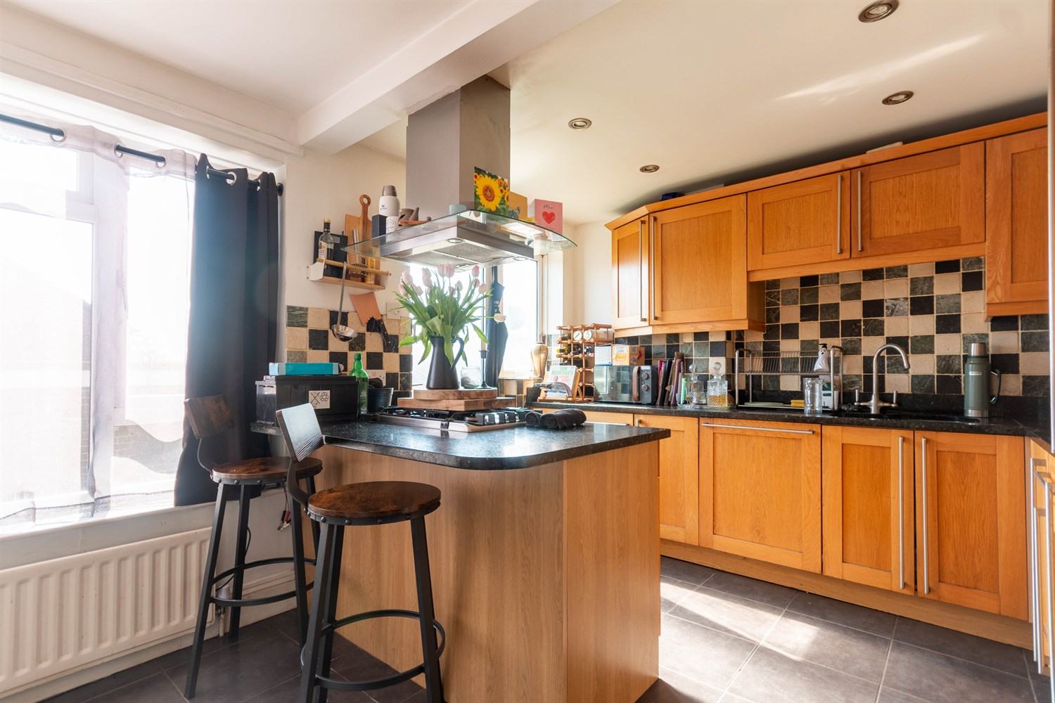
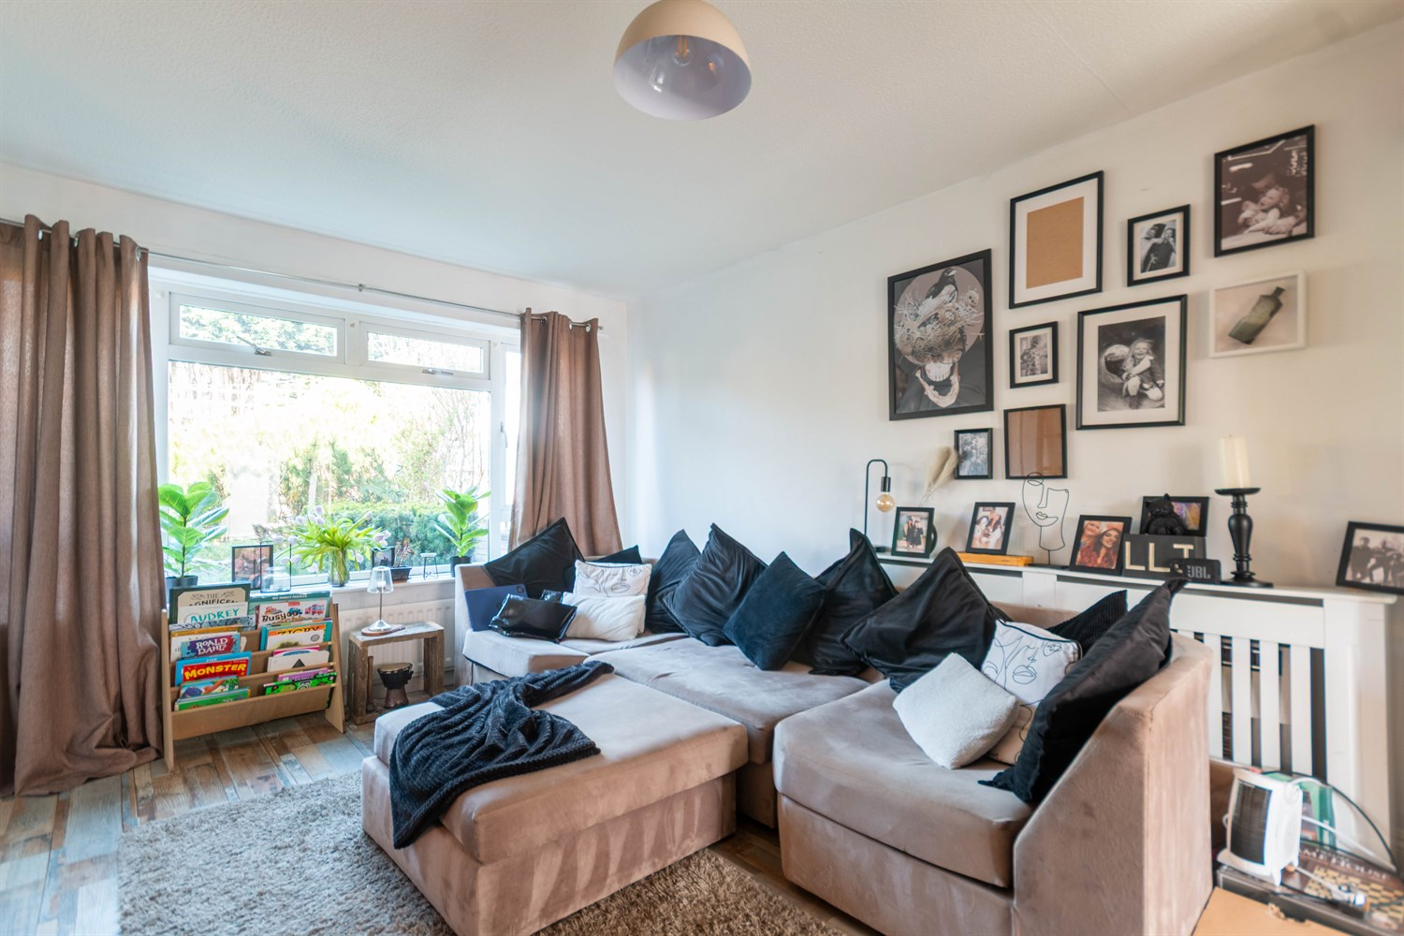
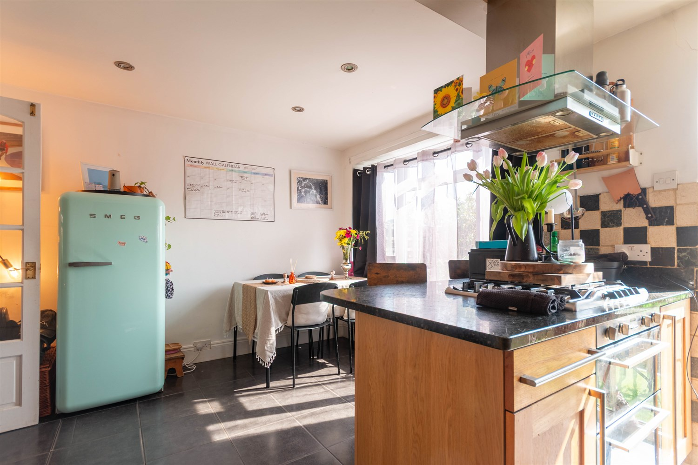
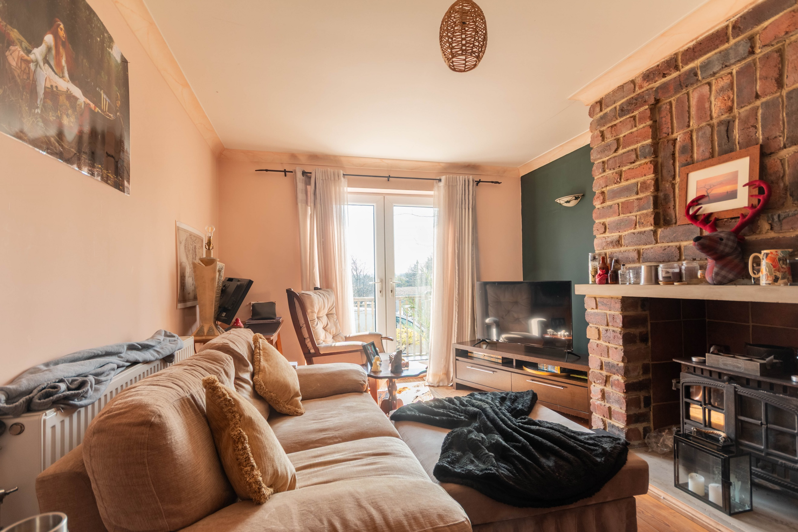
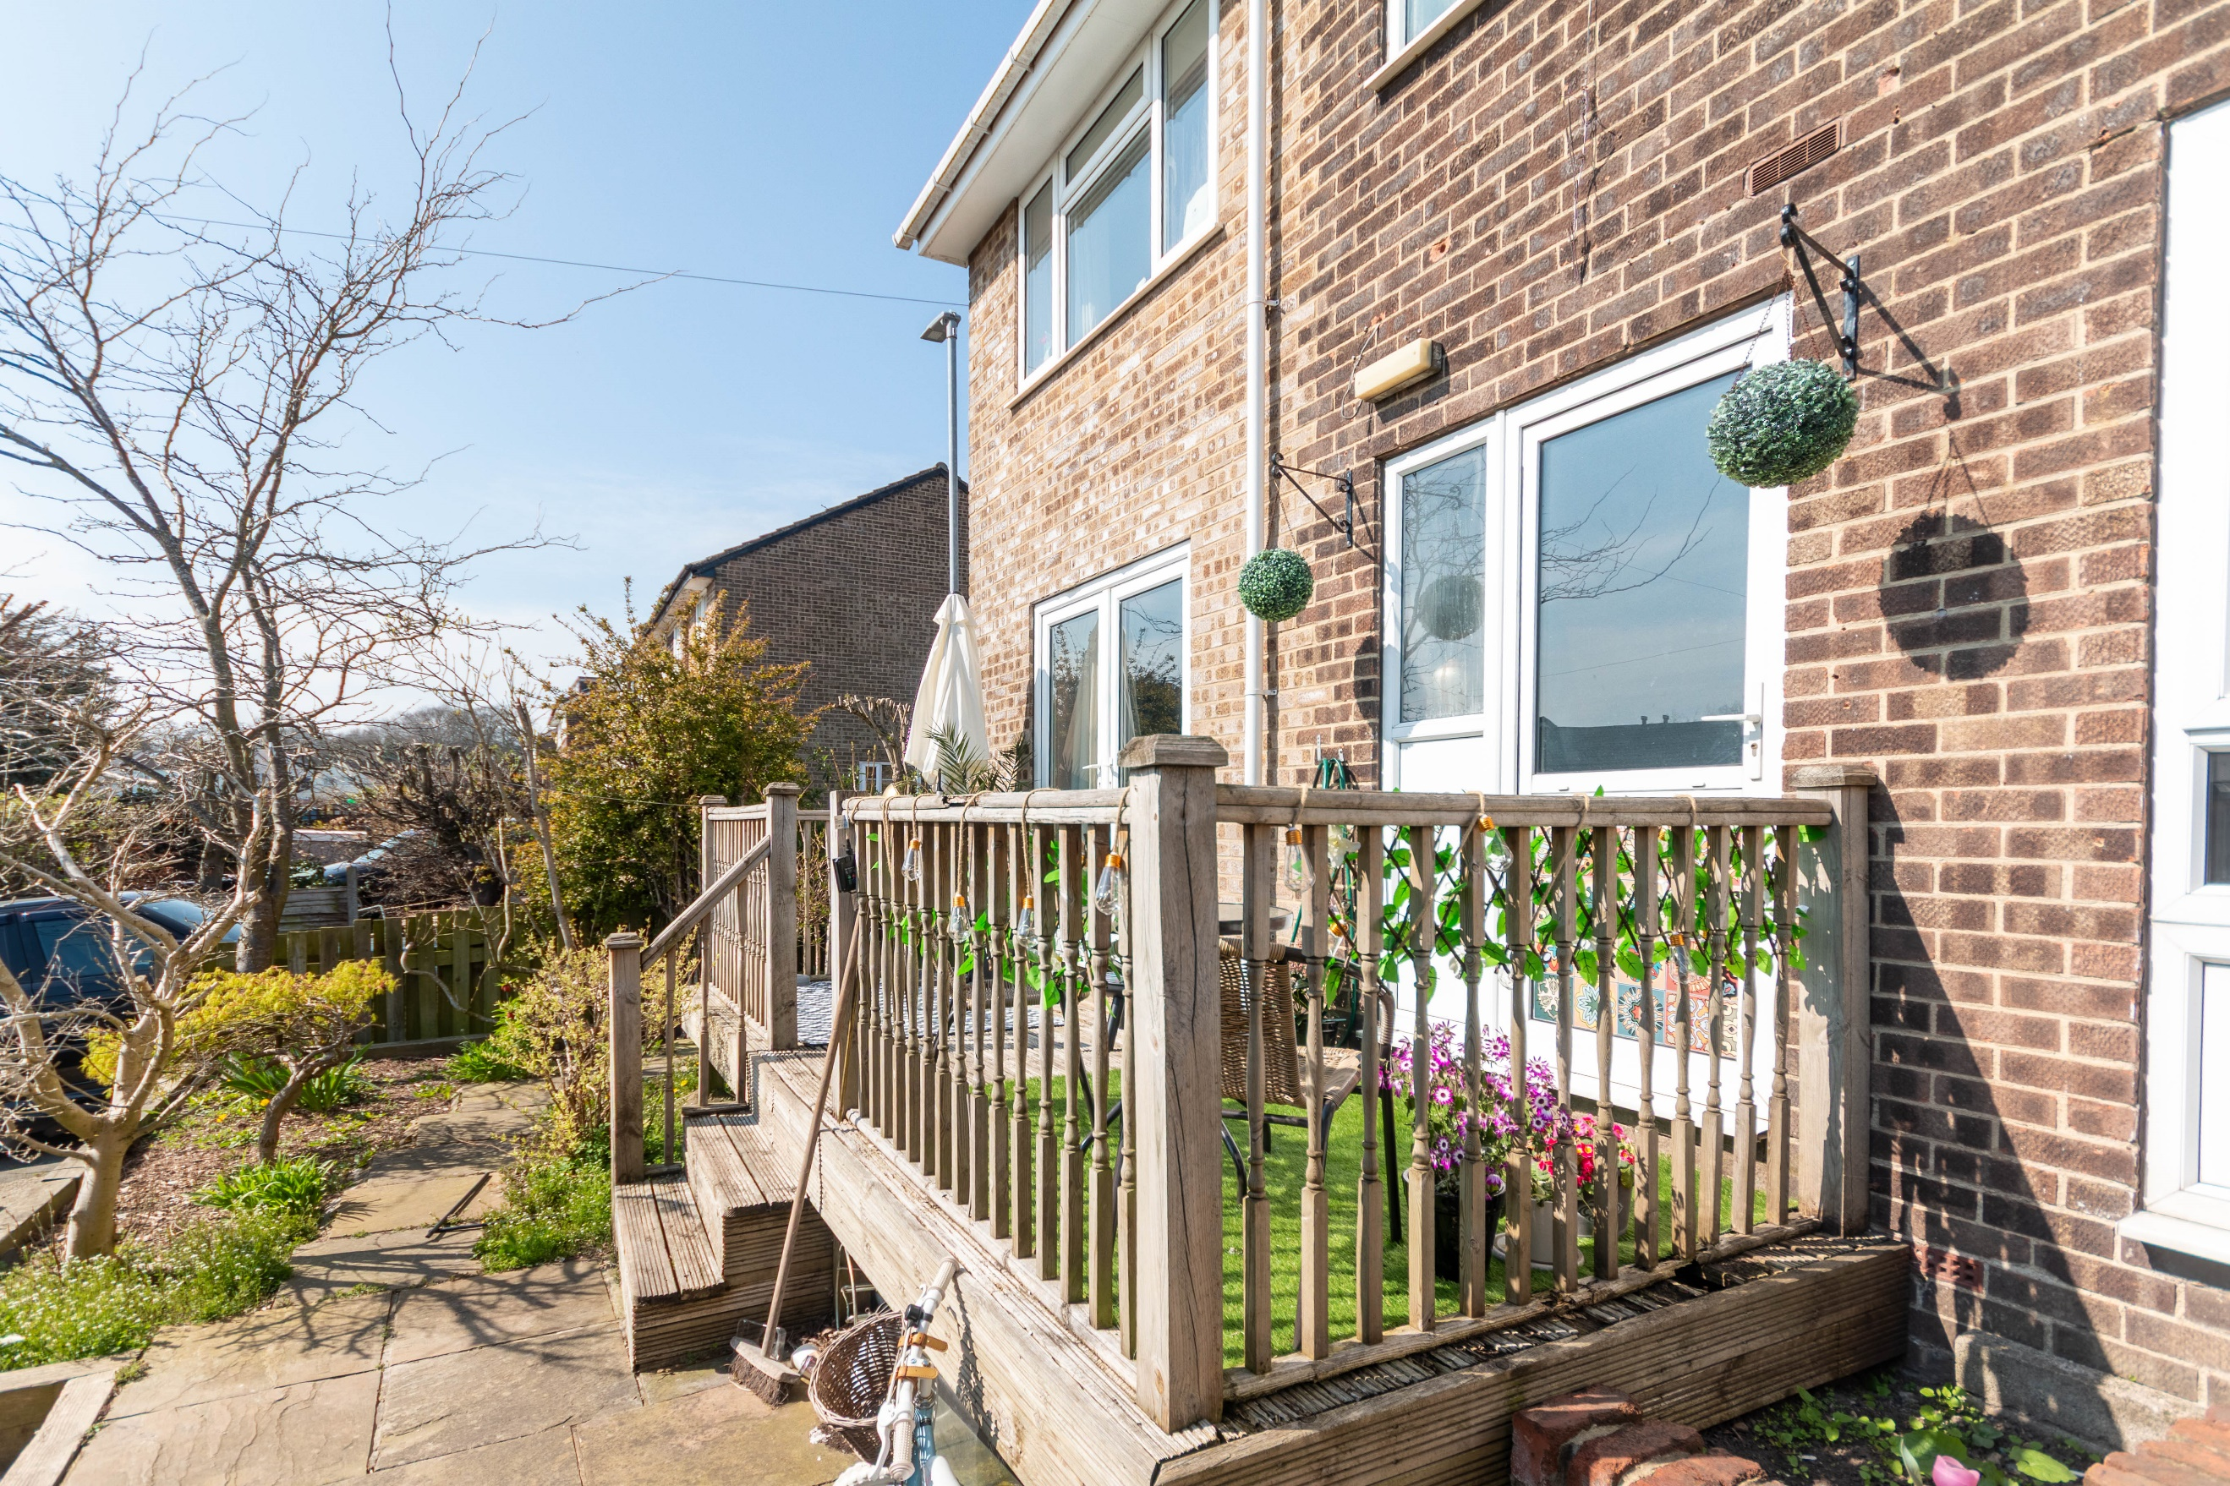
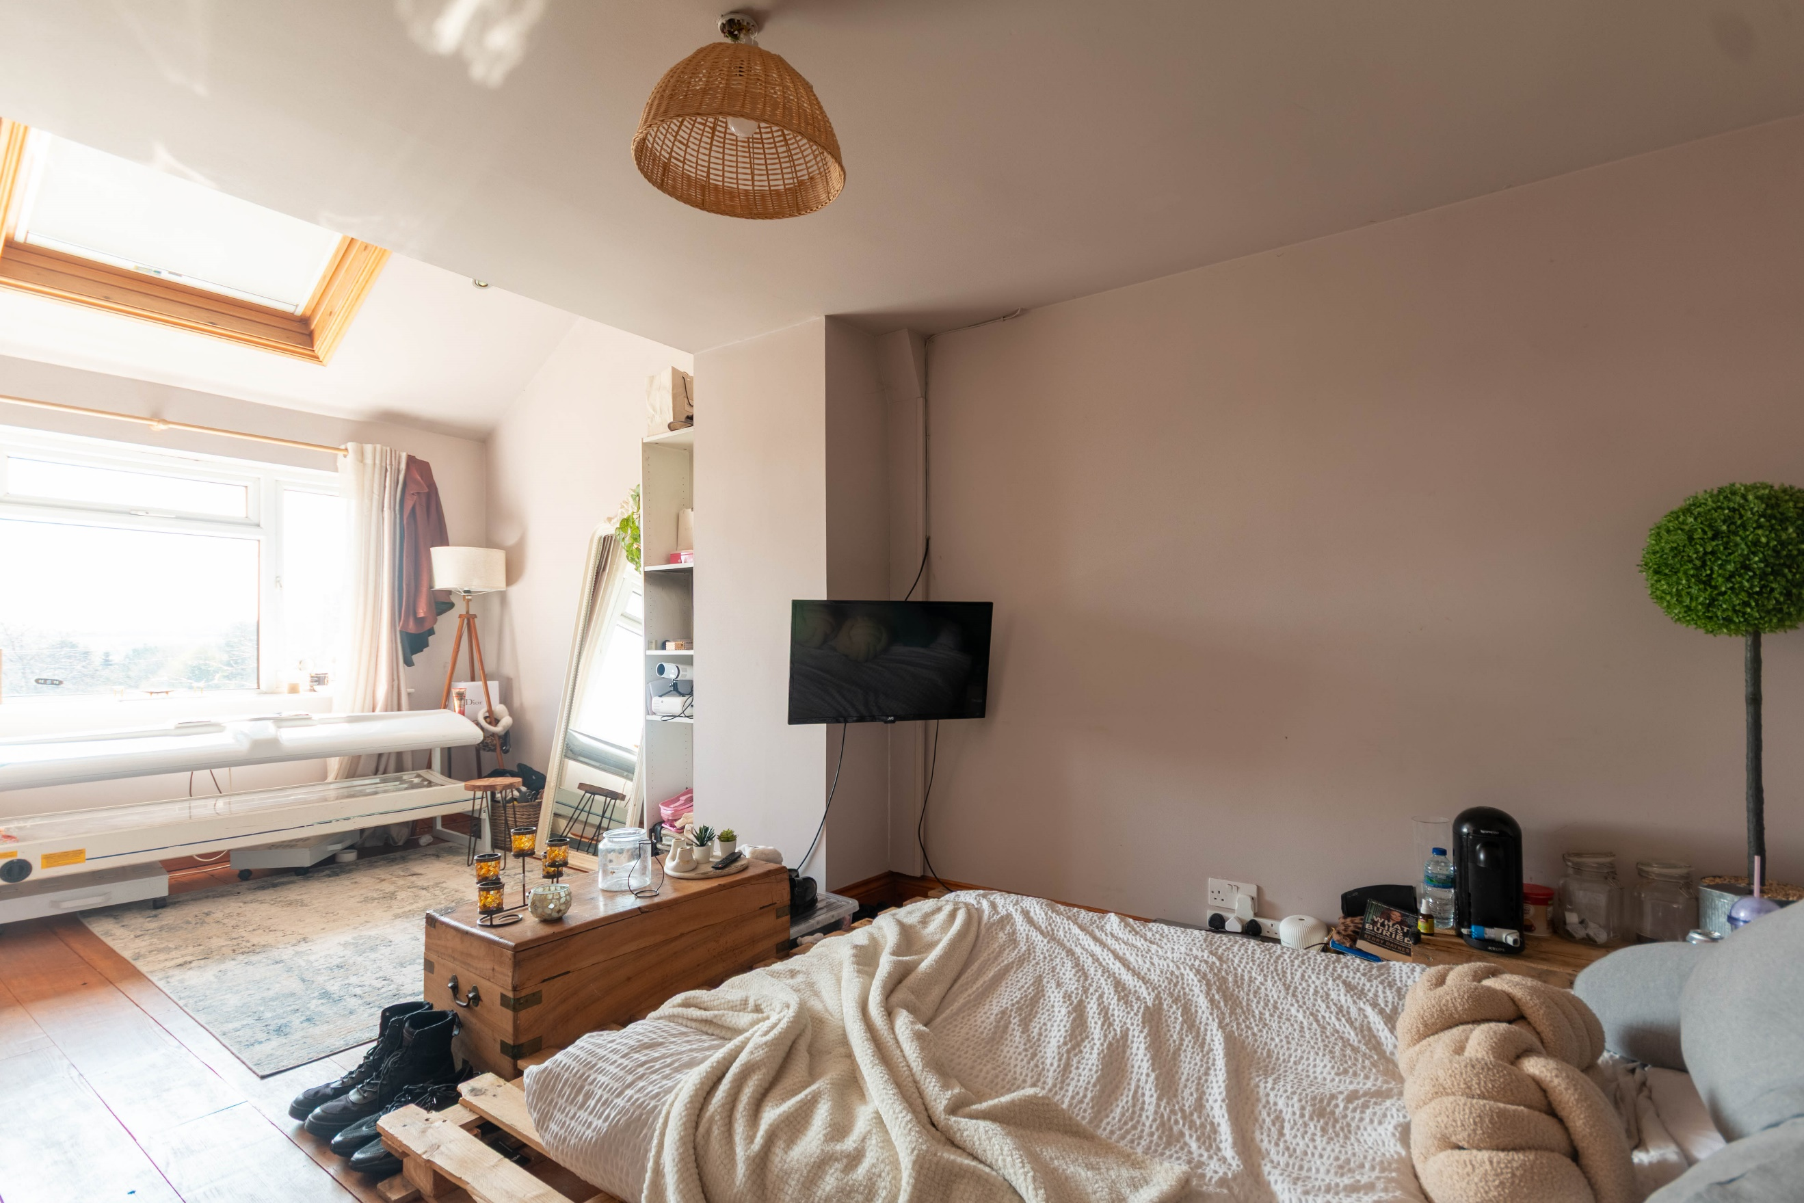
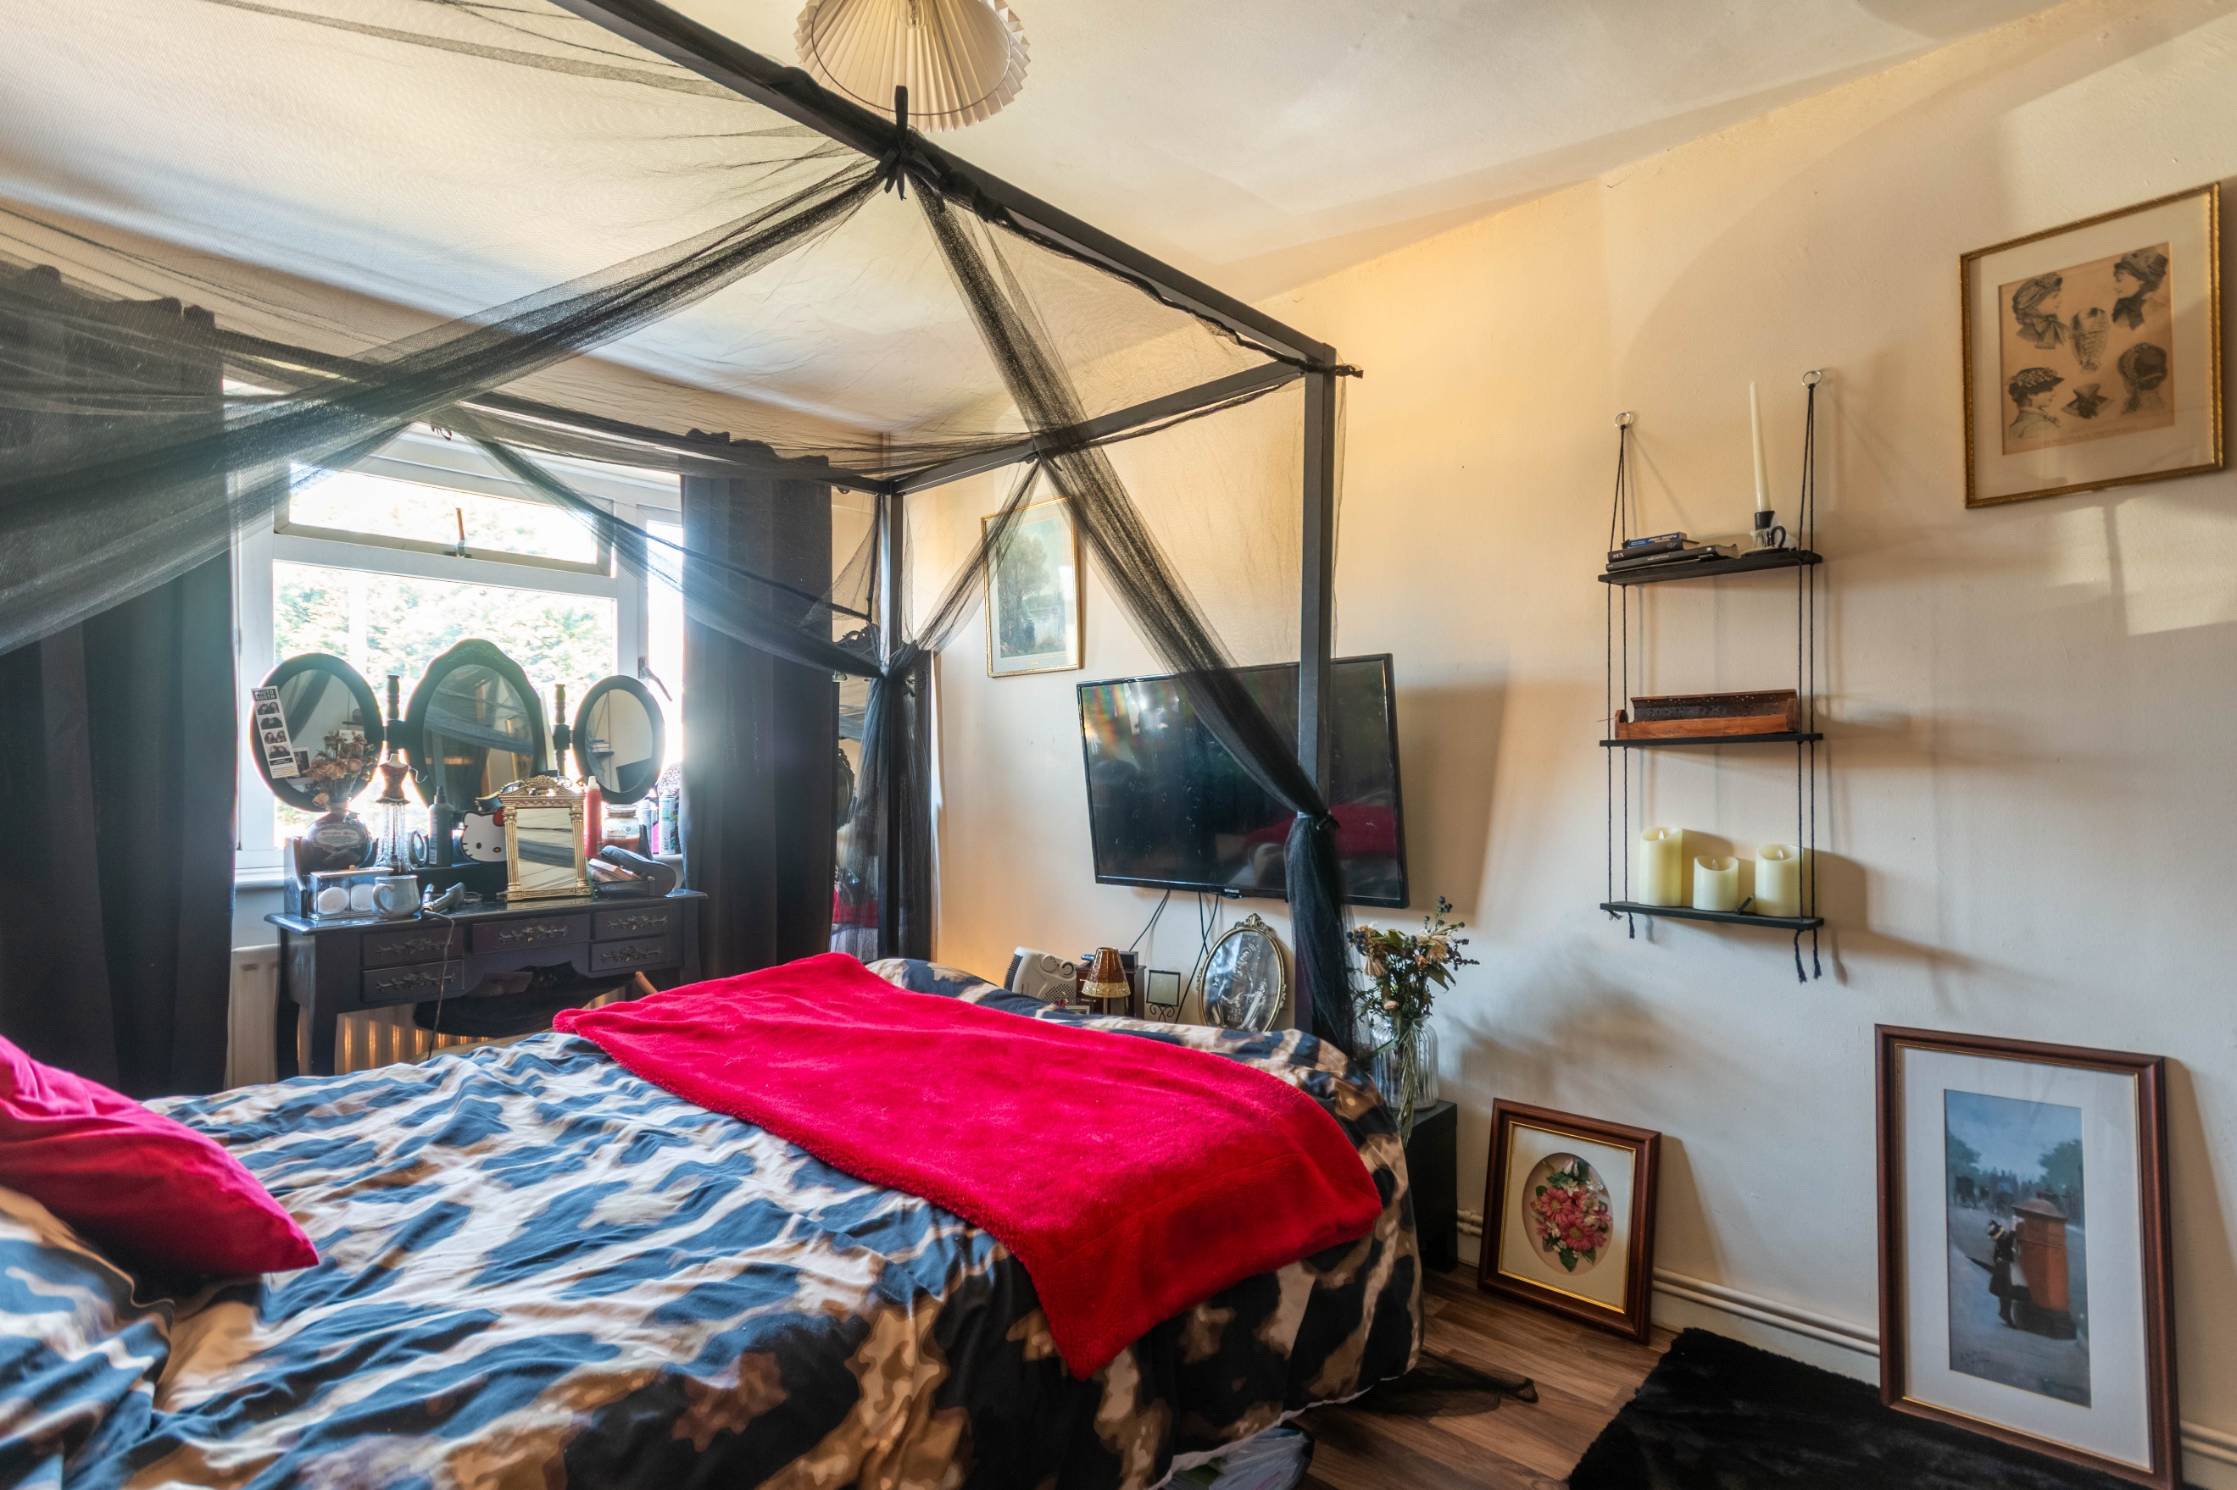
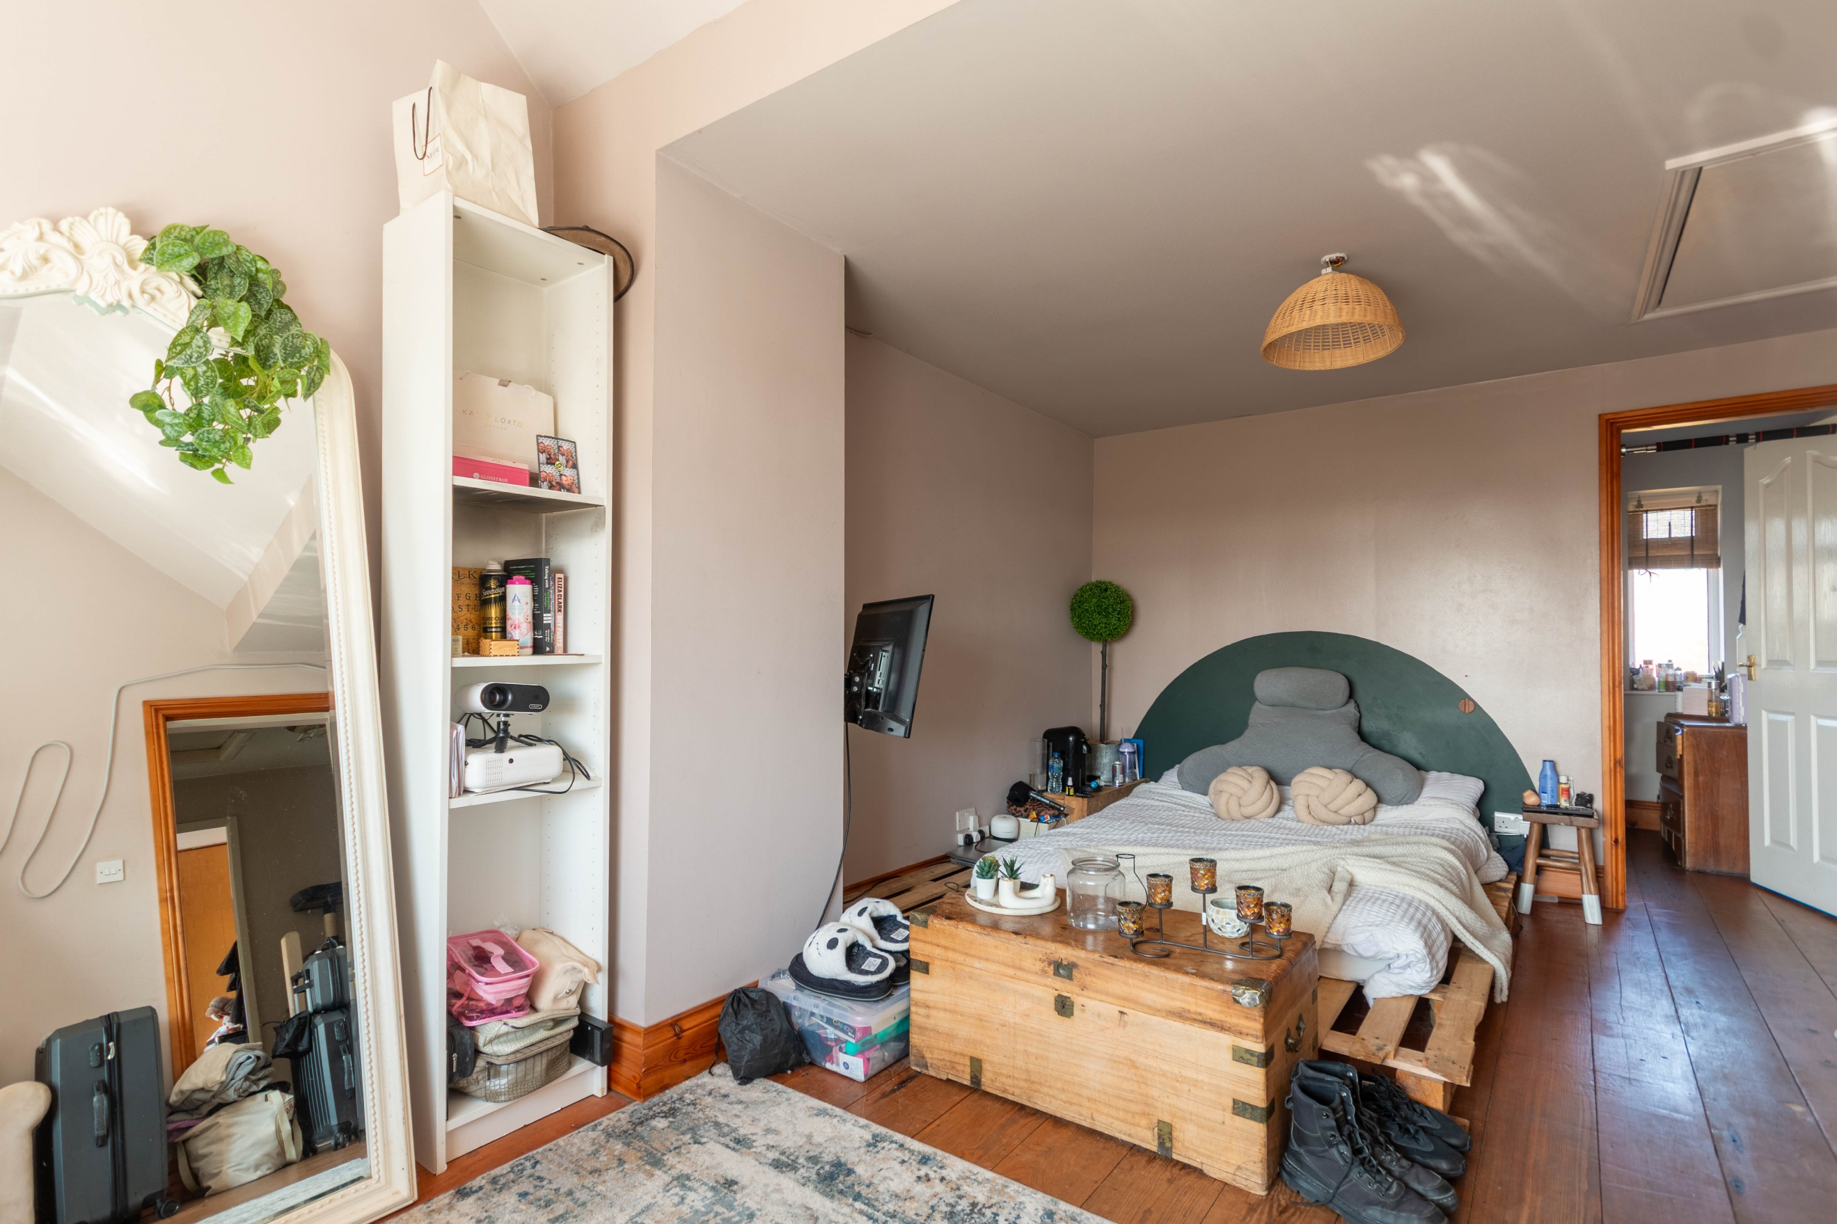

Hallway
Via front entrance door.

Utility
Fitted with cupboards with worktops over. Stainless steel sink with mixer tap and drainer. Part tiled walls. uPVC double glazed window. Plumbed for washing machine.

Ground Floor WC/Shower Room
Fitted with a two piece suite comprising WC and shower cubicle.

Sitting Room 3.65m (12') x 4.64m (15'3)
Light and airy living area with uPVC double glazed window to front. Gas central heating radiator.

Living Room 3.29m (10'10) x 5.22m (17'2)
Second reception room with uPVC double glazed doors leading out to the rear garden. Exposed brick wall to chimney breast. Gas central heating radiator.

Kitchen/Diner 4.65m (15'3) x 3.21m (10'6)
Fitted with a range of wall, base and drawer units with worktops over. Integrated double oven with gas hob and extractor hood over. Integrated fridge freezer and dishwasher. Sink with mixer tap and drainer. Part tiled walls. Inset ceiling spotlights. uPVC double glazed door leading to rear garden. Dining area with uPVC double glazed window to rear. Gas central heating radiator.

First Floor

Bedroom 1 3.25m (10'8) x 5.86m (19'3)
Master bedroom with uPVC double glazed window to rear and Velux window to ceiling. Gas central heating radiator.

En-suite
Fitted with three piece suite comprising; WC, wash hand basin and bath. uPVC double glazed window.

Bedroom 2 2.73m (8'11) x 4.41m (14'6)
Double bedroom with uPVC double glazed window to front. Gas central heating radiator.

Bedroom 3 2.73m (8'11) x 3.44m (11'3)
Third bedroom with uPVC double glazed window to rear. Gas central heating radiator.

Bedroom 4 1.8m (5'11) x 2.35m (7'9)
Bedroom with uPVC double glazed window to front. Gas central heating radiator.

House Bathroom
Fitted with a three piece suite comprising bath, WC and wash hand basin. uPVC double glazed window to rear.

Outside
Well presented gardens to the front and rear with a decked area ideal for entertaining. Detached single garage with up and over door.

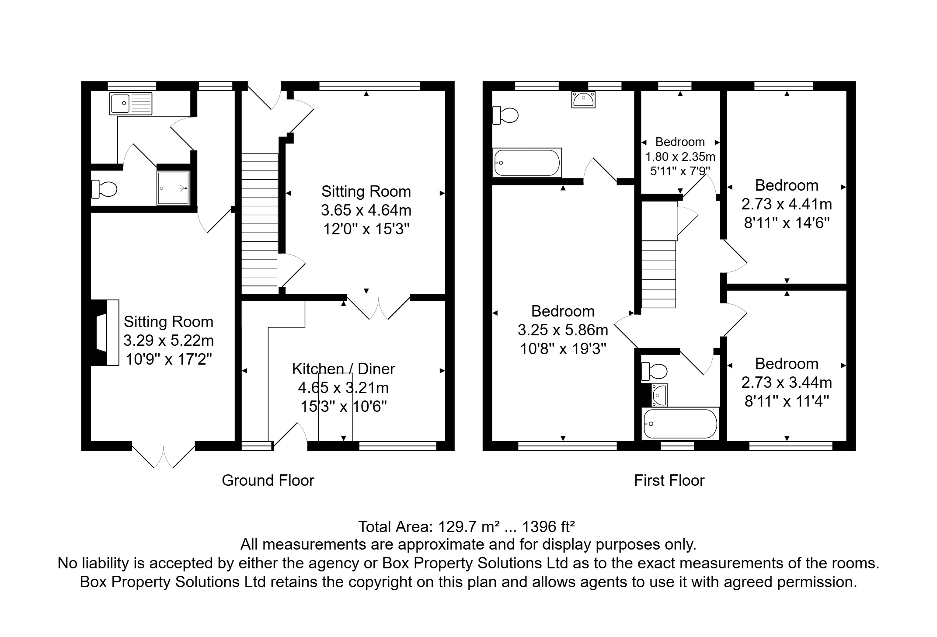

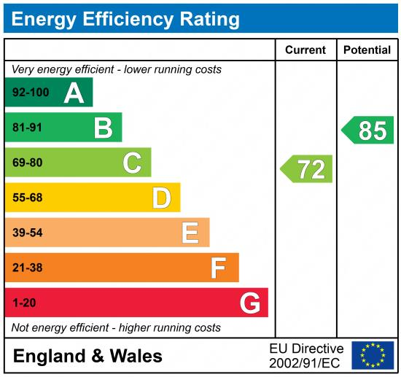

These particulars are intended to give a fair description of the property, but their accuracy cannot be guaranteed, and they do not constitute an offer of contract. Intending purchasers must rely on their own inspection of the property. None of the above appliances/services have been tested by ourselves. We recommend purchasers arrange for a qualified person to check all appliances/services before legal commitment.

Property Ref: 5793

For more information, please contact

0113 258 1150 | sales@adairpaxton.co.uk | www.adairpaxton.co.uk

