

**Rosemont Place, Bramley**

**For Sale £170,000**

**THREE BEDROOM MID -TERRACE HOUSE with NO ONWARD CHAIN** Adair Paxton are pleased to offer to the market this mid terrace house, conveniently situated close to Bramley Train Station and Bramley Shopping Centre as well as good road links to Leeds and Bradford city centres. The property is set over three floors and briefly comprises; Living room and kitchen to the ground floor. Cellar. Master bedroom, second bedroom and bathroom to the first floor. To the second floor there is a bedroom and study area. Externally the property has an enclosed patio area to the front.

**0113 258 1150**

**0800 000 000**

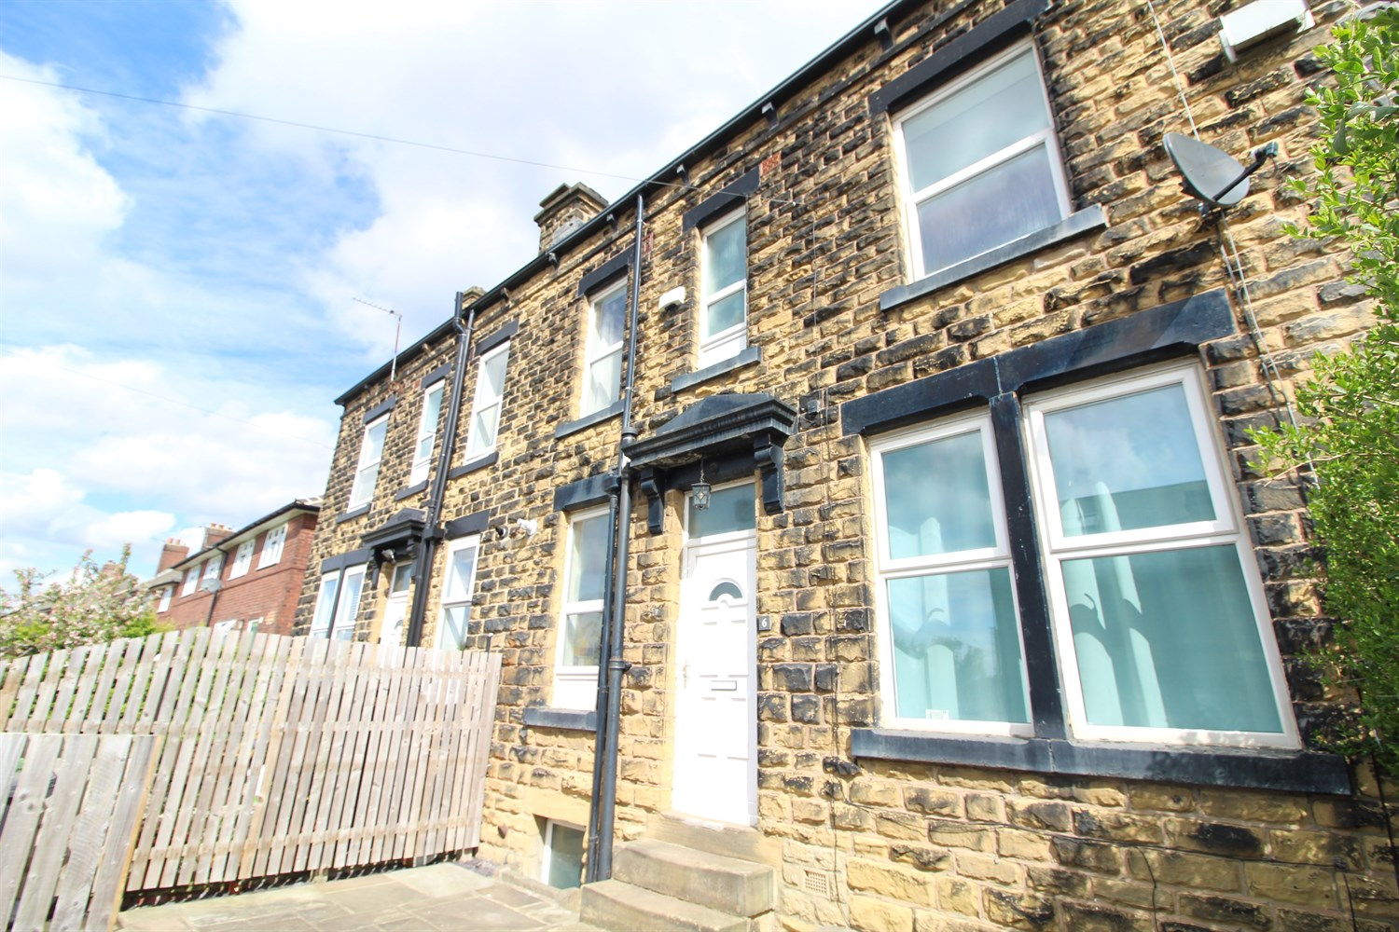



1 Reception

1 Bathroom

3 Bedrooms

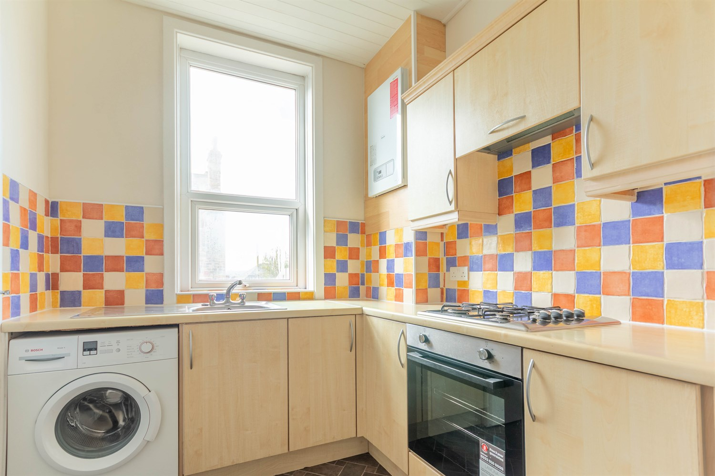

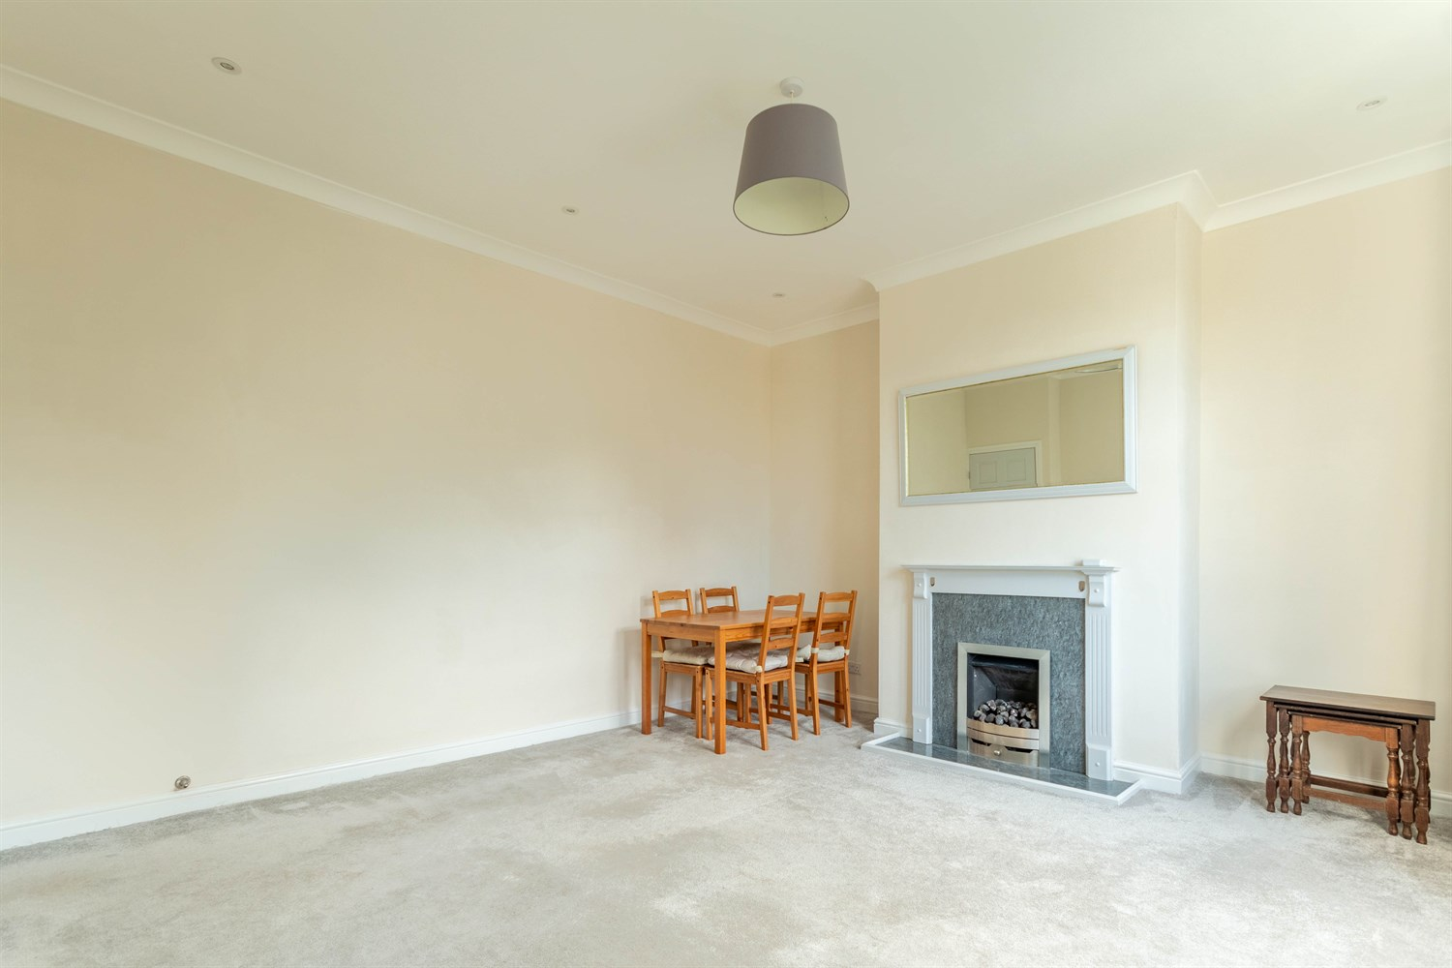

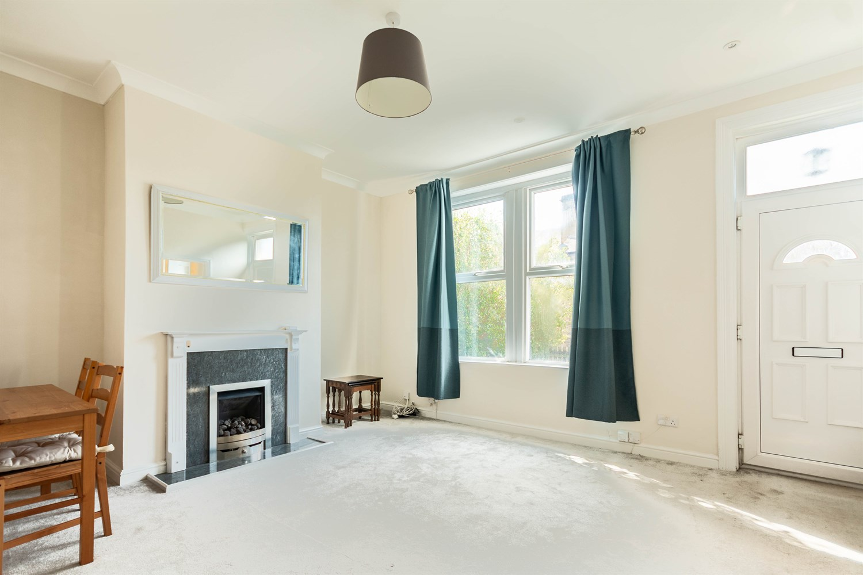

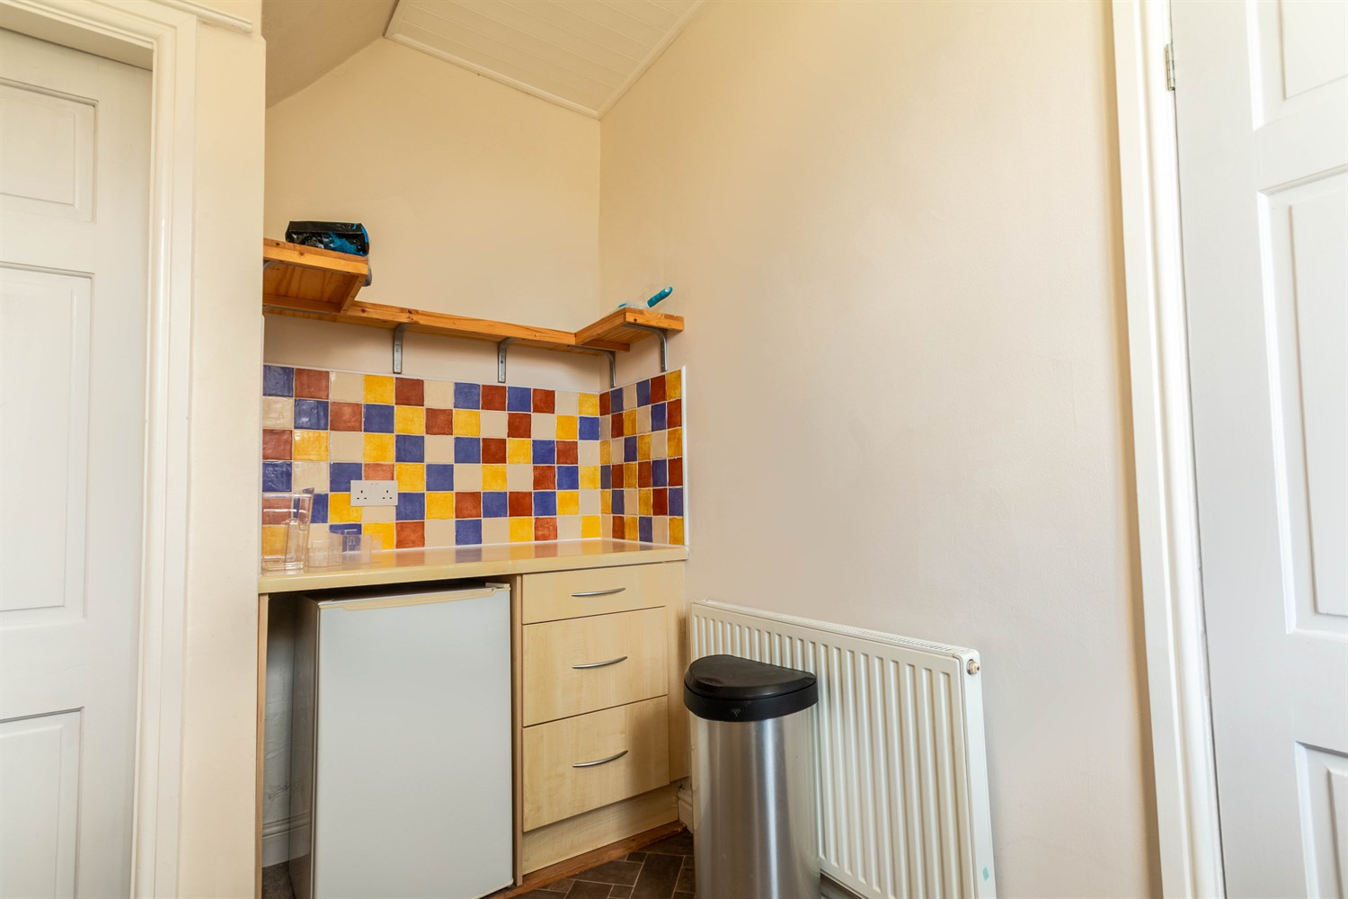

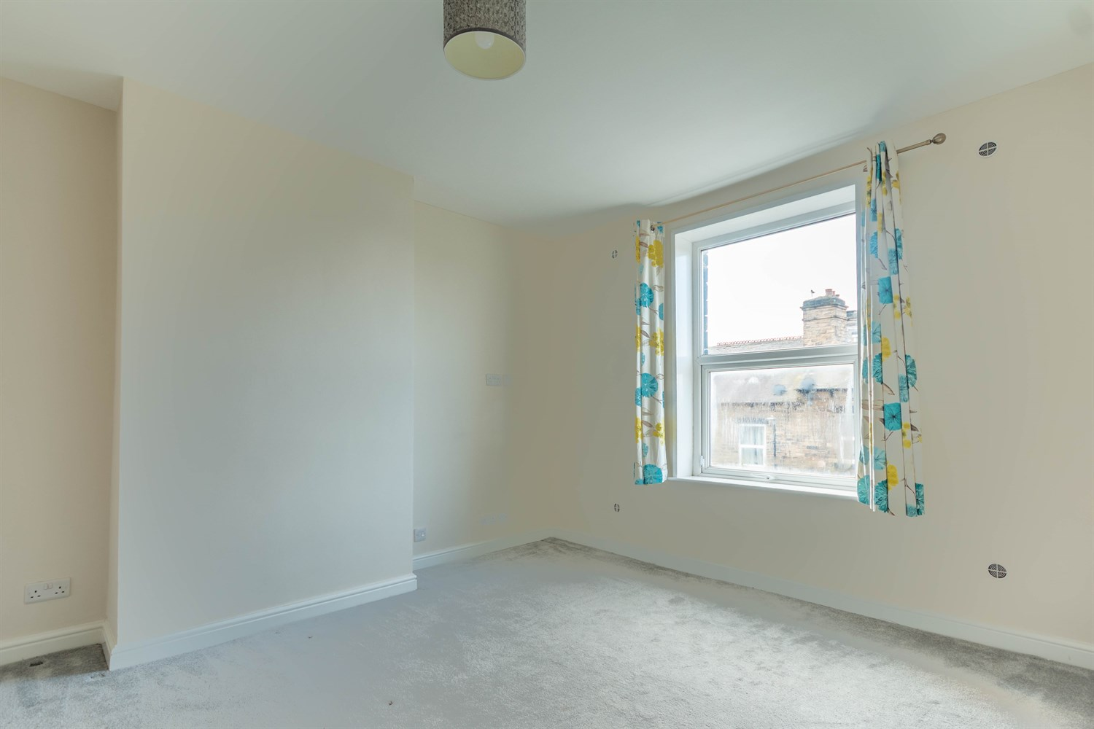

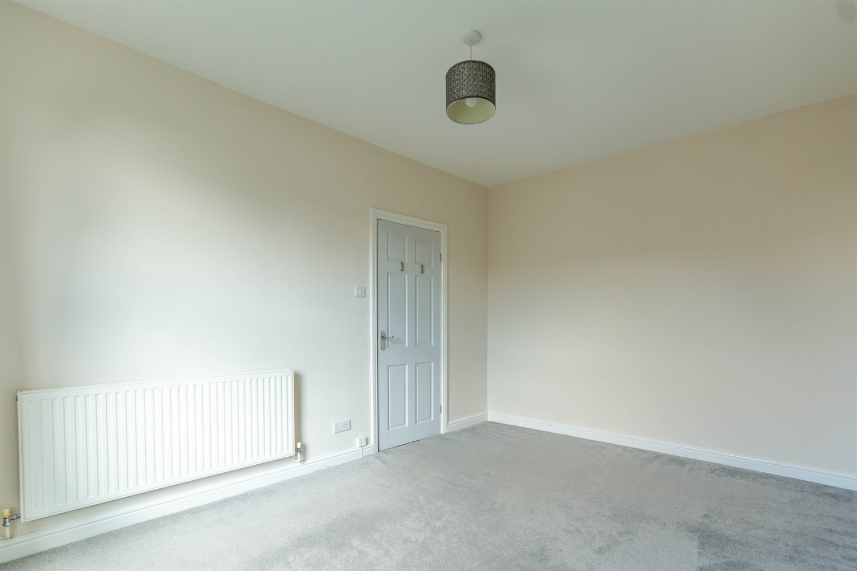

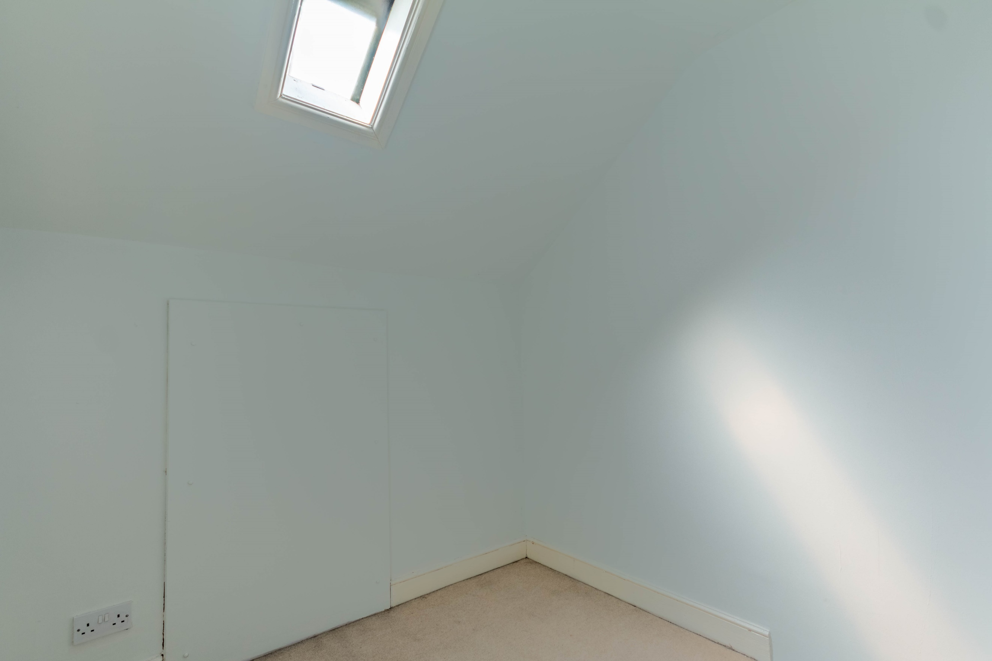

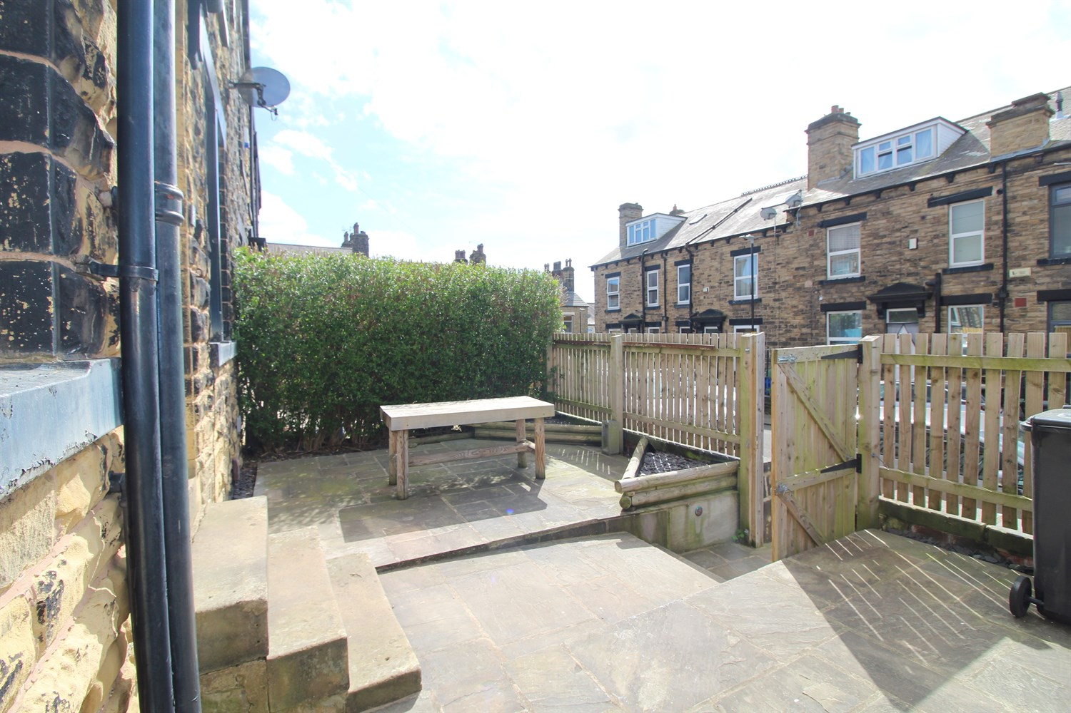

|  |
| --- |
| **Sitting Room 4.84m (15'11) x 4.34m (14'3)**  Spacious living area with uPVC double glazed window to front. Gas central heating radiator. |
| **Kitchen 2.18m (7'2) x 3.42m (11'3)**  Fitted with a range of wall, base and drawer units with worktops over. Integrated electric oven with 4-ring gas hob and extractor hood over. Stainless steel sink with mixer tap and drainer. Space for washing machine. uPVC double glazed window. |
| **Bedroom 1 3.39m (11'1) x 4.34m (14'3)**  Double bedroom with double glazed window to front. Gas central heating radiator. |
| **Bathroom**  Fitted with a three piece suite comprising; bath with shower over, WC and wash hand basin. Chrome towel rail. uPVC double glazed window. |
| **Bedroom 2 2.17m (7'1) x 2.81m (9'3)**  Second double bedroom with double glazed window to rear. Gas central heating radiator. |
| **Bedroom 3 4.78m (15'8) x 2.85m (9'4)**  Third double bedroom with double glazed window to rear. Gas central heating radiator. |
| **Study 2.17m (7'1) x 2.85m (9'4)**  Useful study area with velux window. |

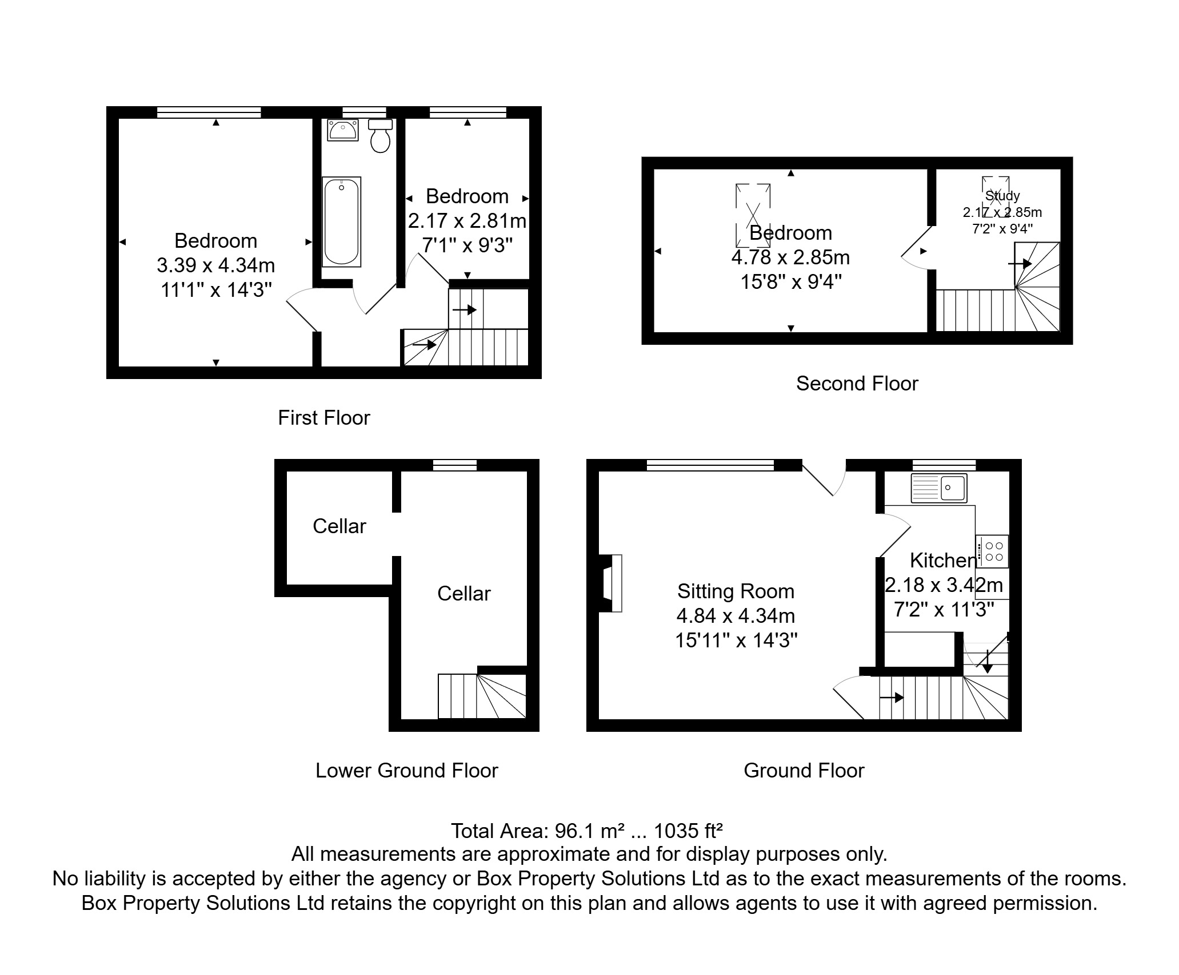

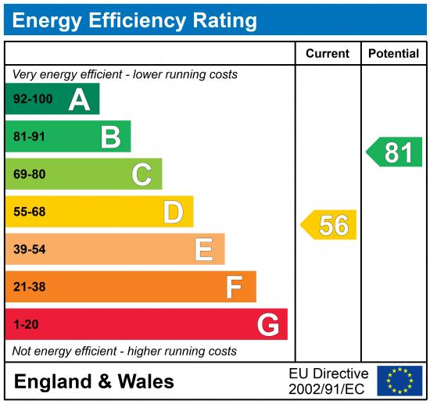

|  |
| --- |
|  |

These particulars are intended to give a fair description of the property, but their accuracy cannot be guaranteed, and they do not constitute an offer of contract. Intending purchasers must rely on their own inspection of the property. None of the above appliances/services have been tested by ourselves. We recommend purchasers arrange for a qualified person to check all appliances/services before legal commitment.

**Property Ref:** 5846

**For more information, please contact**

0113 258 1150 **|** [sales@adairpaxton.co.uk](mailto:sales@adairpaxton.co.uk) **|** www.adairpaxton.co.uk