

**0113 258 1150**

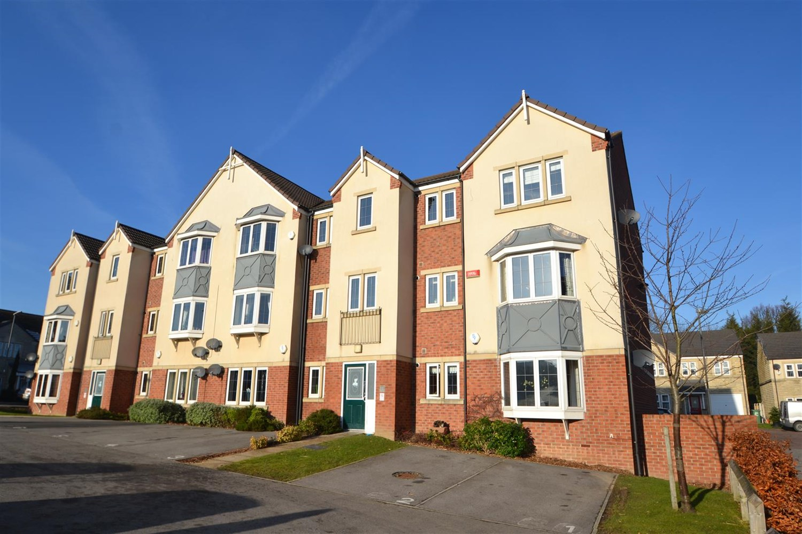



**Available to let £795.00pcm**

**Fielding Court, Leeds, LS27**

Fielding Court is ideally located in the historic market town of Morley, and is well placed for access to both Leeds and Wakefield City Centres, the M62 motorway network and surrounding areas. The apartment itself can be found on the first floor of this residential development, offers two double bedrooms and benefits from a separate kitchen and allocated parking space. With nearby shopping facilities including the White Rose Shopping Centre and Birstall Retail Park, its own train station and excellent bus links, Morley is incredibly sought after, and this property is bound to let quickly. Due to the lease this property has a no pet policy. Available14th April 2025 Deposit £915, EPC rating C, Council tax band A.

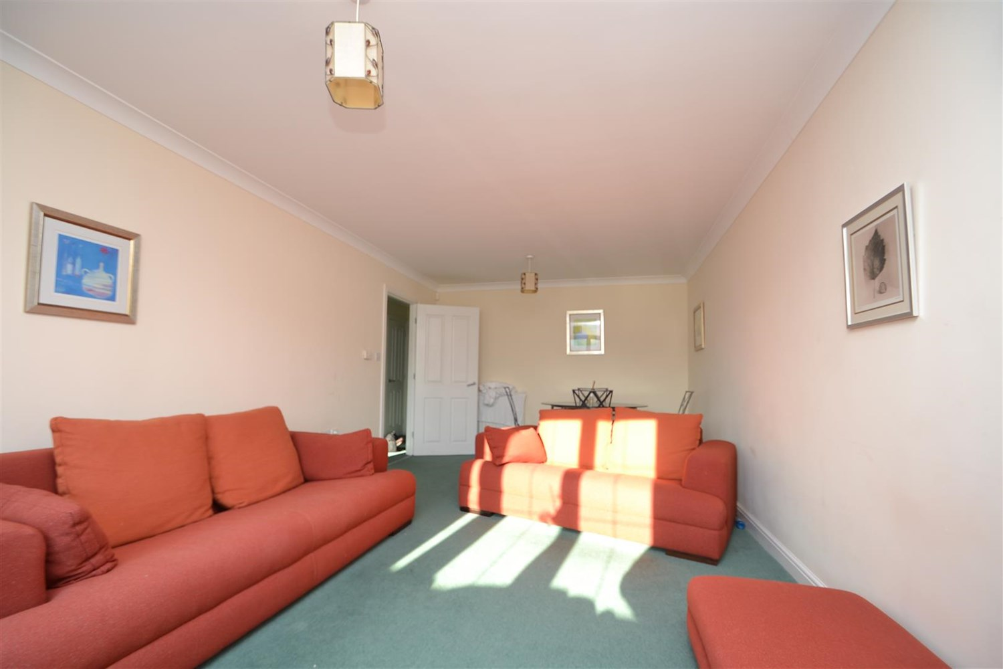

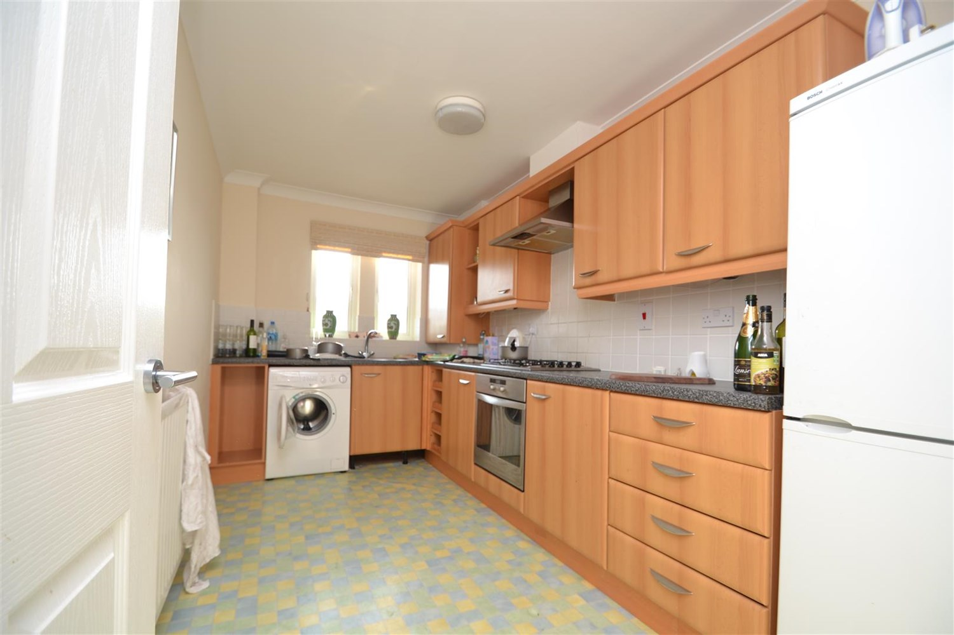

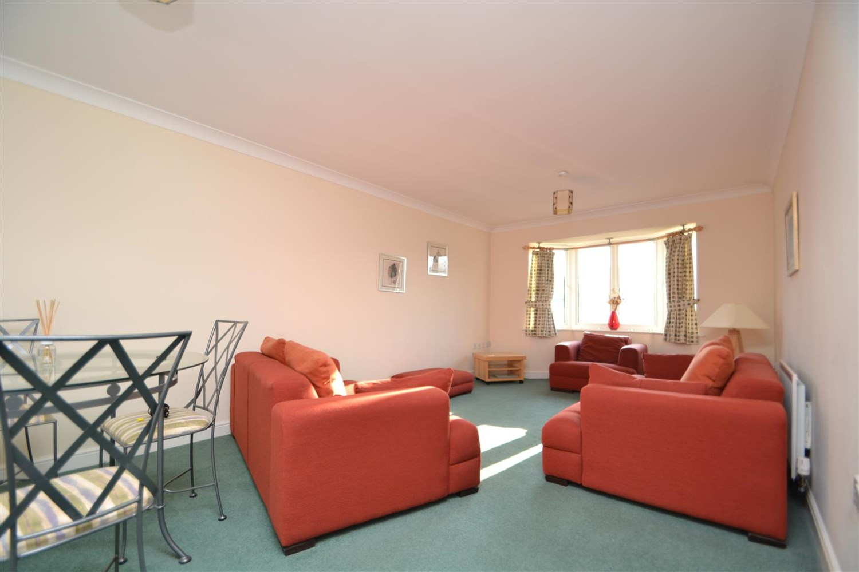

1 Bathroom(s)

1 Reception(s)

2 Bedroom(s)

00

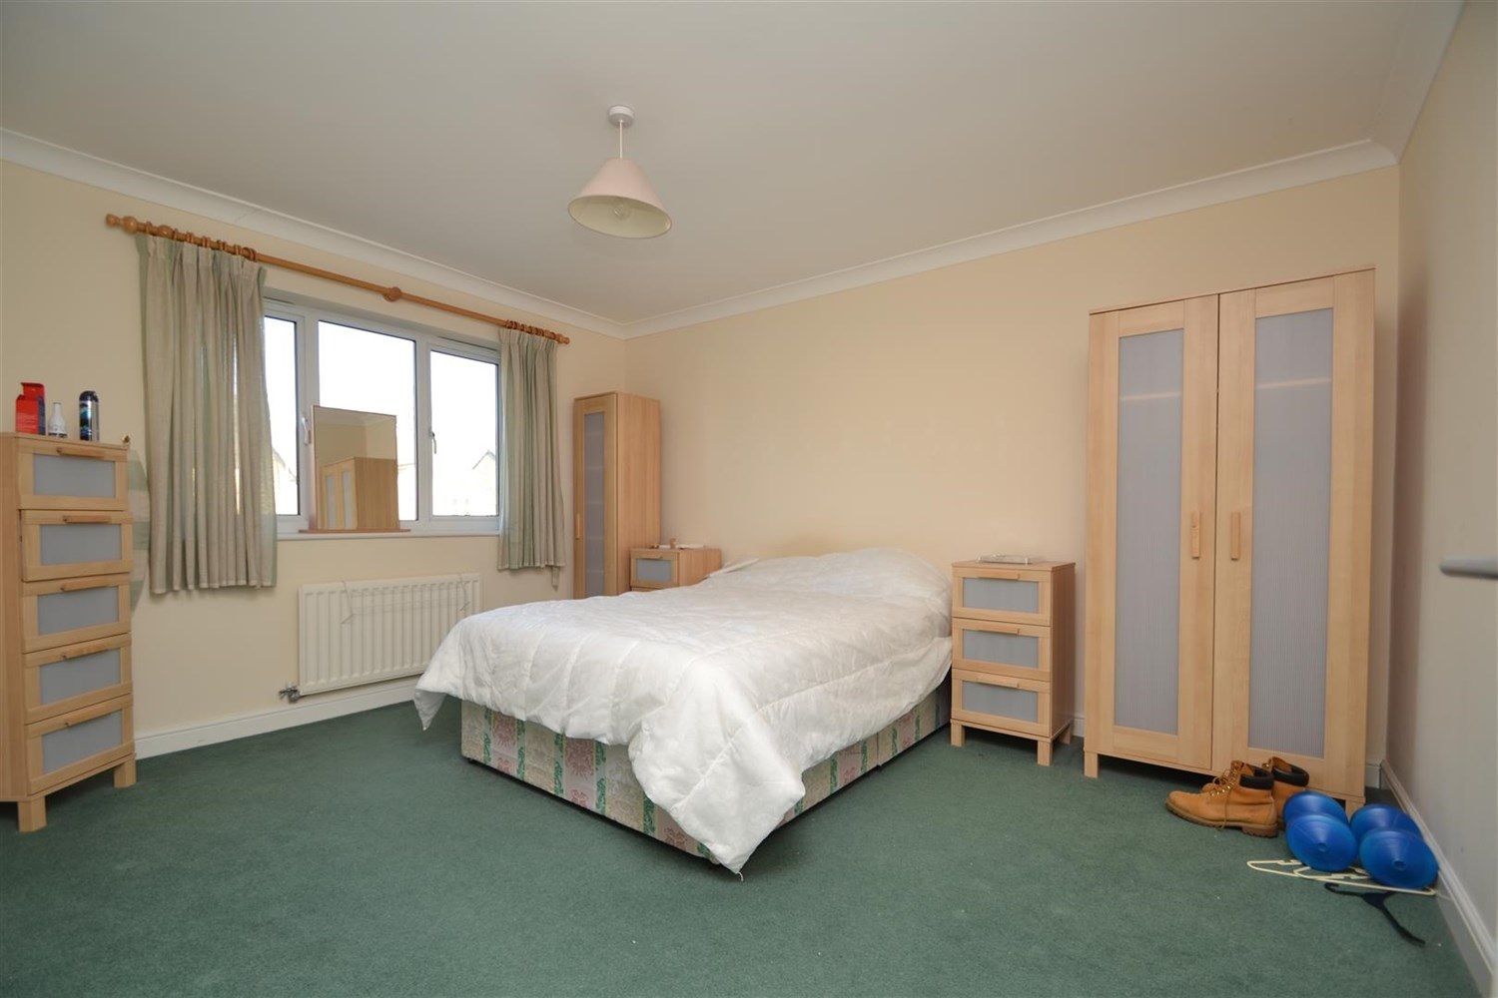

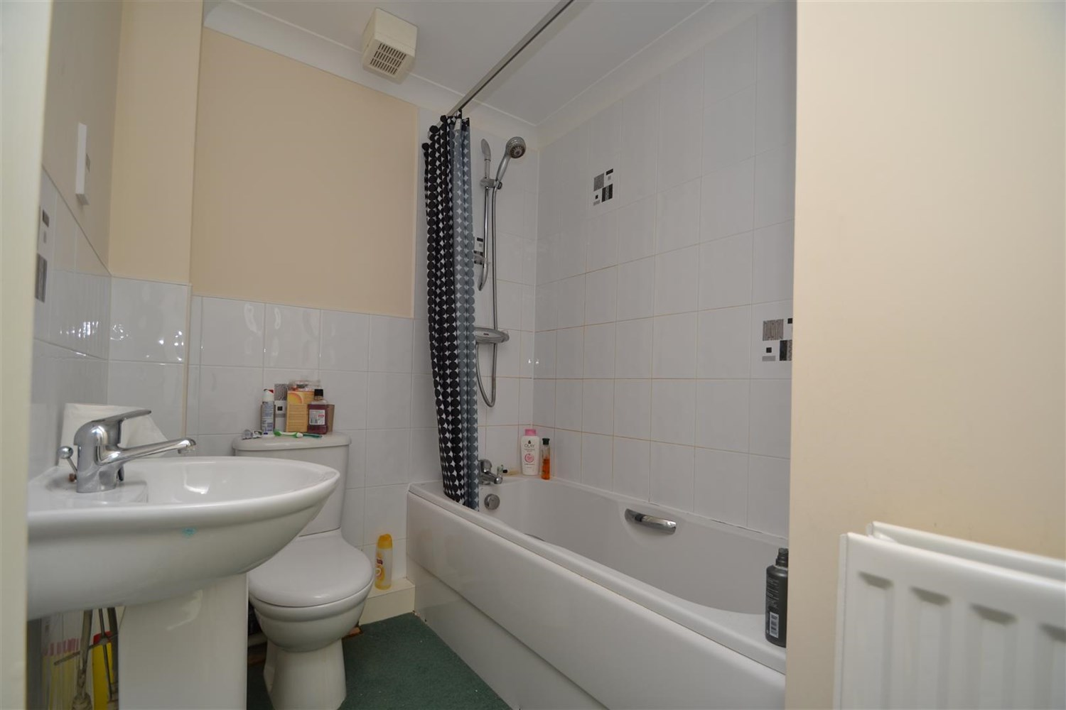

|  |
| --- |
| **Communal Entrance Hall**  With telephone entry system, mailboxes and access to all floors via staircase |
| **Private Entrance Hall**  A carpeted entrance hall with entry system, storage cupboard and alarm |
| **Living/Dining**  A large carpeted room with ample space for both dining, entertaining and relaxing. Double glazed window and gas central heating radiator, window to front. |
| **Kitchen**  Kitchen comprising a range of wall and base mounted units, single drainer stainless steel sink unit with mixer tap, integrated oven, hob and extractor. Lino flooring, double glazed window and gas central heating radiator. |
| **Bedroom 1**  A large double bedroom, carpeted, with double glazed window and gas central heating radiator |
| **Bedroom 2**  A carpeted room with double glazed window and gas central heating radiator |
| **House Bathroom**  White suite comprising panelled bath with mixer shower over, low flush w.c and basin, lino effect flooring and gas central heating radiator |
| **Home Information**  COUNCIL TAX BAND:A  EPC Rating: C  Leasehold property Allocated parking  Broadband : Standard 16 Mbps 1 Mbps Good Superfast 236 Mbps 35 Mbps Good Ultrafast 1000 Mbps 1000 Mbps  Mobile availability: EE limited coverage. O2 likely to have good coverage. Three limited coverage. Vodafone limited coverage.  Utilities: Water supplied on standard meters. Electric mains supplied on standard meters. |

|  |  |
| --- | --- |
| These particulars are intended to give a fair description of the property, but their accuracy cannot be guaranteed, and they do not constitute an offer of contract. Intending purchasers must rely on their own inspection of the property. None of the above appliances/services have been tested by ourselves. We recommend purchasers arrange for a qualified person to check all appliances/services before legal commitment.  **Property Ref:** 5261  **For more information, please contact**  0113 258 1150 **|** [lettings@adairpaxton.co.uk](mailto:lettings@adairpaxton.co.uk) **|** www.adairpaxton.co.uk |  |