

**0113 258 1150**

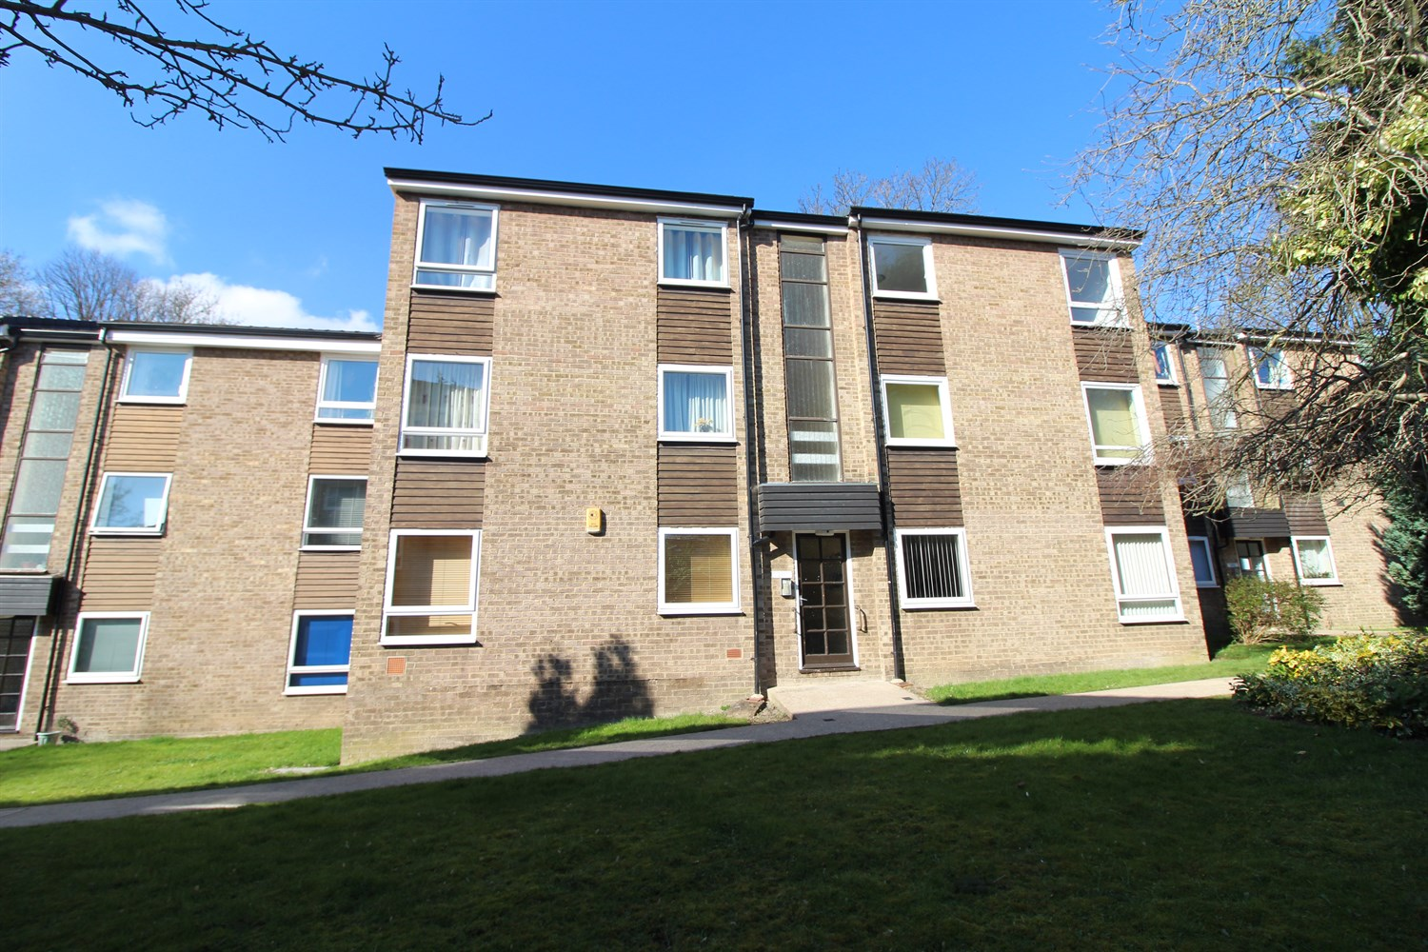



**Available to let £825.00pcm**

**Grosvenor Park Gardens, Headingley**

Located in a pleasant North Leeds location ideally placed for the colleges and University and affording easy access into Leeds City is this spacious second floor apartment. Being set within well maintained and pleasant communal grounds the modern interior would well suit the professional couple. The property benefits from gas central heating and uPVC double glazing and briefly comprises of: Entrance Hallway, spacious Lounge, fitted kitchen, two bedrooms and a house Bathroom and single garage. Council Tax Band B, AVAILABLE NOW! Deposit £950

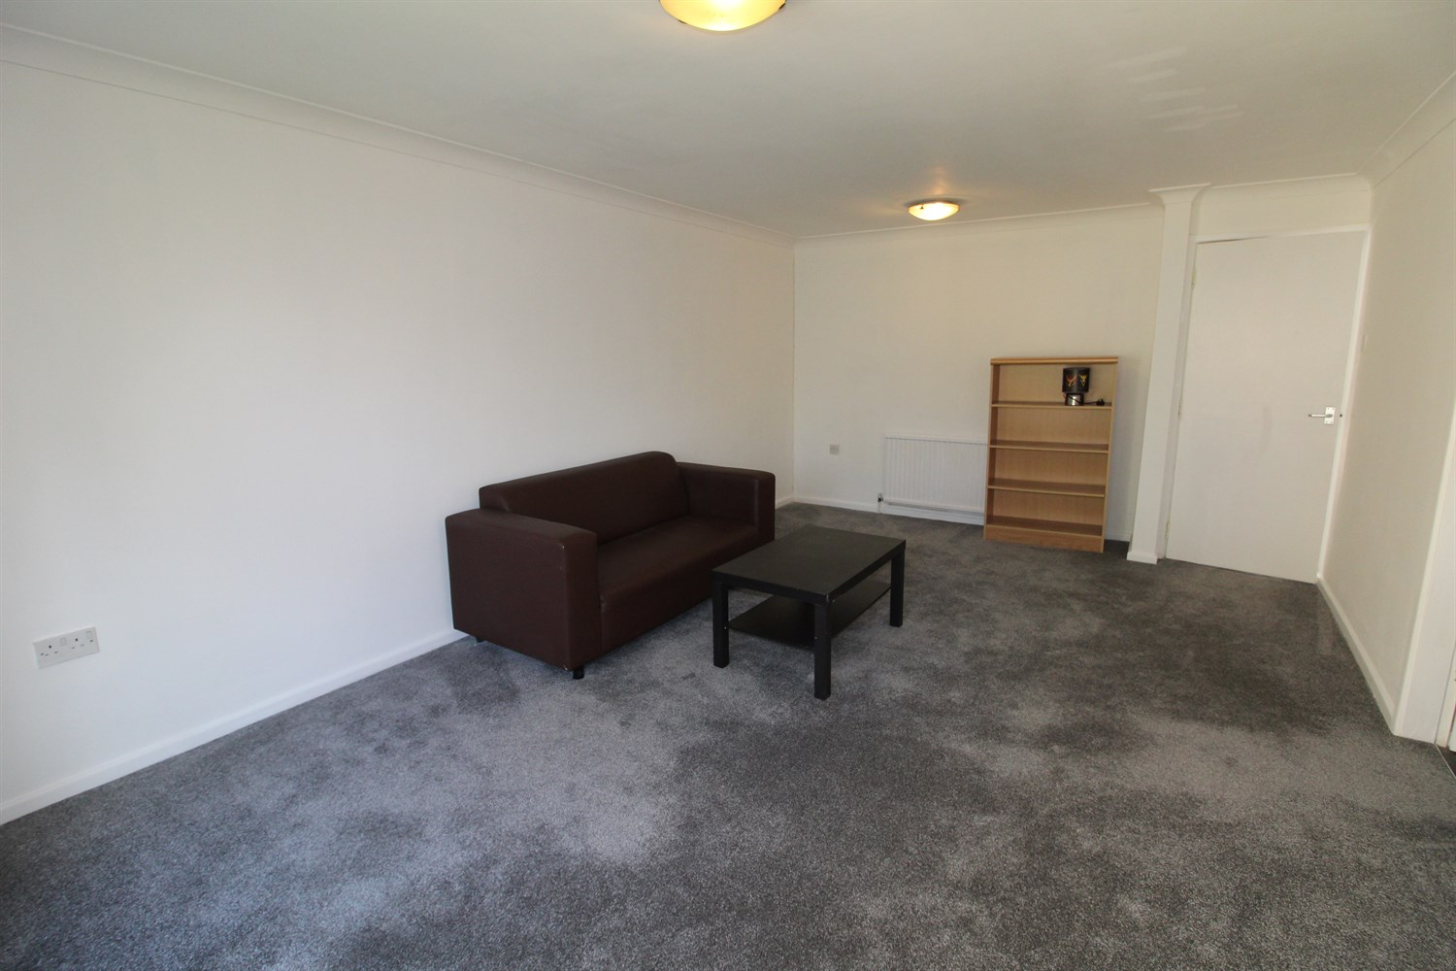

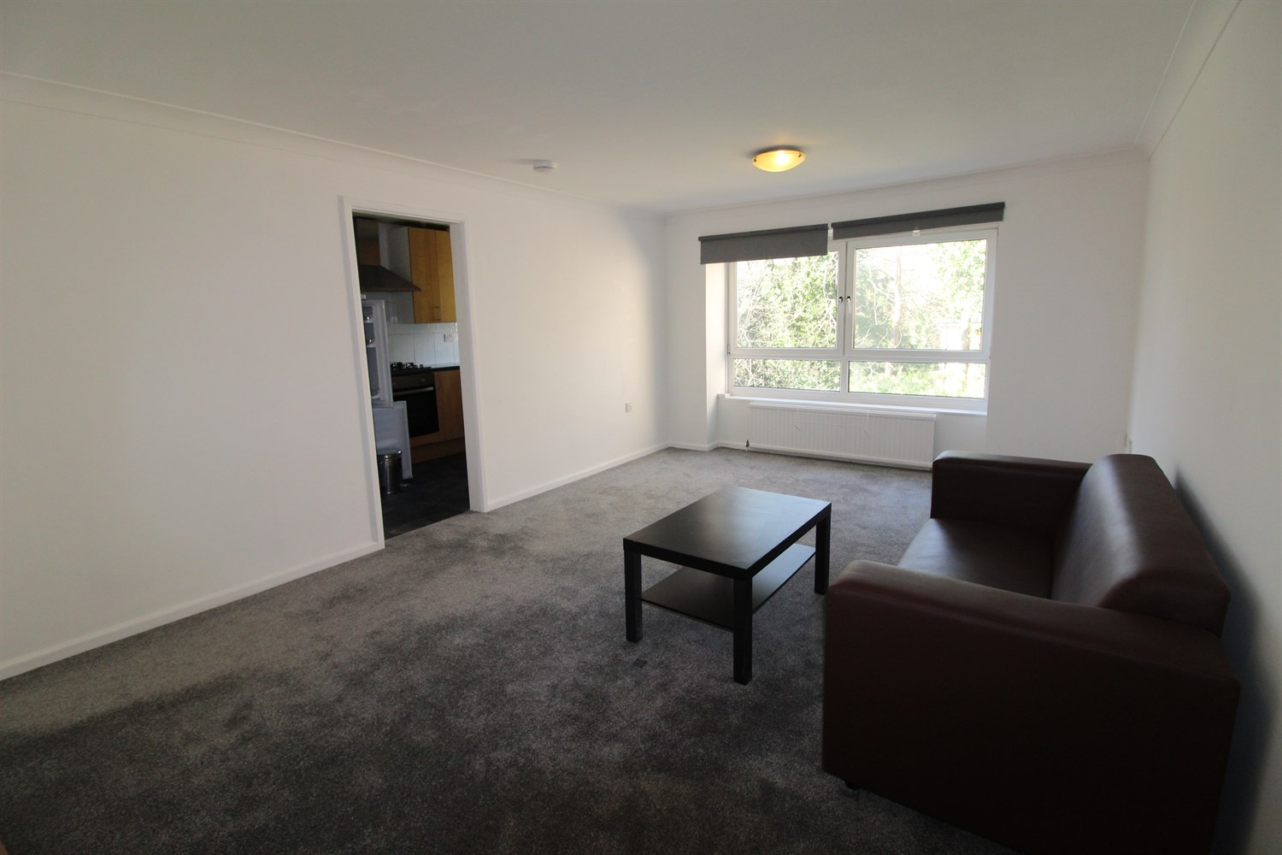

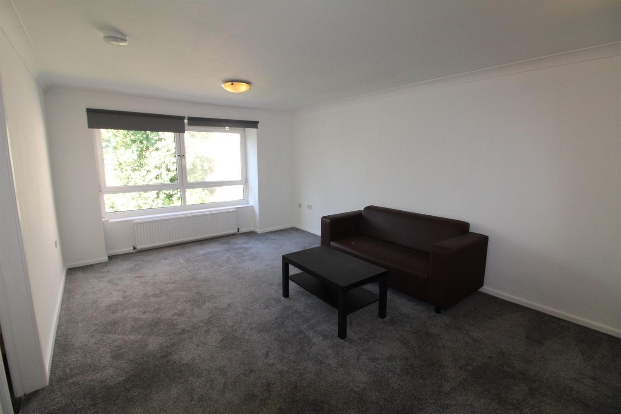

1 Bathroom(s)

1 Reception(s)

2 Bedroom(s)

00

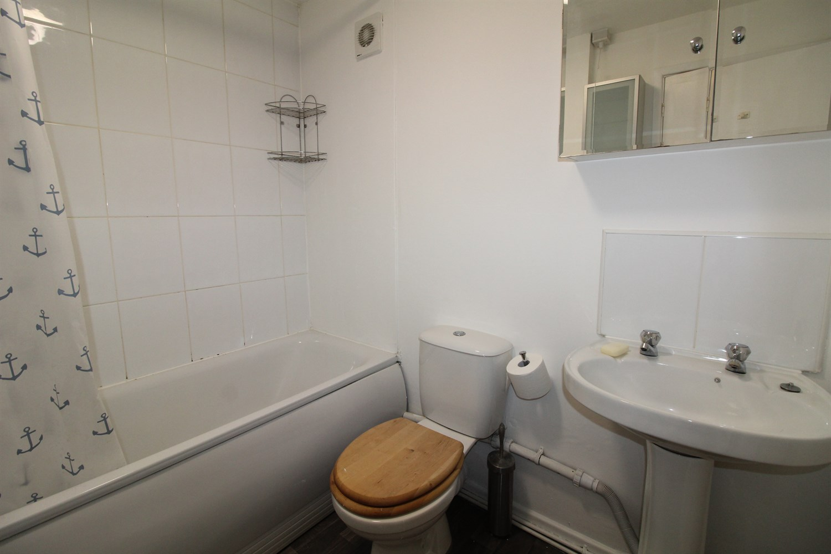

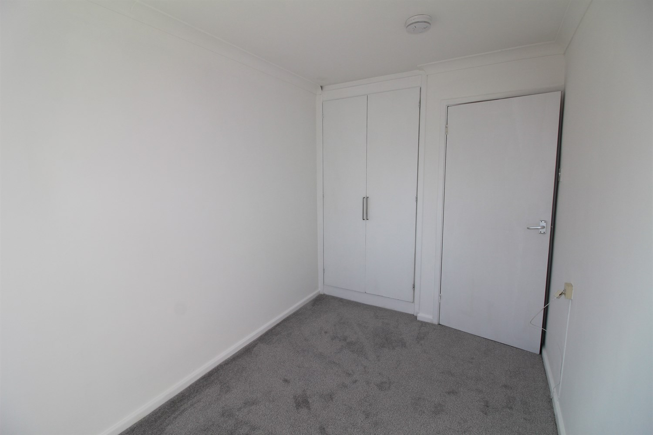

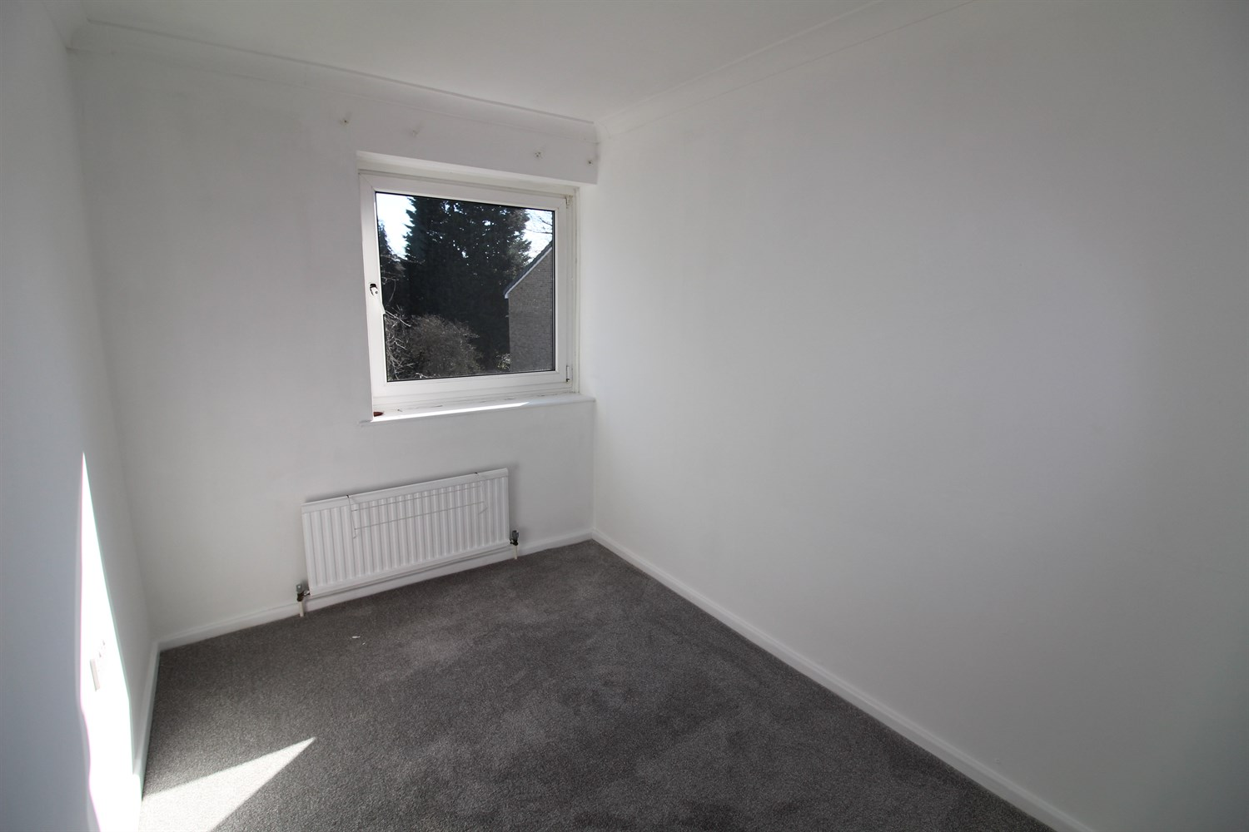

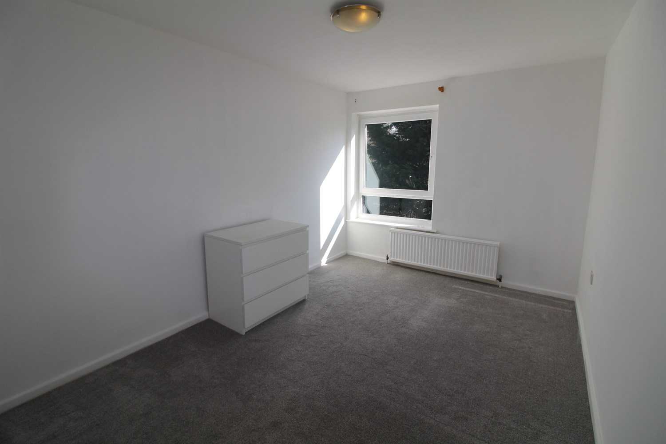

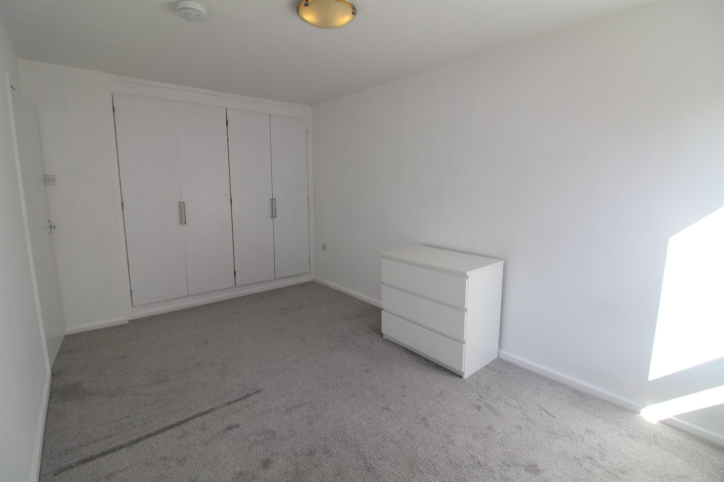

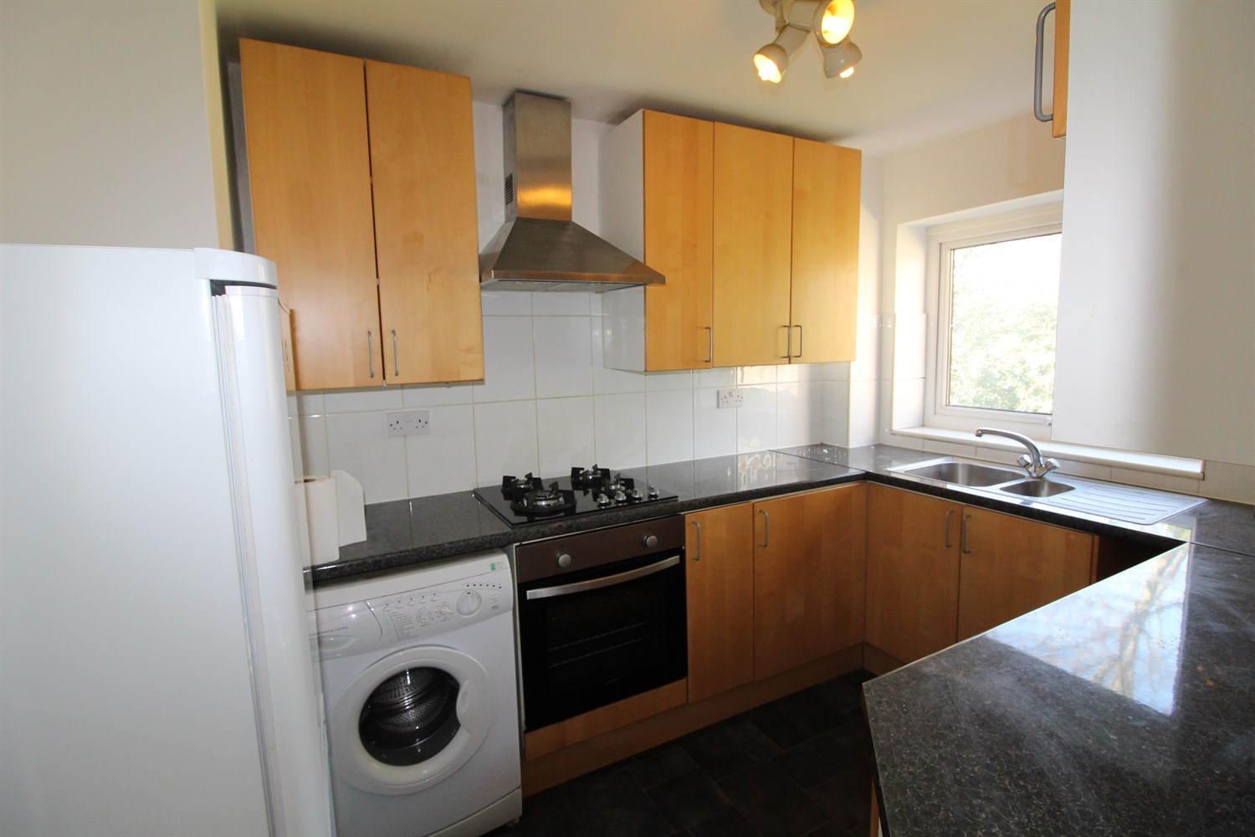

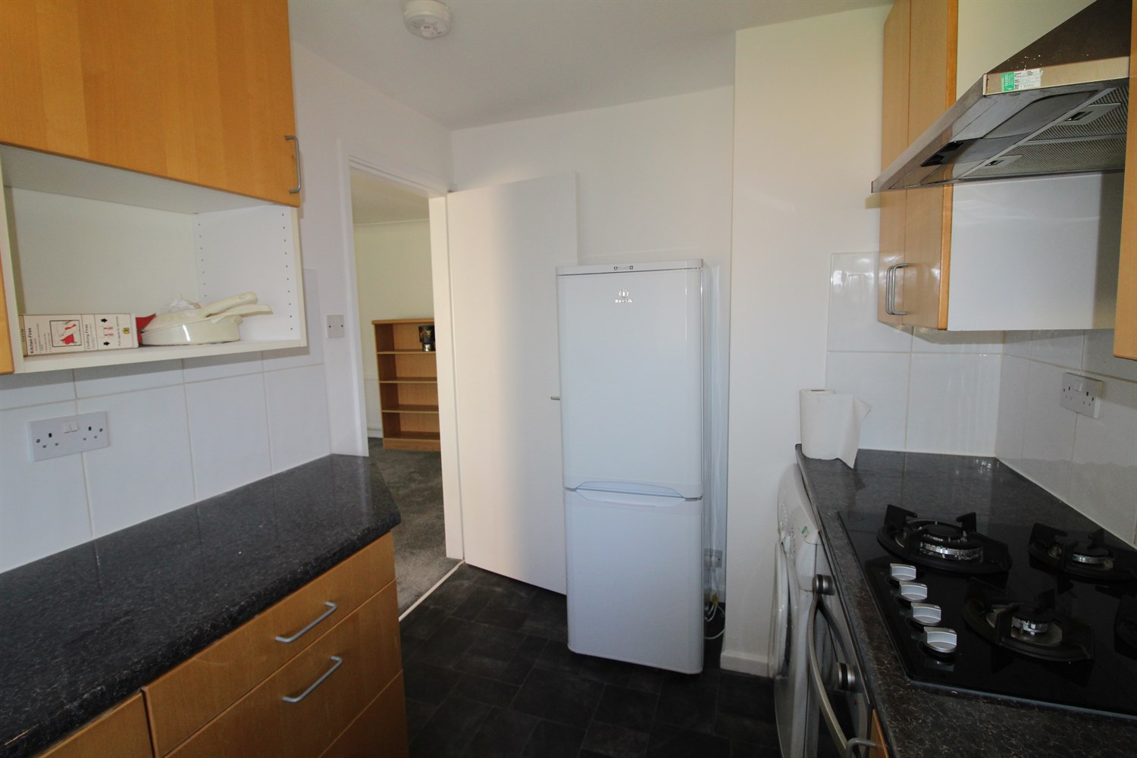

|  |
| --- |
| **Communal Entrance**  Via front entrance door. |
| **Living Room**  Spacious living area with uPVC double glazed window. Gas central heating radiator. |
| **Kitchen**  Fitted with a range of wall, base and drawer units with worktops over. Integrated oven with 4-ring hob and extractor hood over. Freestanding fridge/freezer. uPVC double glazed window. |
| **Bedroom 1**  Double bedroom with uPVC double glazed window. Gas central heating radiator. Built in wardrobes. |
| **Bedroom 2**  Single bedroom with uPVC double glazed window. Gas central heating radiator. |
| **House Bathroom**  Fitted with a three piece suite comprising; bath with shower over, WC and wash hand basin. |
| **Home Information**  COUNCIL TAX BAND:B  EPC Rating: C   Leasehold property Allocated parking  Broadband : Standard 16 Mbps 1 Mbps Good Superfast 71 Mbps 16 Mbps Good Ultrafast 1800 Mbps 220 Mbps   Mobile availability: EE limited coverage. Three likely to have good coverage. O2 limited coverage. Vodafone limited coverage.  Utilities: Water supplied on standard meters. Electric mains supplied on standard meters. |

|  |  |
| --- | --- |
| These particulars are intended to give a fair description of the property, but their accuracy cannot be guaranteed, and they do not constitute an offer of contract. Intending purchasers must rely on their own inspection of the property. None of the above appliances/services have been tested by ourselves. We recommend purchasers arrange for a qualified person to check all appliances/services before legal commitment.  **Property Ref:** 5609  **For more information, please contact**  0113 258 1150 **|** [lettings@adairpaxton.co.uk](mailto:lettings@adairpaxton.co.uk) **|** www.adairpaxton.co.uk |  |