

**0113 258 1150**

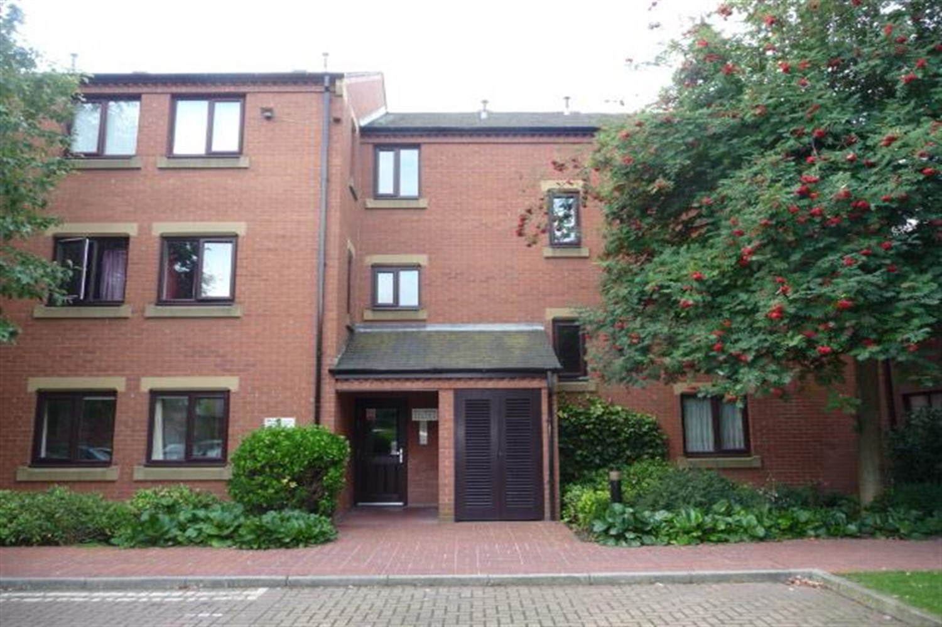



**Available to let £850.00pcm**

**Chantrell Court, LS2**

***Refurbished*** This stunning one bedroom apartment in Leeds City Centre. This apartment is fully furnished throughout. There is one parking space too and due to the excellent location, there is an abundance of nearby amenities for you to enjoy such as the vibrant City Centre and the widely popular Leeds Docks. Available Now deposit £980, EPC rating C, council tax band A.

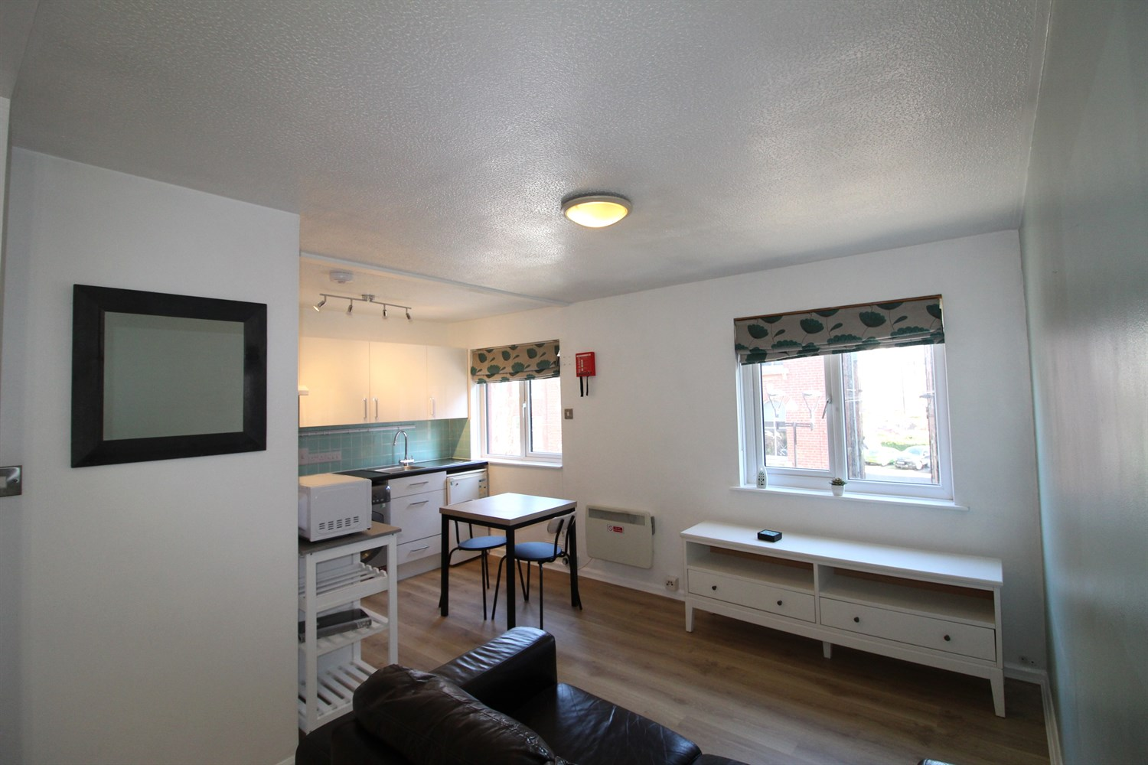

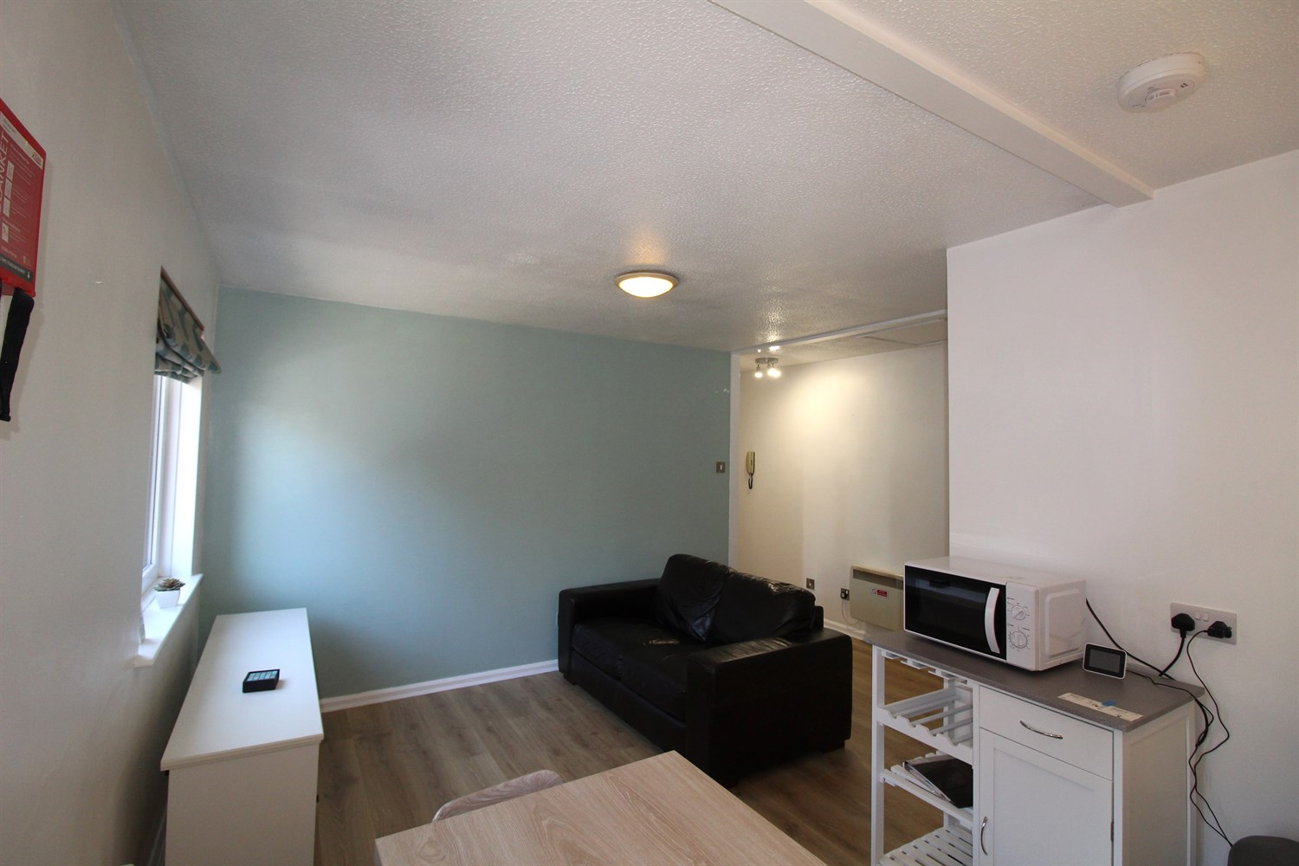

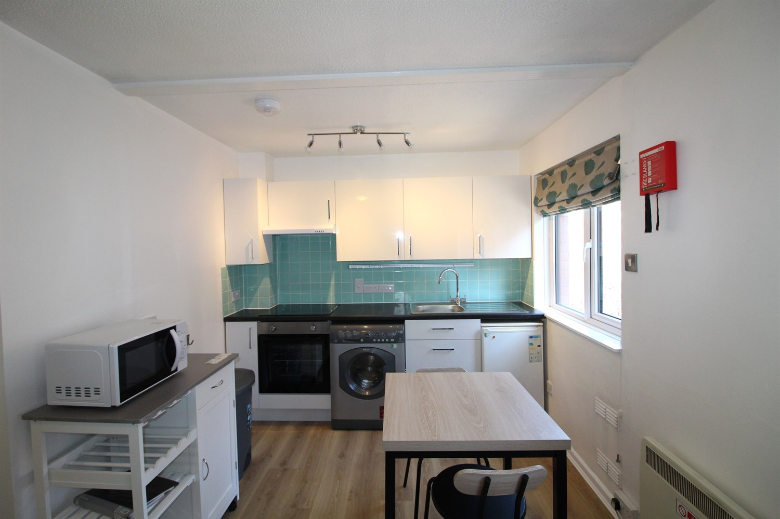

1 Bathroom(s)

1 Reception(s)

0 Bedroom(s)

00

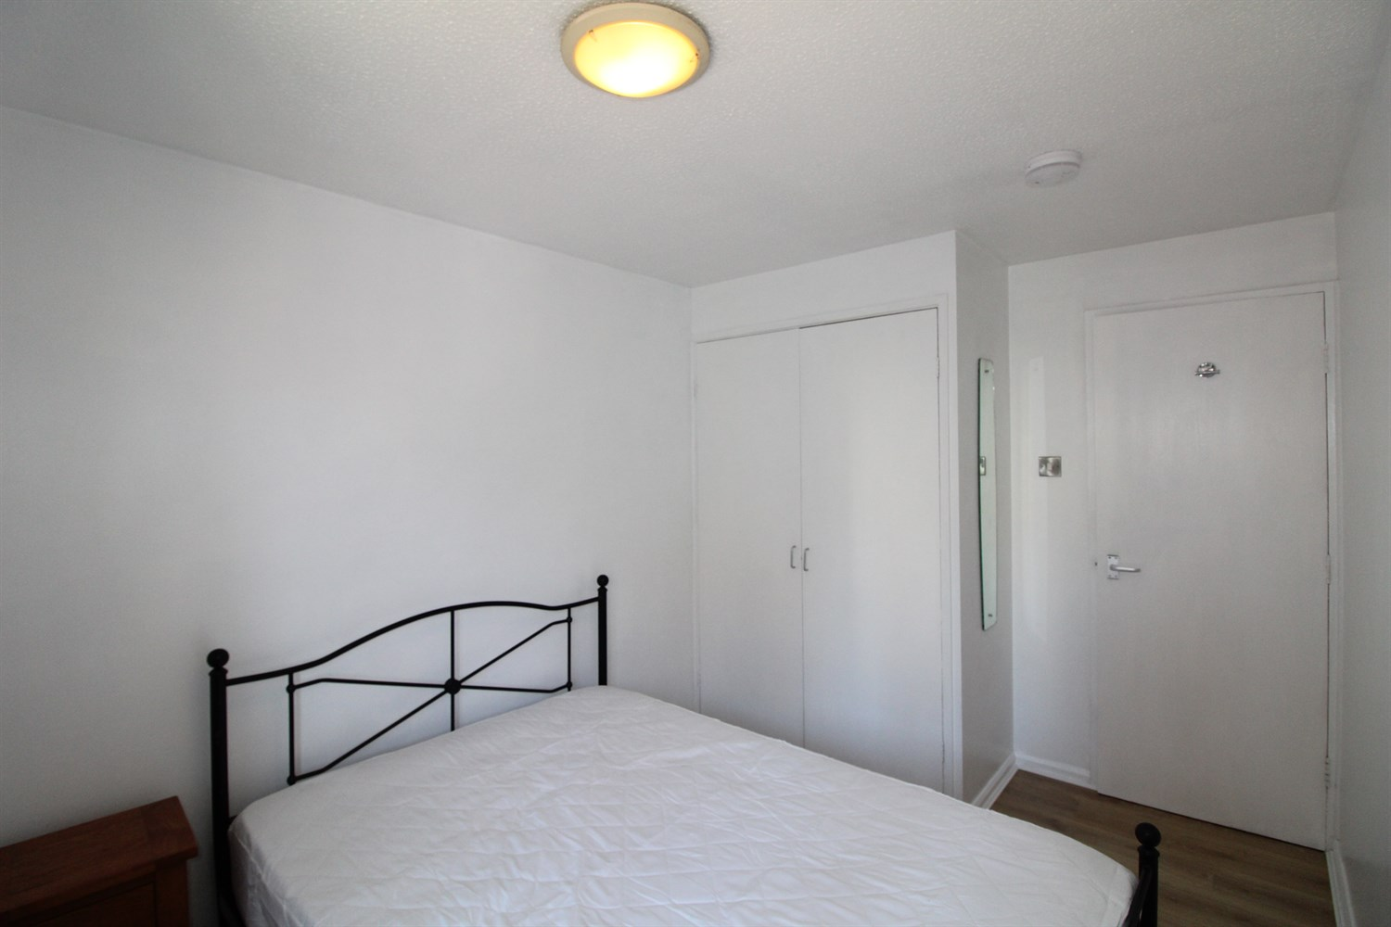

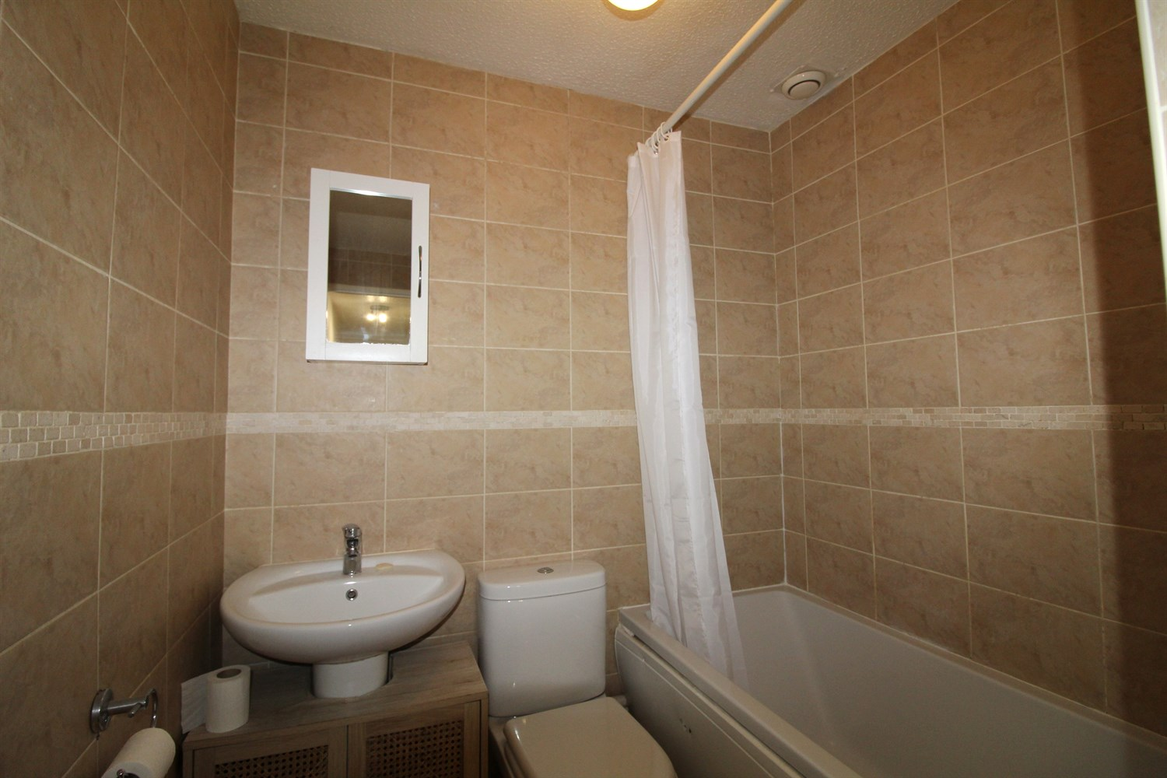

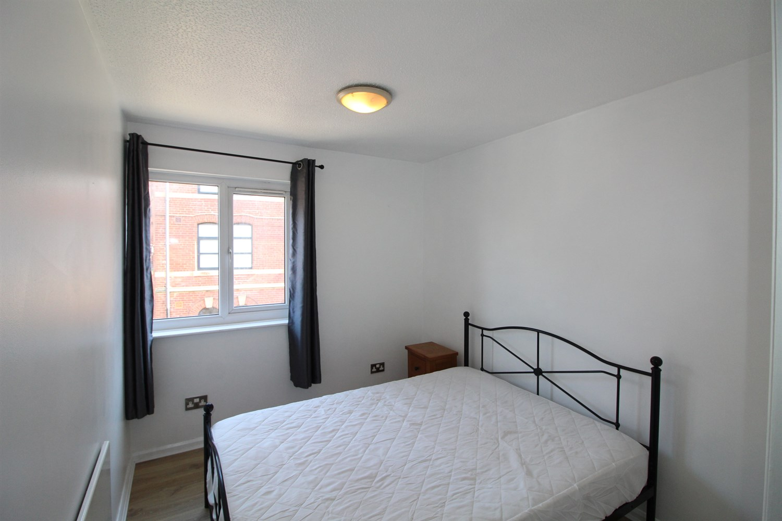

|  |
| --- |
| **Living room/kitchen**  Open plan kitchen and living area with new wood effect flooring, brand new kitchen fitted with a range of wall and base units with work tops over, stainless steel sink with mixer tap and drainer. electric heater and double glazed window. |
| **Double Bedroom With External Window**  Double bedroom with new wood effect flooring, electric heating and double glazed window. |
| **House Bathroom**  Three piece white bathroom suite with shower over, tiled walls and floor. |
| **Home Information**  COUNCIL TAX BAND: A EPC Rating: C  Leasehold property Parking Available  Mobile availability: EE limited coverage. Three likely to have good coverage. O2 likely to have good coverage. Vodafone likely to have good coverage. Broadband: Standard 18 Mbps 1 Mbps Good Superfast --Not available --Not available Unlikely Ultrafast --Not available --  Utilities: Water supplied on standard meters. Electric mains supplied on standard meters. |

|  |  |
| --- | --- |
| These particulars are intended to give a fair description of the property, but their accuracy cannot be guaranteed, and they do not constitute an offer of contract. Intending purchasers must rely on their own inspection of the property. None of the above appliances/services have been tested by ourselves. We recommend purchasers arrange for a qualified person to check all appliances/services before legal commitment.  **Property Ref:** 918  **For more information, please contact**  0113 258 1150 **|** [lettings@adairpaxton.co.uk](mailto:lettings@adairpaxton.co.uk) **|** www.adairpaxton.co.uk |  |