

**Faroe, Leeds**

**For Sale £225,000.00**

**SPACIOUS TWO BEDROOM APARTMENT with ALLOCATED PARKING** Located in Faroe, part of the popular City Island development. Situated between the river and the canal, overlooking the river and within walking distance of Leeds City Centre and the train station. This spacious apartment briefly comprises; Communal entrance hall, private hallway, living room with doors leading out to the balcony overlooking the river, kitchen, two good sized double bedrooms and a house bathroom. Externally the development has communal gardens, seating areas and water features. The property benefits from secure underground parking. The apartment MUST BE VIEWED to be appreciated.

**0113 258 1150**

**0800 000 000**

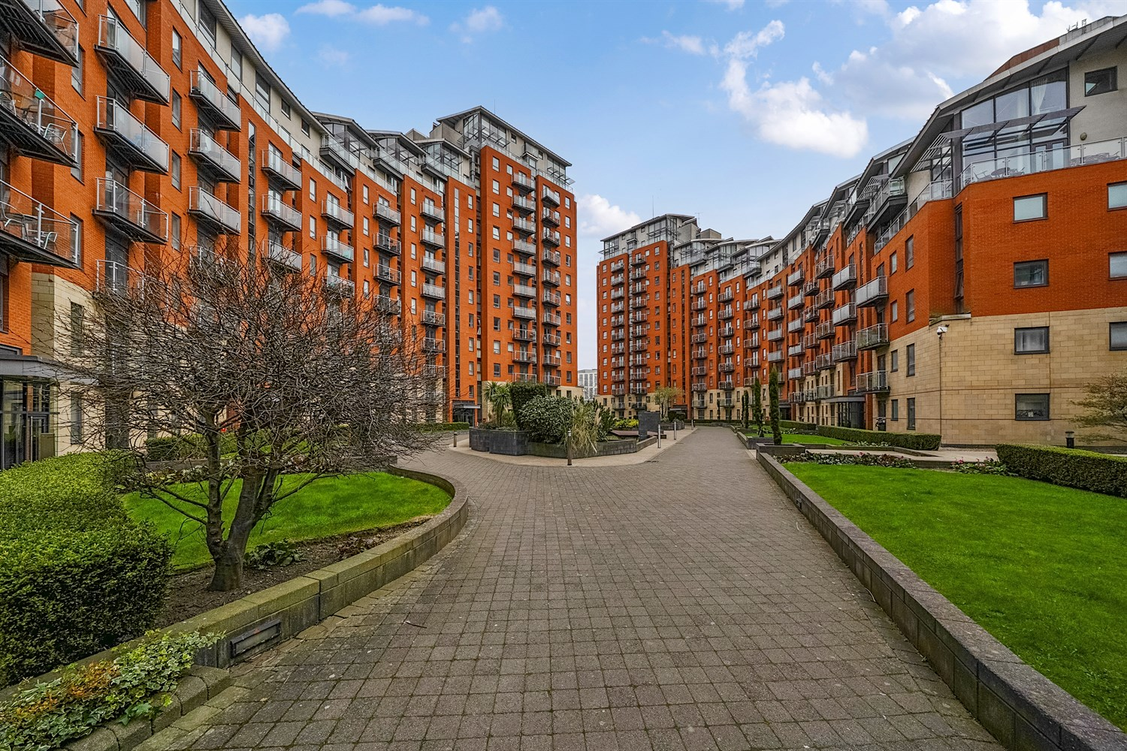



1 Reception

1 Bathroom

2 Bedrooms

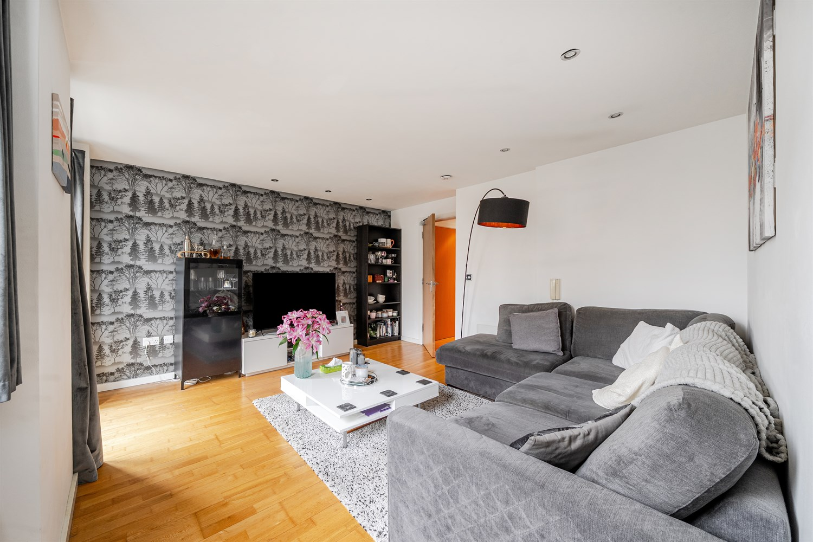

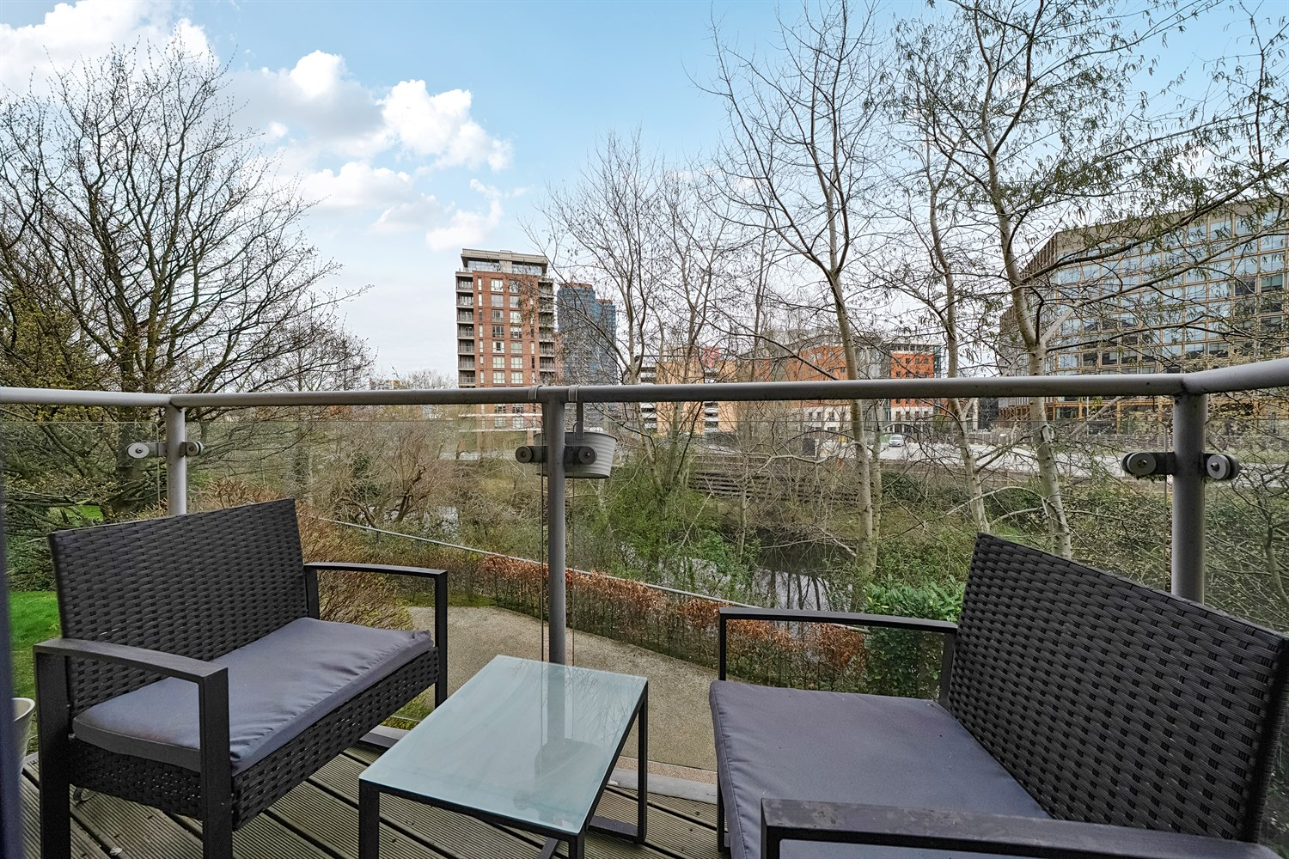

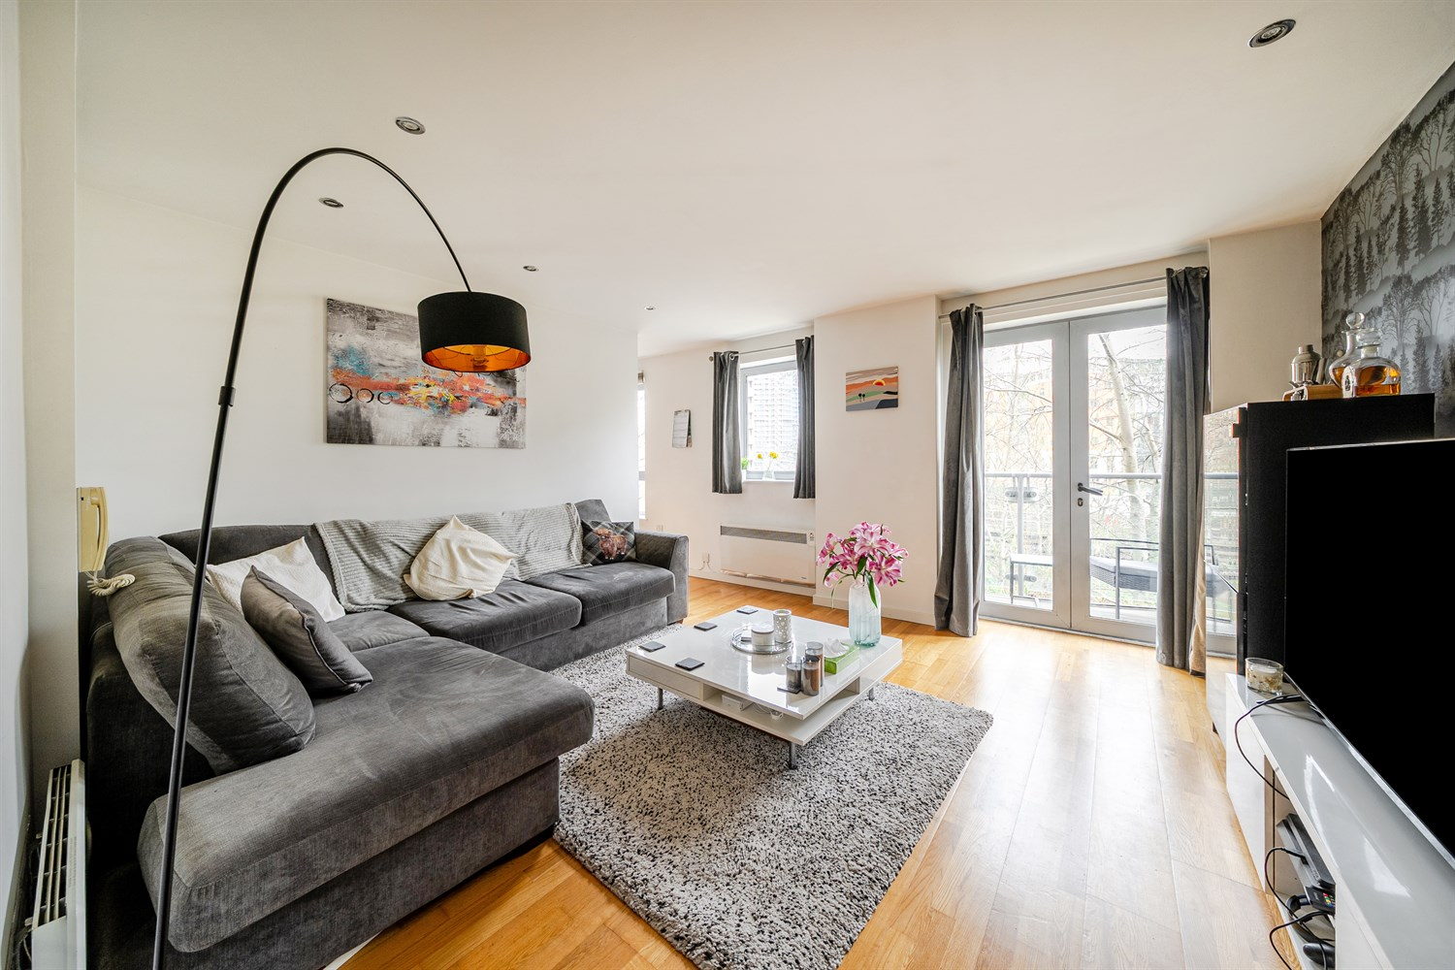

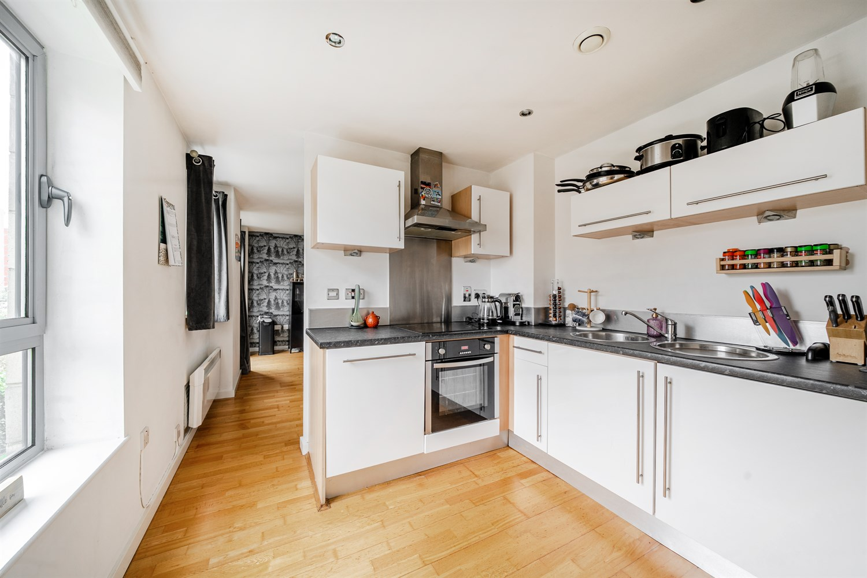

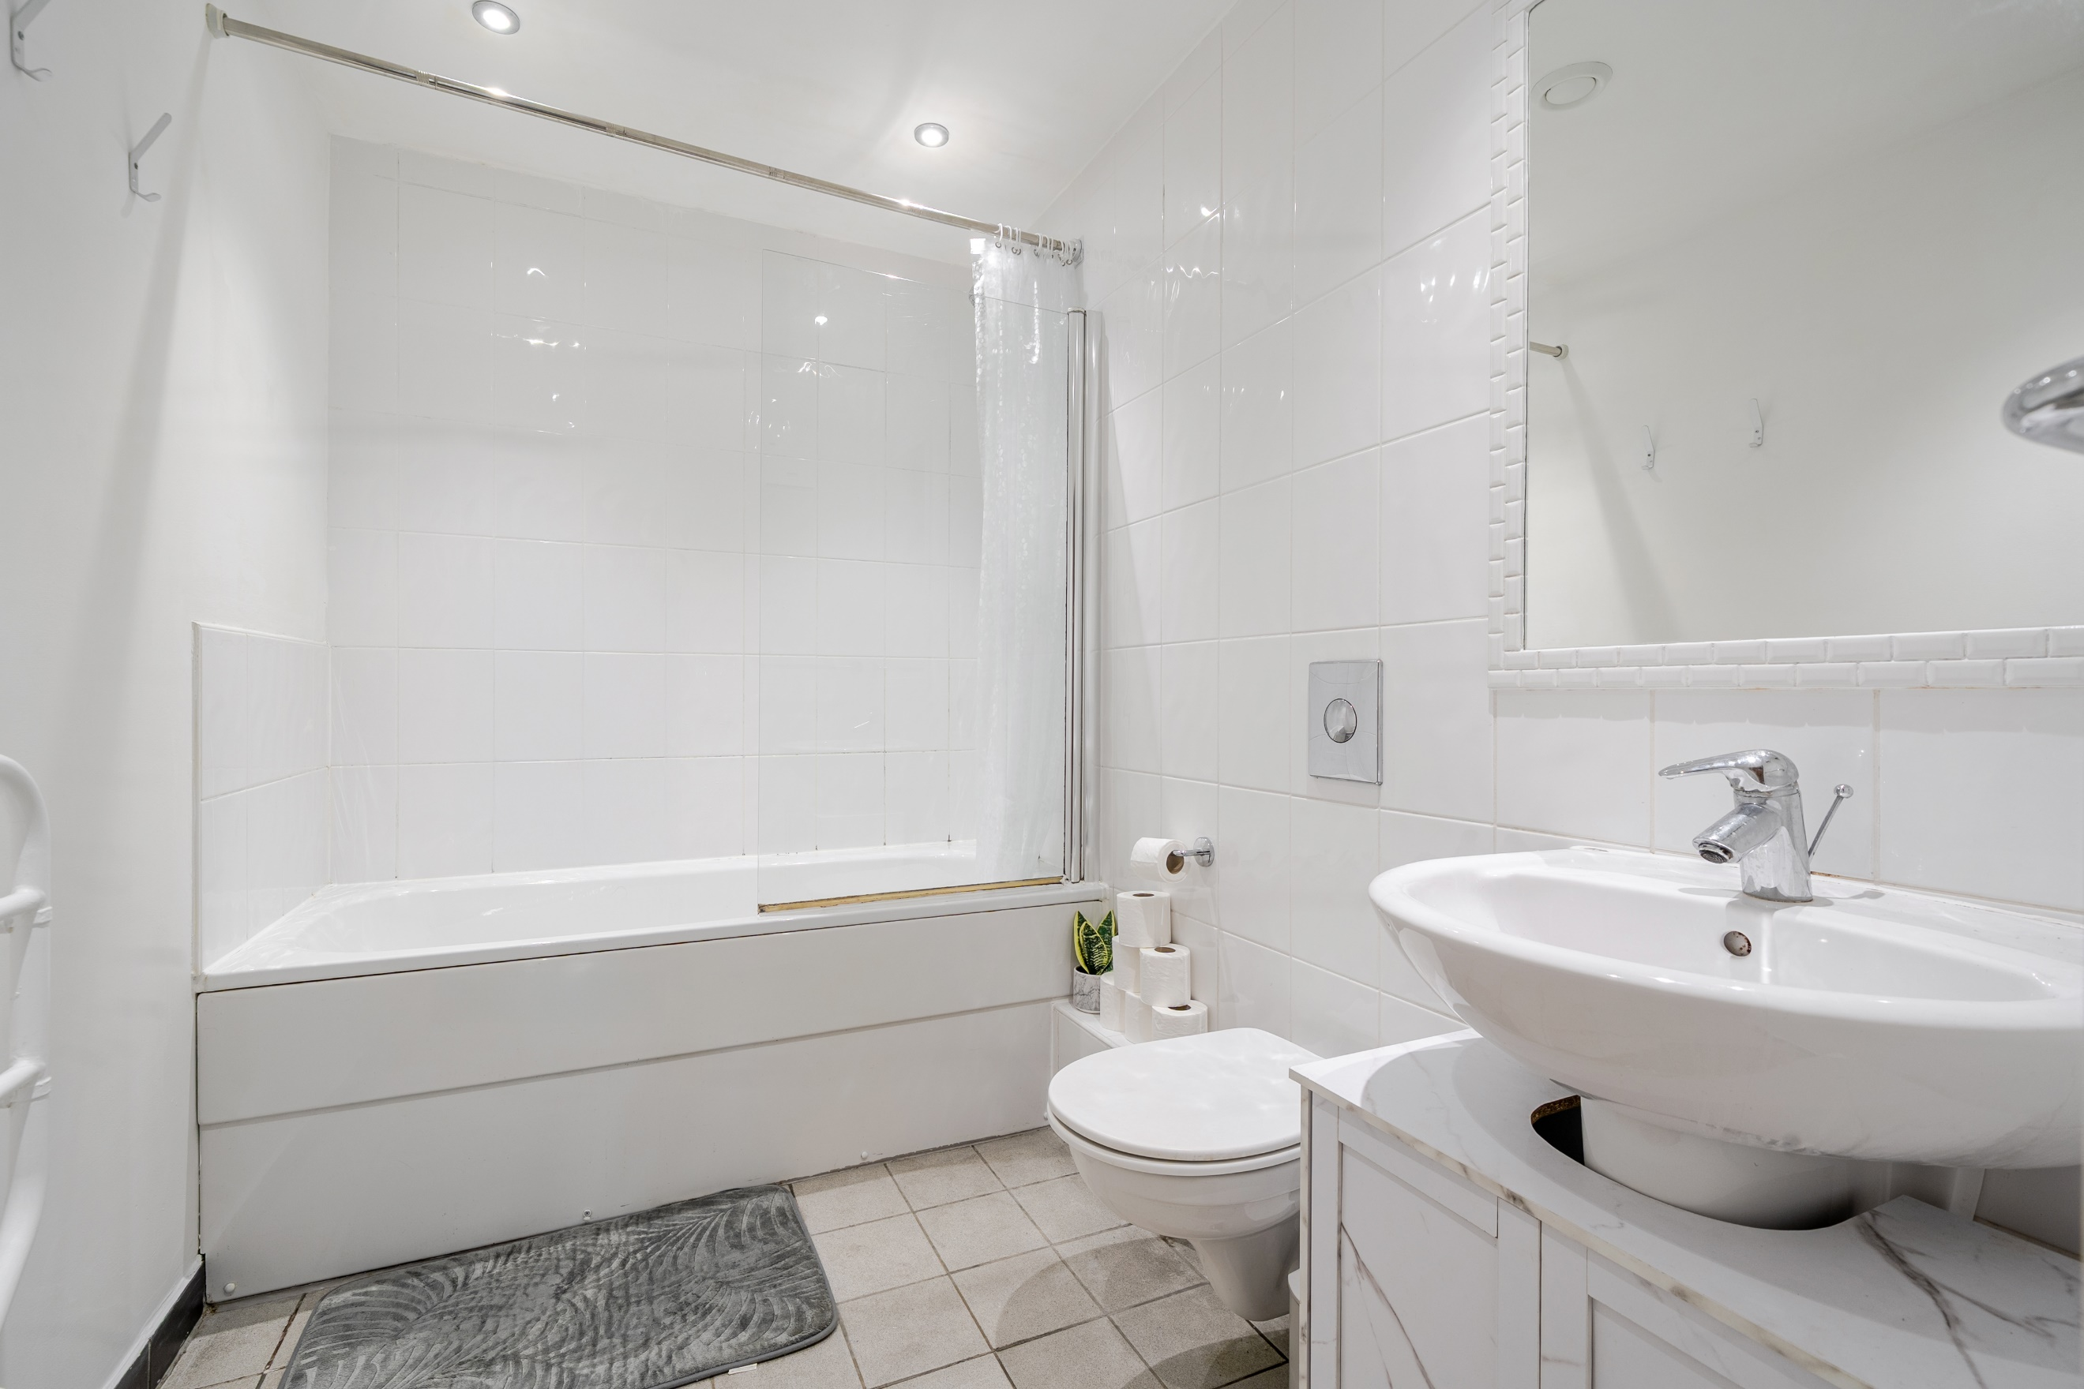

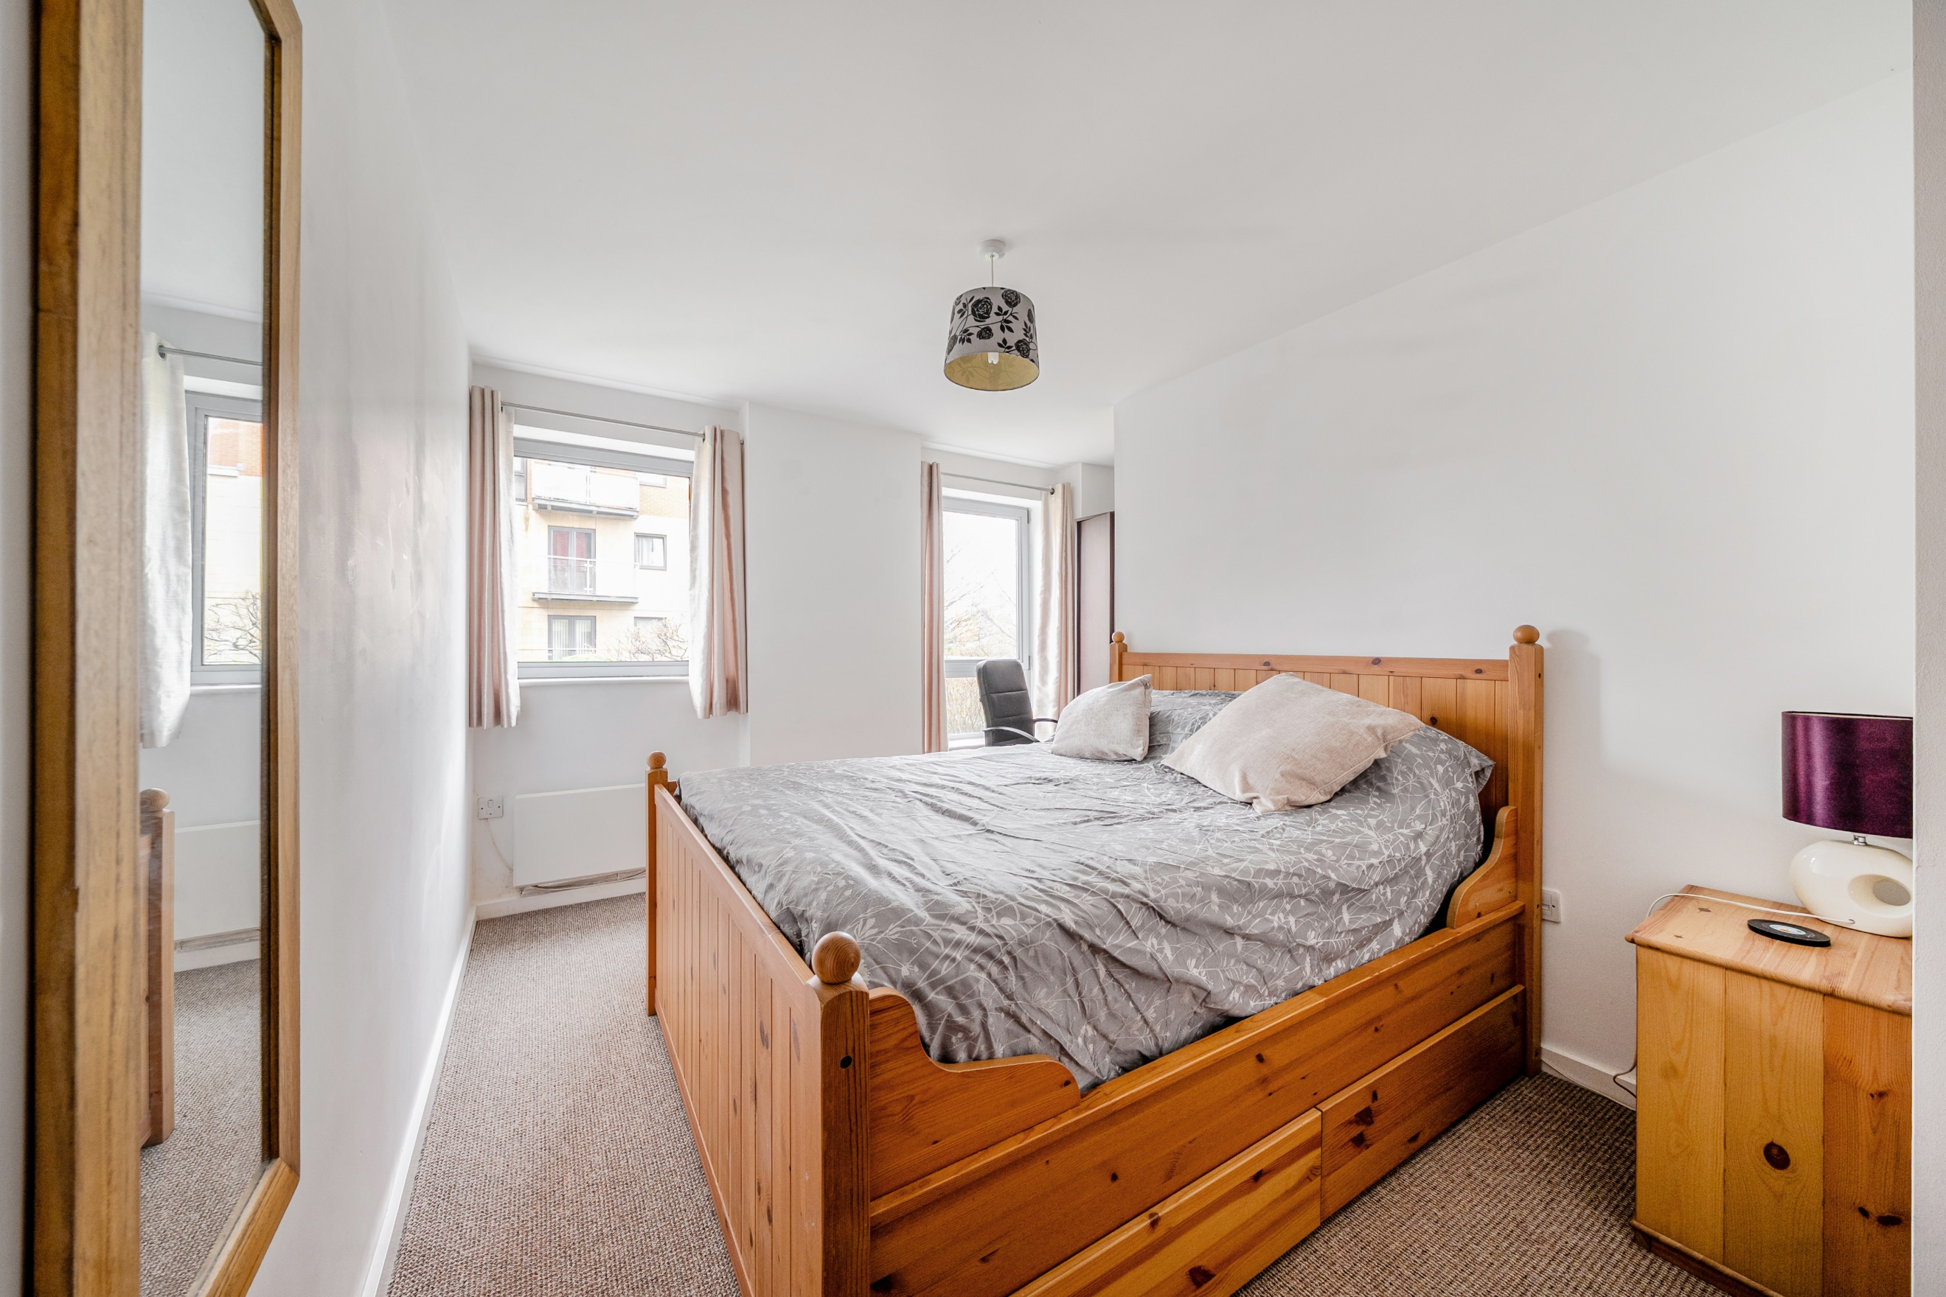

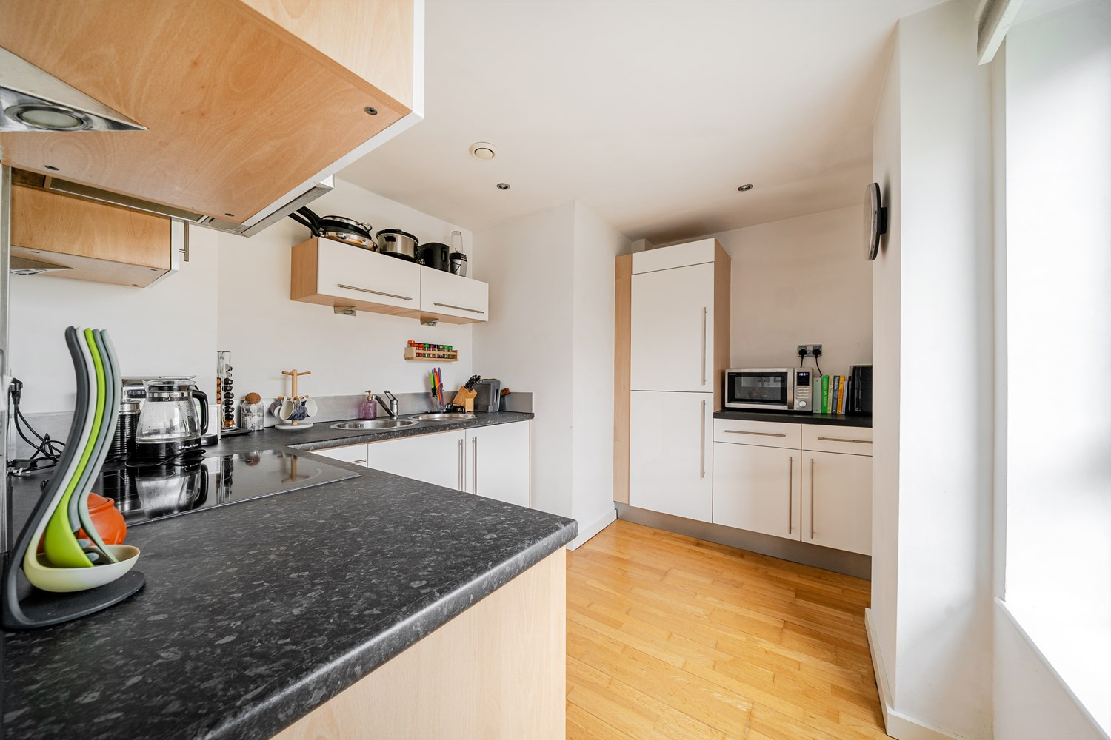

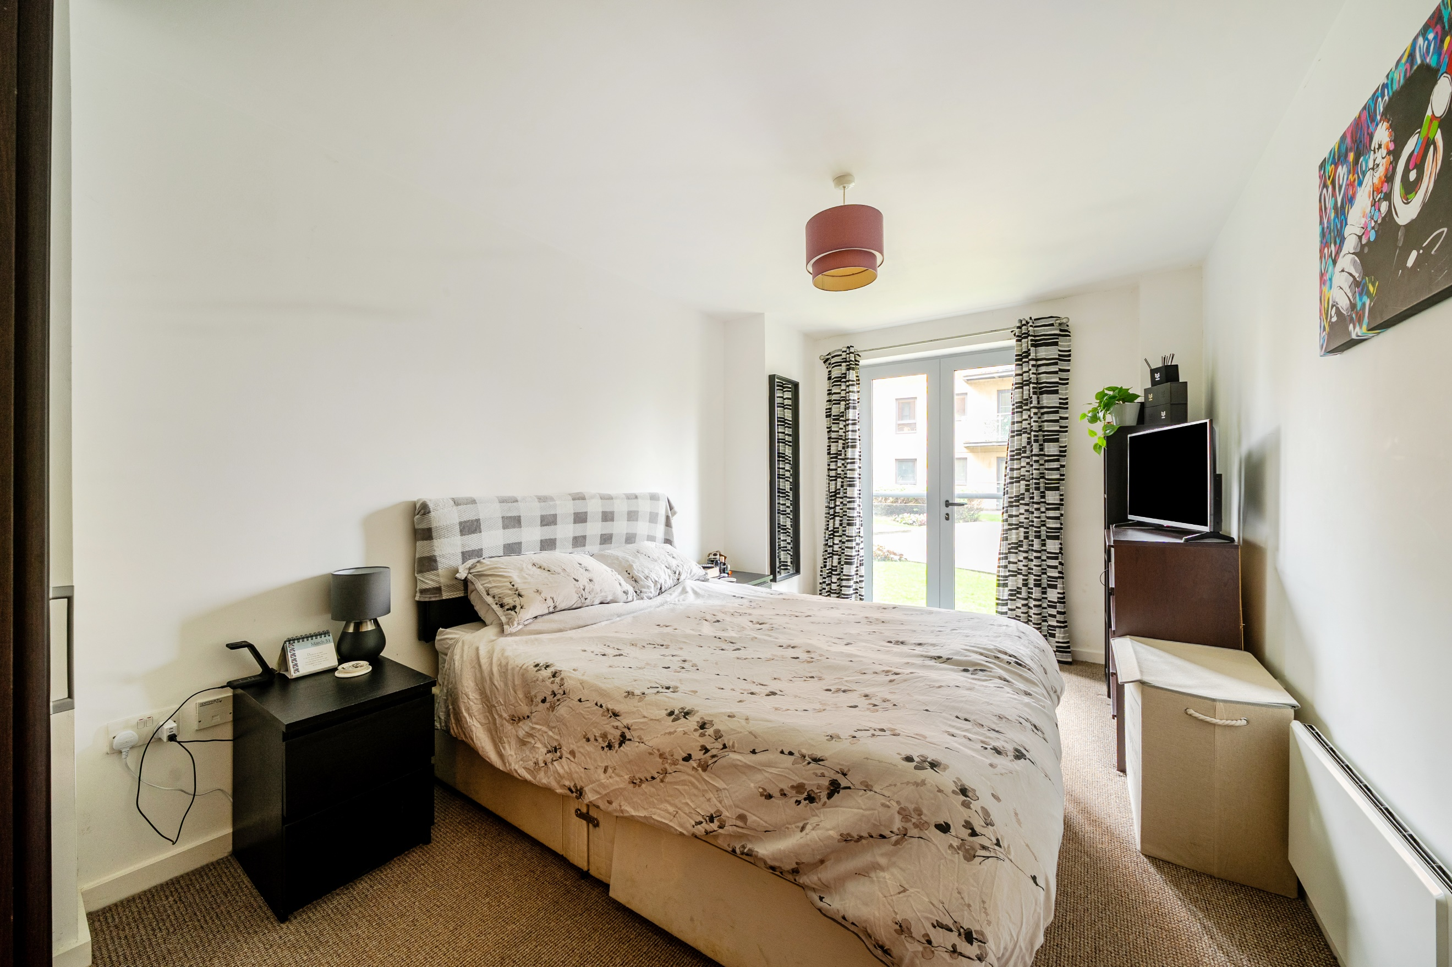

|  |
| --- |
| **Communal Entrance**  Lift and stairs to all floors. |
| **Hallway**  Spacious hallway accessed via front entrance door. |
| **Living Room 4.41m (14'6) x 4.16m (13'8)**  Light and airy living room with double doors opening to the balcony with views directly over the river. Wall mounted electric radiator. Inset ceiling spotlights. |
| **Kitchen 3.59m (11'9) Max x 2.61m (8'7) Max**  Fitted with a range of wall, base and drawer units with worktops over. Integrated fridge/freezer, washing machine and dishwasher. Integrated oven with 4-ring hob and extractor hood over. Inset ceiling spotlights. uPVC double glazed window. |
| **Bedroom 1 5.02m (16'6) Max x 3.77m (12'4) Max**  Double bedroom with two double glazed windows. Wall mounted electric radiator. |
| **Bedroom 2 5.01m (16'5) Max x 2.78m (9'1) Max**  Second double bedroom with double door leading out to Juliet balcony. Wall mounted electric radiator. |
| **Bathroom**  Fitted with a three piece white suite comprising; bath with shower over, WC and wash hand basin. Tiled walls and floor. Inset ceiling spotlights. |
| **Service Charge**  Service charge - £2,470.66 per annum  Service charge for parking - £33.64 per annum |
| **Tenure**  Leasehold - Length of lease - 999 years from 2003. Ground Rent - £200 per year |
| **Communal Gardens** |
| **Allocated Parking** |

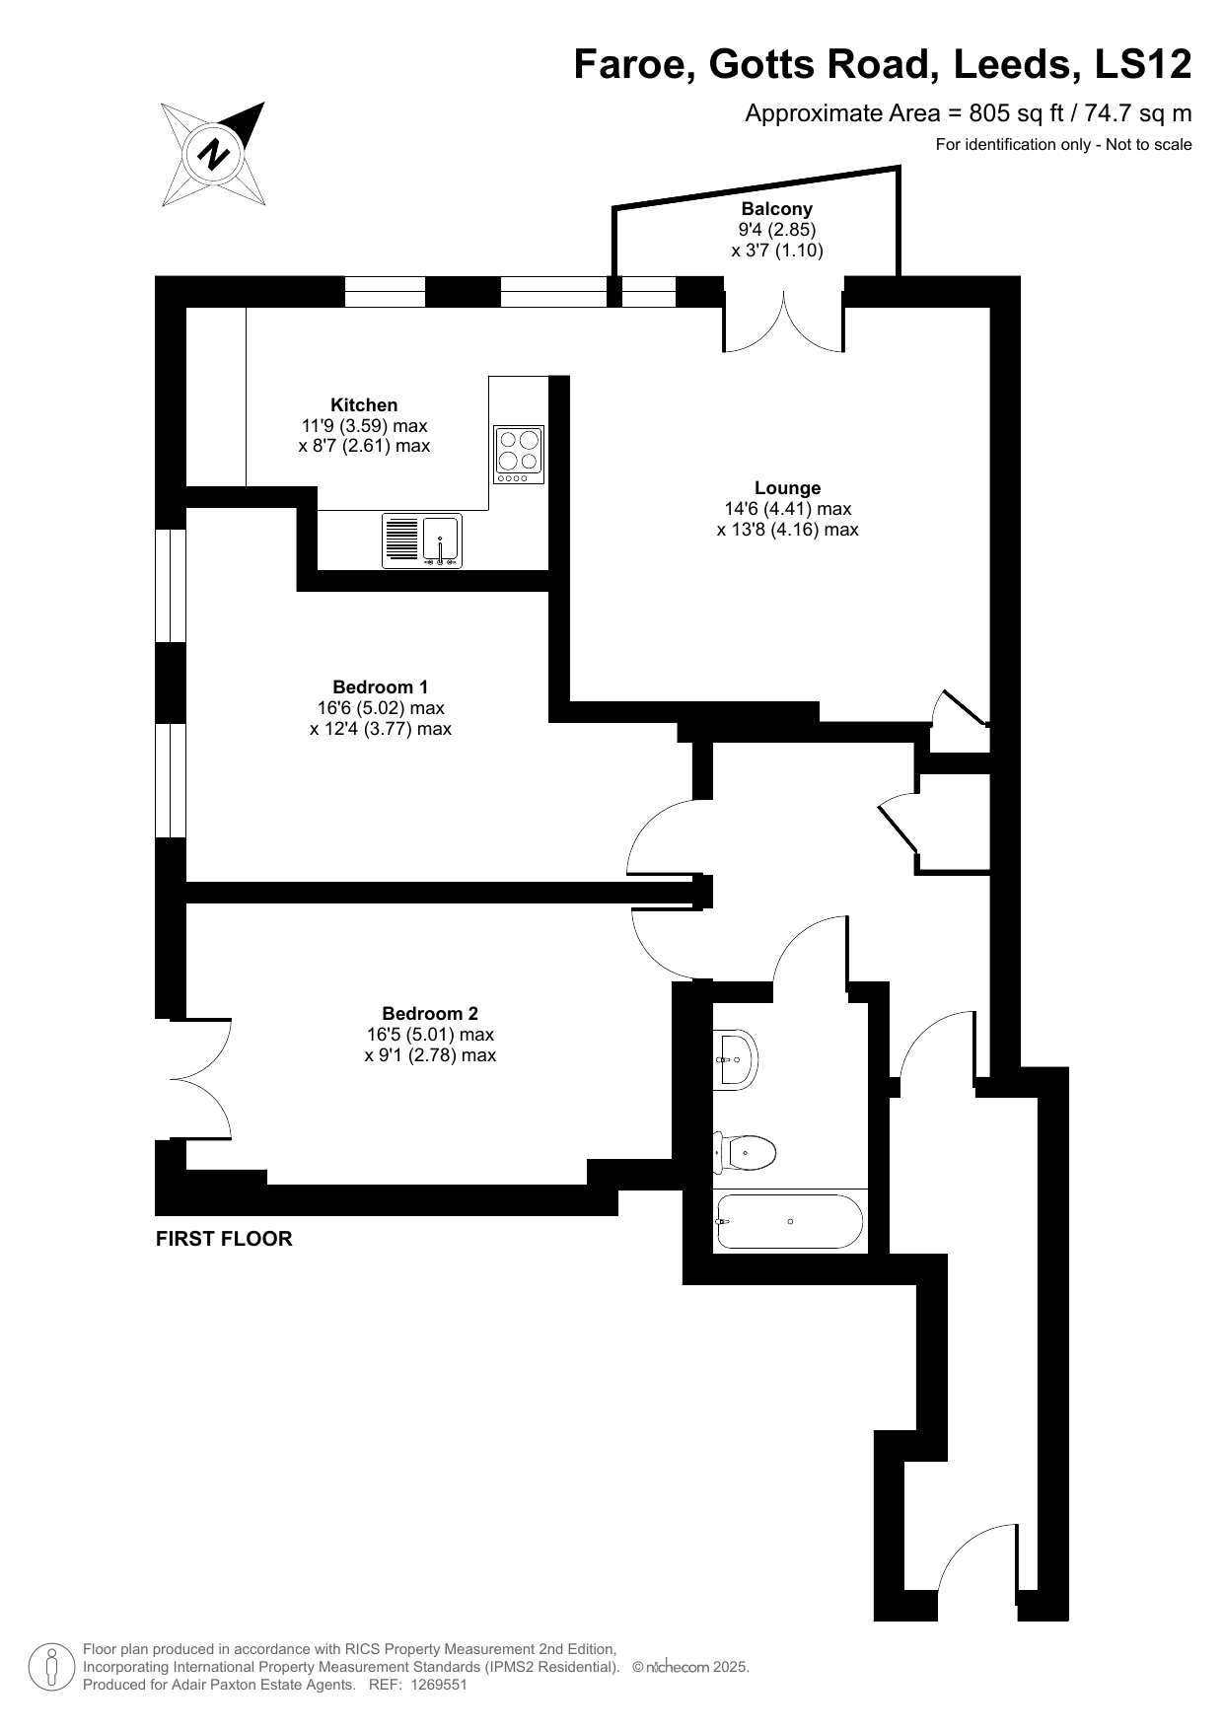

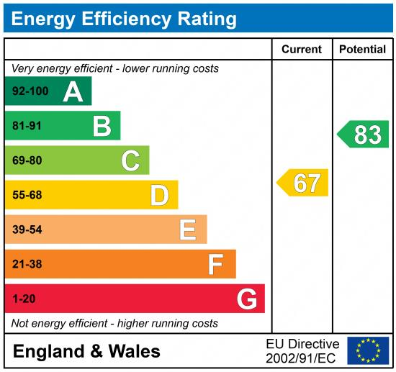

|  |
| --- |
|  |

These particulars are intended to give a fair description of the property, but their accuracy cannot be guaranteed, and they do not constitute an offer of contract. Intending purchasers must rely on their own inspection of the property. None of the above appliances/services have been tested by ourselves. We recommend purchasers arrange for a qualified person to check all appliances/services before legal commitment.

**Property Ref:** 5620

**For more information, please contact**

0113 258 1150 **|** [sales@adairpaxton.co.uk](mailto:sales@adairpaxton.co.uk) **|** www.adairpaxton.co.uk