

Newlands, Farsley
For Sale £239,950.00

Adair Paxton are pleased to offer this two bedroom mid-terrace house, situated in this highly popular residential area of Farsley. This lovely home is in ready to move into condition and briefly comprises; Living room and dining kitchen to the ground floor. To the first floor there are two bedrooms and a house bathroom. Externally, the property has an enclosed rear garden and two off street parking spaces to the front. The property is just a short distance from the village centre as well as being within commuting distance of Leeds and Bradford city centres and is sure to appeal to a range of buyers including first time buyers and young families.
0113 258 1150
0800 000 000
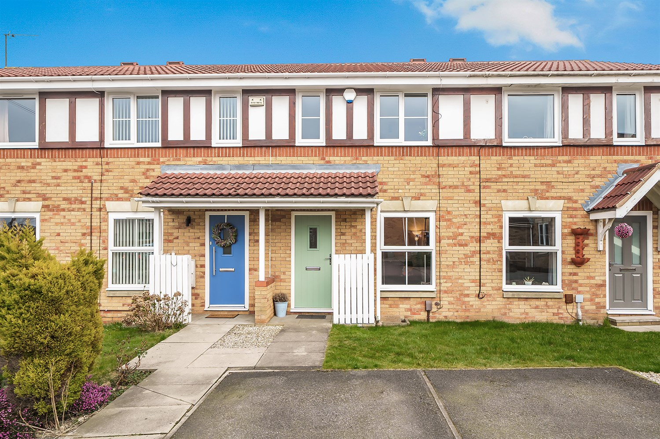



1 Reception
1 Bathroom
2 Bedrooms
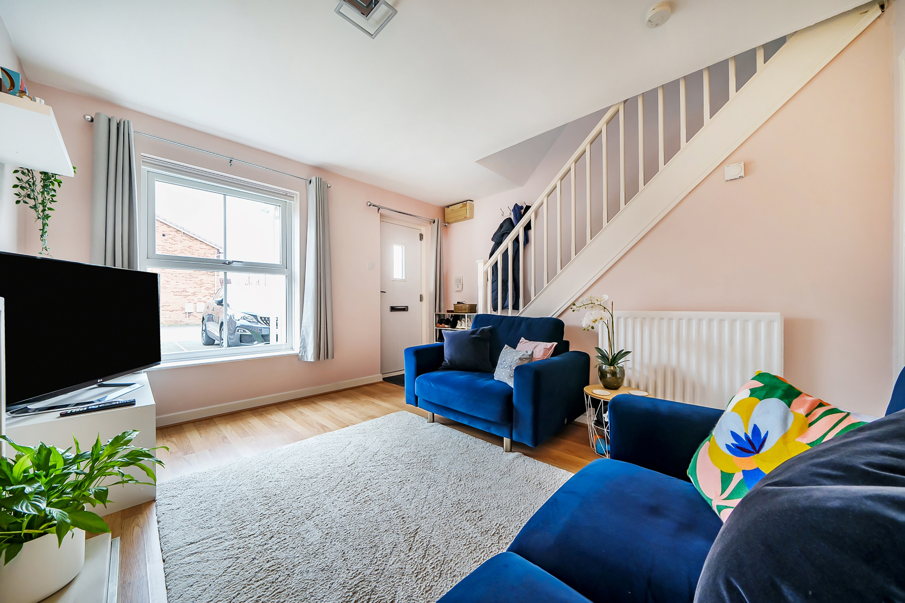
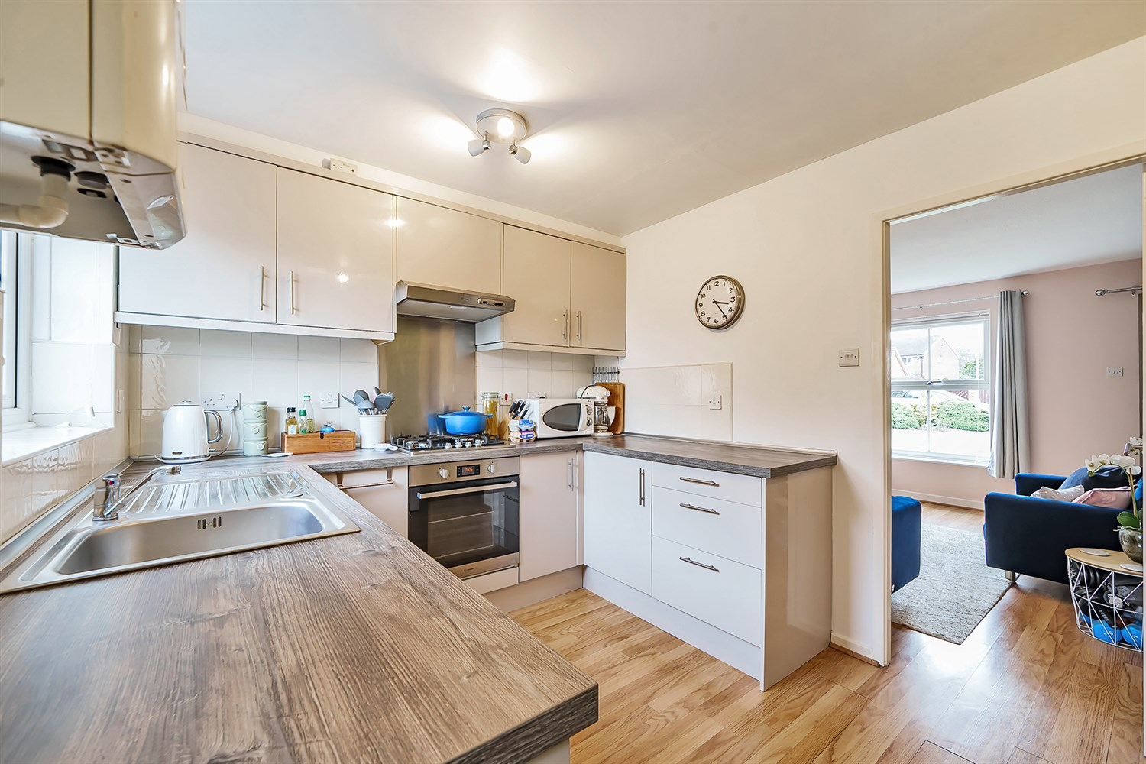
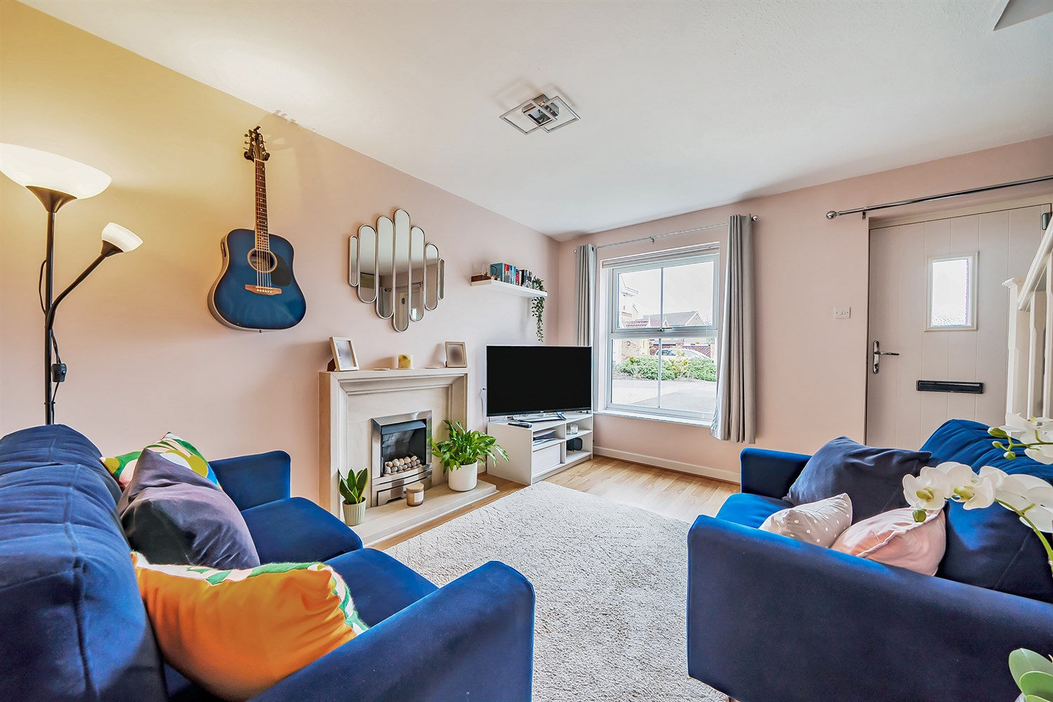
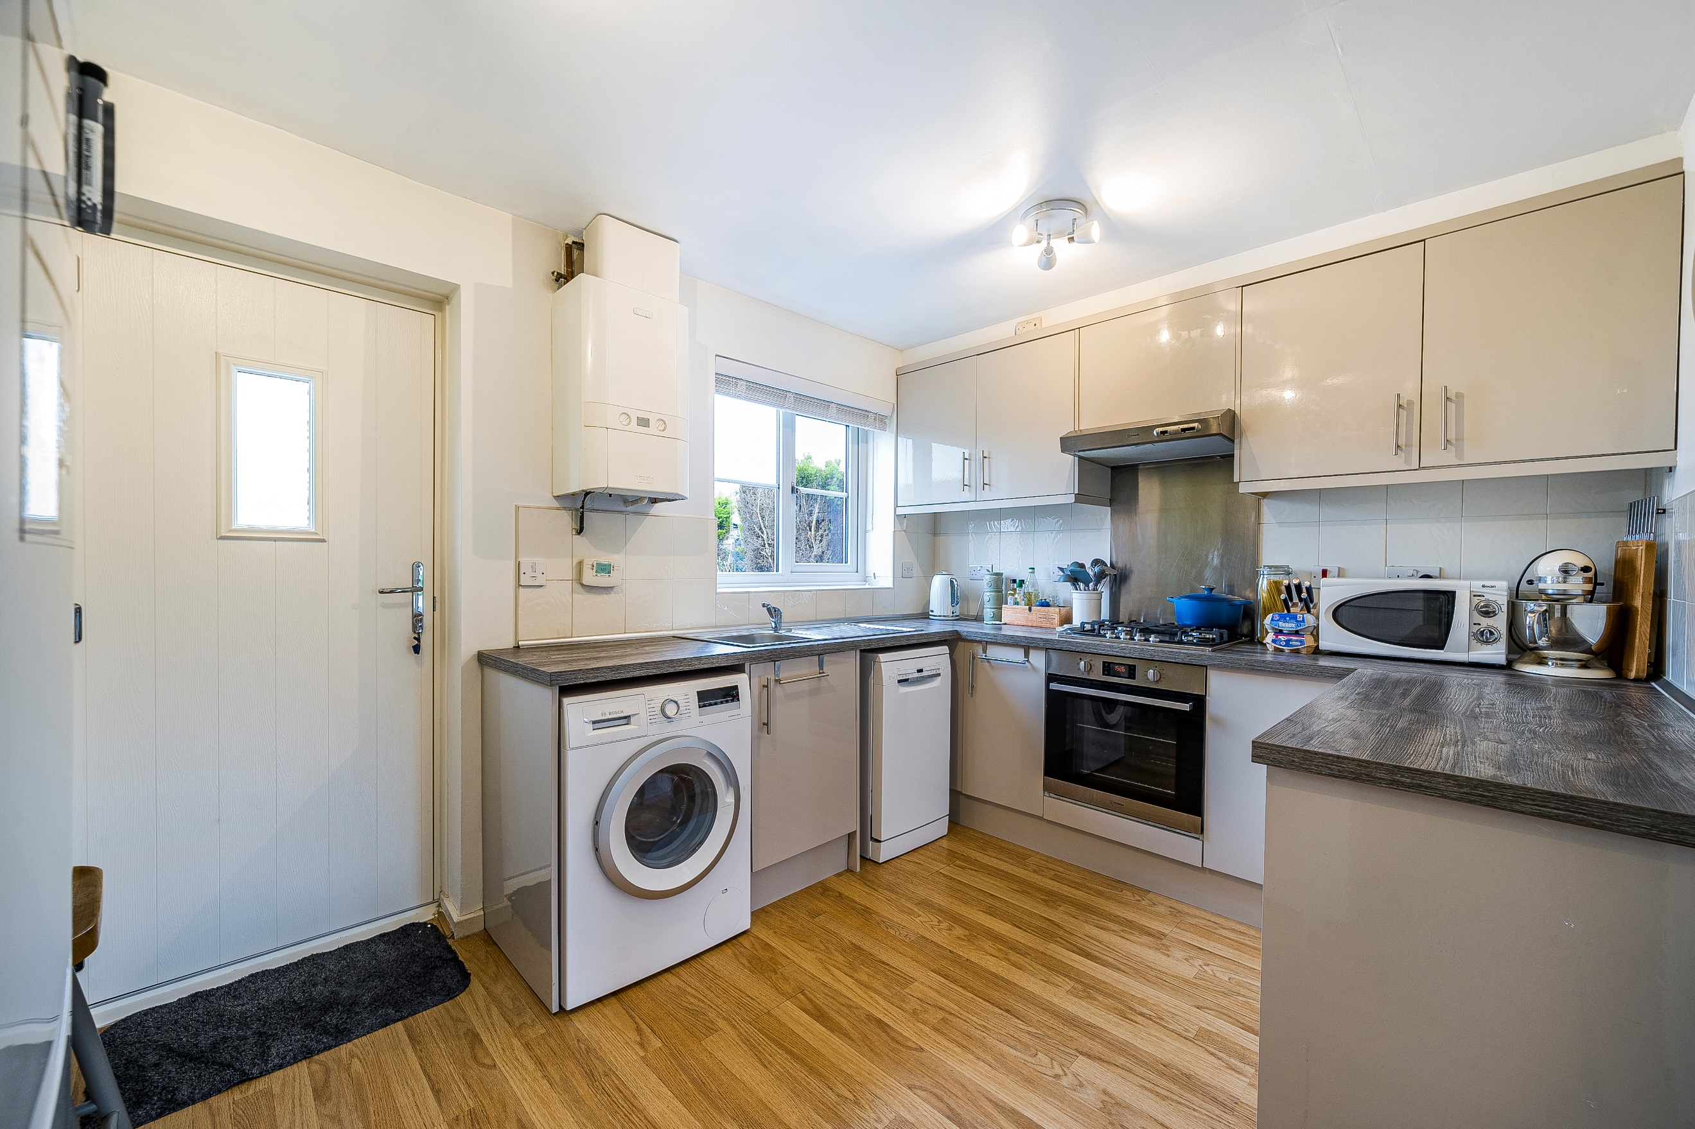
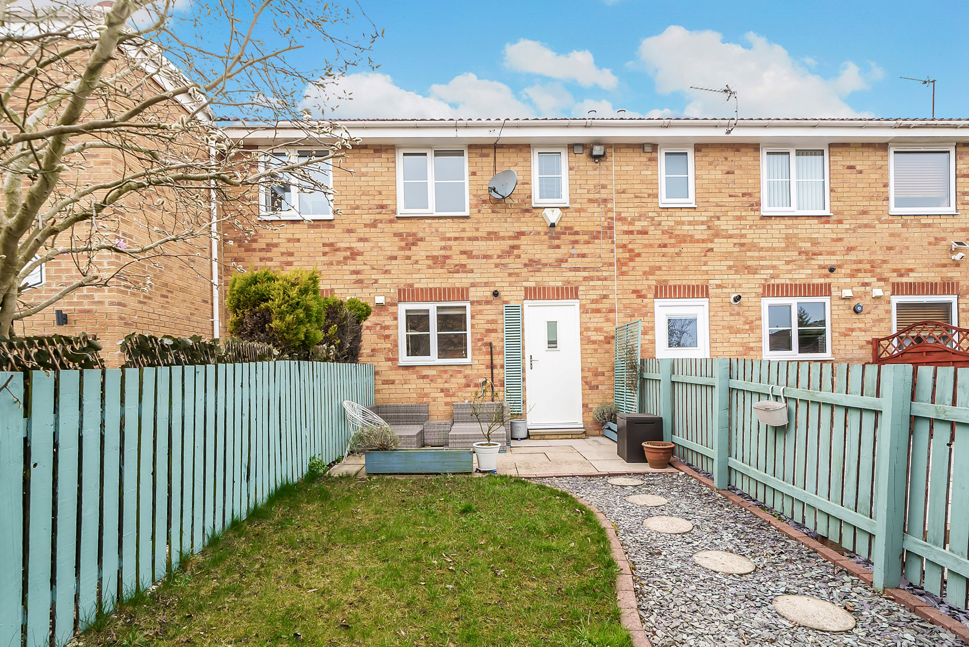
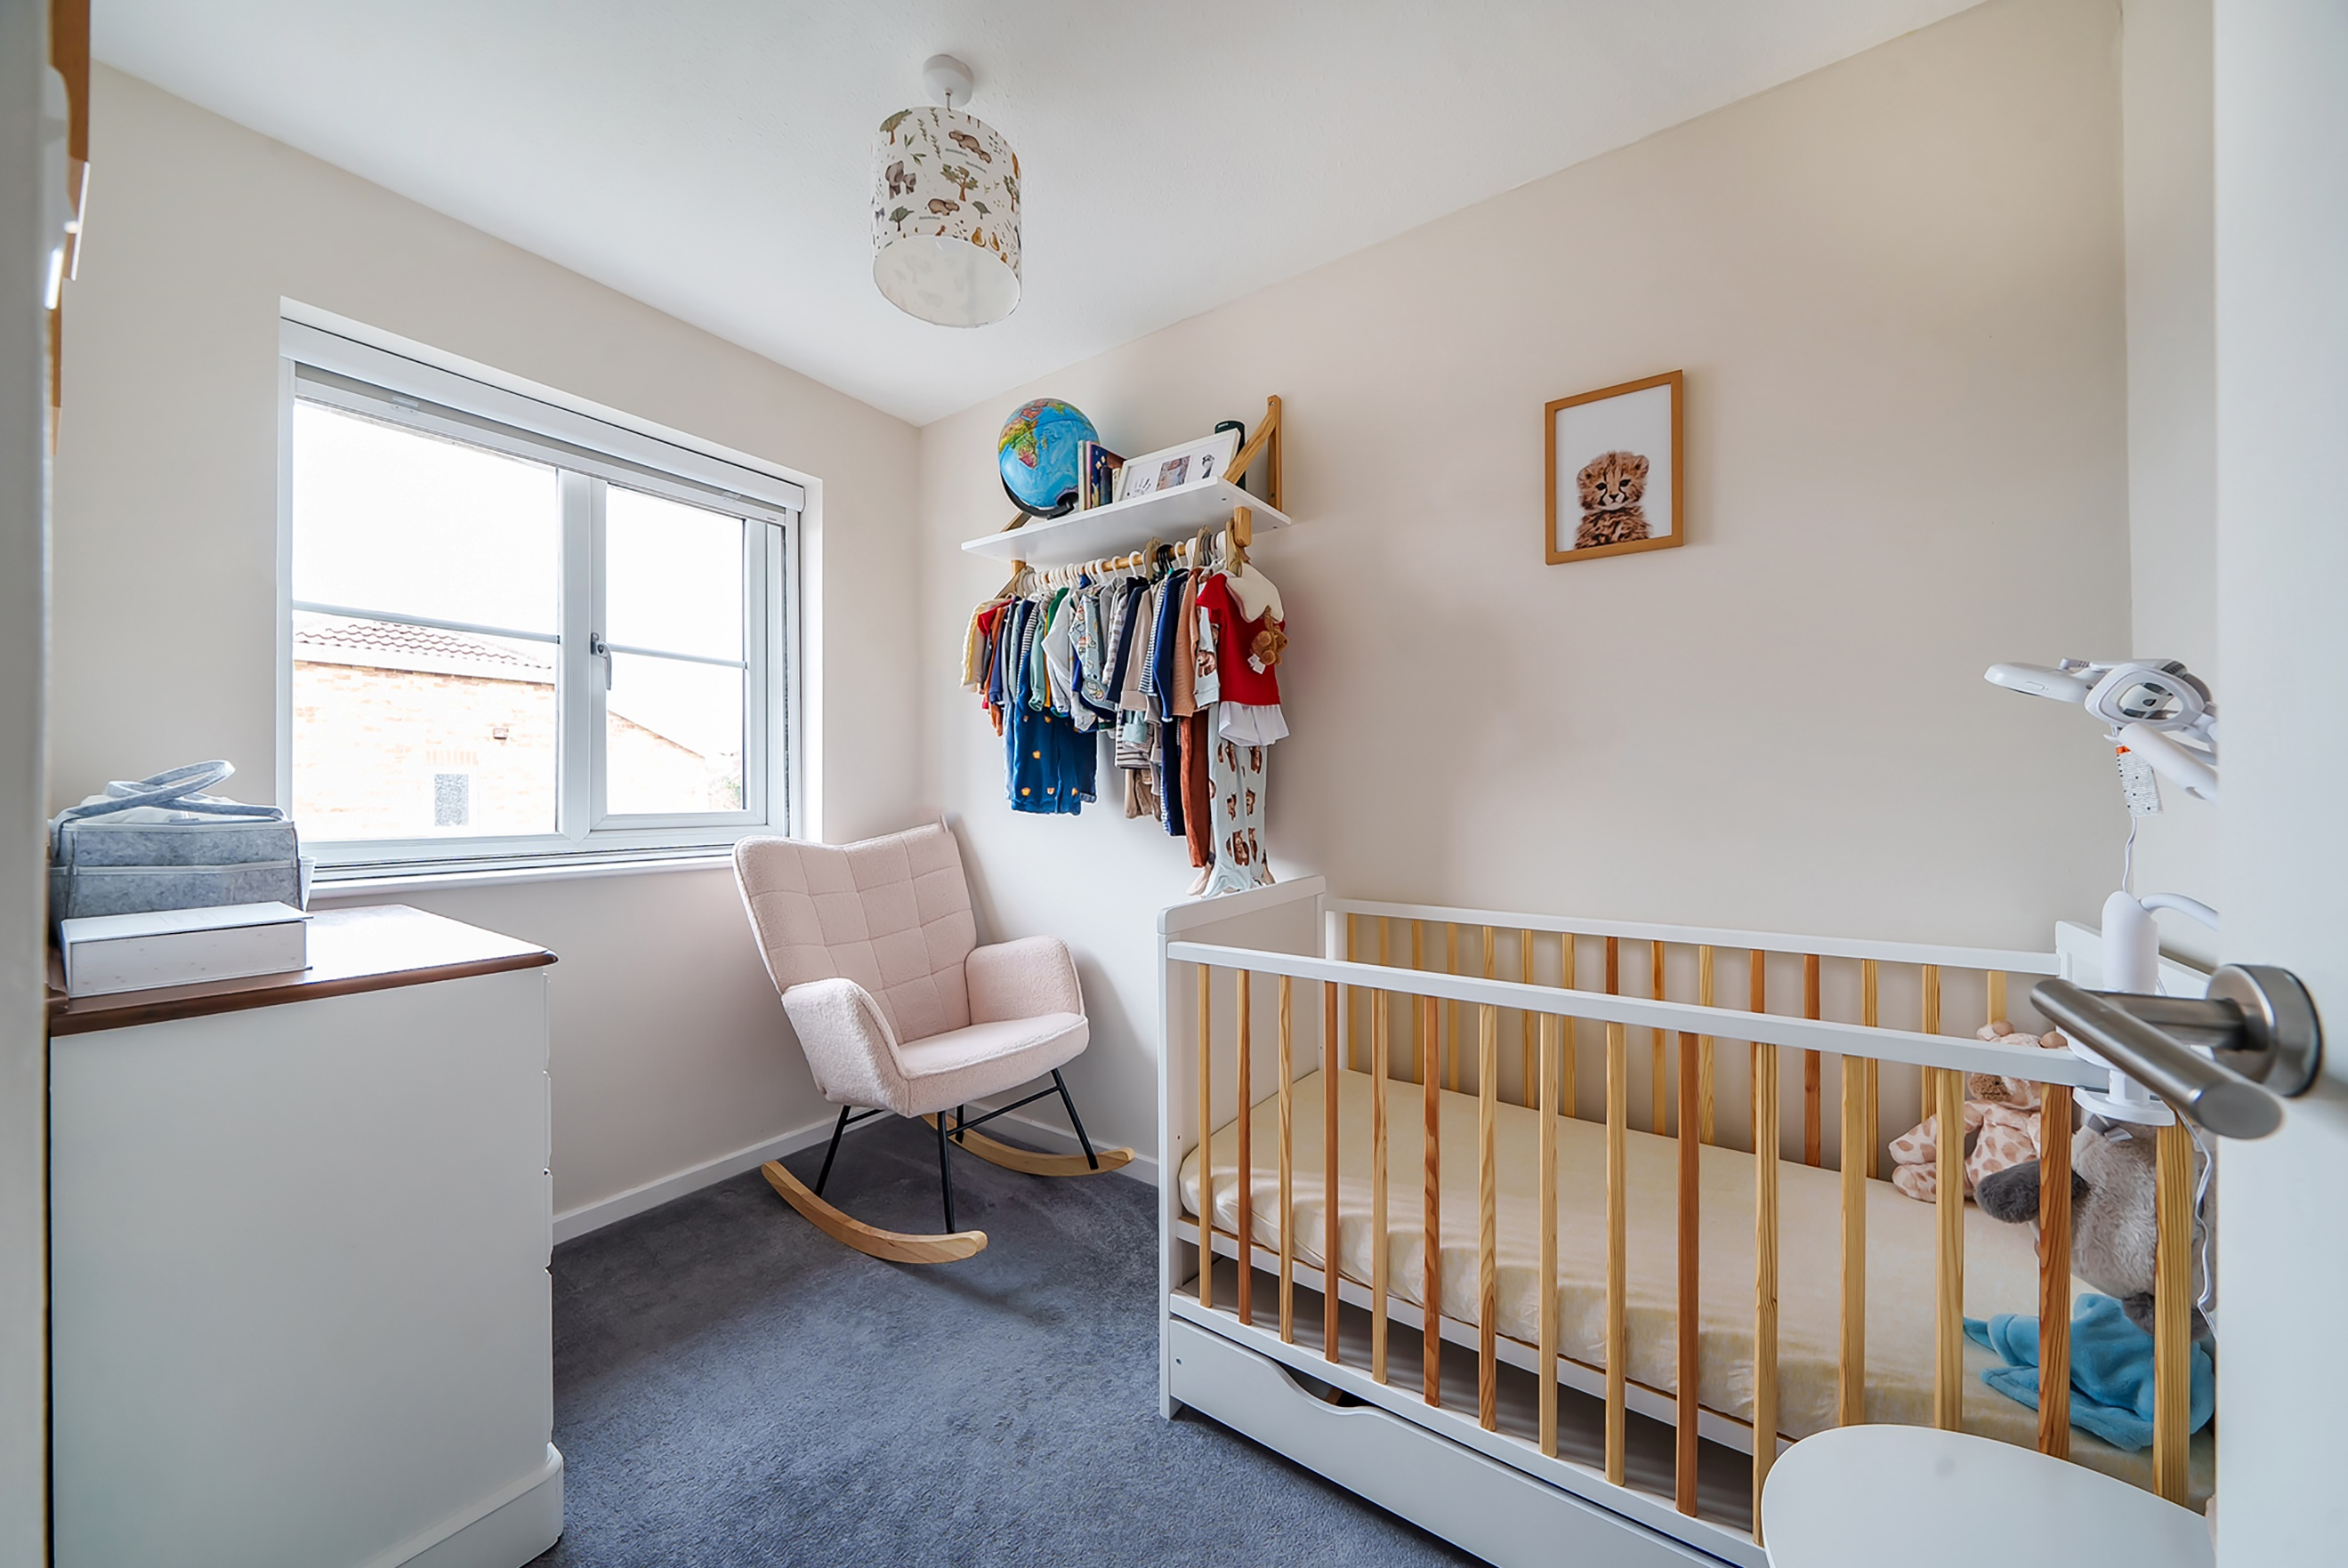
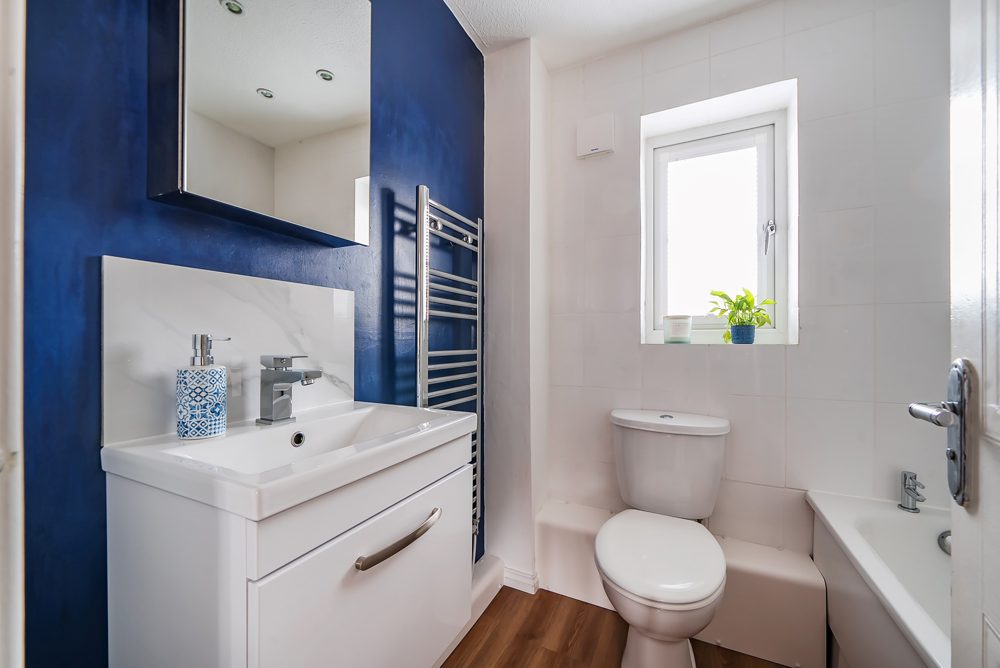
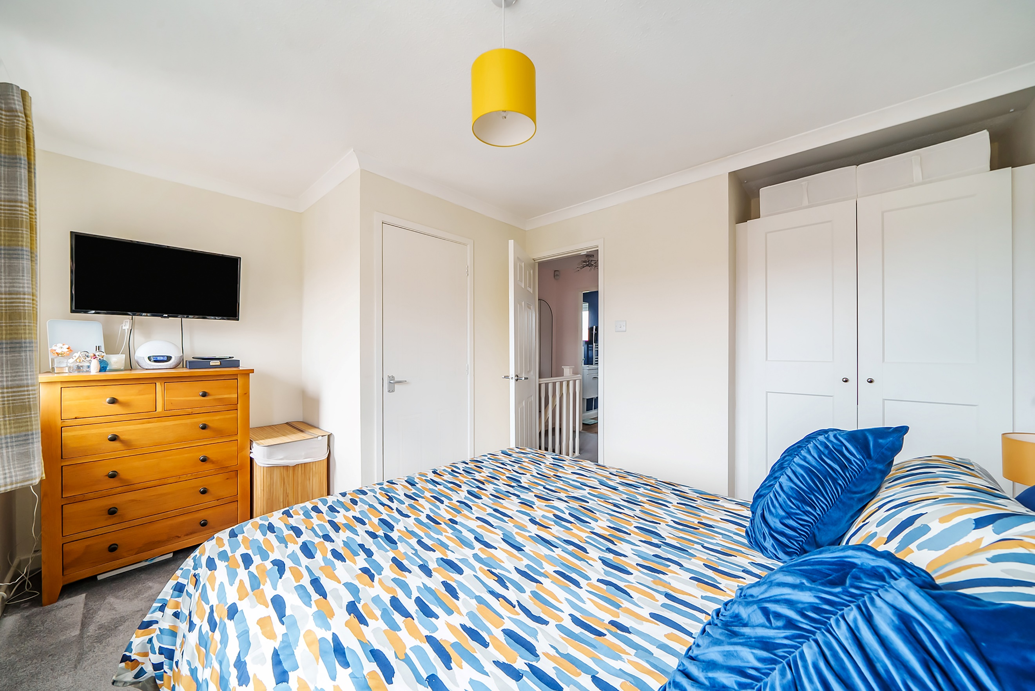

Lounge 3.82m (12'6) x 3.78m (12'5)
Via front entrance door. Light and airy living area with uPVC double glazed window to front. Gas fire in modern surround. Gas central heating radiator. Stairs to first floor.

Kitchen 3.82m (12'6) x 2.65m (8'8)
Fitted with a range of wall, base and drawer units with worktops over. Integrated oven with 4-ring gas hob and extractor hood over. Stainless steel sink with drainer and mixer tap. Under stairs storage. uPVC double glazed window and door to rear. Gas central heating radiator.

First Floor

Bedroom 1 3.82m (12'6) x 3.7m (12'2)
Double bedroom with two uPVC double glazed windows to front. Gas central heating radiator. Store cupboard.

Bedroom 2 2.8m (9'2) x 1.8m (5'11)
Second bedroom with uPVC double glazed window to rear. Gas central heating radiator.

Bathroom
Fitted with a three piece suite comprising; bath with shower over, WC and wash hand basin. Wall mounted heated towel rail. Tiled walls. uPVC double glazed window.

Outside
To the rear of the property is a well maintained enclosed garden which has been mainly laid to lawn . A patio area which is great for outdoor entertaining. To the front of the property there are two allocated parking spaces.

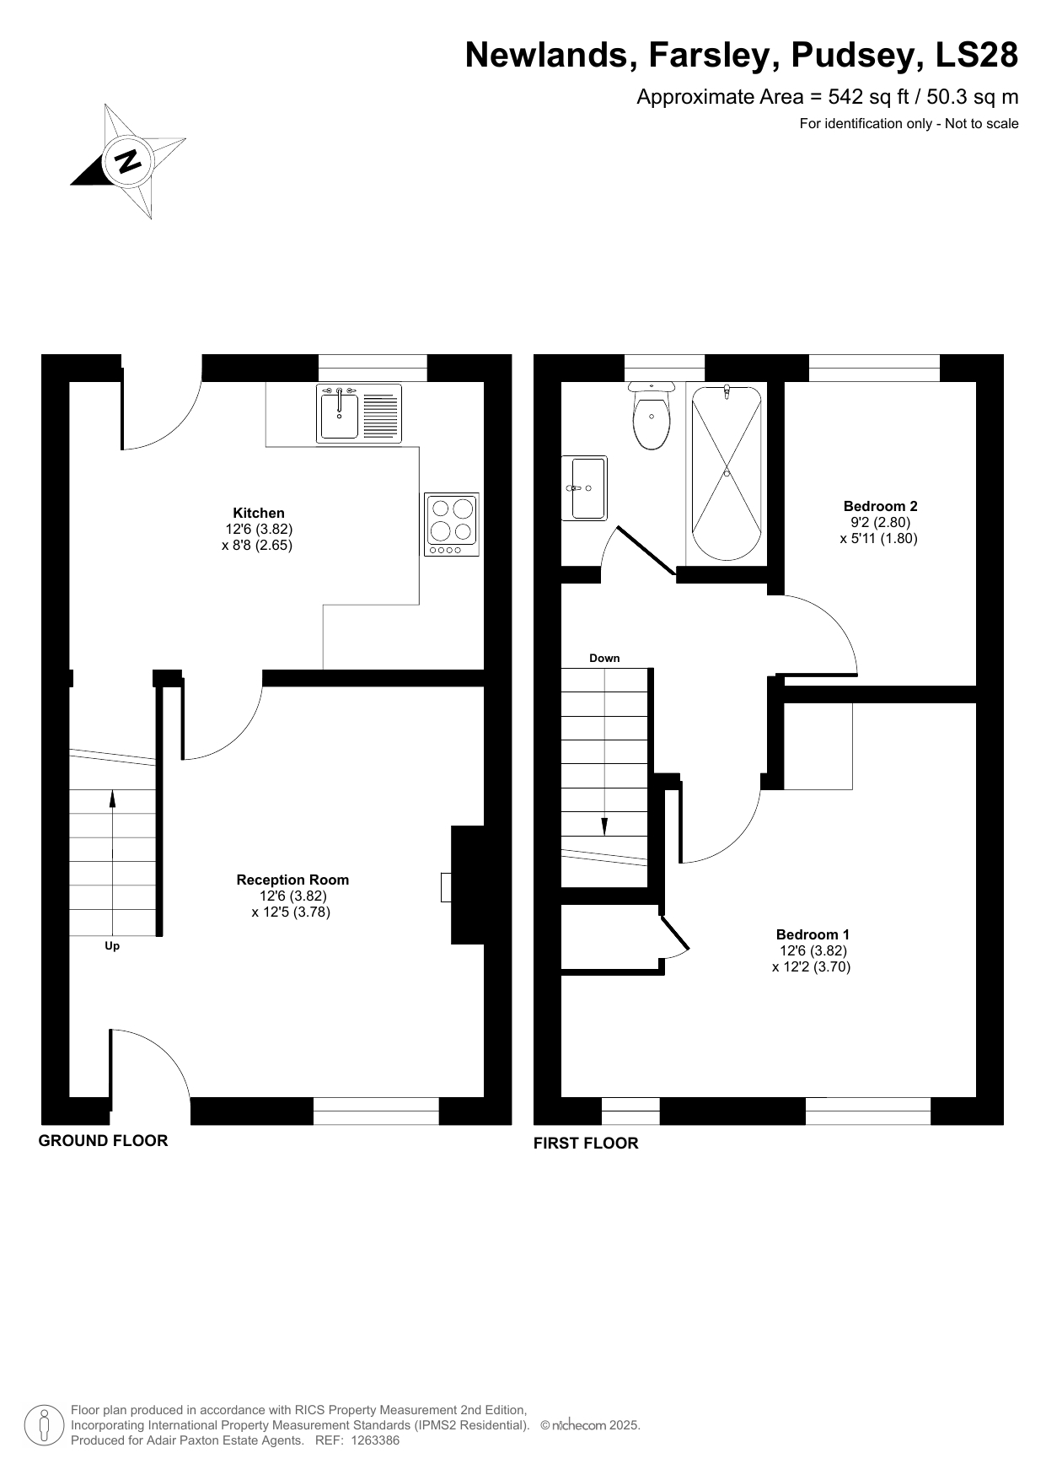

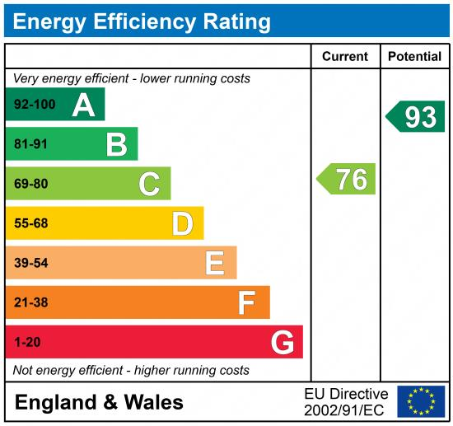

These particulars are intended to give a fair description of the property, but their accuracy cannot be guaranteed, and they do not constitute an offer of contract. Intending purchasers must rely on their own inspection of the property. None of the above appliances/services have been tested by ourselves. We recommend purchasers arrange for a qualified person to check all appliances/services before legal commitment.

Property Ref: 5627

For more information, please contact

0113 258 1150 | sales@adairpaxton.co.uk | www.adairpaxton.co.uk

