

**0113 258 1150**

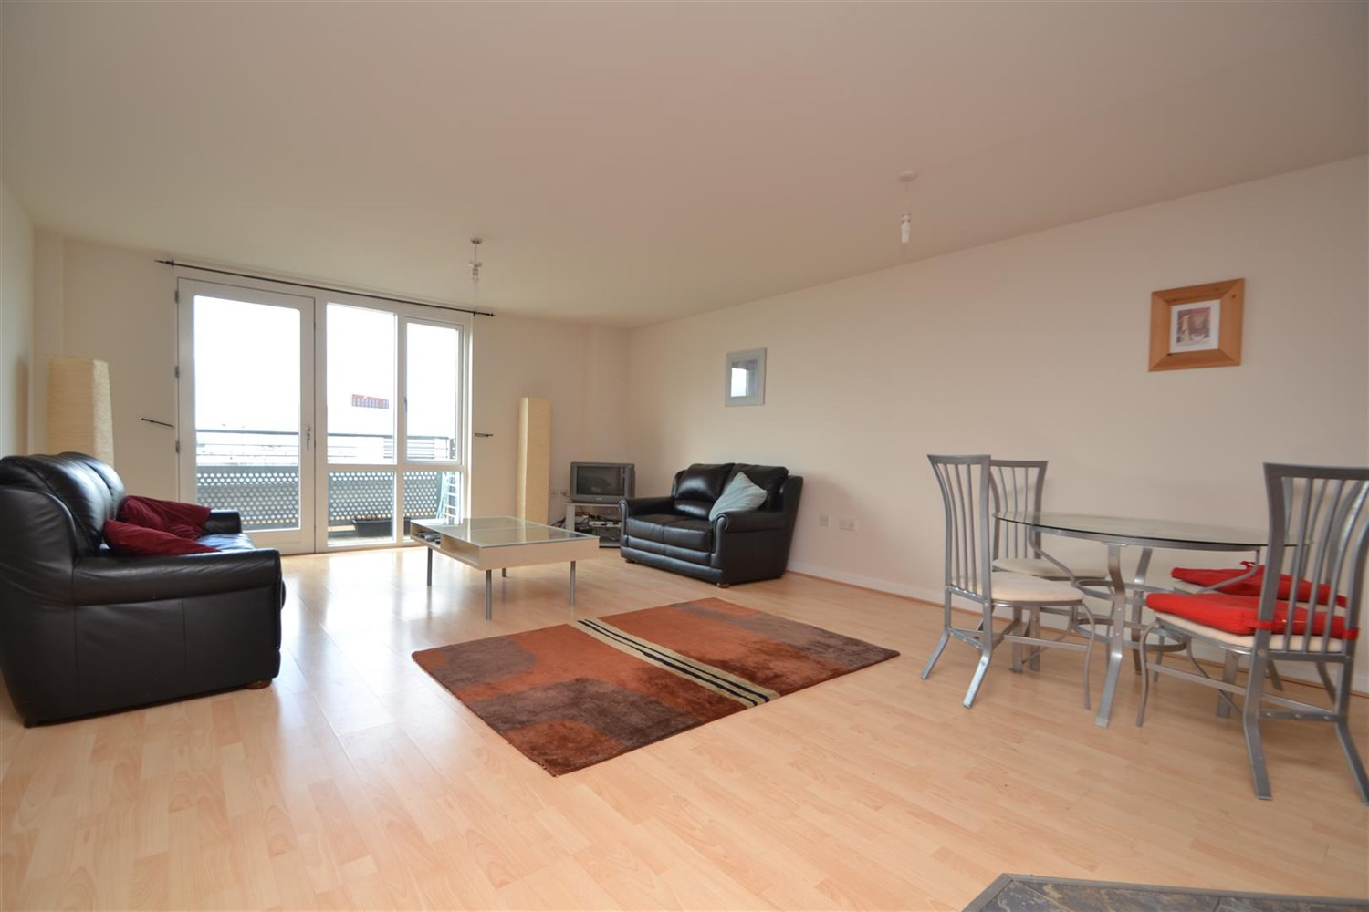



**Available to let £995.00pcm**

**Aspect 14, Aspect 14, Leeds, LS2**

Spacious two bedroom two bathroom apartment in the popular development of Aspect 14, located close to Leeds Universities, hospitals and shopping district. Accommodation briefly comprising open plan living kitchen, access to balcony with city views. Two double bedrooms, four piece bathroom suite. Available 19th April. Deposit £1145, Council tax band D. EPC rating c. Due to the lease this property has a no pets policy.

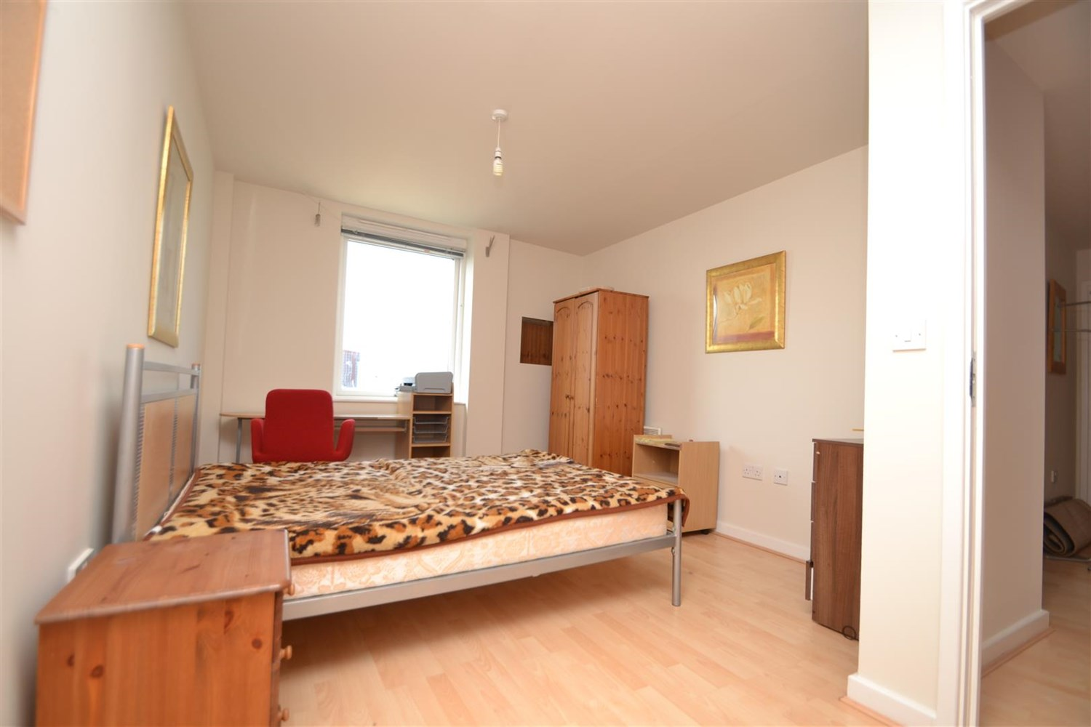

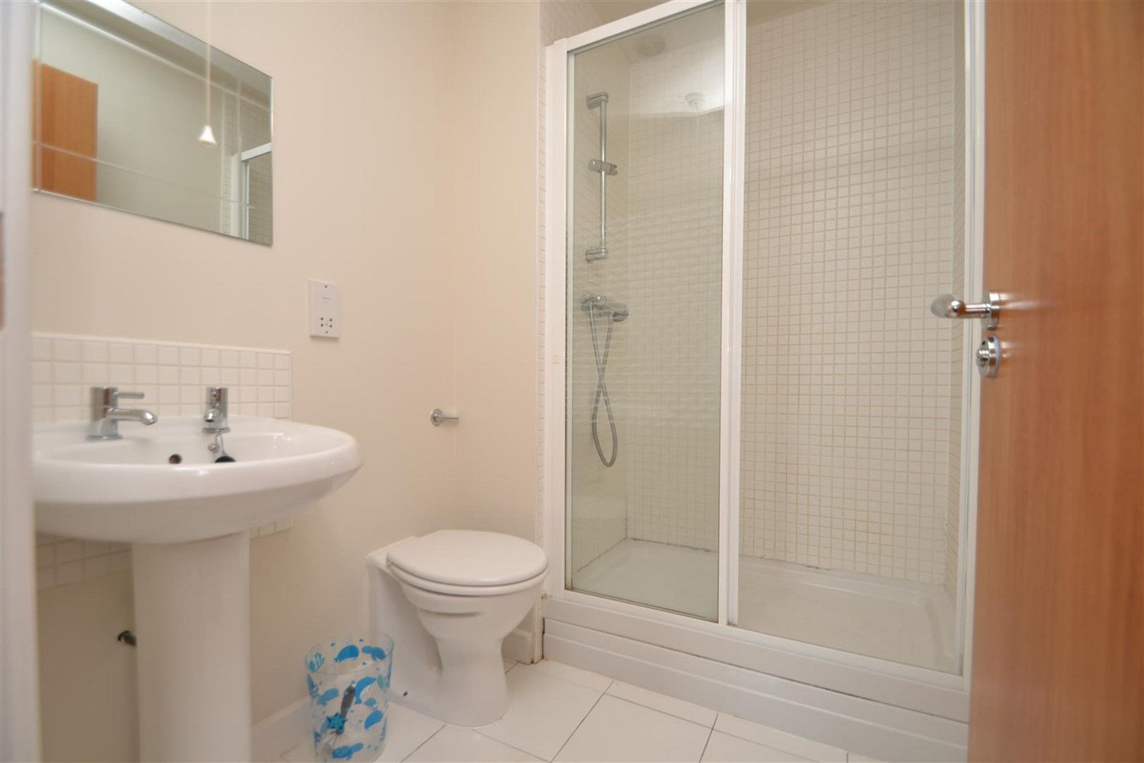

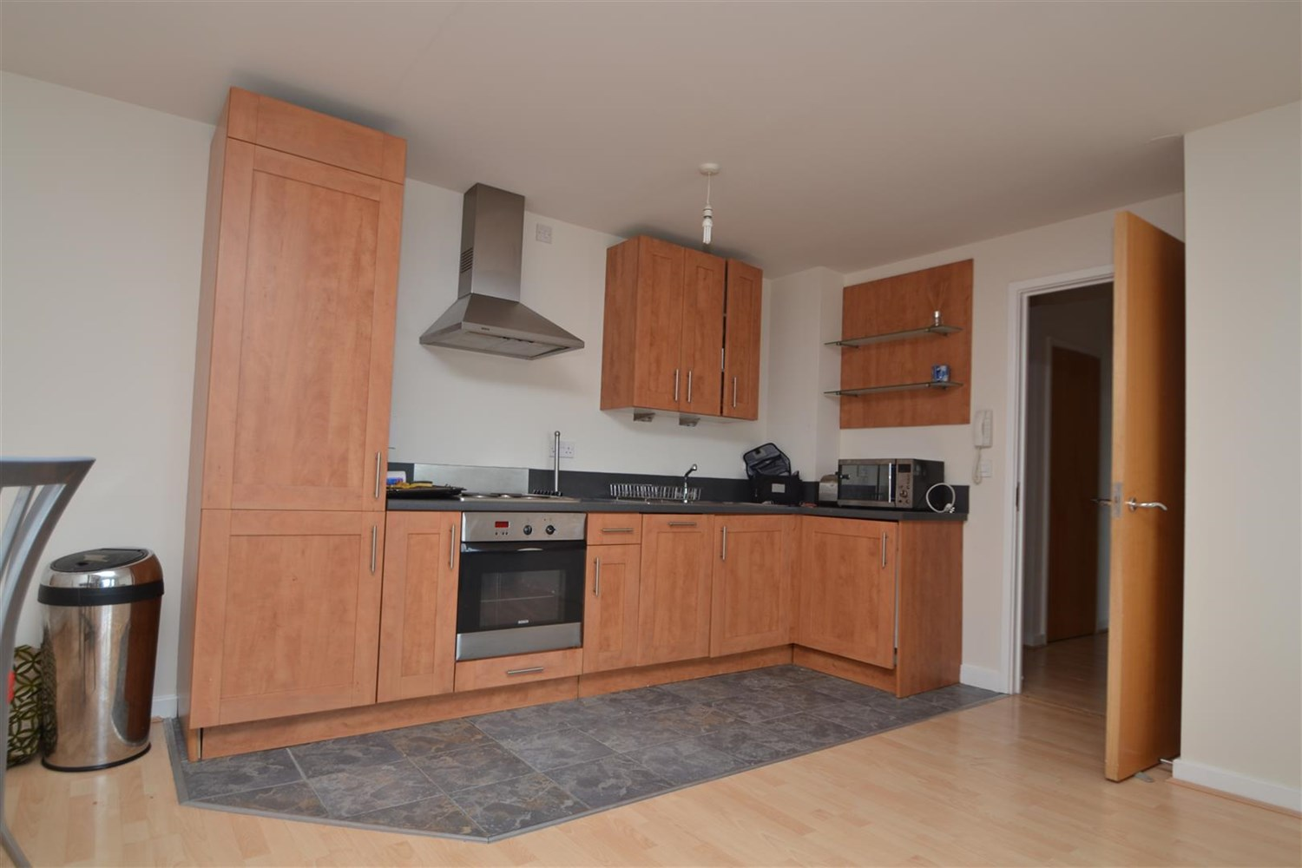

1 Bathroom(s)

1 Reception(s)

2 Bedroom(s)

00

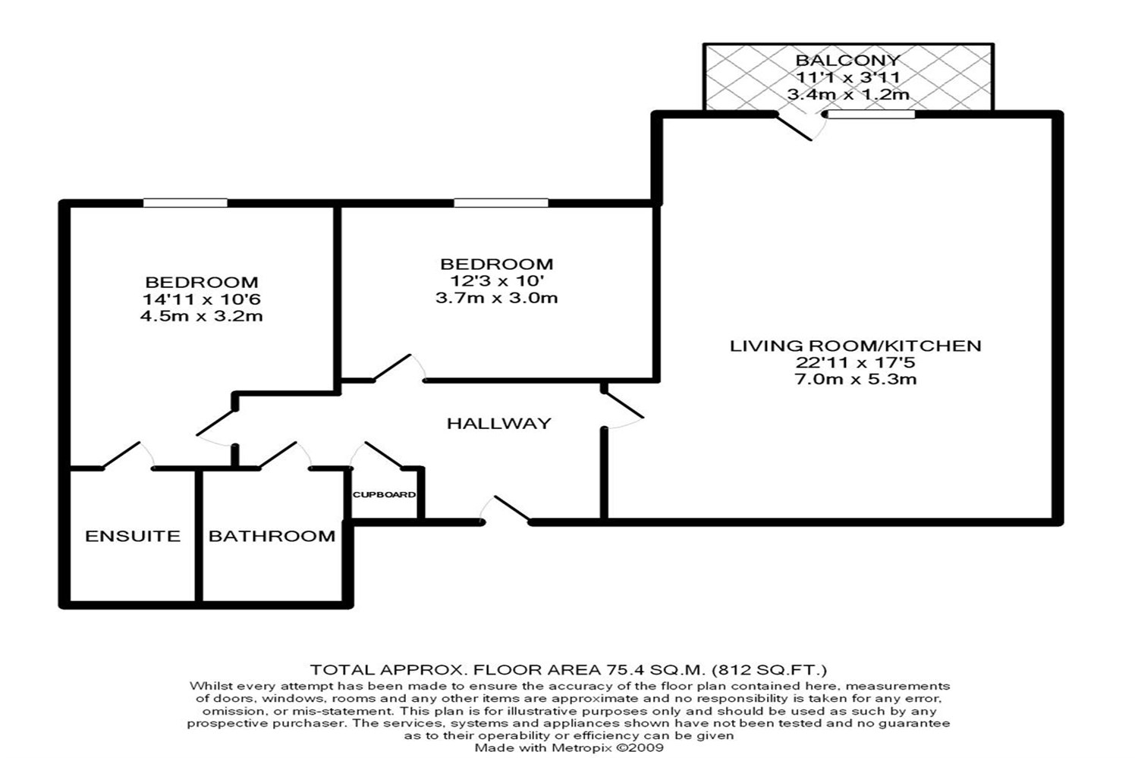

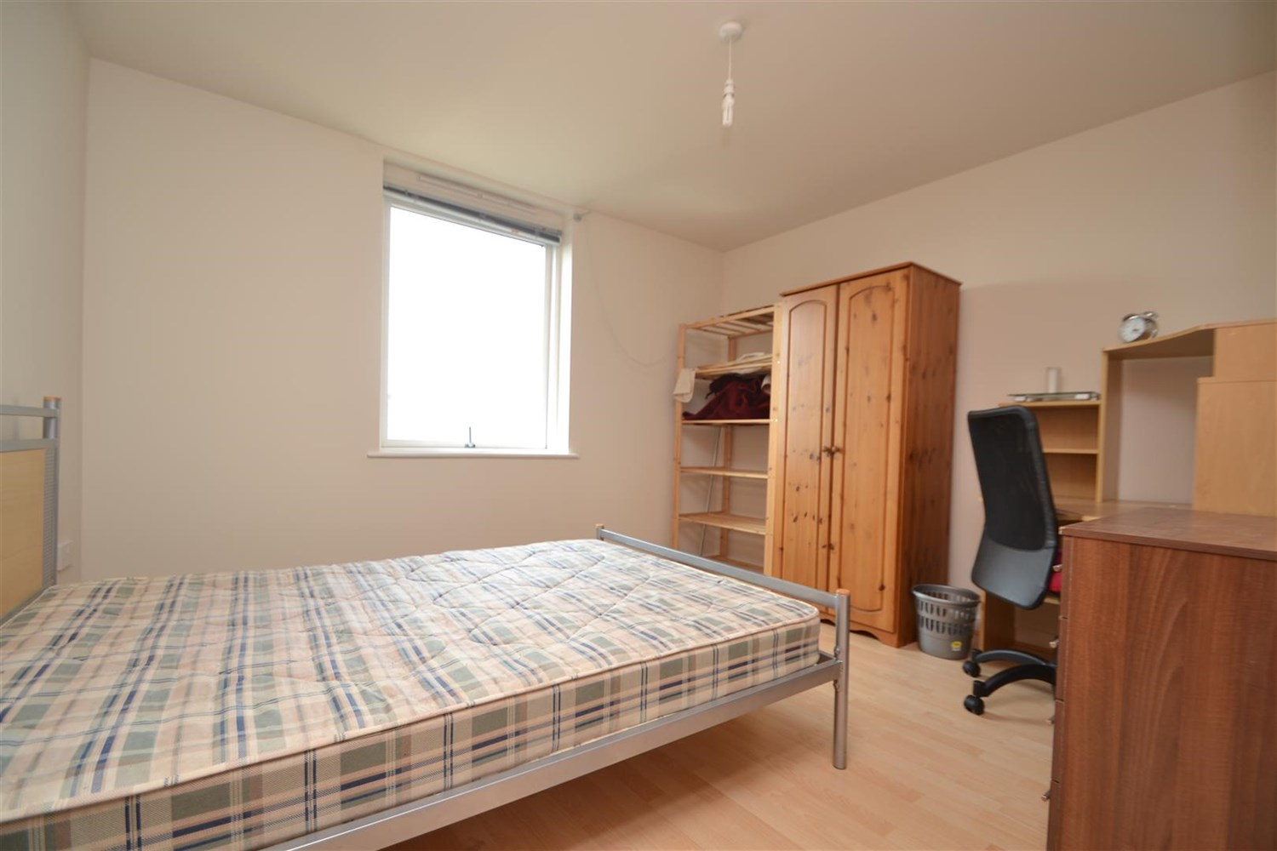

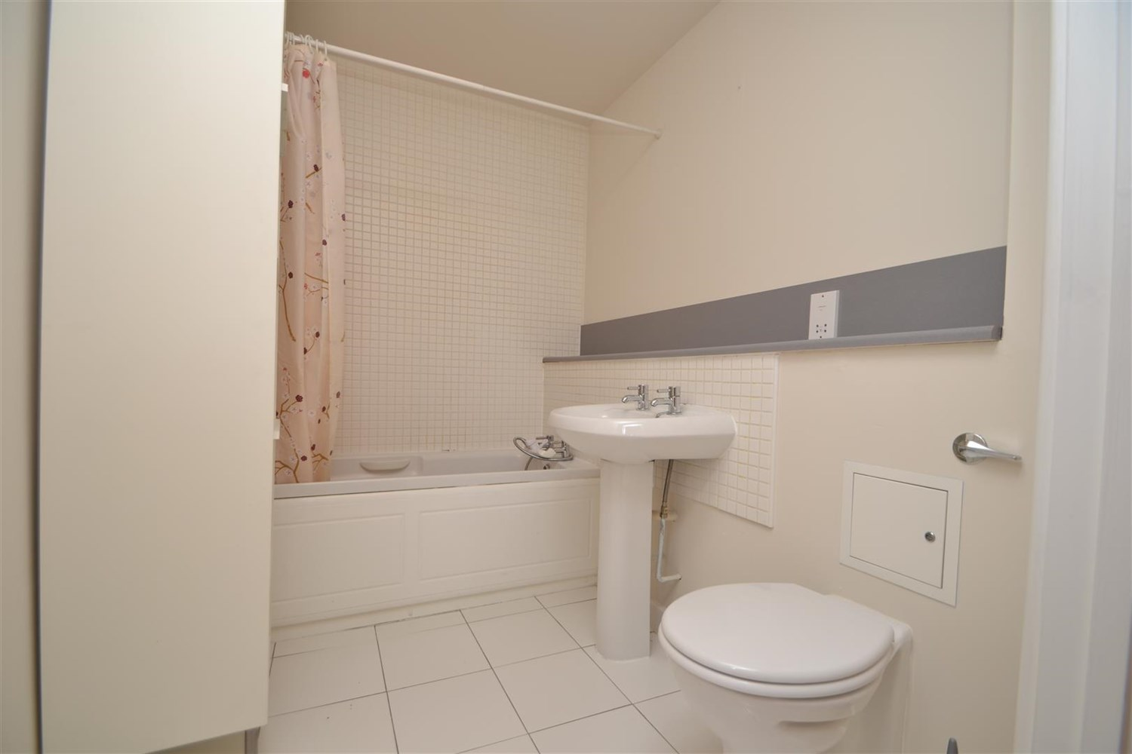

|  |
| --- |
| **Communal Entrance**  Secure entrance with post boxes, video entrance phone and access to all floors via lift and stairs. |
| **Open Plan Living Room/Kitchen**  Open plan living area with access to balcony. Kitchen area having a range of wall, base and drawer units with worktops over. integrated oven, hob and extractor, single drainer stainless steel sink unit with mixer tap, washing machine, fridge freezer and dishwasher. Electric radiator. |
| **Bedroom 1**  Double bedroom with window, electric wall heater and access to ensuite. |
| **En-Suite Bathroom**  Three piece shower room with walk in shower, w/c and hand wash basin. Tiled walls and floor. |
| **Bedroom 2**  Double bedroom with window and electric wall heater. |
| **Allocated Parking**  Allocated parking space. |
| **Home Information**  COUNCIL TAX BAND:  EPC Rating:   Leasehold property  Standard 16 Mbps 1 Mbps Good Superfast 8995 Mbps 2995 Mbps Good Ultrafast 1995995995 Mbps 1995995995 Mbps   Mobile availability: EE likely to have good coverage. Three likely to have good coverage. O2 likely to have good coverage. Vodafone likely to have good coverage.  Utilities: Water supplied on standard meters. Electric mains supplied on standard meters. |

|  |  |
| --- | --- |
| These particulars are intended to give a fair description of the property, but their accuracy cannot be guaranteed, and they do not constitute an offer of contract. Intending purchasers must rely on their own inspection of the property. None of the above appliances/services have been tested by ourselves. We recommend purchasers arrange for a qualified person to check all appliances/services before legal commitment.  **Property Ref:** 5323  **For more information, please contact**  0113 258 1150 **|** [lettings@adairpaxton.co.uk](mailto:lettings@adairpaxton.co.uk) **|** www.adairpaxton.co.uk |  |