

**0113 258 1150**

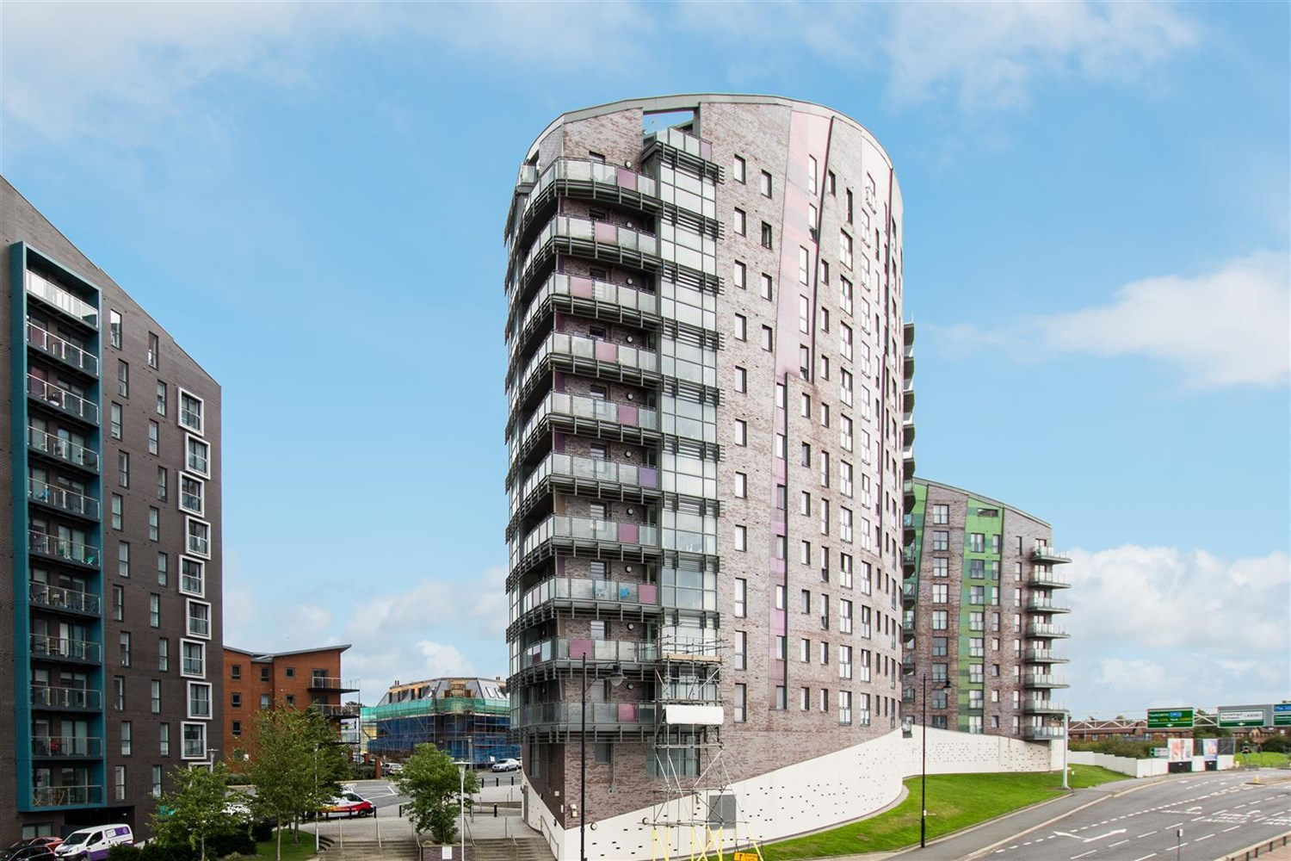



**Available to let £750.00pcm**

**Echo Central 1, Leeds**

A SUPERB ONE BEDROOM apartment conveniently placed close to the MI/M62 Motorway network. Offering a STYLISH and CONTEMPORARY FURNISHED interior including modern, kitchen and shower room, the accommodation would well suit the professional city dweller looking for a ready-to-move-into central base. Briefly comprising; Communal Entrance with security intercom and lift to all floors, Private Hallway with separate Utility/Store, Spacious Open plan Living/Dining/Kitchen with contemporary furniture, integrated appliances and Juliette balcony, Separate Double Bedroom, Shower room. VIEWING HIGHLY RECOMMENDED!! FURNISHED. Available 17th April. Deposit £865. EPC rating C, Council tax band A.

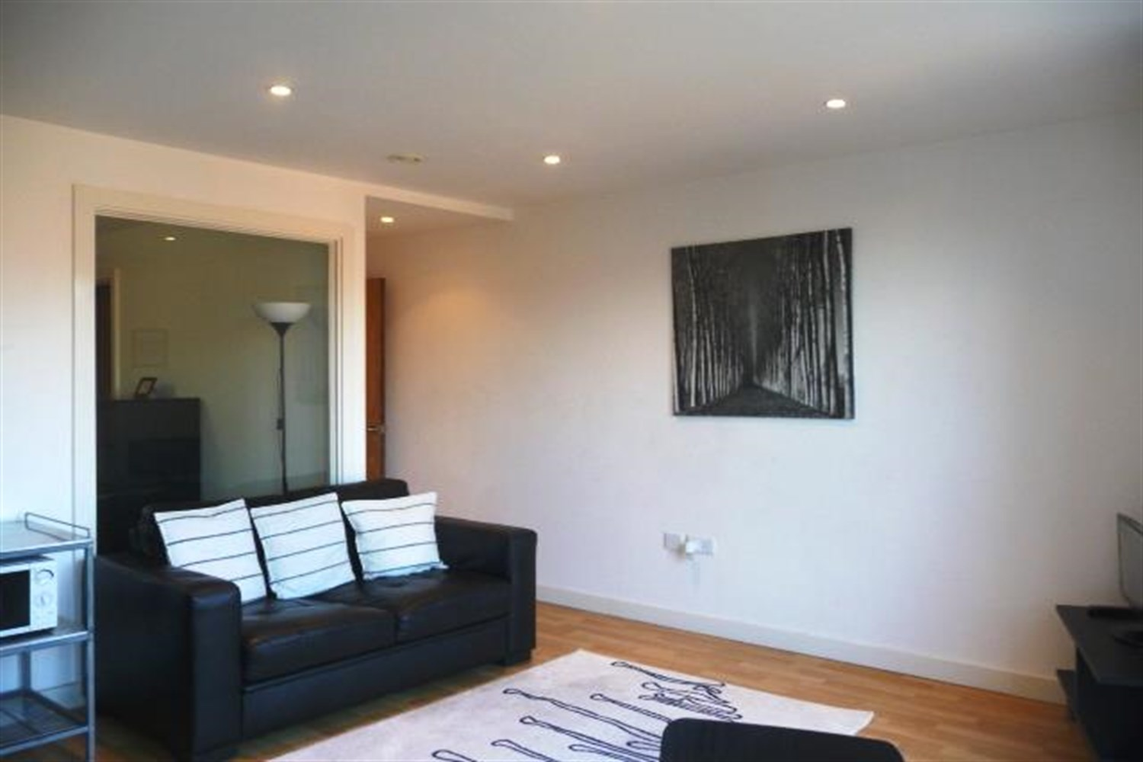

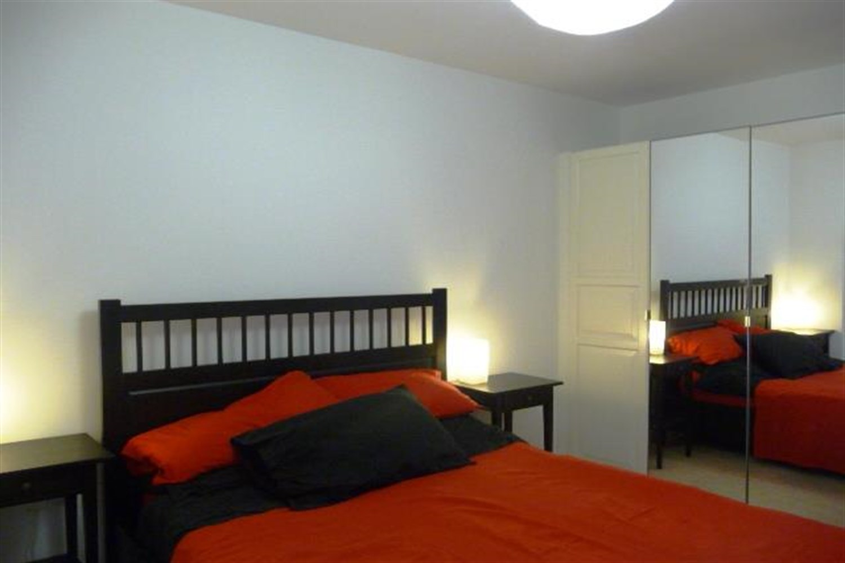

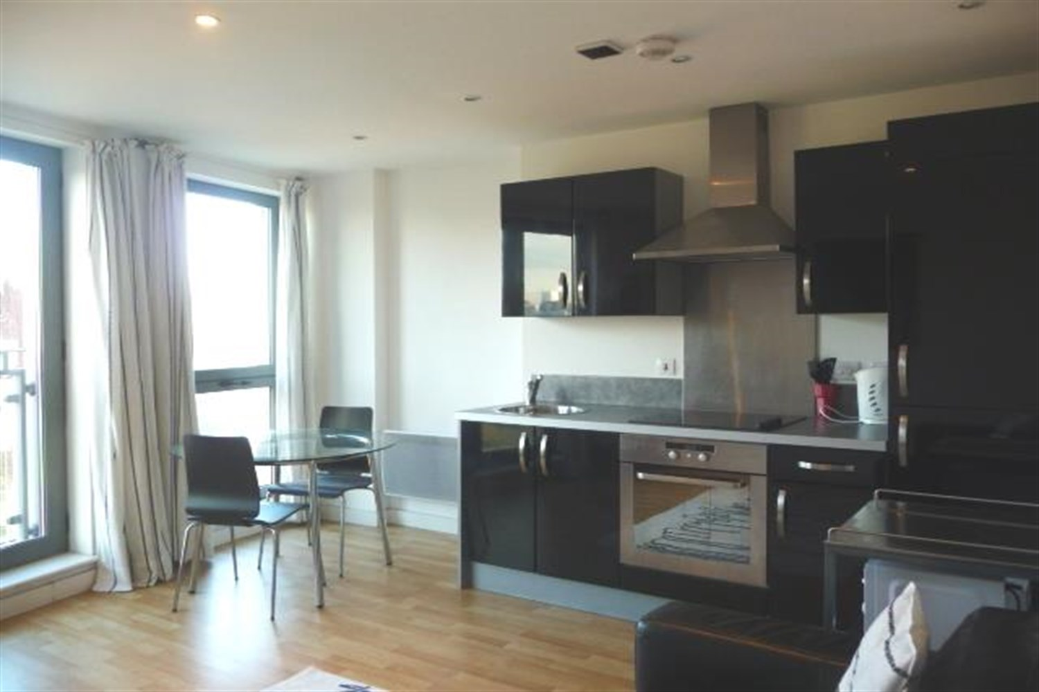

1 Bathroom(s)

1 Reception(s)

1 Bedroom(s)

00

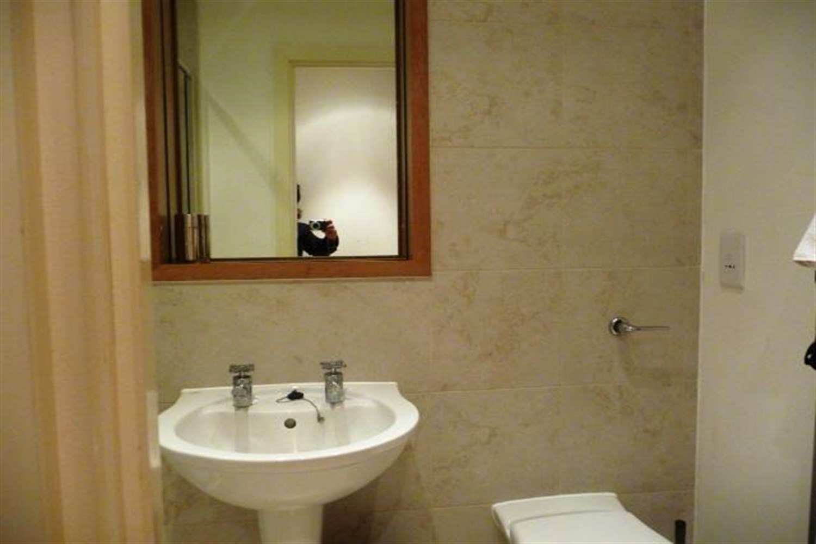

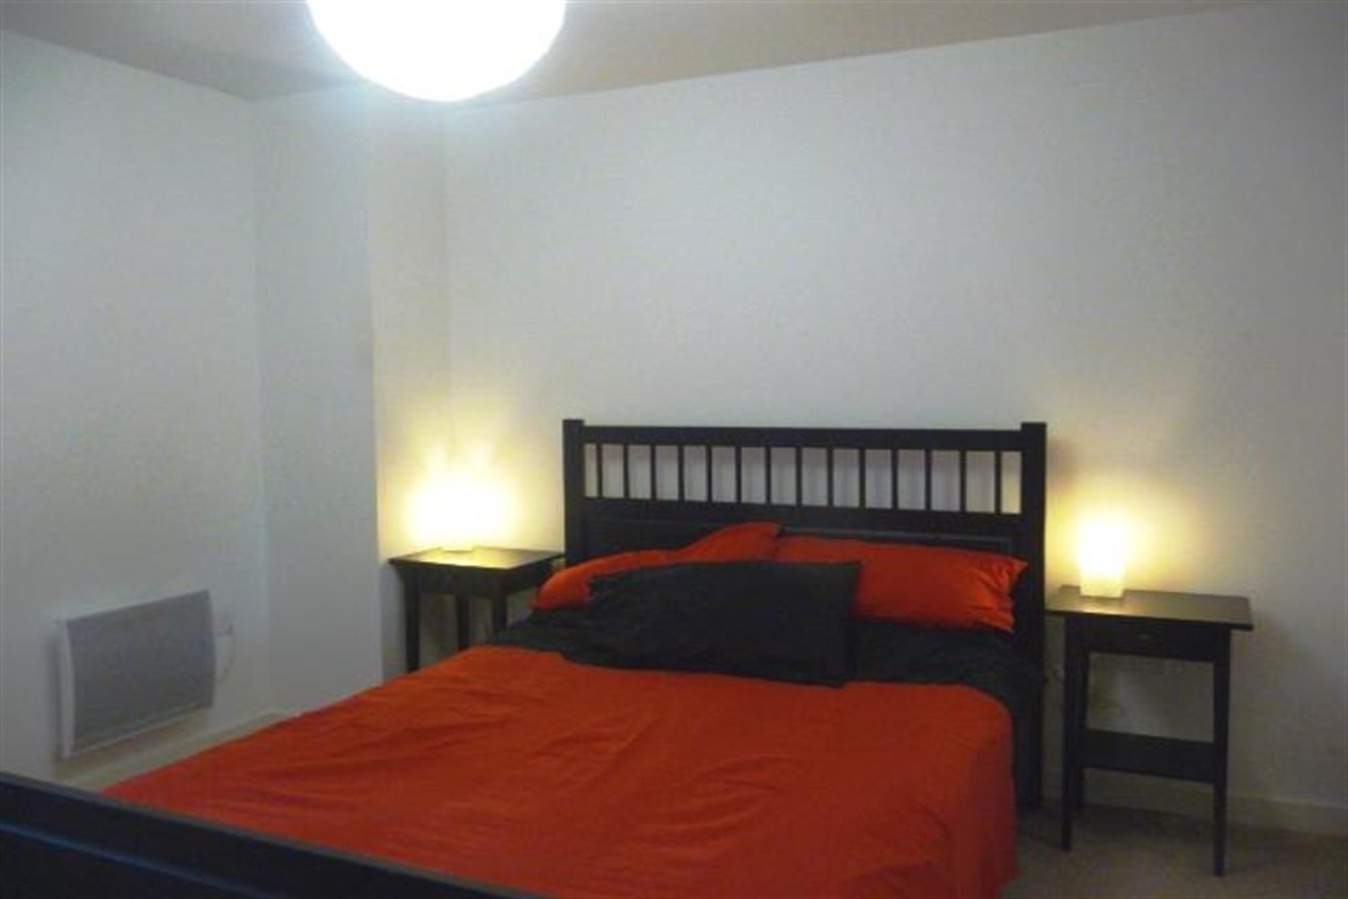

|  |
| --- |
| **Communal Entrance**  Communal entrance with lift to all floors. |
| **Private Entrance Hall**  Entrance hall with storage cupboard. |
| **Living/ Kitchen**  Living area with doors opening to a Juliet balcony, kitchen fitted with range of wall base units with work tops over integrated fridge freezer. |
| **Bedroom**  Carpeted double bedroom with wardrobe. Electric wall heater. |
| **Bathroom**  Fitted with walk in shower, w/c and hand wash basin, tiled walls and floor, electric heater. |
| **Home Information**  COUNCIL TAX BAND: A EPC Rating B  Leasehold property Broadband: Standard 9 Mbps 0.9 Mbps Good Superfast 80 Mbps 20 Mbps Good Ultrafast 1000 Mbps 1000 Mbps  Mobile availability: EE Limited Three Likely to have good coverage O2 Likely to have good coverage Vodafone Likely to have good coverage.  Electric mains supply, water on mains supply. |

|  |  |
| --- | --- |
| These particulars are intended to give a fair description of the property, but their accuracy cannot be guaranteed, and they do not constitute an offer of contract. Intending purchasers must rely on their own inspection of the property. None of the above appliances/services have been tested by ourselves. We recommend purchasers arrange for a qualified person to check all appliances/services before legal commitment.  **Property Ref:** 3994  **For more information, please contact**  0113 258 1150 **|** [lettings@adairpaxton.co.uk](mailto:lettings@adairpaxton.co.uk) **|** www.adairpaxton.co.uk |  |