

**0113 258 1150**

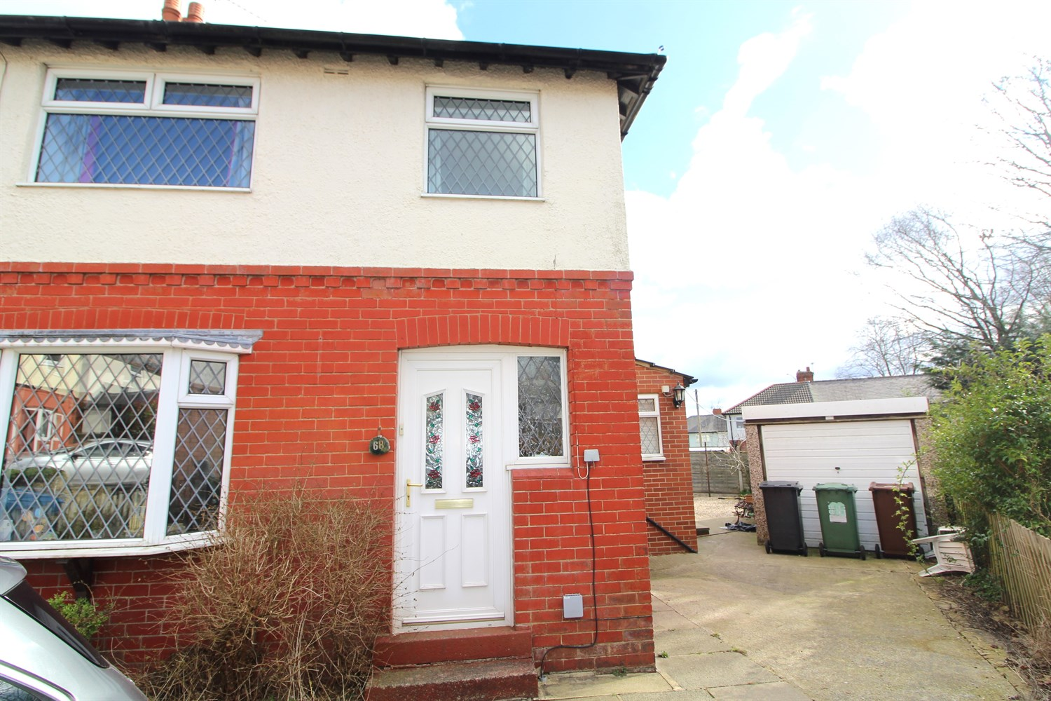



**Available to let £1,095.00pcm**

**Broadgate Walk, LS18**

Sitting on a good size plot this 3 bedroom semi detached house with large garden to the rear, paved area for parking to the front & a detached garage. Well presented family home close to amenities, highly regarded schools, train station & great road/bus links. Briefly, entrance hall, good size lounge, fabulous kitchen with sun room rear, , TWO DOUBLE beds., single/study, house bathroom. EPC rating D, council tax band B , deposit £1260, Available 14th April 2025

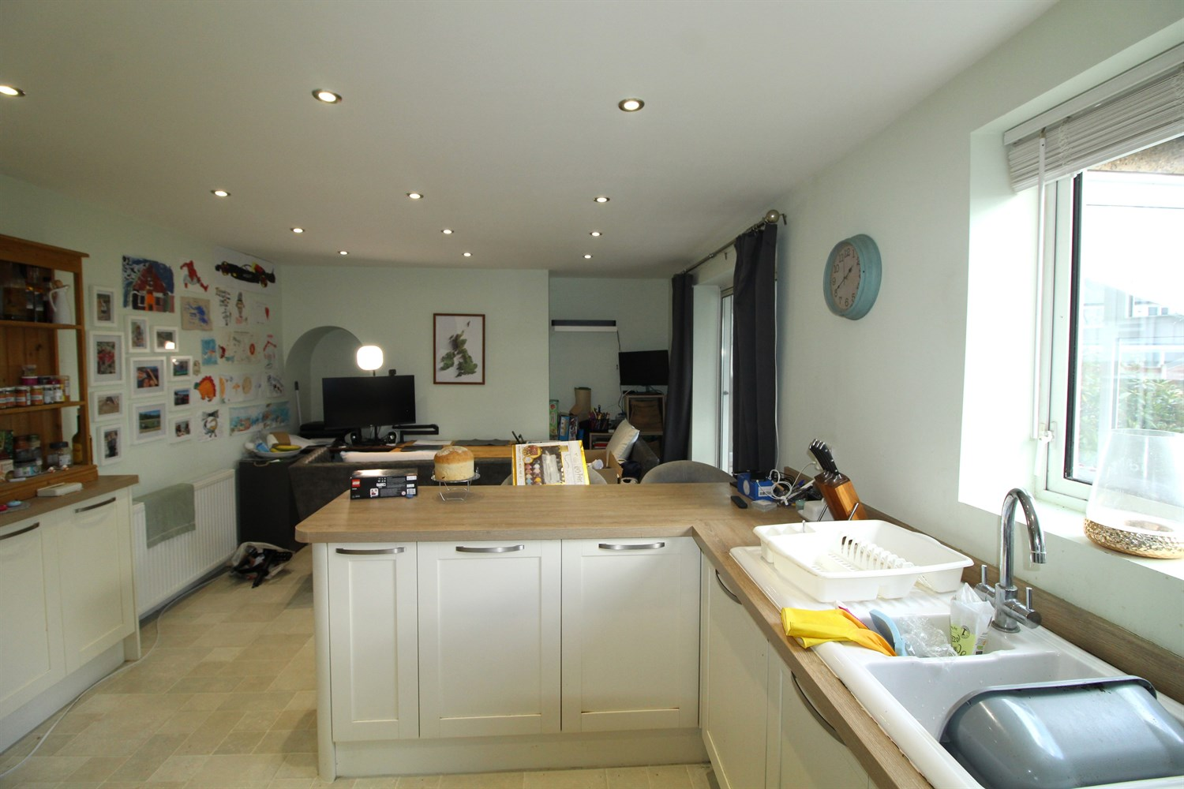

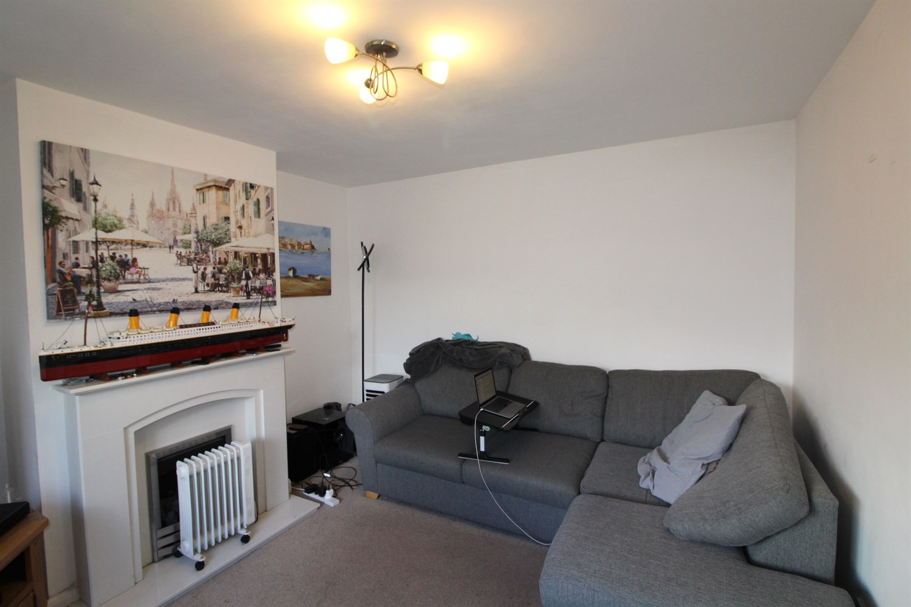

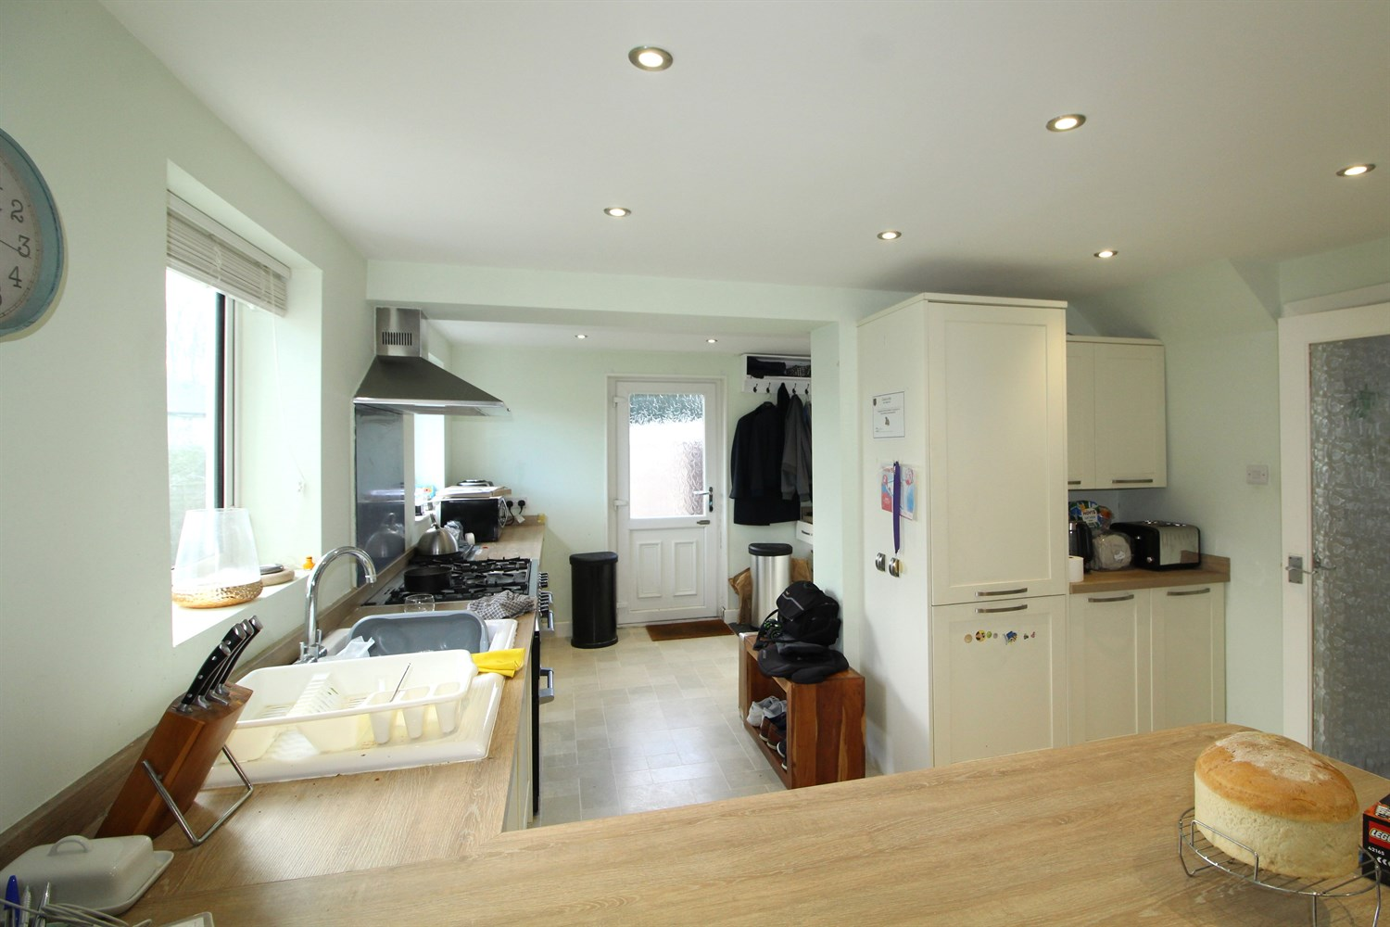

1 Bathroom(s)

1 Reception(s)

2 Bedroom(s)

00

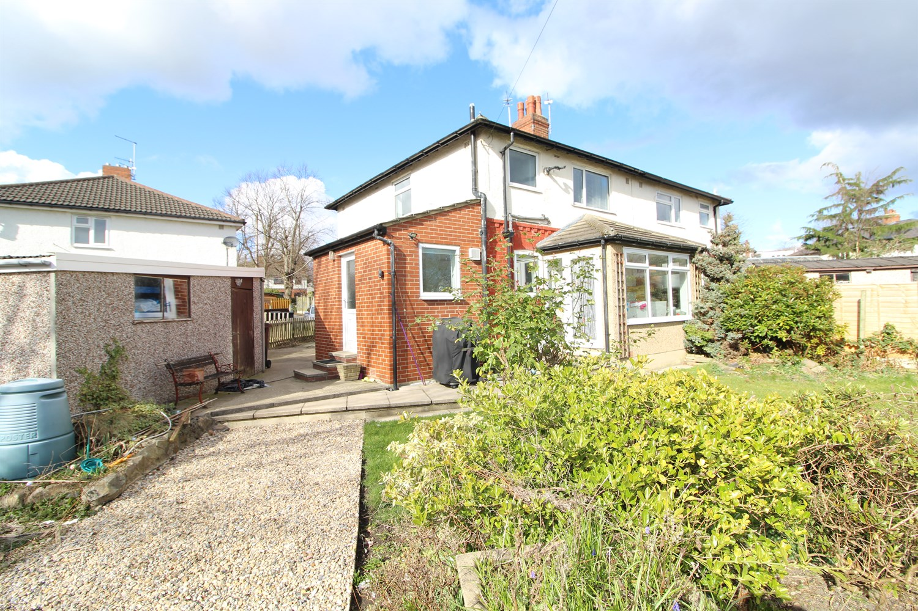

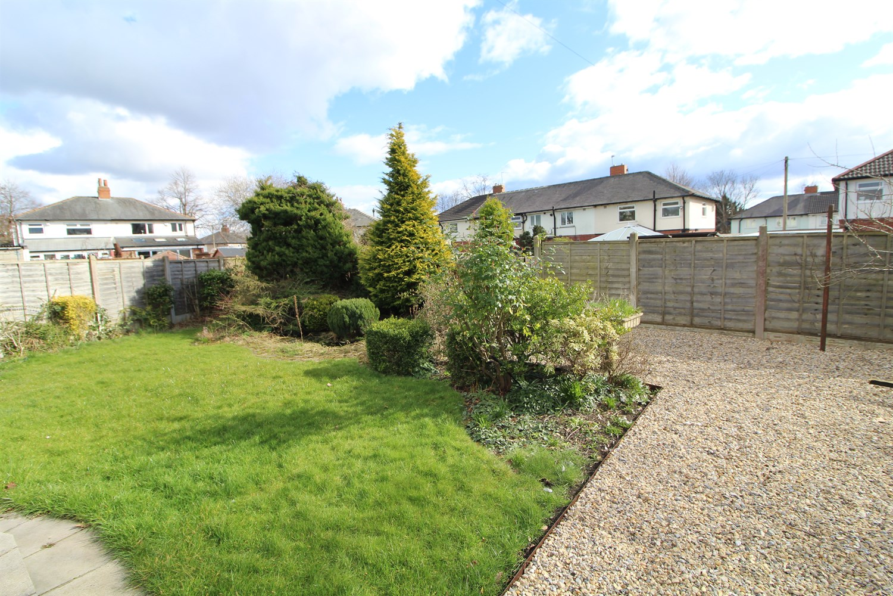

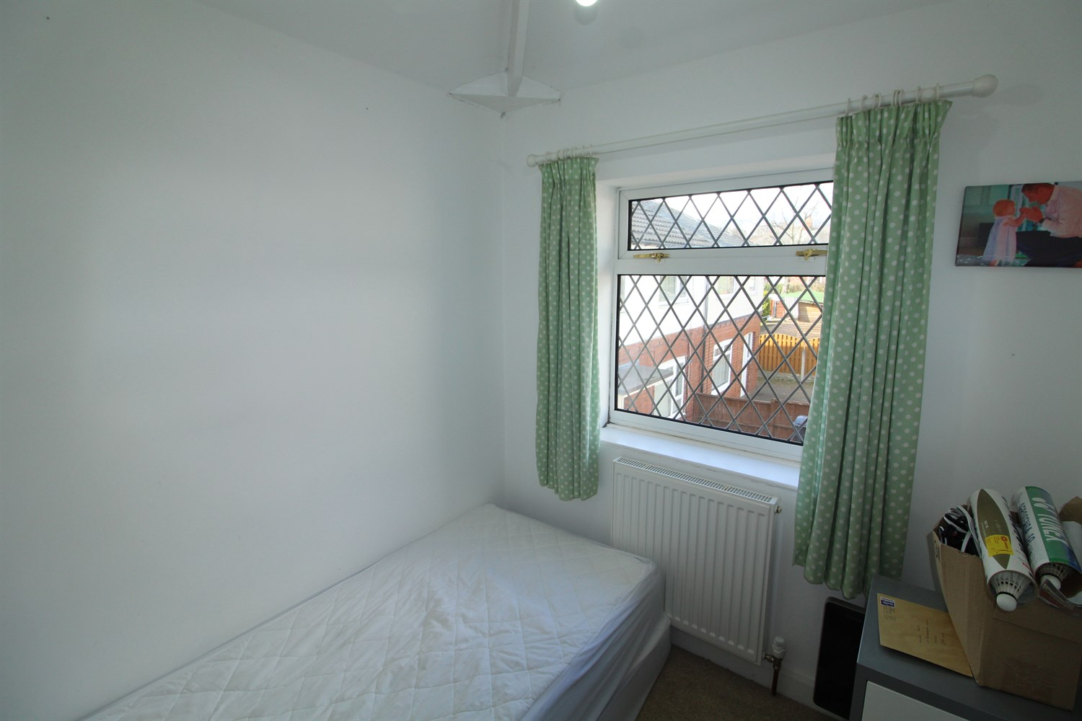

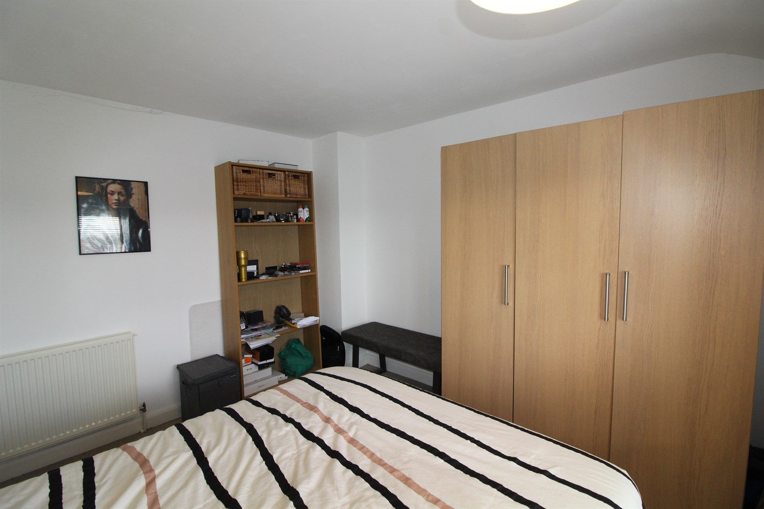

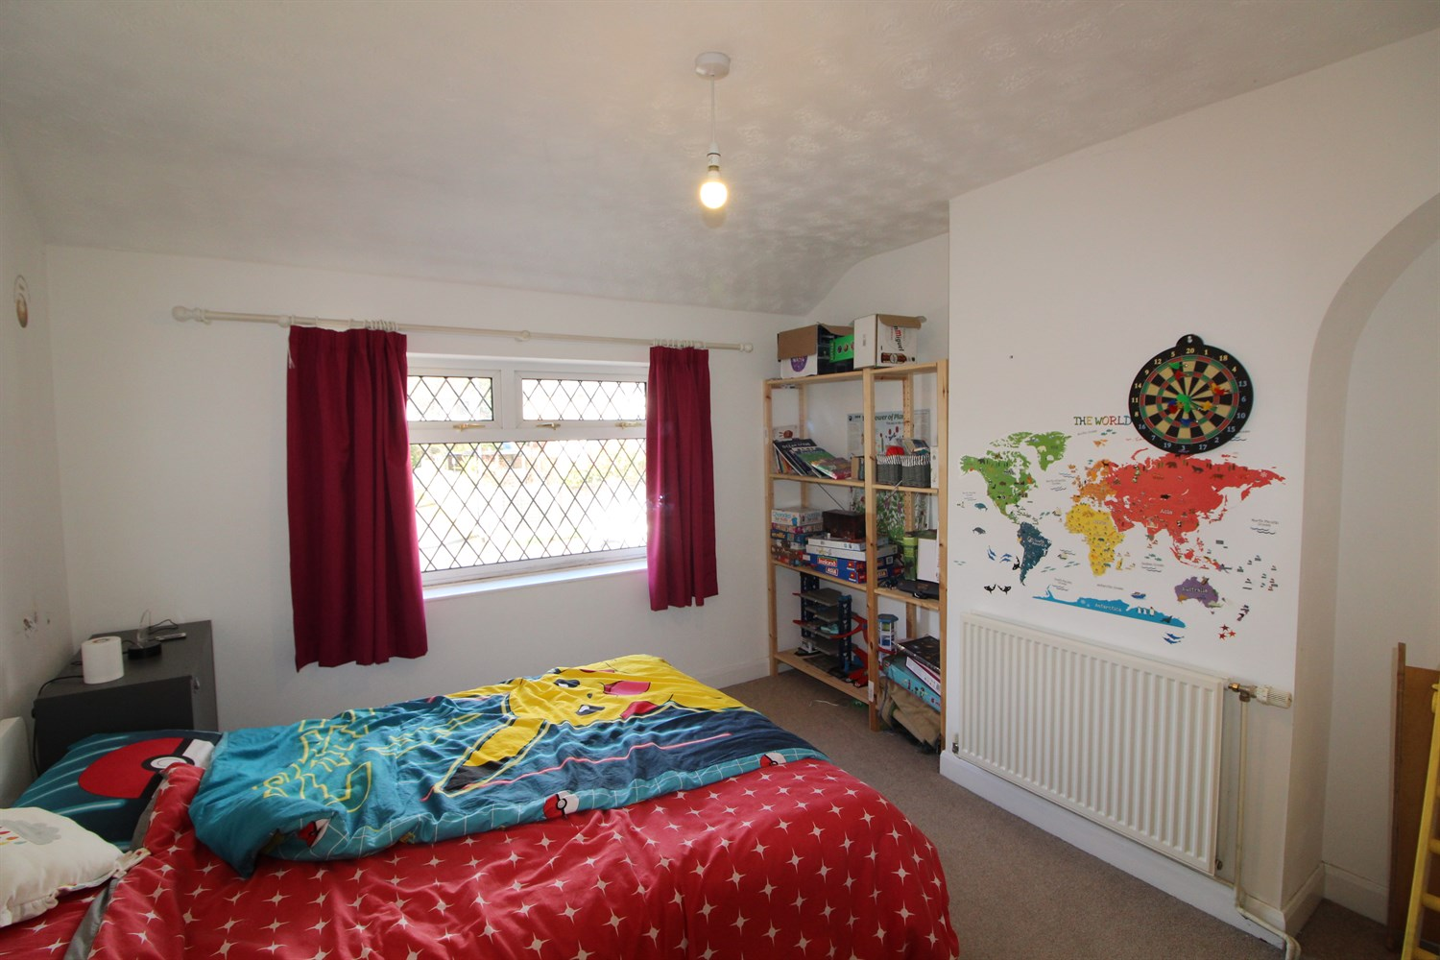

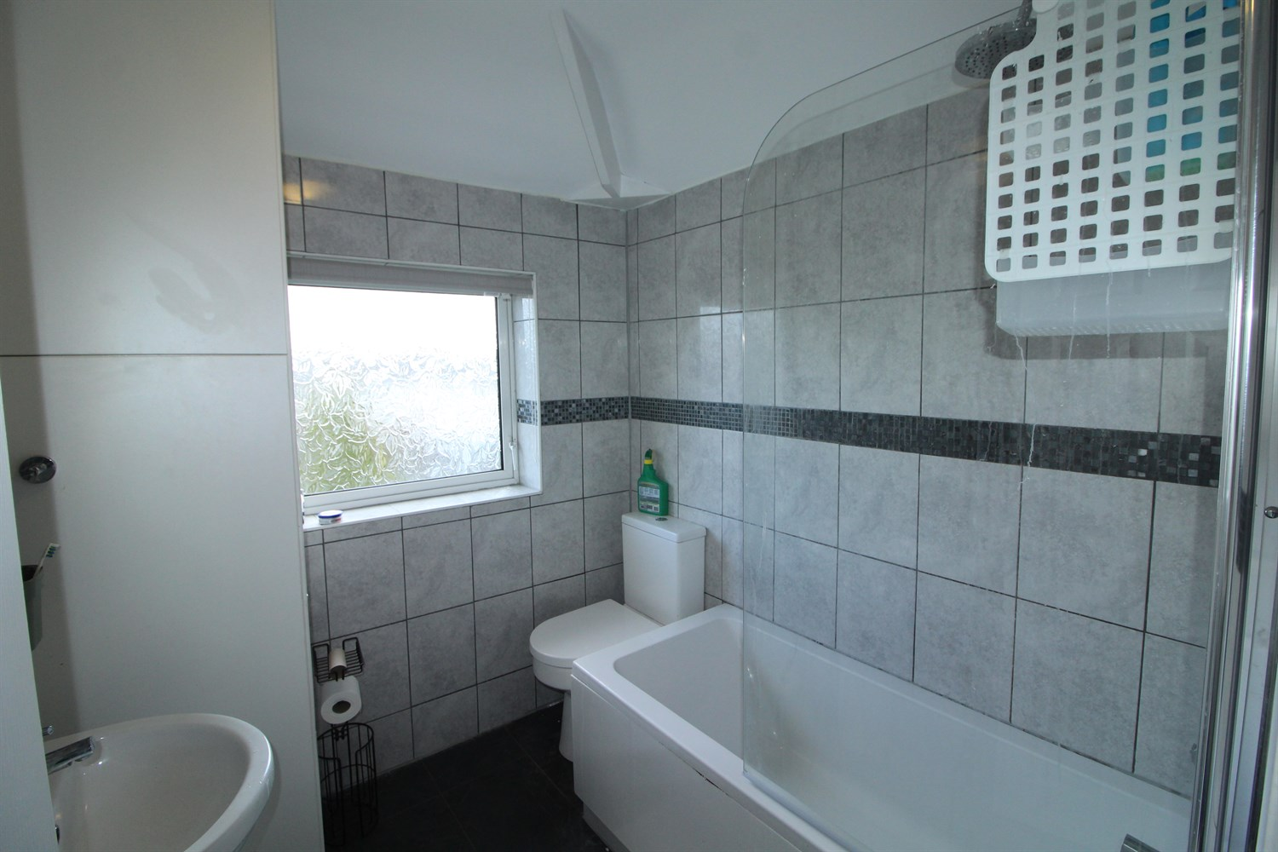

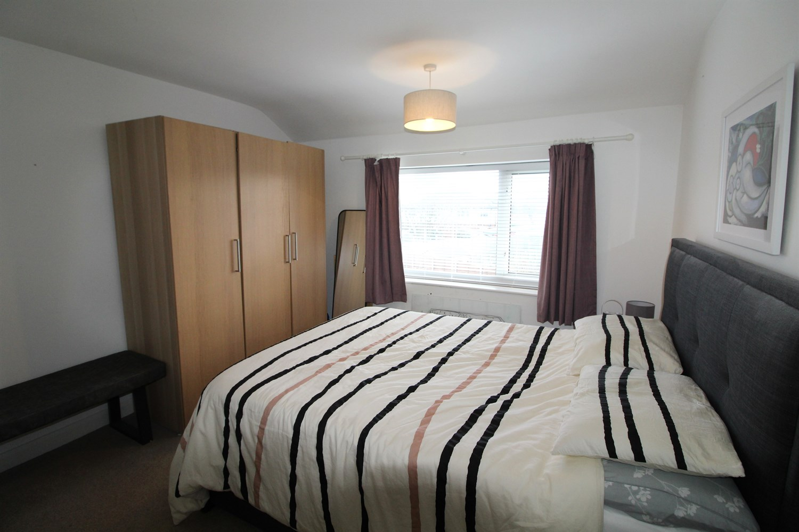

|  |
| --- |
| **Living Room 3.72m (12'2) x 3.51m (11'6)**  Light and airy lounge with large window to the front, Fire and surround, gas central heating radiator. |
| **Kitchen 7.77m (25'6) x 3.45m (11'4)**  Beautifully fitted kitchen with utility area, fitted with a range of wall and base units with work tops over, sink with drainer and mixer tap, 5 ring gas oven and hob with extractor over .integrated fridge freezer. Space for dining large dining table. Access to the sun room. |
| **Sun room**  Nice and cosy sun room just off the kitchen over looking the rear garden. |
| **Bedroom 3.4m (11'2) x 3.56m (11'8)**  Large double bedroom with window to rear, gas central heating radiator. |
| **Bedroom 2 3.62m (11'11) x 3.39m (11'1)**  Second double bedroom with window to the front, gas central heating radiator. |
| **Bathroom**  Three piece bathroom suite with shower over bath, shower screen, w/c and hand wash basin, tiled walls, gas central heating radiator. |
| **Bedroom 3 2.1m (6'11) x 1.97m (6'6)**  Single bedroom with window to front, gas central heating radiator. |
| **Home Information**  COUNCIL TAX BAND:  EPC Rating   Freehold property: Drive for parking   Broadband: Standard 16 Mbps 1 Mbps Good Superfast 55 Mbps 12 Mbps Good Ultrafast 1800 Mbps 220 Mbps  Mobile availability: EE limited coverage. Three likely to have good coverage. O2 likely to have good coverage. Vodafone likely to have good coverage.  Utilities: Water supplied on standard meters. Electric mains supplied on standard meters. Gas meters supplied on standard meters. |

|  |  |
| --- | --- |
| These particulars are intended to give a fair description of the property, but their accuracy cannot be guaranteed, and they do not constitute an offer of contract. Intending purchasers must rely on their own inspection of the property. None of the above appliances/services have been tested by ourselves. We recommend purchasers arrange for a qualified person to check all appliances/services before legal commitment.  **Property Ref:** 5455  **For more information, please contact**  0113 258 1150 **|** [lettings@adairpaxton.co.uk](mailto:lettings@adairpaxton.co.uk) **|** www.adairpaxton.co.uk |  |