

**0113 258 1150**

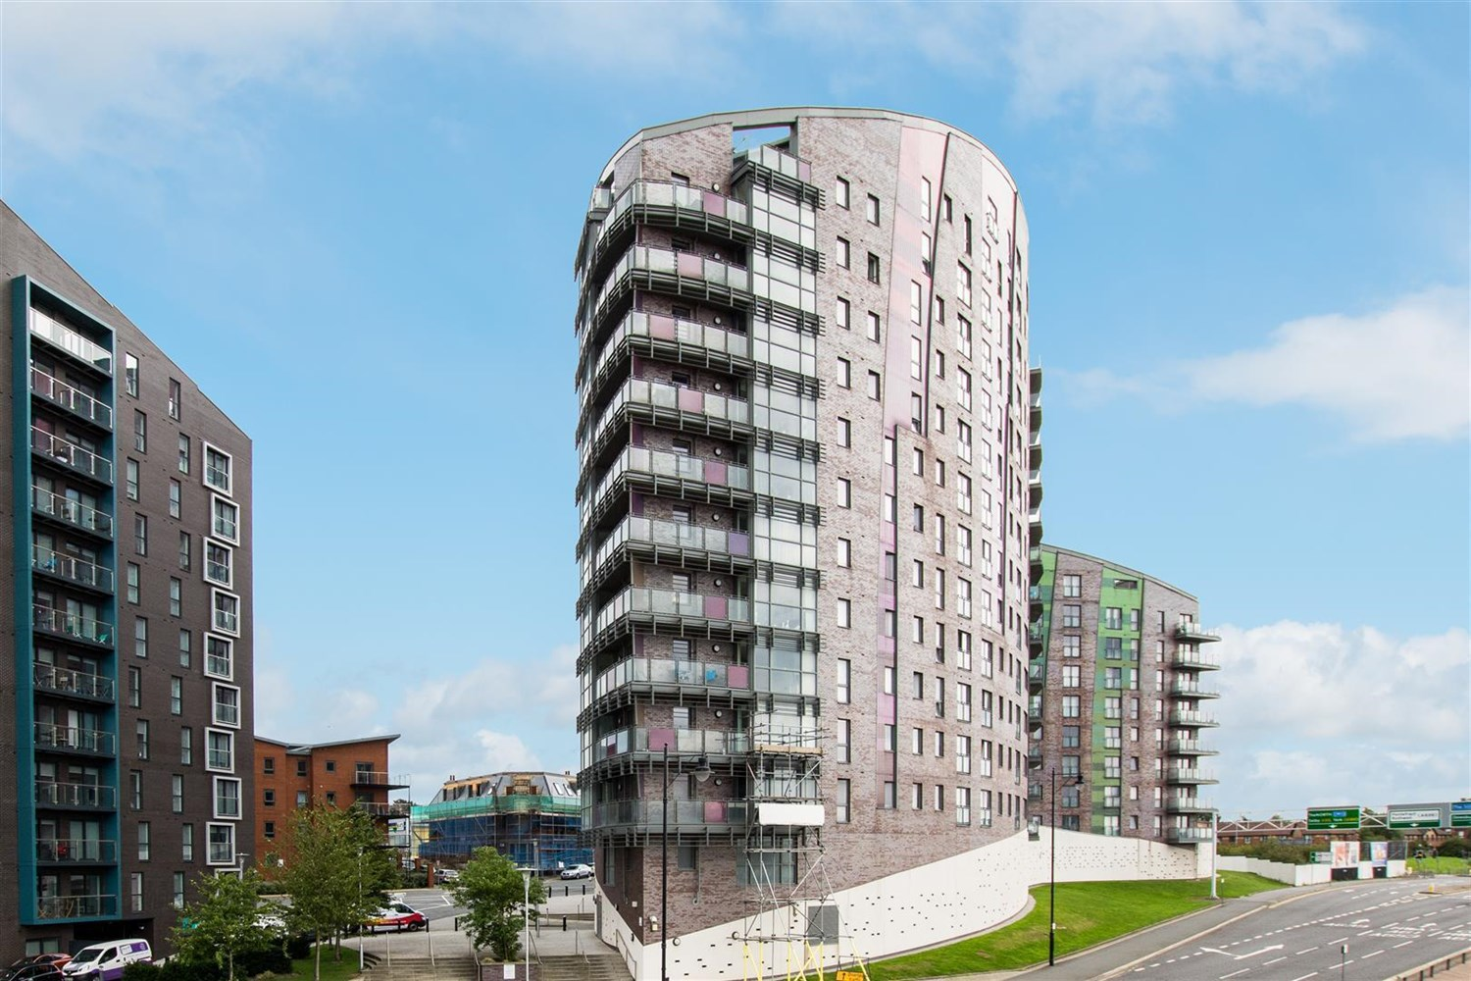



**Available to let £950.00pcm**

**Echo Central 1, Leeds**

*** A SUPERB TWO BEDROOM apartment with PARKING *** This property is conveniently placed close to the M1/M62 Motorway network. Ideal INVESTORS Opportunity. Offering stylish and contemporary interior including modern, high quality kitchen and shower room. Briefly comprising; Communal Entrance with security intercom and lift to all floors, Private hallway with separate utility/store, spacious open plan living/dining/kitchen with integrated appliances and Juliette balcony, Two separate Double Bedrooms , En-suite shower room, and house bathroom. Available 17th March, deposit £1095. EPC rating C, council tax band C.

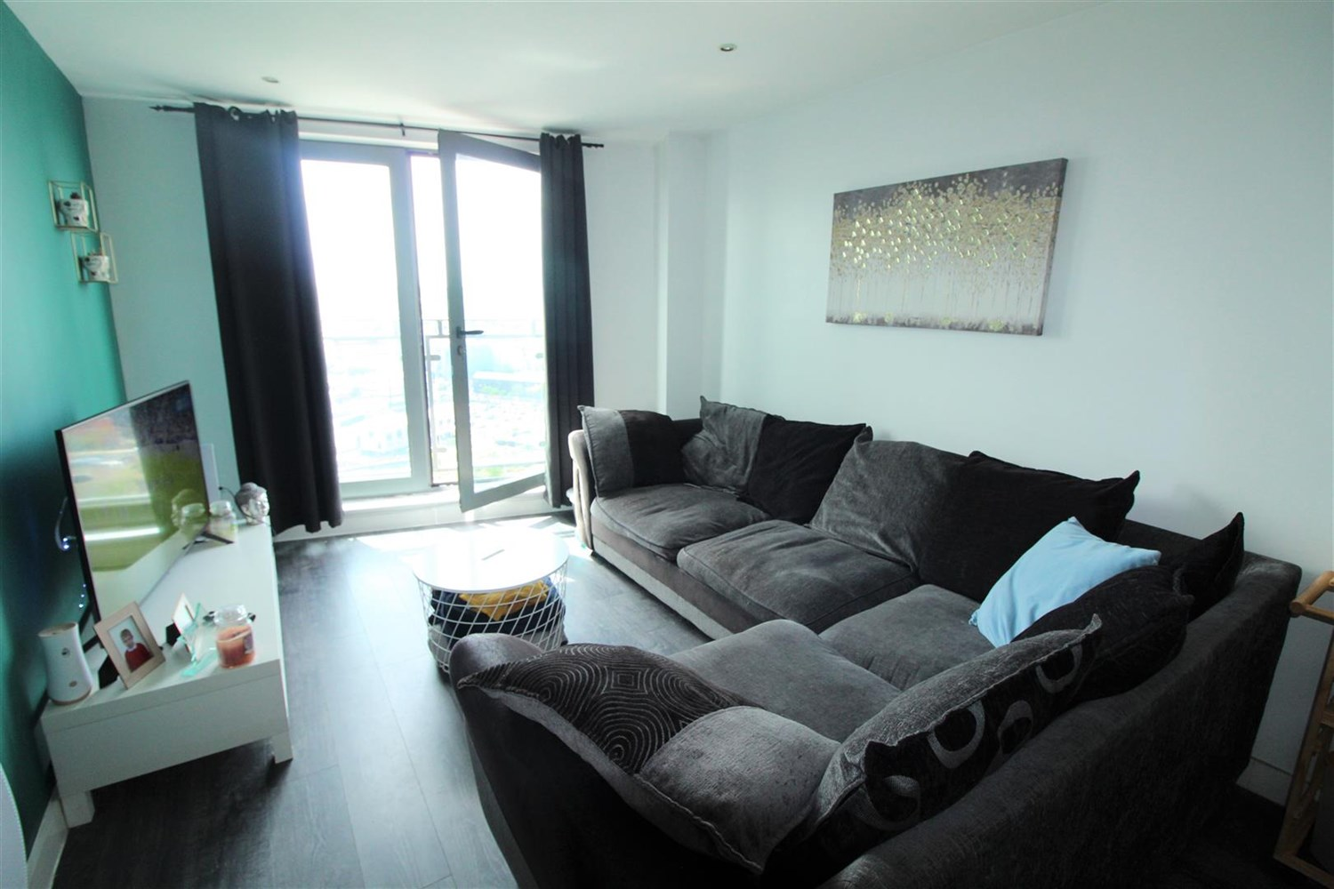

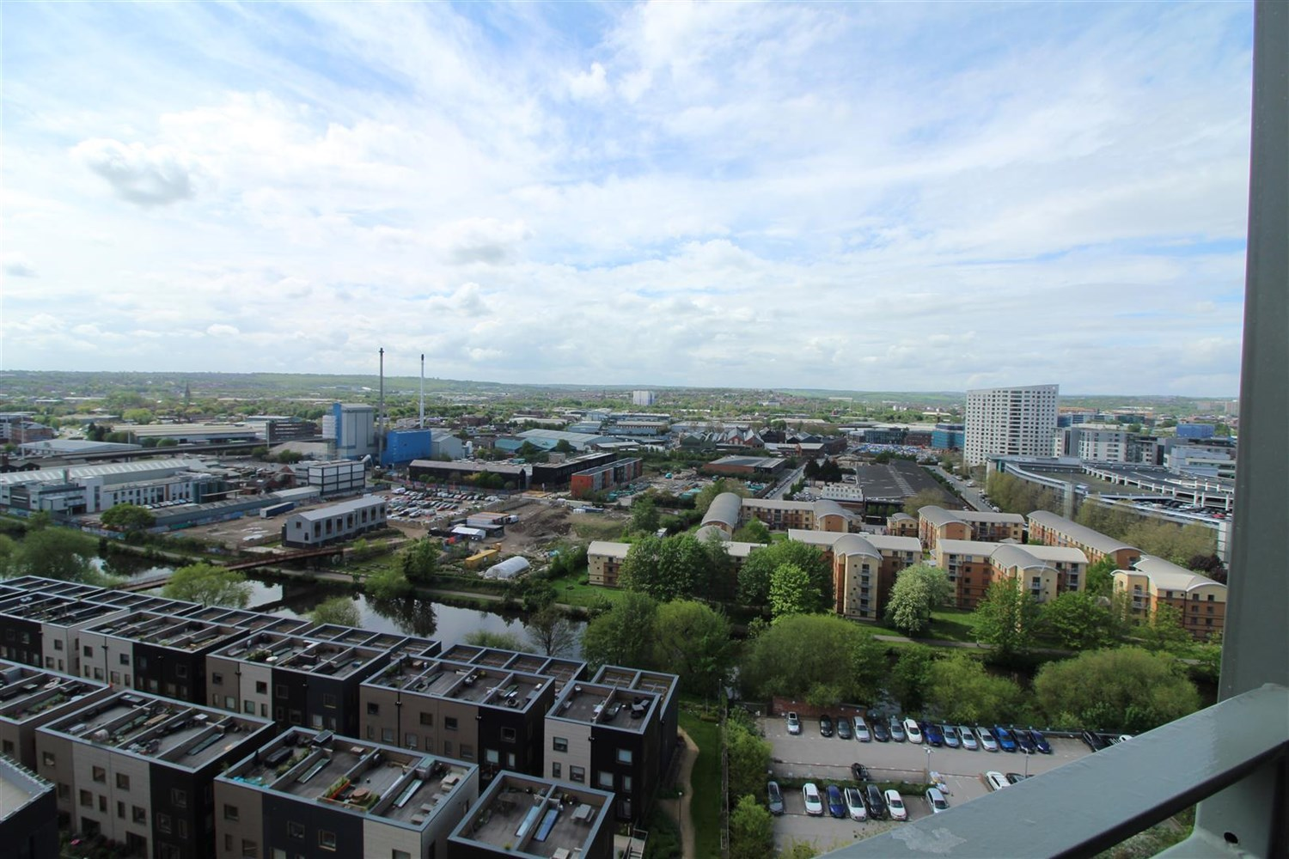

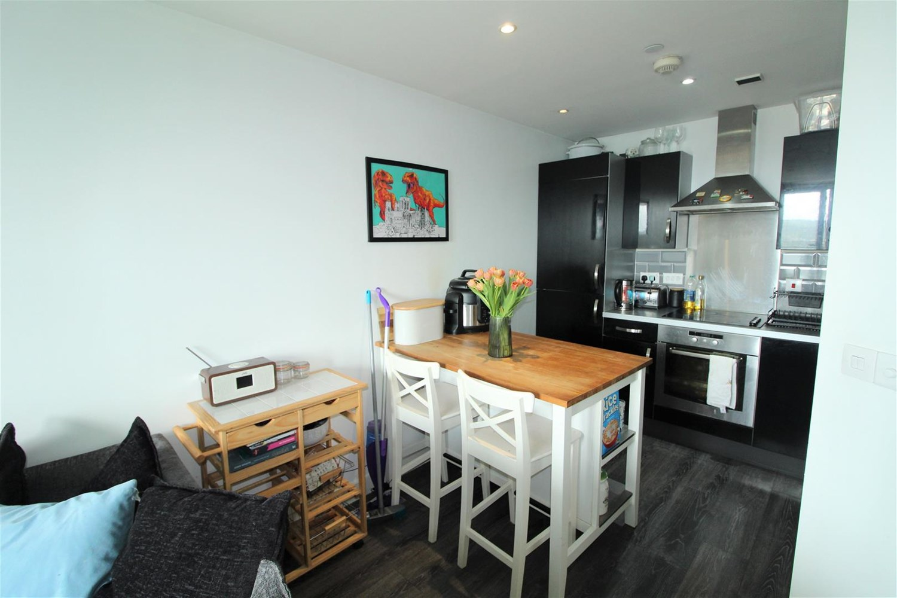

2 Bathroom(s)

0 Reception(s)

2 Bedroom(s)

00

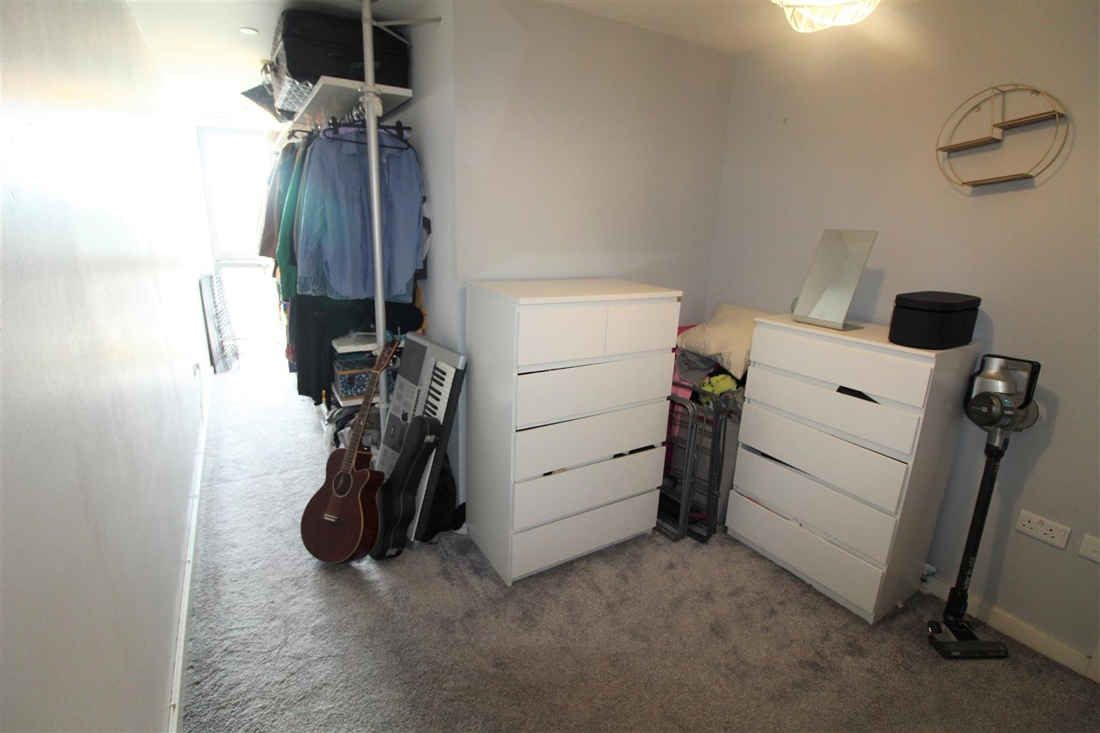

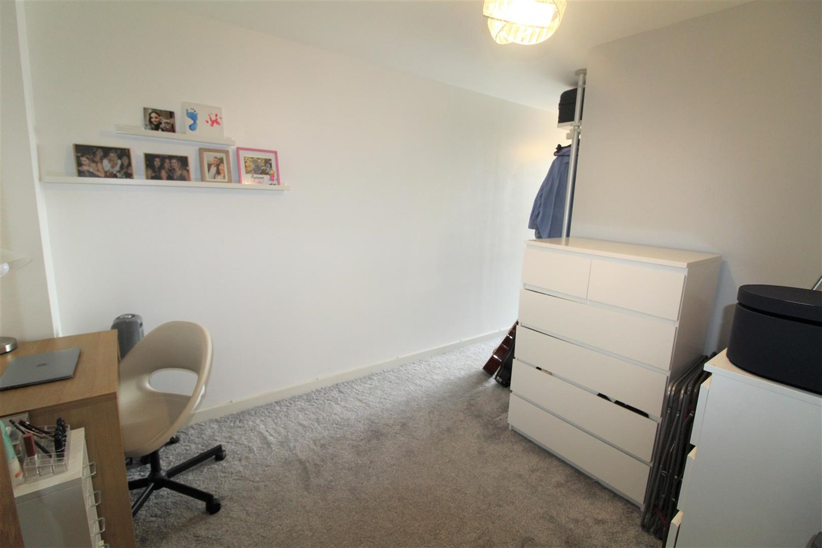

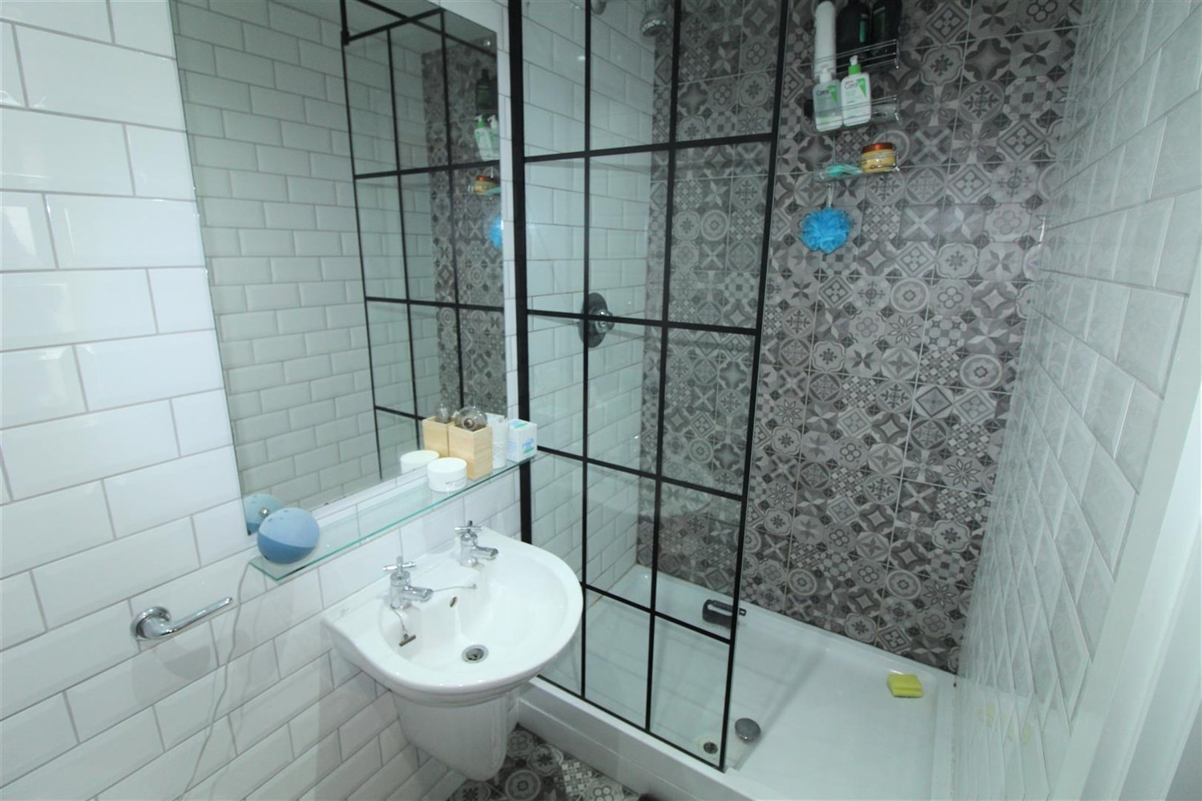

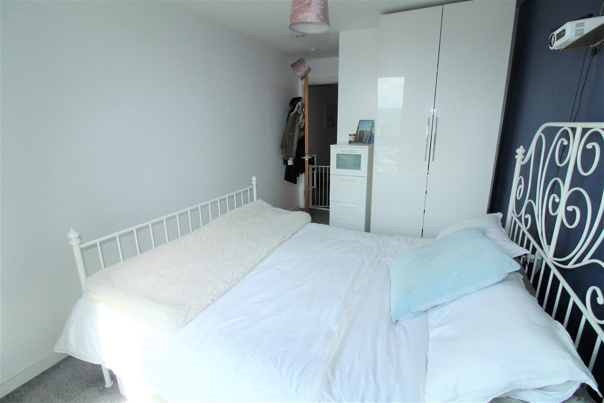

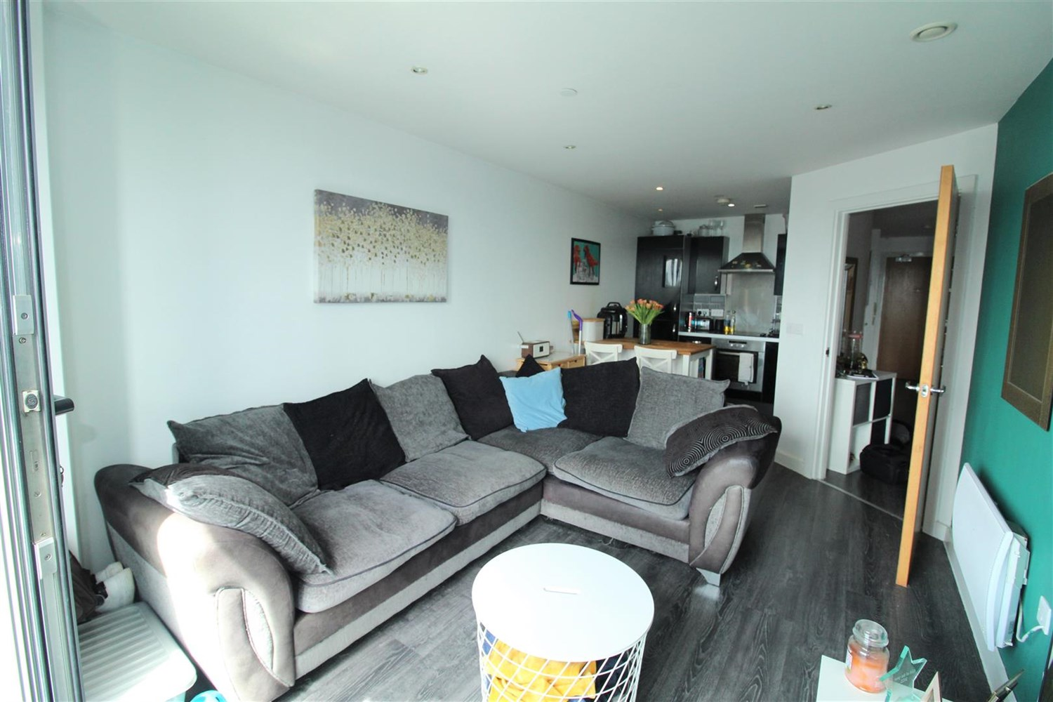

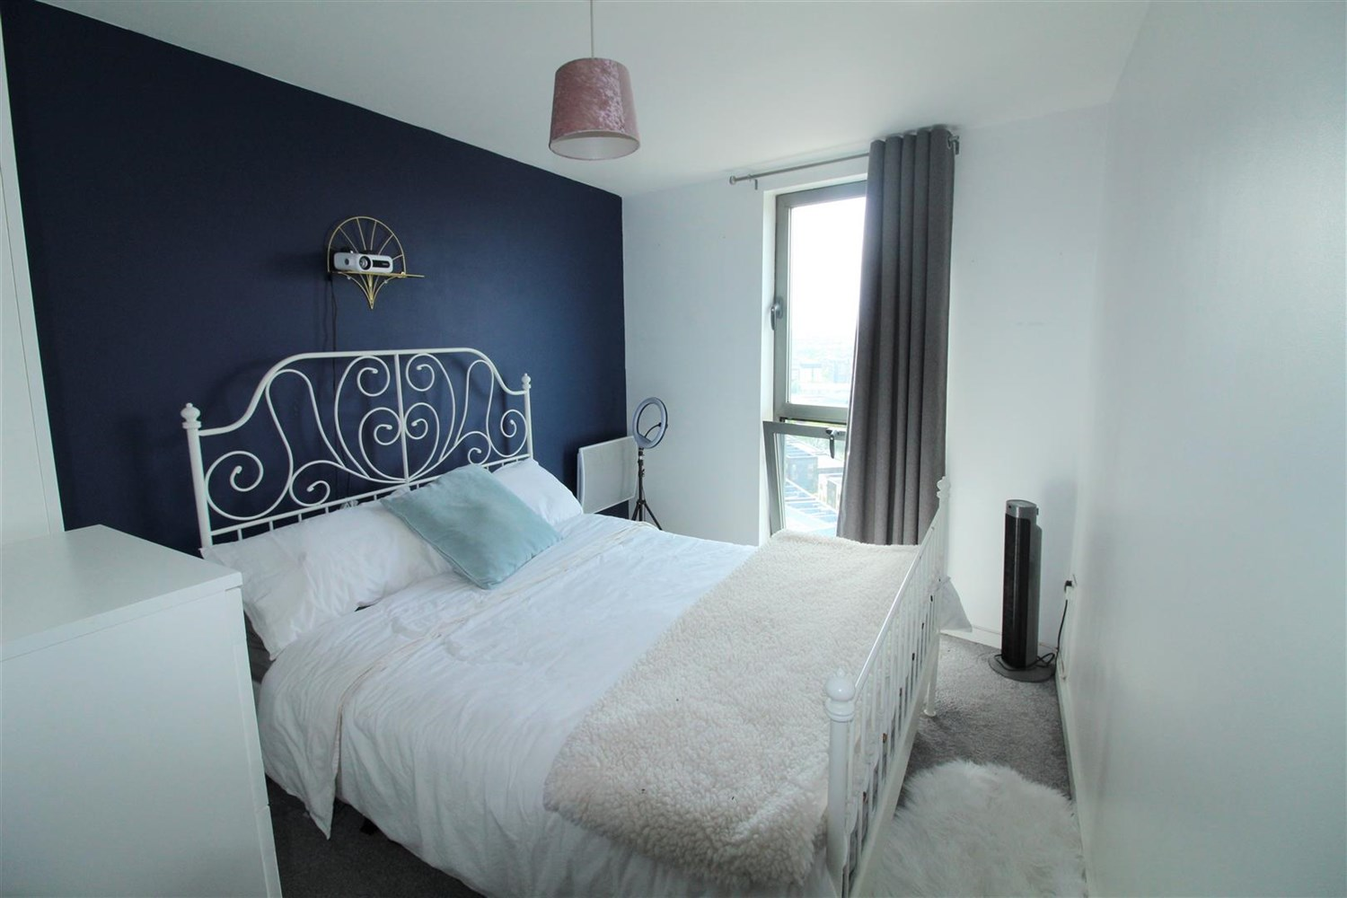

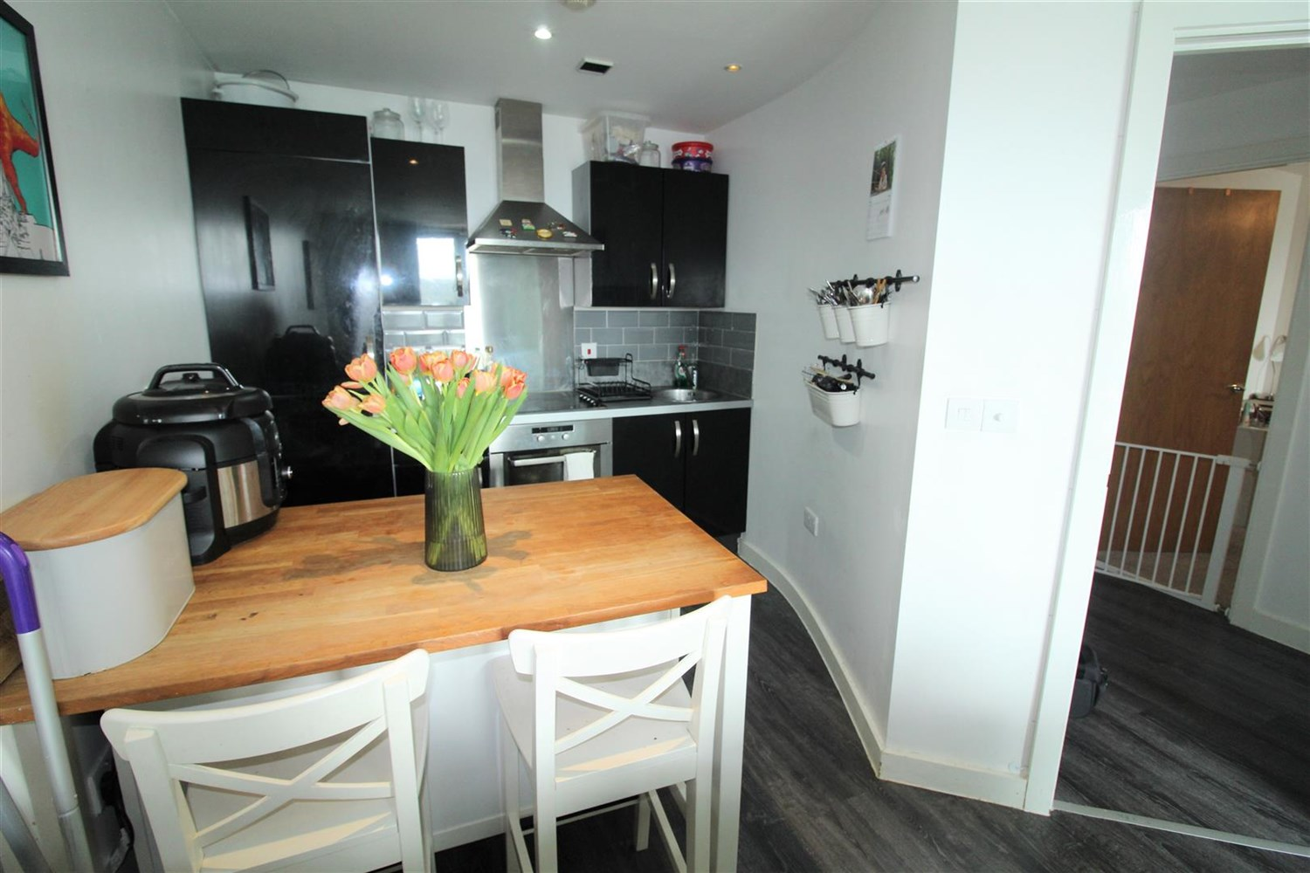

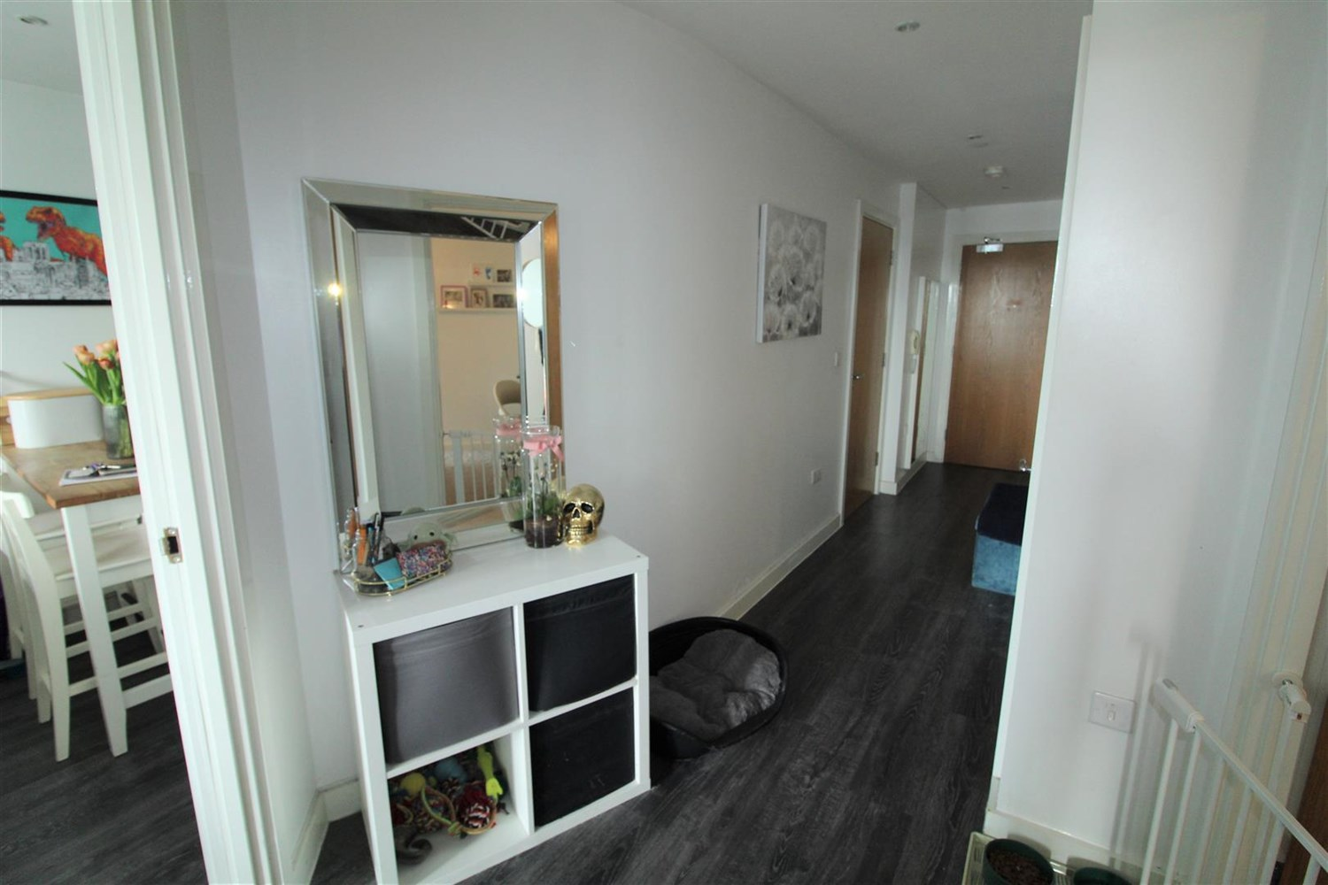

|  |
| --- |
| **Communal Entrance**  Via secure intercom entry system. Stairs & lift access to all floors. |
| **Private Entrance**  Useful walk in storage cupboard housing the boiler and plumbing for the washing machine. Secure intercom entry system. |
| **Open Plan Living Room/Kitchen**  A delightful open plan living room/kitchen with a dining area. French doors opening to a Juliet balcony. Laminate flooring. Wall mounted electric radiator. The kitchen is fitted with a range of black gloss wall, base and drawer units with work surfaces over. Circular stainless steel sink with mixer tap. Integrated electric oven and hob with extractor hood over. Integrated Fridge/freezer. Inset ceiling spotlights. |
| **Bedroom 1**  Double bedroom with double glazed window. Wall mounted electric heater. |
| **En-suite**  En-suite comprising; shower cubicle, WC and wash hand basin. Part tiled walls & tiled floor. Chrome heated towel rail. |
| **Bedroom 2**  Second bedroom with double glazed window. Wall mounted electric heater. |
| **Bathroom**  Fitted with a three piece white suite comprising bath, WC and wash hand basin. Tiled walls & tiled floor. Chrome heated towel rail. Inset ceiling spotlights. |
| **Parking**  Secure allocated underground parking. |
| **Home Information**  COUNCIL TAX BAND: C EPC Rating C  Leasehold property Parking Available Broadband: Standard 9 Mbps 0.9 Mbps Good Superfast 80 Mbps 20 Mbps Good Ultrafast 1000 Mbps 1000 Mbps  Mobile availability: EE Limited ThreeLikely to have good coverage O2 Likely to have good coverage Vodafone Likely to have good coverage.  Electric mains supply, water on mains supply. |

|  |  |
| --- | --- |
| These particulars are intended to give a fair description of the property, but their accuracy cannot be guaranteed, and they do not constitute an offer of contract. Intending purchasers must rely on their own inspection of the property. None of the above appliances/services have been tested by ourselves. We recommend purchasers arrange for a qualified person to check all appliances/services before legal commitment.  **Property Ref:** 2162  **For more information, please contact**  0113 258 1150 **|** [lettings@adairpaxton.co.uk](mailto:lettings@adairpaxton.co.uk) **|** www.adairpaxton.co.uk |  |