

**Concord Street, Leeds**

**£750.00pcm**

**Apartment**

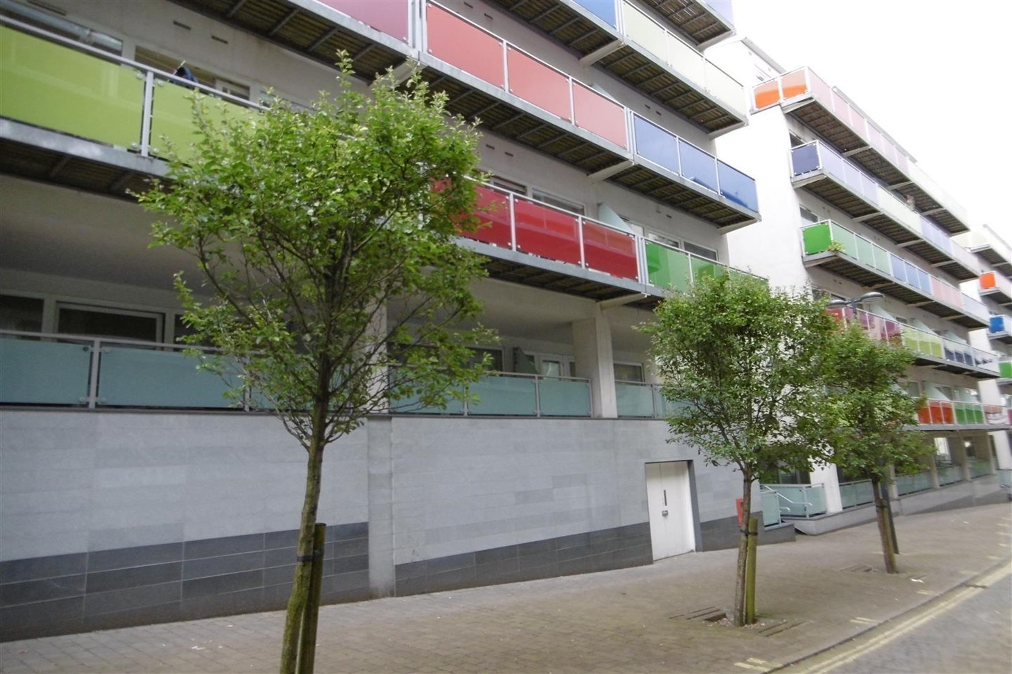

1 Bathroom(s)

1 Reception(s)

1 Bedroom(s)

Conveniently located spacious one bedroom apartment in a contemporary block situated in the Northern Quarter of Leeds City Centre. Well placed for Universities and good transport links. Comprising: Hallway, spacious open plan lounge/dining/kitchen area with floor to ceiling windows, and balcony, fitted kitchen with appliances, one double bedroom and bathroom with shower. Furnished. Council Tax Band C, EPC rating B. Deposit £865. Available 21st April . Due to the lease this property has a no pet policy.



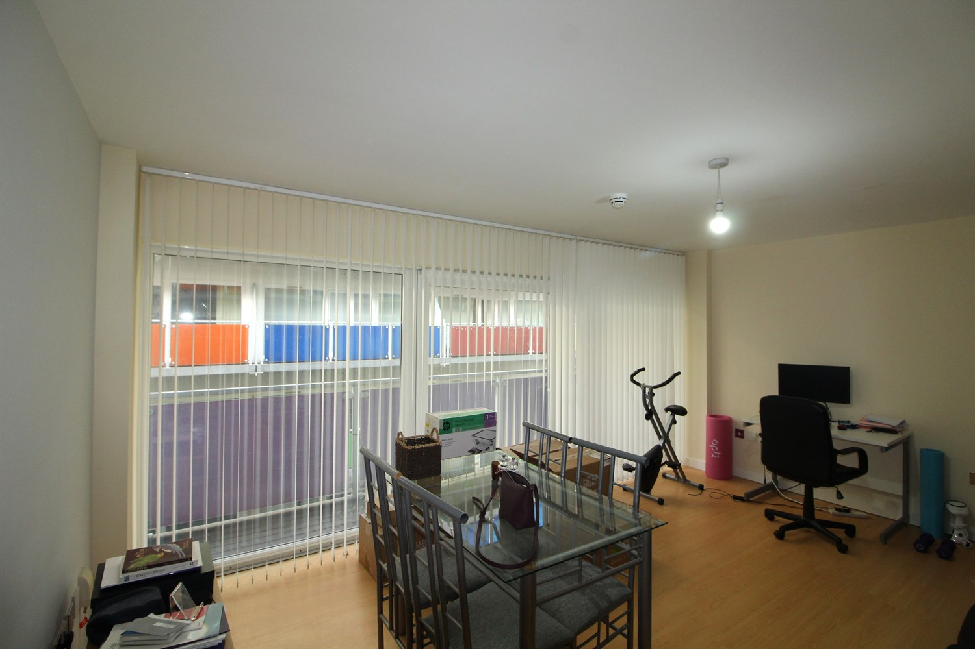

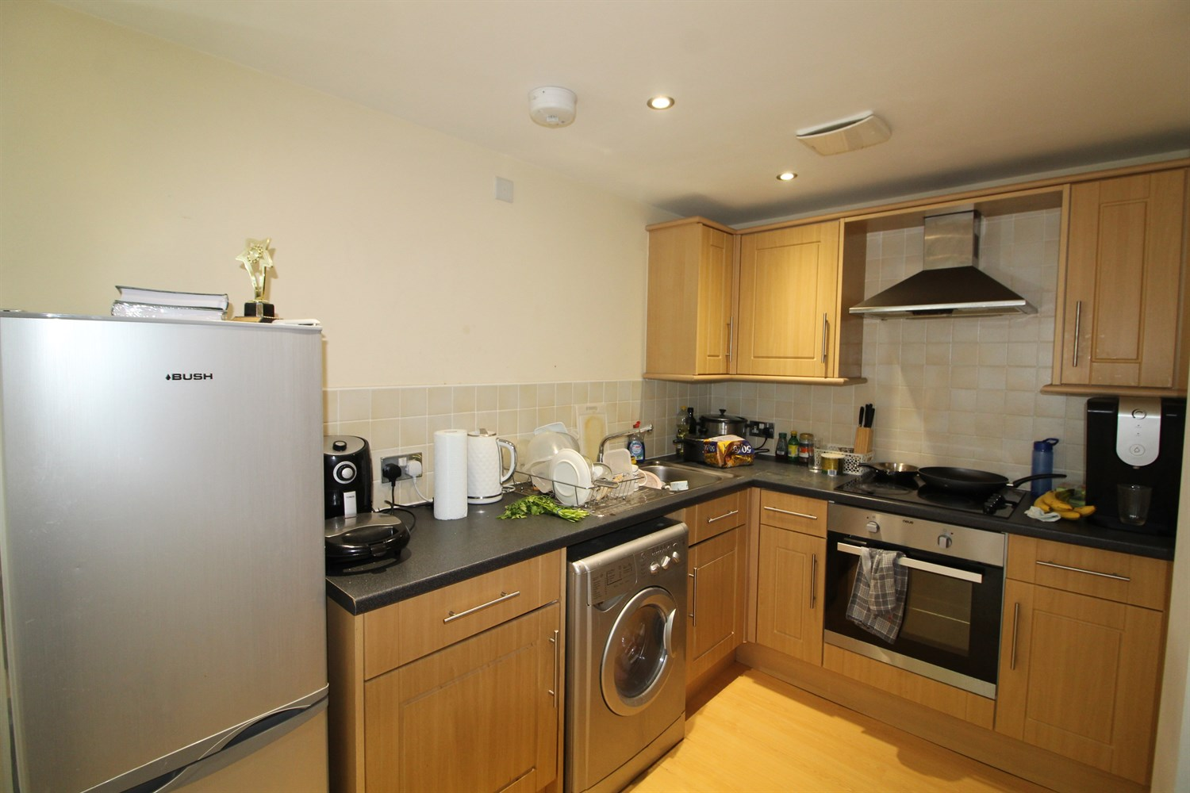

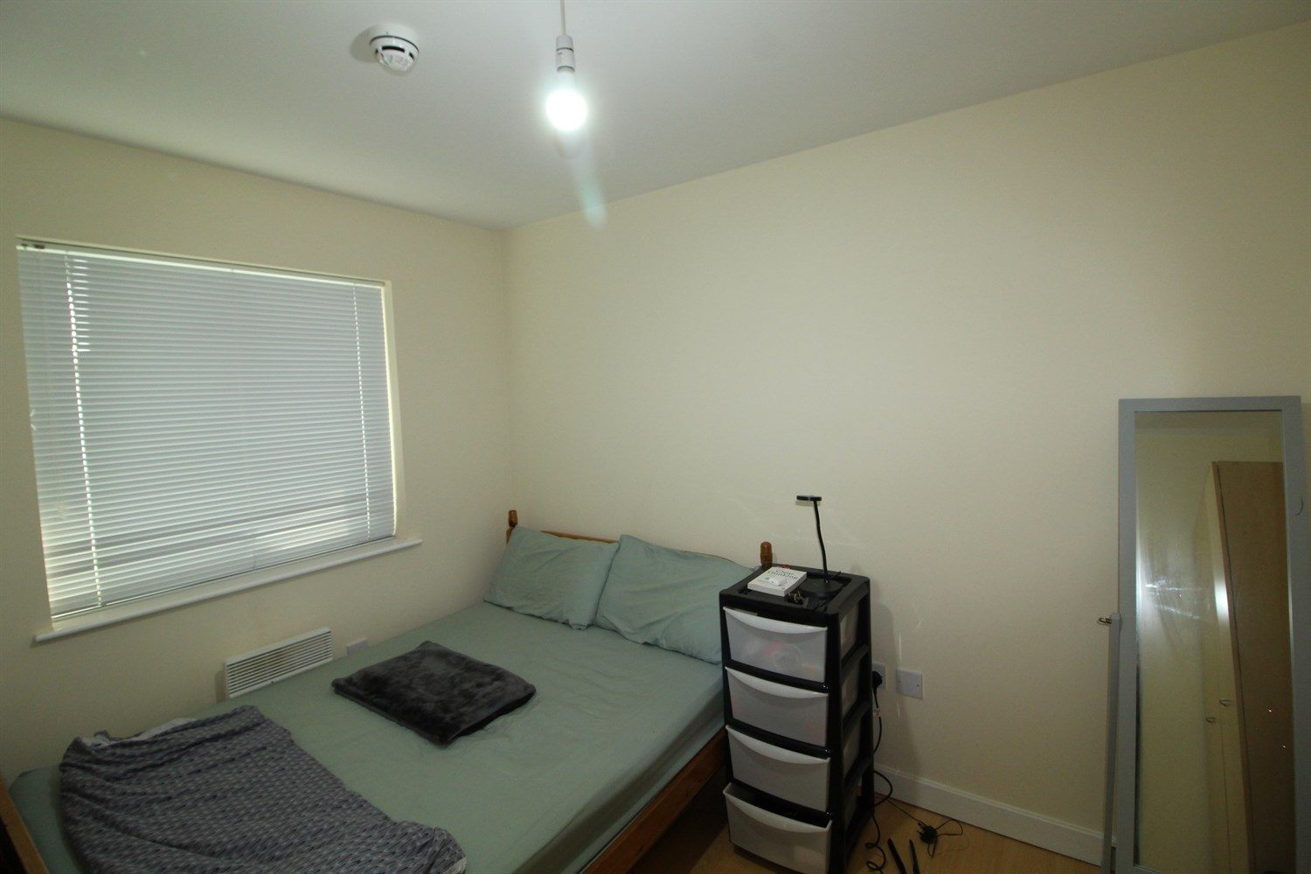

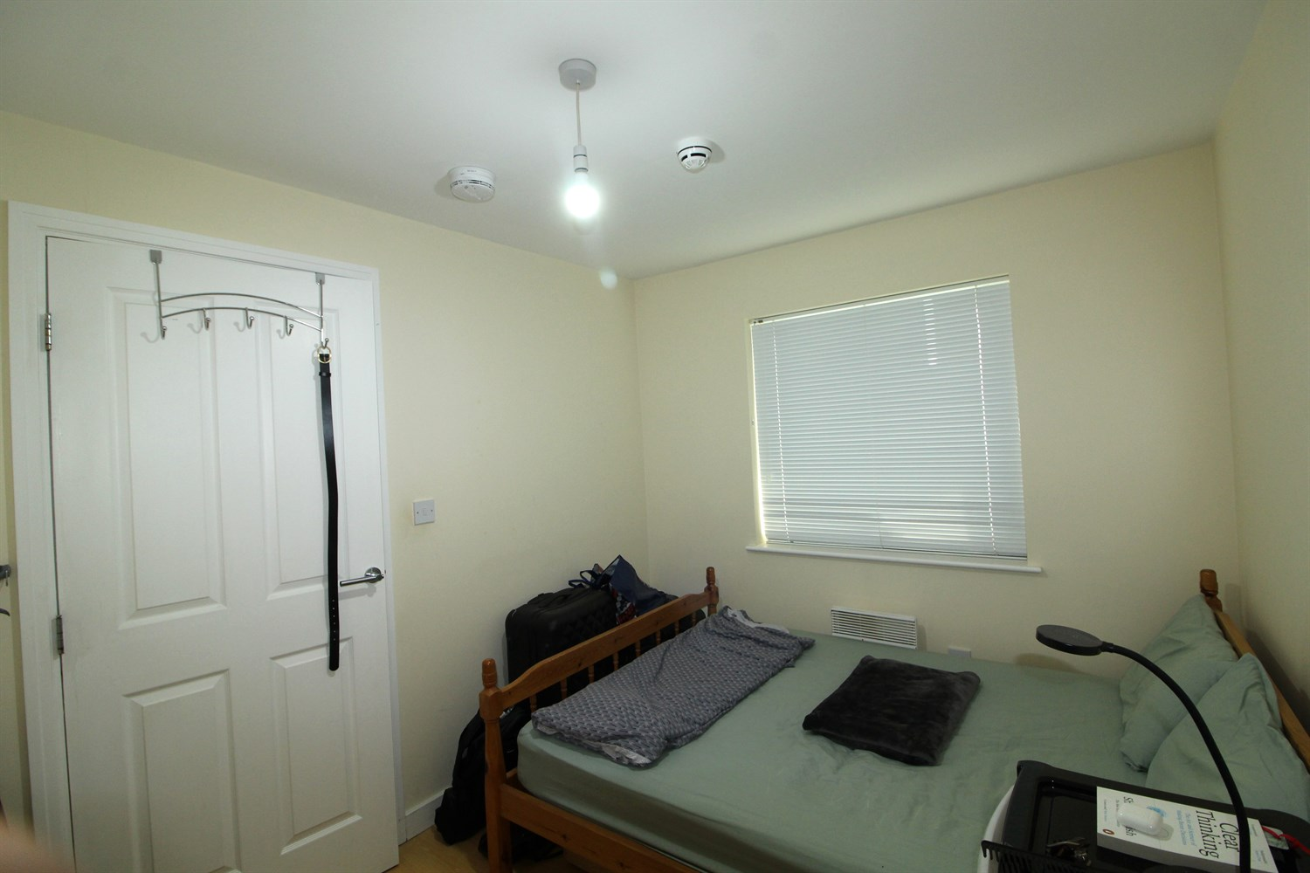



|  |
| --- |
| **Communal Entrance**  Fob entry, letterboxes on left of entrance and hallway has a lift to all floors. |
| **Living/ Kitchen**  Living roomwith sliding doors leading on the balcony. kitchen fitted with a range of wall and base units with worktops over, electric oven and hob, washing machine and fridge freezer. Part tiles around units. Intercom system mounted on wall. Underfloor heating. |
| **Bedroom**  Double bedroom with window to rear, electric heater. |
| **Bathroom**  Three piece bathroom suite, walk in shower cubical, hand wash basin and w/c, ceramic floor and walls tiles heated electric towel rail. |
| **Home Information**  COUNCIL TAX BAND: C EPC Rating C  Leasehold property No Parking.  Broadband VIRGIN MEDIA ONLY: Standard 15 Mbps 1 Mbps Good Superfast 8750 Mbps 2750 Mbps Good Ultrafast 1750750750 Mbps 1750750750 Mbps  Mobile availability: EE likely to have good coverage. Three likely to have good coverage. O2 likely to have good coverage. Vodafone limited coverage.  Utilities: Water supplied on standard meters. Electric mains supplied on standard meters. |

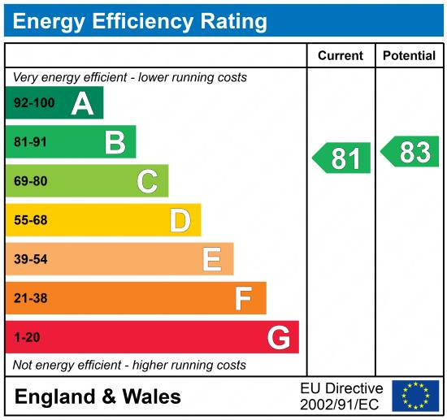

|  |
| --- |
|  |

These particulars are intended to give a fair description of the property, but their accuracy cannot be guaranteed, and they do not constitute an offer of contract. Intending purchasers must rely on their own inspection of the property. None of the above appliances/services have been tested by ourselves. We recommend purchasers arrange for a qualified person to check all appliances/services before legal commitment.

**Property Ref:** 5535

**For more information, please contact**

0113 258 1150 **|** [lettings@adairpaxton.co.uk](mailto:lettings@adairpaxton.co.uk) **|** www.adairpaxton.co.uk