

**0113 258 1150**

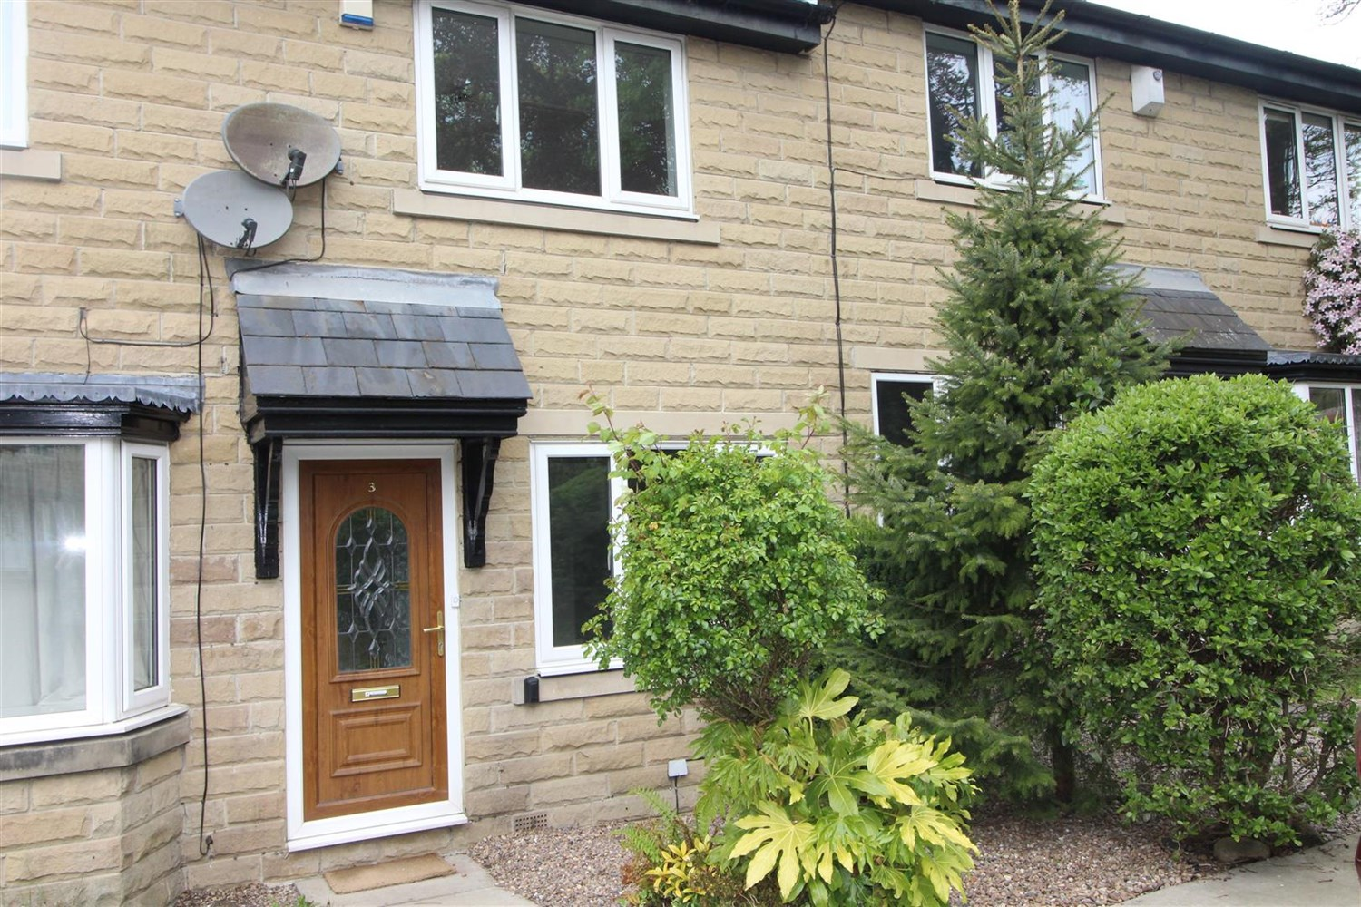



**Available to let £995.00pcm**

**Coverley Garth, Yeadon**

Two bed inner town house in a cul-de-sac location, close to all amenities in Yeadon and Guiseley. With great transport links and easy access to the airport. The property has the benefit of gas central heating and double glazing. Comprising; Entrance lobby, lounge with feature fireplace, good size kitchen with stylish units and integrated appliances, bathroom with three piece suite and shower over the bath, two double bedrooms with fitted wardrobes. Externally there is an enclosed rear garden with garden shed. Allocated parking space with additional visitor parking. Unfurnished with white goods. Council tax band C, EPC rating C. Deposit £1145. Available 14th April.

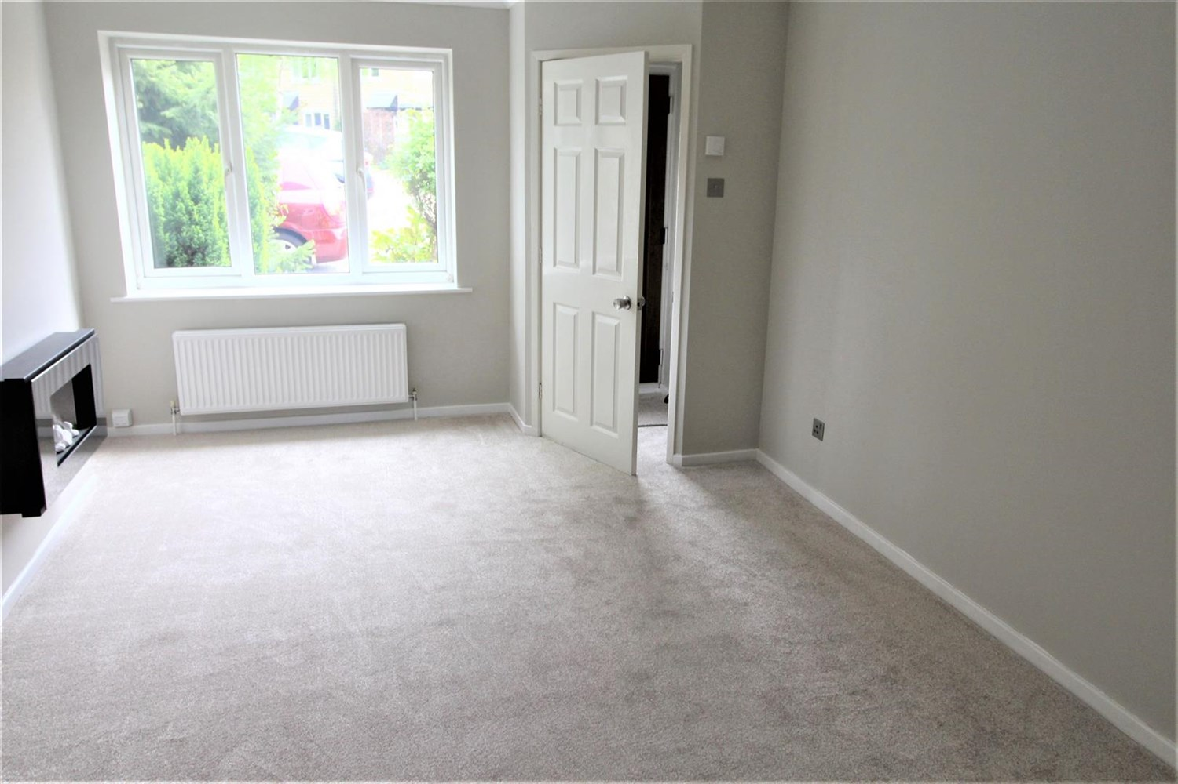

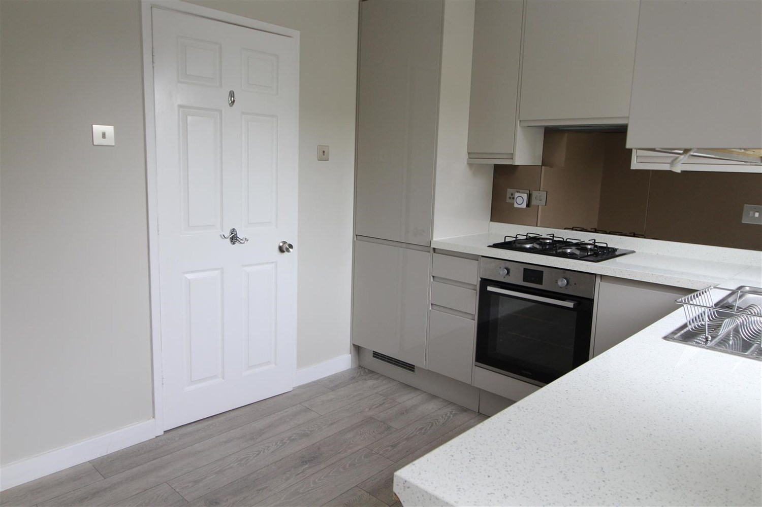

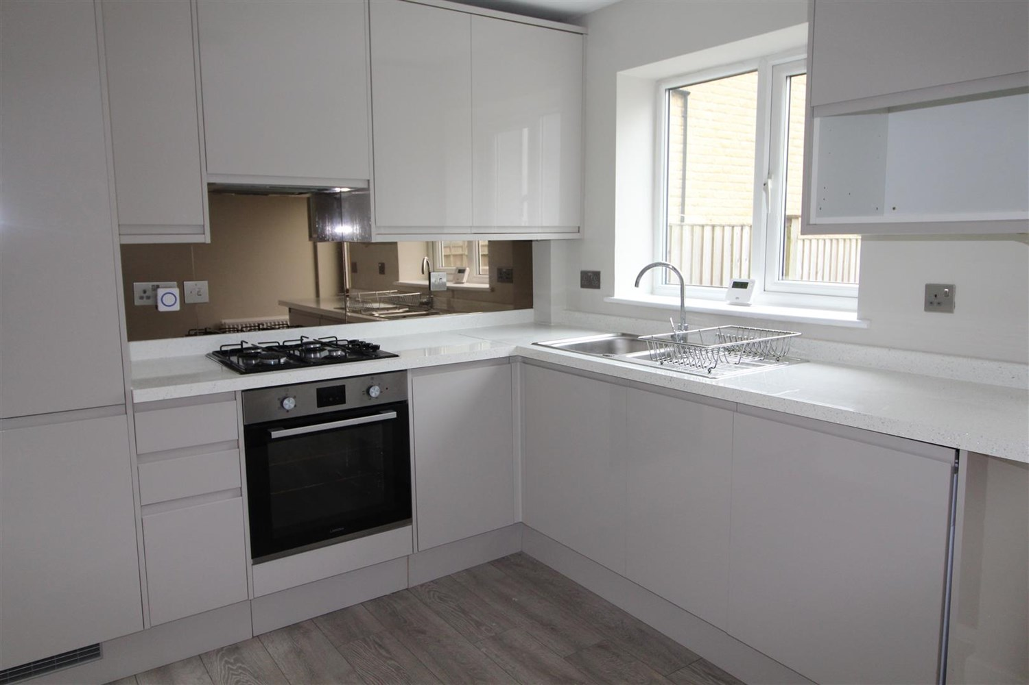

1 Bathroom(s)

1 Reception(s)

2 Bedroom(s)

00

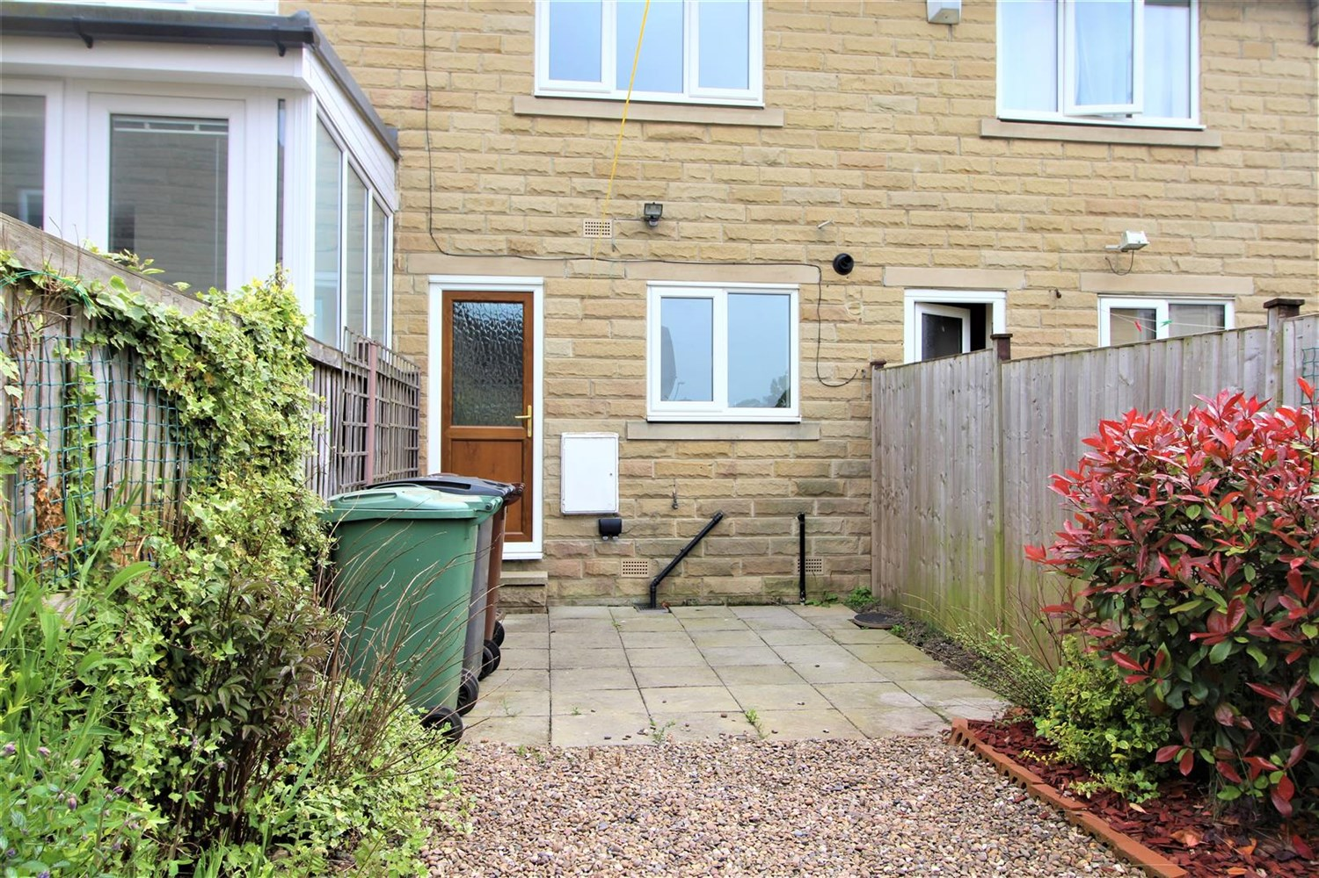

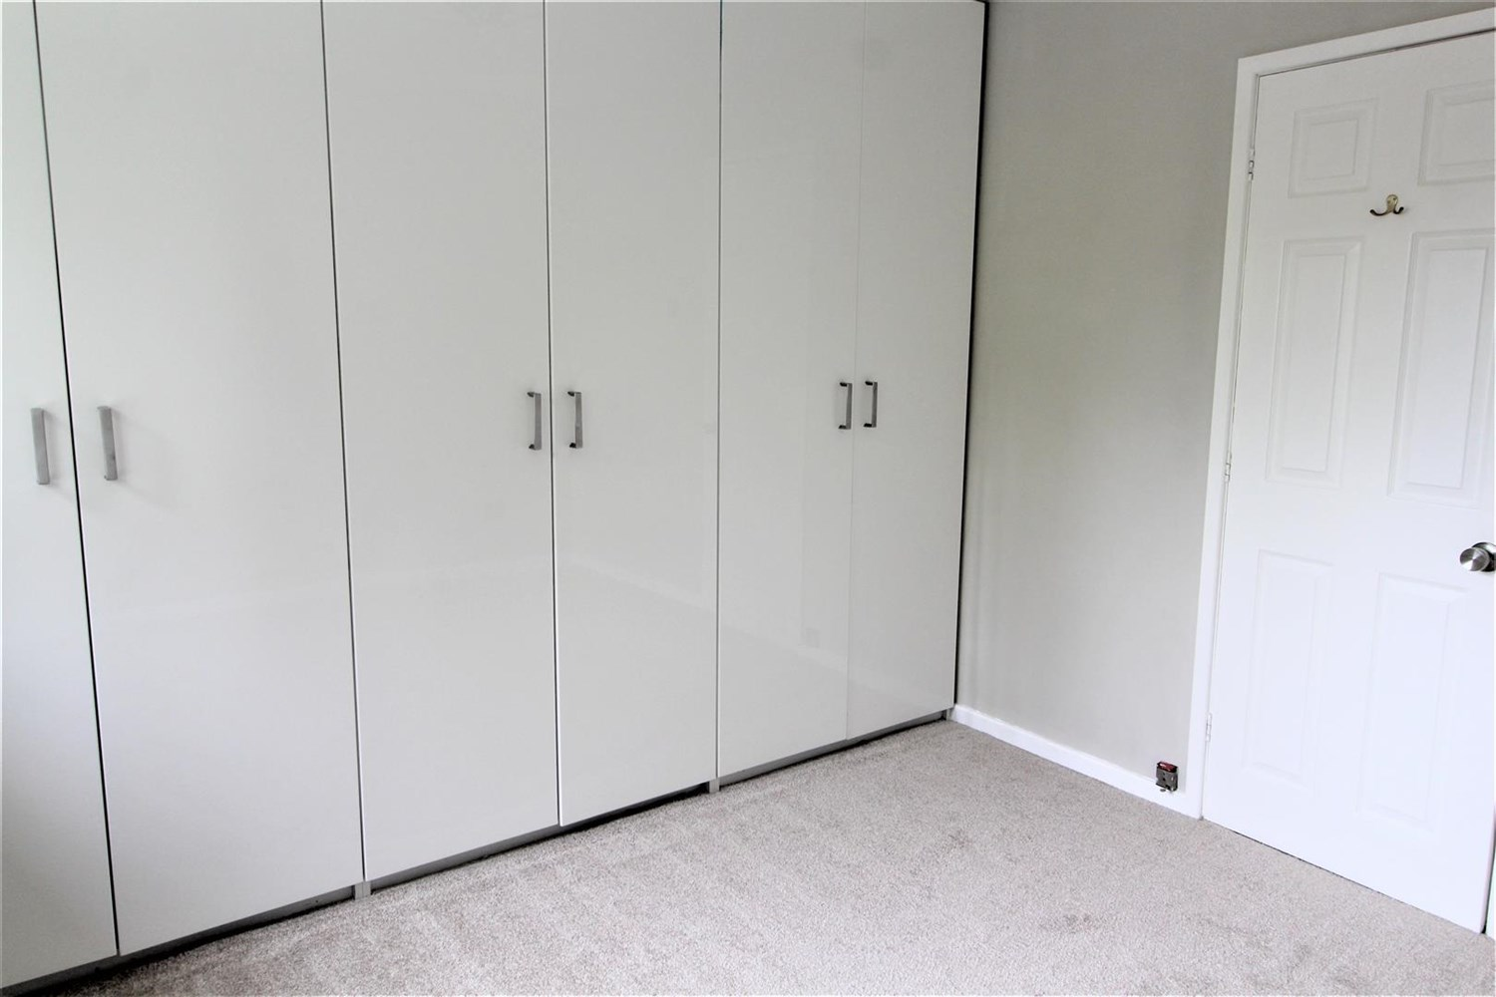

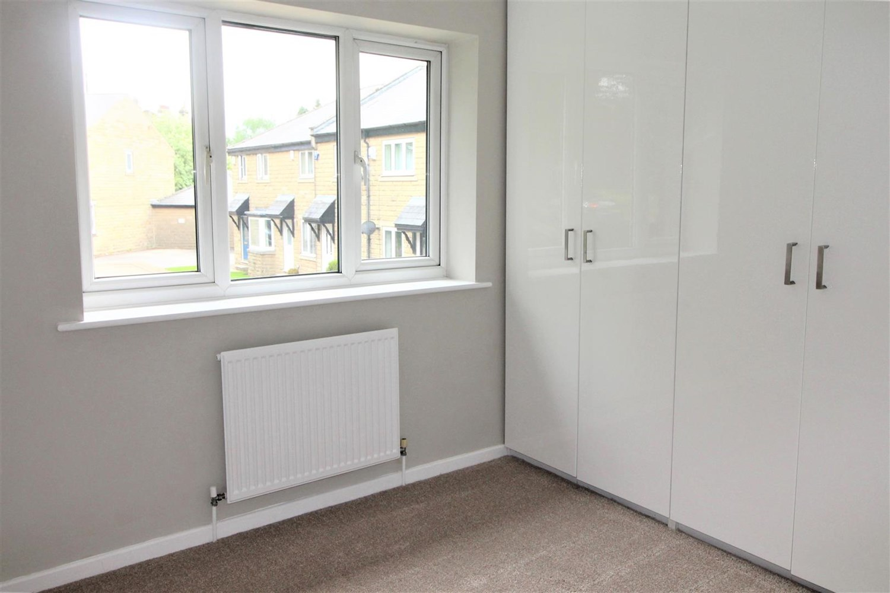

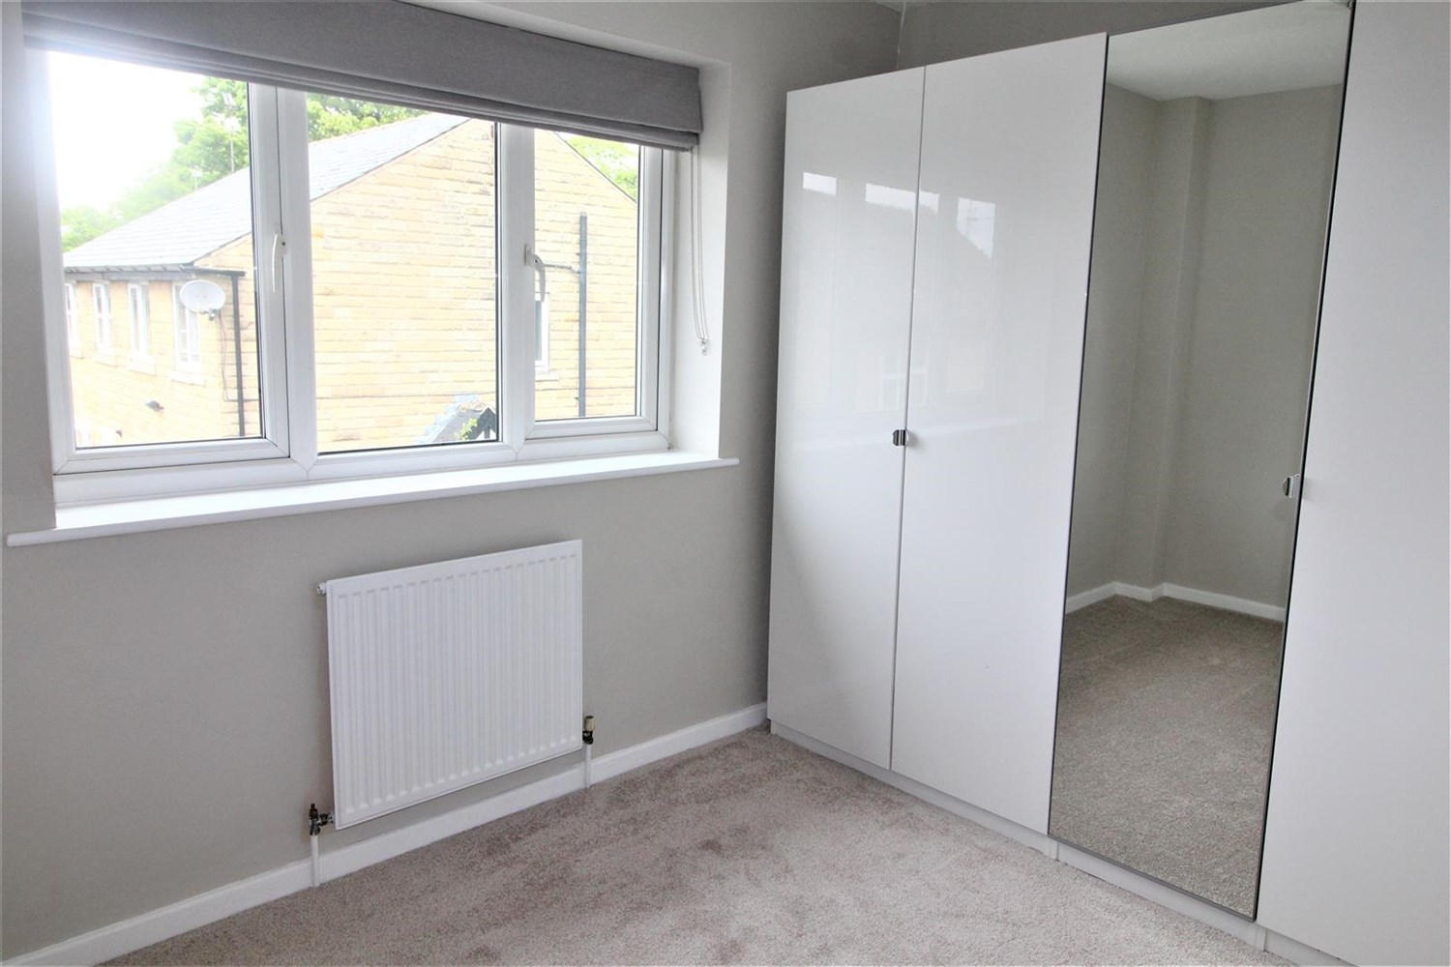

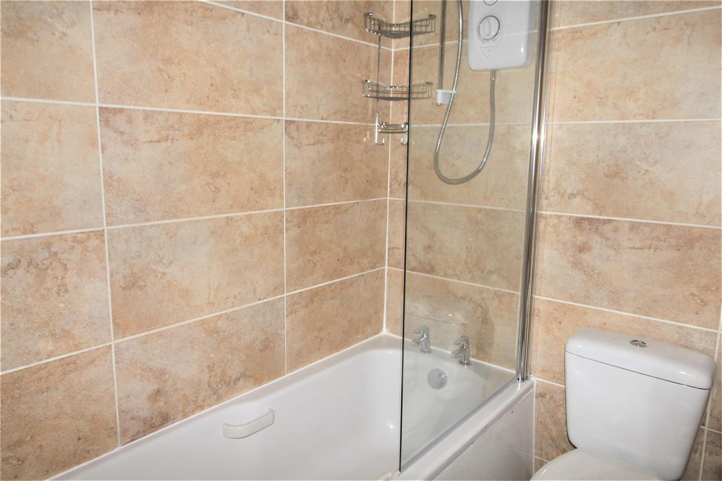

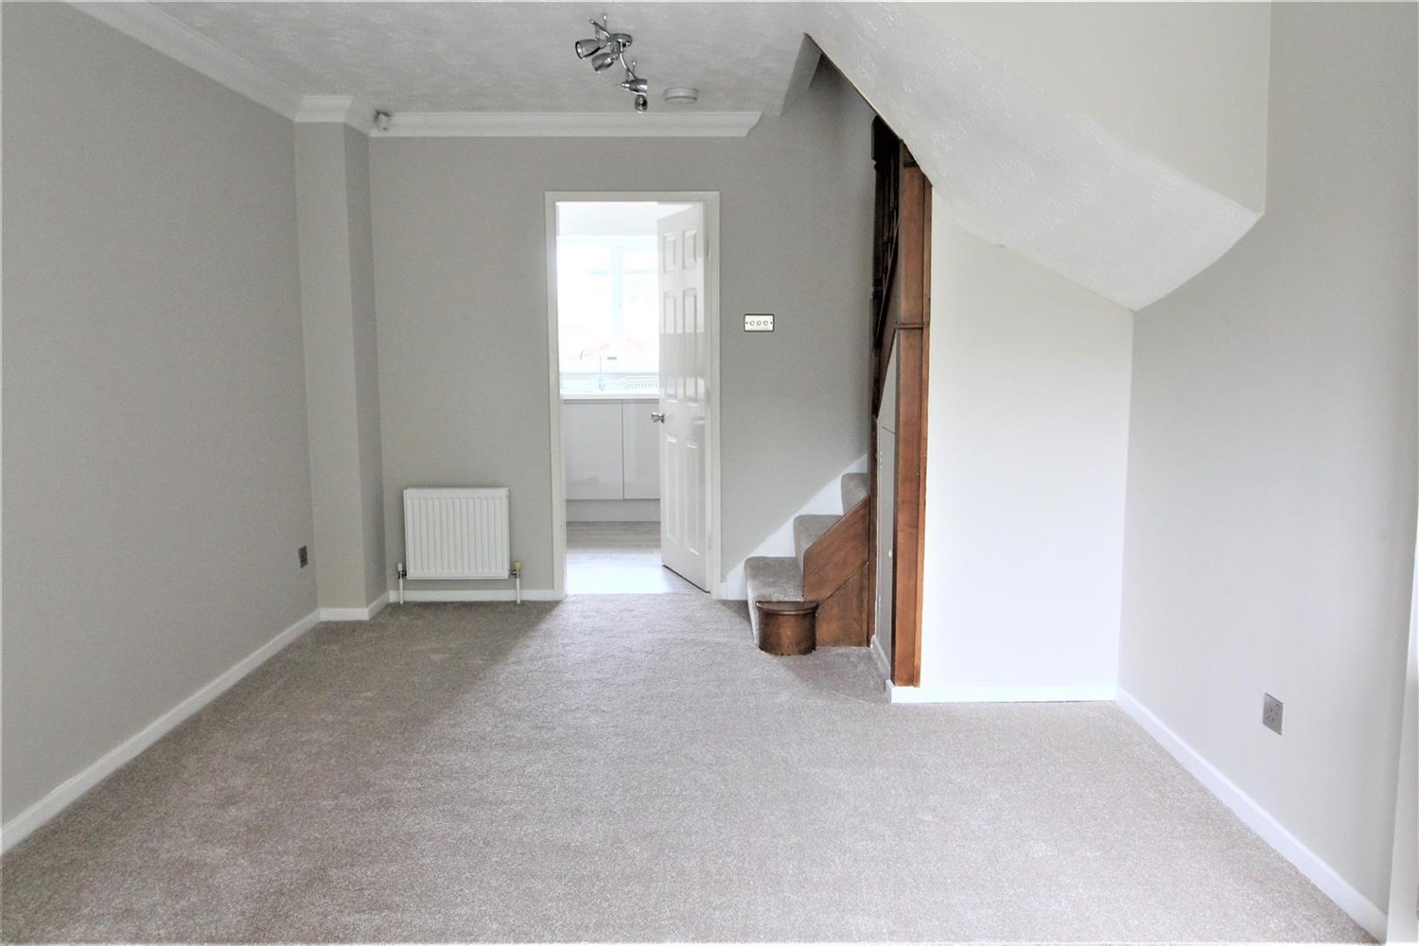

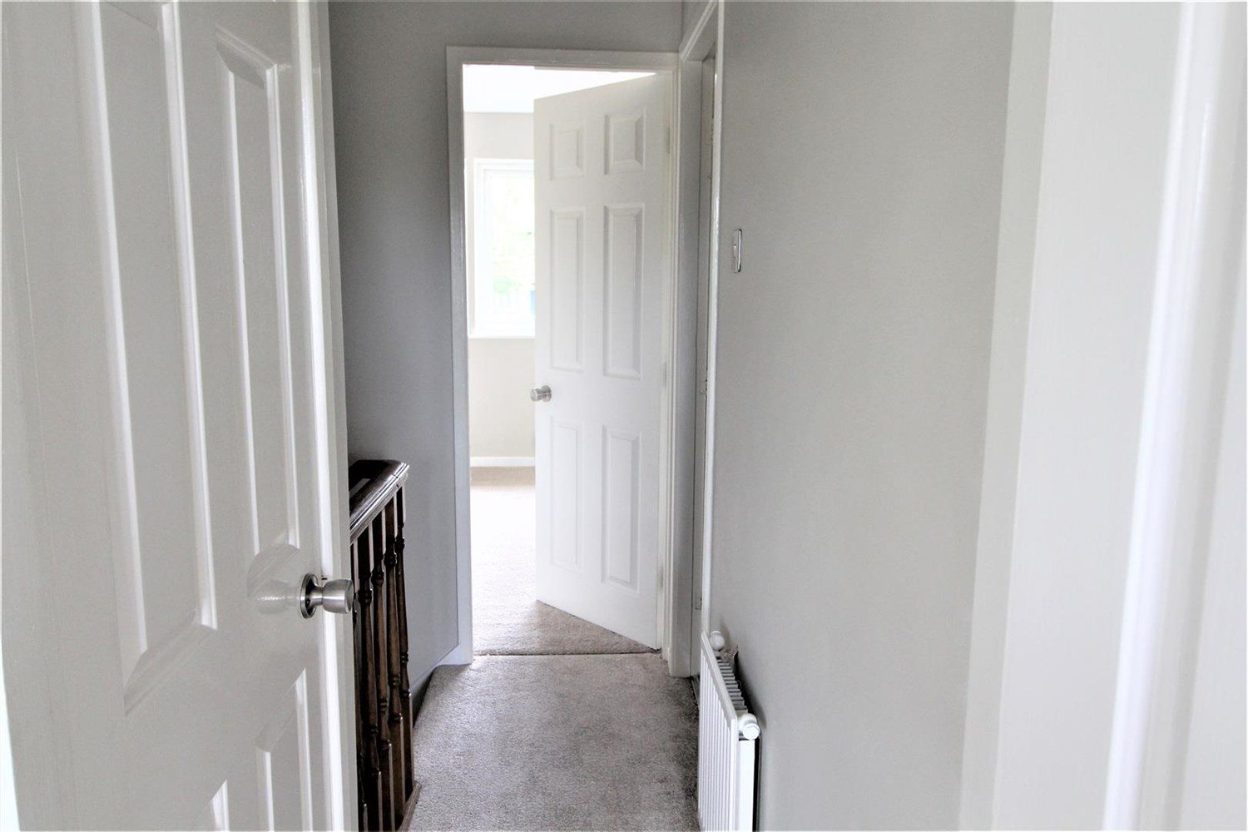

|  |
| --- |
| **Living Room**  The lounge includes a electric fire, gas central heating radiators, television point, telephone point and an under stairs cupboard for storage. uPVC double glazed bay window to the front. Staircase to the first floor. |
| **Kitchen**  The kitchen is fitted with a range of wall and base units with worksurface, one radiator, extractor fan and a PVCU double glazed window and door to the rear. Timber effect floor finish. |
| **Bedroom**  uPVC double glazed window to the front and radiator. wardrobes, carpeted finish. |
| **Bedroom**  uPVC double glazed window to the rear and radiator. wardrobes, carpeted finish |
| **Bathroom**  The bathroom includes a three piece bathroom suite encompassing low level WC, panelled bath with electric shower over and a wash hand basin, extractor fan, one radiator and a PVCU double glazed window to the side. Part tiled walls and timber effect floor finish. |
| **Outside The Property**  To the rear there is an enclosed garden with a paved area and planted borders. |
| **Home Information**  COUNCIL TAX BAND: C EPC Rating C  Freehold property Allocated Parking.  Broadband: Standard 6 Mbps 0.8 Mbps Good Superfast 80 Mbps 20 Mbps Good Ultrafast 1800 Mbps 220 Mbps  Mobile availability: EE limited coverage. Three likely to have good coverage. Vodafone likely to have good coverage. O2 limited coverage.  Utilities: Water supplied on standard meters. Electric mains supplied on standard meters. Gas mains supplied on standard meters. |

|  |  |
| --- | --- |
| These particulars are intended to give a fair description of the property, but their accuracy cannot be guaranteed, and they do not constitute an offer of contract. Intending purchasers must rely on their own inspection of the property. None of the above appliances/services have been tested by ourselves. We recommend purchasers arrange for a qualified person to check all appliances/services before legal commitment.  **Property Ref:** 5345  **For more information, please contact**  0113 258 1150 **|** [lettings@adairpaxton.co.uk](mailto:lettings@adairpaxton.co.uk) **|** www.adairpaxton.co.uk |  |