

The Willow, Navigation Vale, Woodlesford, Leeds.
Available to let £1,200pcm

**TWO BEDROOM, TWO BATHROOM TOP FLOOR APARTMENT with stunning CANAL VIEWS** Adair Paxton are pleased to offer to the market this stylish new build apartment created by Chartford Homes. Please visit www.chartfordhomes.com for more information. The property briefly comprises; entrance hall, open plan living room/kitchen with two balconies, master bedroom with en-suite shower room, second double bedroom and a house bathroom. Externally the property benefits from an allocated parking space for residents and visitors with use of a dedicated EV charger. This spacious apartment overlooking the Aire and Calder Navigation is just a stroll away from Woodlesfords many amenities, including shops, supermarket, pharmacy, post office, railway station only a short walk away and with travel time to Leeds City Station of just 12 minutes and primary school. Bond £1375. Available Now. SORRY NO PETS.
0113 258 1150
0800 000 000
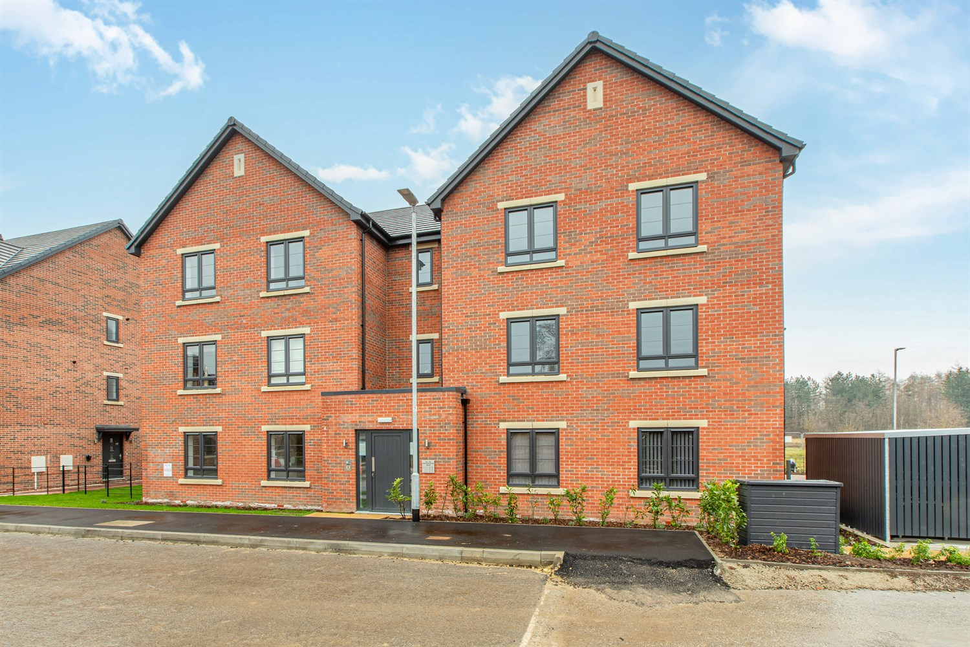
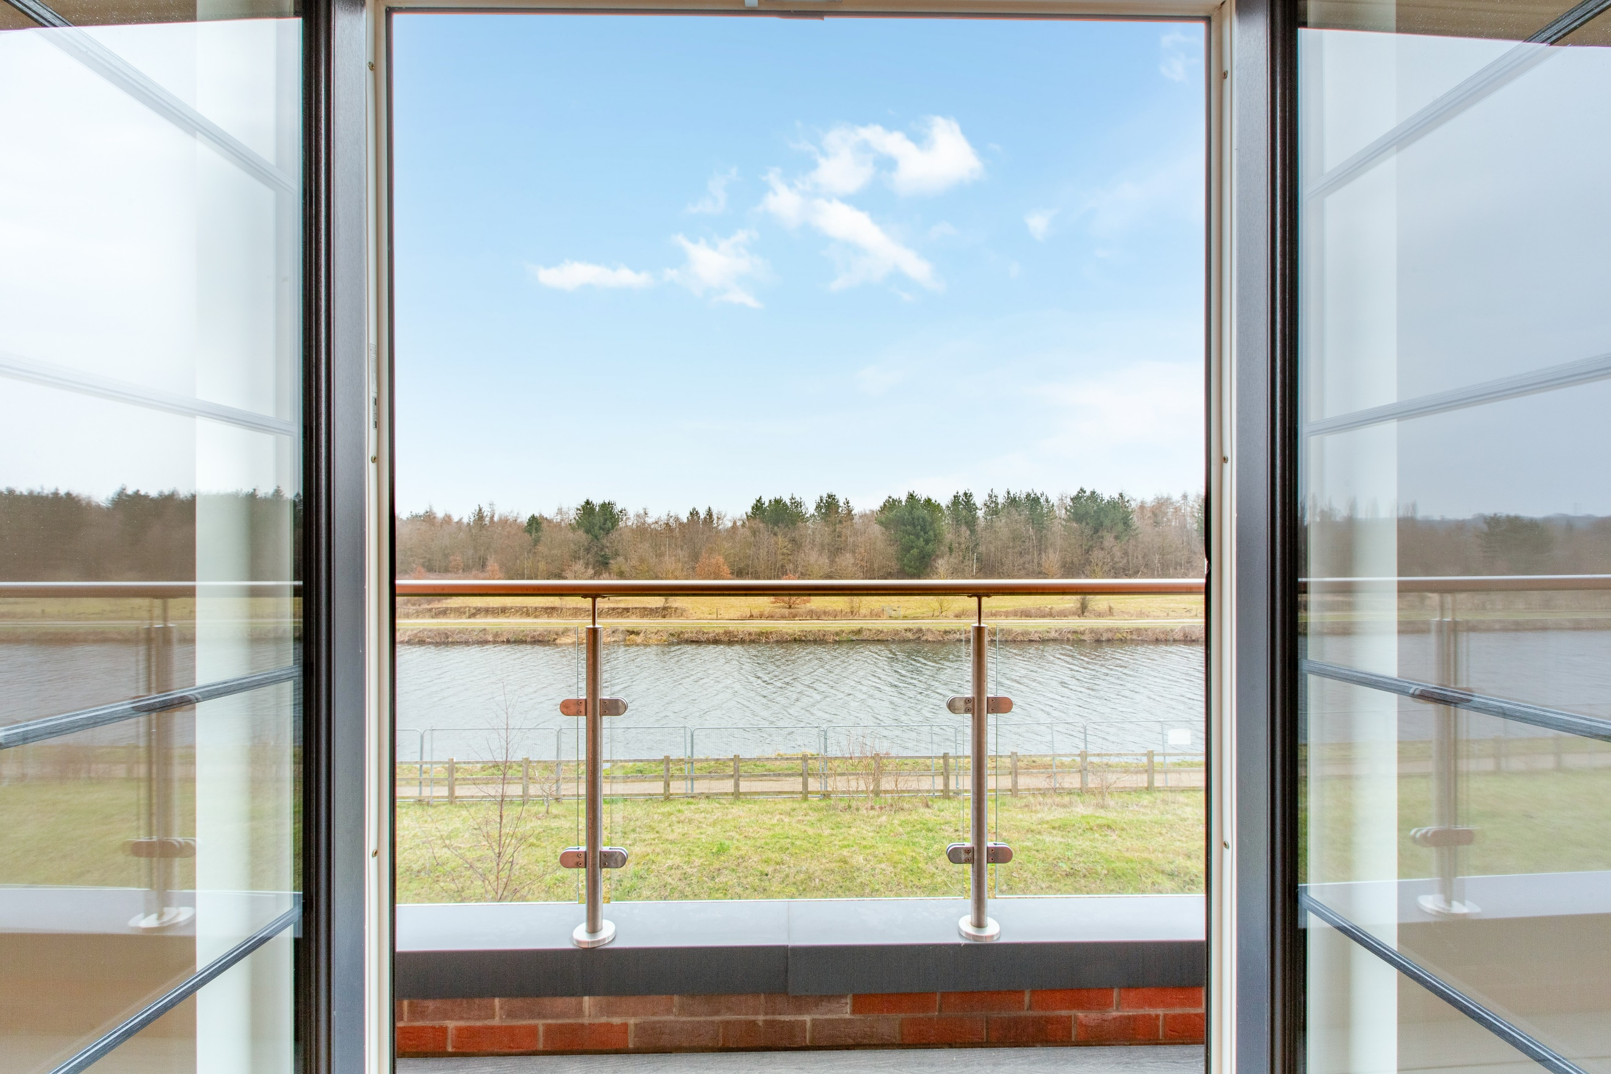
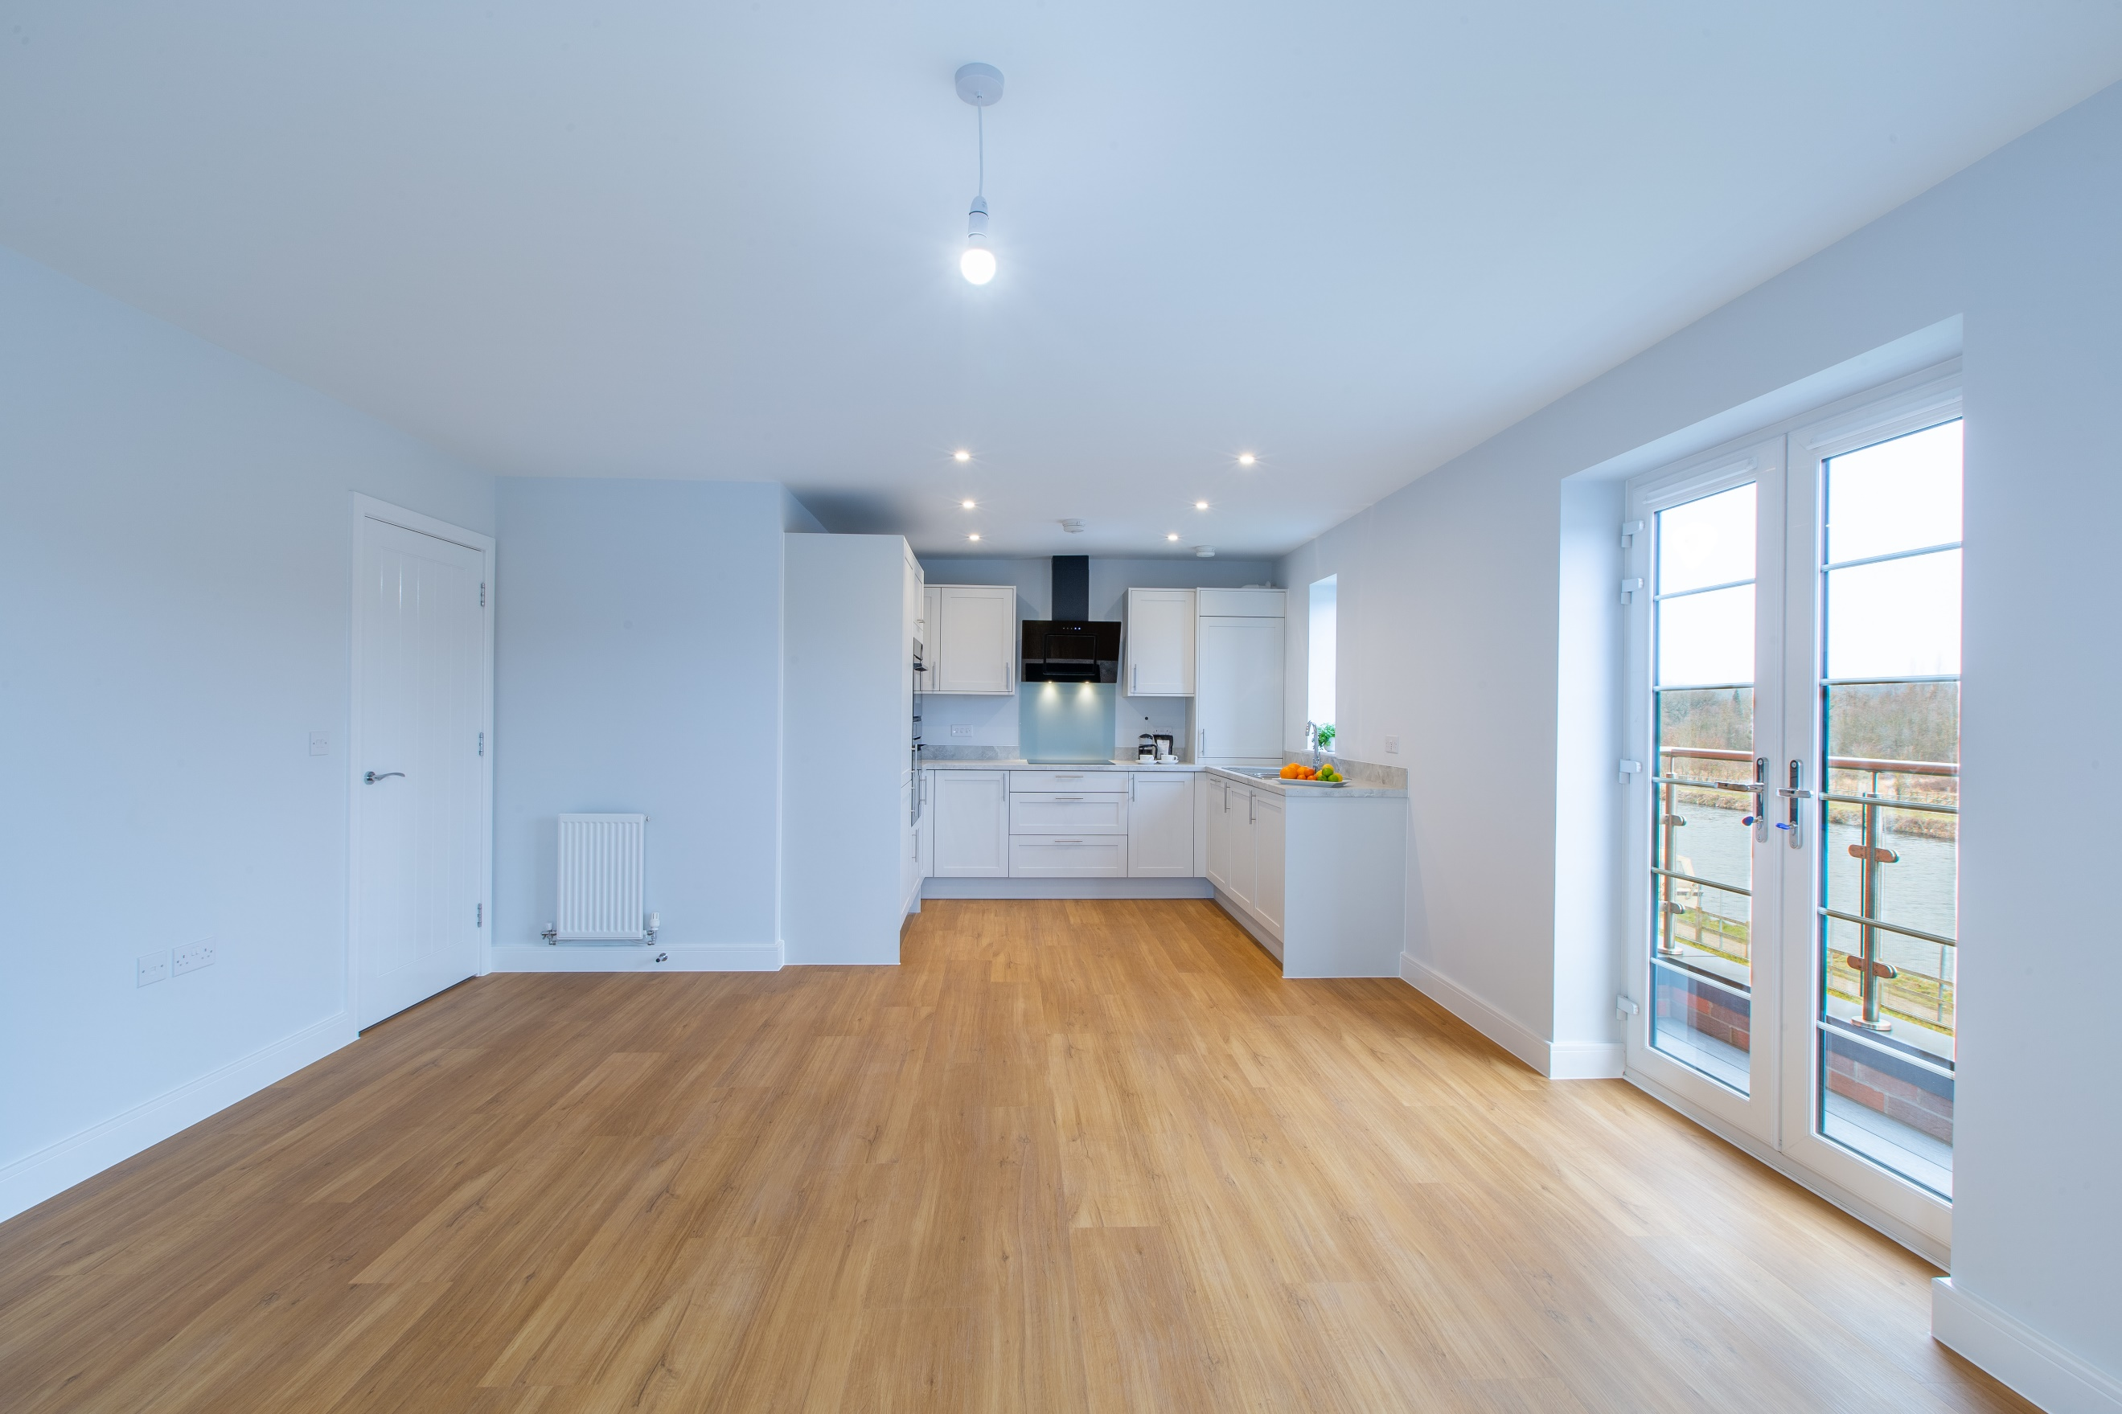
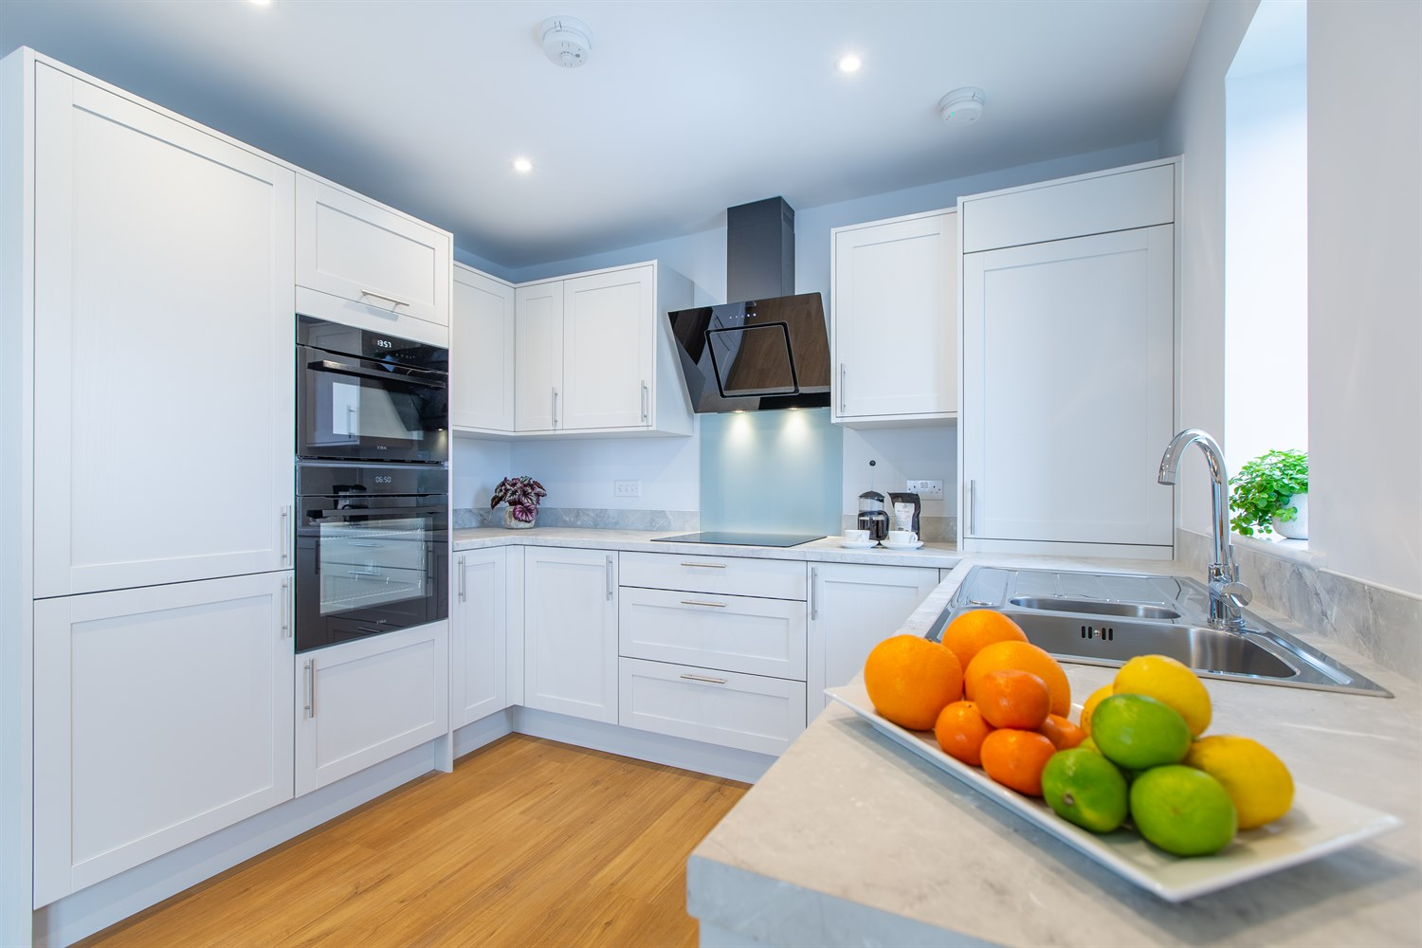
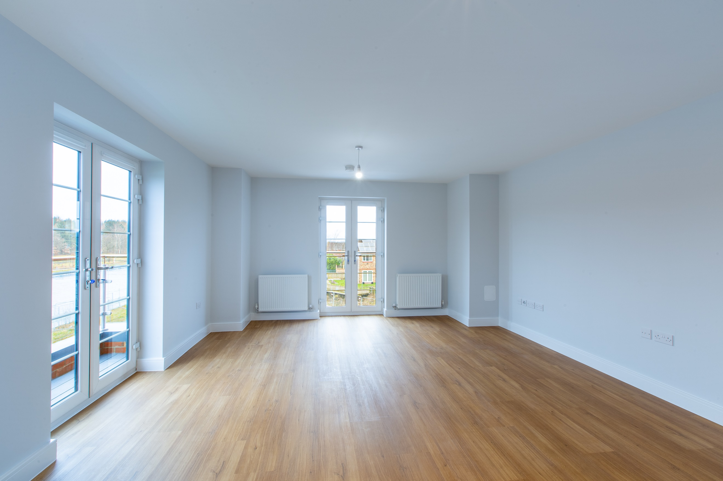
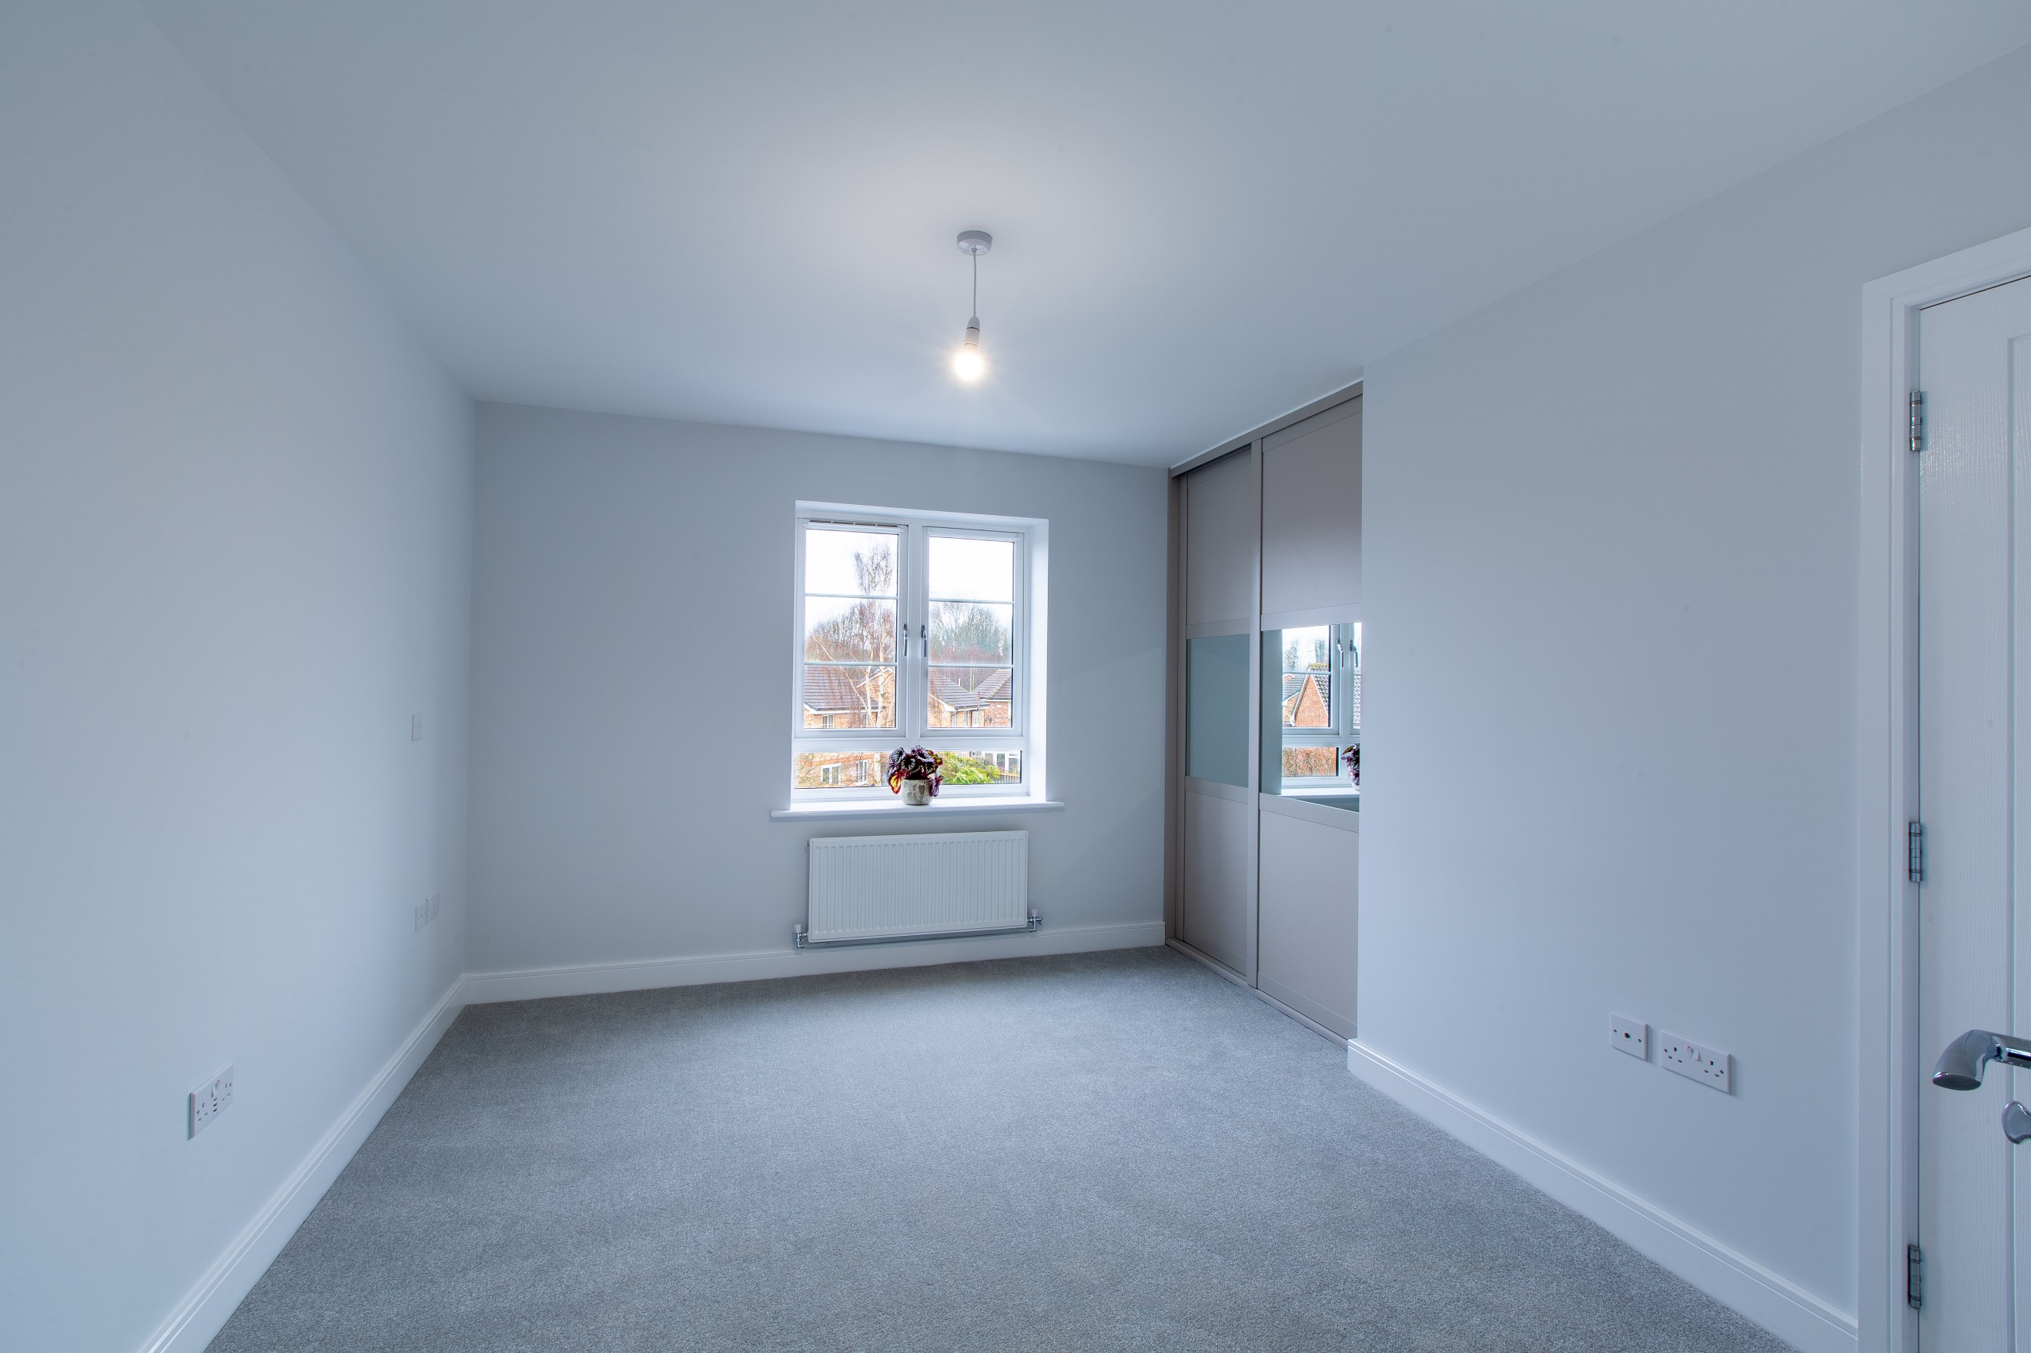
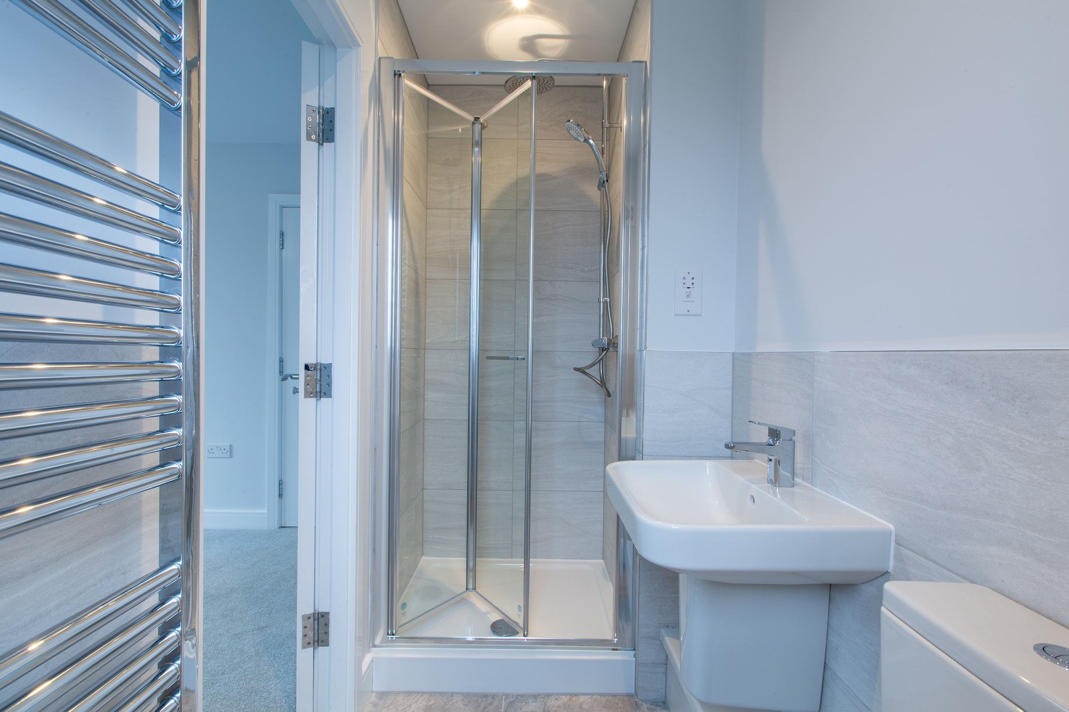
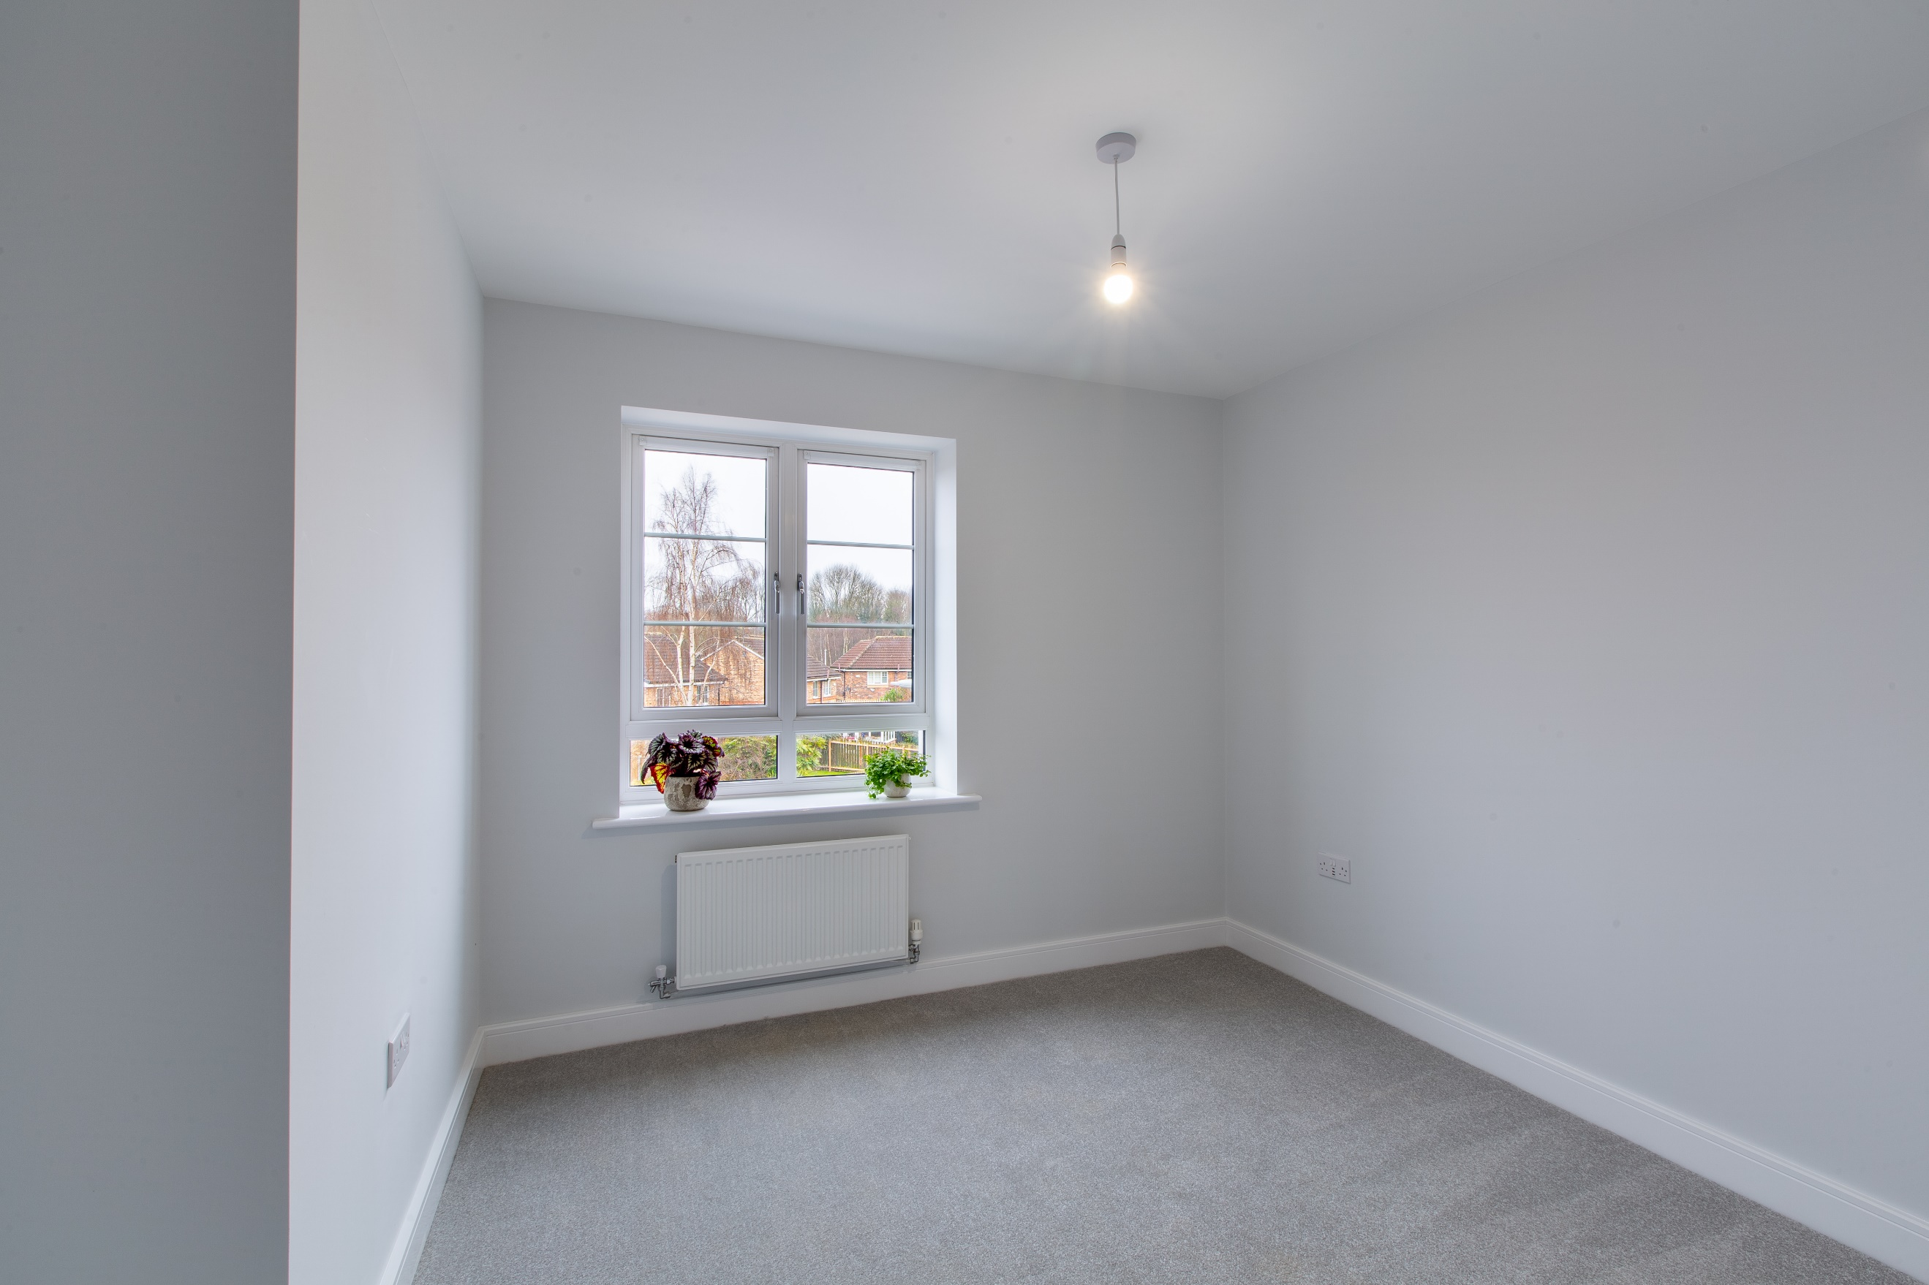
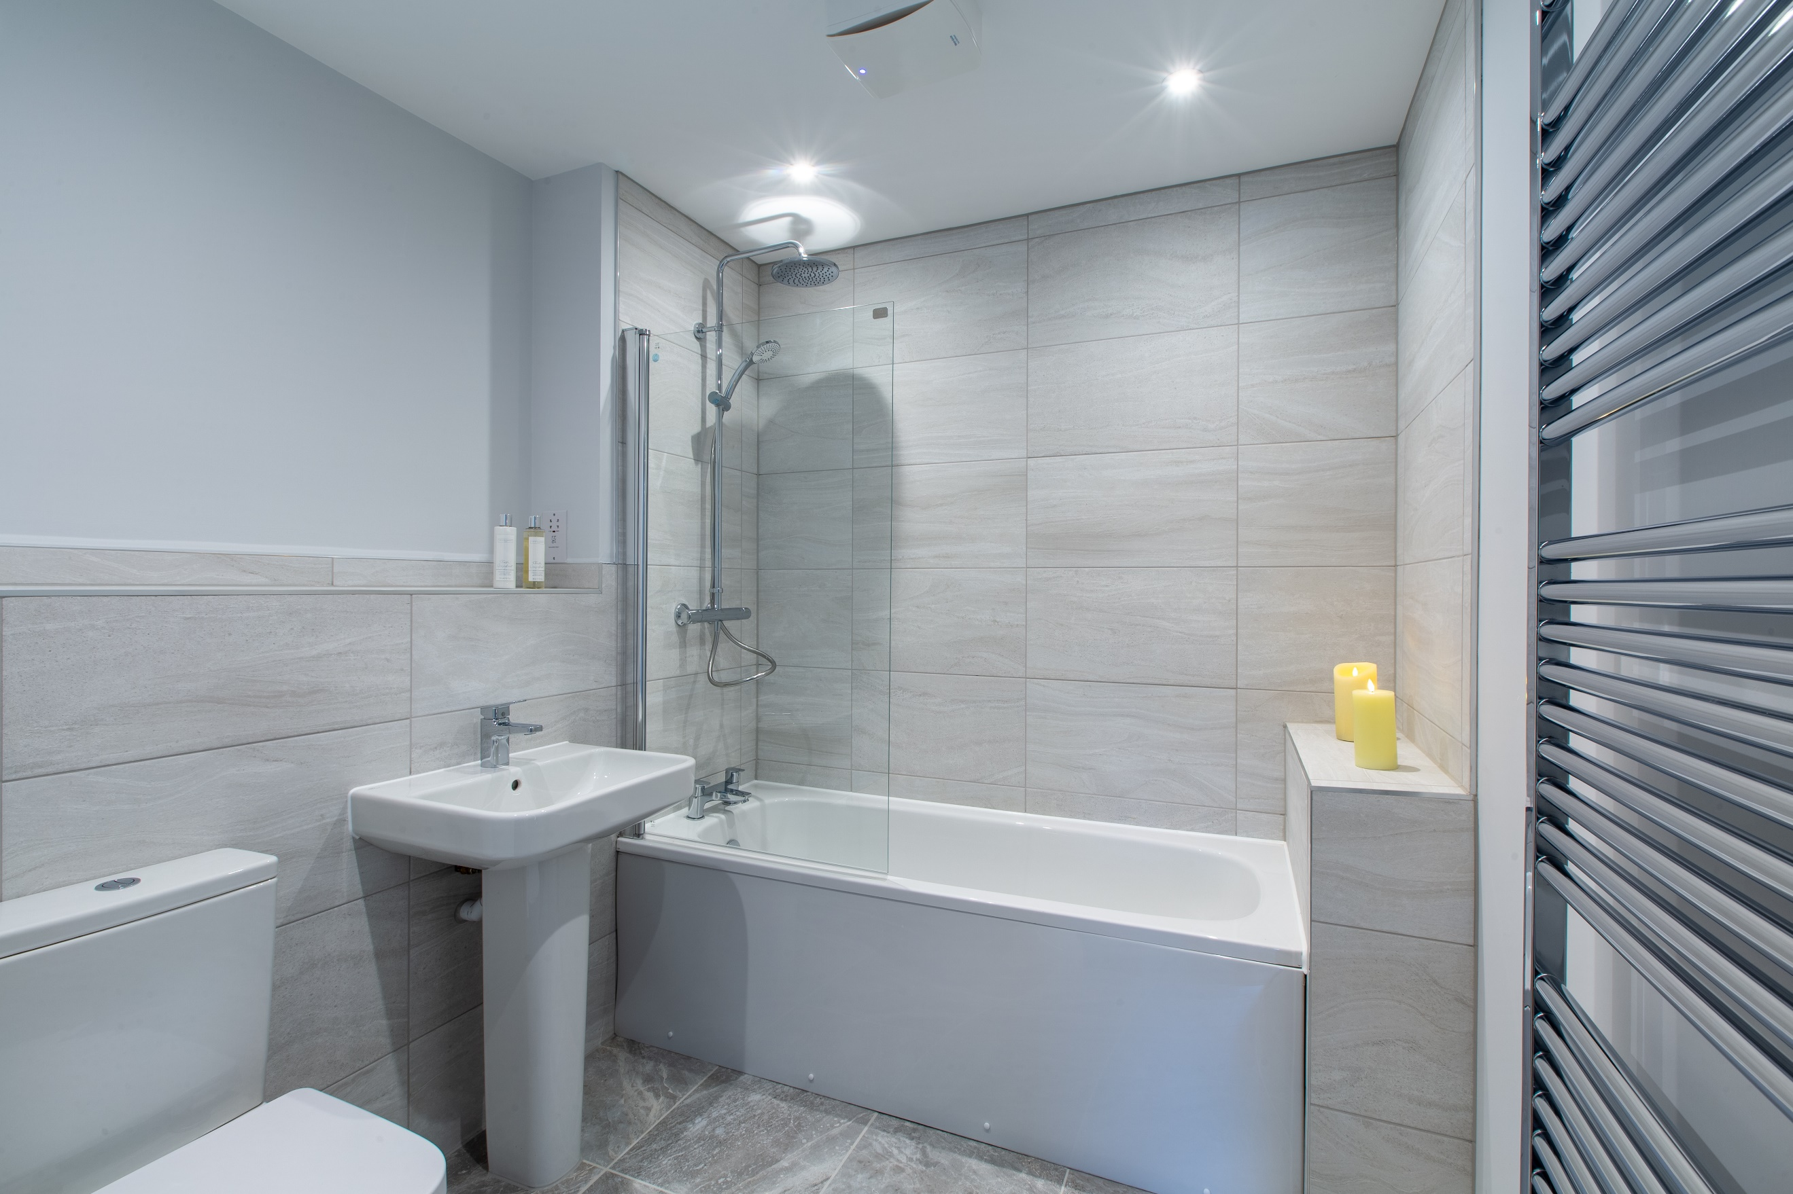

Entrance Hall
Via front entrance door. Secure video entry phone system. Store cupboard.

Open plan lounge/kitchen 7.29m (23'11) x 4.42m (14'6)
Fitted with a range of wall, base and drawer units worktops over. Integrated oven, microwave, fridge/freezer, dishwasher and washing machine. 4-ring hob with extractor hood over. 1.5 bowl stainless steel sink with mixer tap and drainer. uPVC double glazed window. Inset ceiling spotlights.

Lounge
Light and airy living area with uPVC double glazed doors leading to balcony with views over the canal and uPVC double glazed doors leading to side balcony. Two gas central heating radiators. Inset ceiling spotlights.

Bedroom 1 3.98m (13'1) x 3.7m (12'2)
Double bedroom with uPVC double glazed window. Build it wardrobes. Gas central heating radiator.

En-Suite Shower Room 2.3m (7'7) x 1.17m (3'10)
Fitted with a three piece suite comprising; shower cubicle, WC and wash hand basin. Part tiled walls. Inset ceiling spotlights. Wall mounted heated towel rail.

Bedroom 2 3.57m (11'9) x 2.84m (9'4)
Second double bedroom with uPVC double glazed window. Gas central heating radiator.

House Bathroom
Fitted with a three piece white suite comprising; bath with shower over, WC and wash hand basin. Part tiled walls. Inset ceiling spotlights. Wall mounted heated towel rail.

Parking
Allocated Parking with dedicated EV charging point.

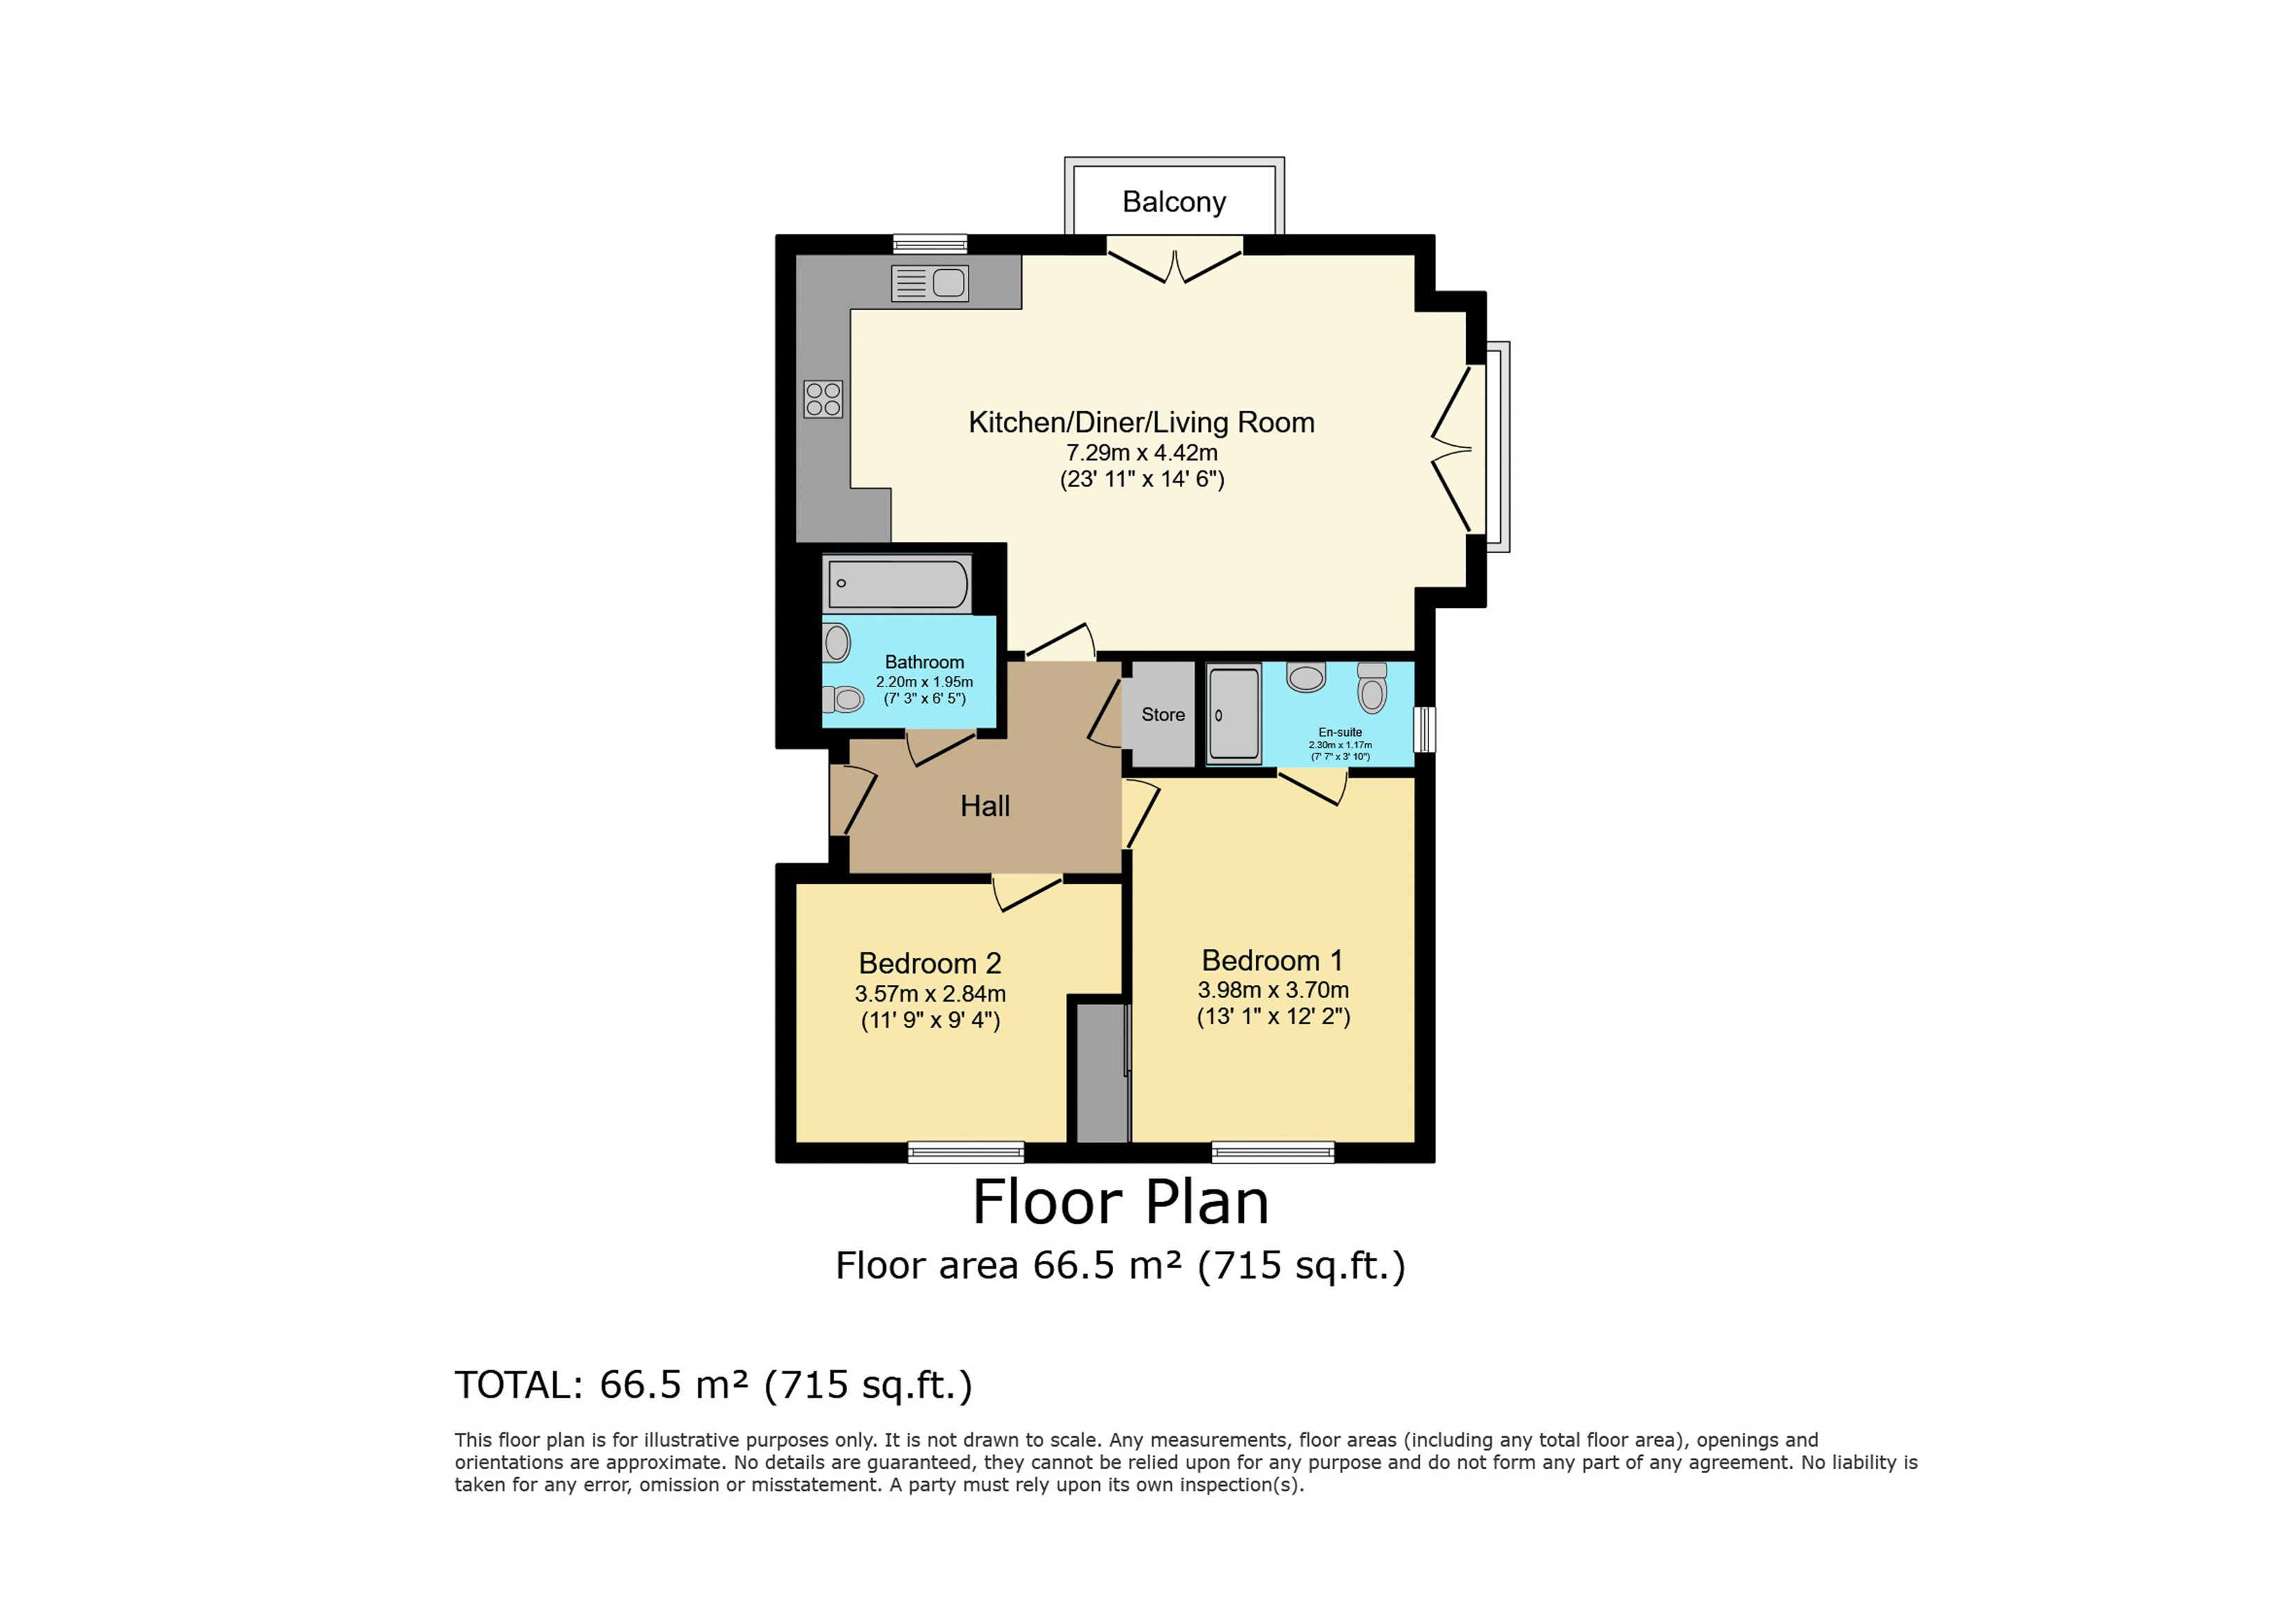

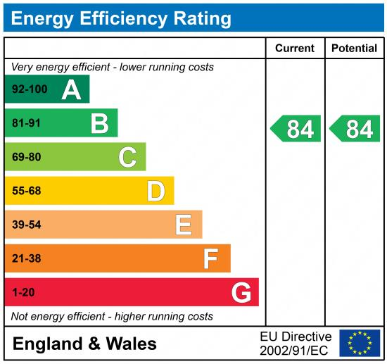

These particulars are intended to give a fair description of the property, but their accuracy cannot be guaranteed, and they do not constitute an offer of contract. Intending purchasers must rely on their own inspection of the property. None of the above appliances/services have been tested by ourselves. We recommend purchasers arrange for a qualified person to check all appliances/services before legal commitment.

Property Ref: 5308

For more information, please contact

0113 258 1150 | lettings@adairpaxton.co.uk | www.adairpaxton.co.uk

