

**Faroe, Gotts Road**

**For Sale £135,000.00**

***SPACIOUS ONE BEDROOM APARTMENT - NO ONWARD CHAIN*** Located in this popular development, this delightful eighth floor apartment briefly comprises: entrance hall, open plan living room and kitchen with access to a balcony, one double bedroom and house bathroom. City Island itself is an incredibly popular development, situated around a central piazza and but a short stroll away from Leeds business and shopping districts, and is well placed for access to the motorway network and Ring Road.

**0113 258 1150**

**0800 000 000**

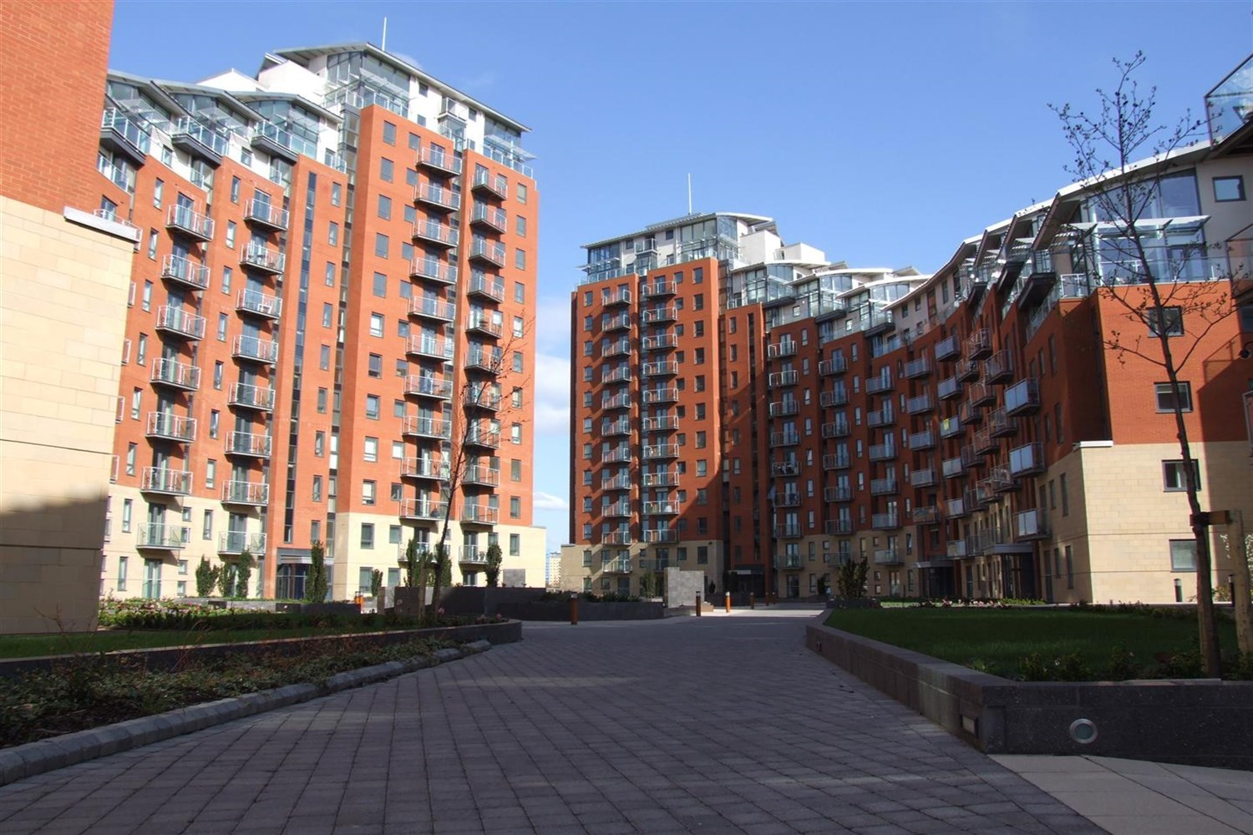



1 Reception(s)

1 Bathroom(s)

1 Bedroom(s)

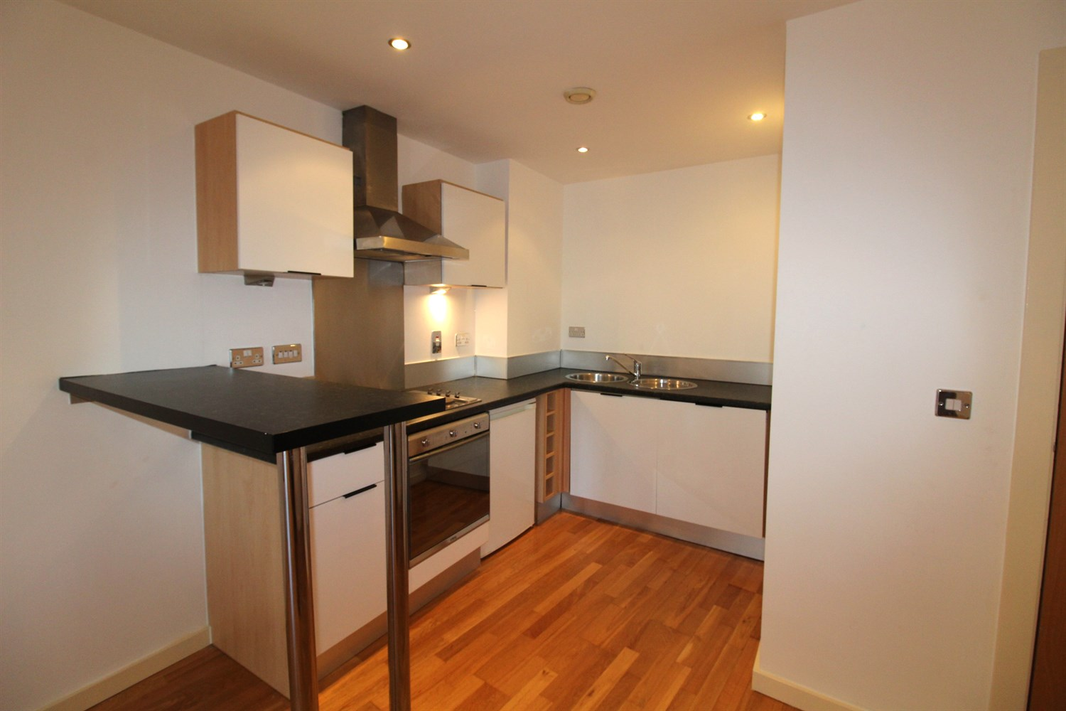

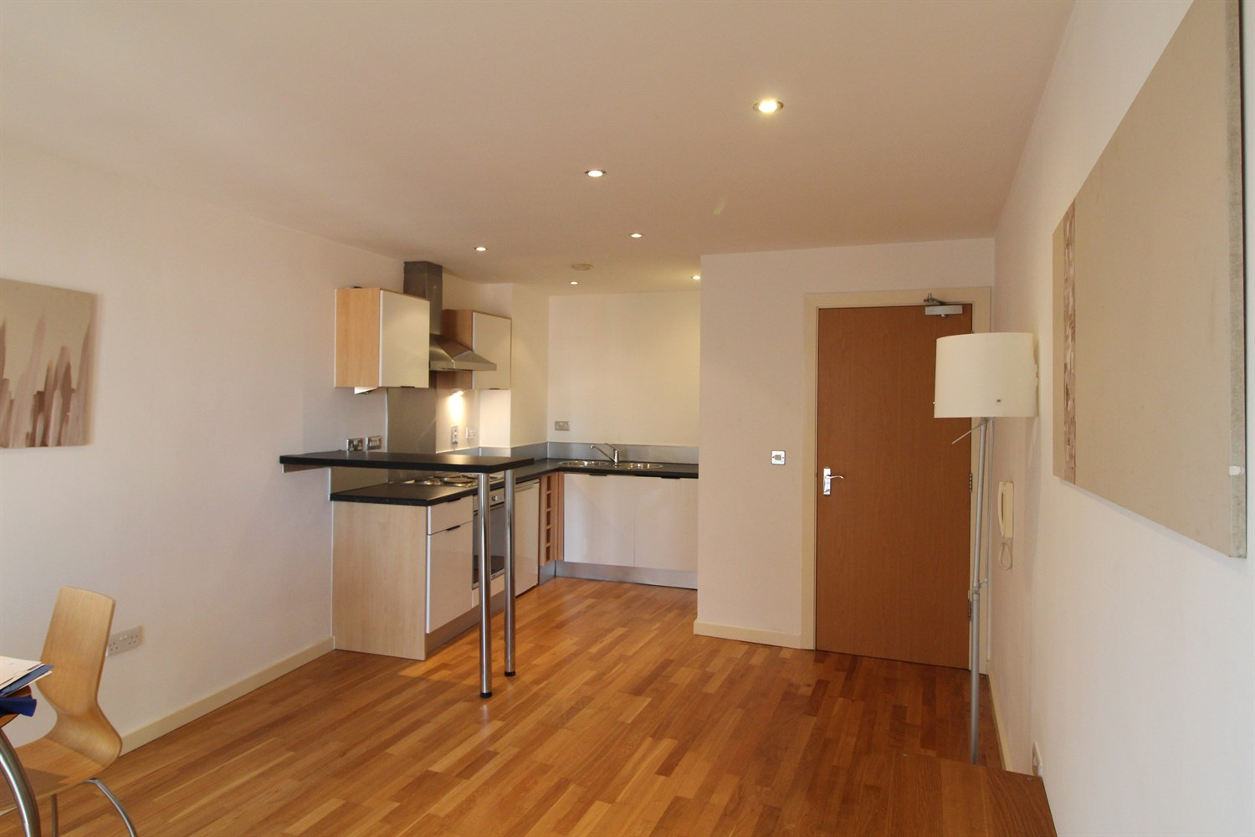

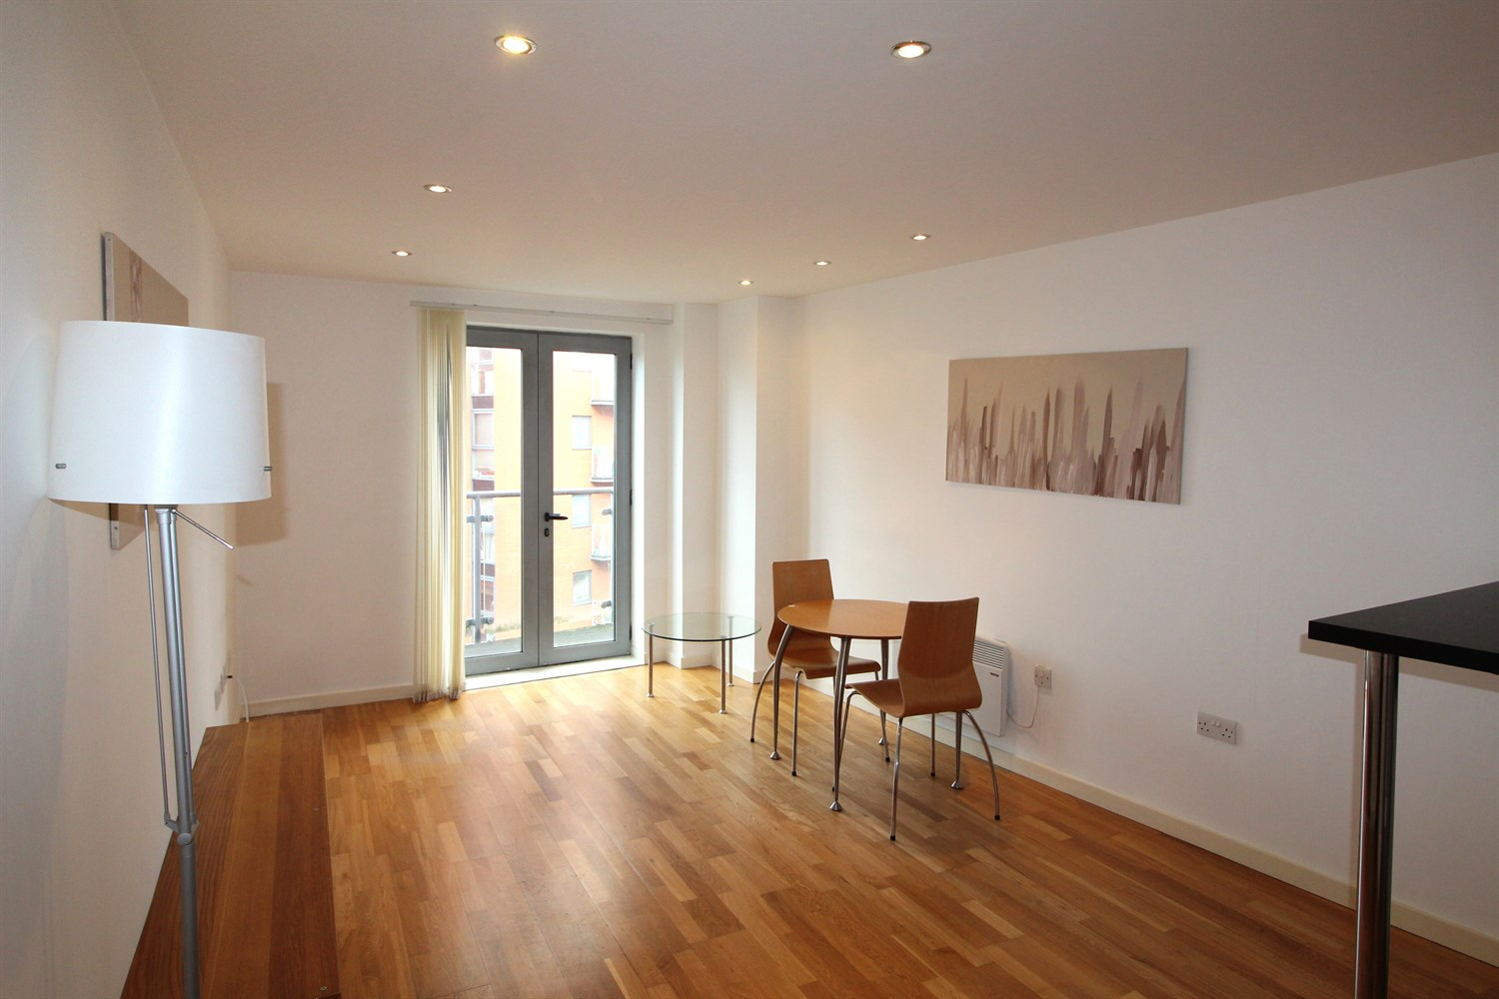

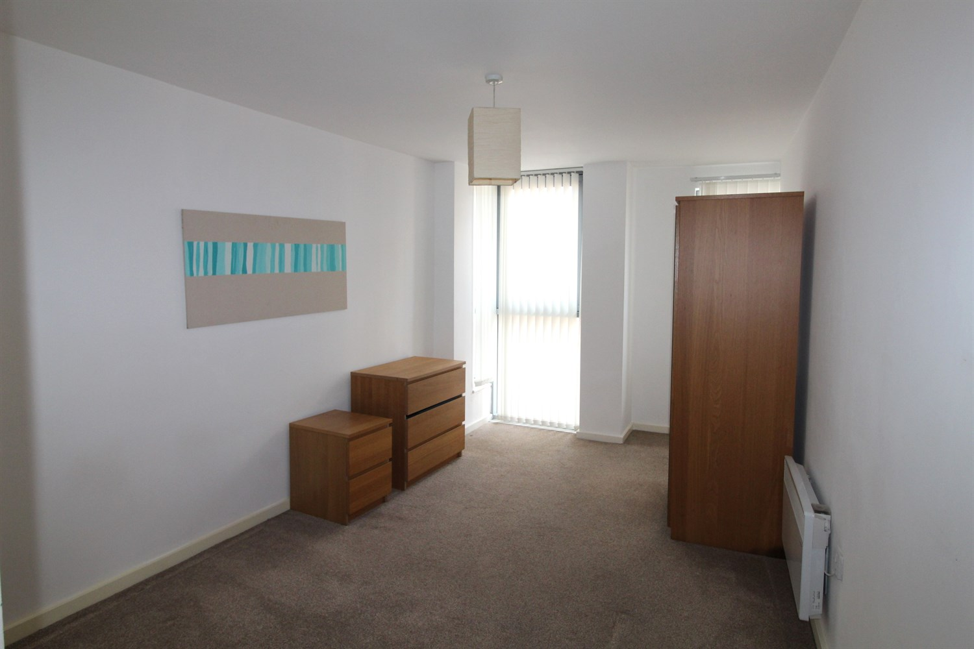

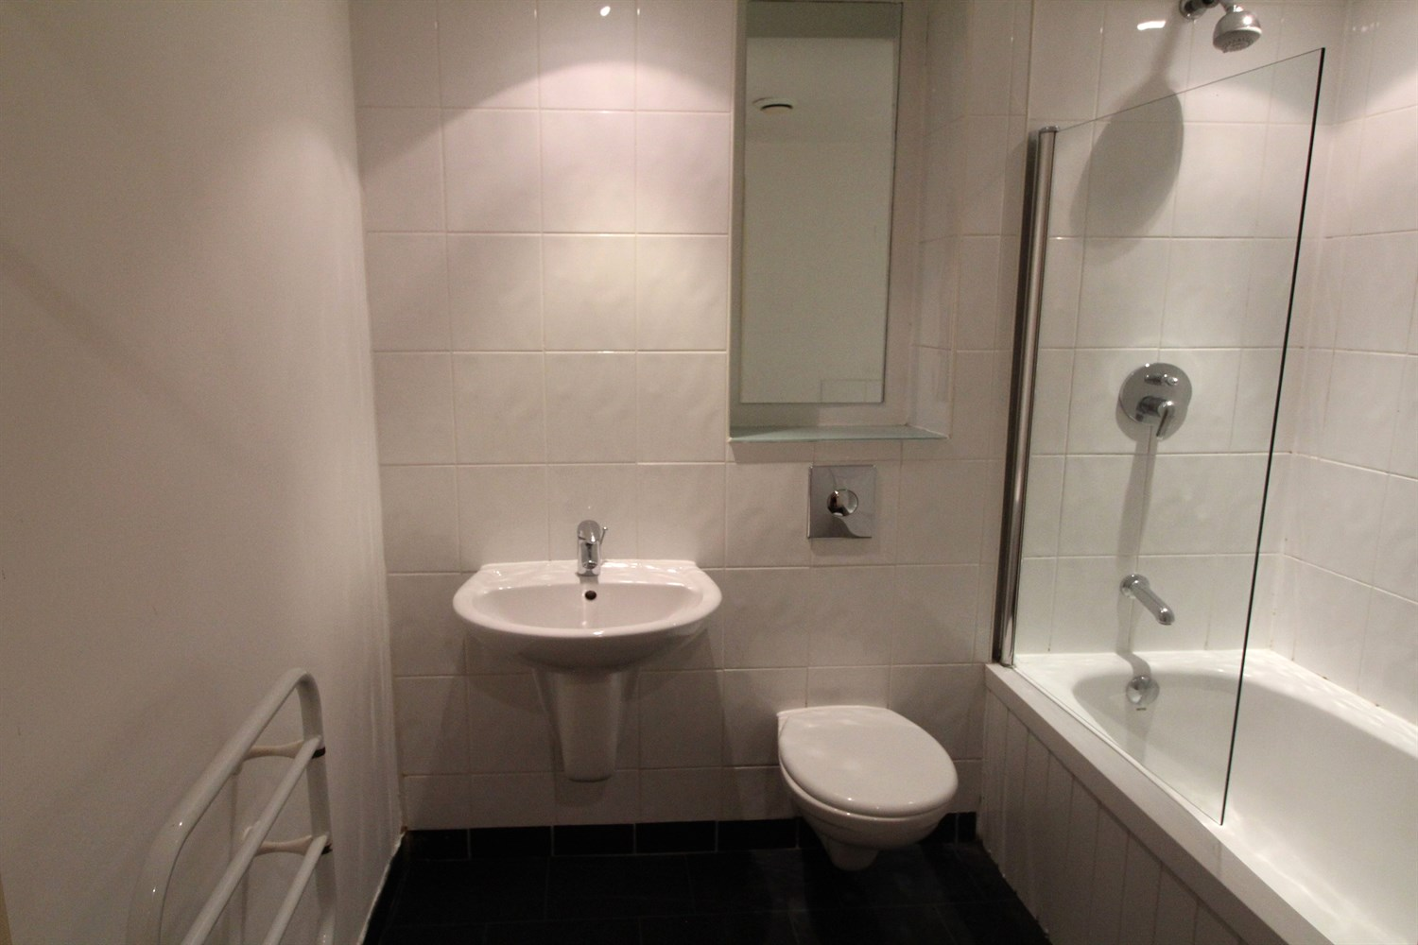

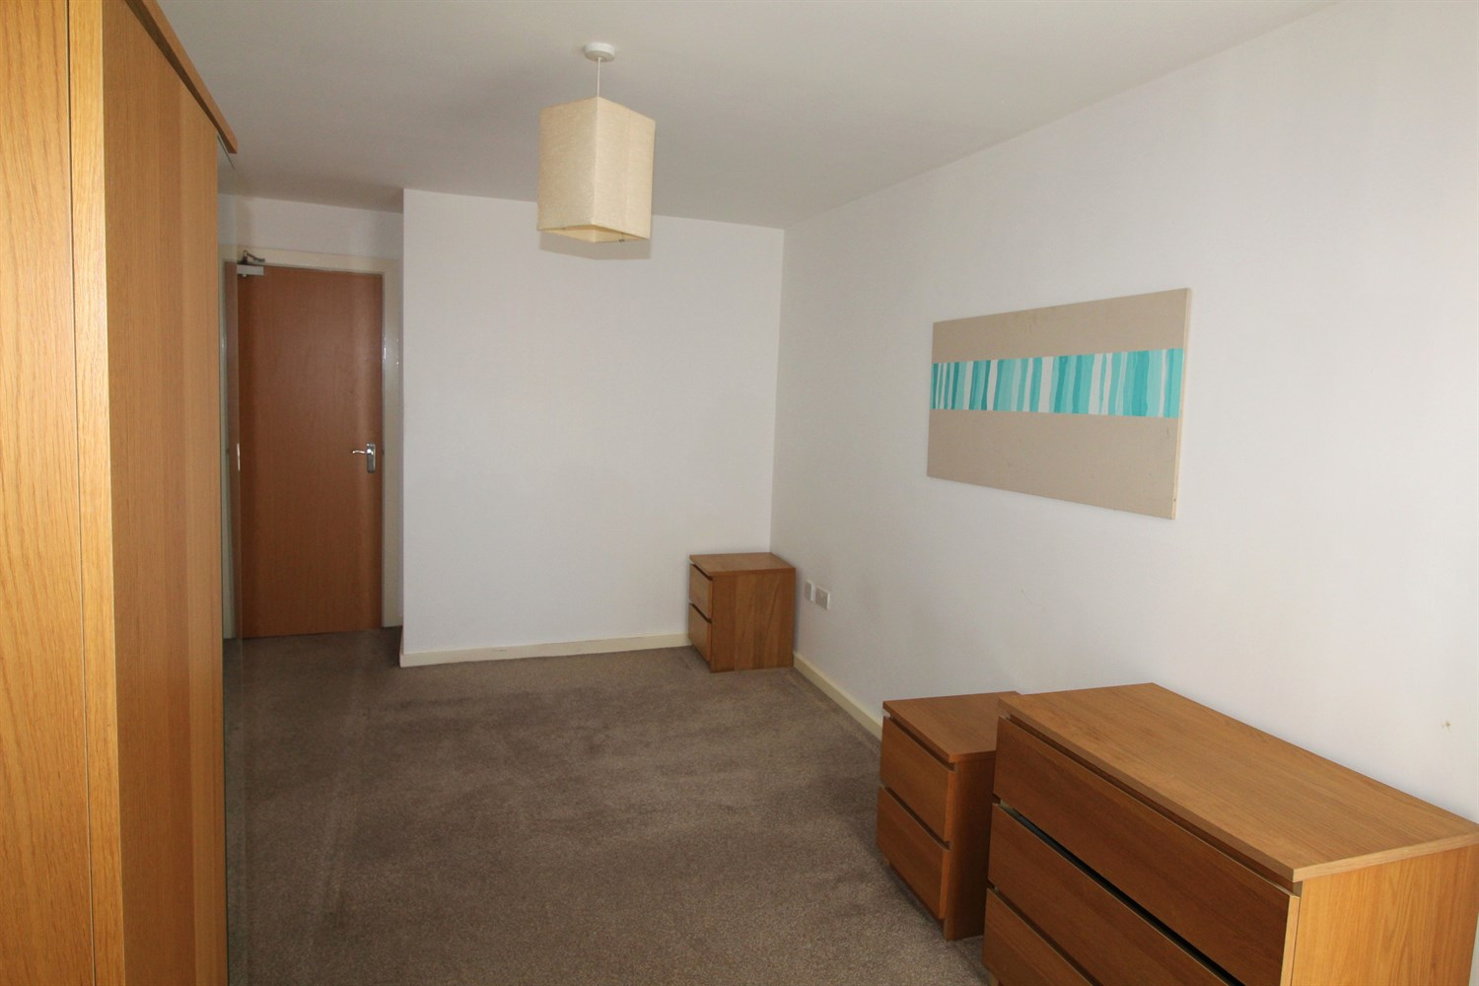

|  |
| --- |
| **Communal Entrance**  With intercom system and access to all floors via lift and staircase. |
| **Private Entrance Hall**  With laminate flooring, entry phone system and door to boiler cupboard. |
| **Open Plan Living Room/Kitchen 1.9m (6'3) x 3m (9'10)**  A well stocked kitchen comprising wall and base mounted units with single drainer stainless steel sink unit with mixer tap, integrated fridge freezer, oven, hob and extractor, washing machine and dishwasher. Inset ceiling spotlights. |
| **Lounge 3.2m (10'6) x 5.8m (19'0)**  Living area with doors to balcony overlooking the piazza. Wall mounted electric radiator. |
| **Bedroom 2.9m (9'6) x 5.8m (19'0)**  Double bedroom with double glazed window. Wall mounted electric heater. |
| **Bathroom**  Fitted with a three piece white suite comprising: bath with shower above, wash hand basin and WC. Tiled walls. heated towel rail. Inset ceiling spotlights. |
|  |
|  |
| **Tenure**  Ground rent is £200 pa Lease is 999 years from 1st Jan 2003 |
| **Service Charge**  £914.30 half yearly |

|  |
| --- |
|  |

These particulars are intended to give a fair description of the property, but their accuracy cannot be guaranteed, and they do not constitute an offer of contract. Intending purchasers must rely on their own inspection of the property. None of the above appliances/services have been tested by ourselves. We recommend purchasers arrange for a qualified person to check all appliances/services before legal commitment.

**Property Ref:** 5374

**For more information, please contact**

0113 258 1150 **|** [sales@adairpaxton.co.uk](mailto:sales@adairpaxton.co.uk) **|** www.adairpaxton.co.uk