

**0113 258 1150**

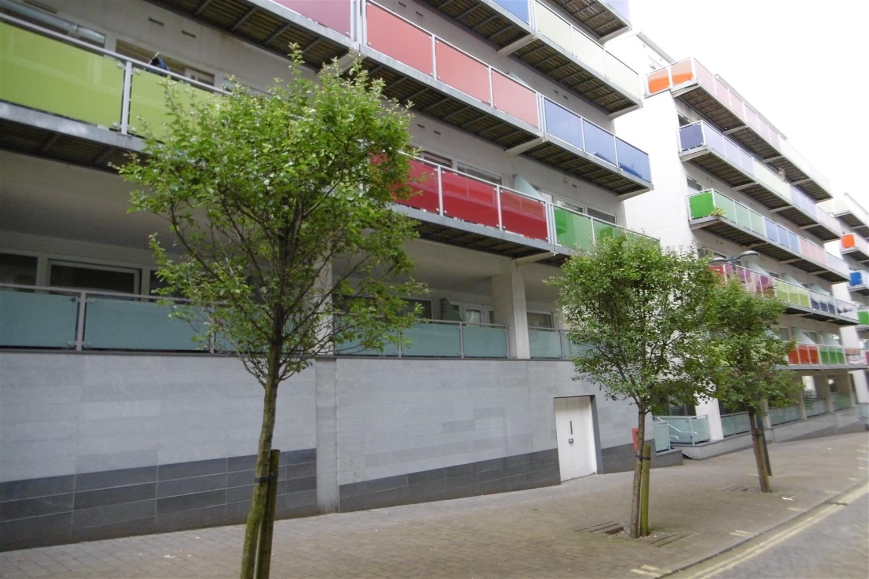



**Available to let £950.00pcm**

**Concord Street, Leeds**

***ALLOCATED PARKING SPACE*** SPACIOUS TWO DOUBLE BEDROOM APARTMENT IN THIS POPULAR BLOCK. A SHORT WALK FROM THE VICTORIA GATE DEVELOPMENT AND TRENDY NORTHERN QUARTER*** Comprising; entrance hall, spacious open plan living/dining/kitchen, floor to ceiling windows and spacious balcony, two double bedrooms and stylish shower room. The apartment must be viewed to be appreciated. Furnished. Bond £1095. Available Now. Council tax band C, EPC rating C.

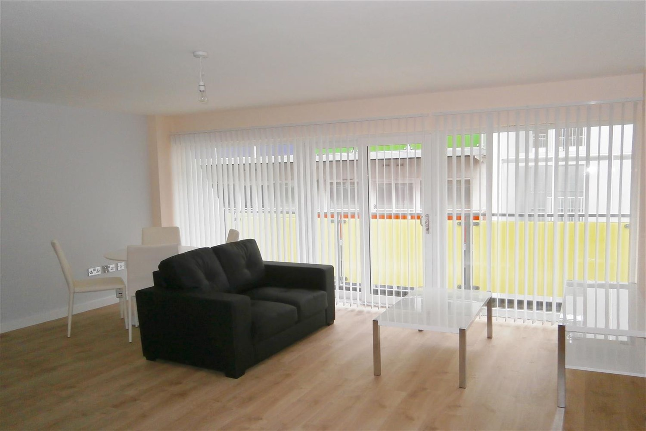

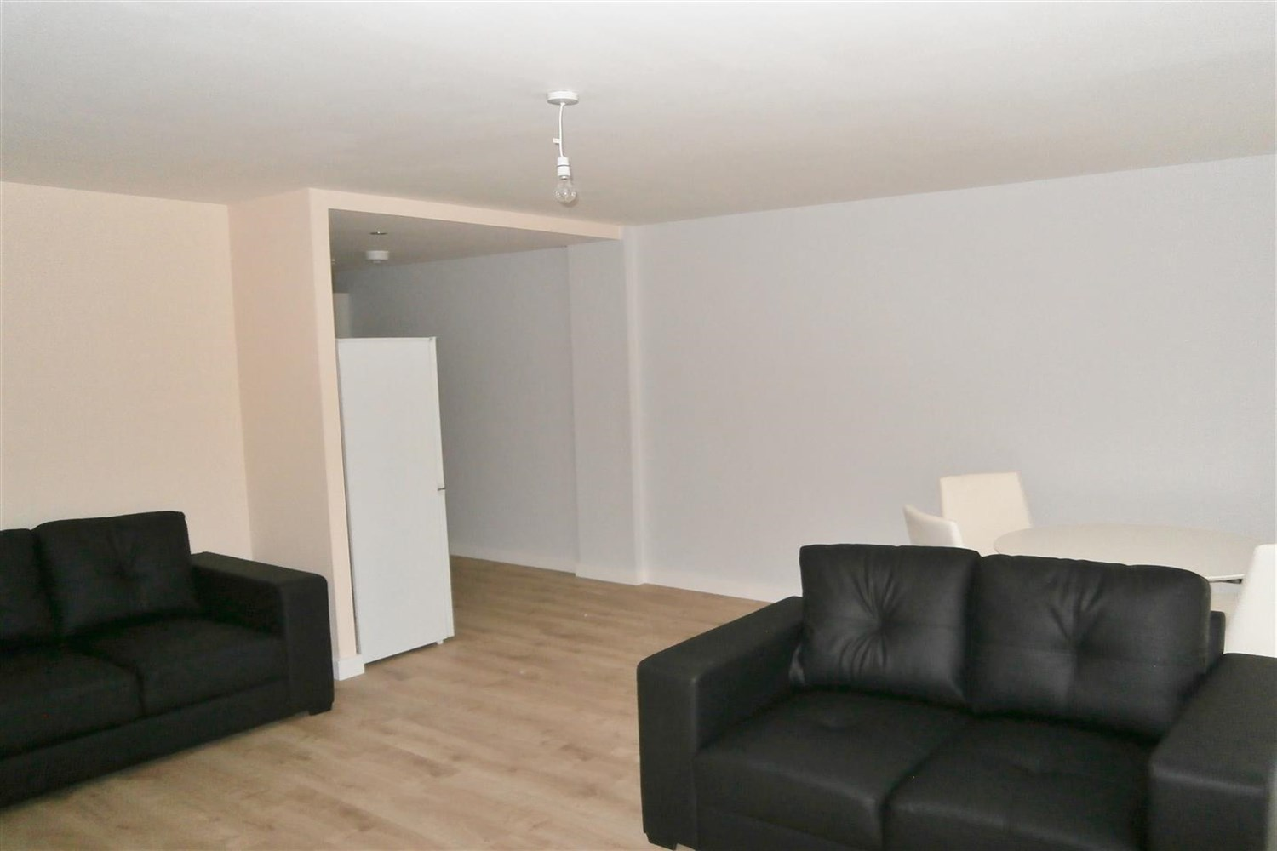

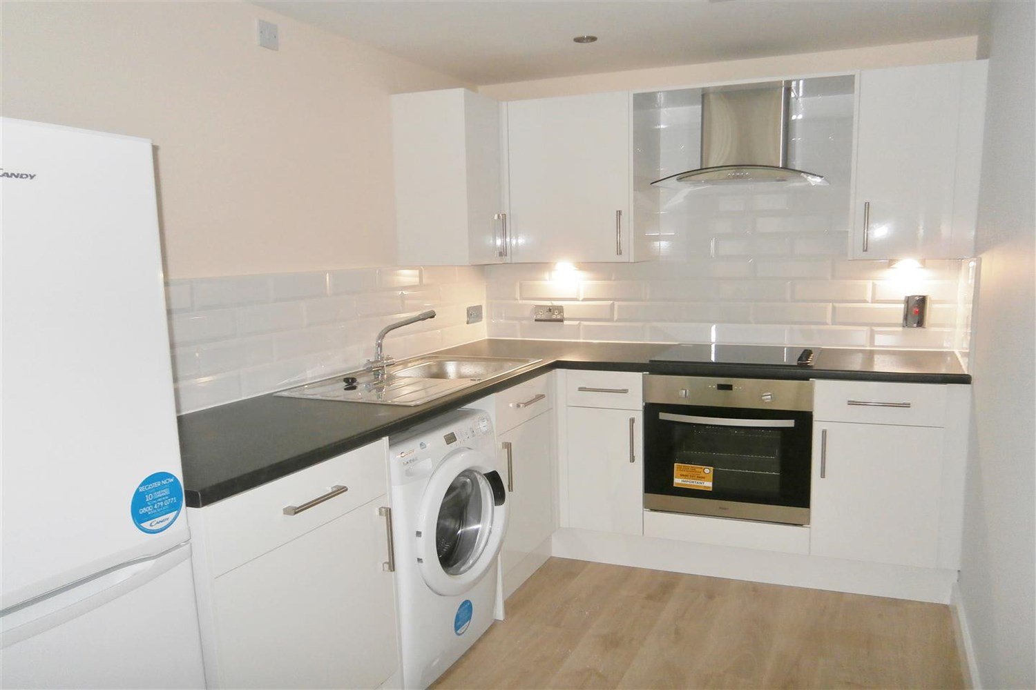

1 Bathroom(s)

1 Reception(s)

0 Bedroom(s)

00

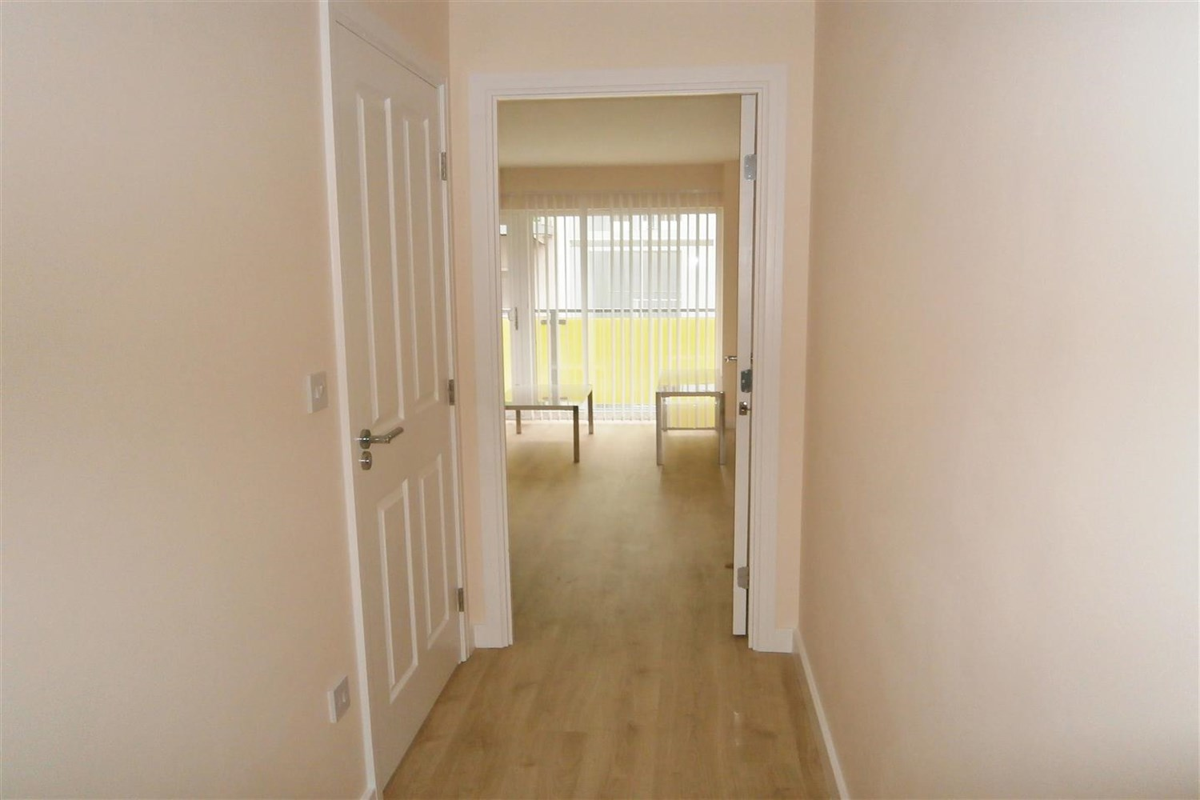

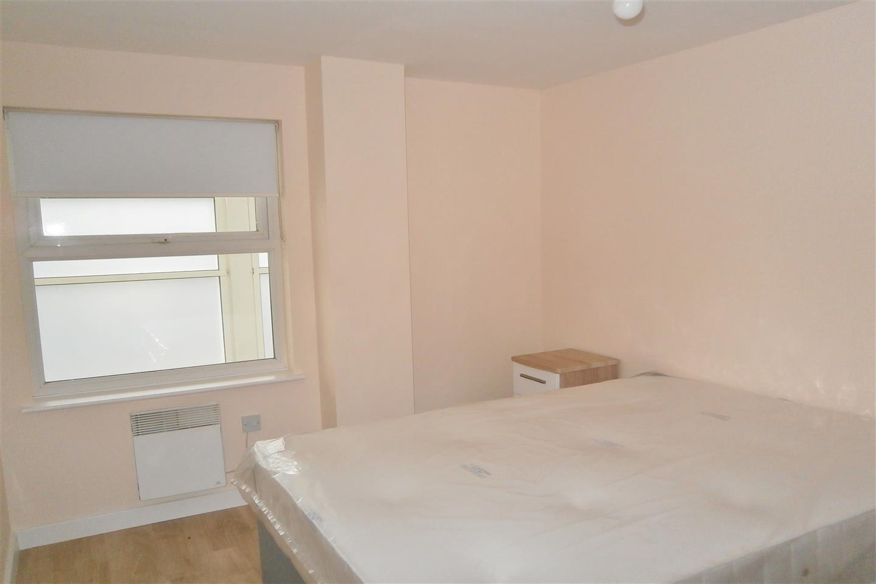

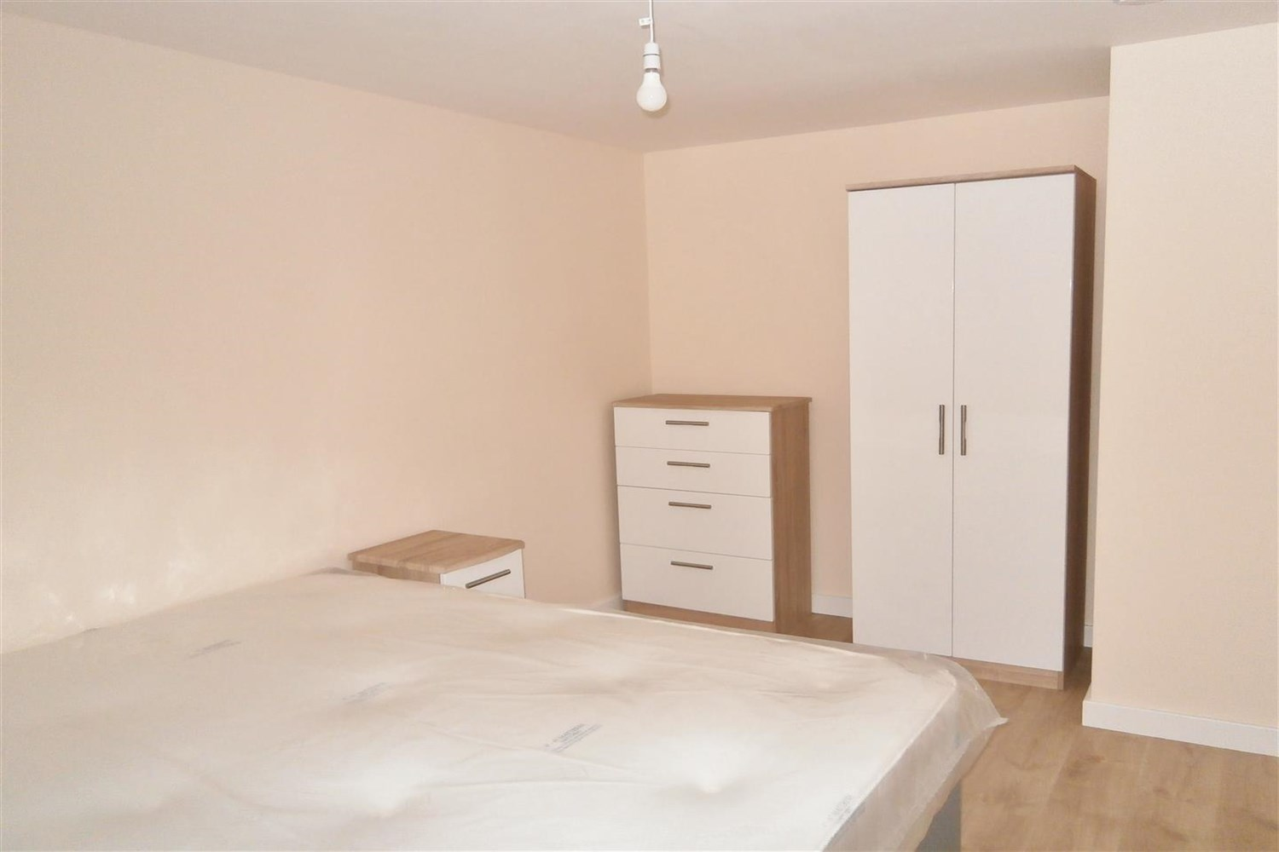

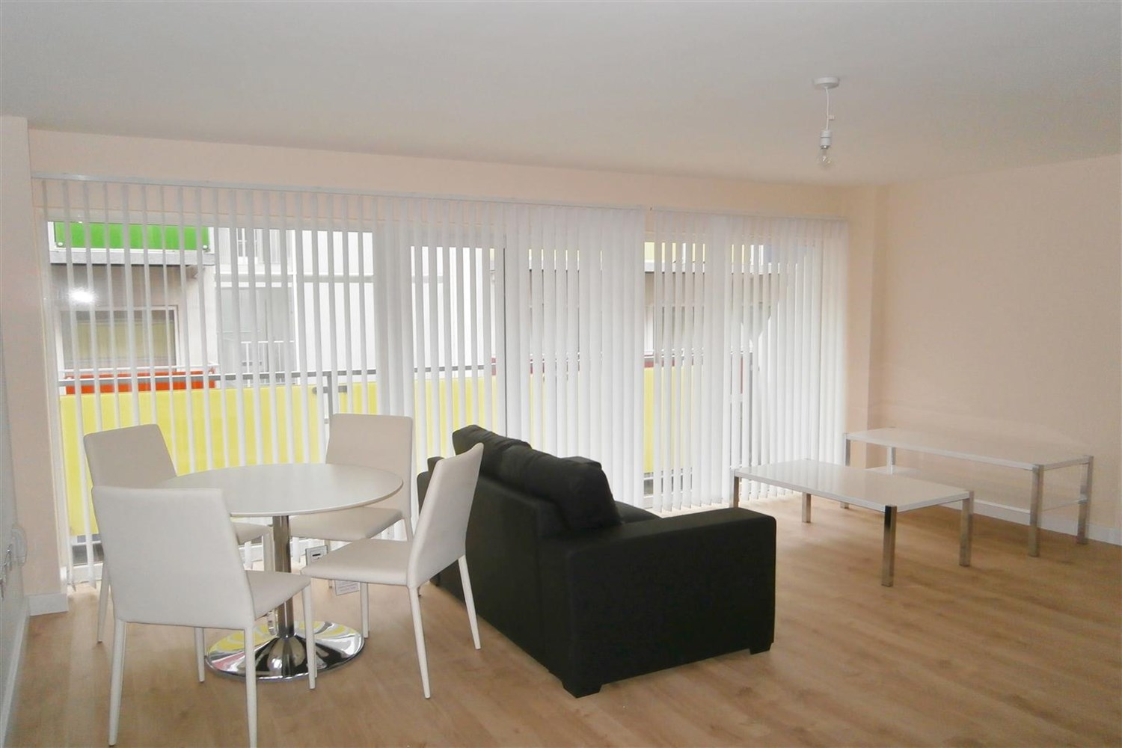

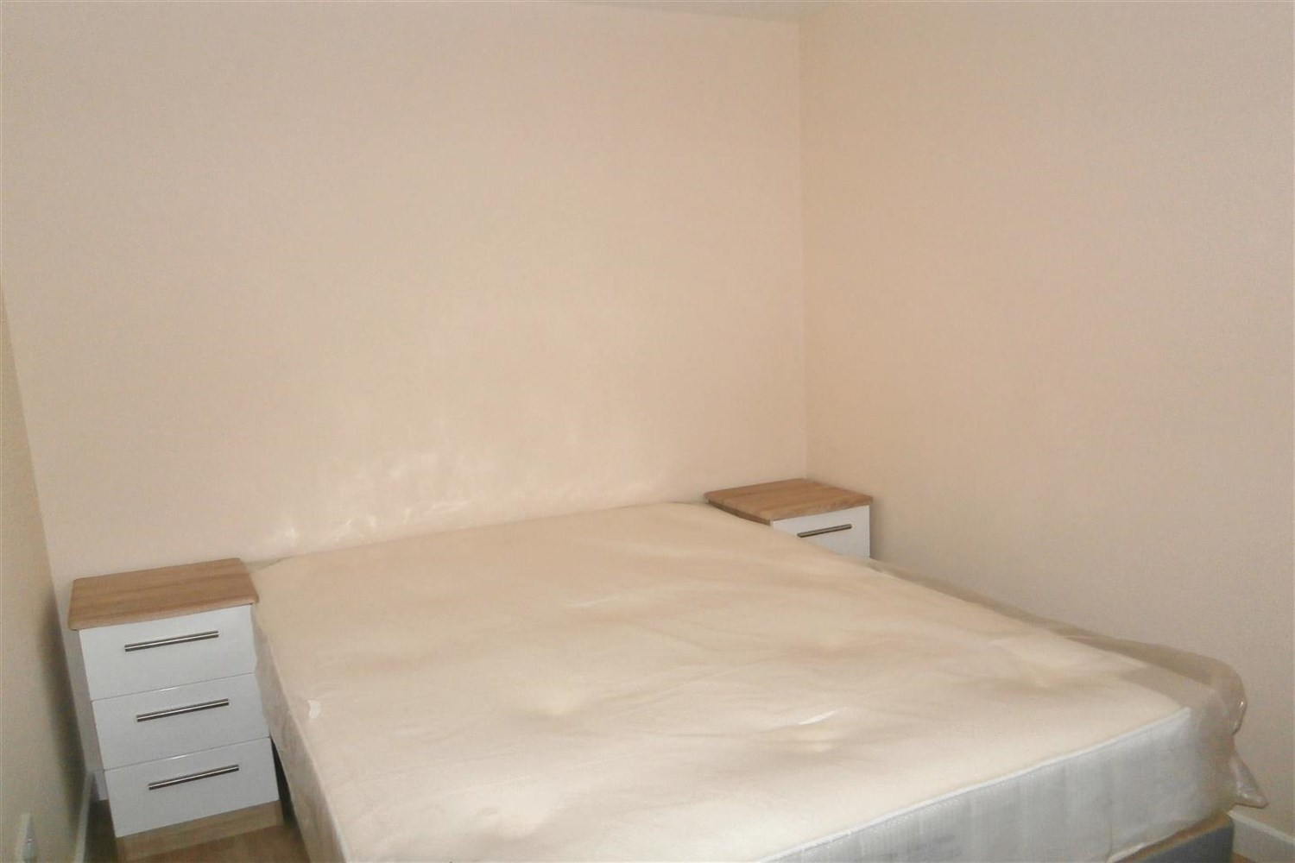

|  |
| --- |
| **Living/ Kitchen**  Spacious open plan living/dining and kitchen, sliding doors leading to balcony. |
| **Bedroom 1**  Double bedroom, with a window to the front and electric wall heater. |
| **Bedroom 2**  Second bedroom with window to rear and electric wall heater. |
| **Bathroom**  Three piece bathroom suite, walk in shower cubical, hand wash basin and w/c, ceramic floor and walls tiles heated electric towel rail. |
| COUNCIL TAX BAND: C EPC Rating C  Leasehold property Parking included  Mobile availability: EE Likely to have good coverage. Three likely to have good coverage. O2 likely to have good coverage. Vodafone limited coverage.  Broadband: Virgin Media only. Standard 15 Mbps 1 Mbps Good Superfast 80 Mbps 20 Mbps Good Ultrafast 1000 Mbps 1000 Mbps  Utilities: Water supplied on standard meters. Electric mains supplied on standard meters. |
| **Parking**  Allocated Parking underground. |

|  |  |
| --- | --- |
| These particulars are intended to give a fair description of the property, but their accuracy cannot be guaranteed, and they do not constitute an offer of contract. Intending purchasers must rely on their own inspection of the property. None of the above appliances/services have been tested by ourselves. We recommend purchasers arrange for a qualified person to check all appliances/services before legal commitment.  **Property Ref:** 4545  **For more information, please contact**  0113 258 1150 **|** [lettings@adairpaxton.co.uk](mailto:lettings@adairpaxton.co.uk) **|** www.adairpaxton.co.uk |  |