

**0113 258 1150**

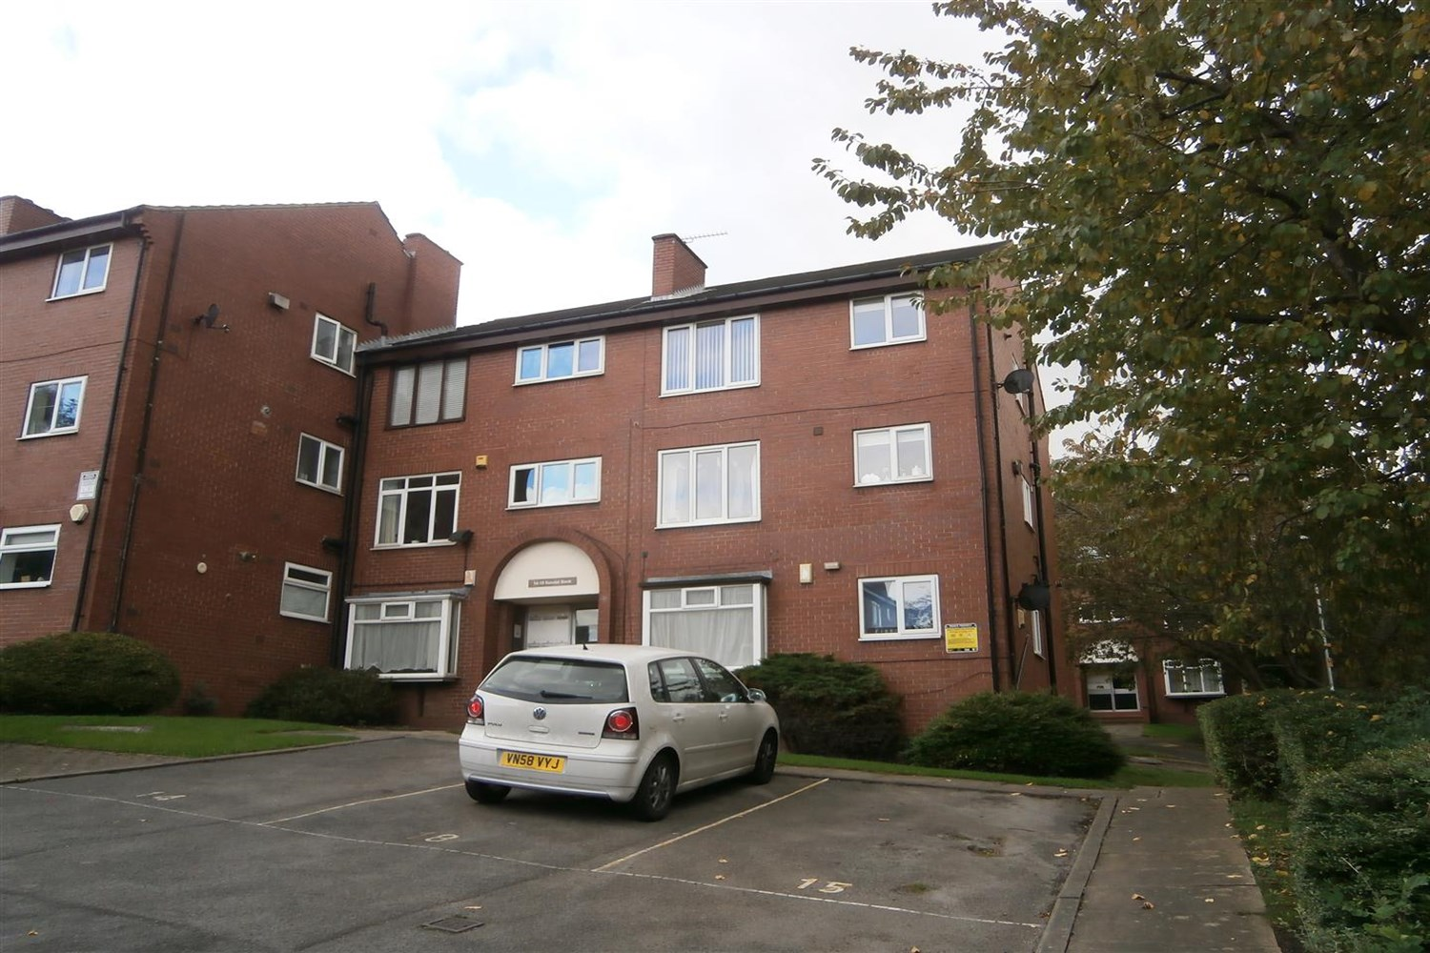



**Reactivated £850.00pcm**

**Kendal Bank, LS3**

Adair Paxton are delighted to offer this well presented top floor two double bedroom furnished apartment with ALLOCATED PARKING in a great location close to the City centre, University and all amenities. The property has been decorated to a high standard throughout and benefits from gas central heating. Comprising; hallway with storage cupboard, spacious lounge, kitchen with white goods, two double bedrooms and bathroom with shower over bath, allocated parking. Available 31st March. FURNISHED. Deposit £980, EPC rating C, Council tax band B.

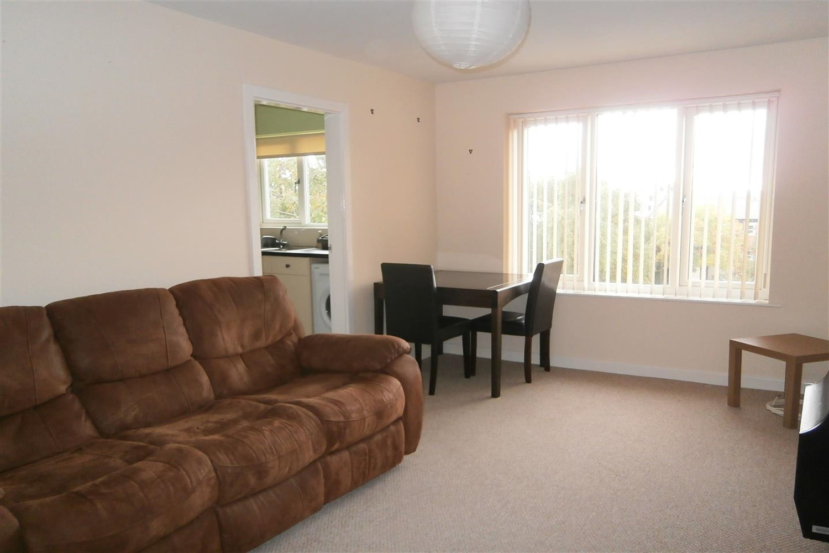

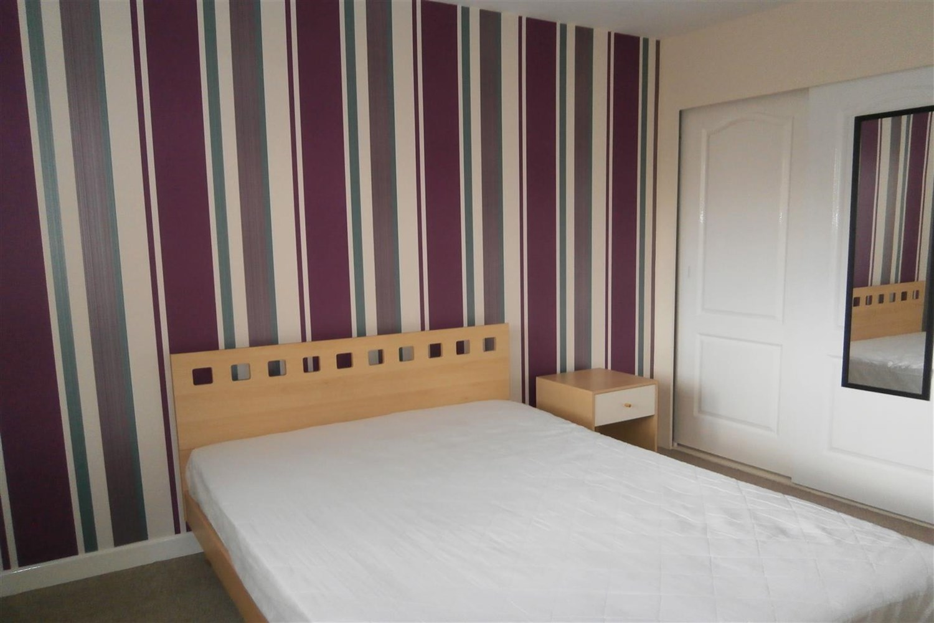

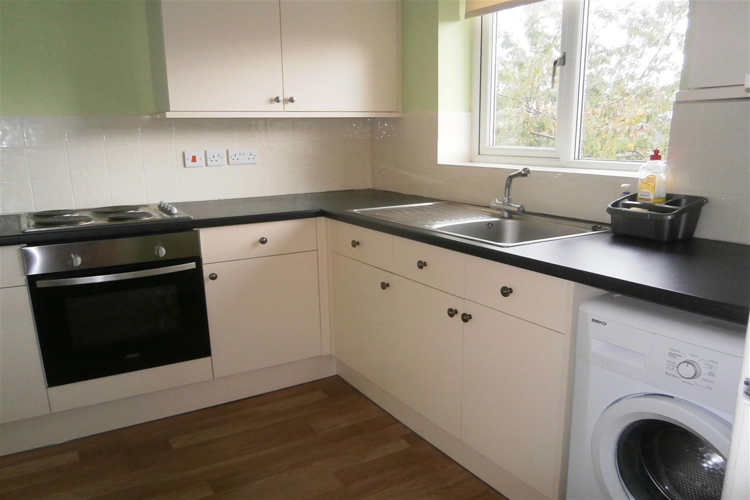

1 Bathroom(s)

1 Reception(s)

2 Bedroom(s)

00

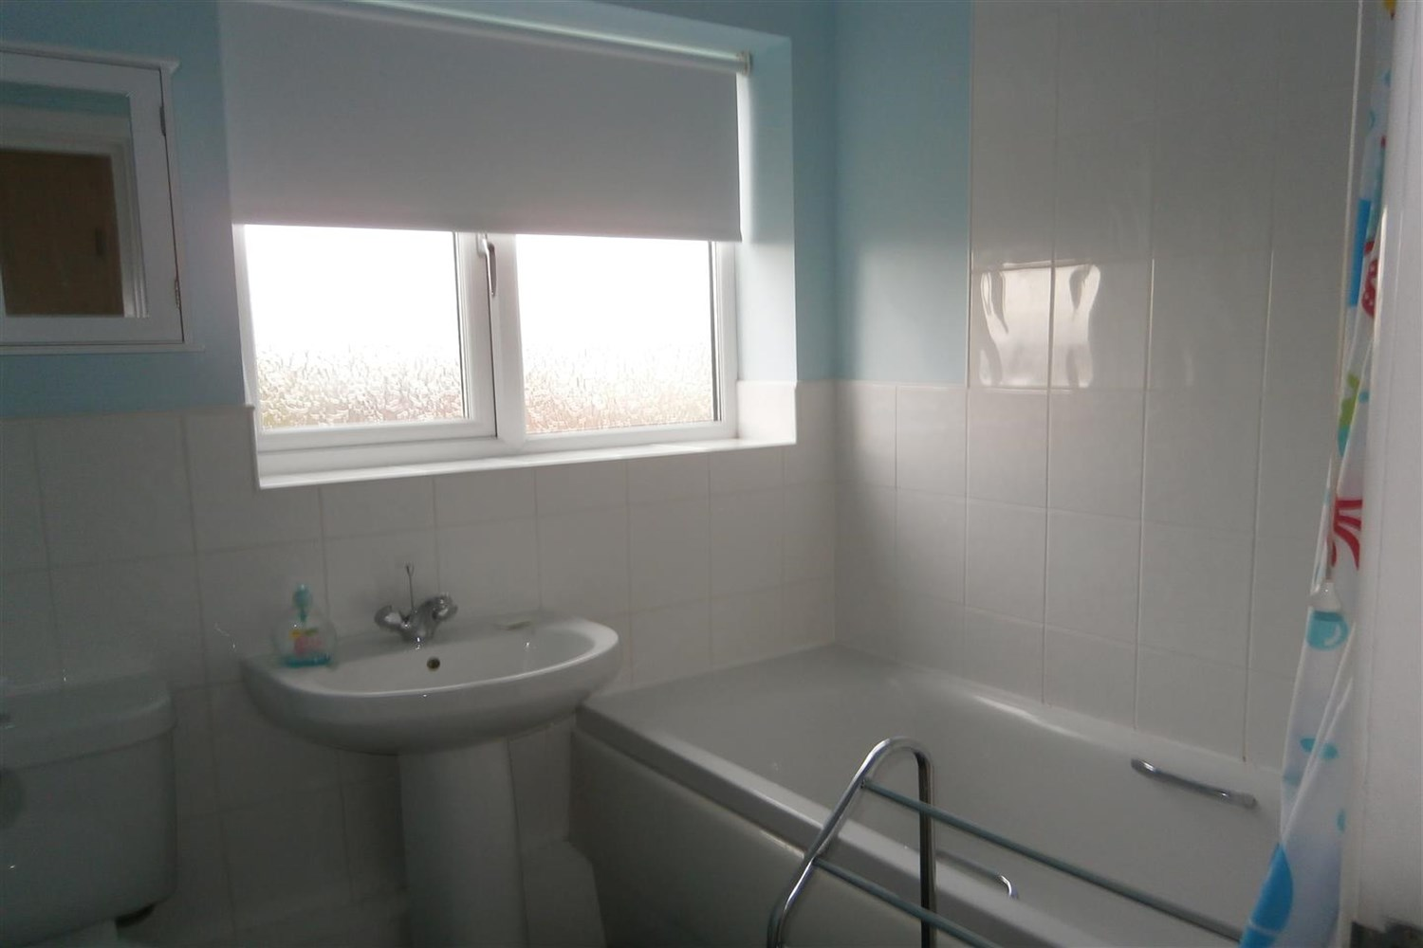

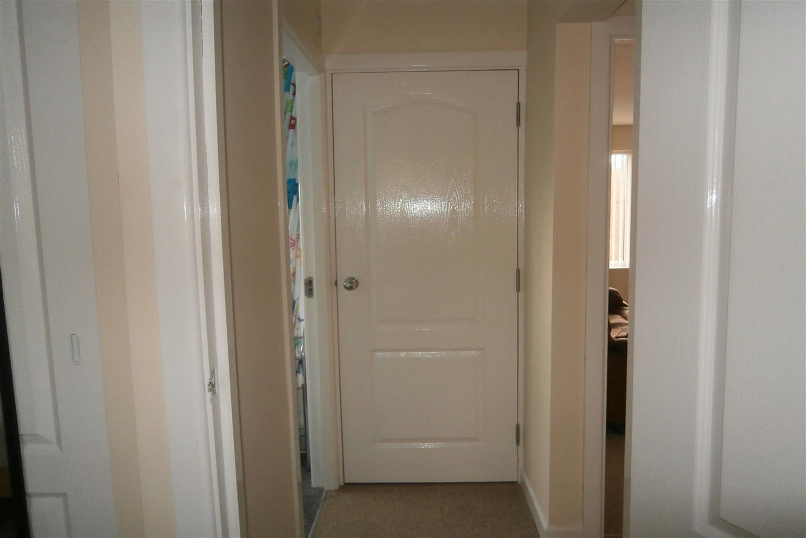

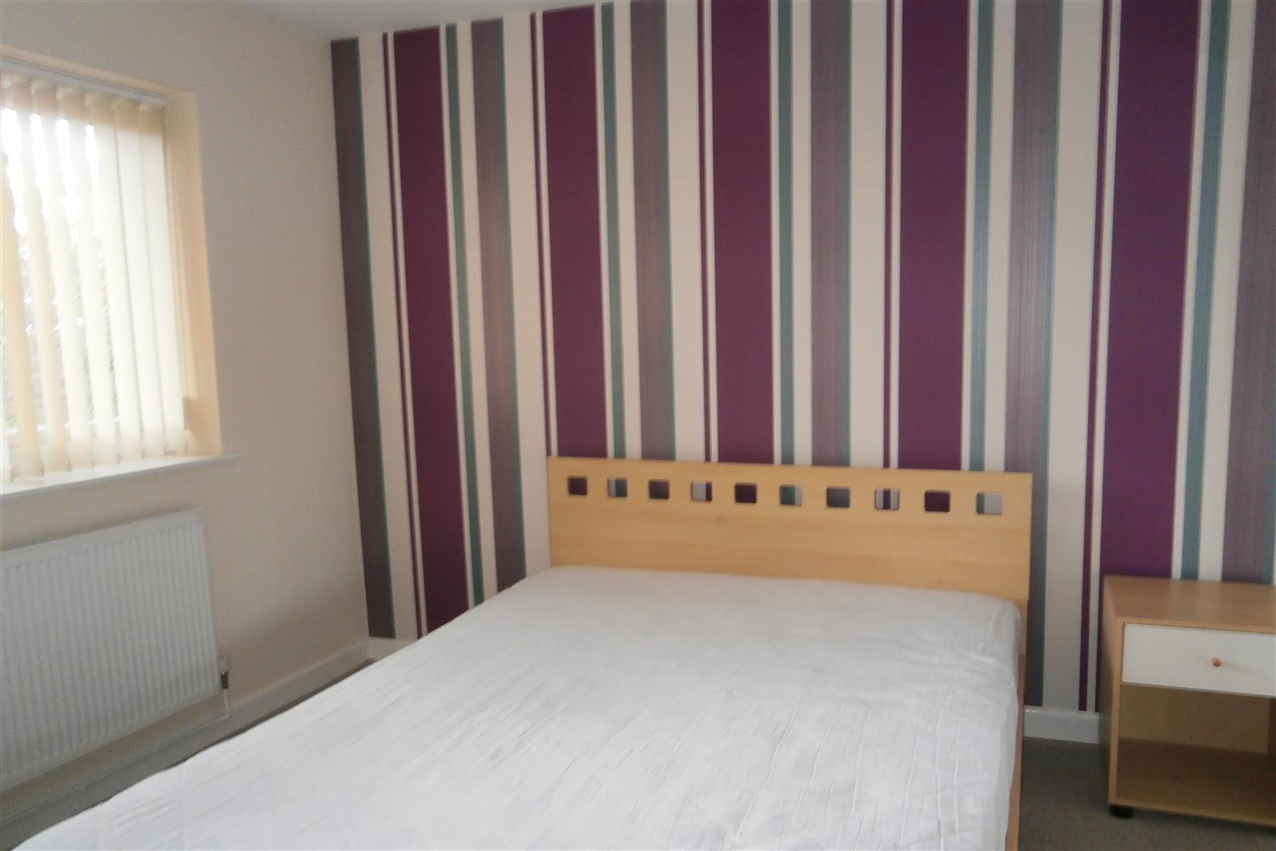

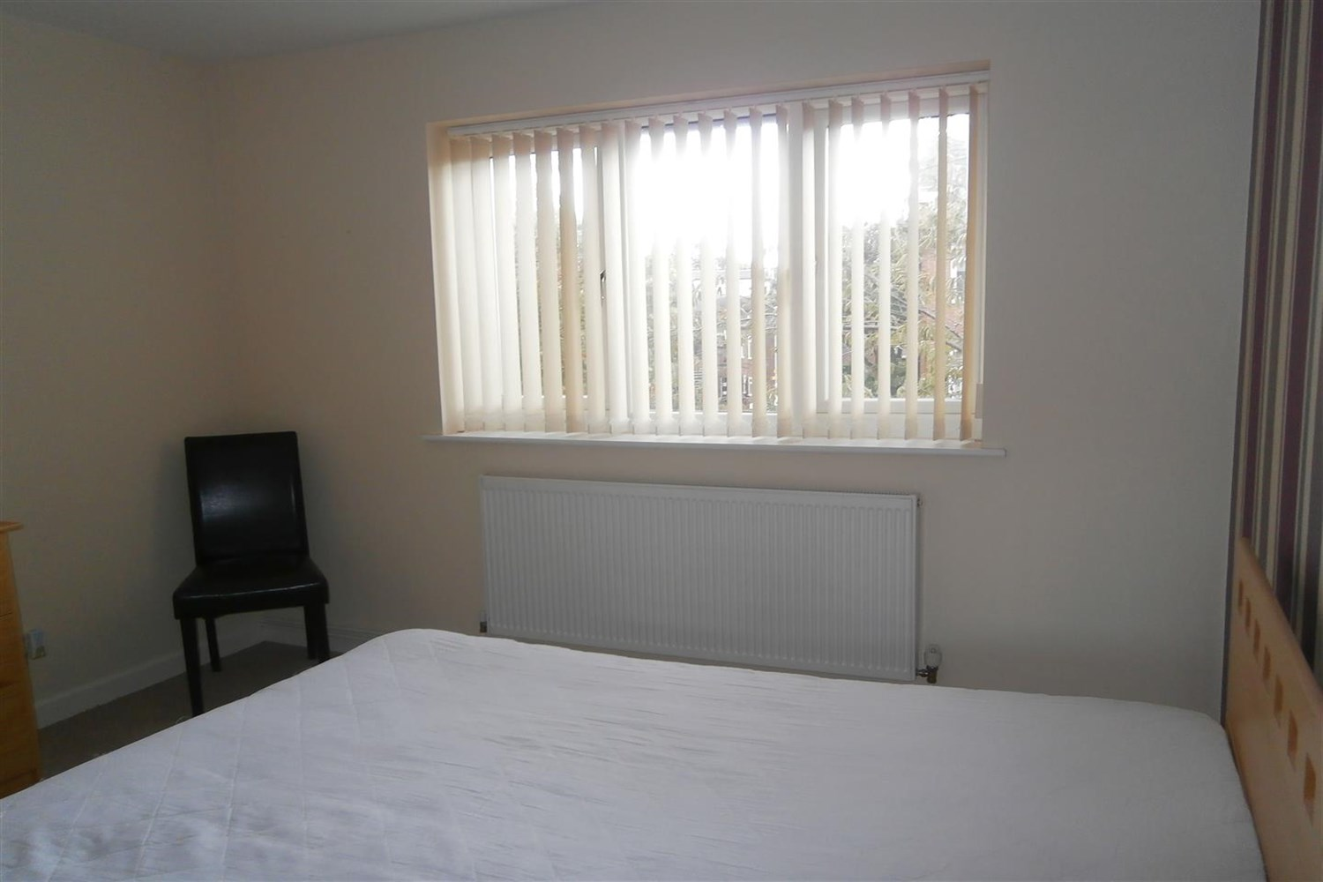

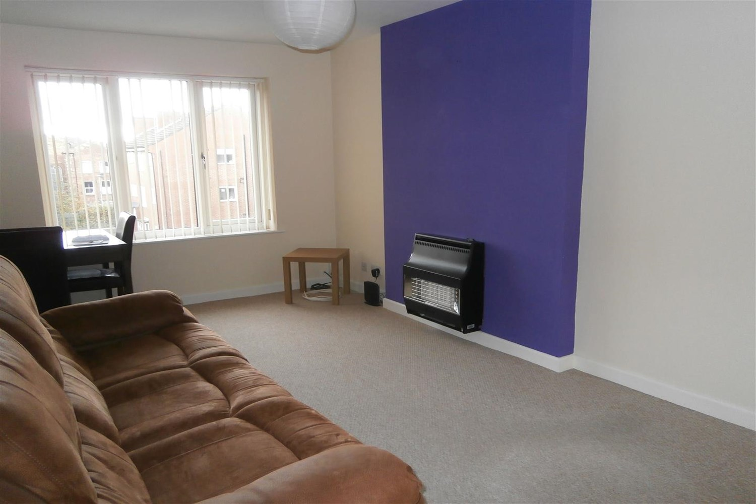

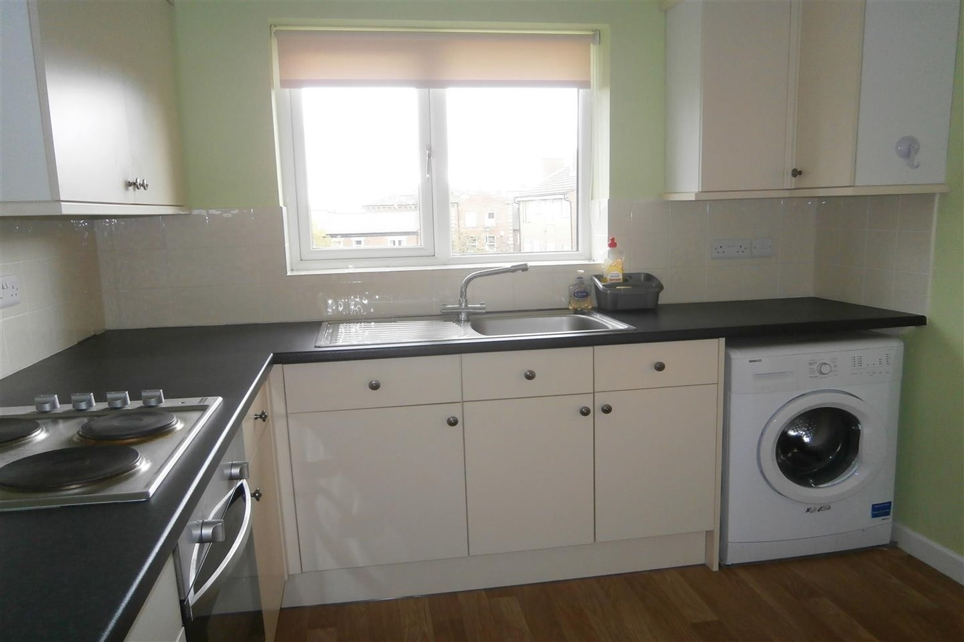

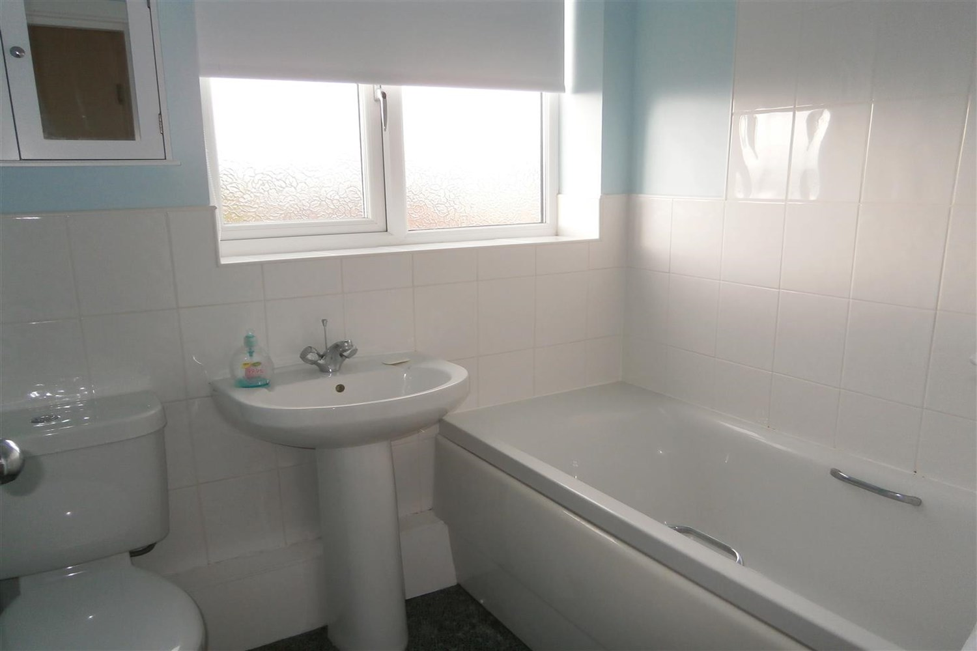

|  |
| --- |
| **Living Room**  Light and airy carpeted living room with window to front. Gas central heating radiator. |
| **Kitchen**  Fitted with a range of wall and base units with worktops over, stainless steel sink with mixer tap. |
| **Bedroom**  Carpeted double bedroom with window to rear. Gas central heating radiator. |
| **Bedroom**  Carpeted double bedroom with window to rear. Gas central heating radiator. |
| **Bathroom**  Three piece bathroom suite, with shower over bath, w/c and hand wash basin. Part tiled walls. |
| **Home Information**  COUNCIL TAX BAND: B EPC Rating C  Leasehold property Parking permit included Broadband: Standard 9 Mbps 0.9 Mbps Good Superfast 80 Mbps 20 Mbps Good Ultrafast 1000 Mbps 1000 Mbps Mobile availability: EE limited coverage. Three limited coverage. O2 likely to have good coverage. Vodafone likely to have good coverage.  Utilities: Water supplied on standard meters. Electric mains supplied on standard meters. |

|  |  |
| --- | --- |
| These particulars are intended to give a fair description of the property, but their accuracy cannot be guaranteed, and they do not constitute an offer of contract. Intending purchasers must rely on their own inspection of the property. None of the above appliances/services have been tested by ourselves. We recommend purchasers arrange for a qualified person to check all appliances/services before legal commitment.  **Property Ref:** 340  **For more information, please contact**  0113 258 1150 **|** [lettings@adairpaxton.co.uk](mailto:lettings@adairpaxton.co.uk) **|** www.adairpaxton.co.uk |  |