

**Whitehall Road, Leeds**

**For Sale £97,500.00**

Offered to the market with NO ONWARD CHAIN, this well presented modern accommodation is this spacious FIRST FLOOR APARTMENT. Being ideally suited to a first time buyer or investor alike and having electric heating, modern fittings and on-site parking the property is well placed for easy access to Leeds City centre, the Motorway network and local transport links. Briefly comprising of: Entrance Hallway with security intercom, spacious Lounge, fully fitted kitchen/diner, Master bedroom with en-suite shower room, second double bedroom, modern house bathroom with three piece white suite and shower. Pleasant communal gardens and parking. Currently tenanted at £800PCM until June 2025.

**0113 258 1150**

**0800 000 000**

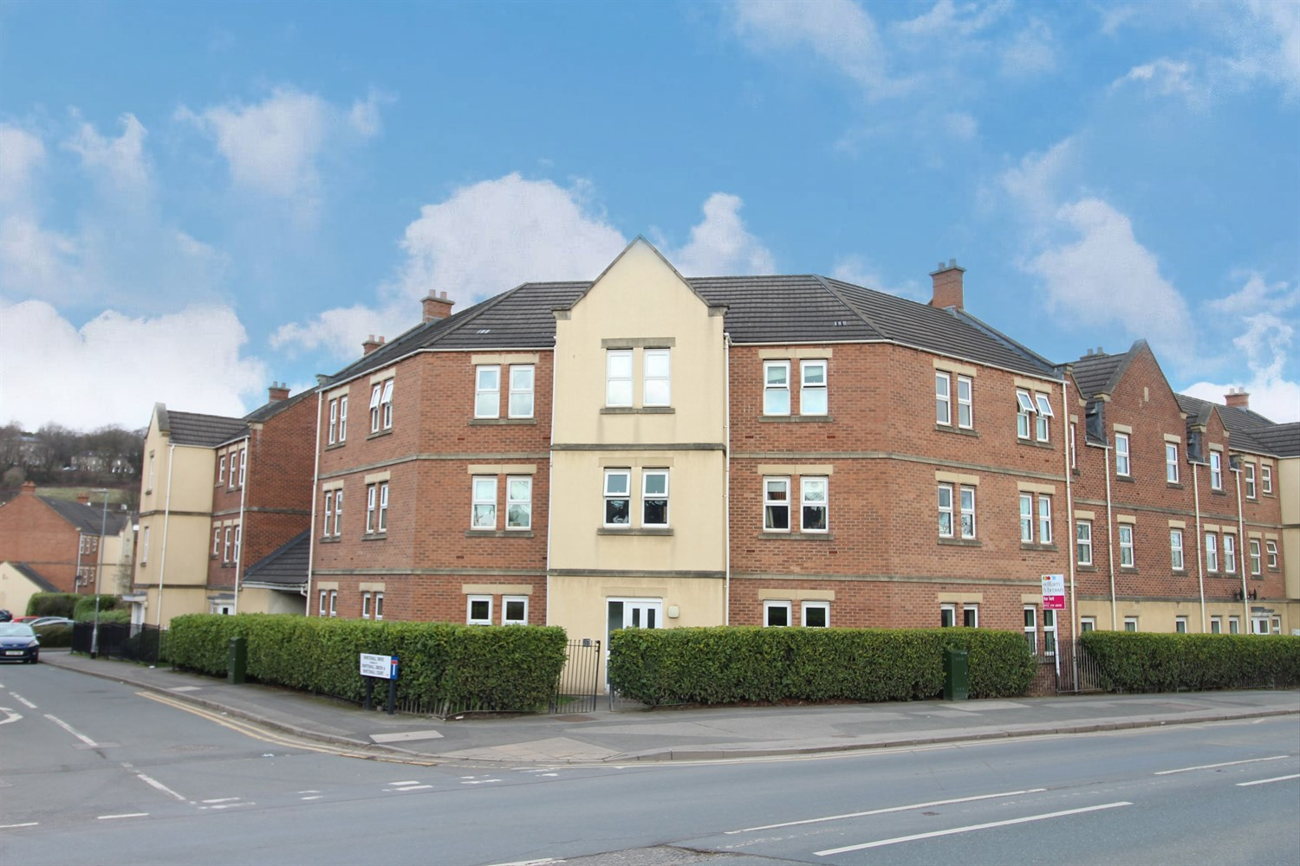



1 Reception(s)

2 Bathroom(s)

2 Bedroom(s)

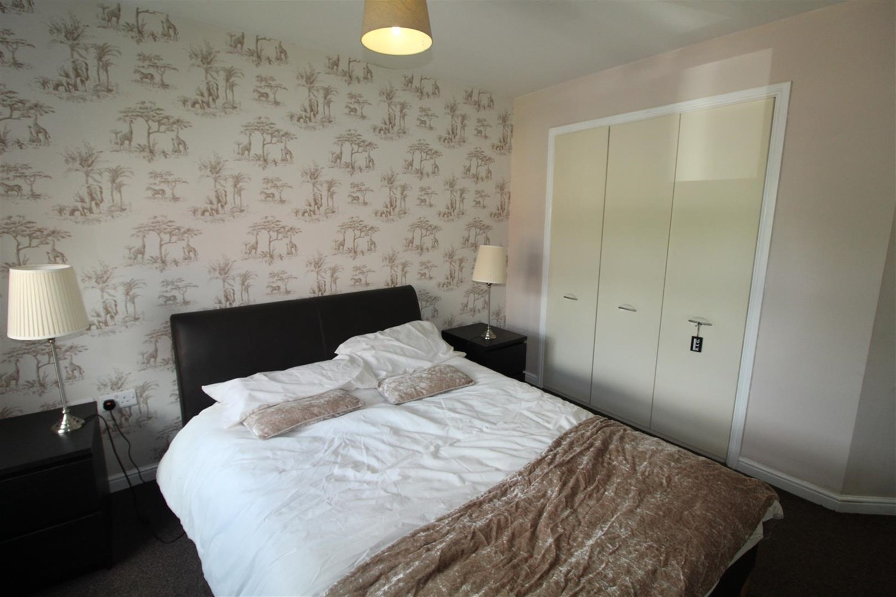

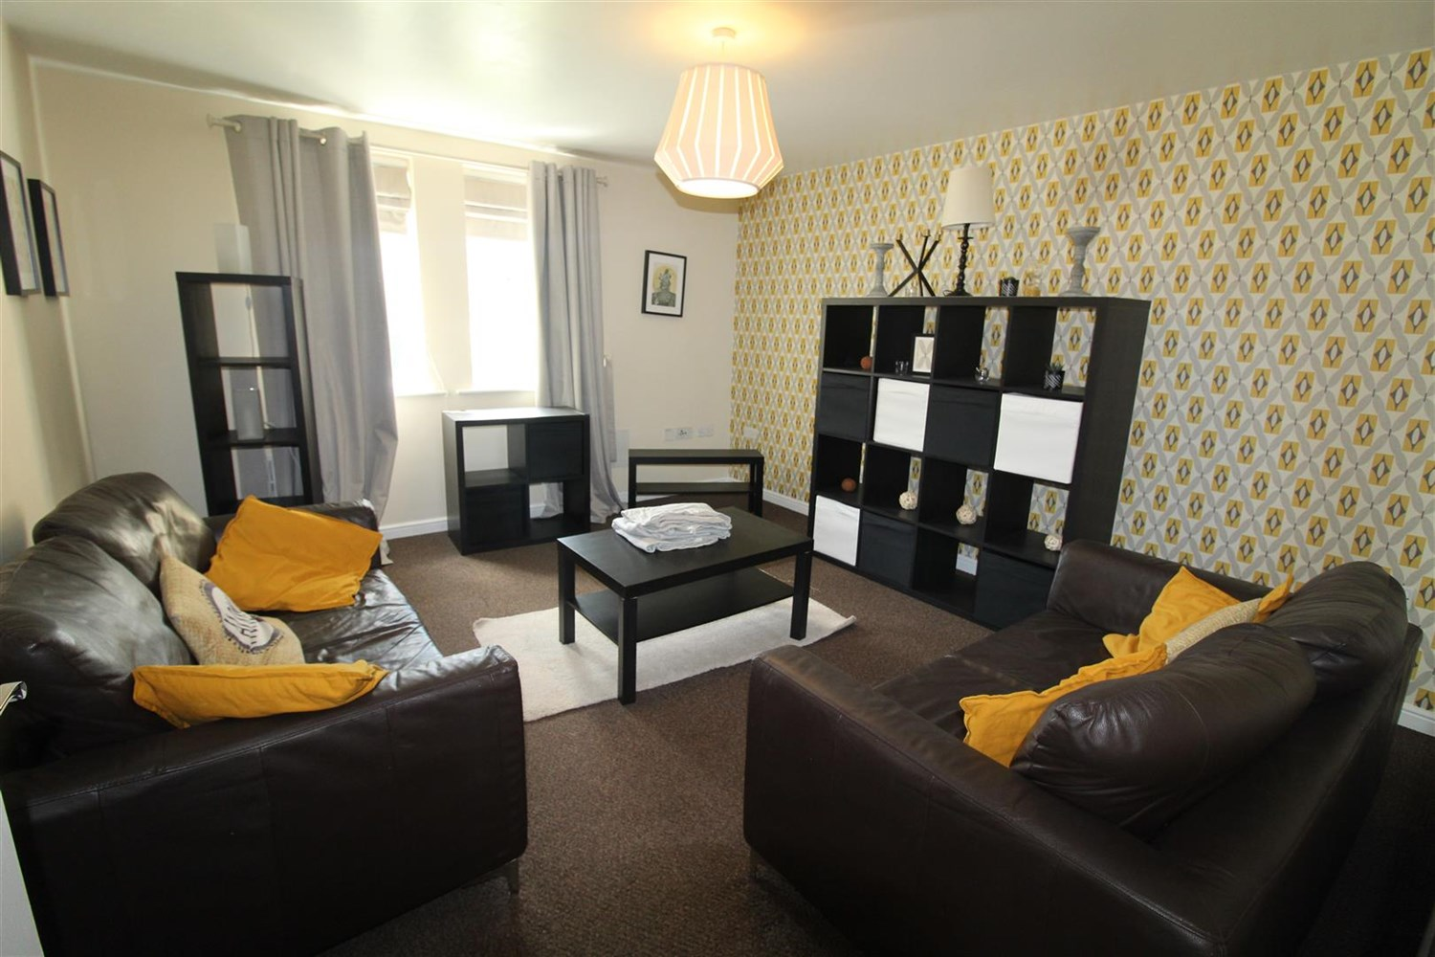

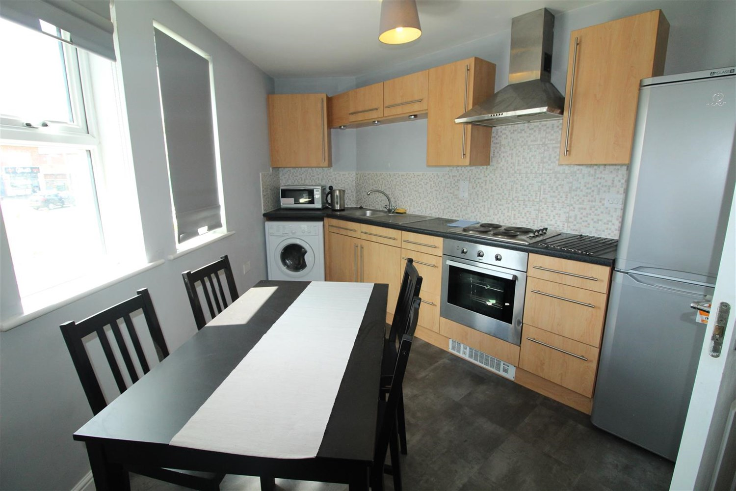

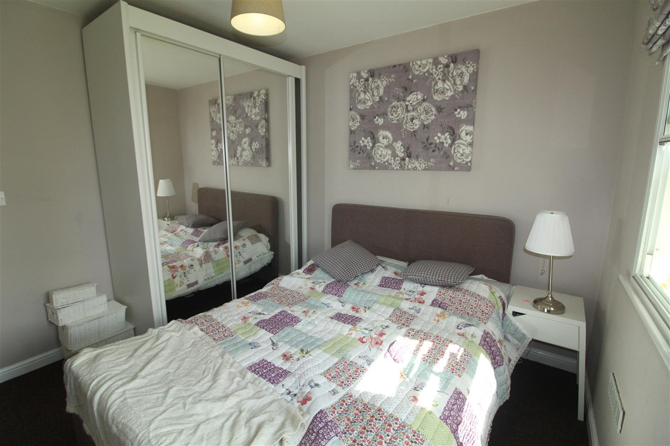

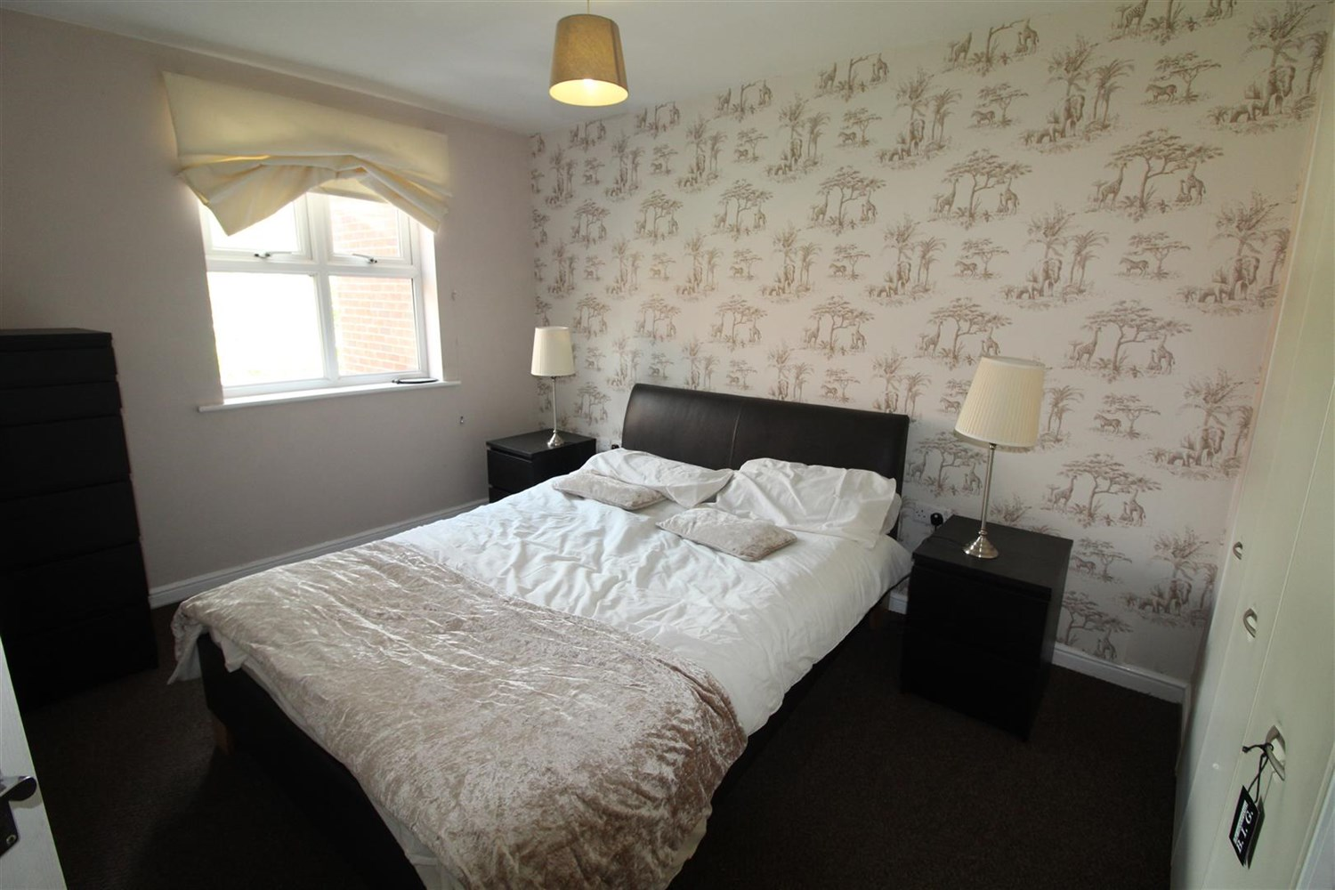

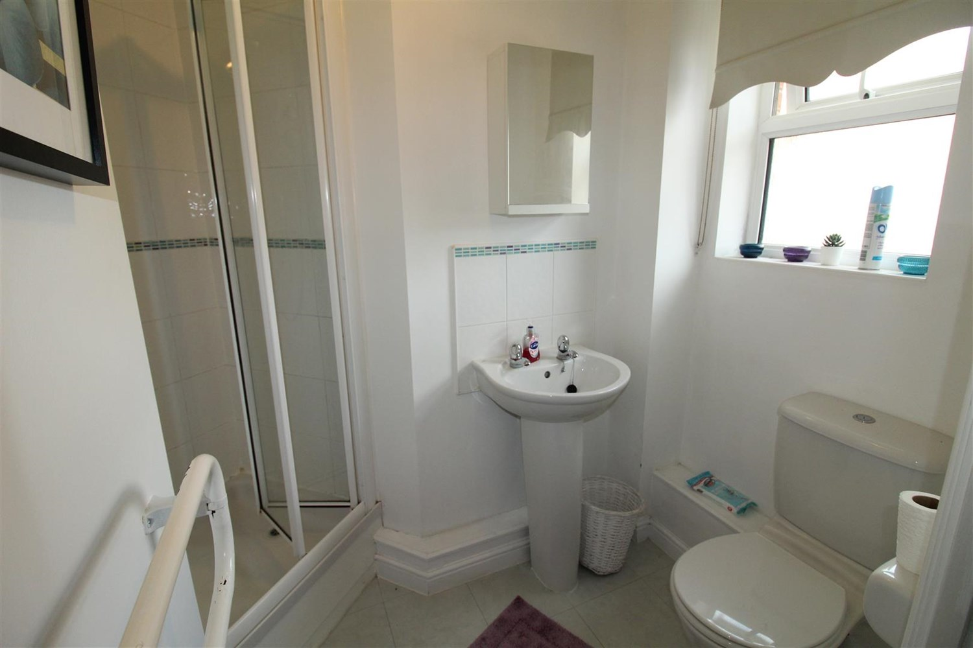

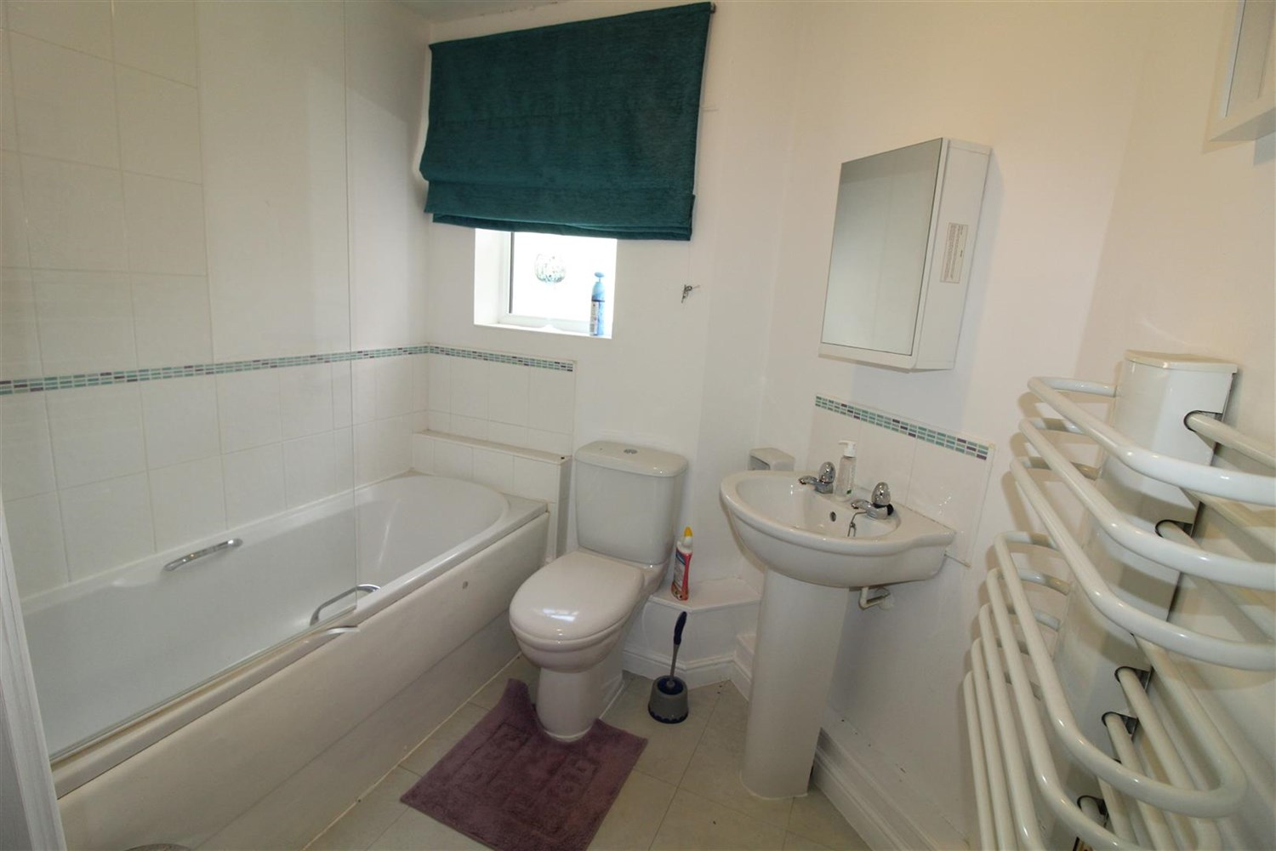

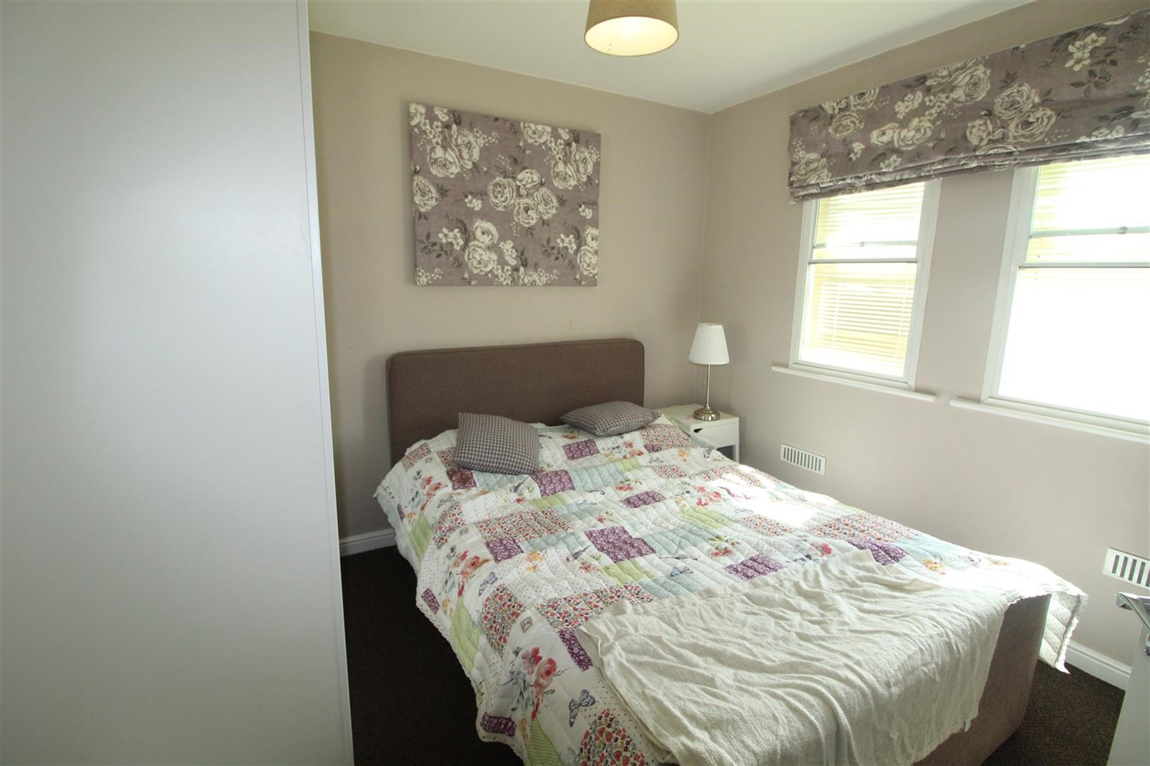

|  |
| --- |
| **Communal Entrance**  Having security intercom system and secure personal mail box. |
| **Private Entrance Hall**  Being of a good size having electric panel heater, storage cupboard housing hot water cylinder. |
| **Lounge**  Spacious living room with two uPVC double glazed window. Wall mounted electric heater. |
| **Kitchen/Diner**  Fitted with a range of wall, base and drawer units with work surfaces and attractive tiled splashbacks. Inset single drainer stainless steel sink unit with mixer tap, integrated stainless steel oven, electric hob and extractor hood over, space for fridge and space for washing machine and uPVC double glazed window. Dining area. |
| **Bedroom 1**  Double bedroom with uPVC double glazed window. Wall mounted electric heater. |
| **En-Suite Shower Room**  Fitted with a three piece white suite comprising; shower cubicle, wash basin and WC. Tiled walls. uPVC double glazed window. |
| **Bedroom 2**  Second double bedroom with uPVC double glazed window. Wall mounted electric heater. |
| **Bathroom**  Fitted with a three piece white suite comprising; bath with shower above, WC and wash hand basin. Tiled walls. uPVC double glazed window. |
| **Tenure**  Leasehold - 125 years from September 2005. Ground rent - £270.00 per annum |
| **Service Charge**  Service charge - £518.96 per six months |

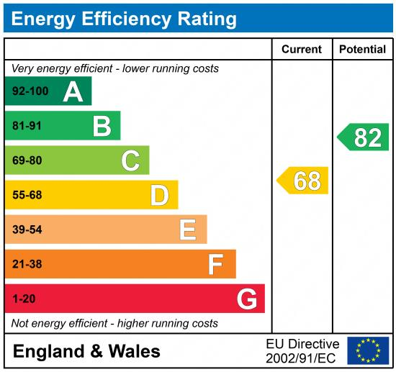

|  |
| --- |
|  |

These particulars are intended to give a fair description of the property, but their accuracy cannot be guaranteed, and they do not constitute an offer of contract. Intending purchasers must rely on their own inspection of the property. None of the above appliances/services have been tested by ourselves. We recommend purchasers arrange for a qualified person to check all appliances/services before legal commitment.

**Property Ref:** 5307

**For more information, please contact**

0113 258 1150 **|** [sales@adairpaxton.co.uk](mailto:sales@adairpaxton.co.uk) **|** www.adairpaxton.co.uk