

**0113 258 1150**

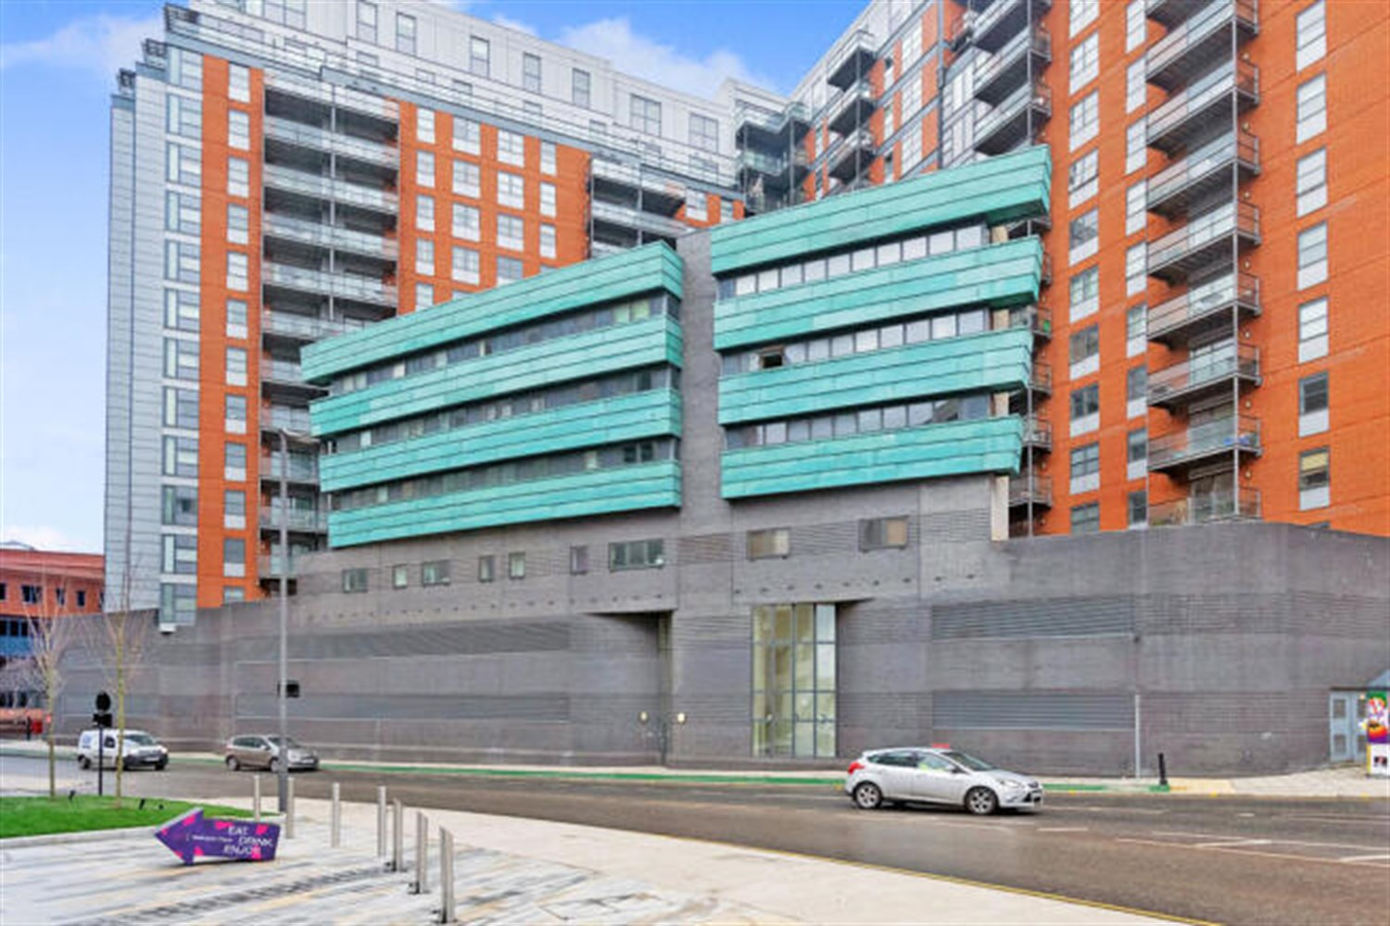



**Available to let £850.00pcm**

**Northern Street Apartments, Leeds**

One bedroom apartment centrally located in the sought after development just off Wellington Street. Perfectly positioned within Leeds's business district. A stones throw from Leeds City Station, and having grocery shops, cafes and bars on your doorstep. southerly views. This first floor apartment is available now and briefly comprises; Hallway, open plan lounge/kitchen, double bedroom and shower room. Council tax band C, EPC rating: C Deposit £980.

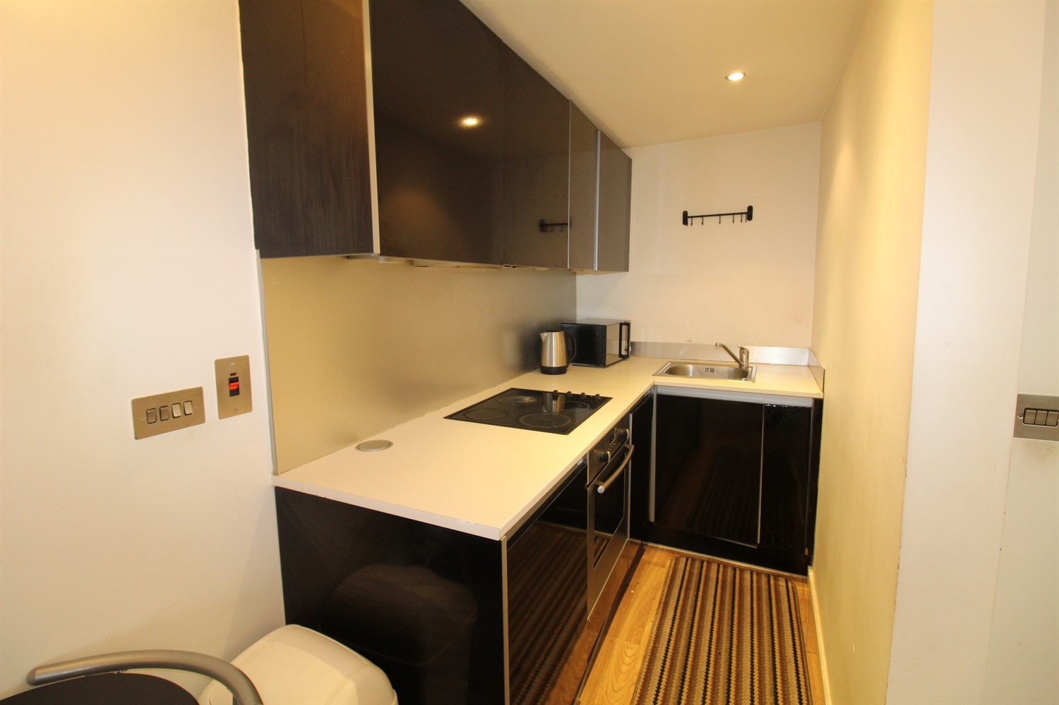

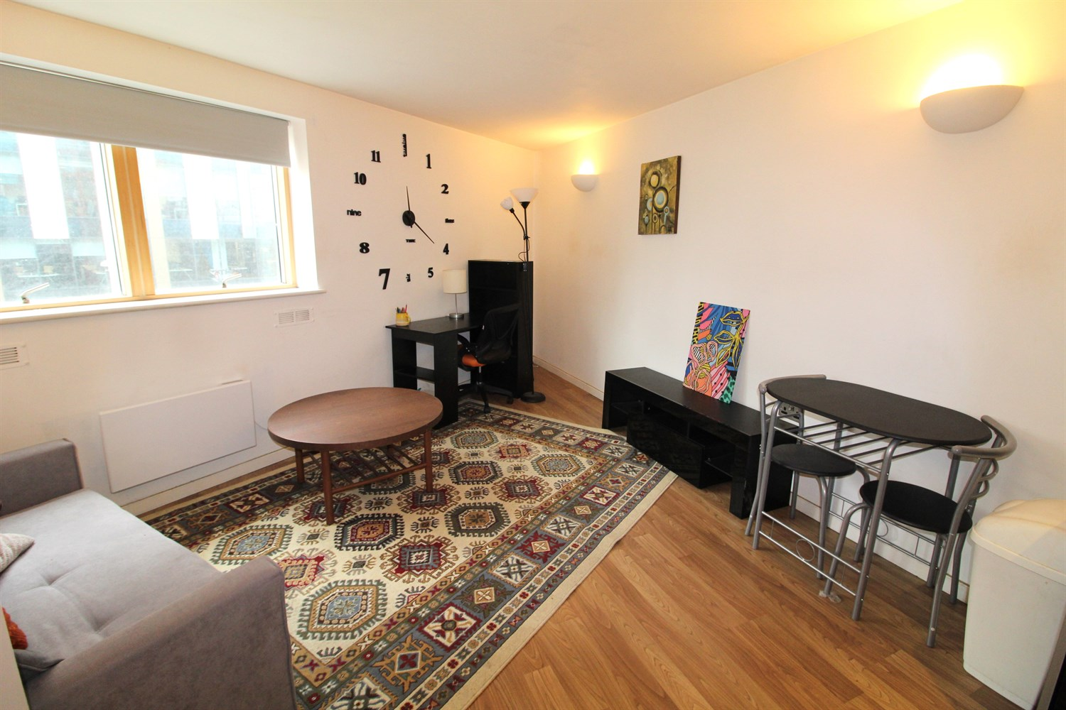

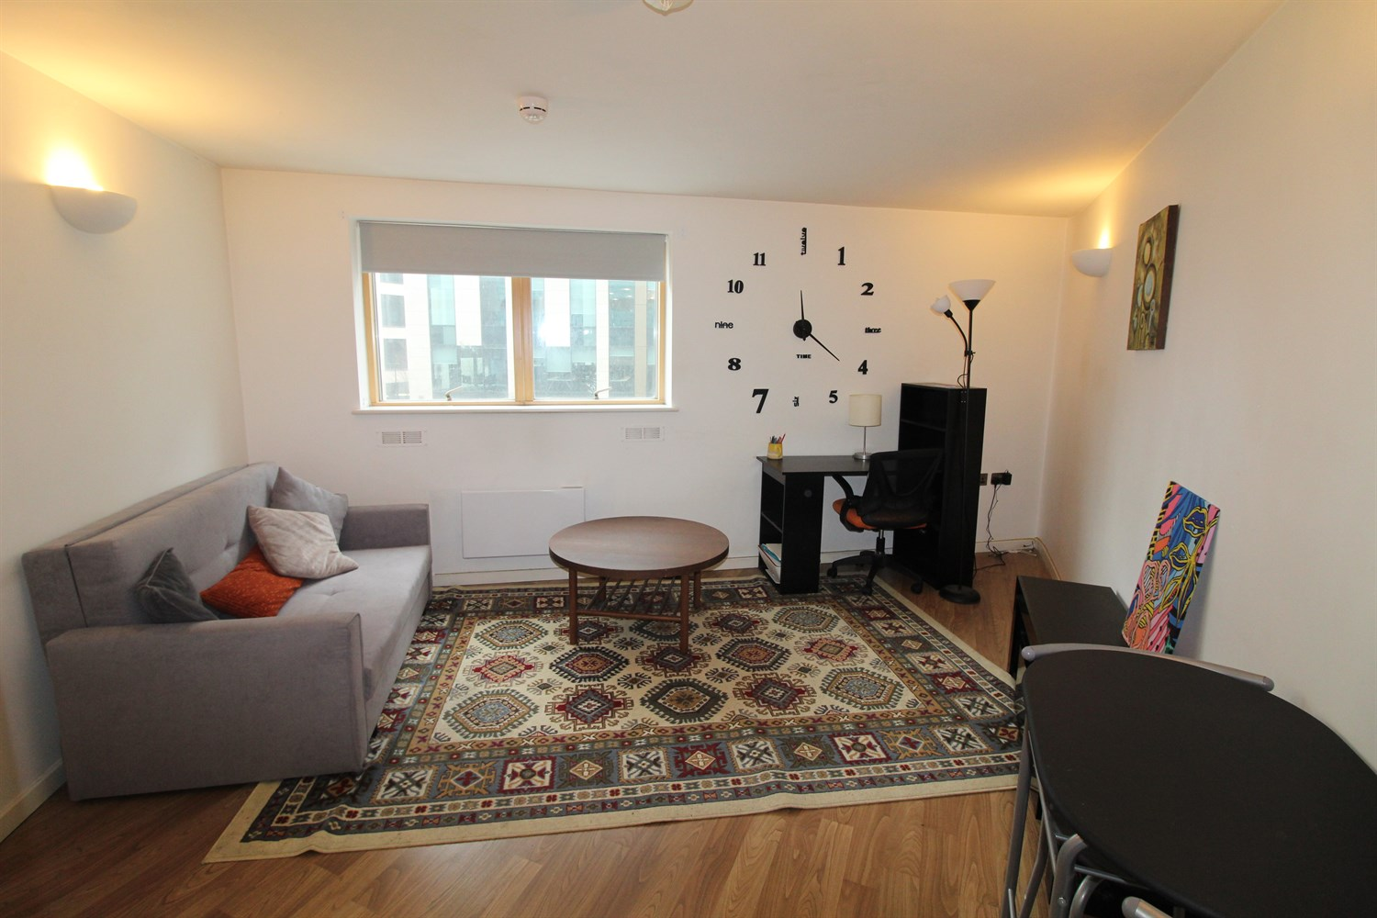

1 Bathroom(s)

1 Reception(s)

1 Bedroom(s)

00

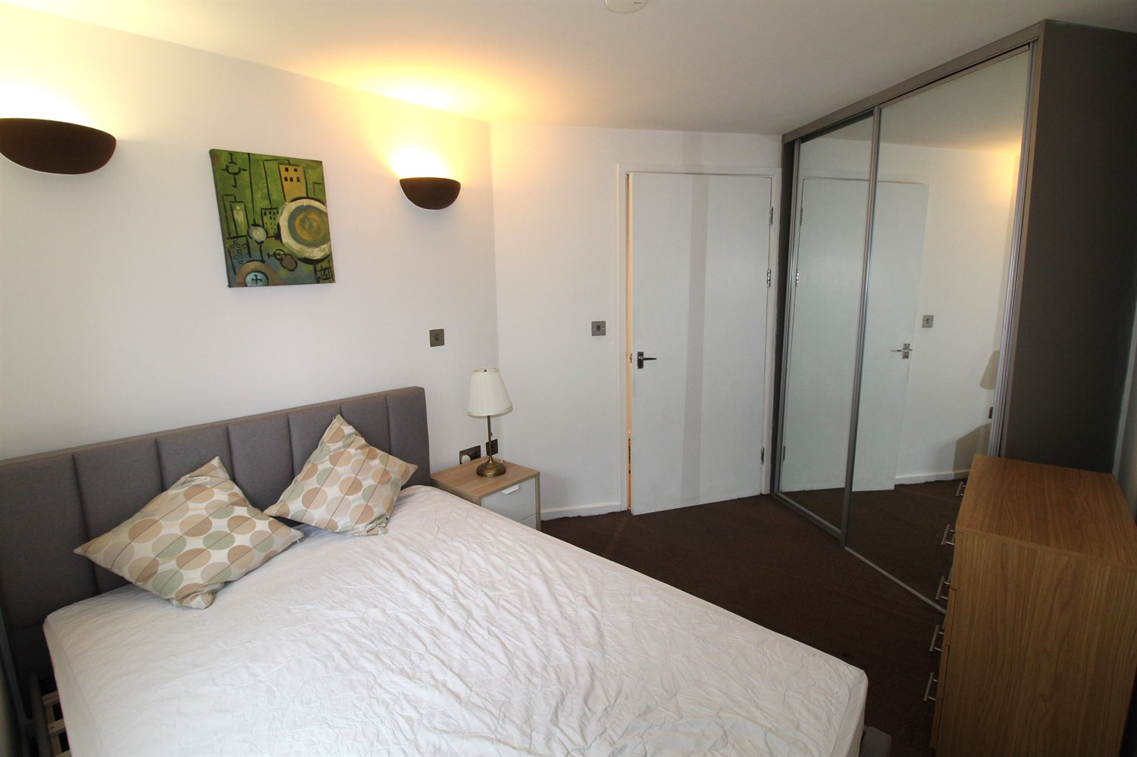

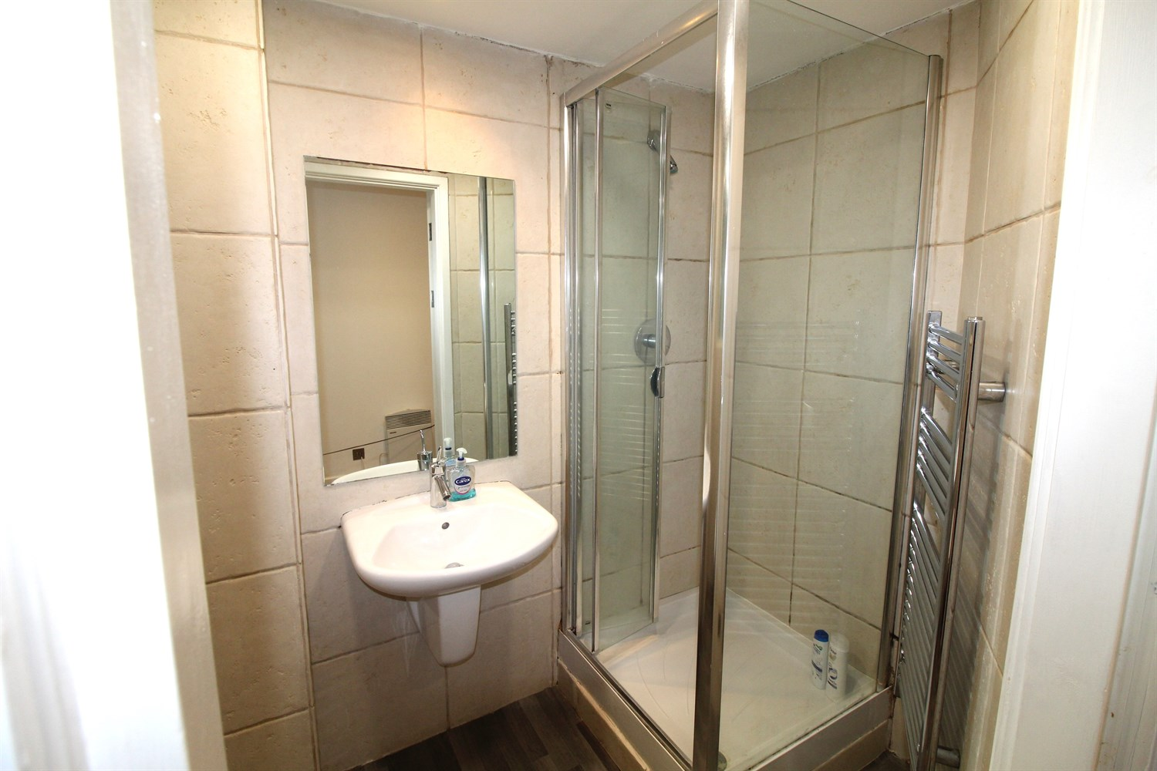

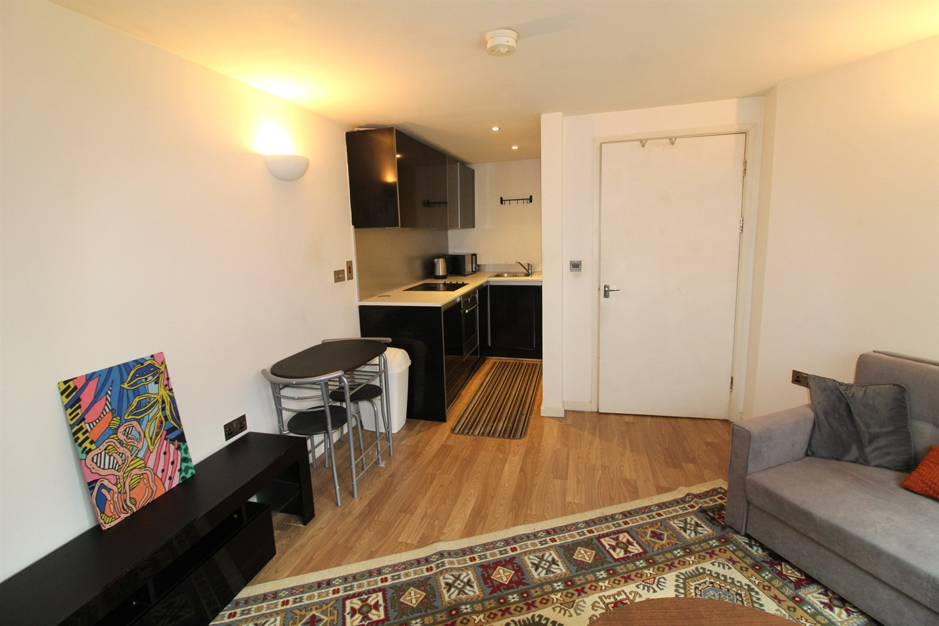

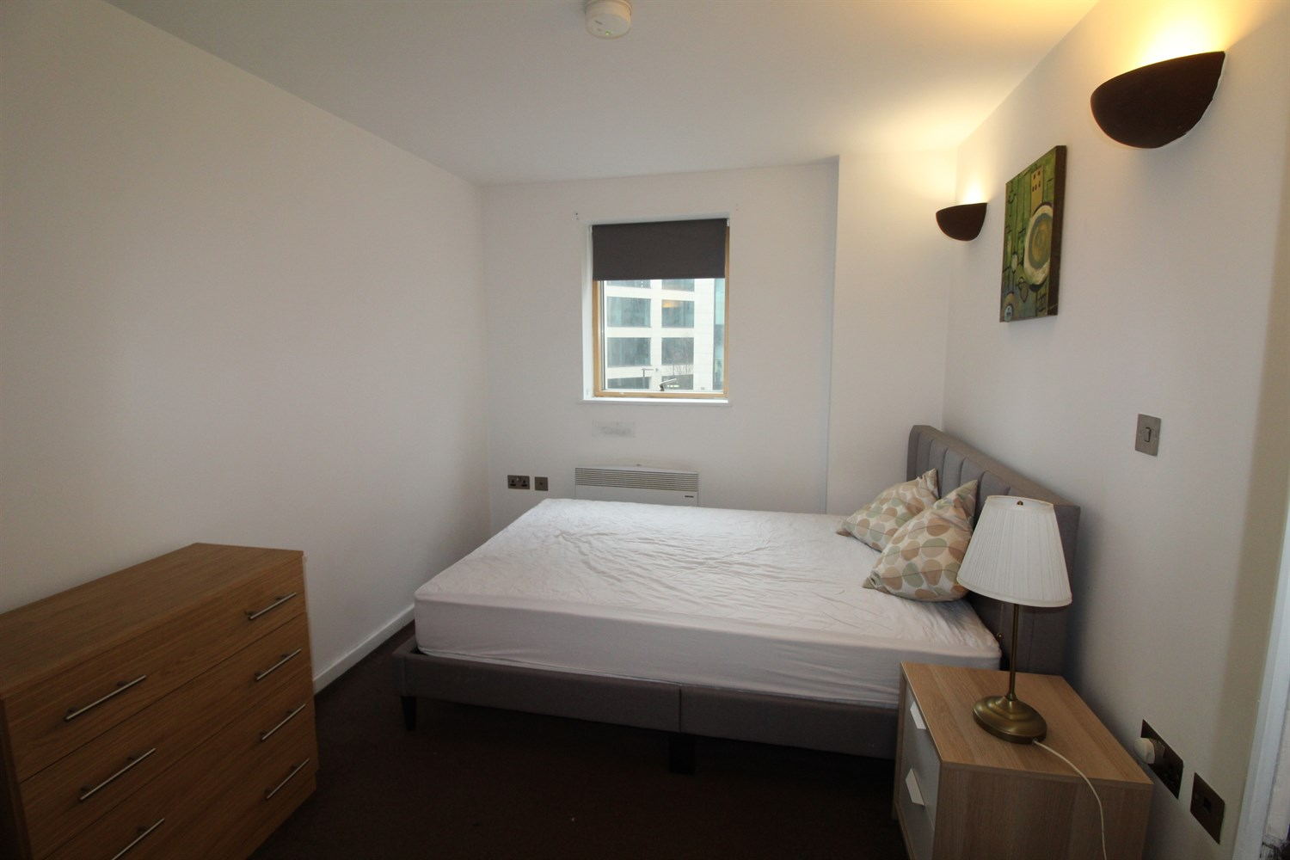

|  |
| --- |
| **Communal Entrance**  Stairs and lift access to all floors. |
| **Entrance Hall**  Cupboard housing washing machine. |
| **Open plan Lounge/Kitchen**  Living area with double glazed windows to front. Electric radiator. |
| **Kitchen**  Kitchen area comprising; wall, base and drawer units with worktops over. Integrated oven with hob and extractor over. Integrated fridge. Sink with mixer tap and drainer. |
| **Bedroom**  Double bedroom with double glazed window to front. Electric radiator. |
| **Shower Room**  Fitted with a three piece suite comprising; shower cubicle, WC and wash hand basin. Tiled walls. |
| **Property Size**  According to the EPC register the total floor area is 57 square metres. |
| COUNCIL TAX BAND: C EPC Rating: D  Leasehold property No Parking  Broadband:Standard 16 Mbps 1 Mbps Good Superfast --Not available --Not available Unlikely Ultrafast --Not available -- Mobile availability: EE Limited Three Limited O2 Likely Vodafone Likely  Electric mains supply, water on mains supply. |

|  |  |
| --- | --- |
| These particulars are intended to give a fair description of the property, but their accuracy cannot be guaranteed, and they do not constitute an offer of contract. Intending purchasers must rely on their own inspection of the property. None of the above appliances/services have been tested by ourselves. We recommend purchasers arrange for a qualified person to check all appliances/services before legal commitment.  **Property Ref:** 5300  **For more information, please contact**  0113 258 1150 **|** [lettings@adairpaxton.co.uk](mailto:lettings@adairpaxton.co.uk) **|** www.adairpaxton.co.uk |  |