

**0113 258 1150**

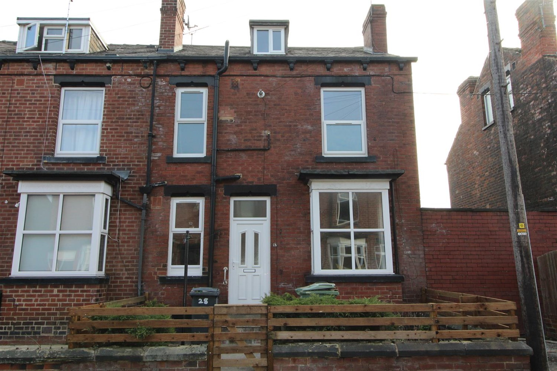



**Available to let £875.00pcm**

**Brooklyn Street, LS12**

Spacious two bed mid terrace property over three floors. Within walking distance of all amenities and with great transport links. Comprising; spacious lounge with feature fire surround, kitchen with range of units, oven, hob and extractor. First floor, good size double bedroom, bathroom with shower over bath, Top floor, second double bedroom. Gas central heating. Small front garden. On street parking. Unfurnished. Council tax band A. Available 17th March 2025.Deposit £1005.

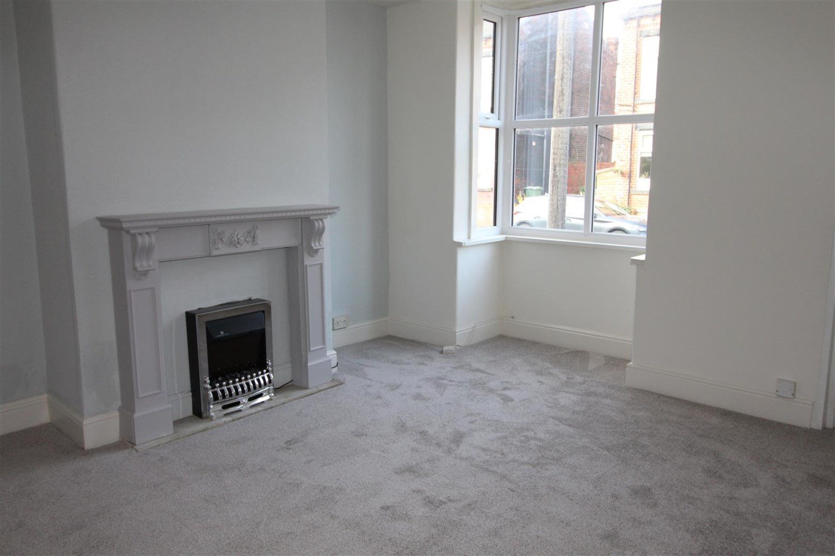

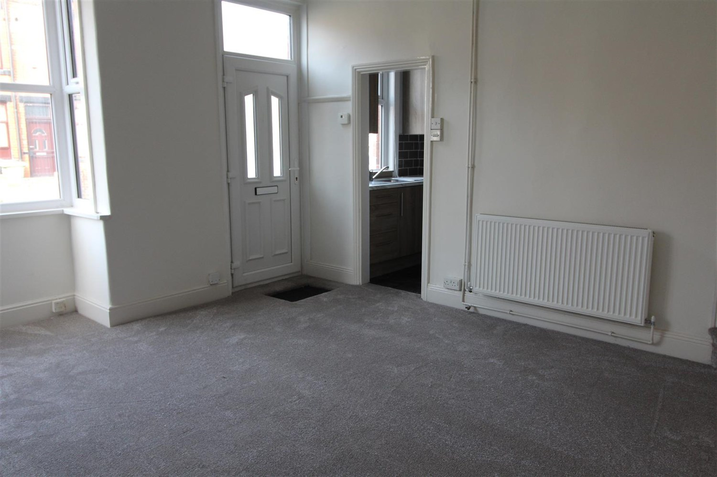

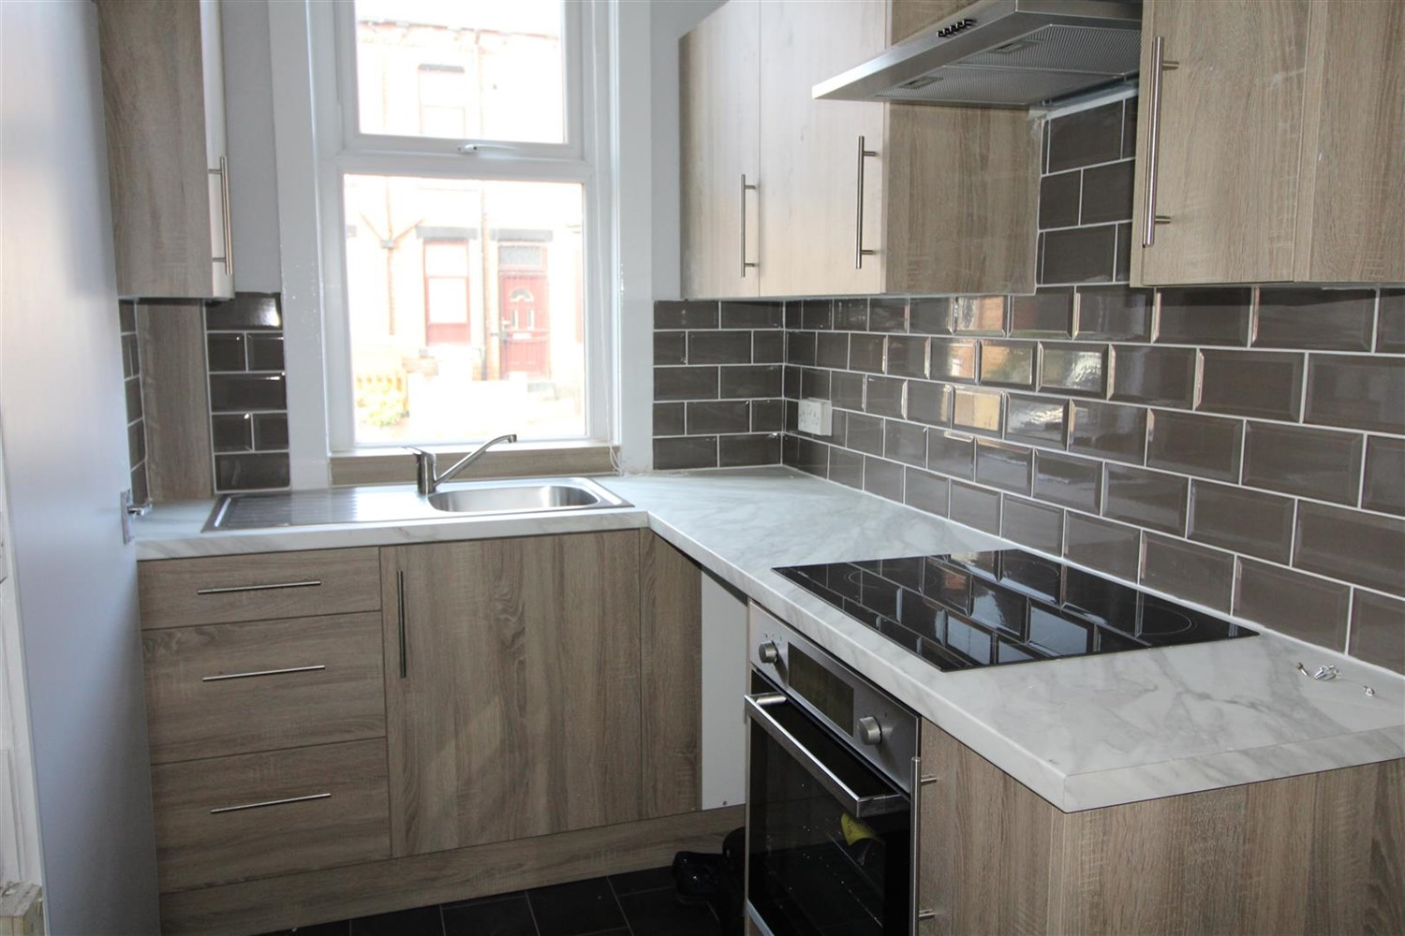

1 Bathroom(s)

1 Reception(s)

2 Bedroom(s)

00

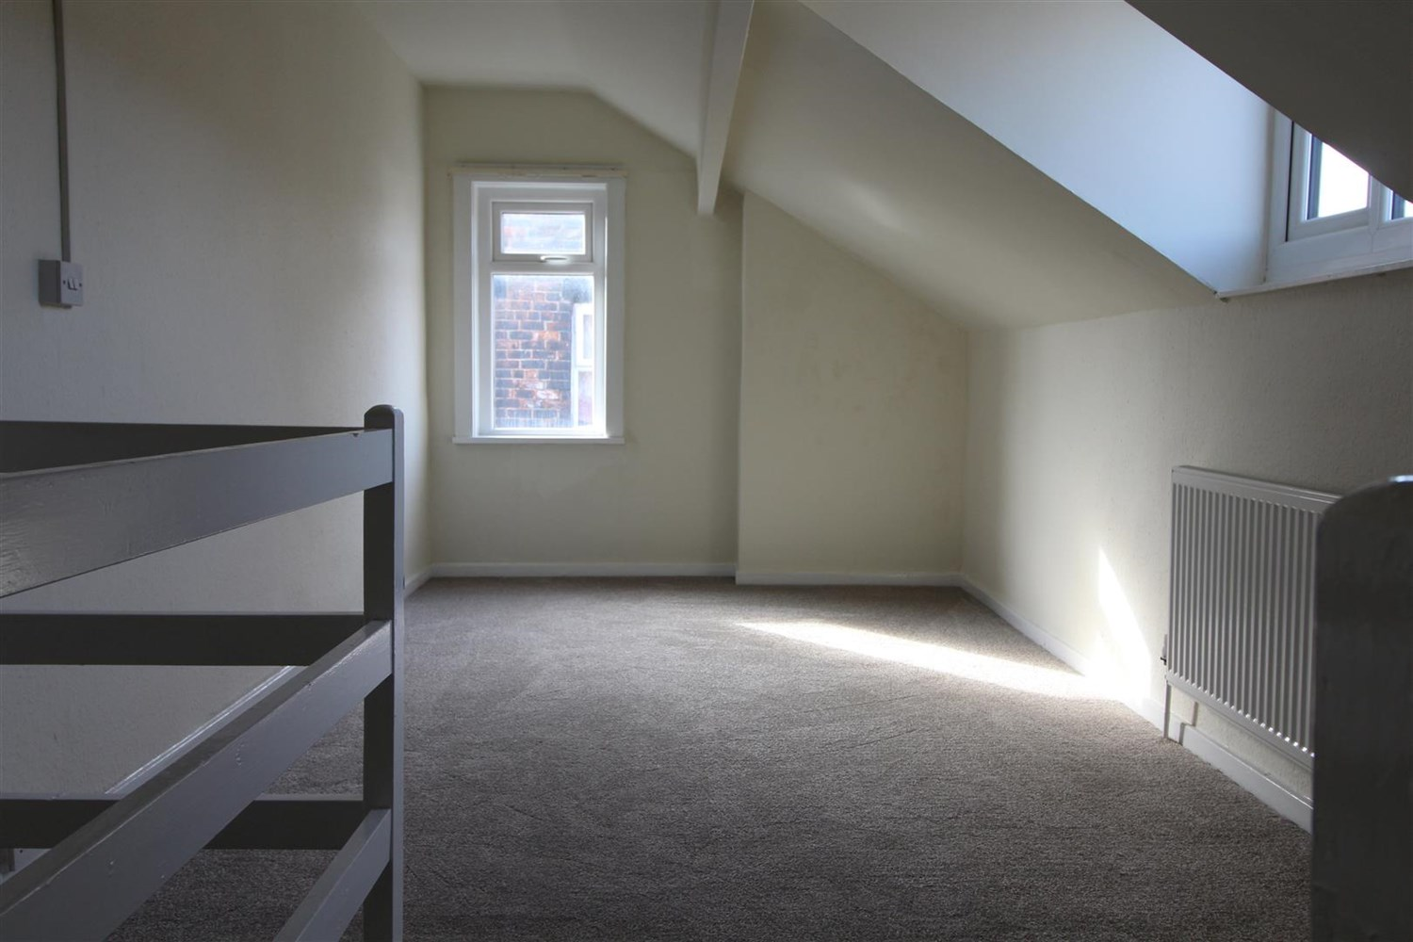

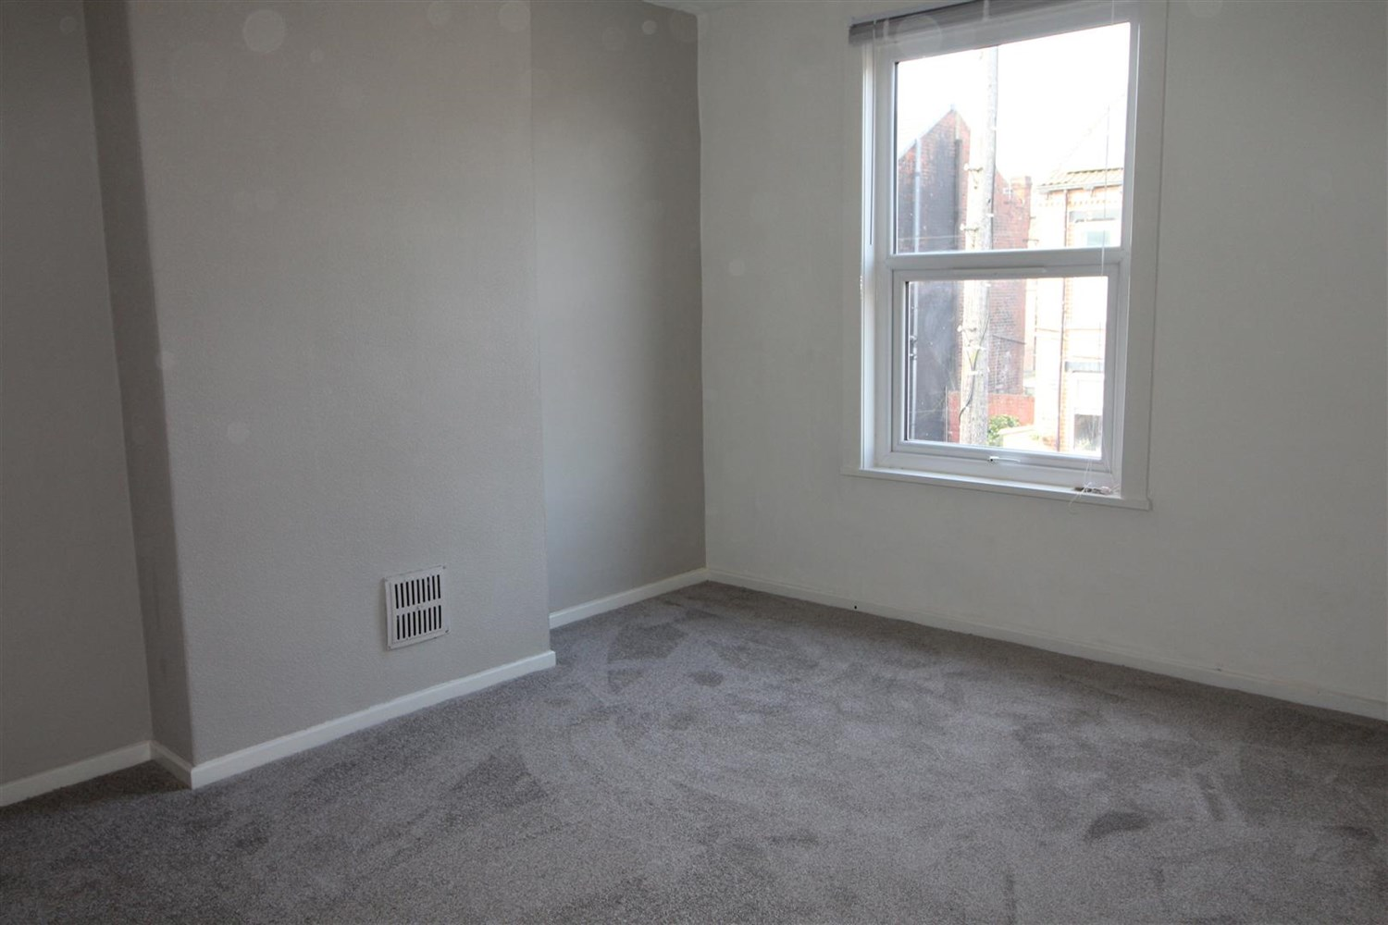

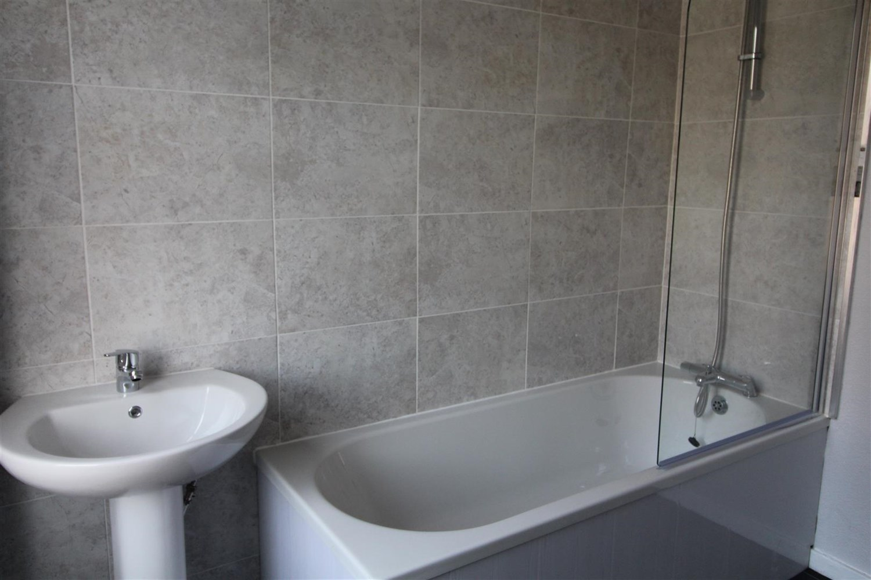

|  |
| --- |
| **Living Room**  Spacious Lounge with large window, gas central heating radiator, fire place and surround. |
| **Kitchen**  Fitted with a range of wall and base units with work tops over electric oven and hob with extractor over. Stainless steel sink with mixer tap. Part tiled walls. |
| **Bathroom**  Three piece bathroom suite with shower over bath, shower screen, tiled walls, gas central heating radiator. |
| **Bedroom**  Carpeted double bedroom with double glazed window, gas central radiator. |
| **Bedroom**  Carpeted double bedroom with double two double glazed windows , gas central radiator. |
| **Home Information**  COUNCIL TAX BAND: A EPC Rating: E  Freehold property Street Parking  Broadband: Standard 18 Mbps 1 Mbps Good Superfast 80 Mbps 20 Mbps Good Ultrafast 1800 Mbps 1000 Mbps   Mobile availability: EE coverage likely. Three Limited. O2 limited. Vodafone limited coverage.  Utilities: Water supplied on standard meters. Electric mains supplied on standard meters. Gas mains supplied on standard meters. |

|  |  |
| --- | --- |
| These particulars are intended to give a fair description of the property, but their accuracy cannot be guaranteed, and they do not constitute an offer of contract. Intending purchasers must rely on their own inspection of the property. None of the above appliances/services have been tested by ourselves. We recommend purchasers arrange for a qualified person to check all appliances/services before legal commitment.  **Property Ref:** 1092  **For more information, please contact**  0113 258 1150 **|** [lettings@adairpaxton.co.uk](mailto:lettings@adairpaxton.co.uk) **|** www.adairpaxton.co.uk |  |