

**0113 258 1150**

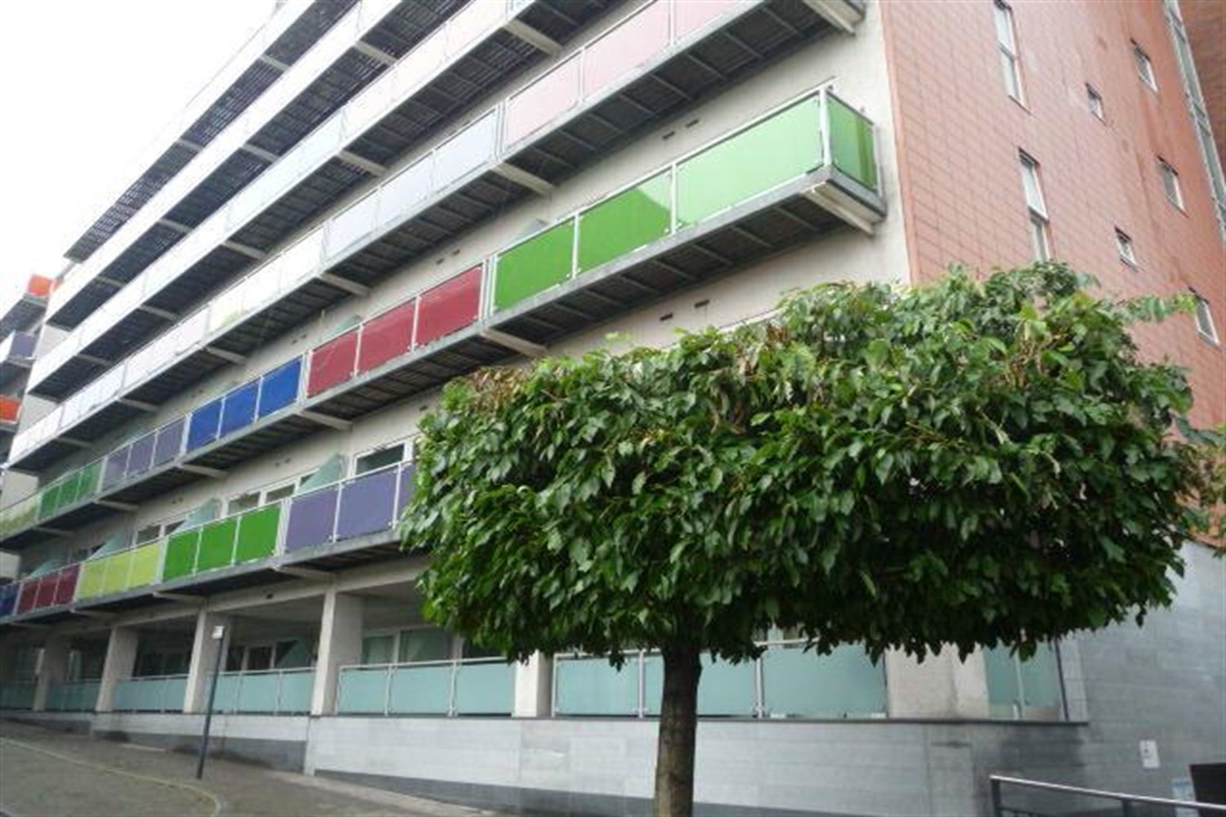



**Available to let £895.00pcm**

**Concord Street, Leeds**

***TWO BED APARTMENT LOCATED IN THE TRENDY NORTHERN QUARTER OF LEEDS CITY CENTRE*** Close to all shops/bars and restaurants and all amenities. Short walk to the Universities and great transport links. Comprising; Entrance hall, Open plan Lounge/Kitchen/Diner and Two Bedrooms, Bathroom. Furnished. Deposit £1095. EPC rating C, council tax band C, Available 19th March 2025.

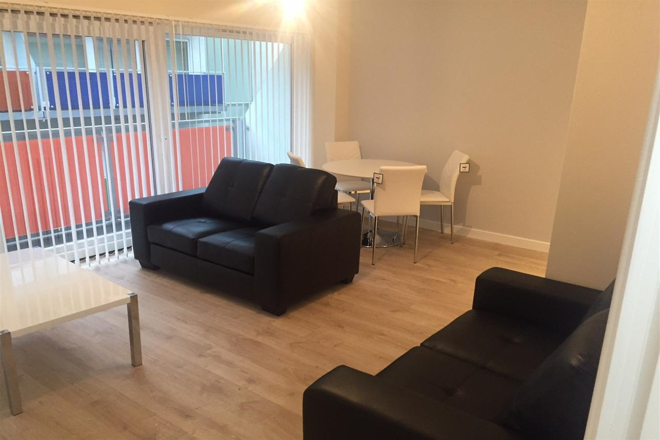

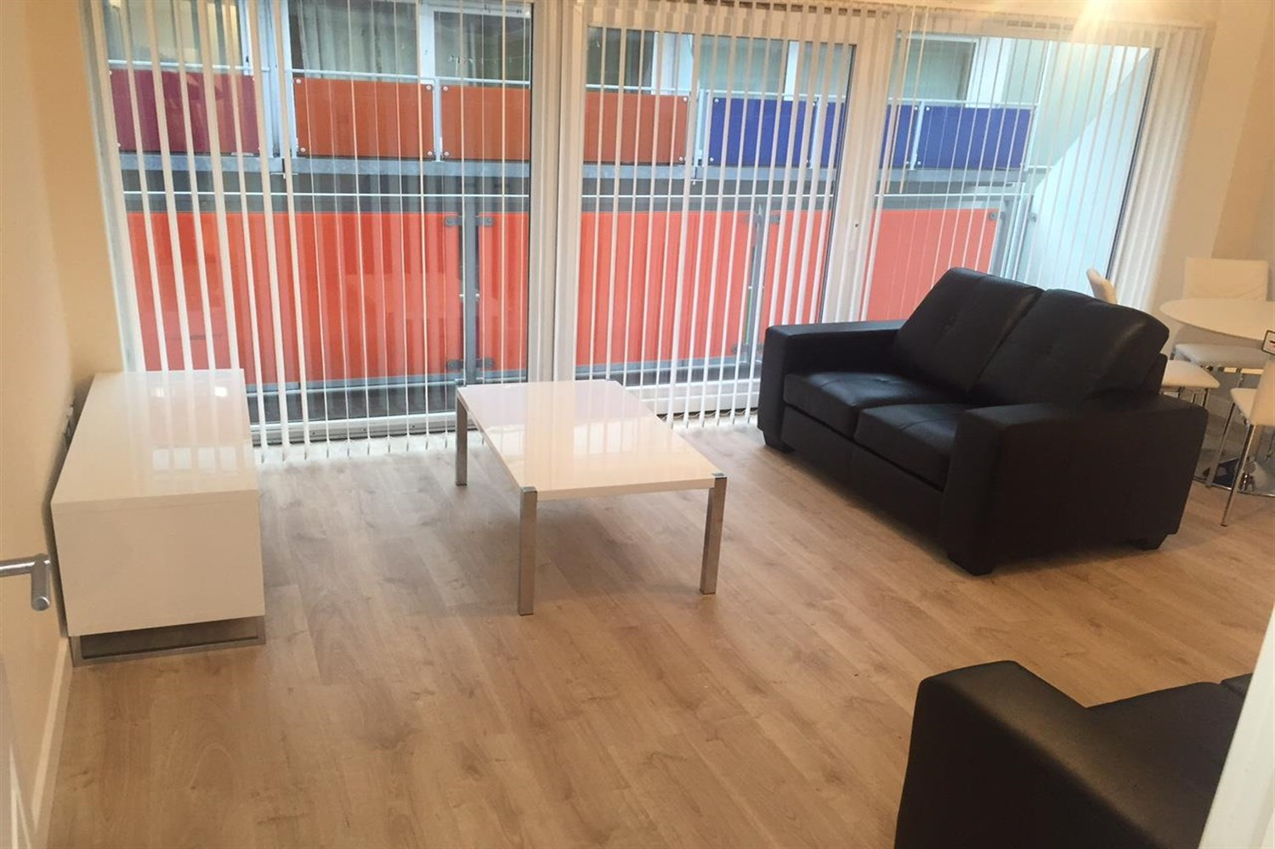

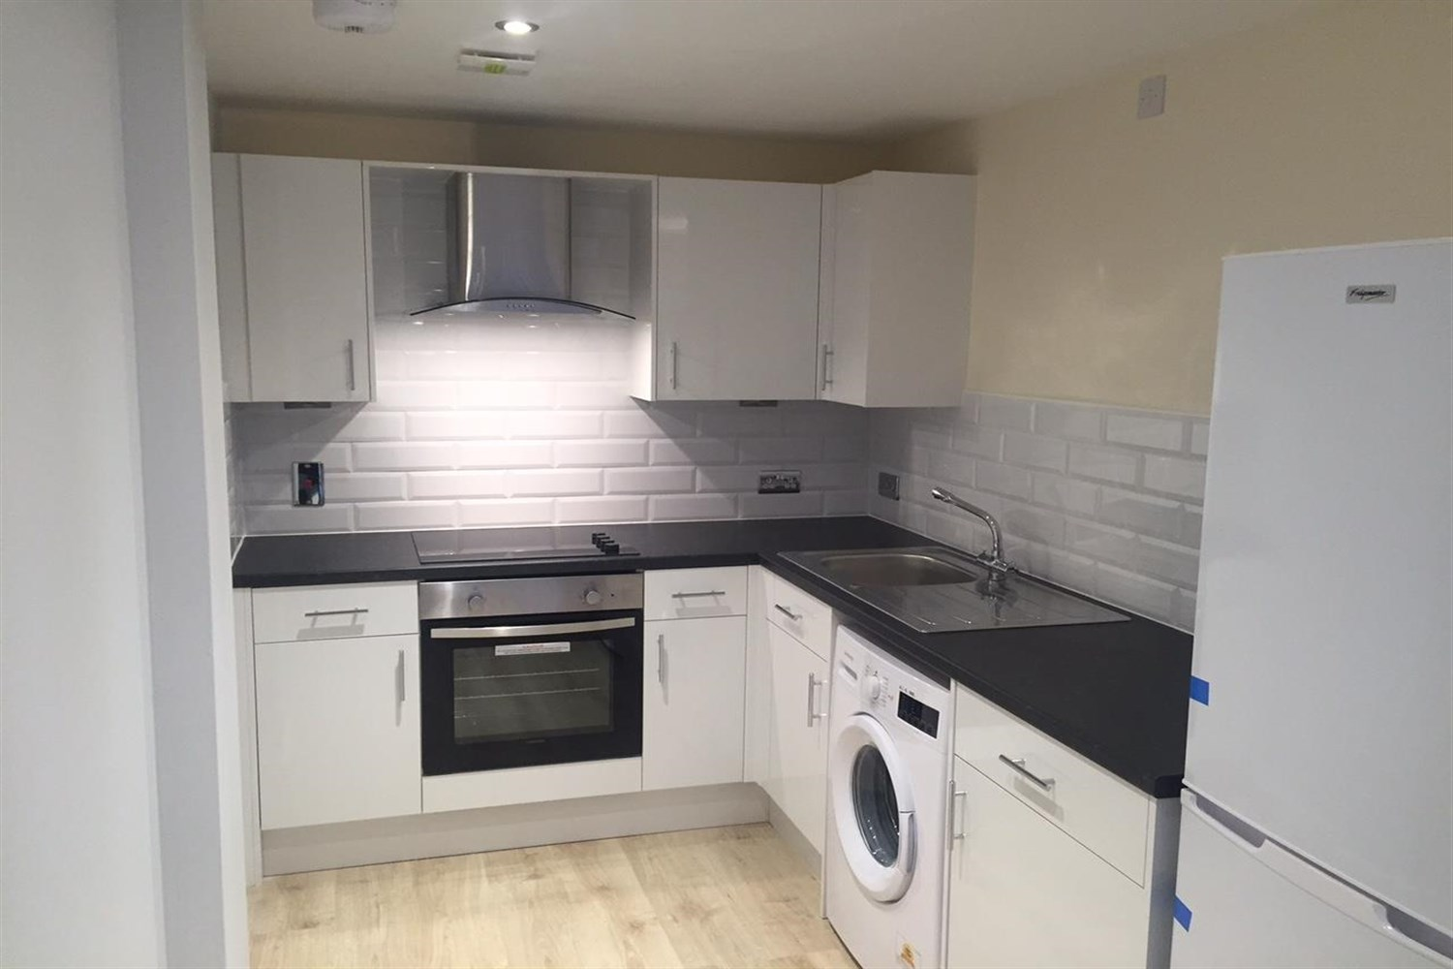

1 Bathroom(s)

1 Reception(s)

1 Bedroom(s)

00

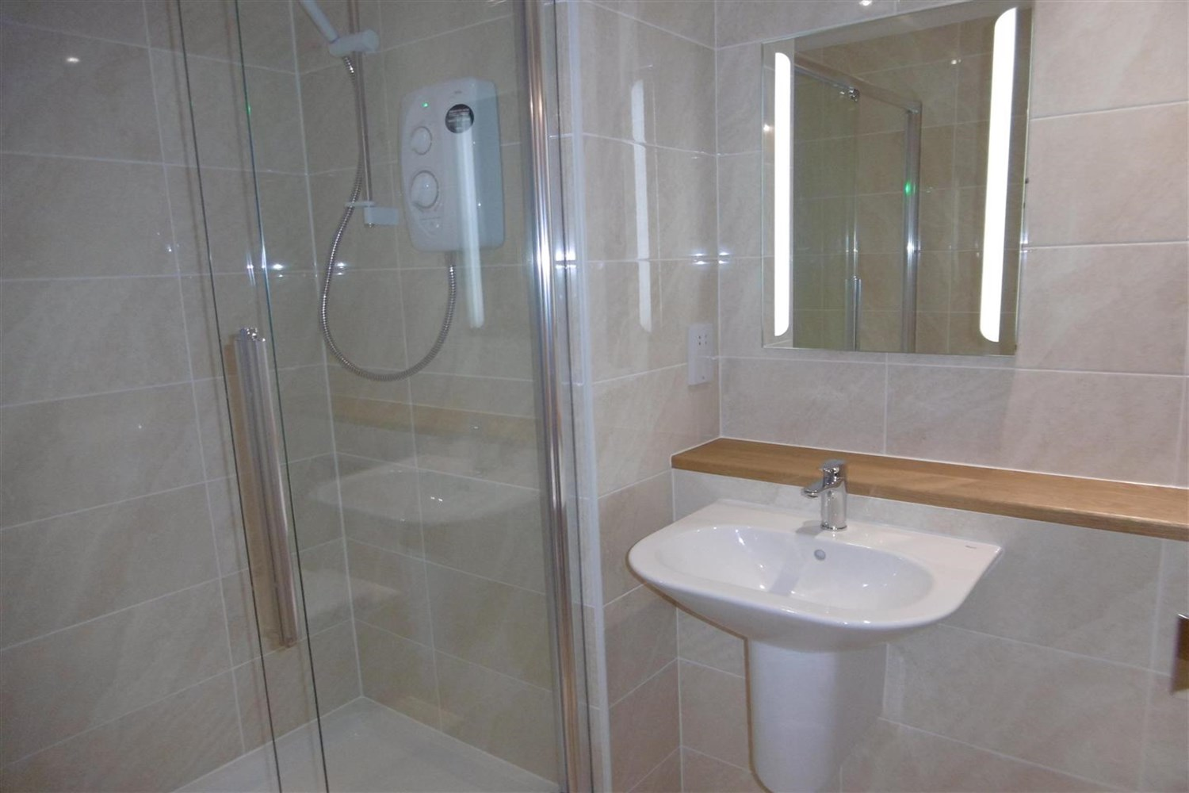

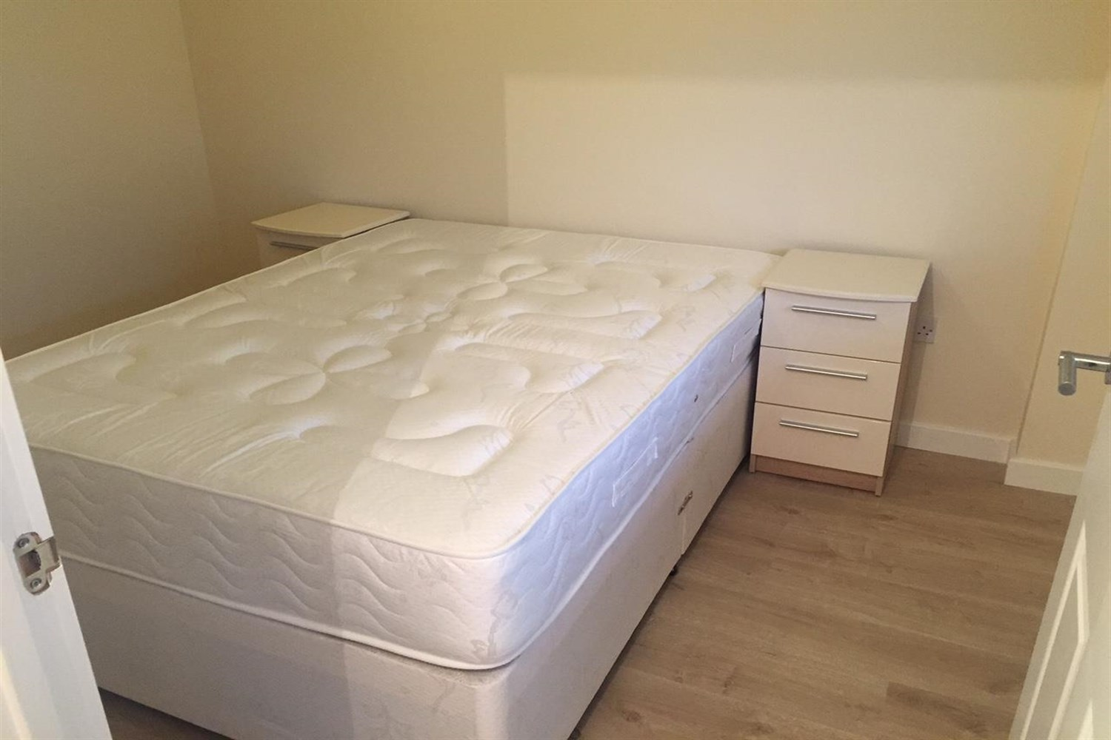

|  |
| --- |
| **Communal Entrance**  Fob entry, letterboxes on left of entrance and hallway has a lift to all floors. |
| **Open Plan Kitchen and Living Room**  Large living space with sliding doors leading on the balcony. kitchen fitted with a range of wall and base units with worktops over, electric oven and hob, washing machine and fridge freezer. Part tiles around units. Intercom system mounted on wall. Underfloor heating. |
| **Bedroom 1**  Double bedroom with window and wall heater. |
| **Bathroom**  Three piece bathroom suite, walk in shower cubical, hand wash basin and w/c, ceramic floor and walls tiles heated electric towel rail. |
| **Bedroom 2**  Double bedroom with window and wall heater. |
| **Home Information**  COUNCIL TAX BAND: C EPC Rating C  Leasehold property No Parking.  Broadband VIRGIN MEDIA ONLY: Standard 15 Mbps 1 Mbps Good Superfast 80 Mbps 20 Mbps Good Ultrafast 1000 Mbps 1000 Mbps  Mobile availability: EE likely to have good coverage. Three likely to have good coverage. O2 likely to have good coverage. Vodafone limited coverage.  Utilities: Water supplied on standard meters. Electric mains supplied on standard meters. |

|  |  |
| --- | --- |
| These particulars are intended to give a fair description of the property, but their accuracy cannot be guaranteed, and they do not constitute an offer of contract. Intending purchasers must rely on their own inspection of the property. None of the above appliances/services have been tested by ourselves. We recommend purchasers arrange for a qualified person to check all appliances/services before legal commitment.  **Property Ref:** 790  **For more information, please contact**  0113 258 1150 **|** [lettings@adairpaxton.co.uk](mailto:lettings@adairpaxton.co.uk) **|** www.adairpaxton.co.uk |  |