

Beaufort Grove, BD2
For Sale £375,000.00

***EXTENDED FOUR BEDROOM DETACHED HOUSE - THREE RECEPTION ROOMS - LARGE DRIVEWAY*** Adair Paxton are pleased to offer to the market this spacious four bedroom detached house situated at the head of a quiet cul-de-sac. This family home briefly comprises; Entrance porch, entrance hallway, guest WC, family room, sitting room, kitchen/diner, dining room and conservatory to the ground floor. To the first floor there are three double bedrooms, a fourth bedroom/study and a house bathroom. Externally, the property has a driveway to the front offering off street parking for several cars and leading to a detached double garage. To the rear is a low maintenance garden.
0113 258 1150
0800 000 000
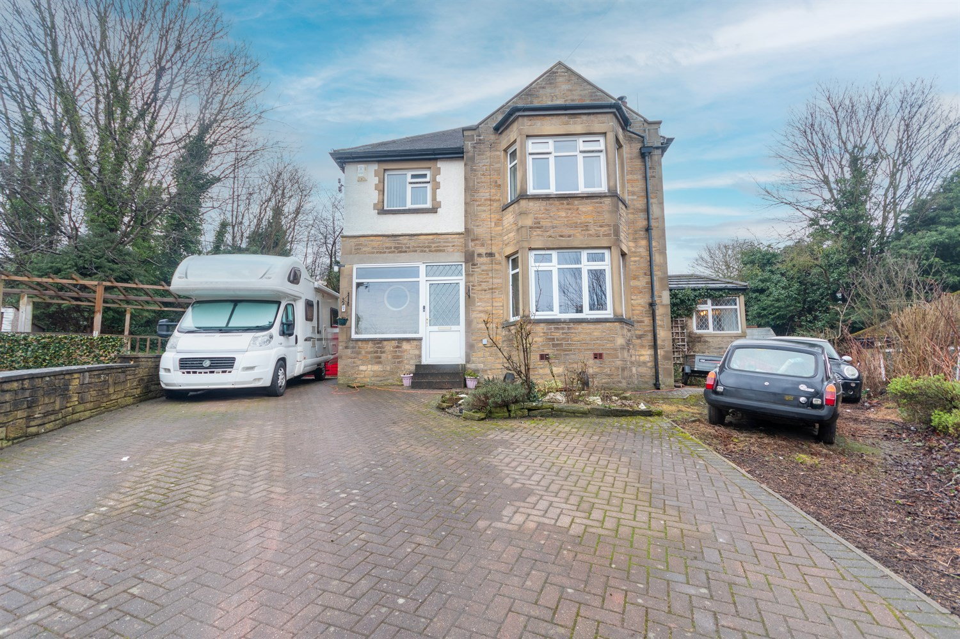
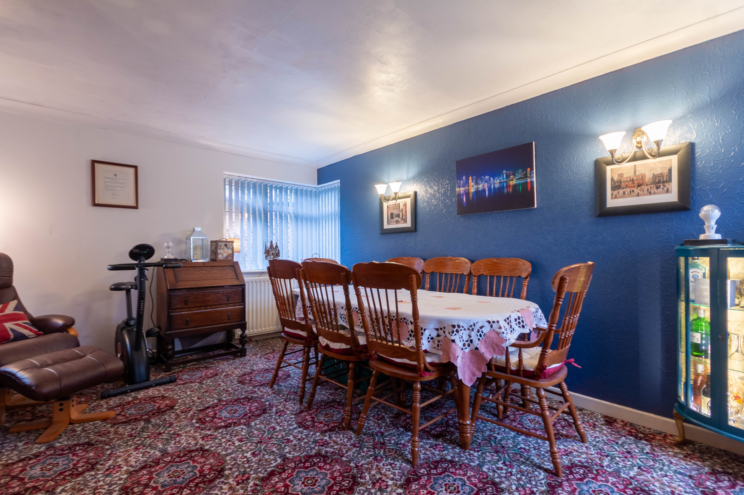
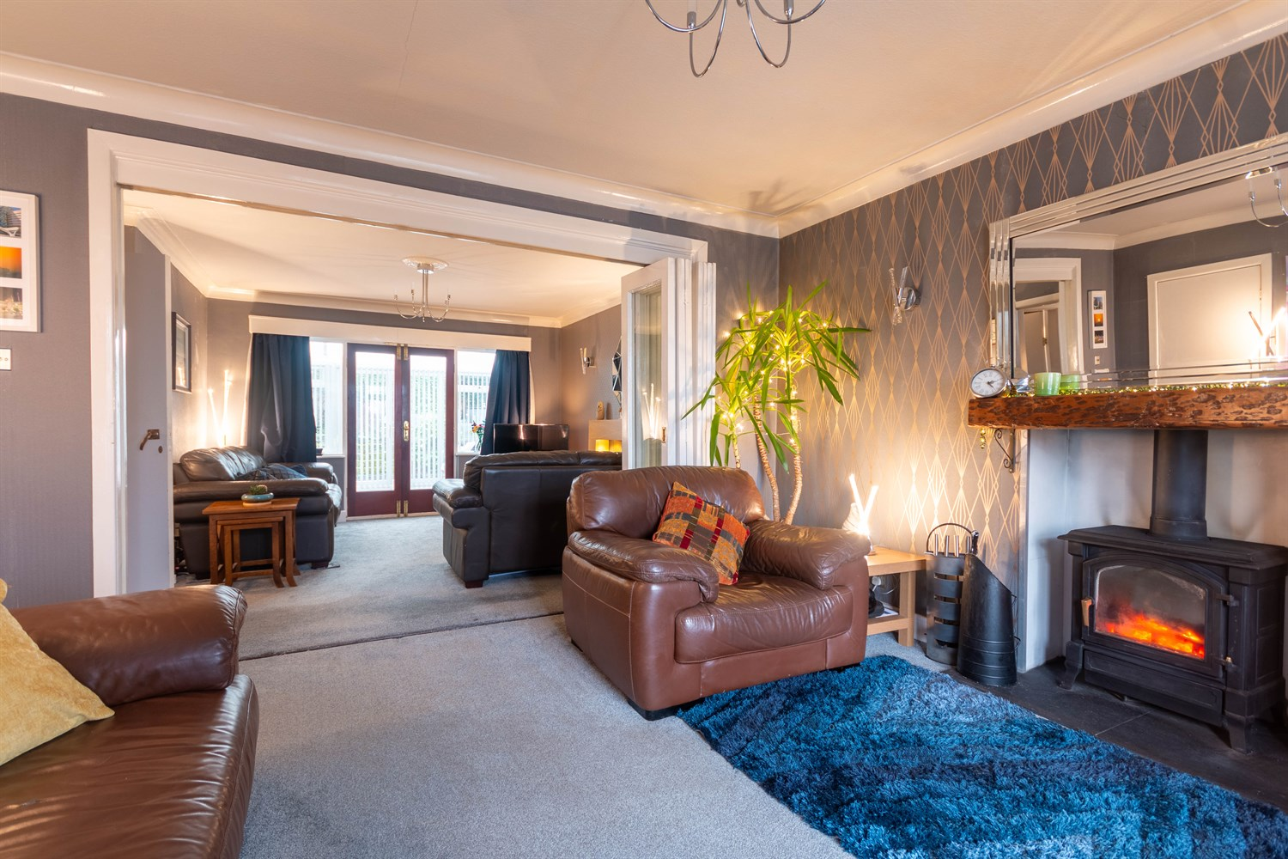
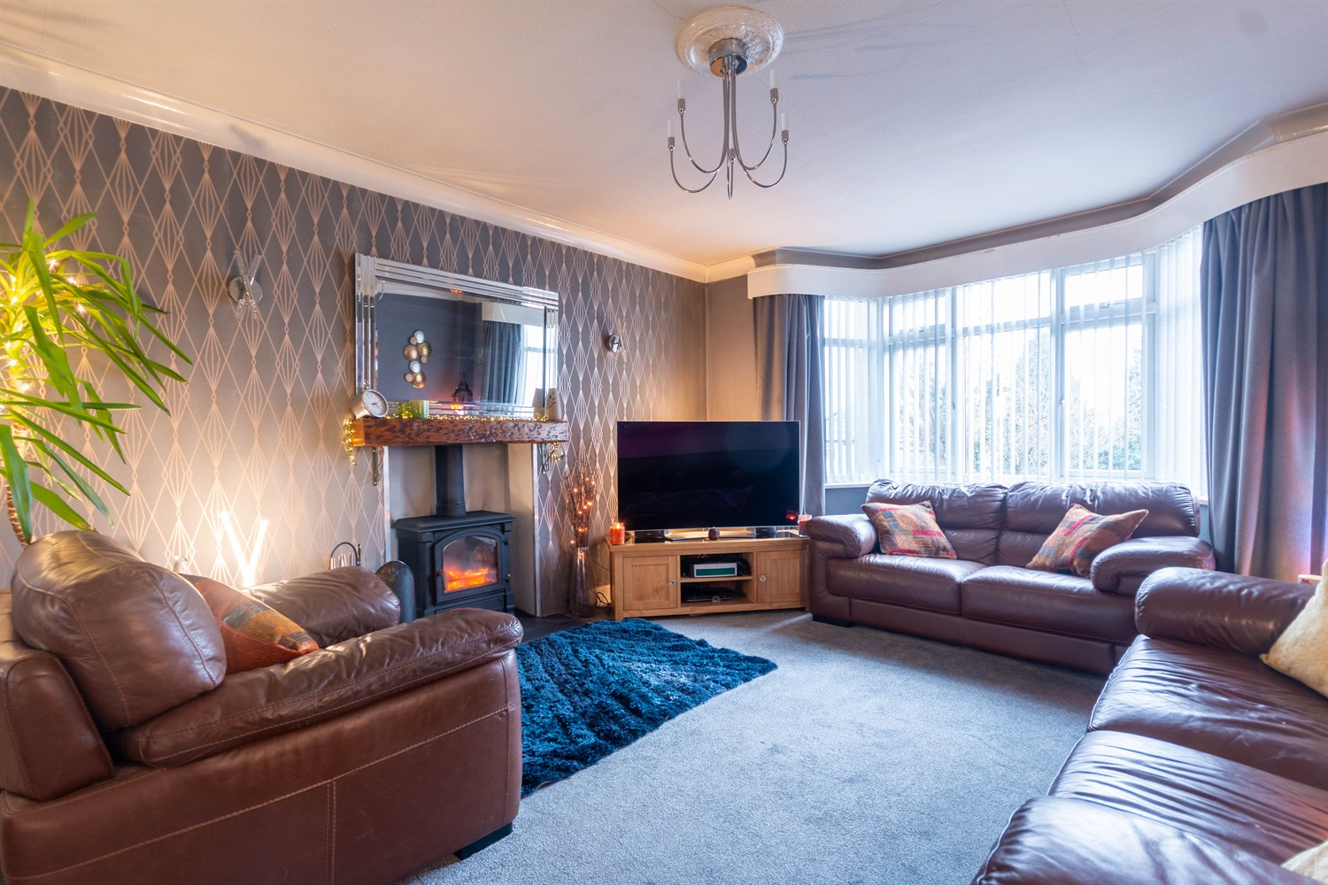
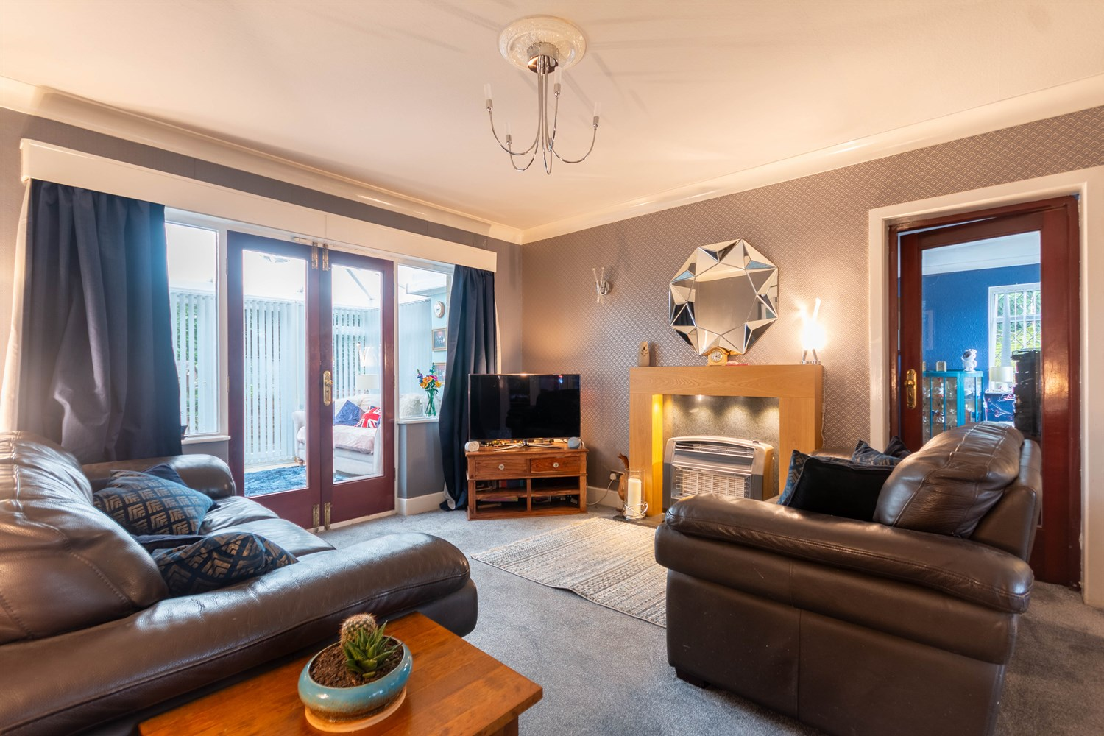
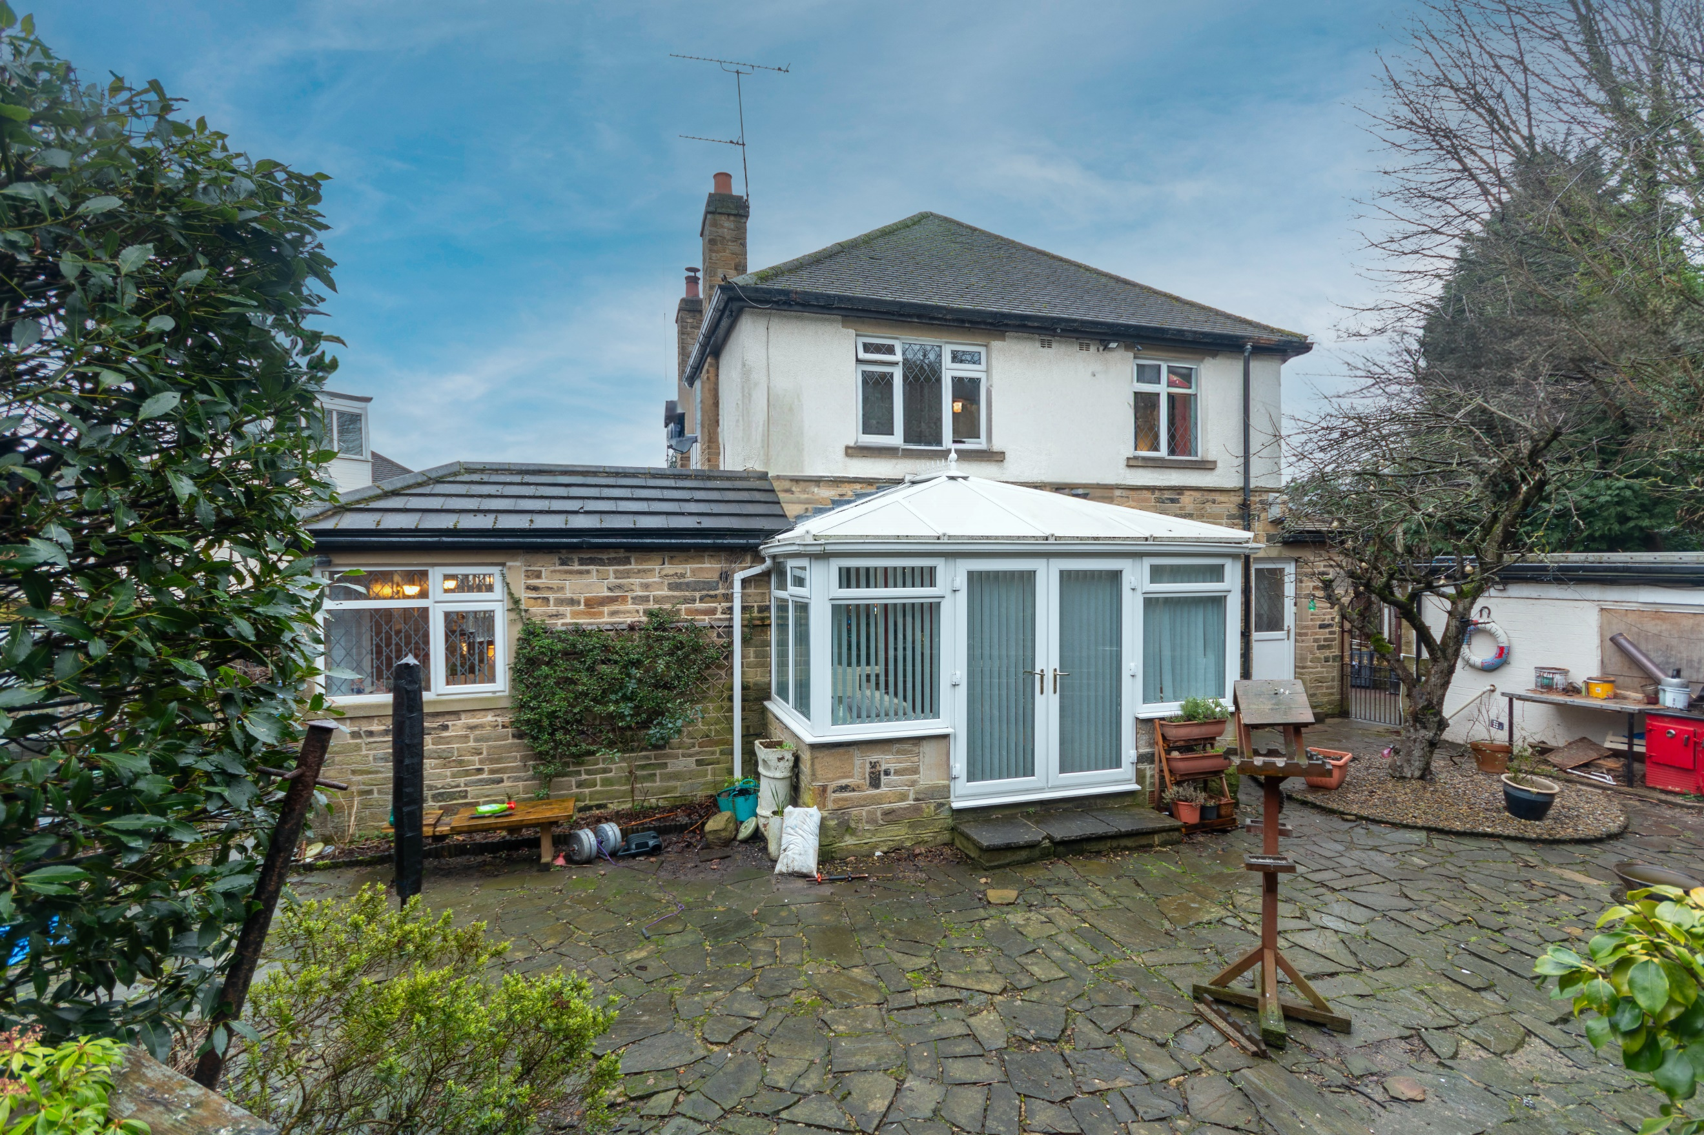
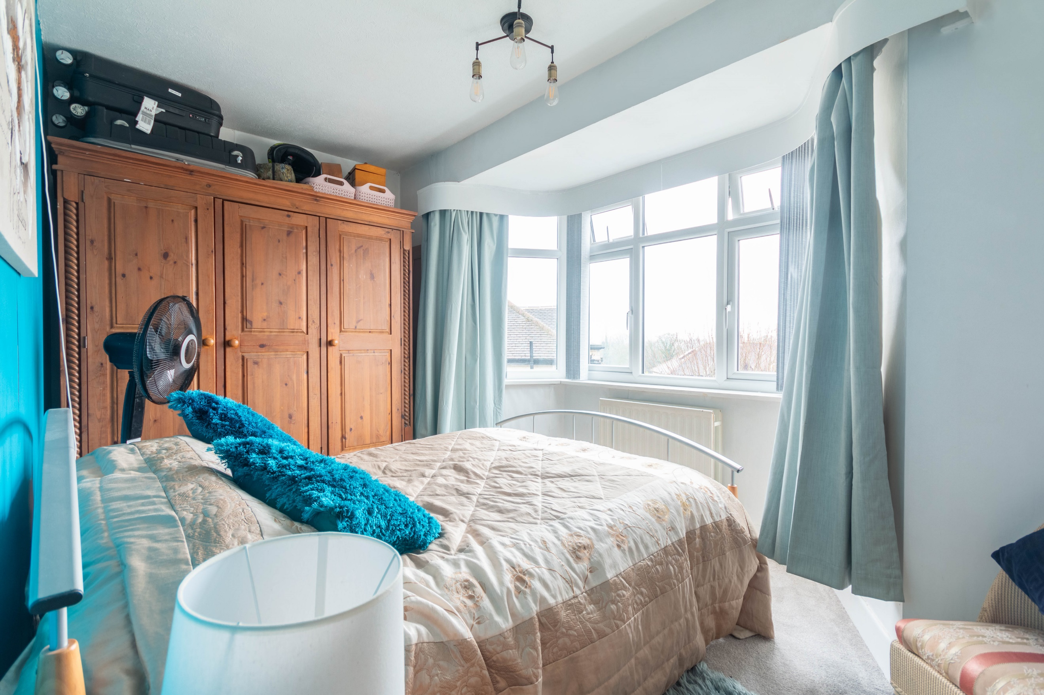
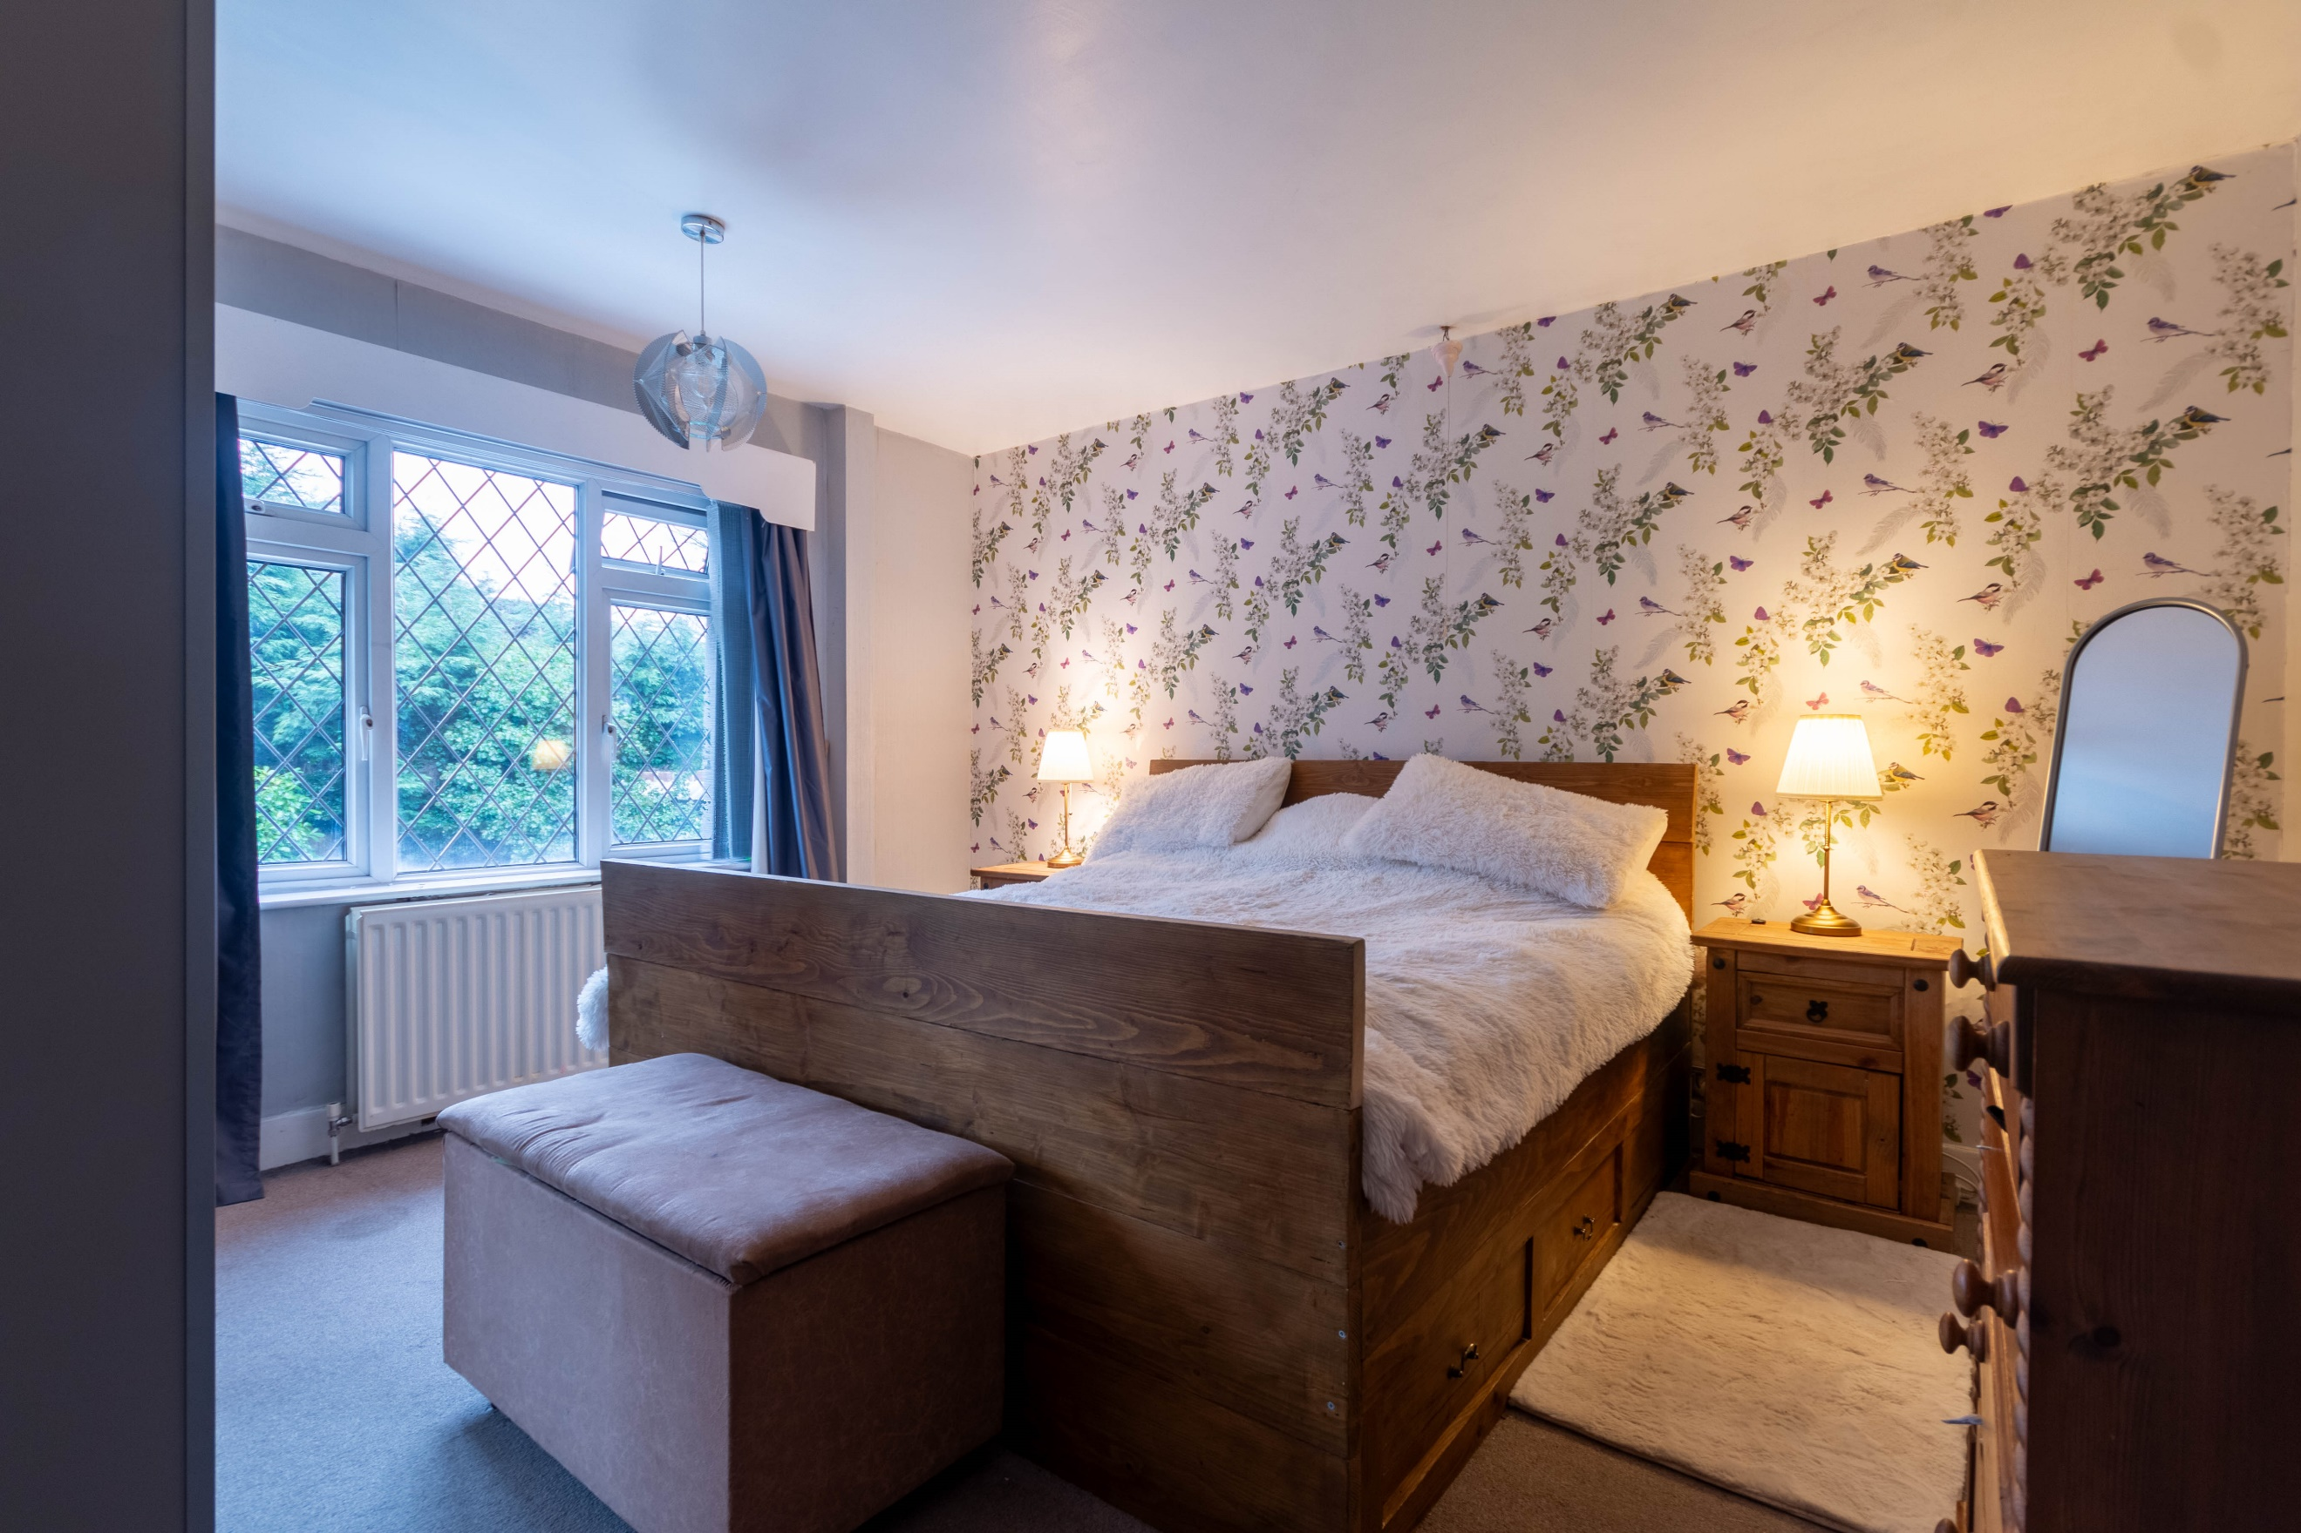
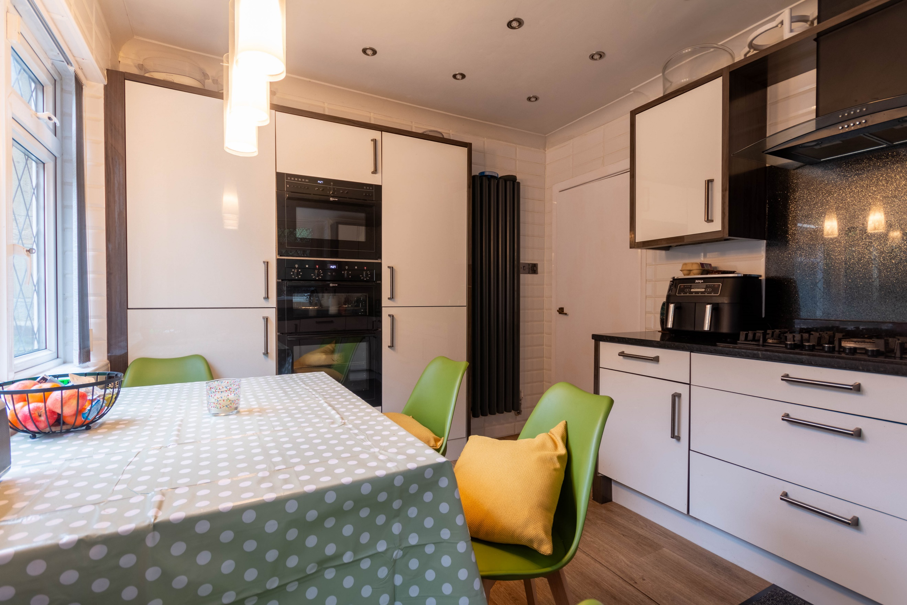

Entrance Hall
Via front entrance Porch. Stairs to first floor. Gas central heating radiator.

Guest WC
Fitted with a two piece suite comprising; WC and wash hand basin.

Family Room 4.16m (13'8) x 4.18m (13'9)
Spacious living room with uPVC double glazed bay window to front. Gas central heating radiator. Space for log burning stove.

Sitting Room 3.8m (12'6) x 4.1m (13'5)
Second reception room with double doors leading to the conservatory. Gas central heating radiator. Gas fire. Opening up to the family room via bi-fold doors.

Conservatory 3.8m (12'6) x 2.97m (9'9)
uPVC double glazed windows to three sides. uPVC double glazed doors to rear garden.

Dining Room 3.64m (11'11) x 5.16m (16'11)
Additional reception room with double glazed windows to the front and rear. Two gas central heating radiators.

Kitchen 3.96m (13') x 2.86m (9'5)
Fitted with a range of wall, base and drawer units with worktops over. Integrated double oven and microwave. 5-ring gas hob with extractor hood over. Integrated fridge/freezer and dishwasher. Inset ceiling spotlights. Tiled walls. uPVC double glazed window to side and rear. uPVC double glazed door to rear garden.

Bedroom 1 4.19m (13'9) x 4.1m (13'5)
Double bedroom with uPVC double glazed window to rear. Gas central heating radiator.

Bedroom 2 4.19m (13'9) x 2m (6'7)
Second double bedroom with uPVC double glazed bay window to front. Gas central heating radiator.

Bedroom 3 2.73m (8'11) x 2.86m (9'5)
Third bedroom with uPVC double glazed window to rear. Gas central heating radiator.

Bedroom 4 3.2m (10'6) x 2.02m (6'8)
Fourth bedroom with uPVC double glazed window to front. Gas central heating radiator.

Bathroom
Fitted with a three piece white suite comprising; bath with shower above, WC and wash hand basin. Tiled walls. uPVC double glazed window.

Outside
To the front of the property is a driveway offering off street parking for several cars and leading to a double detached garage with up and over door. To the rear of the property is a low maintenance garden.

Garage
Double garage.

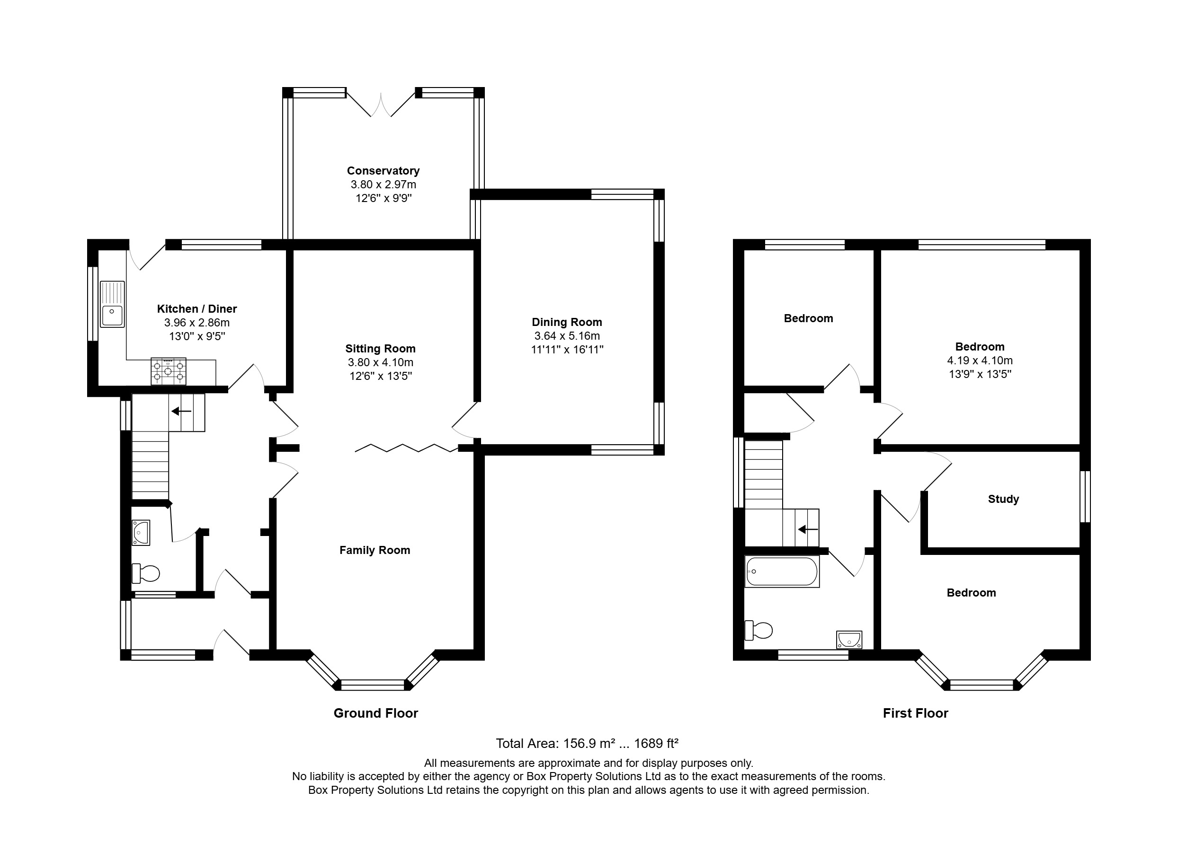

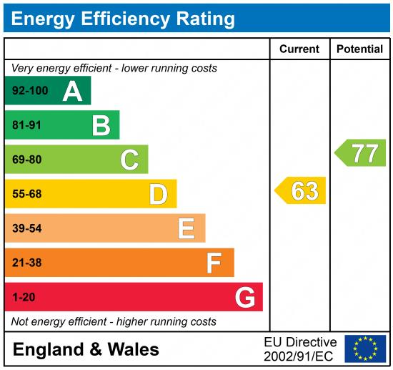

These particulars are intended to give a fair description of the property, but their accuracy cannot be guaranteed, and they do not constitute an offer of contract. Intending purchasers must rely on their own inspection of the property. None of the above appliances/services have been tested by ourselves. We recommend purchasers arrange for a qualified person to check all appliances/services before legal commitment.

Property Ref: 5258

For more information, please contact

0113 258 1150 | sales@adairpaxton.co.uk | www.adairpaxton.co.uk

