

**0113 258 1150**

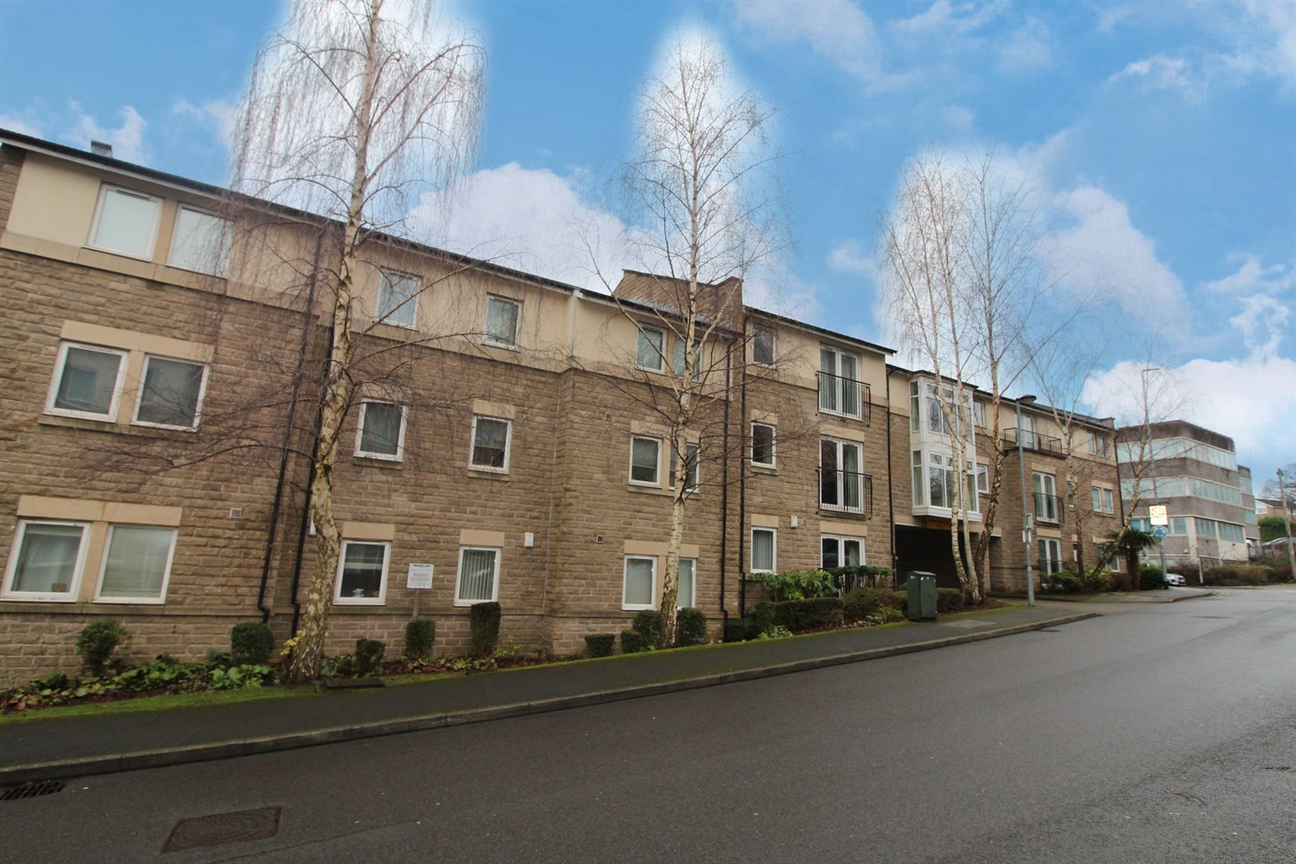



**Available to let £950.00pcm**

**Murray Court, Horsforth**

A well presented two double bedroom apartment providing high quality unfurnished accommodation. Enjoying an easy walk to the Forge train station, is this spacious 2nd floor two double bedroom apartment, excellent storage! Enjoying this popular development in the highly regarded Horsforth area. Available Now, deposit £1095. EPC rating C, Council tax band B.

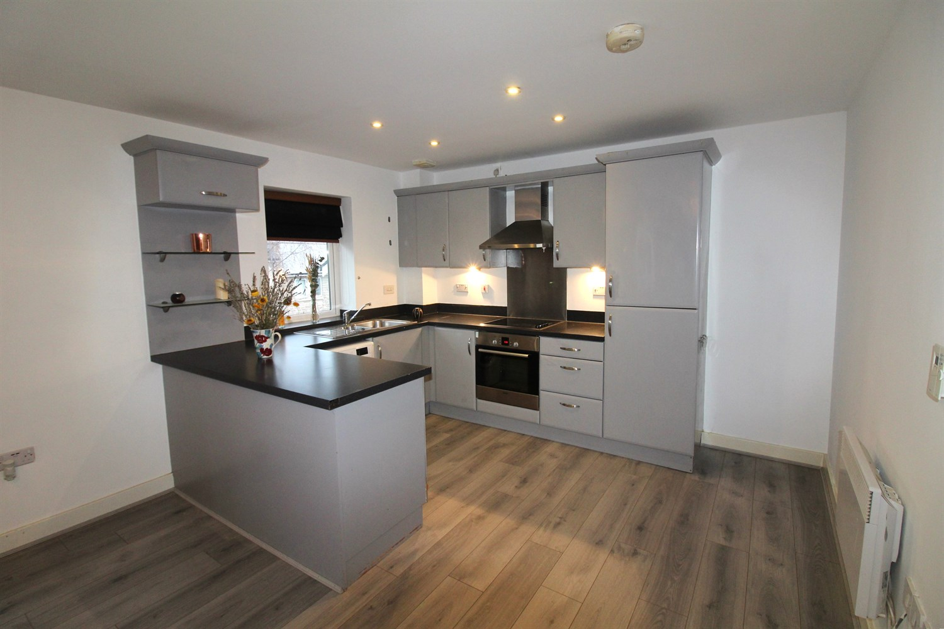

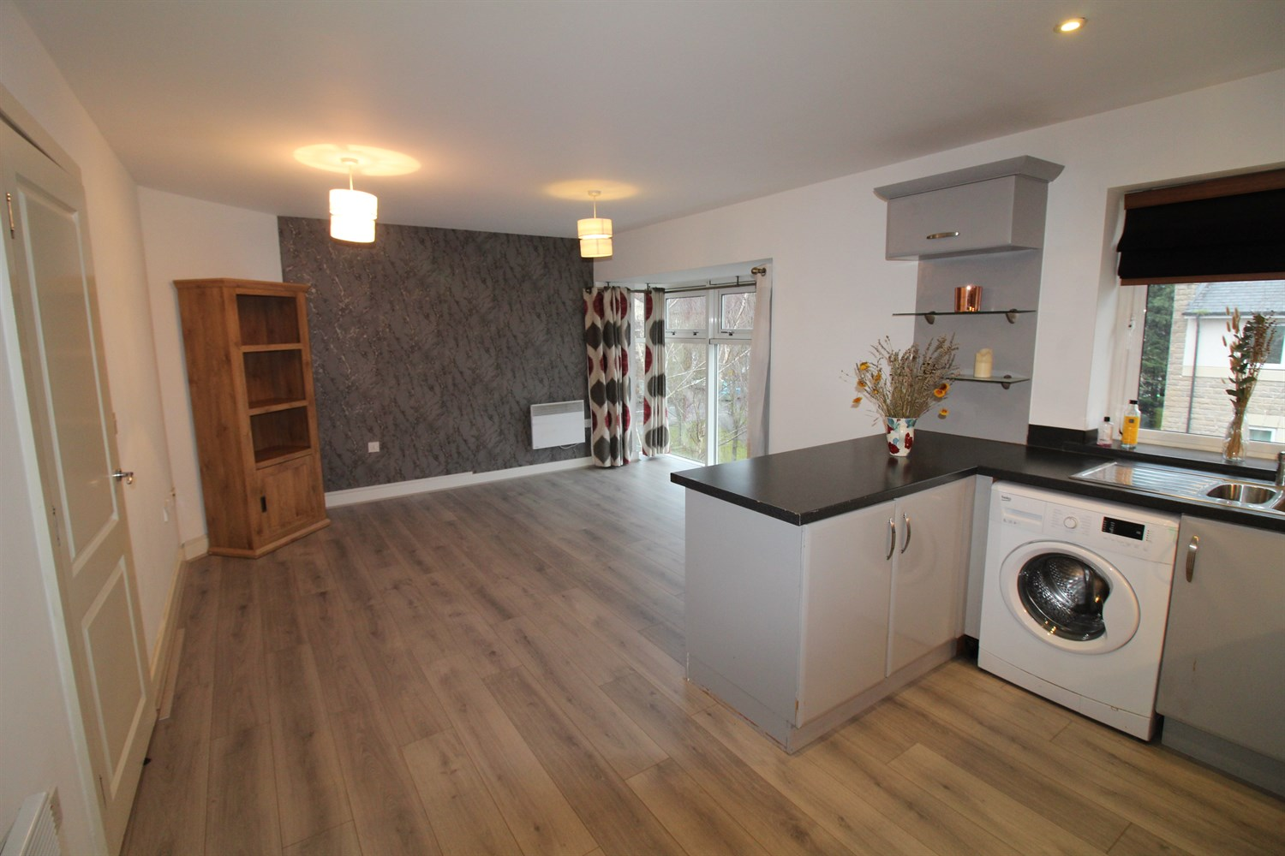

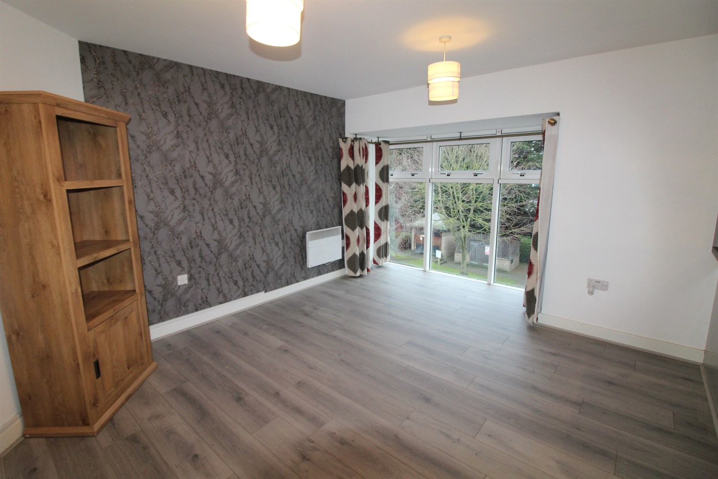

2 Bathroom(s)

1 Reception(s)

2 Bedroom(s)

00

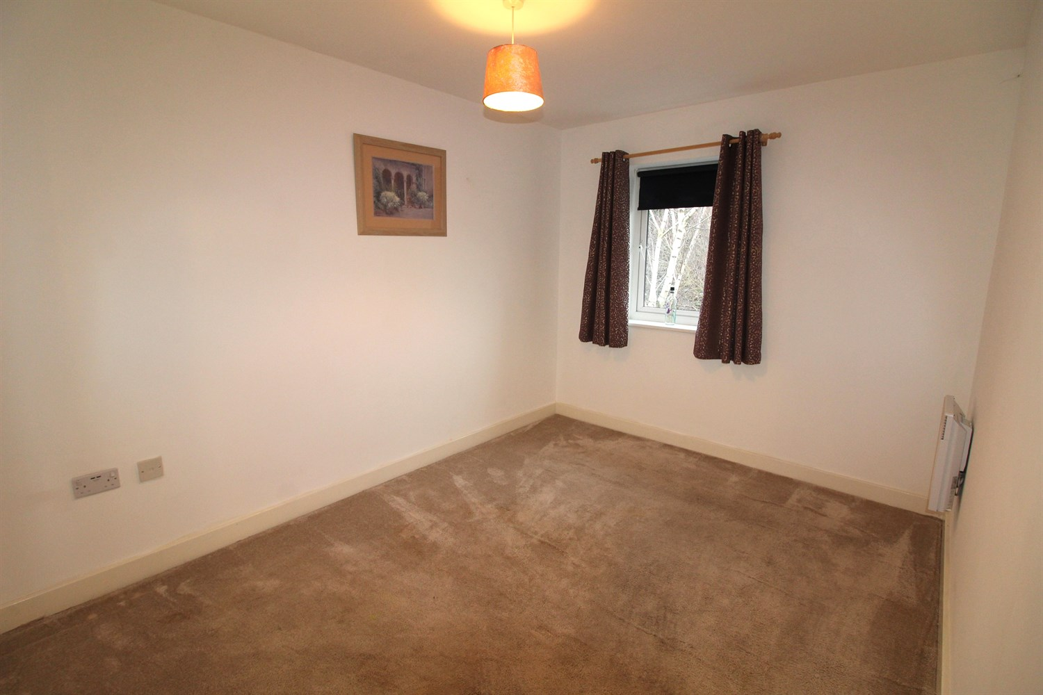

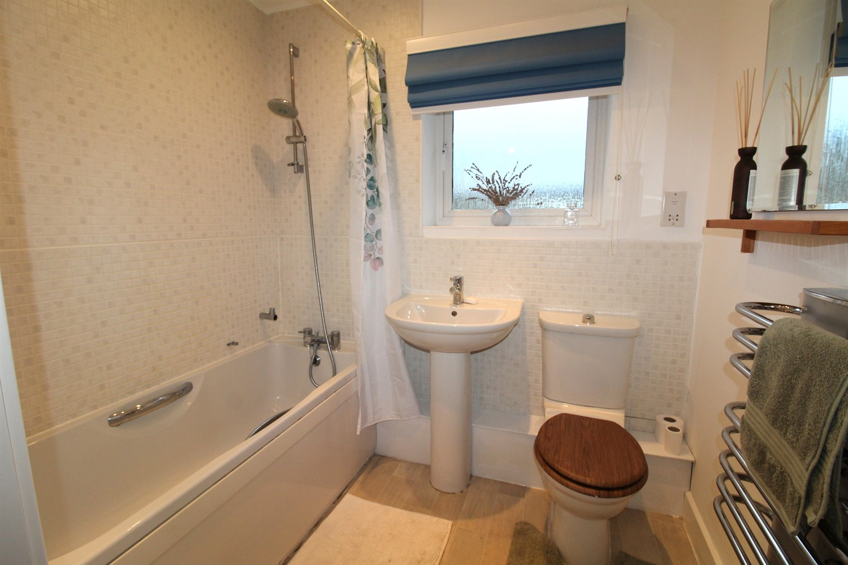

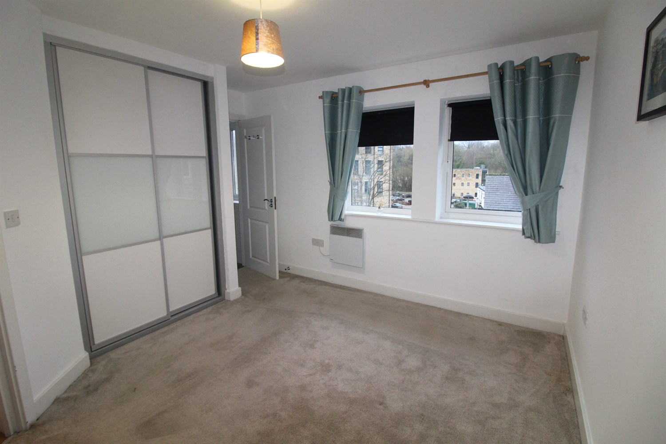

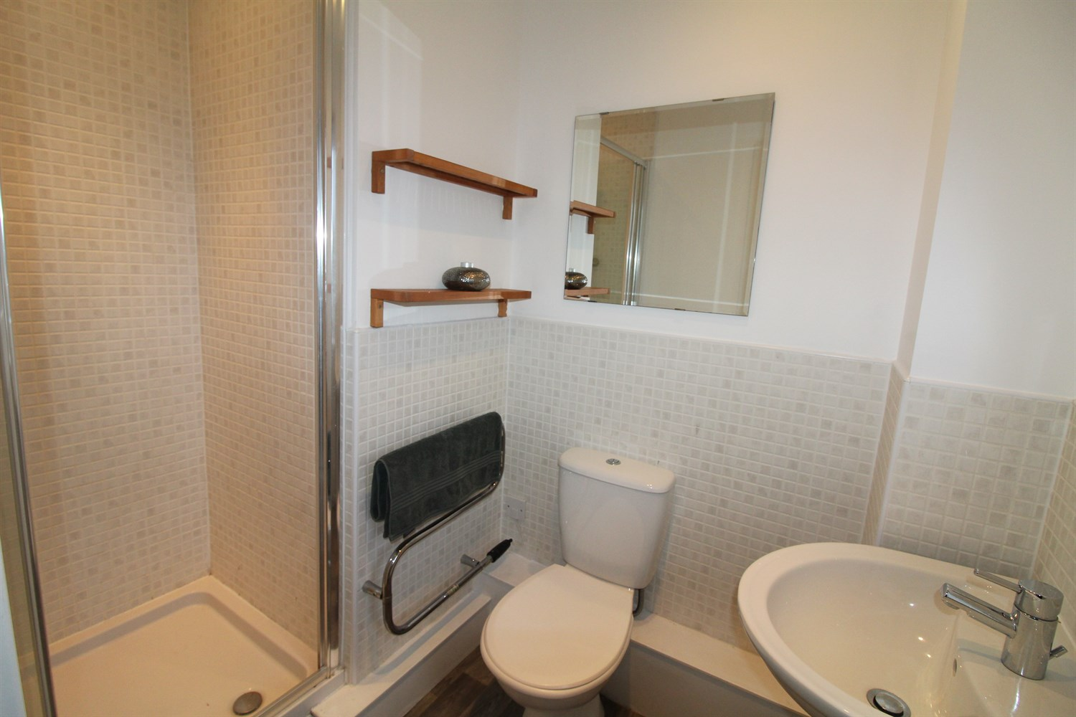

|  |
| --- |
| **Reception 1**  Open plan lounge is a lovely space with a full height bay window. The open plan dining kitchen has a range of base & wall storage units, housing for a fridge/freezer, a washing machine, built in Bosch oven & hob, ample dining space and ceiling inset spotlighting. |
| **Bedroom 1**  Master bedroom with built in wardrobe, Electric heating, double glazed window. |
| **En Suite**  En suite shower room comprising a three piece suite, separate shower cubicle, ceramic tiling and heated towel rail. |
| **Bedroom 2**  Double bedroom, electric wall heater. |
| **Bathroom**  House bathroom has a three piece suite with bath, ceramic tiling, chrome heated towel rail and ceiling inset spotlighting. |
| **Parking**  Allocated parking and visitor parking. |
| **Home Information**  Tenancy. 12 months. COUNCIL TAX BAND: B EPC Rating C  Leasehold property Allocated parking  Broadband: Standard 16 Mbps 1 Mbps Good Superfast 80 Mbps 20 Mbps Good Ultrafast --Not available --  Mobile availability: EE Likely to have good coverage. Three Likely to have good coverage. O2 Likely Likely to have good coverage. Vodafone Likely to have good coverage.  Utilities: Water supplied on standard meters. Electric mains supplied on standard meters. |

|  |  |
| --- | --- |
| These particulars are intended to give a fair description of the property, but their accuracy cannot be guaranteed, and they do not constitute an offer of contract. Intending purchasers must rely on their own inspection of the property. None of the above appliances/services have been tested by ourselves. We recommend purchasers arrange for a qualified person to check all appliances/services before legal commitment.  **Property Ref:** 4980  **For more information, please contact**  0113 258 1150 **|** [lettings@adairpaxton.co.uk](mailto:lettings@adairpaxton.co.uk) **|** www.adairpaxton.co.uk |  |