

**0113 258 1150**

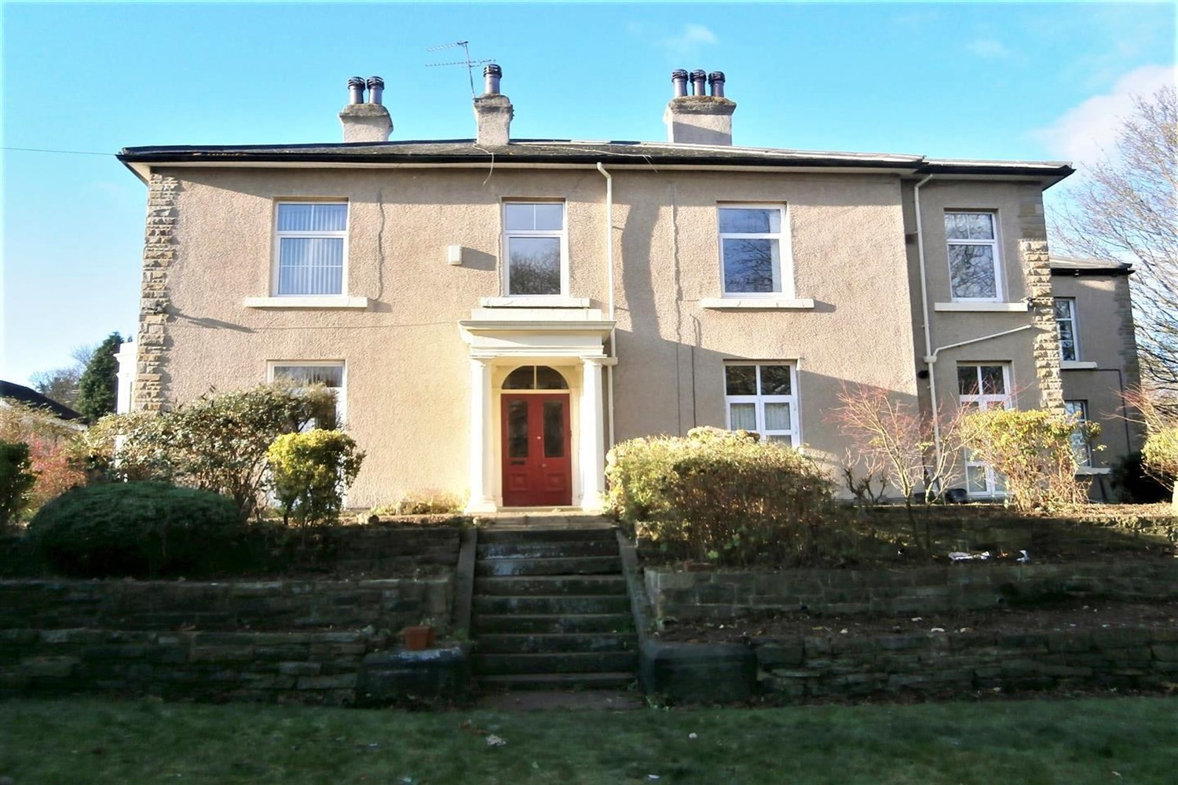



**Available to let £850.00pcm**

**4 Cliff Road, LS6**

Spacious one bed flat within walking distance of the University and Hyde Park Corner. Close to all local amenities and great transport links to the City Centre and beyond. Ground floor flat in an attractive Detached house set in pleasant maintained gardens. Comprising; Lounge, Kitchen, One Double Bedroom and Bathroom. Off street parking for one vehicle. Council Tax Band A. EPC rating D Bond £980. Furnished. Available Now.

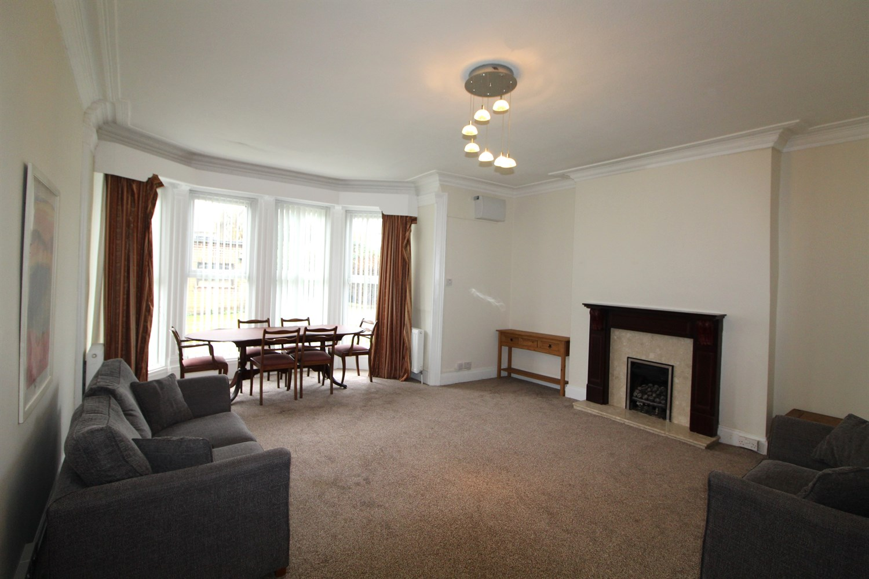

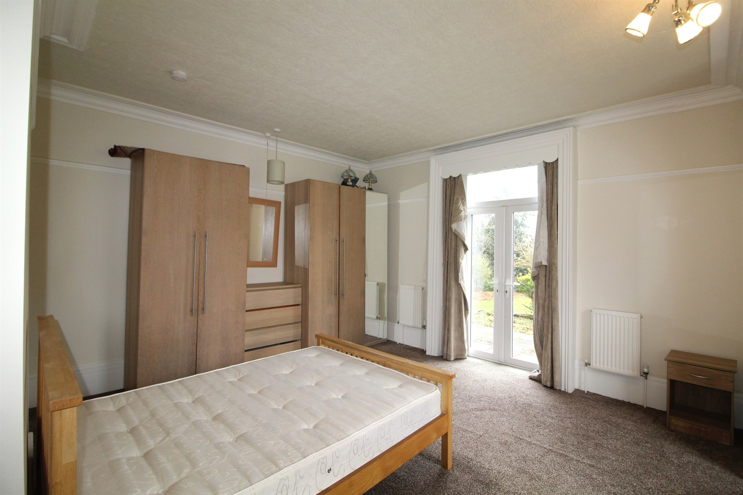

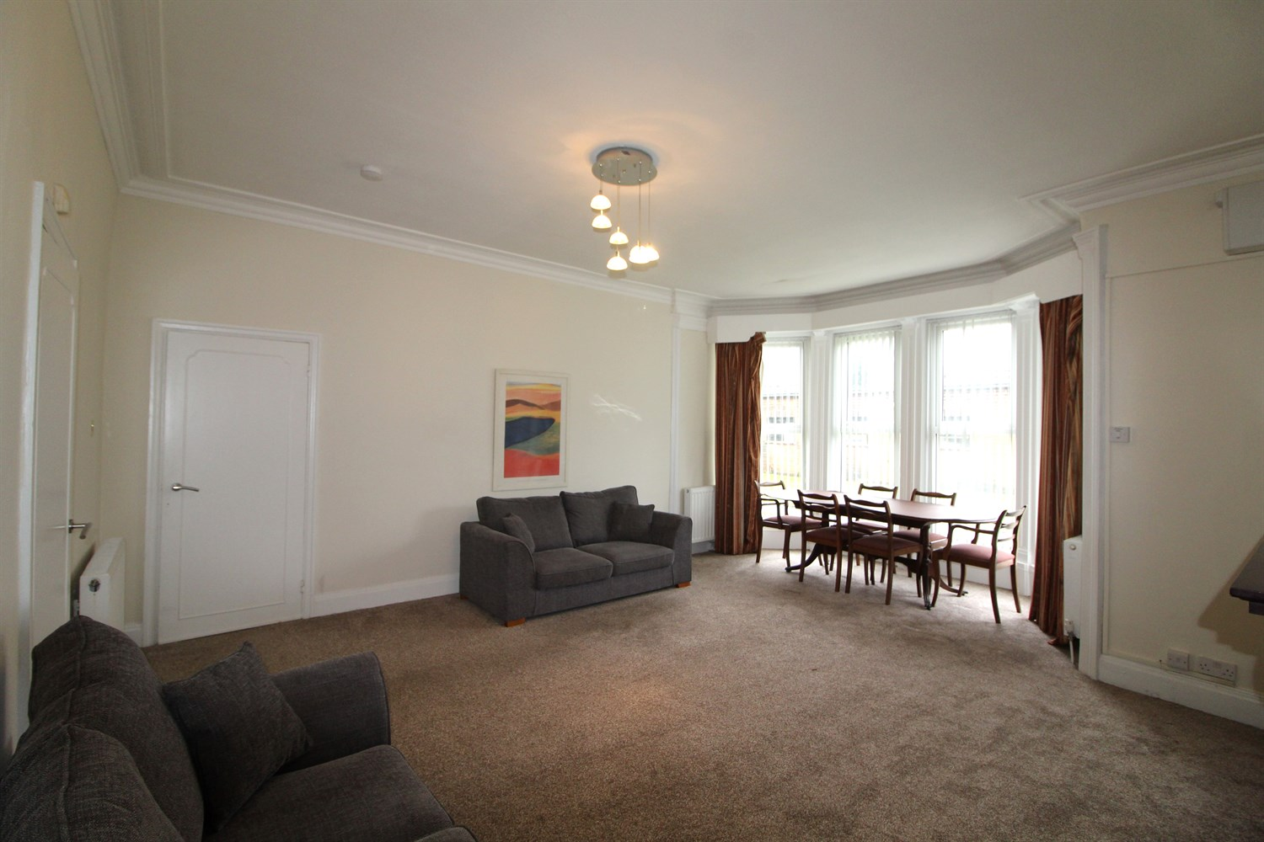

1 Bathroom(s)

1 Reception(s)

1 Bedroom(s)

00

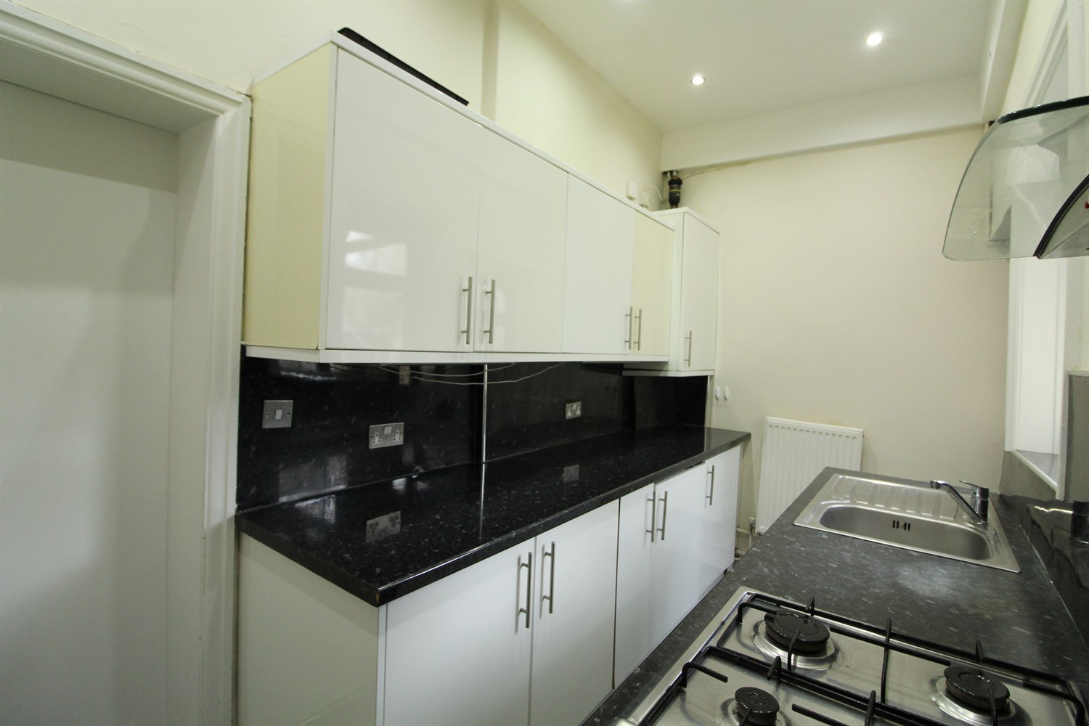

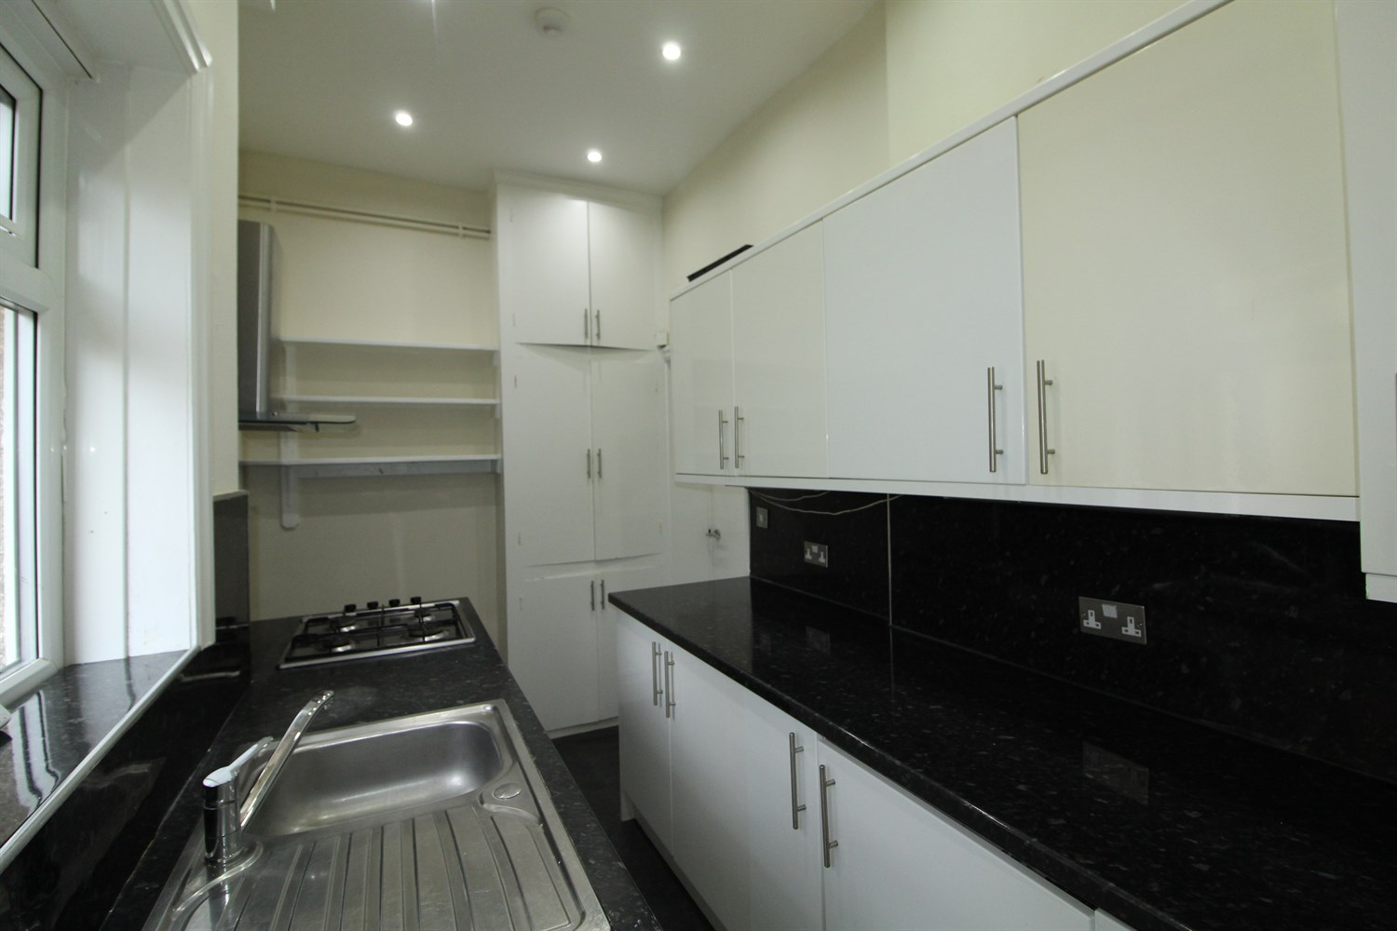

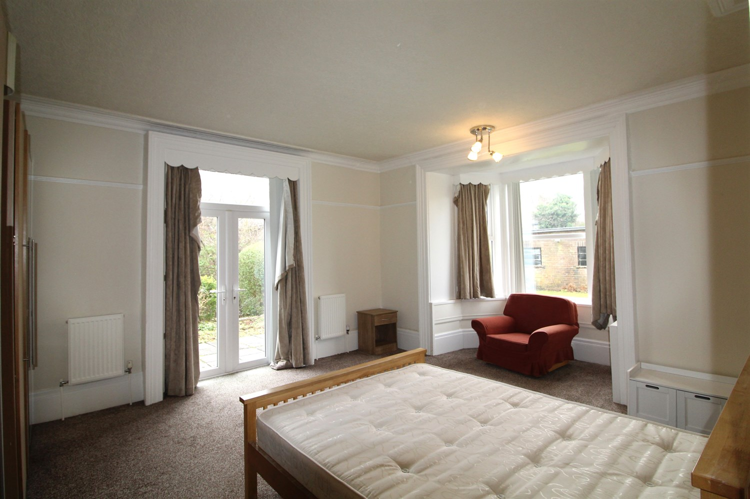

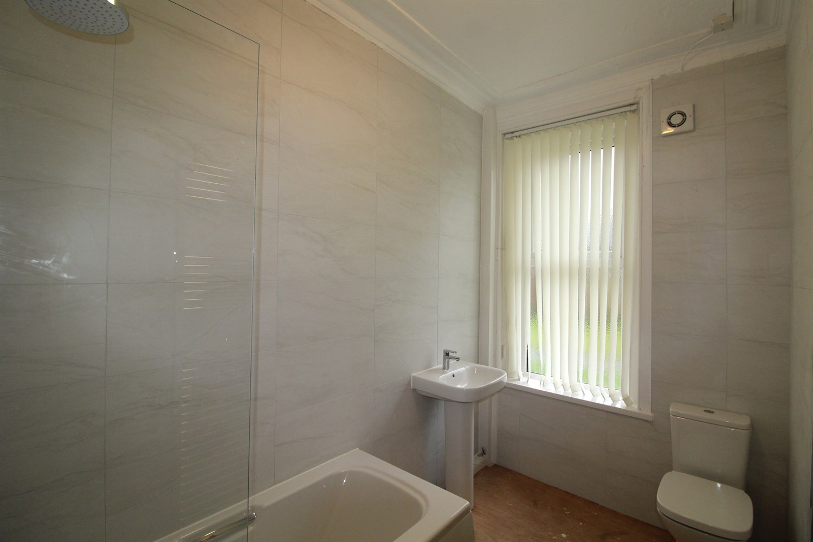

|  |
| --- |
| **Reception 1**  Exceptionally large living room with large windows over looking the garden, space for dining table, gas central heating radiator. |
| **Kitchen**  Fitted with a range of wall and base units with work tops over, stainless steel sink with mixer tap, gas cooker top electric oven, uPVC window to rear. |
| **Bedroom 1**  Large double bedroom with uPVC French doors leading to the side of the property, gas central heating radiator. |
| **Bathroom**  Three piece bathroom suite with shower over bath, w/c and hand wash basin, uPVC window to rear. |
| **Communal Garden**  Communal garden. |
| **Parking**  On street permit parking. |
| **Home Information**  COUNCIL TAX BAND: A EPC Rating D  Freehold property Permit Parking  Broadband:  Standard 15 Mbps 1 Mbps Good Superfast 51 Mbps 8 Mbps Good Ultrafast 1800 Mbps 1000 Mbps Mobile availability: EE Limited coverage. Three limited coverage O2 Likely Likely to have good coverage Vodafone Limited coverage.  Utilities: Water supplied on standard meters. Gas and Electric mains supplied on standard meters. |

|  |  |
| --- | --- |
| These particulars are intended to give a fair description of the property, but their accuracy cannot be guaranteed, and they do not constitute an offer of contract. Intending purchasers must rely on their own inspection of the property. None of the above appliances/services have been tested by ourselves. We recommend purchasers arrange for a qualified person to check all appliances/services before legal commitment.  **Property Ref:** 5177  **For more information, please contact**  0113 258 1150 **|** [lettings@adairpaxton.co.uk](mailto:lettings@adairpaxton.co.uk) **|** www.adairpaxton.co.uk |  |