

**0113 258 1150**

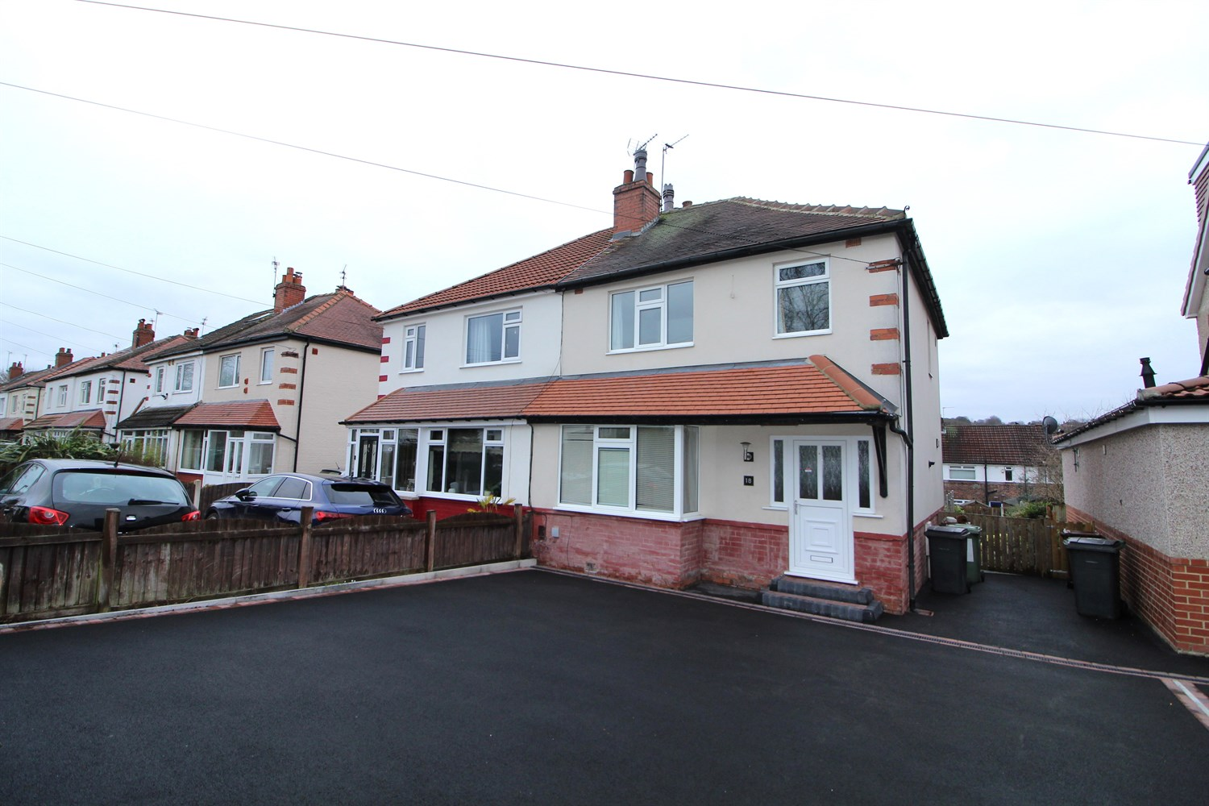



**Available to let £1,450.00pcm**

**18 Brownberrie Walk, Horsforth**

***DELIGHTFUL THREE BEDROOM SEMI DETACHED HOUSE WITH NEW DECOR THROUGHOUT*** within walking distance of Horsforth train station and all the amenities of this sought after location. The property has a generous rear garden and located in a pleasant cul-de-sac. Benefits include uPVC double glazing and gas central heating. The well presented living accommodation briefly comprises front entrance hall, lounge with feature fireplace, pleasant open plan dining kitchen including appliances, first floor landing, three bedrooms (two doubles) and stylish bathroom/w.c/shower. Unfurnished. Bond £1,670. Available Now. Council tax band C, EPC rating E.

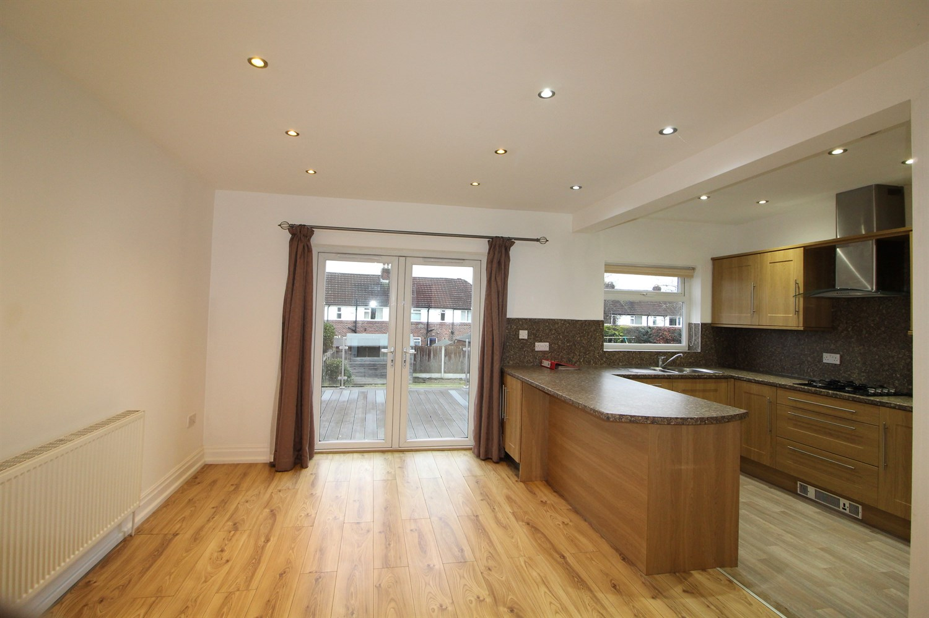

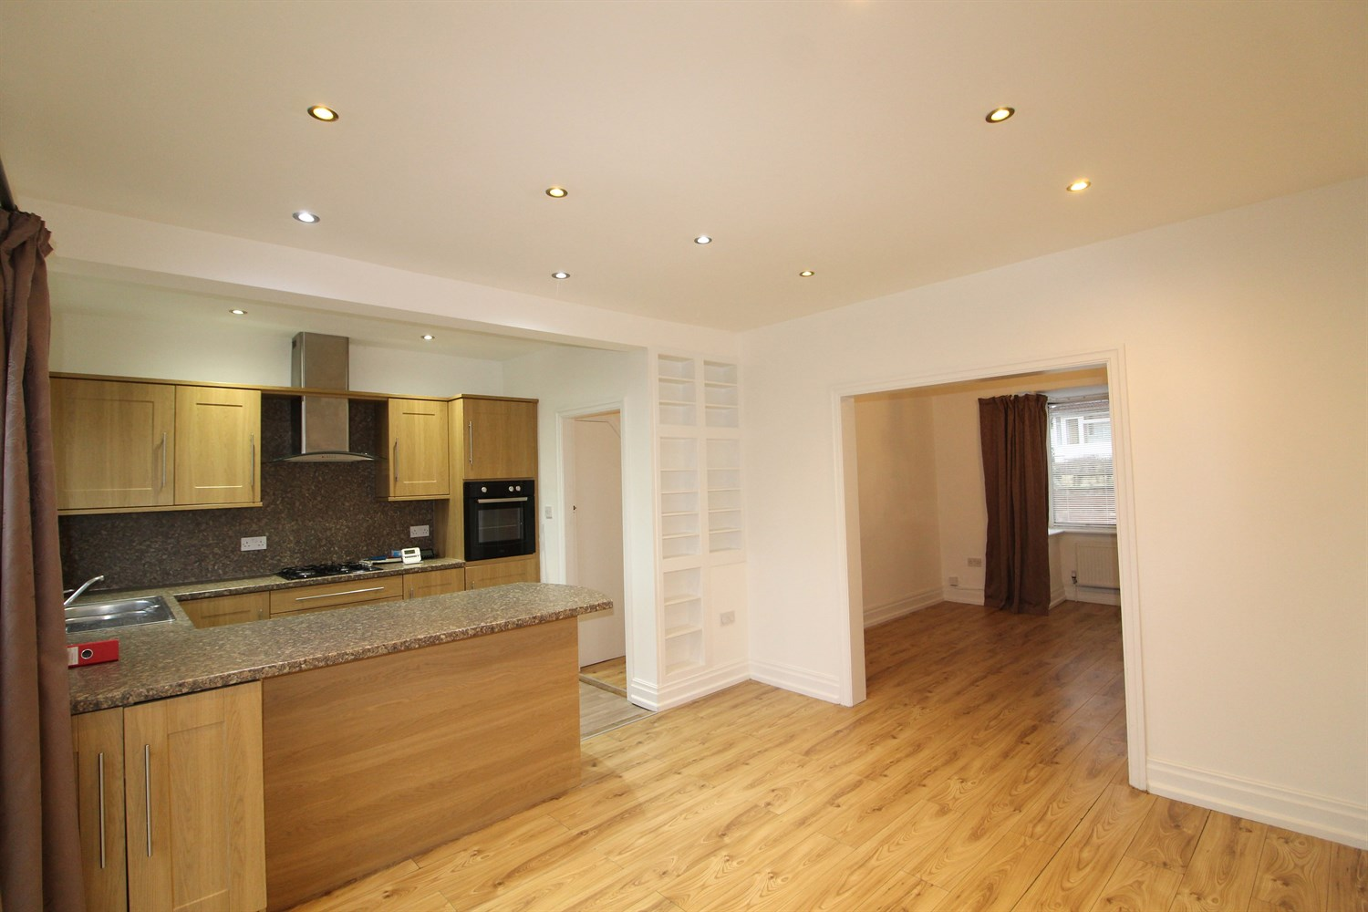

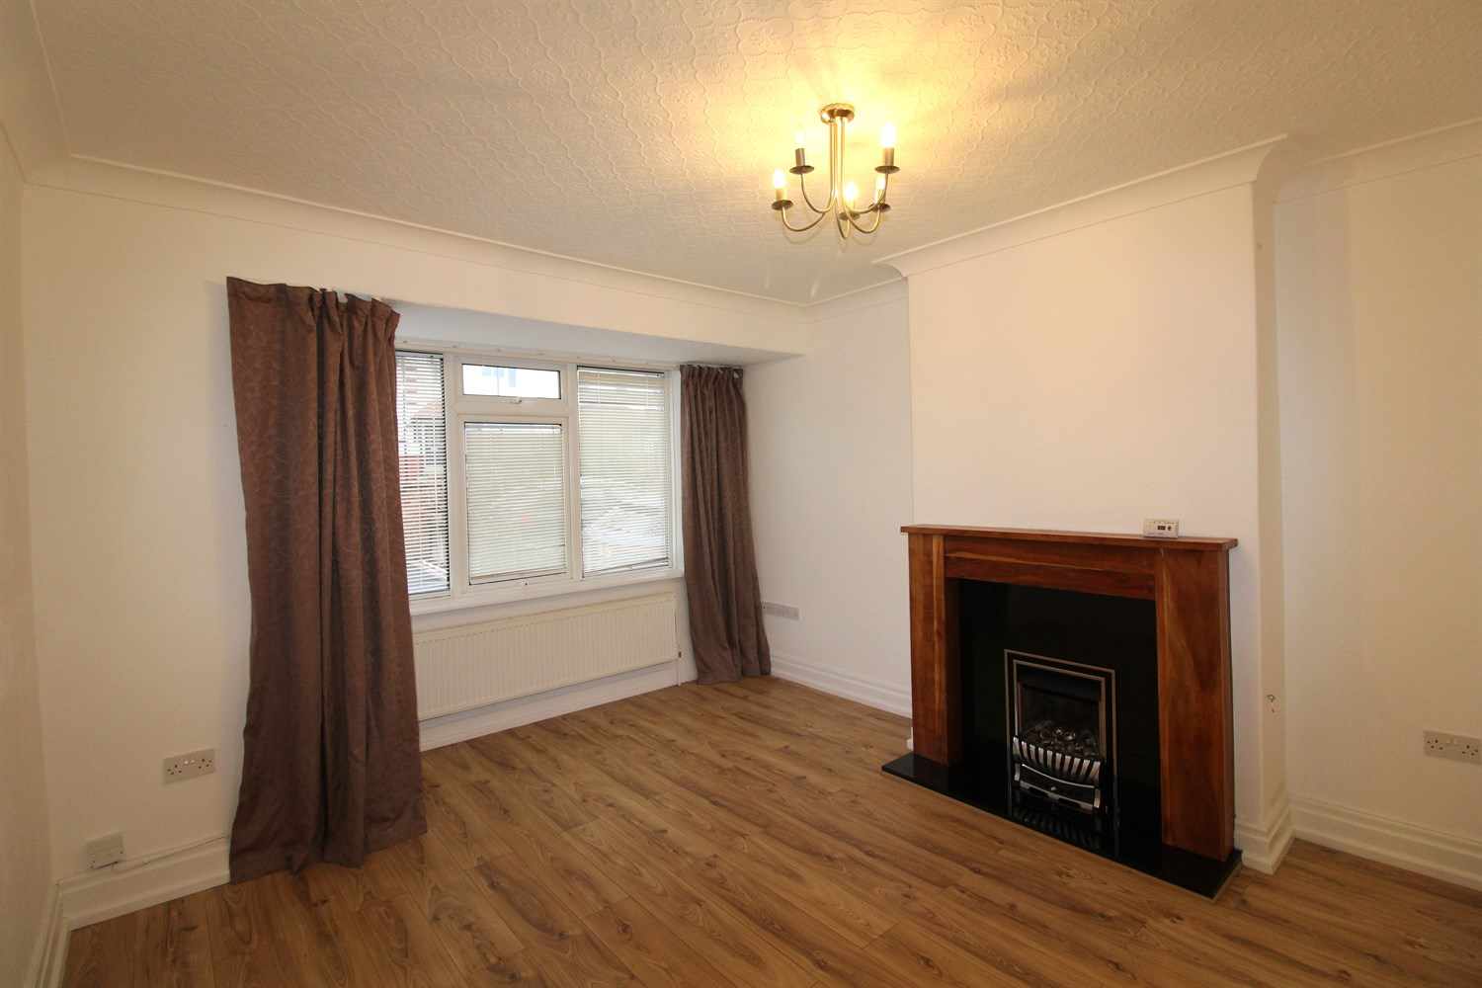

1 Bathroom(s)

1 Reception(s)

3 Bedroom(s)

00

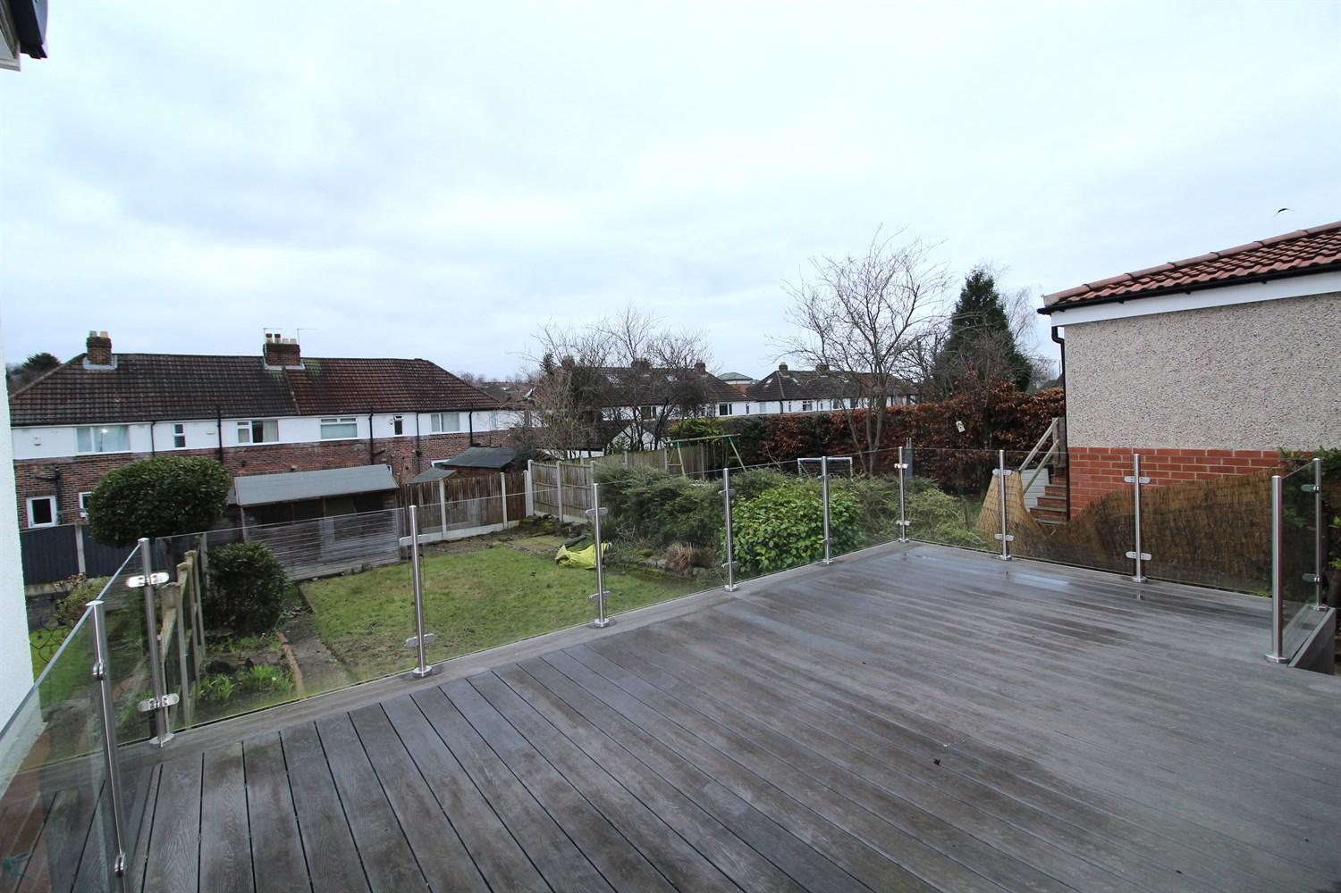

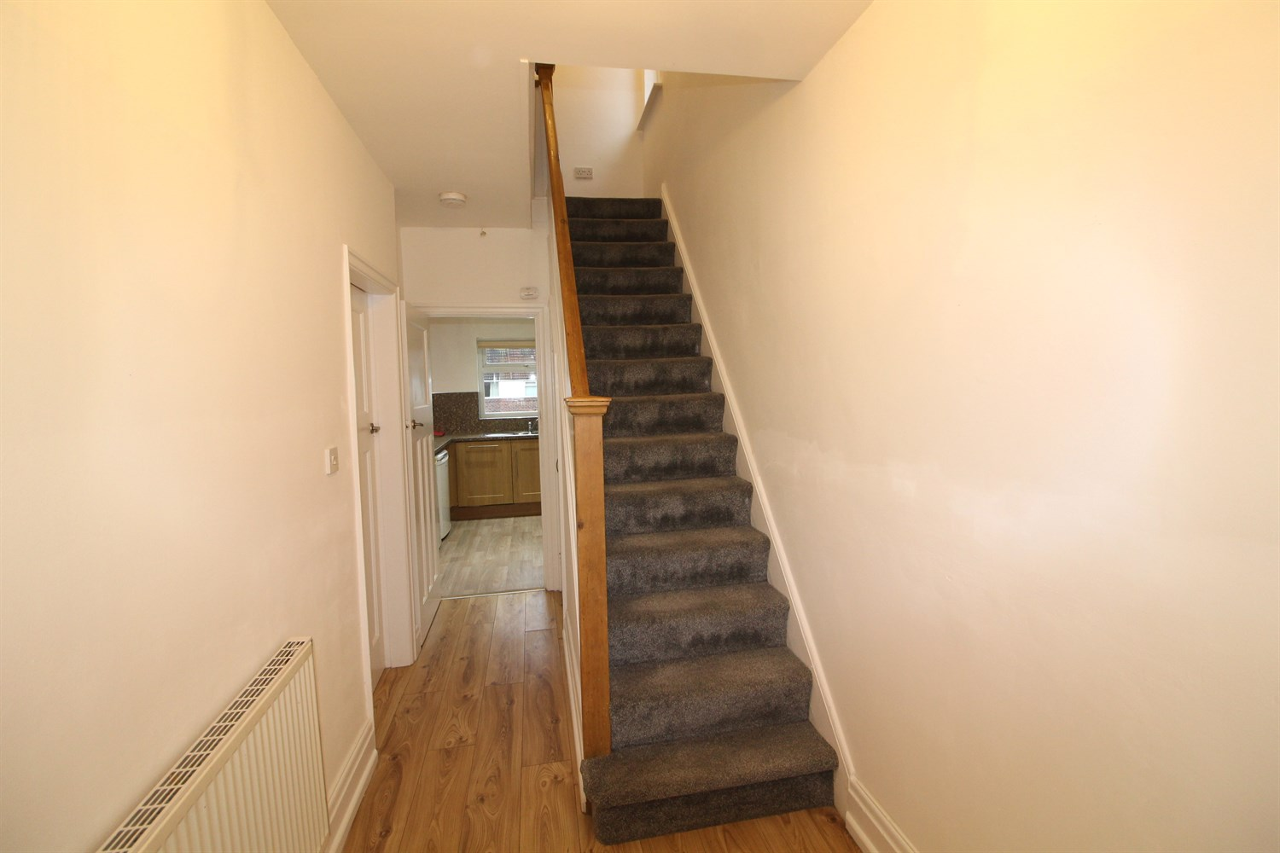

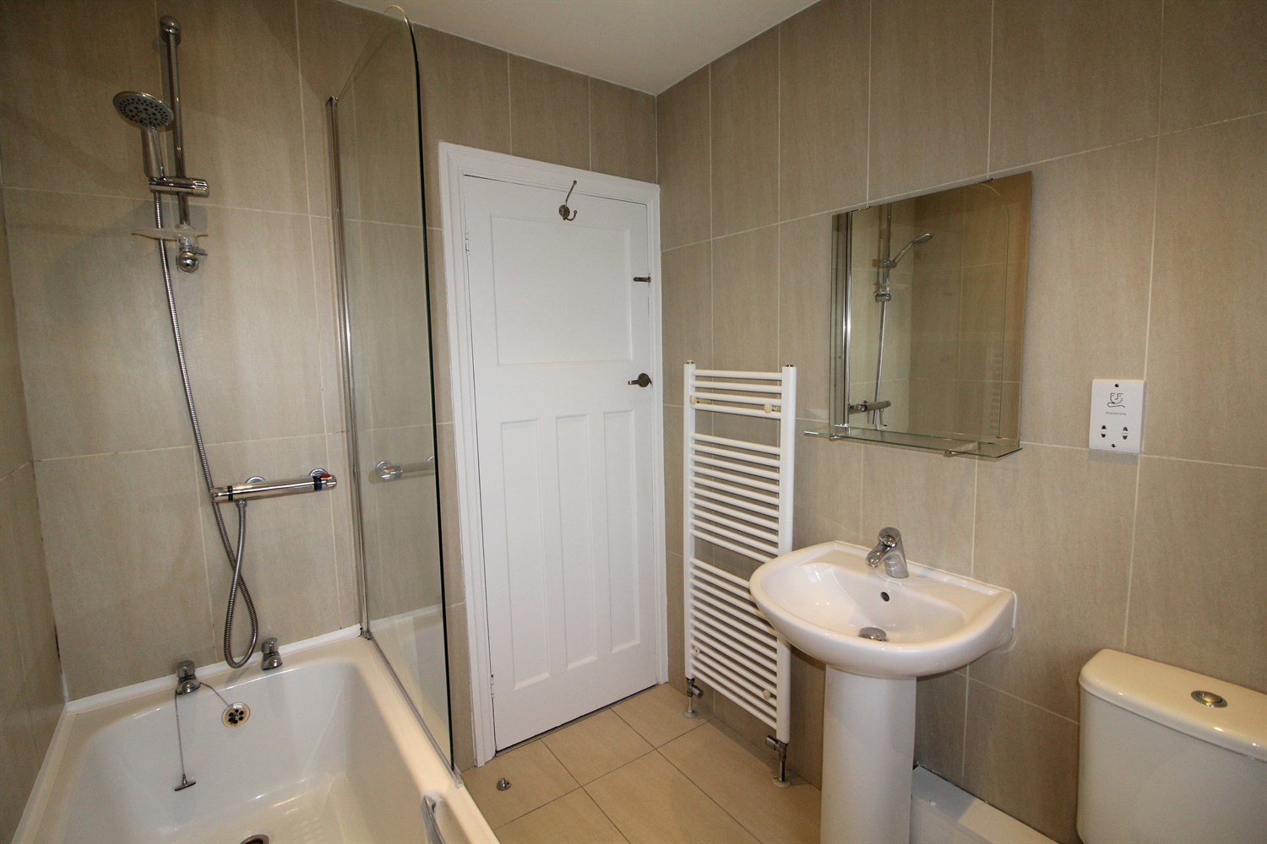

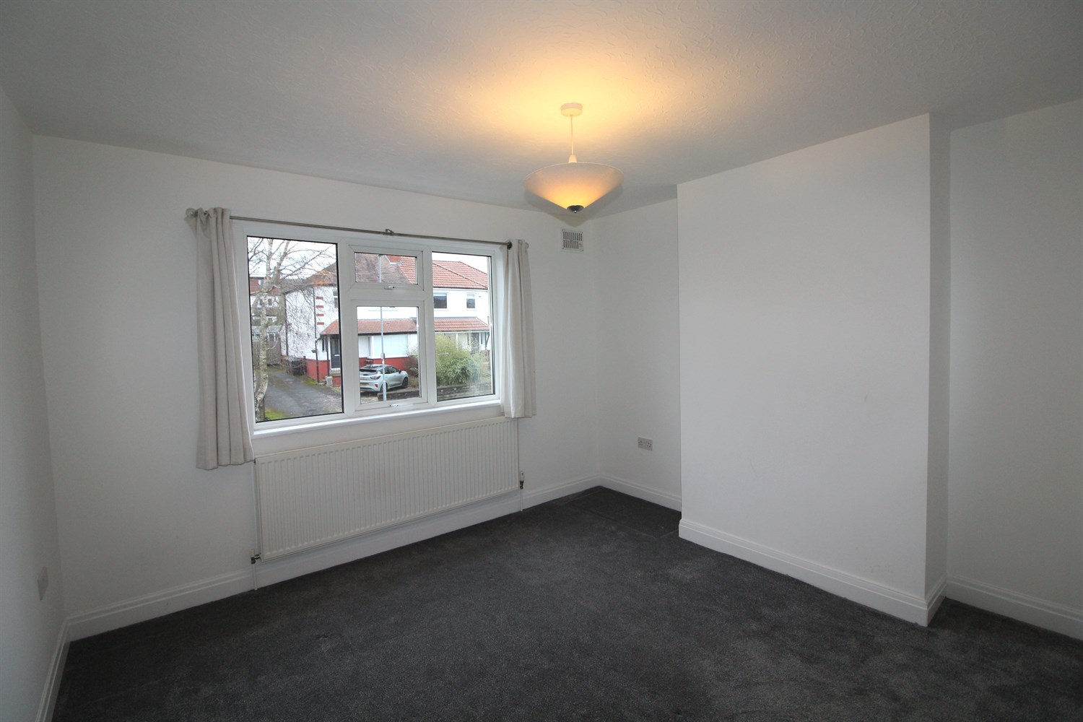

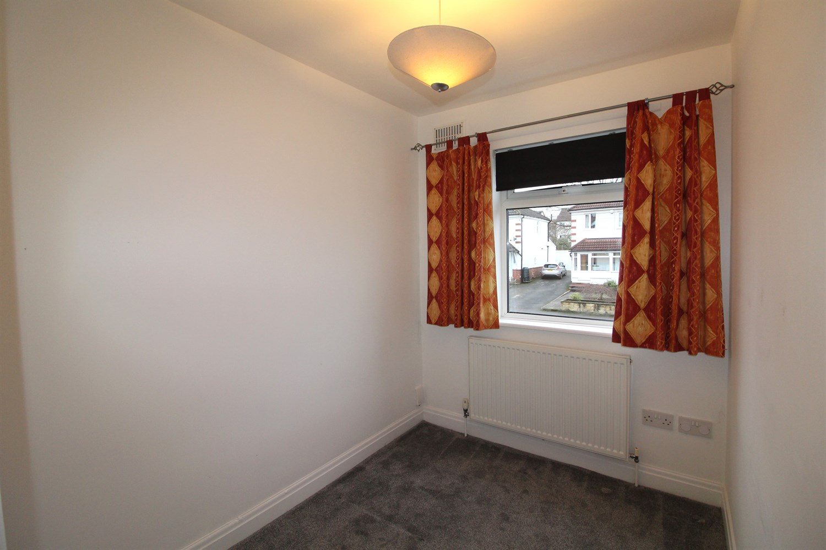

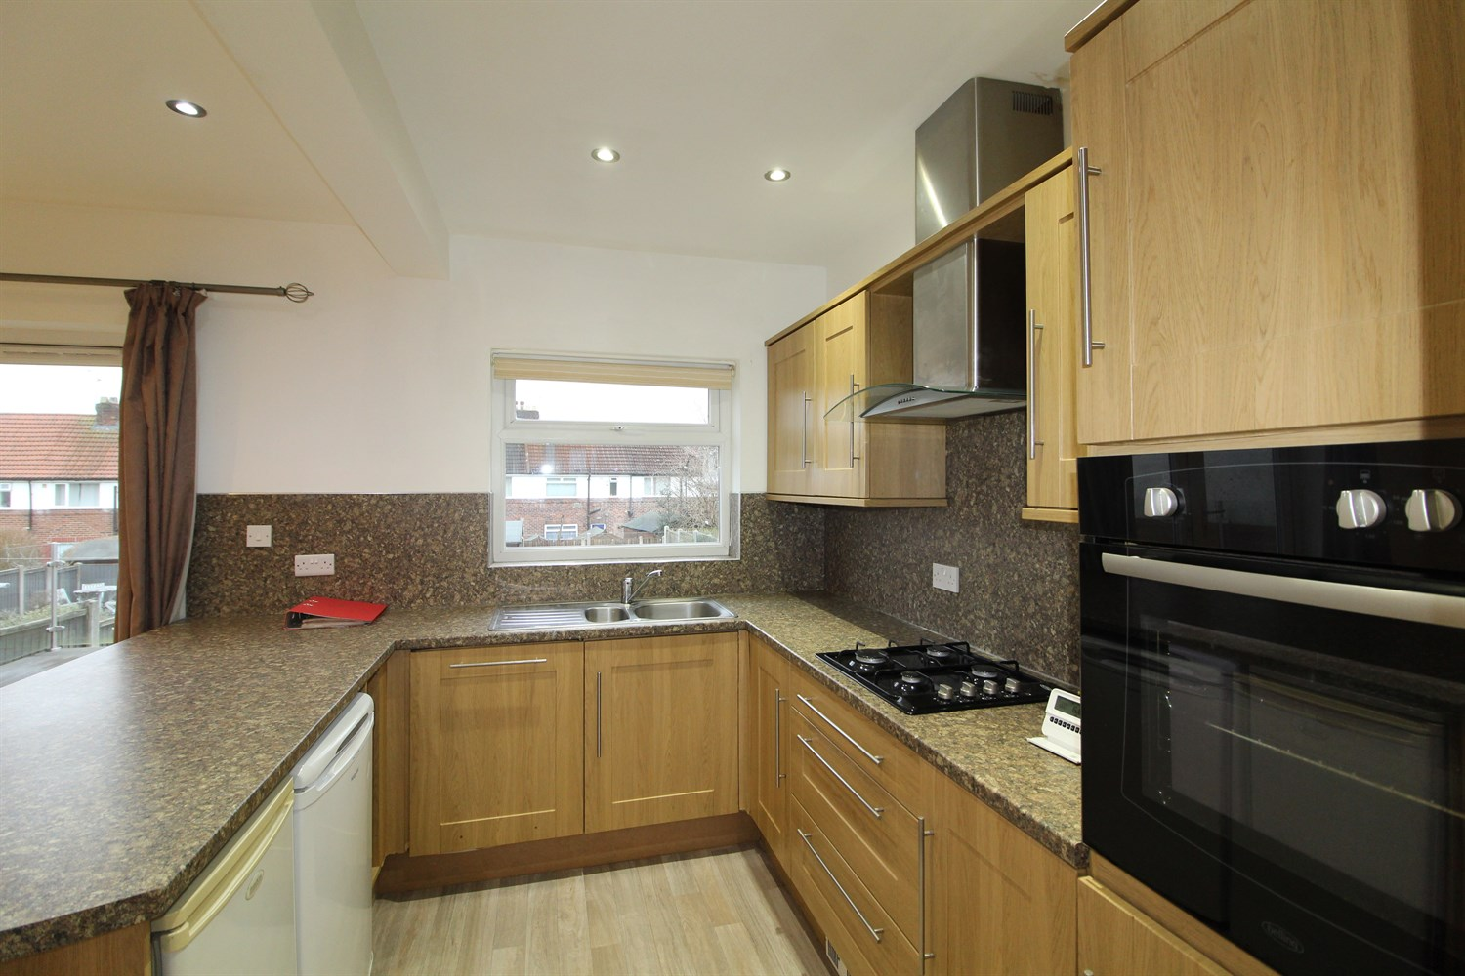

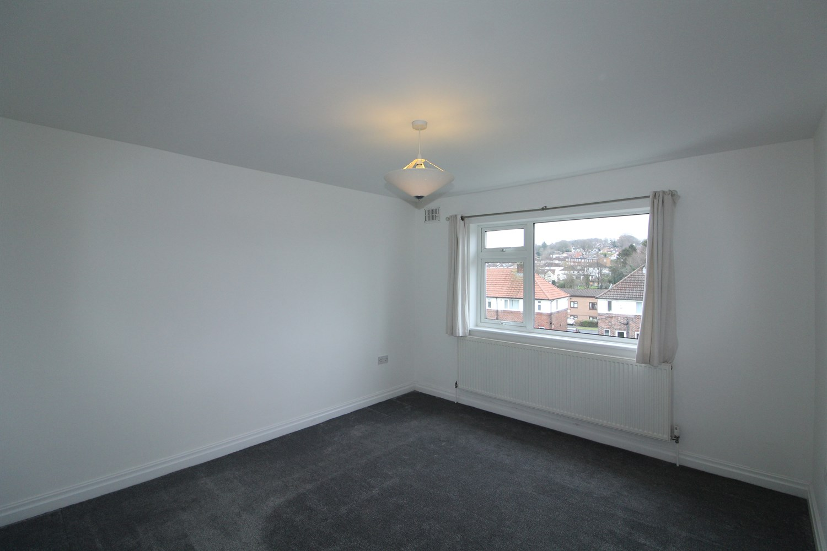

|  |
| --- |
| **Living Room**  Modern fire surround with black granite inset and hearth and coal effect gas fire. Double radiator. uPVC double glazed squared bay window to the front. Ceiling coving. T.V aerial point |
| **Kitchen**  Quality fitted in 'Oak' style wall, base and drawer units with chrome handles. Colour co-ordinated work surfaces and matching splashbacks. Inset stainless steel one and a half bowl sink with side drainer and mixer tap. Integrated electric oven and four ring gas hob with stainless steel extractor chimney above with light. Integrated dishwasher. Cupboard housing an automatic washing machine. Free standing fridge and freezer. uPVC double glazed window to the rear. uPVC double glazed French doors to the rear garden. Laminate wood floor. |
| **Bedroom**  uPVC double glazed window to the rear. Newly carpeted. Radiator. |
| **Bedroom**  uPVC double glazed window to the front. Newly carpeted. Radiator. |
| **Bedroom**  uPVC double glazed window to the front. Newly carpeted. Radiator. |
| **Bathroom**  Fitted in a quality modern white three piece suite comprising pedestal wash basin, low flush w.c and shower style bath with plumbed in shower above and shower screen. Towel radiator. Additional radiator. Built-in cupboard. uPVC double glazed window to the rear. Ceiling spotlights. Extractor fan. Fully tiled in attractive complimentary ceramics including the floor. |
| **Outside**  Outside: To the front of the property is a large driveway offering off street parking for several cars. The rear garden is of a generous size with a decked area and lawned garden enclosed by shrubs, fence and hedging. Two security lights. Cold water tap. The rear of the garden will be upgraded for easy maintenance. |
| **Home Information**  COUNCIL TAX BAND: C EPC Rating E  Freehold property.  Driveway.  Broadband: Standard 10 Mbps 0.9 Mbps Good Superfast --Not available --Not available Unlikely Ultrafast 1800 Mbps 220 Mbps  Mobile availability:  EE limited coverage . Three likely to have good coverage. O2 likely to have good coverage. Vodafone likely to have good coverage.  Utilities: Water supplied on standard meters. Gas and Electric mains supplied on standard meters. |

|  |  |
| --- | --- |
| These particulars are intended to give a fair description of the property, but their accuracy cannot be guaranteed, and they do not constitute an offer of contract. Intending purchasers must rely on their own inspection of the property. None of the above appliances/services have been tested by ourselves. We recommend purchasers arrange for a qualified person to check all appliances/services before legal commitment.  **Property Ref:** 127  **For more information, please contact**  0113 258 1150 **|** [lettings@adairpaxton.co.uk](mailto:lettings@adairpaxton.co.uk) **|** www.adairpaxton.co.uk |  |