

North Close, Oakwood
For Sale £200,000.00

Adair Paxton are pleased to offer to the market this three bedroom end terrace house with NO ONWARD CHAIN. Situated in a popular and sought after part of north Leeds being close to a host of amenities, leisure and shopping facilities, transport networks, well regarded primary and secondary and schools and Roundhay Park. This property is now in need of updating and briefly comprises; entrance hall, kitchen and living room to the ground floor. To the first floor there are three bedrooms and a house bathroom. Externally, the property has gardens to the front and rear with a driveway to the front offering off street parking. An early internal viewing is highly recommended to appreciate the accommodation on offer.
0113 258 1150
0800 000 000
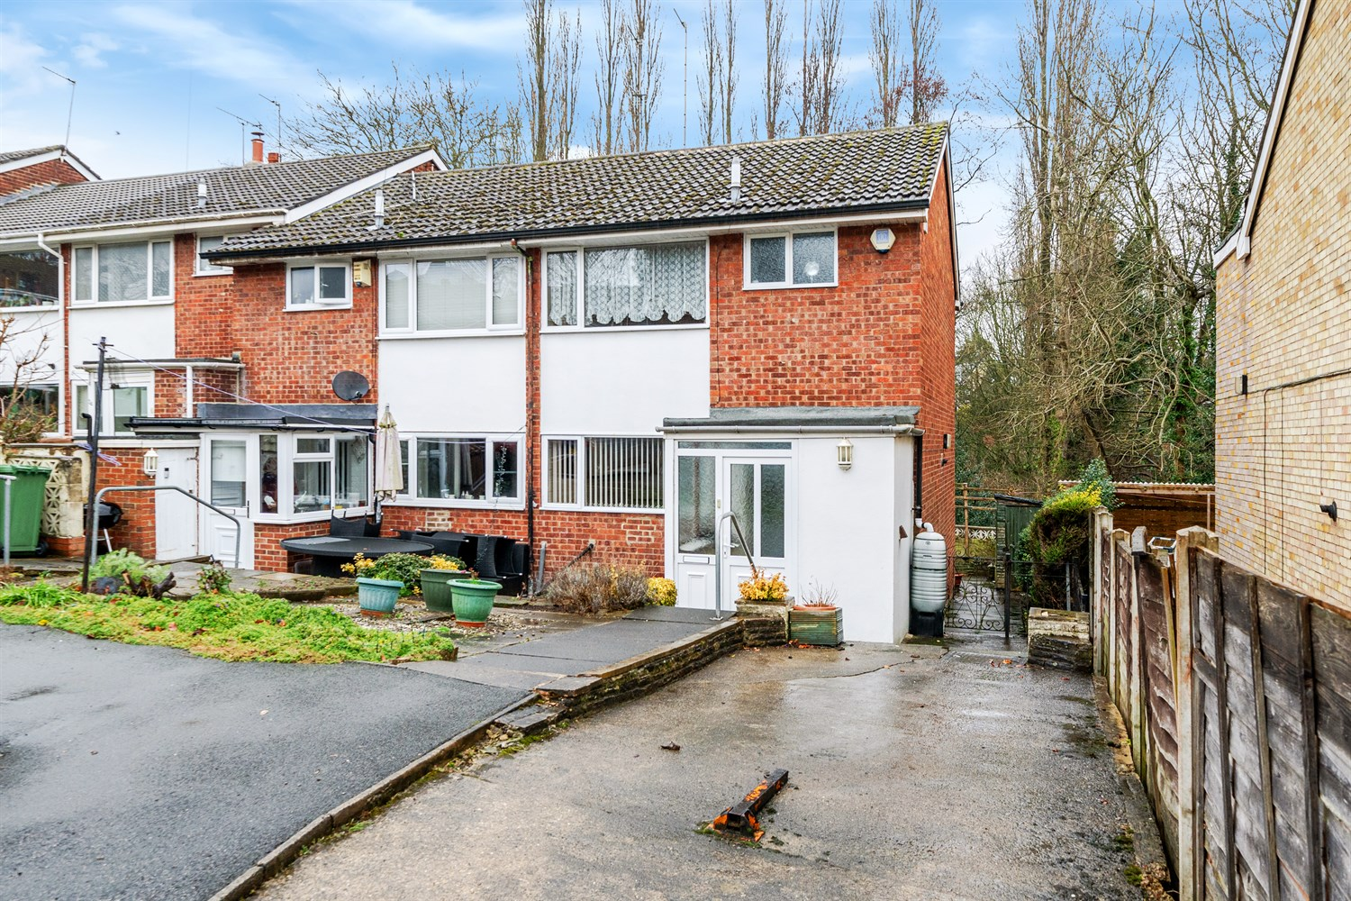
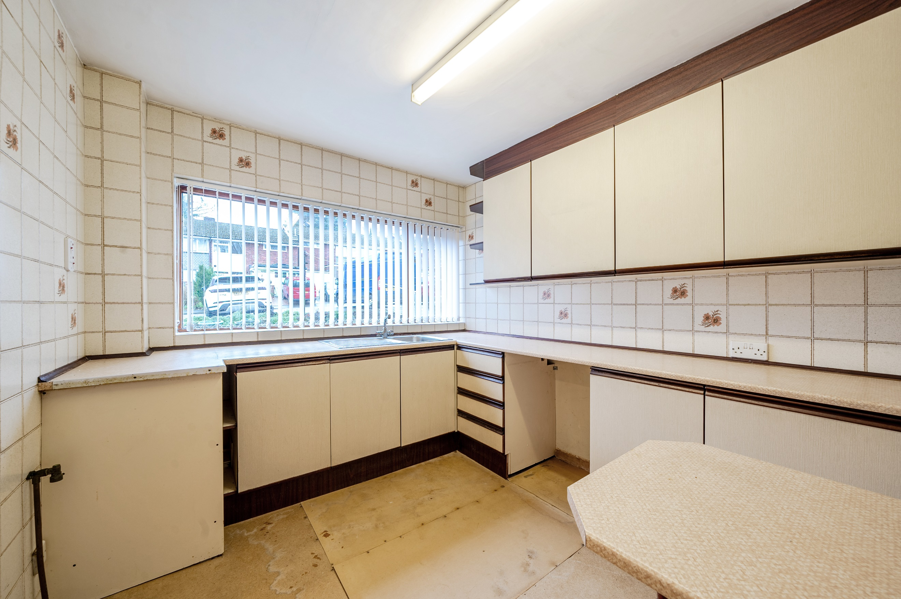
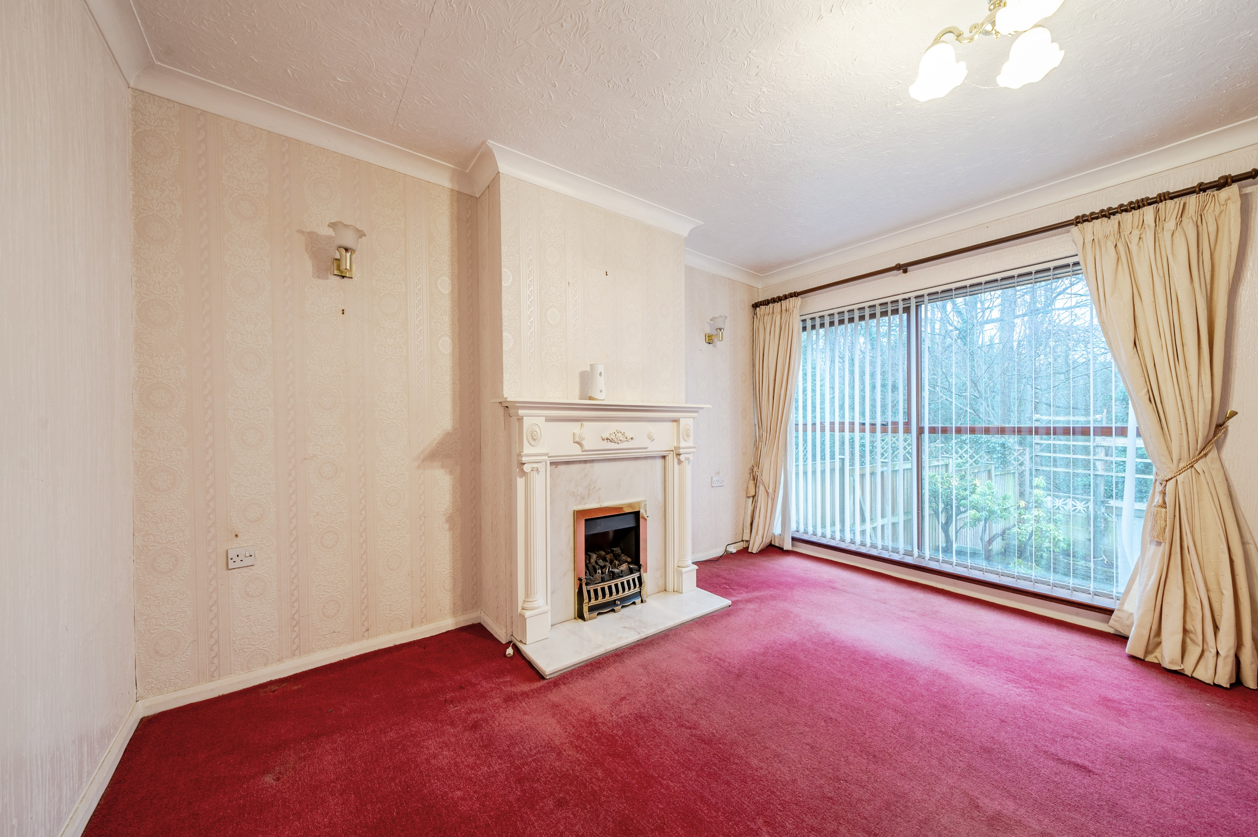
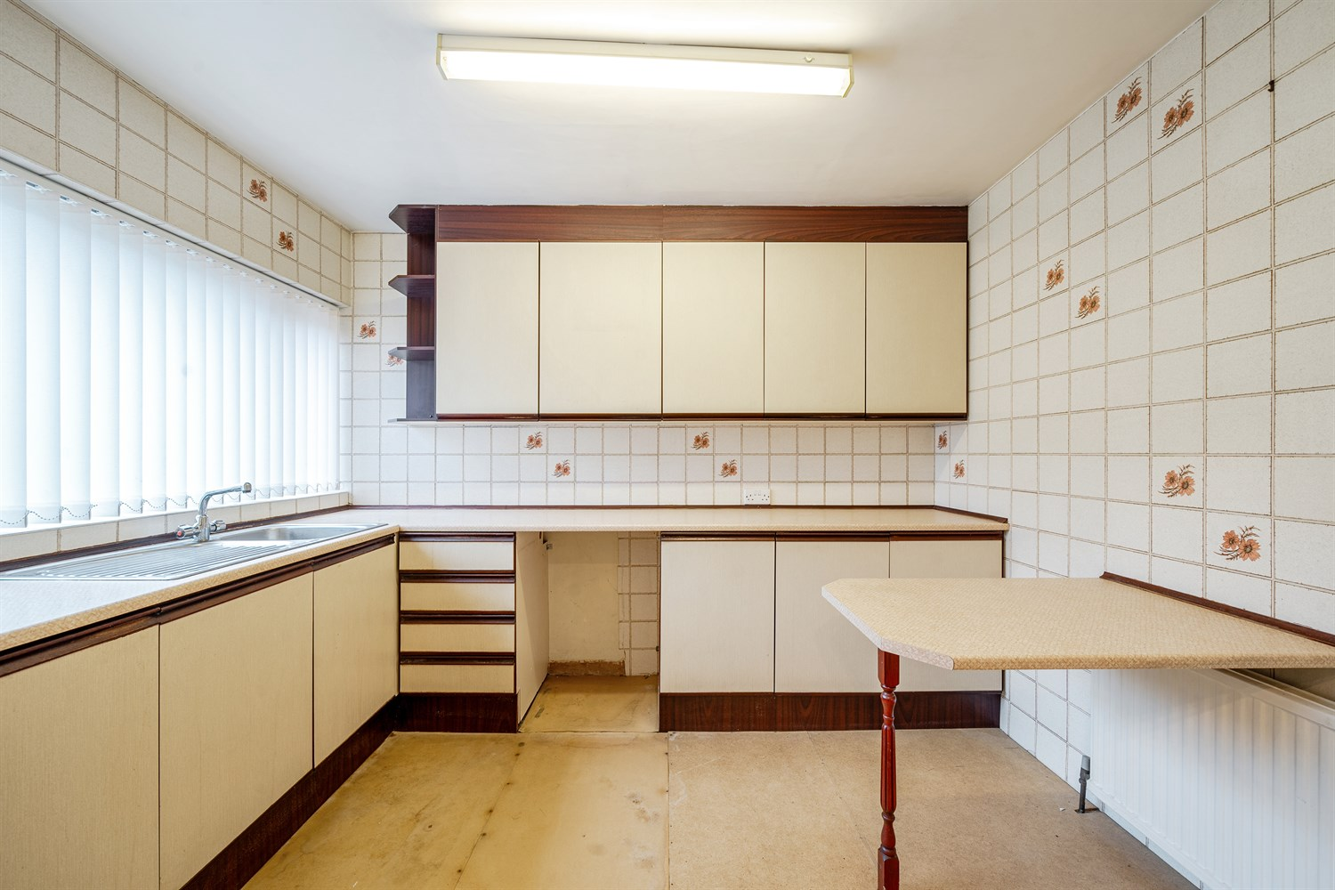
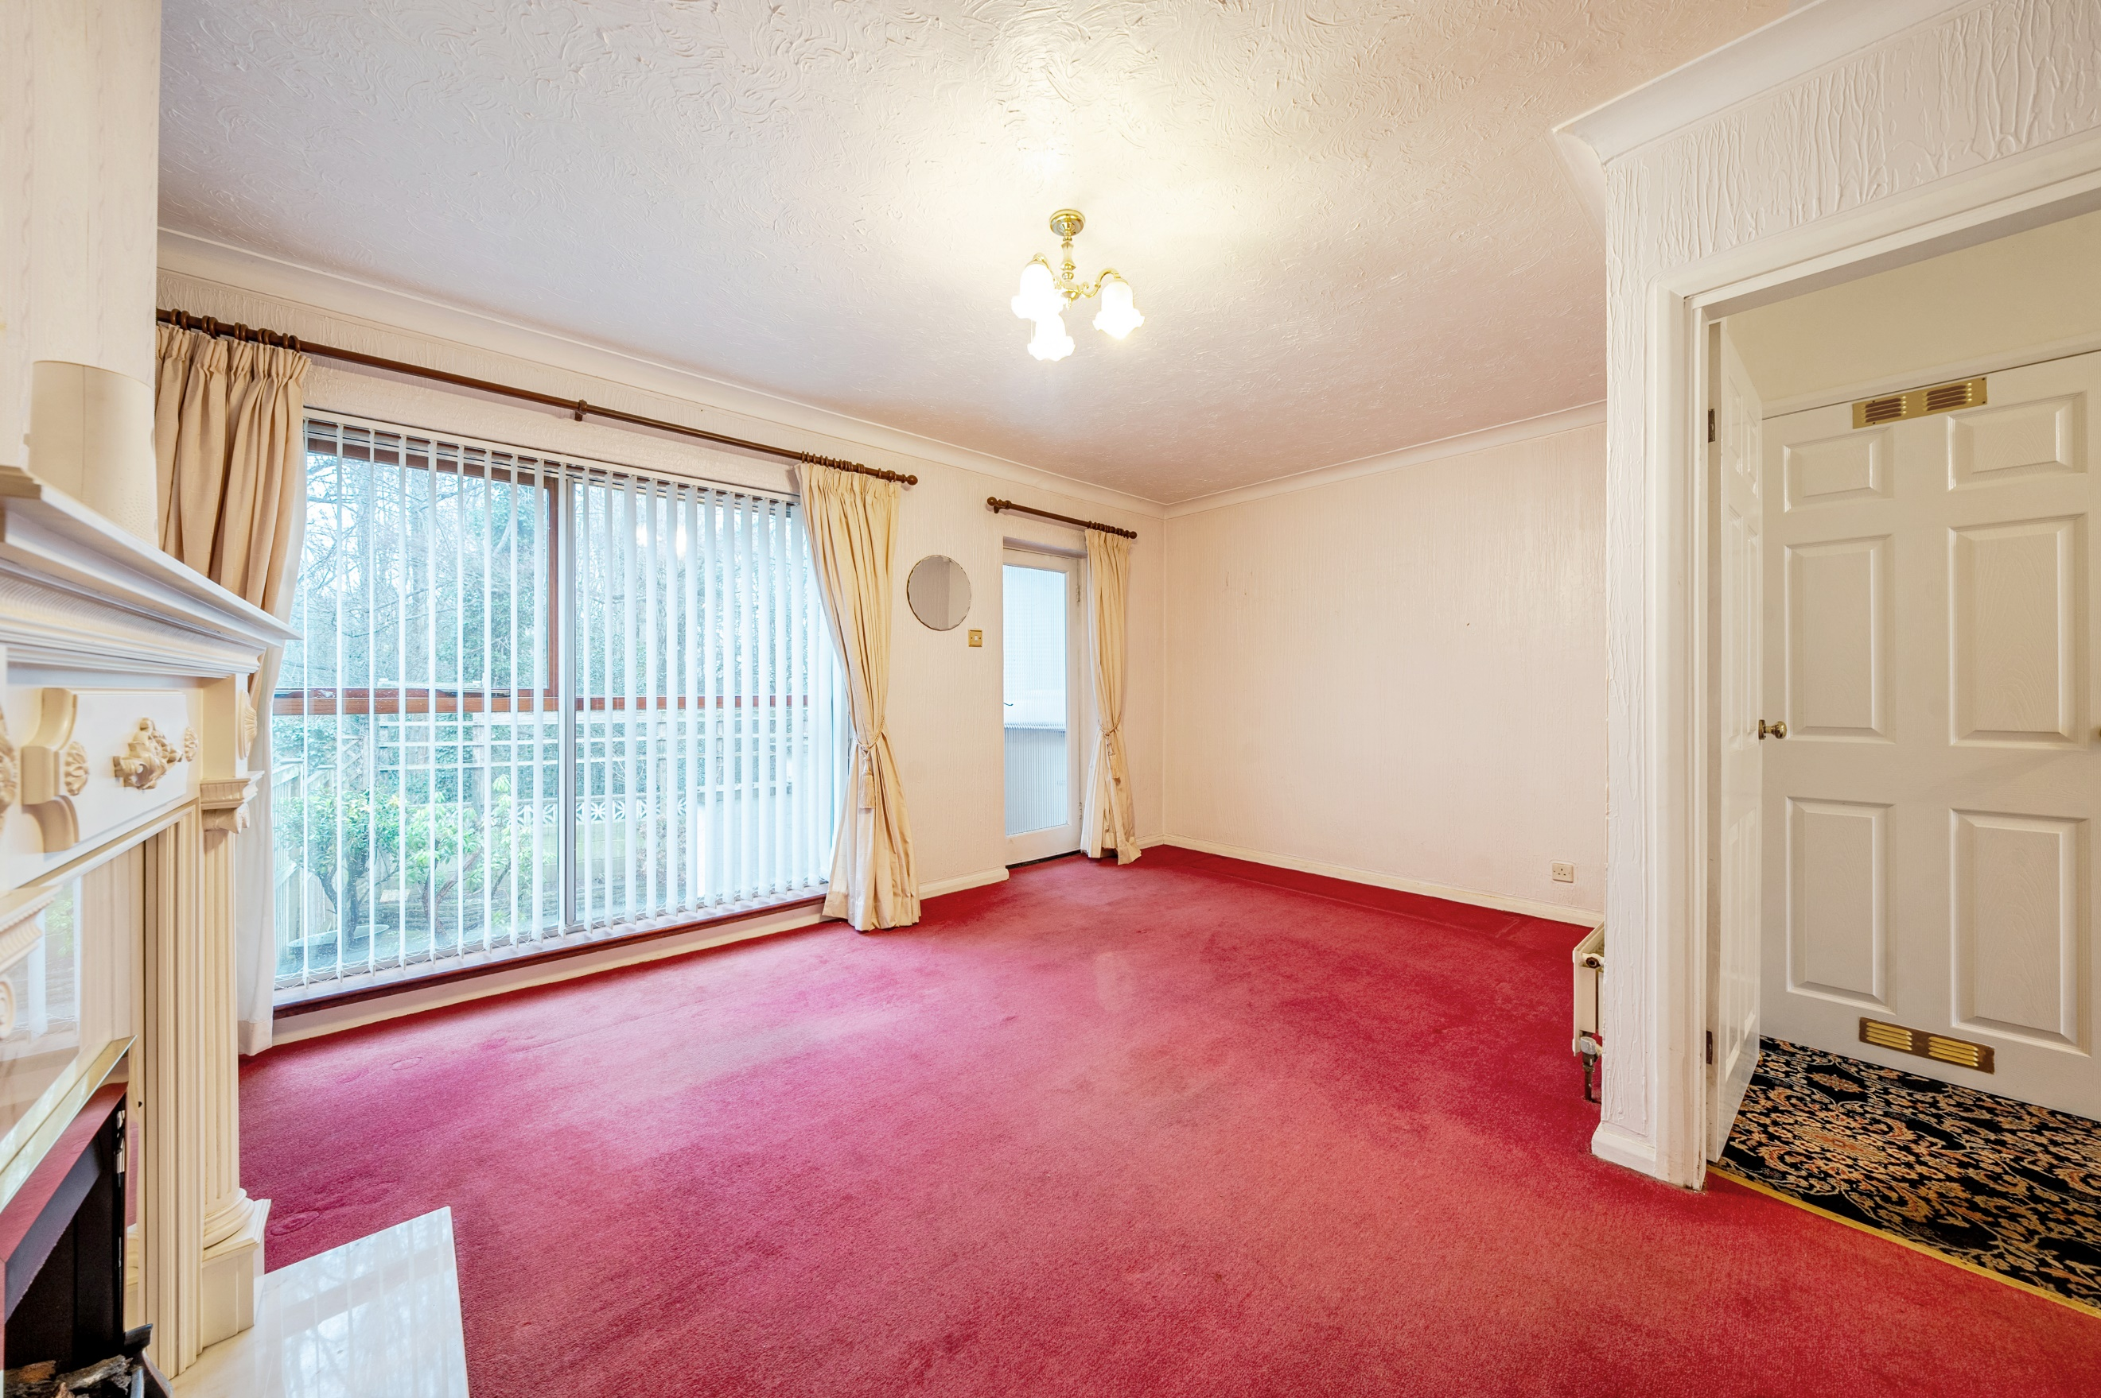
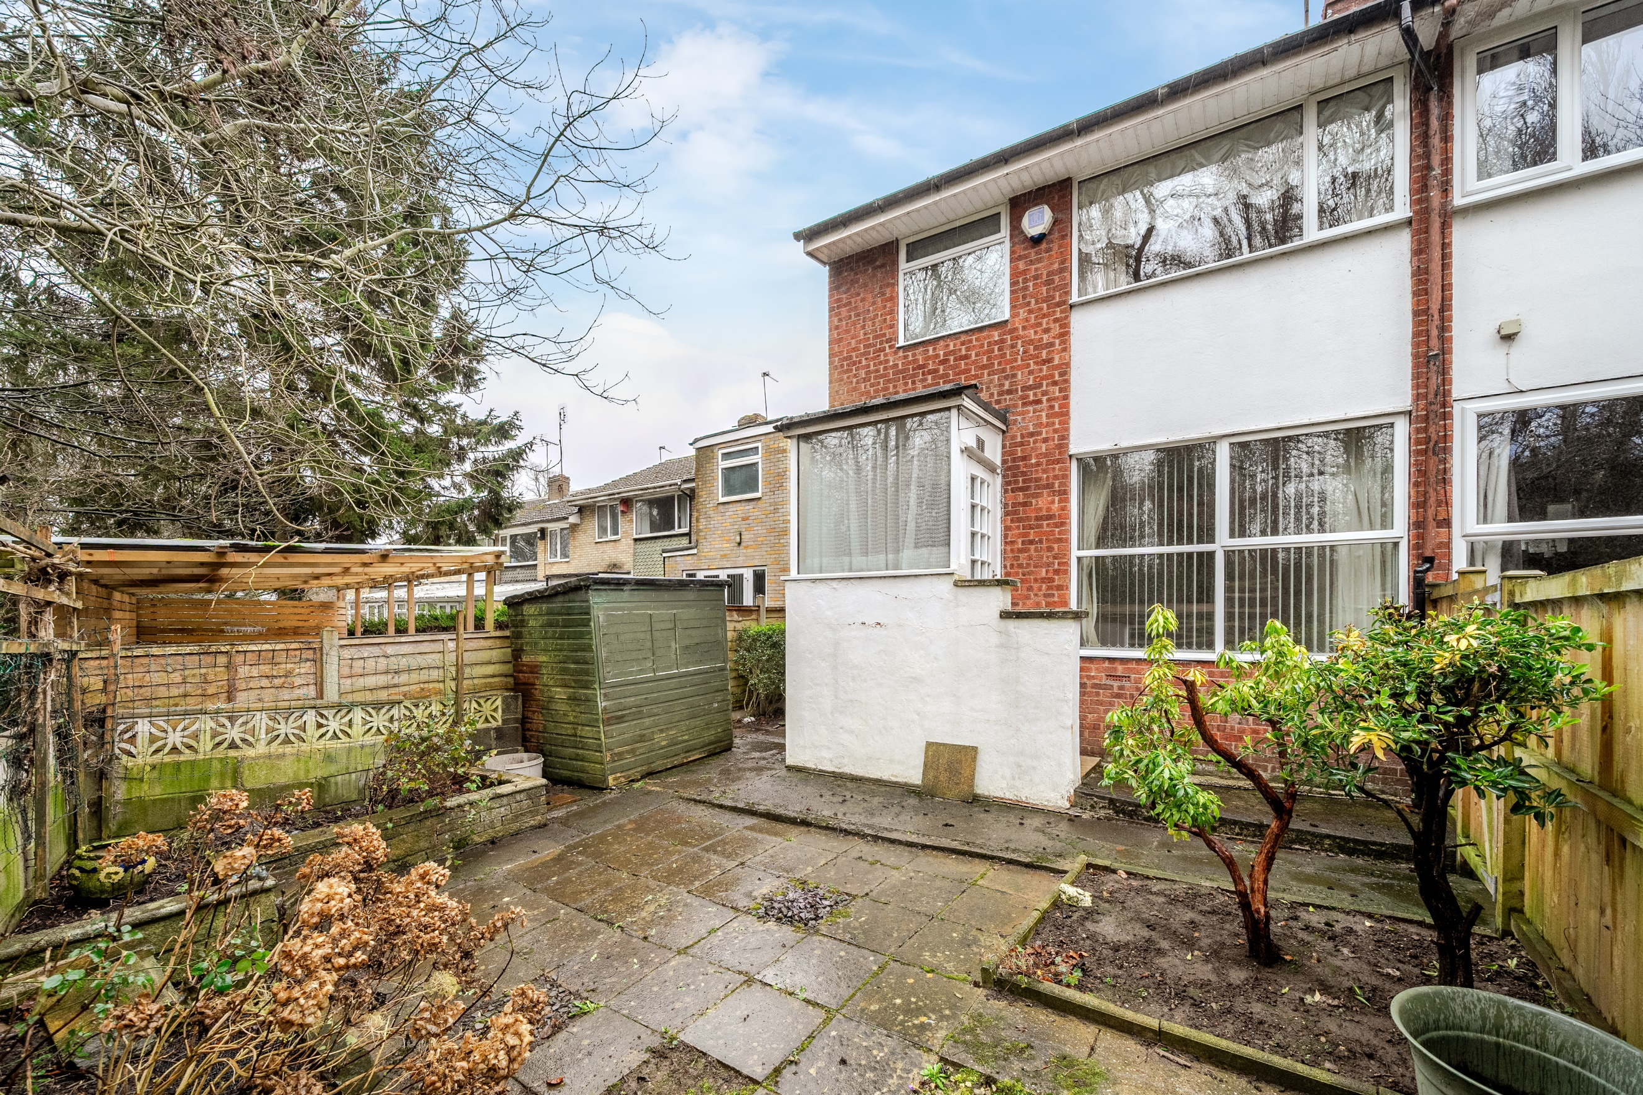
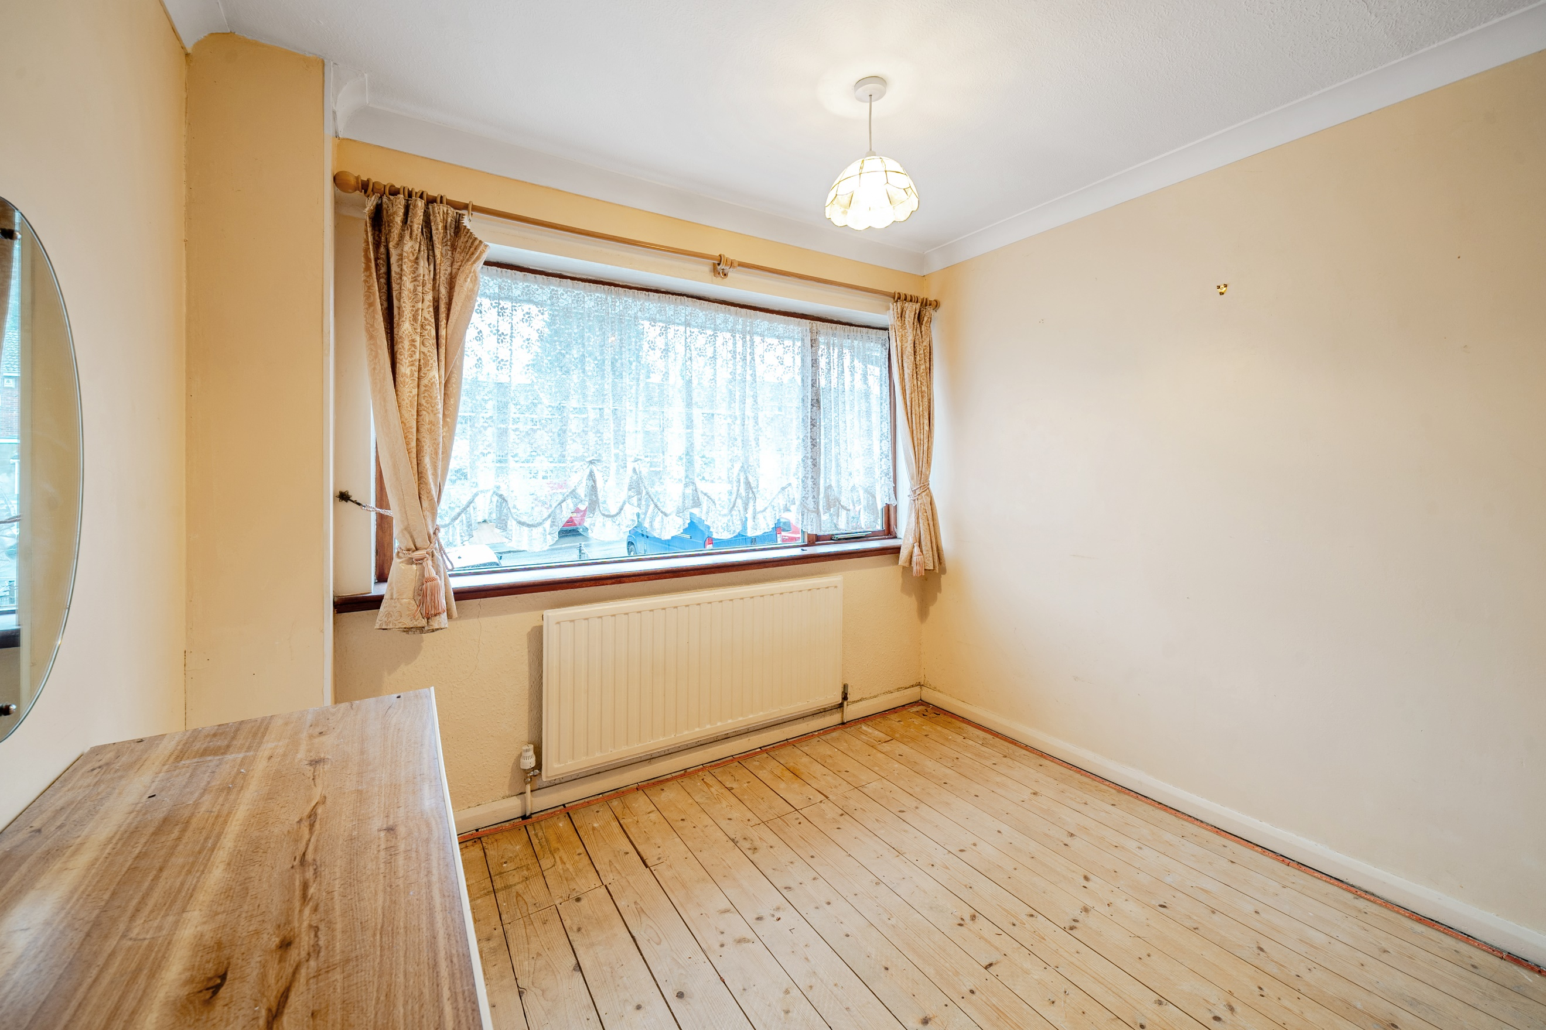
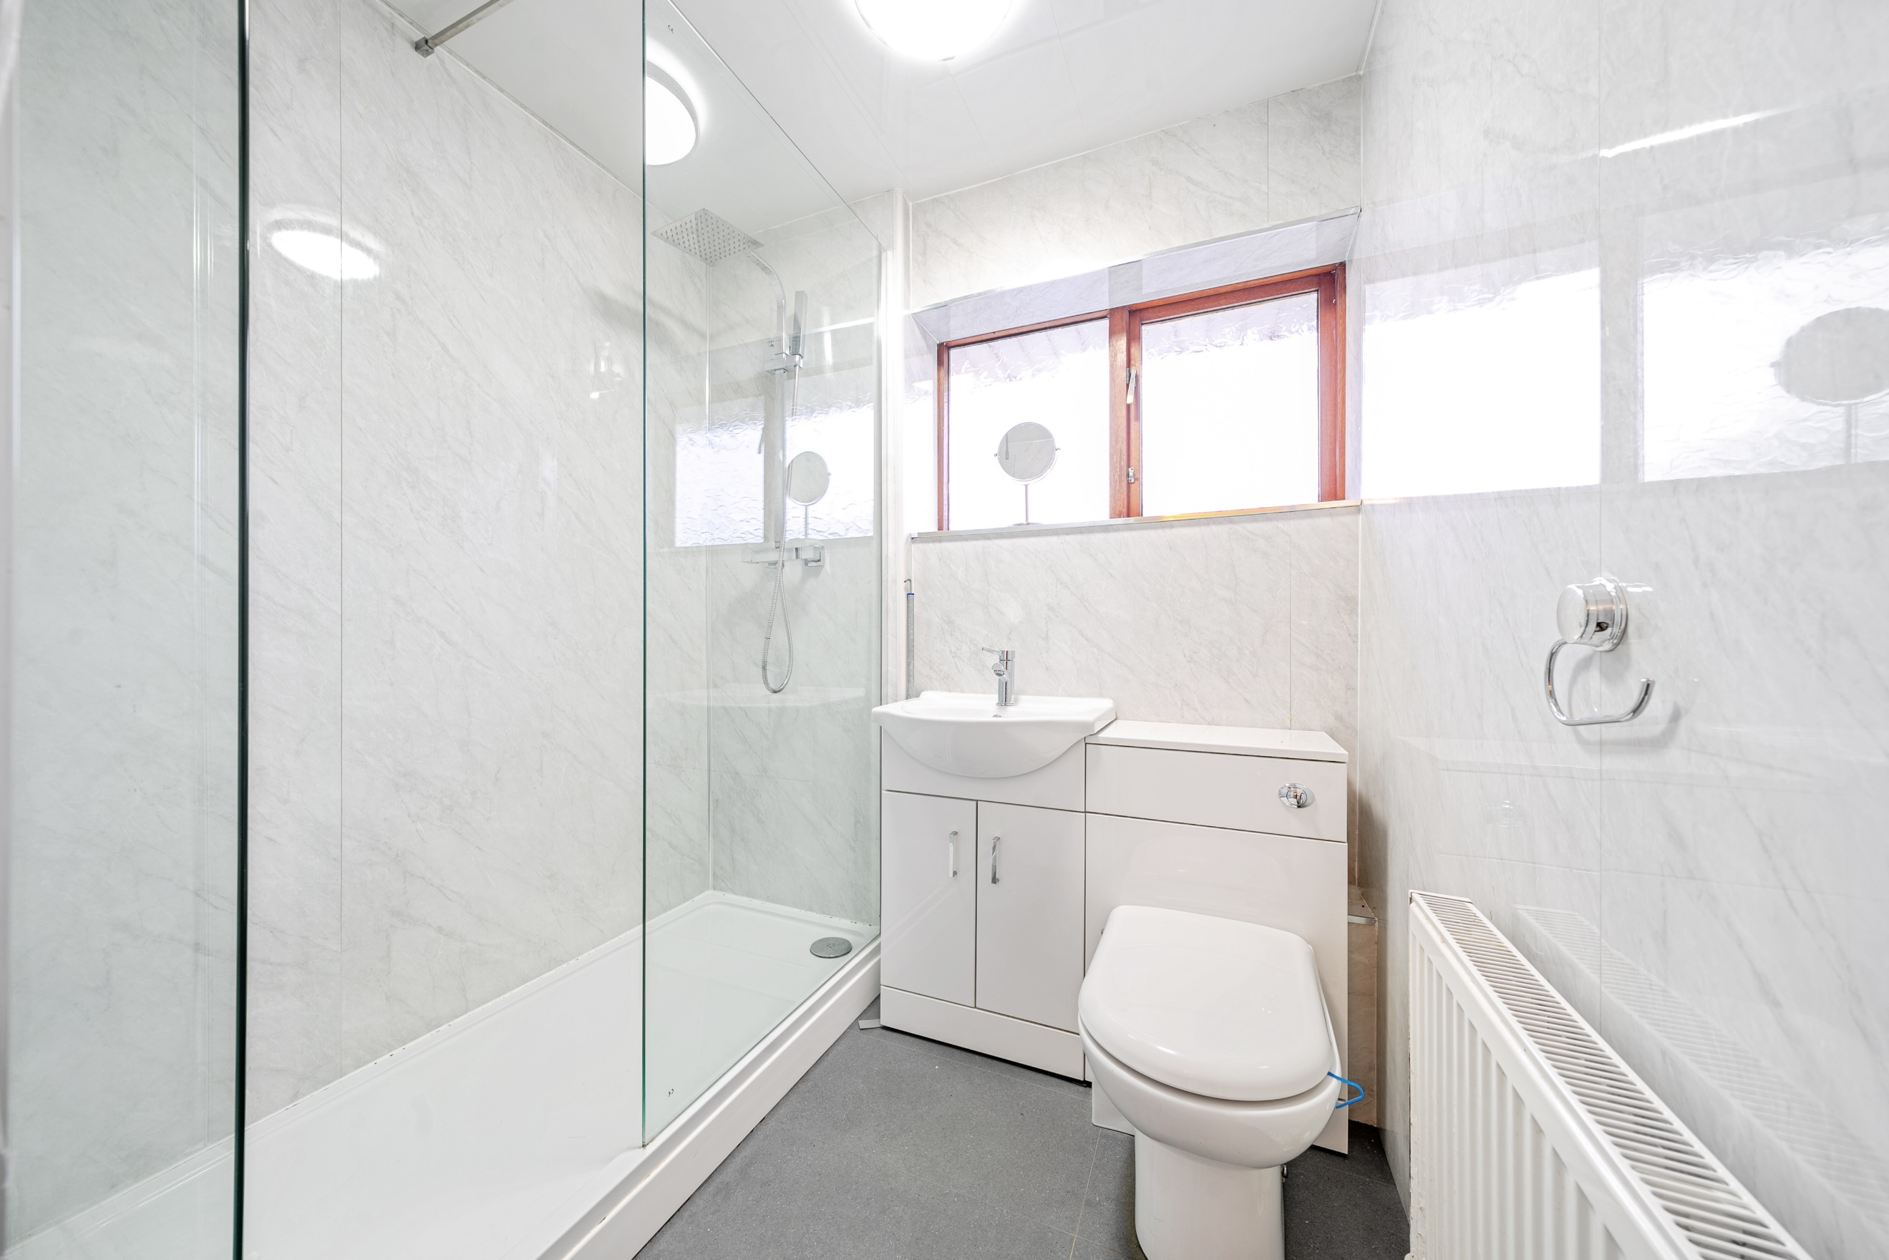
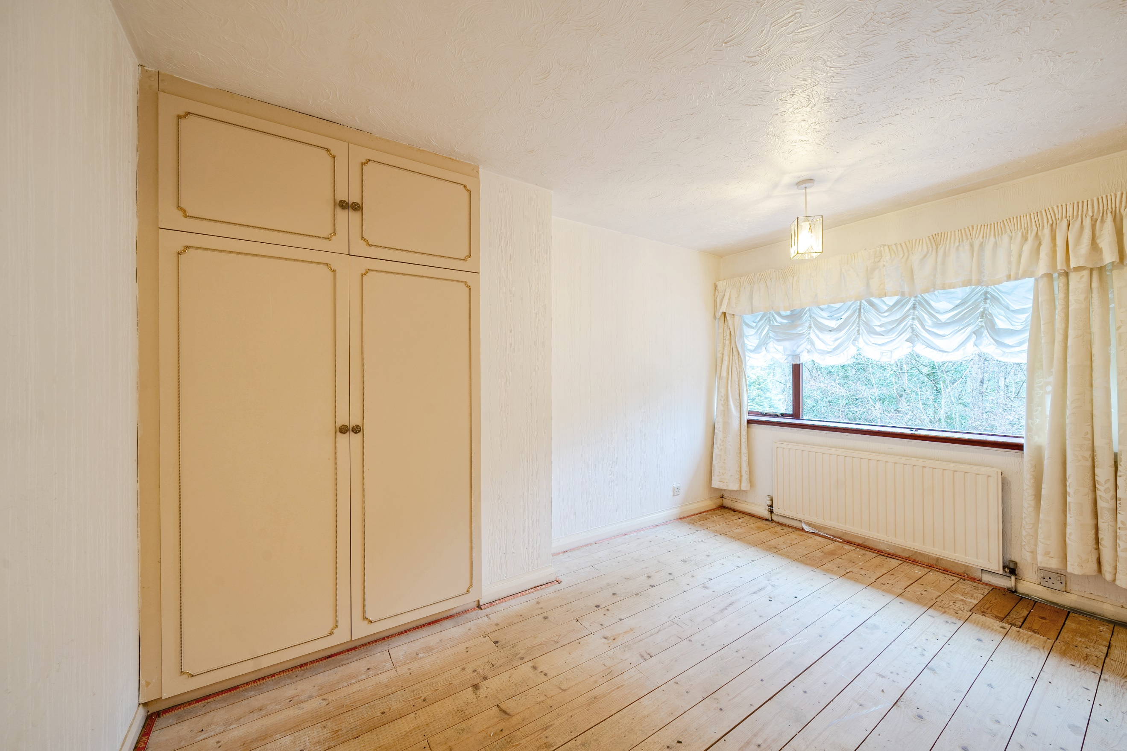

Porch
Via front door.

Hallway
Via front entrance door. Stairs to first floor. Gas central heating radiator.
Under stairs cupboard housing boiler.

Kitchen/Diner 3.26m (10'8) x 2.76m (9'1)
Fitted with a range of wall, base and drawer units with worktops over. Breakfast bar. Tiled walls. Space for washing machine and cooker. Stainless steel sink with mixer tap and drainer. Double glazed window to front. Gas central heating radiator

Living Room 4.78m (15'8) x 3.86m (12'8)
Light and airy living room with floor to ceiling double glazed windows overlooking the rear garden. Gas fire to chimney breast. Gas central heating radiator. Door leading to rear porch.

Bedroom 1 2.78m (9'1) x 3.88m (12'9)
Double bedroom with double glazed window to front. Gas central heating radiator.

Bedroom 2 3.32m (10'11) x 2.79m (9'2)
Second double bedroom with double glazed window to rear. Built in wardrobe. Gas central heating radiator.

Bedroom 3 3.04m (10') x 1.92m (6'4)
Third bedroom with double glazed window to rear. Built in wardrobes. Gas central heating radiator.

Bathroom
Fitted with a three piece white suite comprising; walk in shower cubicle, Vanity wash hand basin and WC. Gas central heating radiator. Double glazed window to front.

Outside
Gardens to the front and rear of the property. The property also benefits from a driveway offering off street parking.

Agents Note
The sale of this property is subject to Grant of Probate.

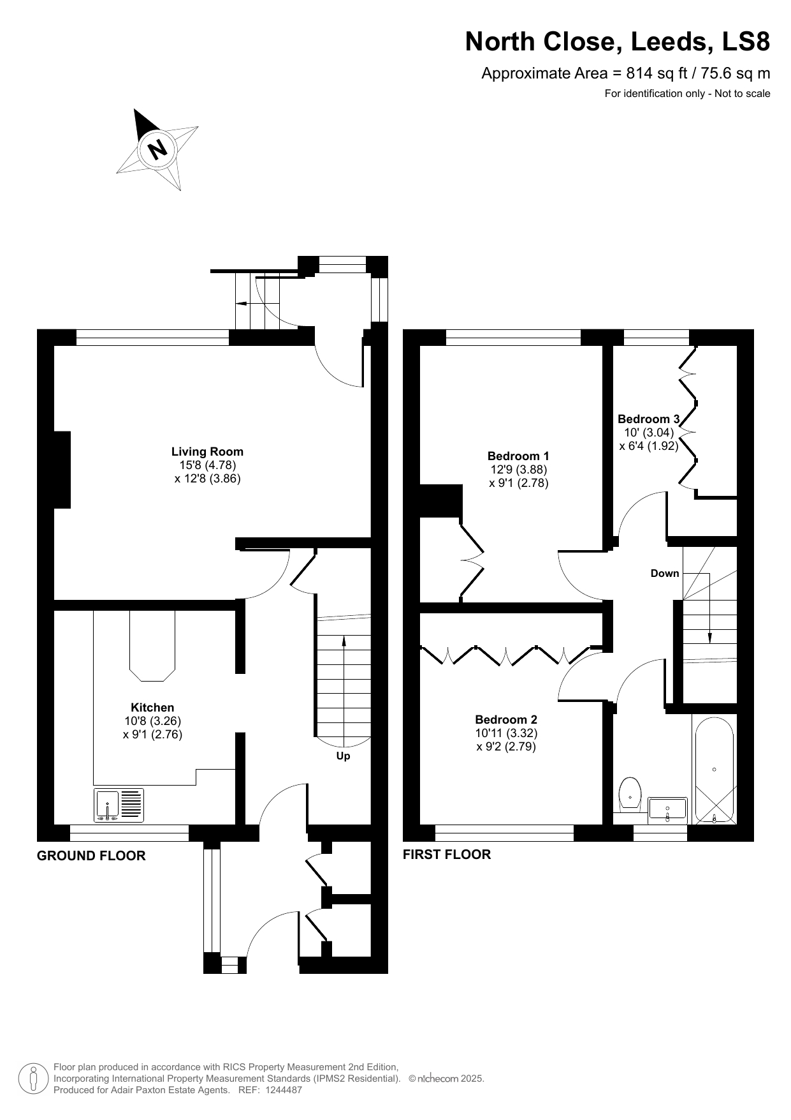

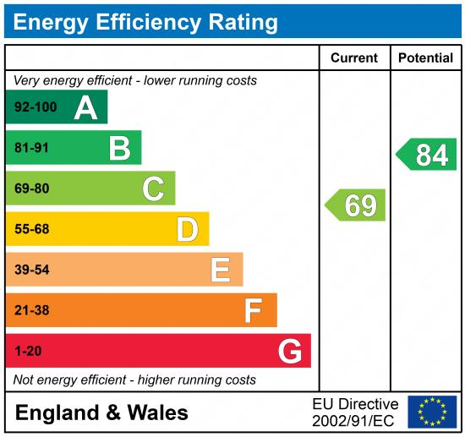

These particulars are intended to give a fair description of the property, but their accuracy cannot be guaranteed, and they do not constitute an offer of contract. Intending purchasers must rely on their own inspection of the property. None of the above appliances/services have been tested by ourselves. We recommend purchasers arrange for a qualified person to check all appliances/services before legal commitment.

Property Ref: 5188

For more information, please contact

0113 258 1150 | sales@adairpaxton.co.uk | www.adairpaxton.co.uk

