

**0113 258 1150**

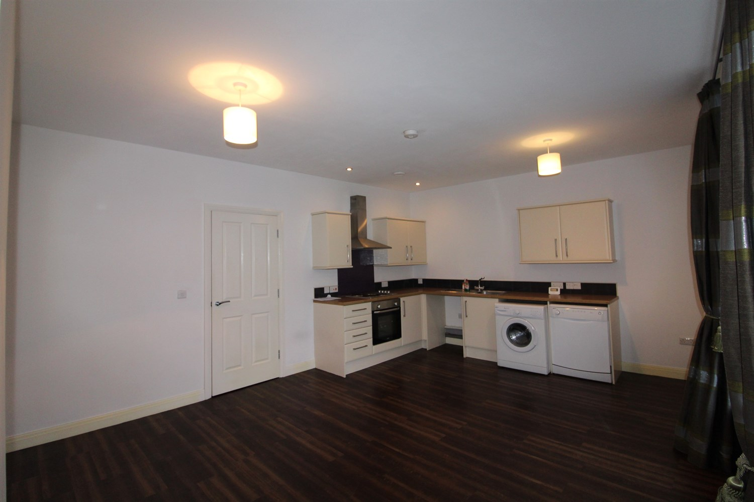



**Available to let £725.00pcm**

**Parkgate, Roundhay Road, Leeds**

Lovely spacious one bedroom apartment in trendy Oakwood, with parking and garage next to Roundhay Park, with great commuting links to the City.  
Comprising open plan kitchen/ living room, one bedroom and bathroom. Ideal for a Single occupant or couple The apartment is unfurnished with white goods. The property is located in the area of Oakwood, moments from Roundhay Park, with many bars, pubs and restaurants and with fantastic links to the City (approximately 20 minutes into Leeds City Centre by bus). Available Now, EPC rating B, council tax band A, deposit £835.

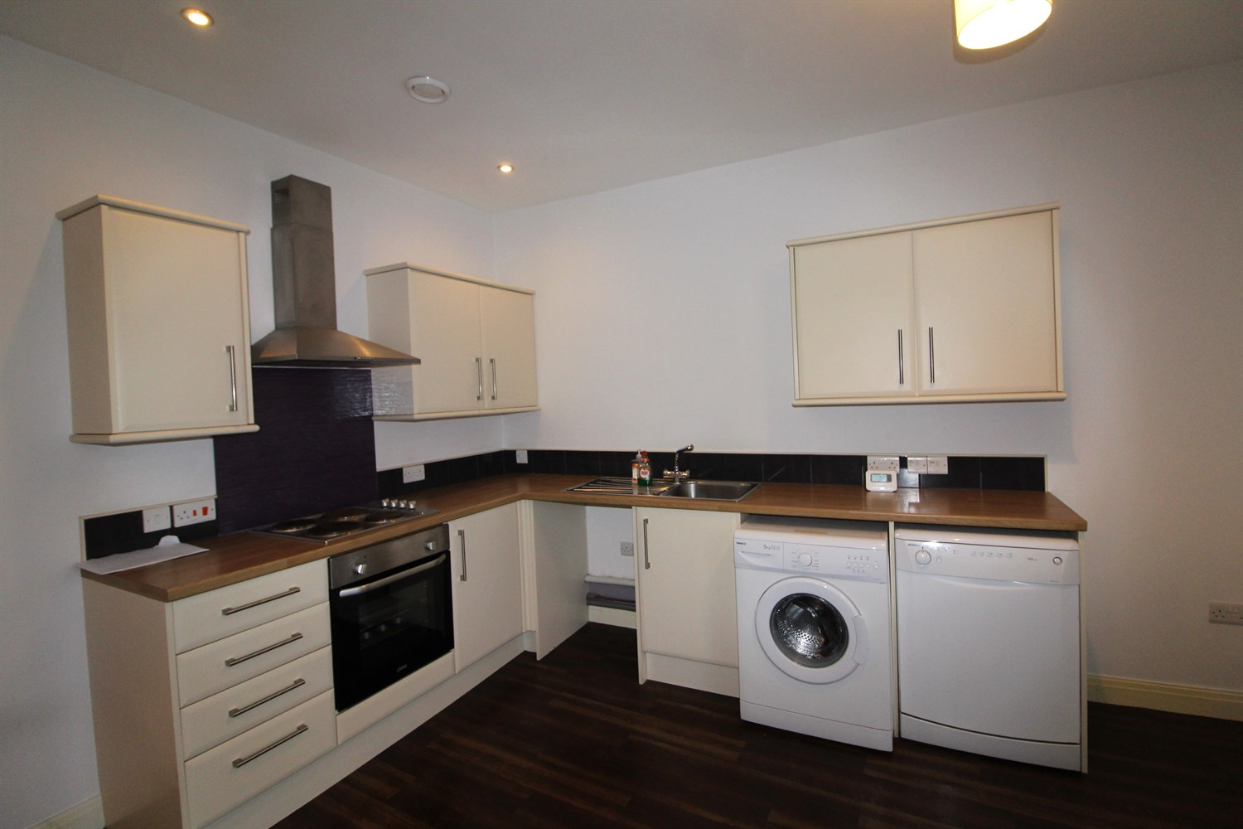

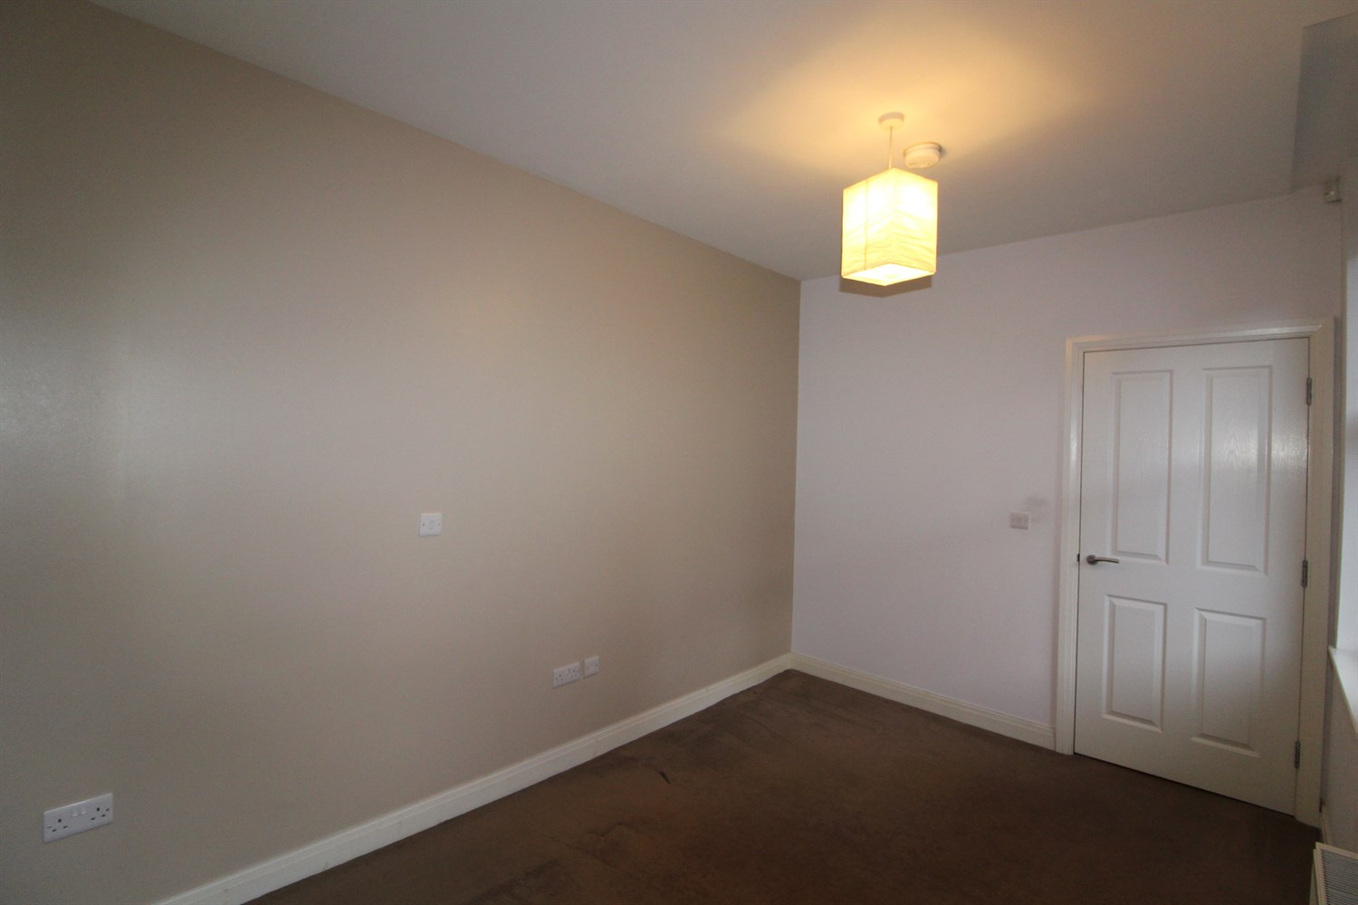

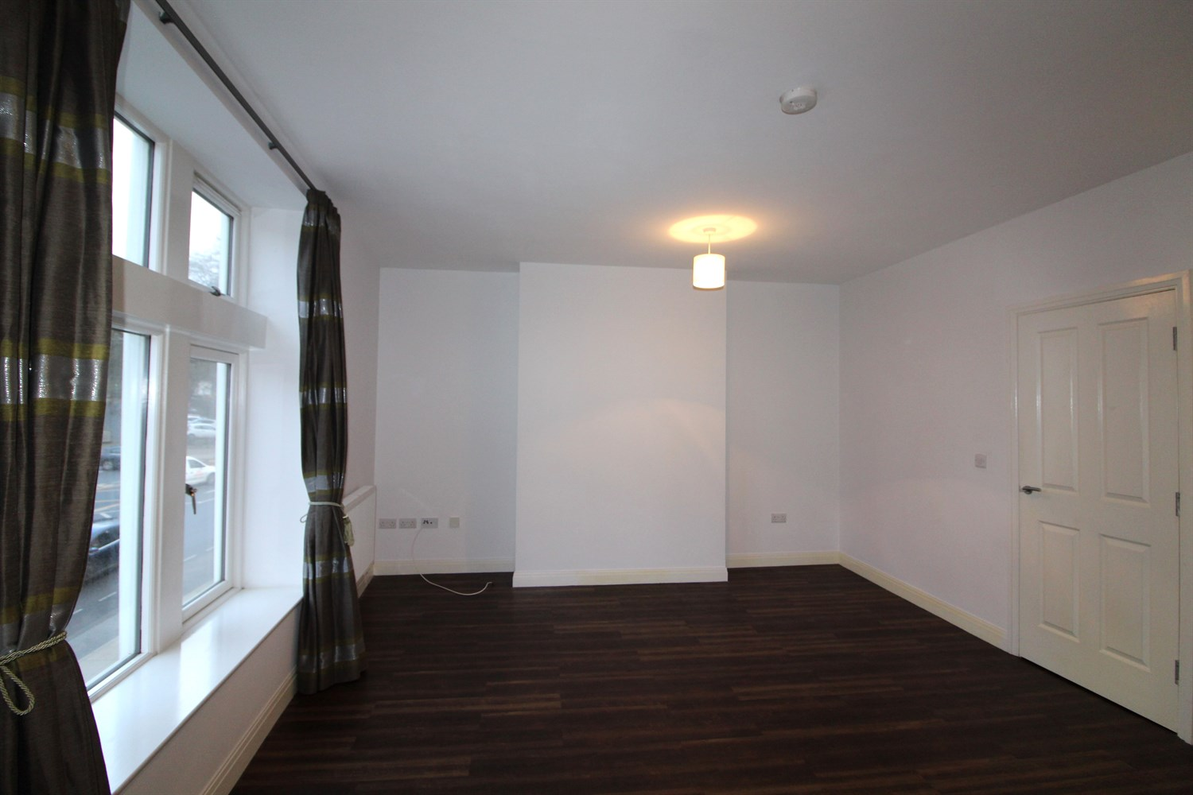

1 Bathroom(s)

1 Reception(s)

1 Bedroom(s)

00

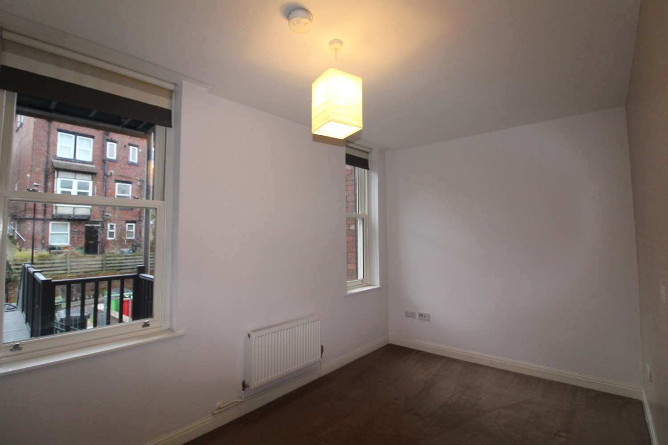

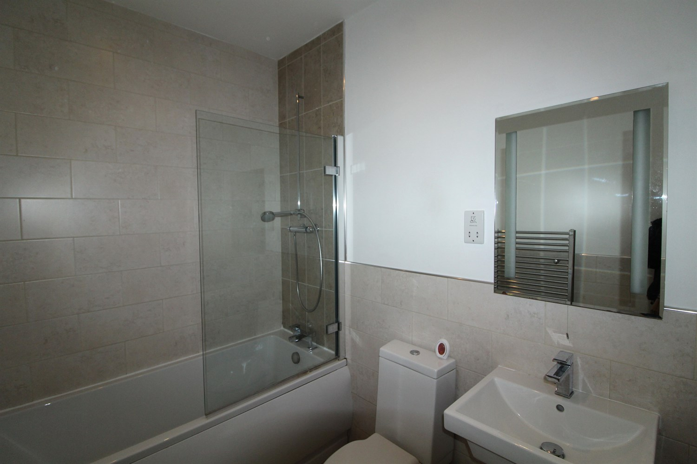

|  |
| --- |
| **Hallway**  Hallway with intercom. |
| **Open Plan Kitchen and Living Room**  Light and airy living are with windows to the front. Morden fitted kitchen compromising of a range of wall and base units with worktops over, stainless steel sink with mixer tap, electric oven and hob with extractor above. Gas central heating radiator. |
| **Bedroom**  Large double bedroom with window to front. Gas central heating radiator. |
| **Bathroom**  Three piece bathroom suite with shower over, shower screen, w/c and hand wash sink, tiled walls and towel radiator. |
| **Home Information**  COUNCIL TAX BAND: A EPC Rating C.  Leasehold property Street Parking Broadband: Standard 3 Mbps 0.5 Mbps Good Superfast 80 Mbps 20 Mbps Good Ultrafast 1000 Mbps 220 Mbps  Mobile availability: EE limited coverage. Three limited coverage. O2 likely to have good coverage. Vodafone likely to have good coverage.  Utilities: Water supplied on standard meters. Electric mains supplied on standard meters. |

|  |  |
| --- | --- |
| These particulars are intended to give a fair description of the property, but their accuracy cannot be guaranteed, and they do not constitute an offer of contract. Intending purchasers must rely on their own inspection of the property. None of the above appliances/services have been tested by ourselves. We recommend purchasers arrange for a qualified person to check all appliances/services before legal commitment.  **Property Ref:** 5130  **For more information, please contact**  0113 258 1150 **|** [lettings@adairpaxton.co.uk](mailto:lettings@adairpaxton.co.uk) **|** www.adairpaxton.co.uk |  |