

**0113 258 1150**

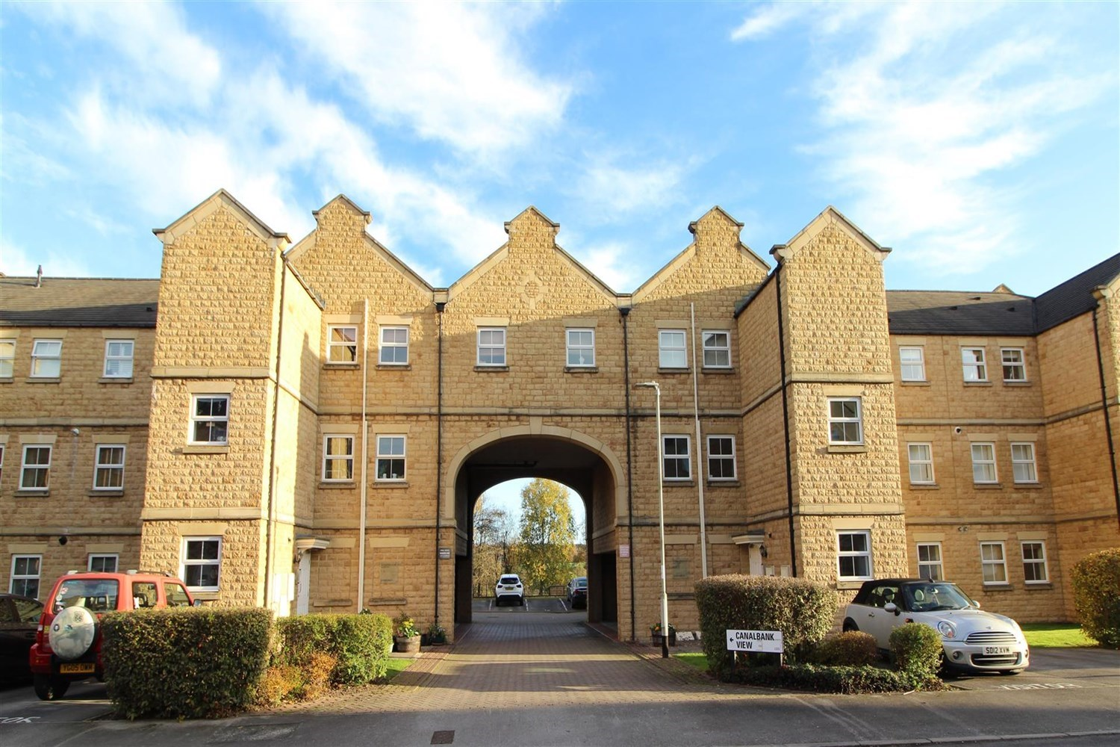



**Available to let £900.00pcm**

**Narrowboat Wharf**

***TWO BEDROOM TOP FLOOR APARTMENT WITH CANAL SIDE LOCATION *** Must be viewed to be appreciated. Set in the delightful Narrowboat Wharf complex, the apartment is ideally located for the shops, bars and restaurants in Rodley as well as useful transport links to both Leeds and Bradford. This apartment briefly comprises: Communal Entrance hall with secure intercom entry system, private entrance hall, open plan lounge/kitchen with balcony overlooking the canal with far reaching views, Master bedroom with en-suite shower room, second bedroom and bathroom. Externally there is an allocated parking space and stunning views over the canal. Early viewing is highly recommended. Available 10th March 2025. Deposit £1035. EPC rating, council tax band.

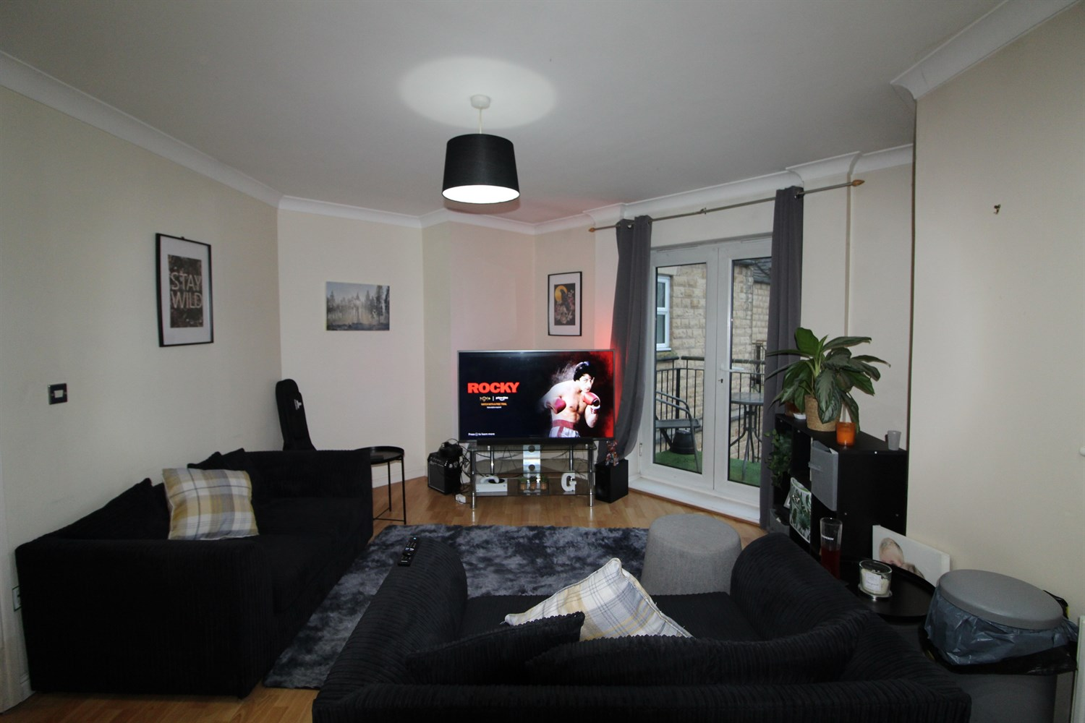

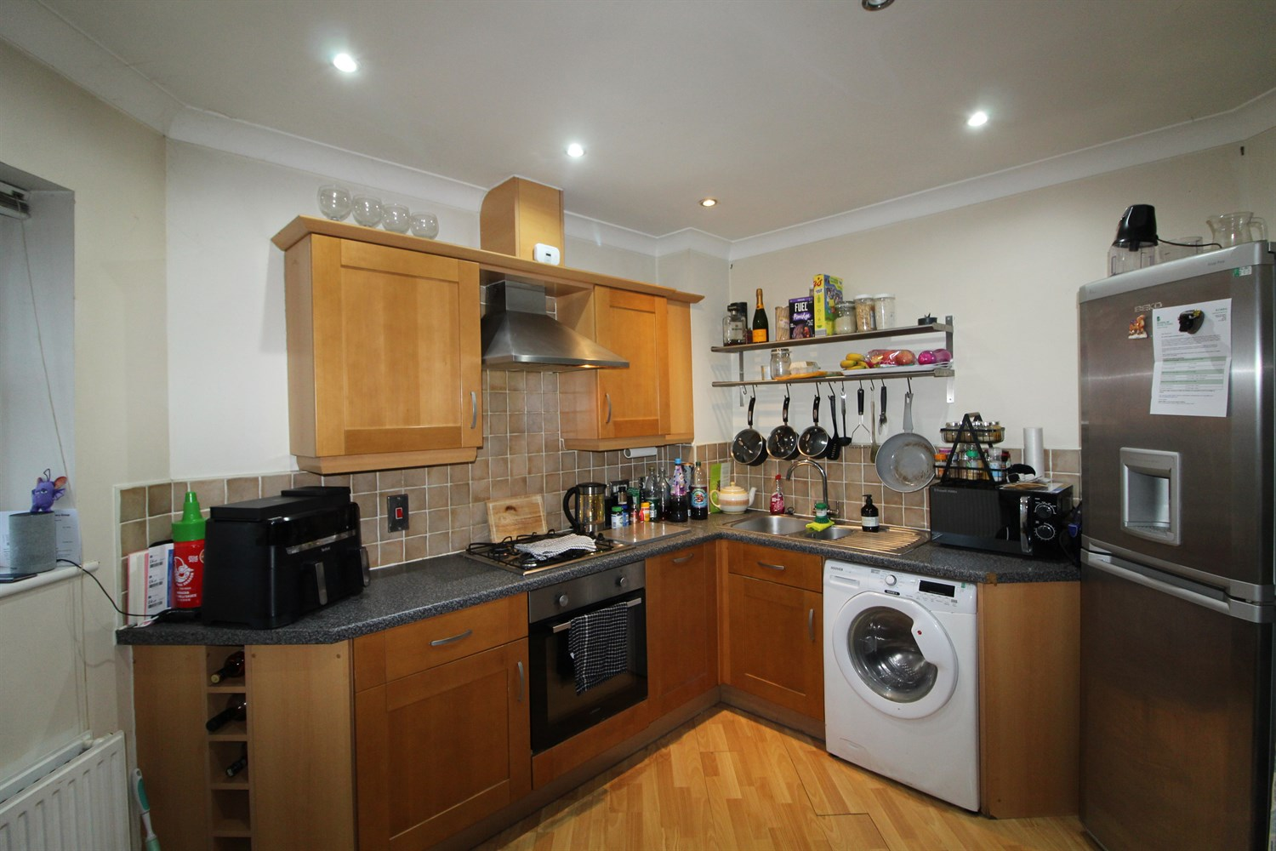

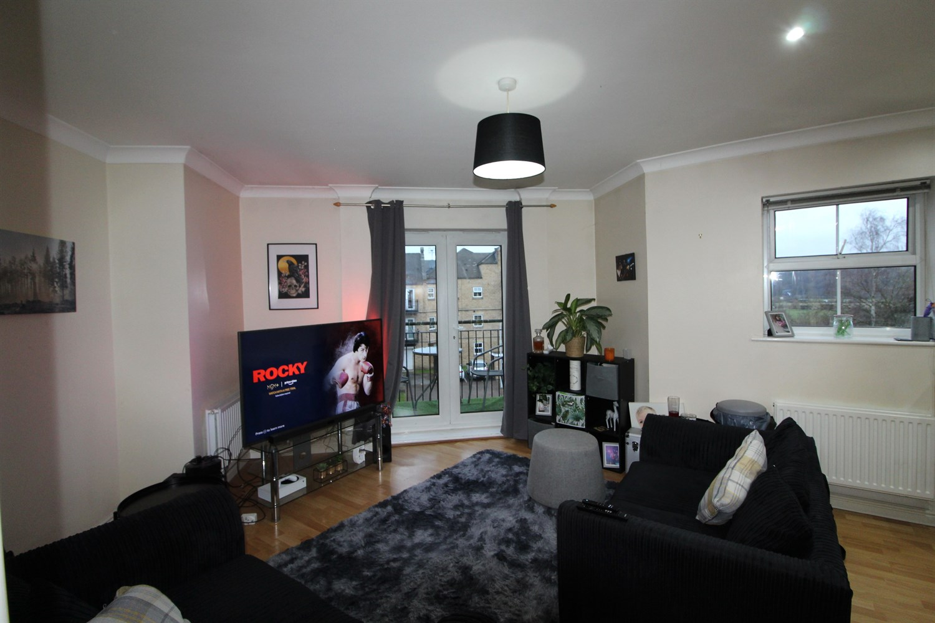

2 Bathroom(s)

1 Reception(s)

0 Bedroom(s)

00

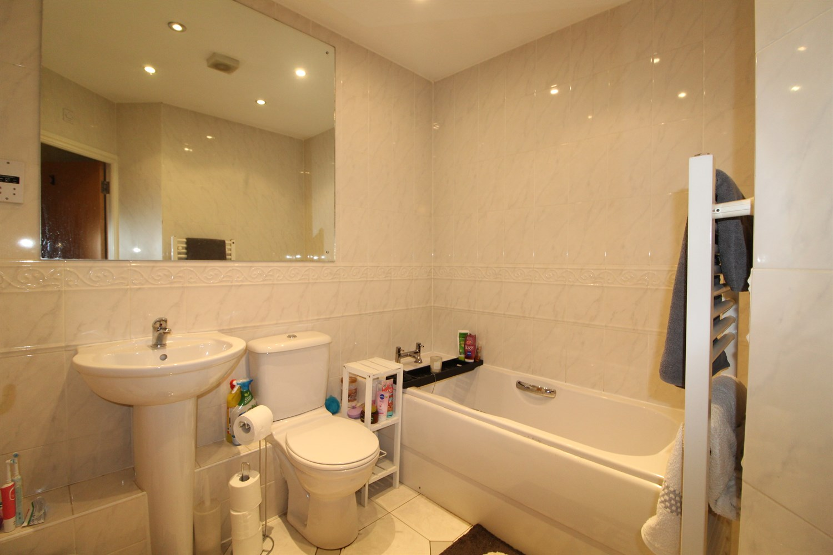

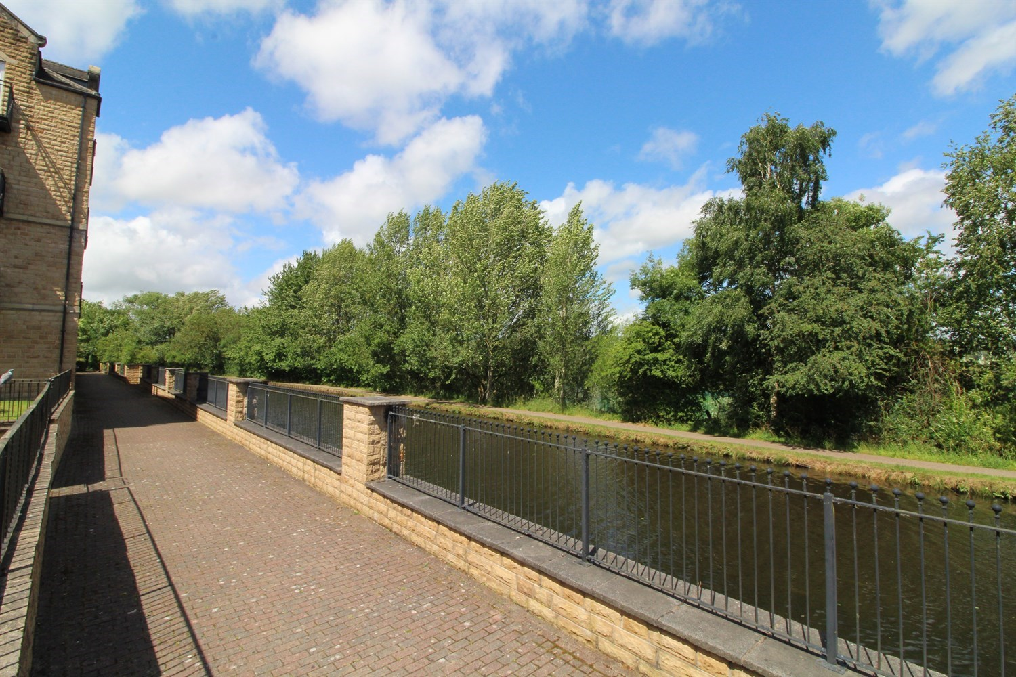

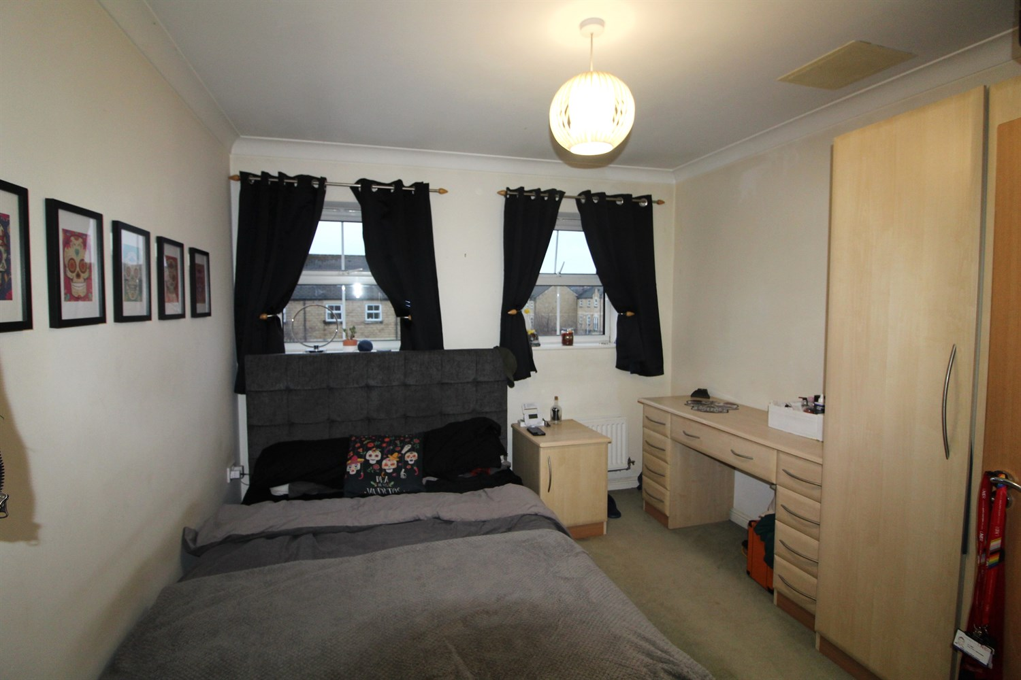

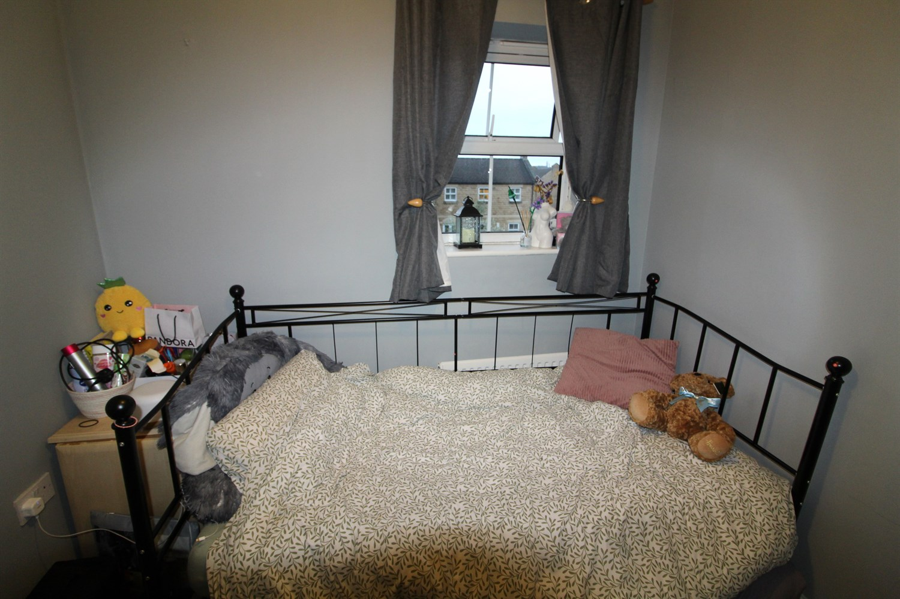

|  |
| --- |
| **Communal Entrance** |
| **Private Entrance Hall**  Via front entrance door. Secure entry phone system. Storage cupboard. |
| **Open Plan Kitchen and Living Room 6.65m (21'10) x 5.16m (16'11)**  Light and airy living area with uPVC double glazed patio doors out to the balcony with views over the canal. Gas central heating radiator. kitchen fitted with a range of wall and base units with worktops over, stainless steel sink with mixer tap and drainer, gas cooker and electric oven with extractor over. |
| **Bedroom 1 3.23m (10'7) x 3.07m (10'1)**  Double bedroom with built in wardrobes. Two uPVC double glazed windows. Gas central heating radiator. |
| **En Suite**  Comprising; Shower cubicle, wash basin and WC. Tiled walls. |
| **Bedroom 2 2.51m (8'3) x 2.51m (8'3)**  Second bedroom with uPVC double glazed window. Gas central heating radiator. |
| **Bathroom**  Fitted with a three piece suite comprising: bath, wash basin and WC. Tiled walls. |
| **Home Information**  COUNCIL TAX BAND: B EPC Rating   Leasehold property Allocated Parking  Broadband Virgin media only: Standard 5 Mbps 0.6 Mbps Good Superfast 138 Mbps 20 Mbps Good Ultrafast 1000 Mbps 1000 Mbps  Mobile availability: EE Likely Three Limited O2 Limited Vodafone Likely  Utilities: Water supplied on standard meters. Electric mains supplied on standard meters. Gas supplied on standard metres. |

|  |  |
| --- | --- |
| These particulars are intended to give a fair description of the property, but their accuracy cannot be guaranteed, and they do not constitute an offer of contract. Intending purchasers must rely on their own inspection of the property. None of the above appliances/services have been tested by ourselves. We recommend purchasers arrange for a qualified person to check all appliances/services before legal commitment.  **Property Ref:** 4995  **For more information, please contact**  0113 258 1150 **|** [lettings@adairpaxton.co.uk](mailto:lettings@adairpaxton.co.uk) **|** www.adairpaxton.co.uk |  |