

**0113 258 1150**

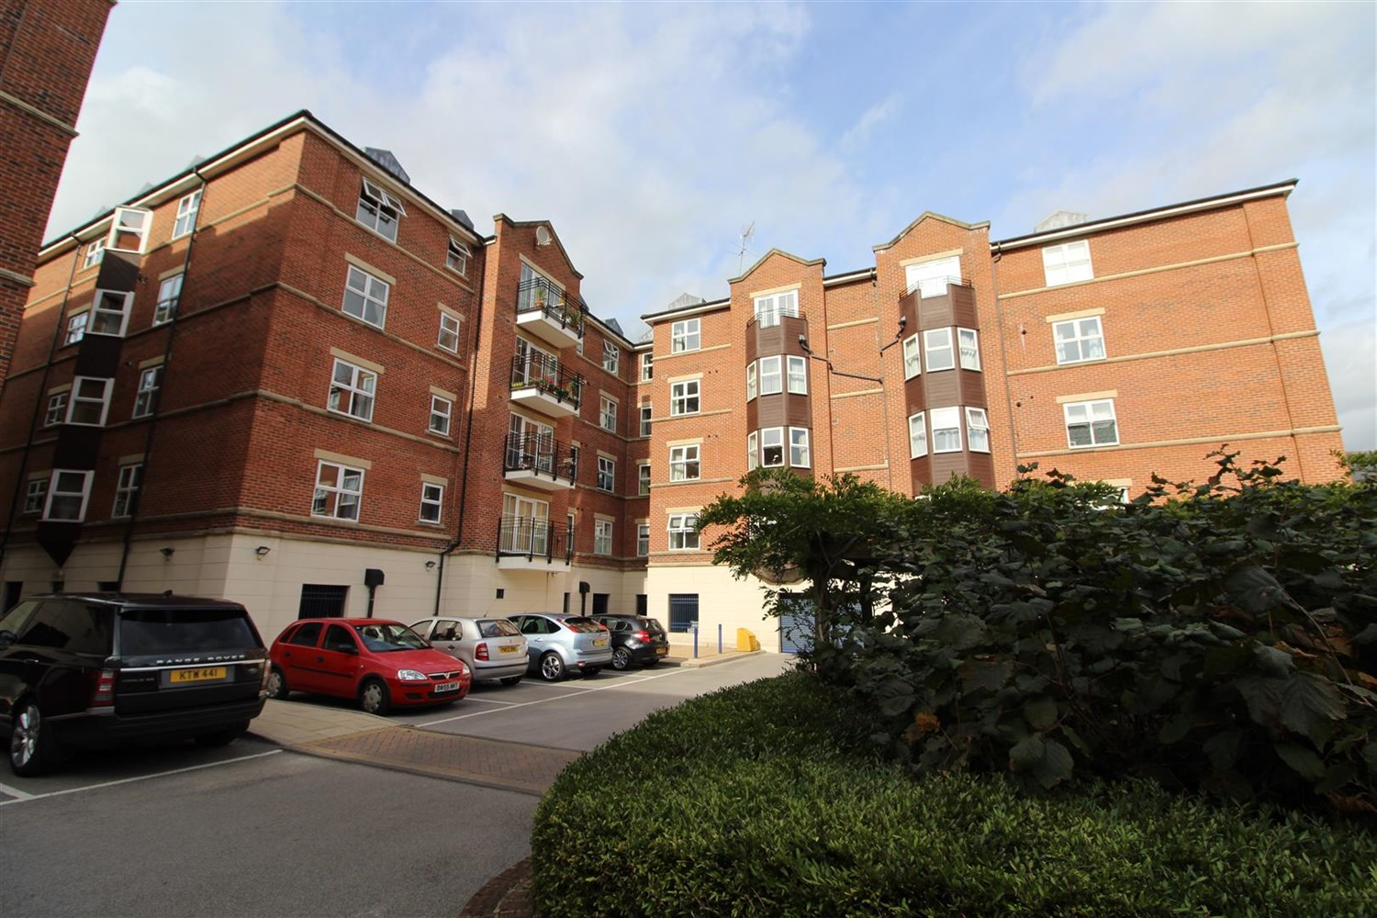



**Available to let £1,495.00pcm**

**Eller House, Far Headingley**

Immaculately presented, this second floor furnished apartment is situated in Far Headingley, ideal for city centre commutes, access to public transport and the motorway network.  
Offering three double bedrooms, this stunningly spacious property benefits from an en-suite bathroom, balcony and not one, but TWO parking spaces. Deposit £1725. Council tax band D, EPC rating C. Available 31st January 2025.

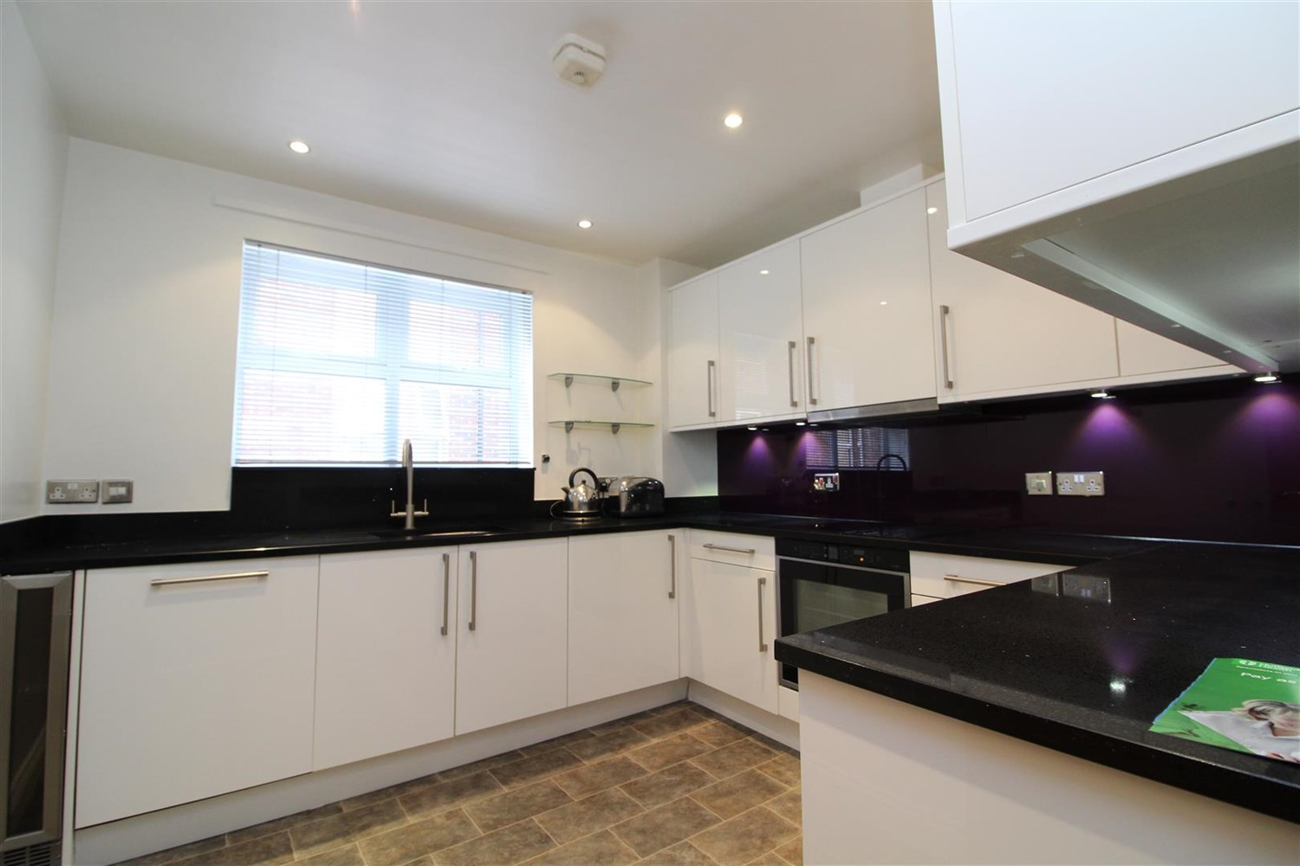

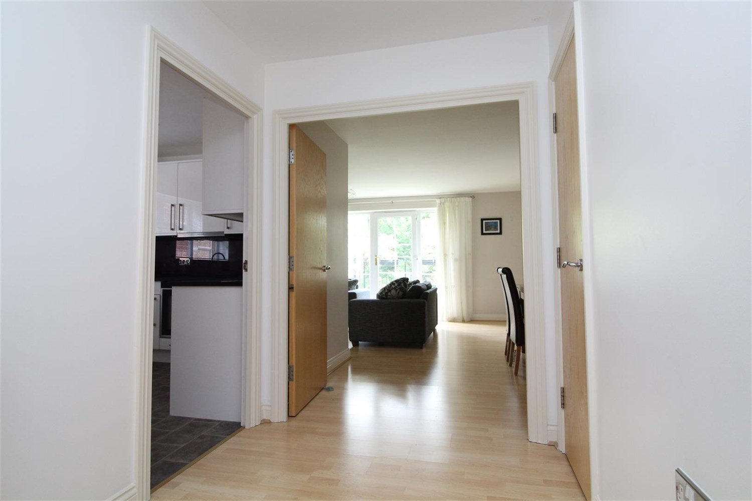

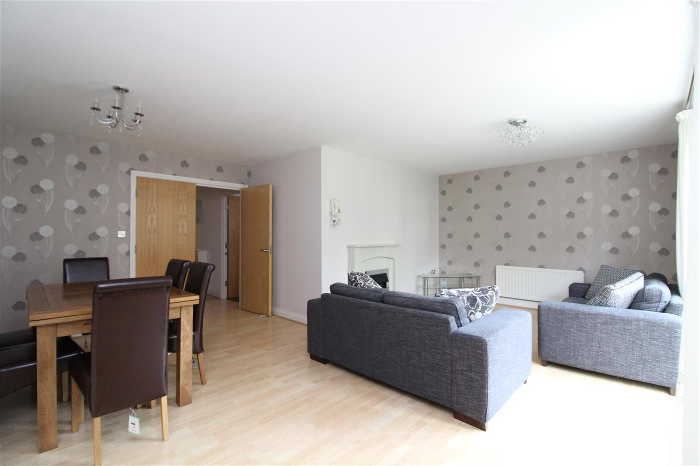

2 Bathroom(s)

1 Reception(s)

0 Bedroom(s)

00

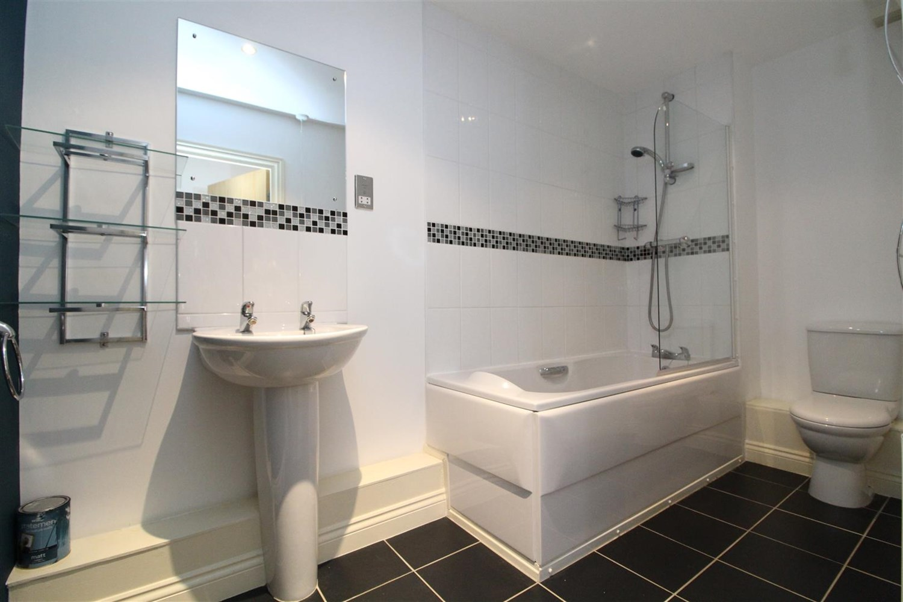

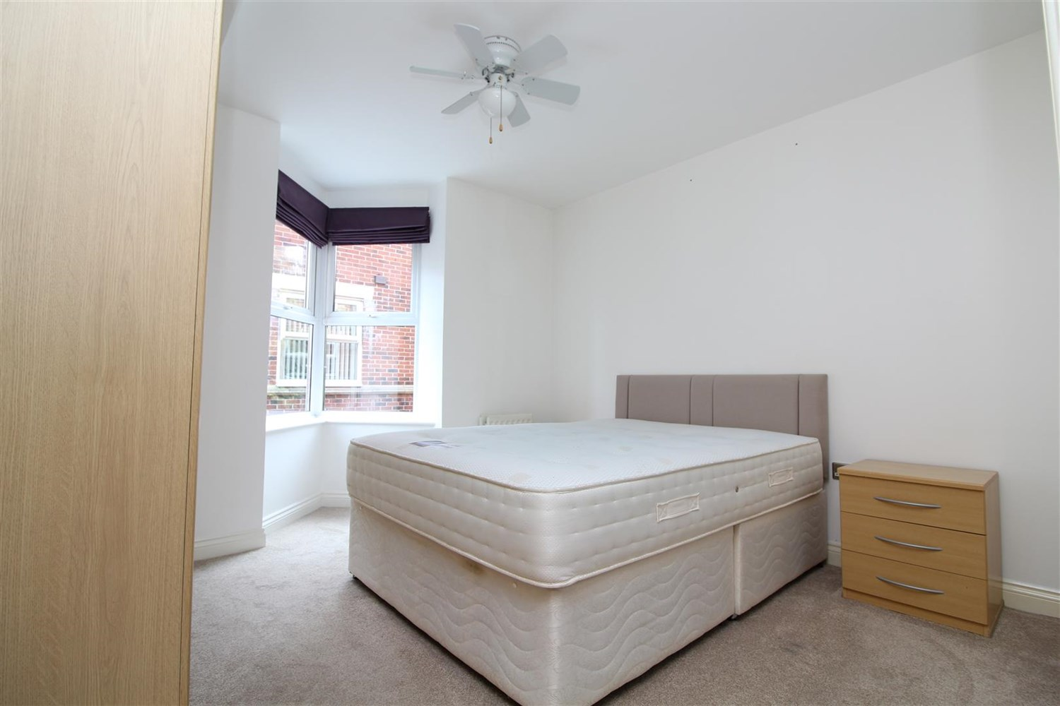

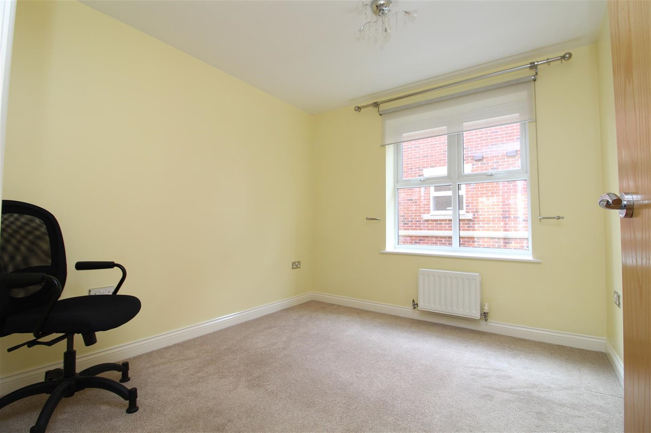

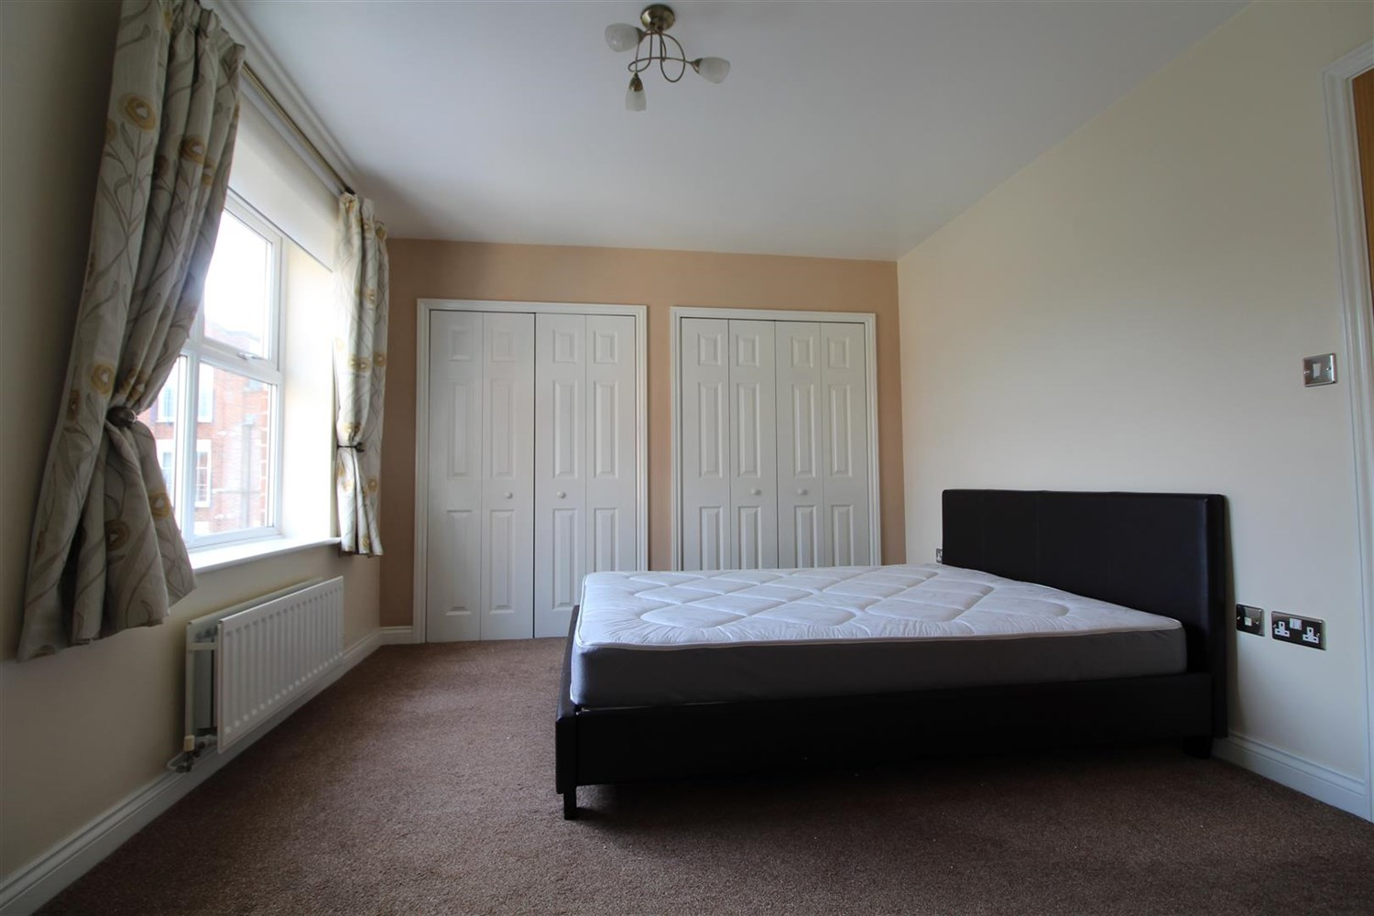

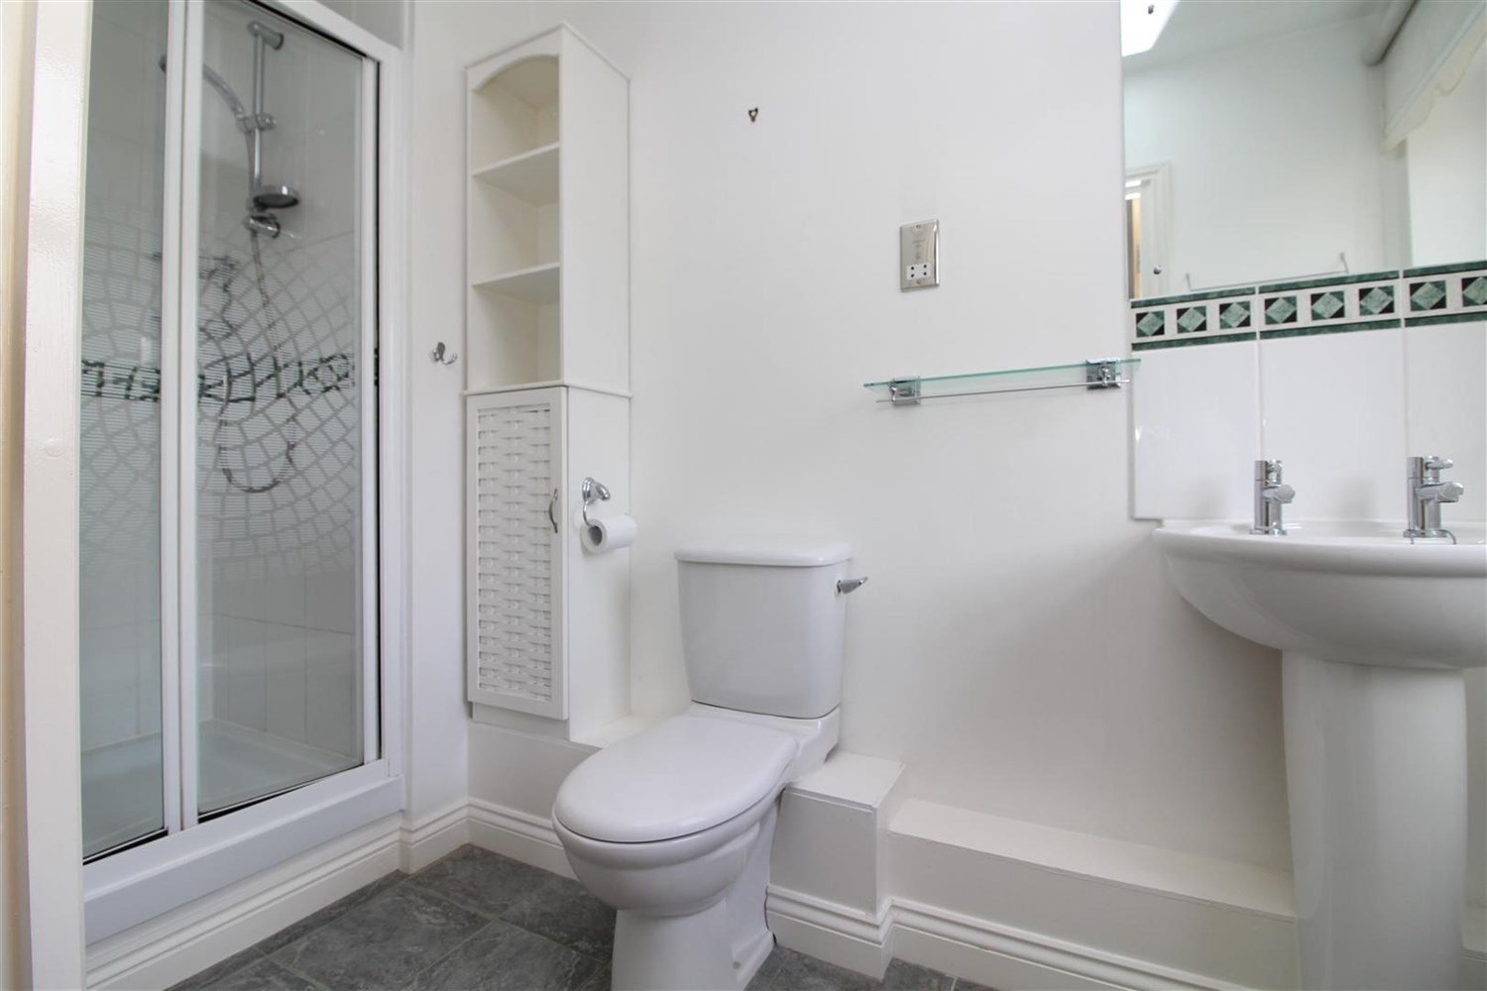

|  |
| --- |
| **Communal Entrance**  Secure communal entrance with intercom system, access to all floors via lift and staircase |
| **Living Room**  A beautiful, spacious room offering bright and airy living and dining space. Door to balcony, |
| **Kitchen**  A well stocked modern kitchen, comprising a range of high gloss wall and base mounted units, under unit lighting, inset sink with mixer tap, integrated oven, hob and extractor, dishwasher and washing machine. Marble top and splash back, vinyl flooring |
| **Bedroom 1**  A bright and spacious carpeted room, with two double door built in wardrobes, double glazed window and gas central heating radiator. Door to: |
| **Bedroom 2**  Another easy double, carpeted, with built in wardrobes, gas central heating radiator and double glazed window |
| **Bedroom 3**  A further good sized carpeted bedroom with double glazed window and gas central heating radiator |
| **En Suite**  Modern suite comprising shower cubicle, low flush w.c and basin. Vinyl flooring. |
| **Bathroom**  A contemporary white suite comprising bath with shower over and glass shower screen, low flush w.c and basin. Tiling to walls and floor. |
| **Home Information**  COUNCIL TAX BAND: D EPC Rating C  12 Month tenancy Leasehold property Parking for 2 cars Broadband: Standard 15 Mbps 1 Mbps Good Superfast 80 Mbps 20 Mbps Good Ultrafast 1000 Mbps 1000 Mbps Mobile availability: EE likely to have good coverage . Three limited coverage. O2 limited. Vodafone limited coverage.  Utilities: Water supplied on standard meters. Gas and Electric mains supplied on standard meters. |
| **Parking For Two Cars**  Allocated parking for two cars. |

|  |  |
| --- | --- |
| These particulars are intended to give a fair description of the property, but their accuracy cannot be guaranteed, and they do not constitute an offer of contract. Intending purchasers must rely on their own inspection of the property. None of the above appliances/services have been tested by ourselves. We recommend purchasers arrange for a qualified person to check all appliances/services before legal commitment.  **Property Ref:** 4667  **For more information, please contact**  0113 258 1150 **|** [lettings@adairpaxton.co.uk](mailto:lettings@adairpaxton.co.uk) **|** www.adairpaxton.co.uk |  |