

**0113 258 1150**

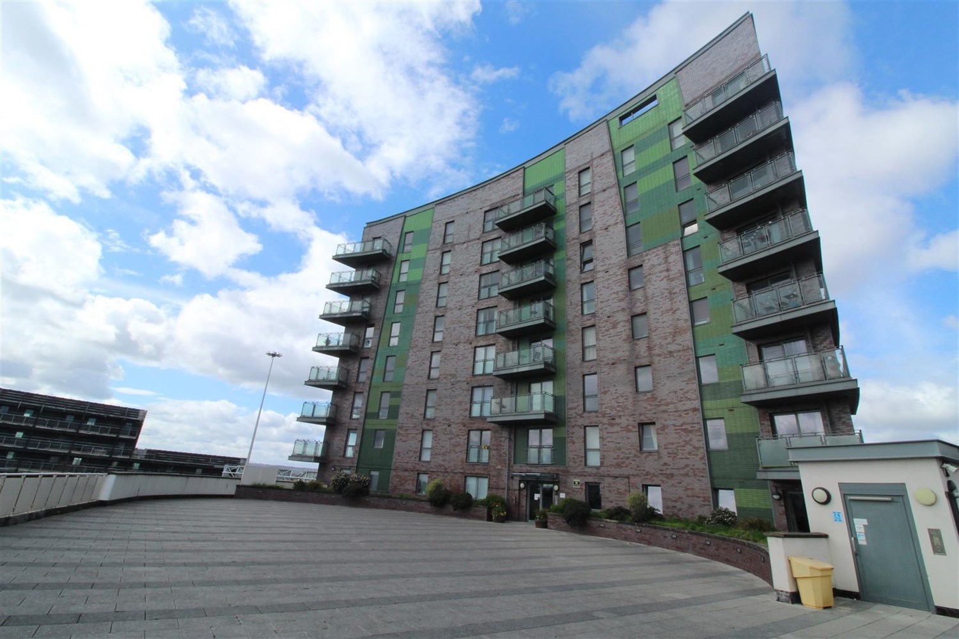



**Available to let £725.00pcm**

**Echo Central 2, Leeds**

***ONE BEDROOM FURNISHED APARTMENT*** Ideally located only a short distance from Leeds city centre as well as being ideally accessible for the motorway network. Offering a modern interior and briefly comprises of hallway with utility/store housing washer/dryer, double bedroom, modern shower room, Open plan living area with a Juliette balcony and kitchen with Integrated appliances. Council Tax Band A, EPC rating B, FURNISHED. Deposit £835. Available Now. SORRY NO PETS.

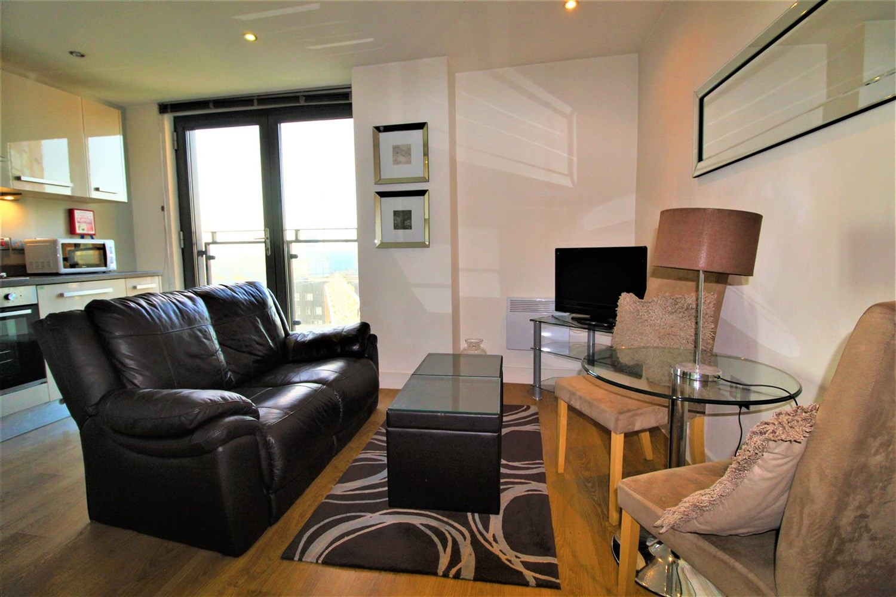

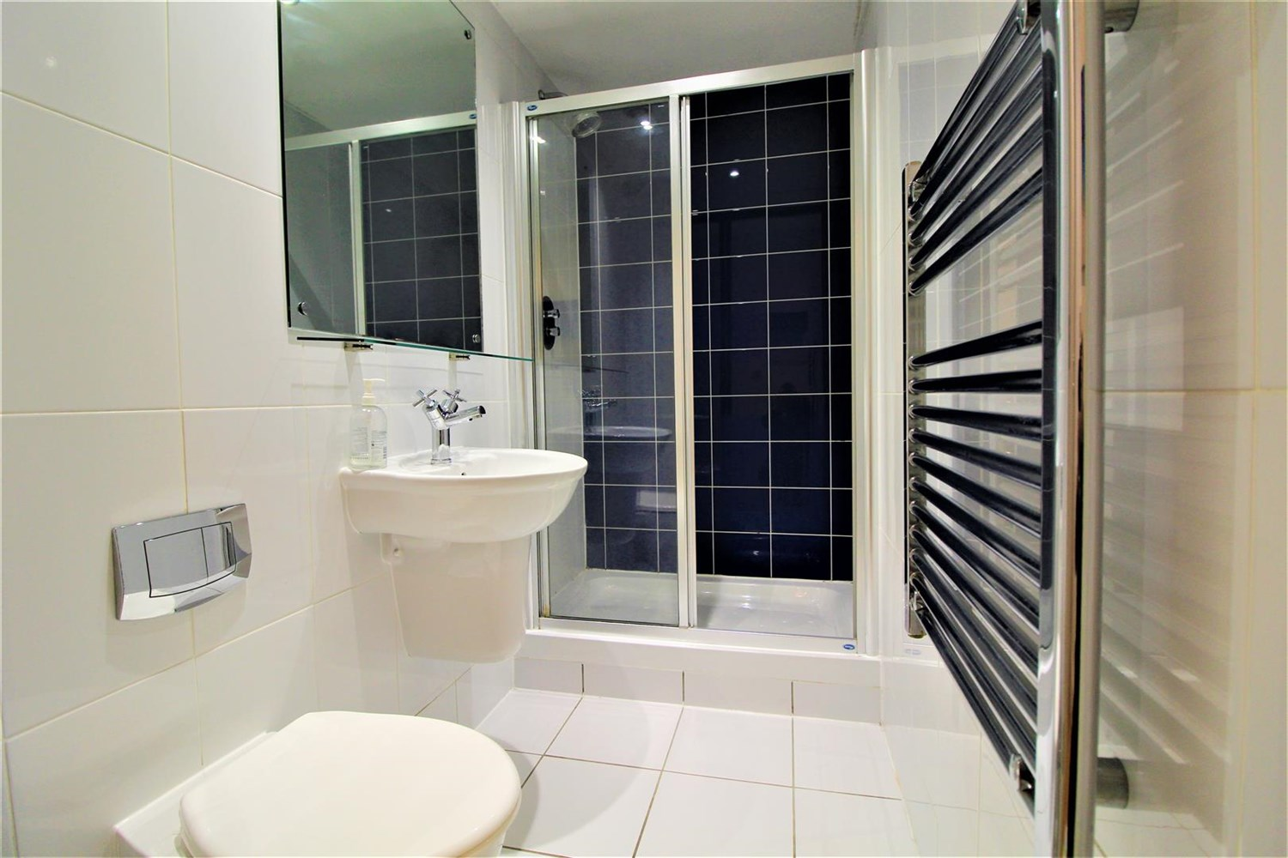

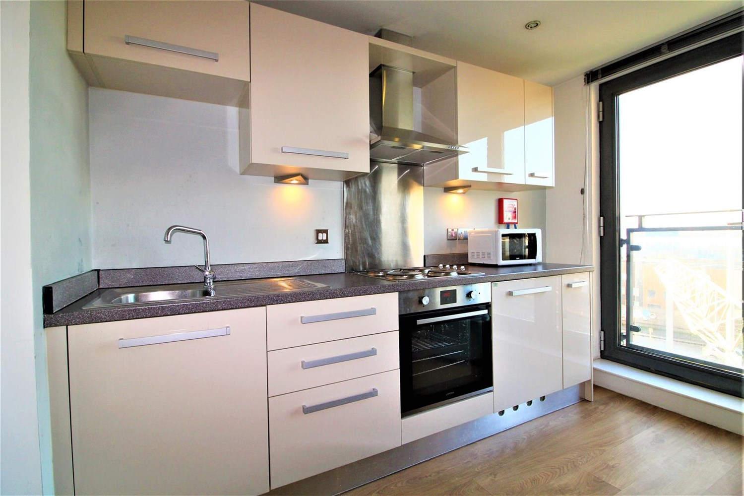

1 Bathroom(s)

1 Reception(s)

0 Bedroom(s)

00

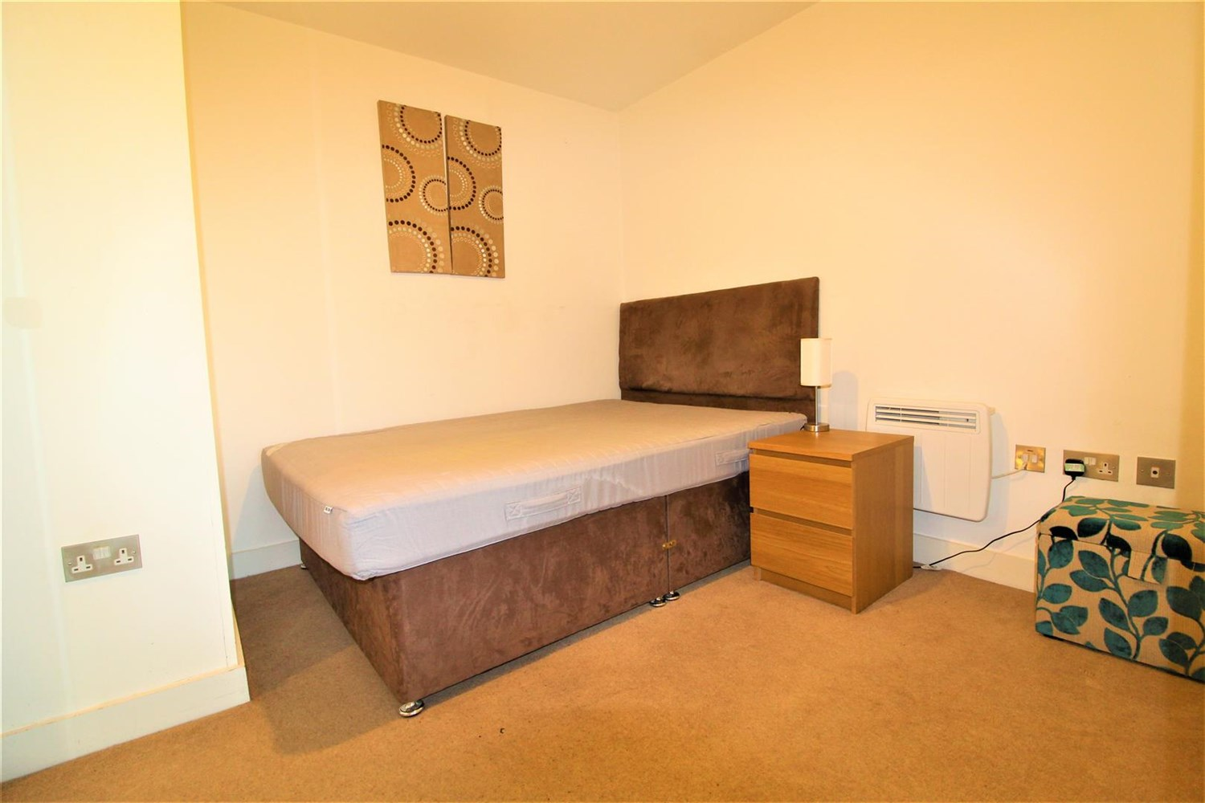

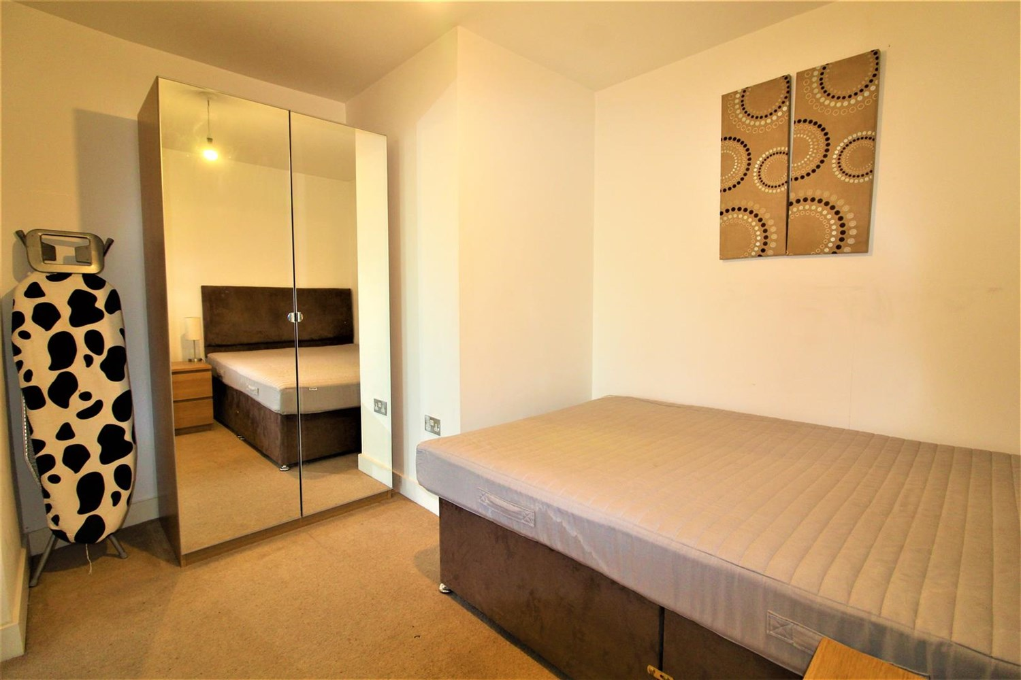

|  |
| --- |
| Contemporary open plan living room/kitchen with double glazed French doors opening to a Juliet balcony. Wall mounted electric heater. Open plan to the living room and fitted with a range of high gloss wall, base and drawer units. Stainless steel sink with mixer tap. Integrated electric oven and hob with extractor hood over. |
| **Bedroom 1**  Double bedroom with carpet and electric wall heater. |
| **Bathroom**  Fitted with a modern three piece suite comprising shower cubicle, wash hand basin and low level WC. Chrome heated ladder towel rail. Tiled floor. Part tiled walls. |
| **Home Information**  COUNCIL TAX BAND: A EPC Rating B  Leasehold property Broadband: Standard 9 Mbps 0.9 Mbps Good Superfast 80 Mbps 20 Mbps Good Ultrafast 1000 Mbps 1000 Mbps  Mobile availability: EE Limited ThreeLikely to have good coverage O2 Likely to have good coverage Vodafone Likely to have good coverage.  Electric mains supply, water on mains supply. |

|  |  |
| --- | --- |
| These particulars are intended to give a fair description of the property, but their accuracy cannot be guaranteed, and they do not constitute an offer of contract. Intending purchasers must rely on their own inspection of the property. None of the above appliances/services have been tested by ourselves. We recommend purchasers arrange for a qualified person to check all appliances/services before legal commitment.  **Property Ref:** 2102  **For more information, please contact**  0113 258 1150 **|** [lettings@adairpaxton.co.uk](mailto:lettings@adairpaxton.co.uk) **|** www.adairpaxton.co.uk |  |