

**0113 258 1150**

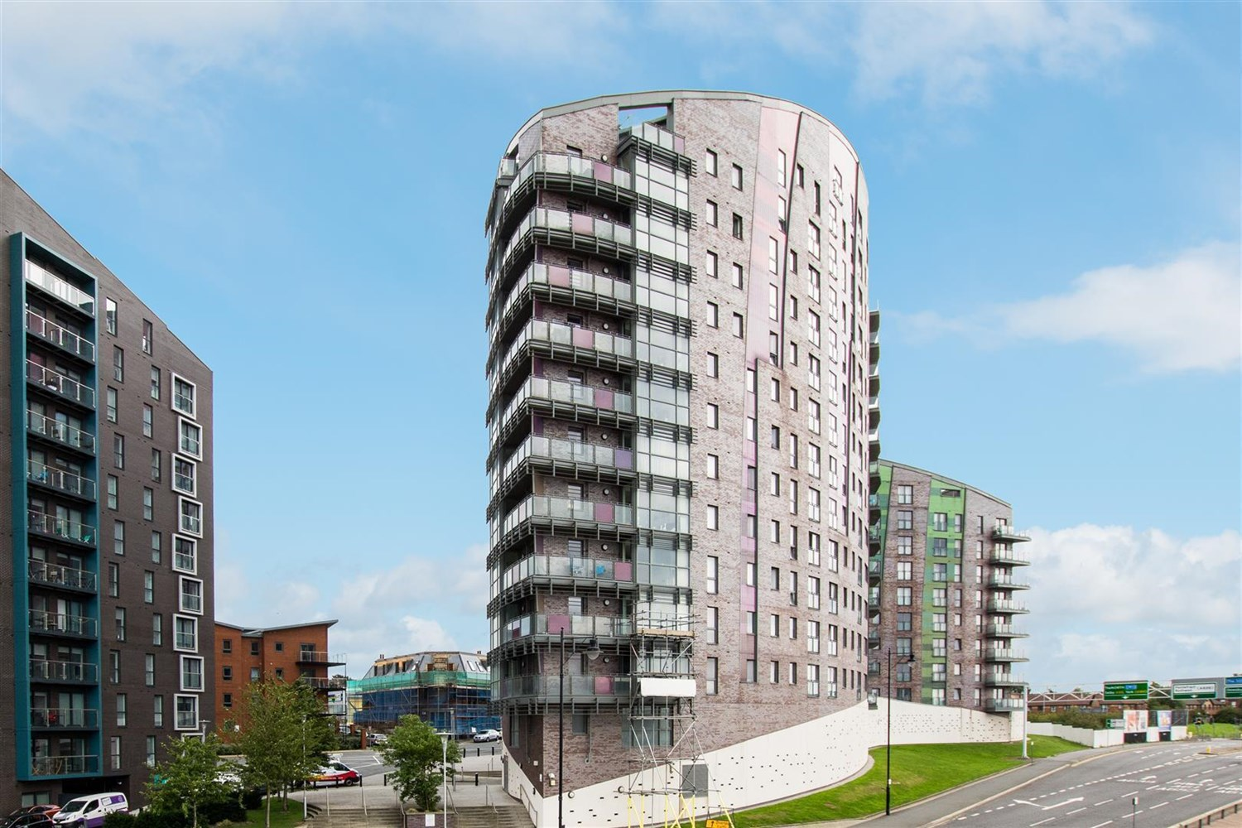



**Available to let £725.00pcm**

**Echo Central 1, LS9**

One bedroom 5th floor apartment in the popular Echo Central development, situated a short walk to the City Centre and and handy for the motorway network. The accommodation briefly comprises: Communal Entrance Hall with secure entry system, private entrance hall to the apartment, open plan Living Room/Kitchen with Juliette Balcony, Double Bedroom and Shower Room. Council Tax Band A. EPC rating C, deposit £835.00, available 14th March 2025.

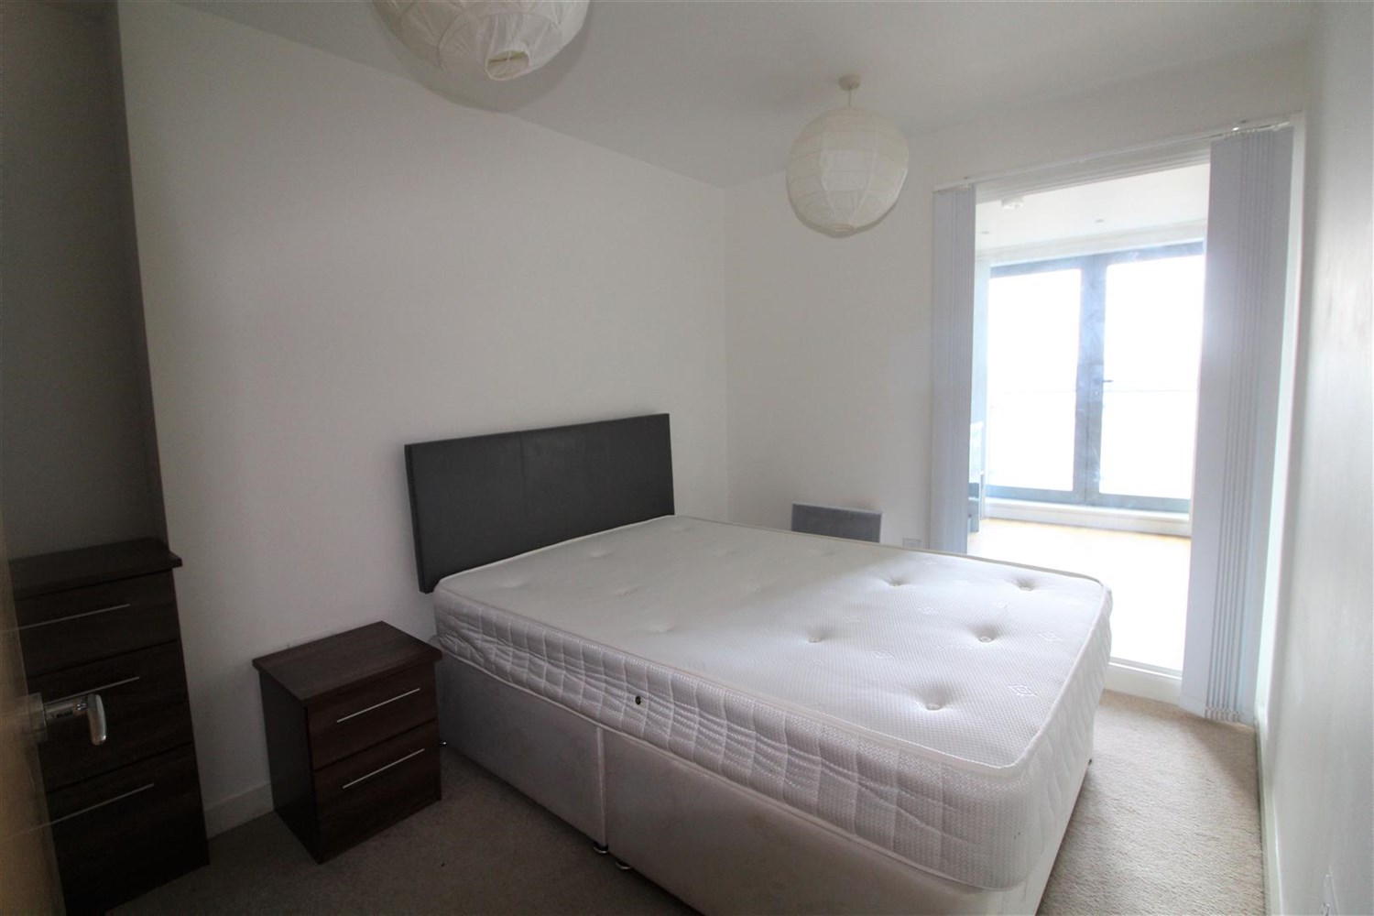

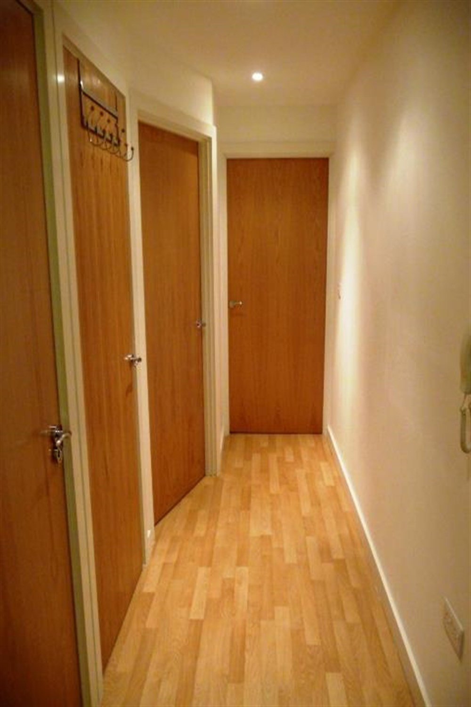

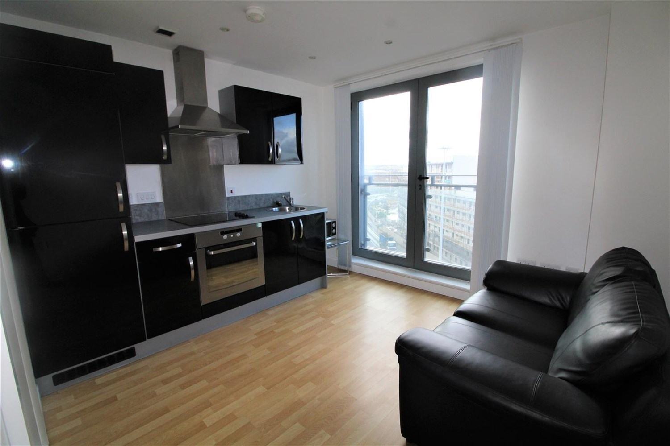

1 Bathroom(s)

1 Reception(s)

0 Bedroom(s)

00

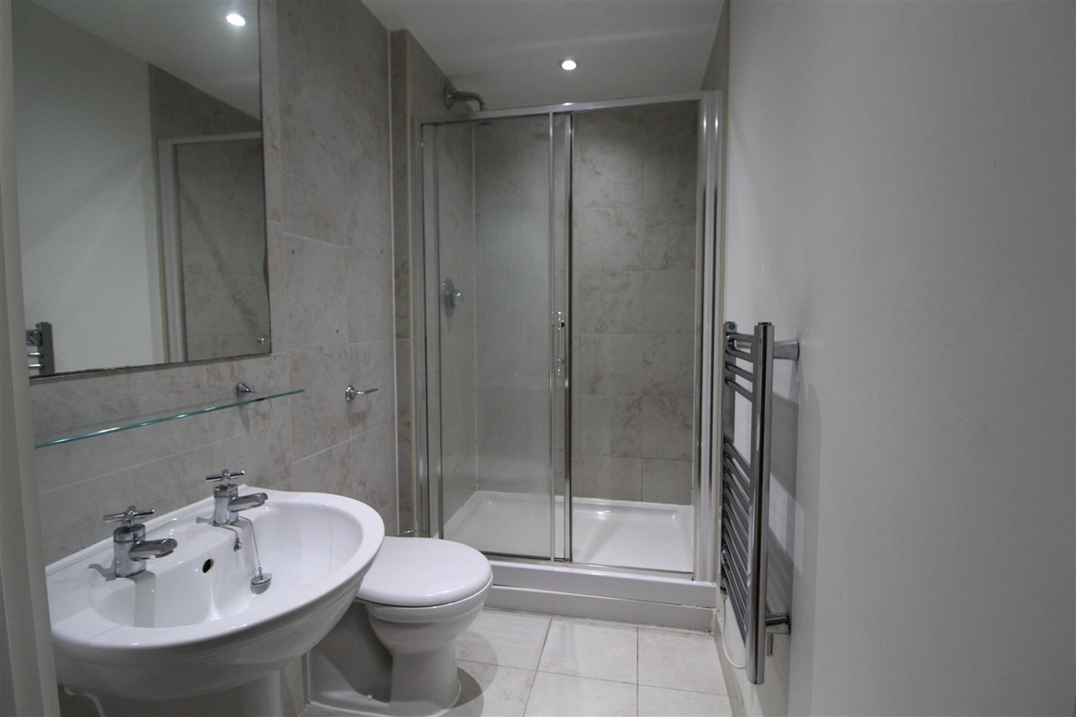

|  |
| --- |
| **Communal Entrance**  Secure intercom entry system. |
| **Private Entrance Hall**  Intercom entry system. Laminate flooring. Storage cupboard housing the boiler and washing machine. |
| **Open Plan Kitchen and Living Room**  Open plan living room/kitchen. Double glazed French doors opening to Juliette balcony. Laminate flooring. Electric wall mounted heater. Kitchen fitted with black high gloss wall and base units. Circular stainless steel sink. Electric oven & hob with extractor hood over. Integrated fridge/freezer. |
| **Bedroom**  Carpeted double bedroom with full height internal window to the living room. Electric wall mounted heater. |
| **Bathroom**  Fitted with a three piece suite comprising shower cubicle, wash hand basin and low level w.c. Shaver point. Fully tiled walls and tiled floor. Heated ladder towel rail. |
| **Home Information**  COUNCIL TAX BAND: A EPC Rating :C  Leasehold property No Parking   Broadband: Standard 9 Mbps 725.9 Mbps Good Superfast 8725 Mbps 2725 Mbps Good Ultrafast 1725725725 Mbps 1725725725 Mbps  Mobile availability: EE Limited Three Likely to have good coverage O2 Likely to have good coverage Vodafone Likely to have good coverage.  Electric mains supply, water on mains supply. |

|  |  |
| --- | --- |
| These particulars are intended to give a fair description of the property, but their accuracy cannot be guaranteed, and they do not constitute an offer of contract. Intending purchasers must rely on their own inspection of the property. None of the above appliances/services have been tested by ourselves. We recommend purchasers arrange for a qualified person to check all appliances/services before legal commitment.  **Property Ref:** 4401  **For more information, please contact**  0113 258 1150 **|** [lettings@adairpaxton.co.uk](mailto:lettings@adairpaxton.co.uk) **|** www.adairpaxton.co.uk |  |