

**0113 258 1150**

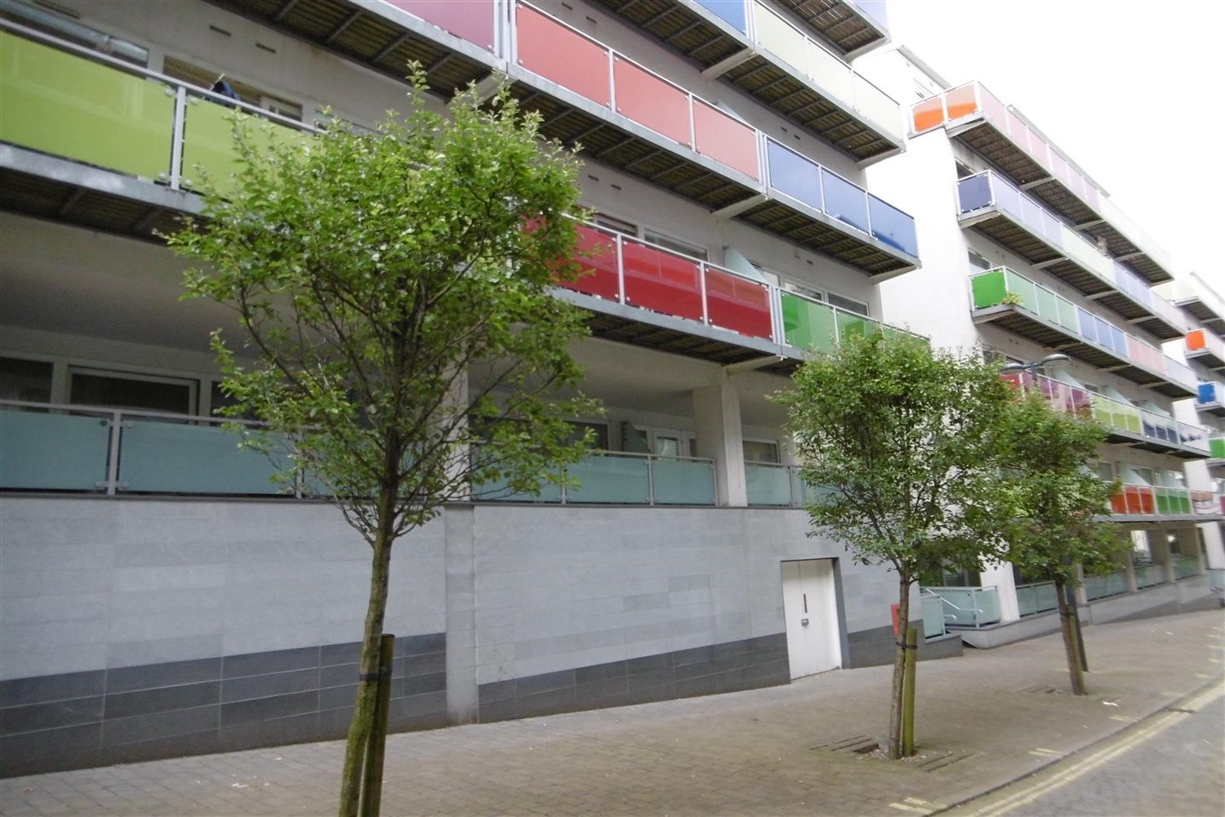



**Available to let £750.00pcm**

**Concord Street, Leeds**

SPACIOUS ONE BEDROOM APARTMENT Conveniently located in a contemporary block situated in the Northern Quarter of Leeds City centre. Well placed for Universities and good transport links. Comprising: Hallway, spacious open plan lounge/dining/kitchen area with floor to ceiling windows, and balcony, fitted kitchen with appliances, double bedroom, bathroom with shower. Council Tax Band C, according to local authority website. Fully Furnished. Deposit £865 Available NOW.

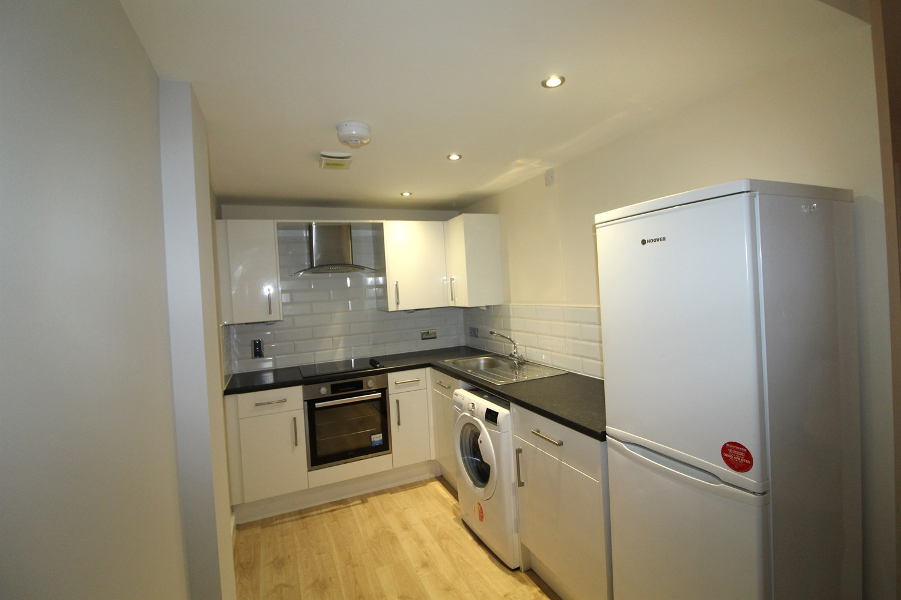

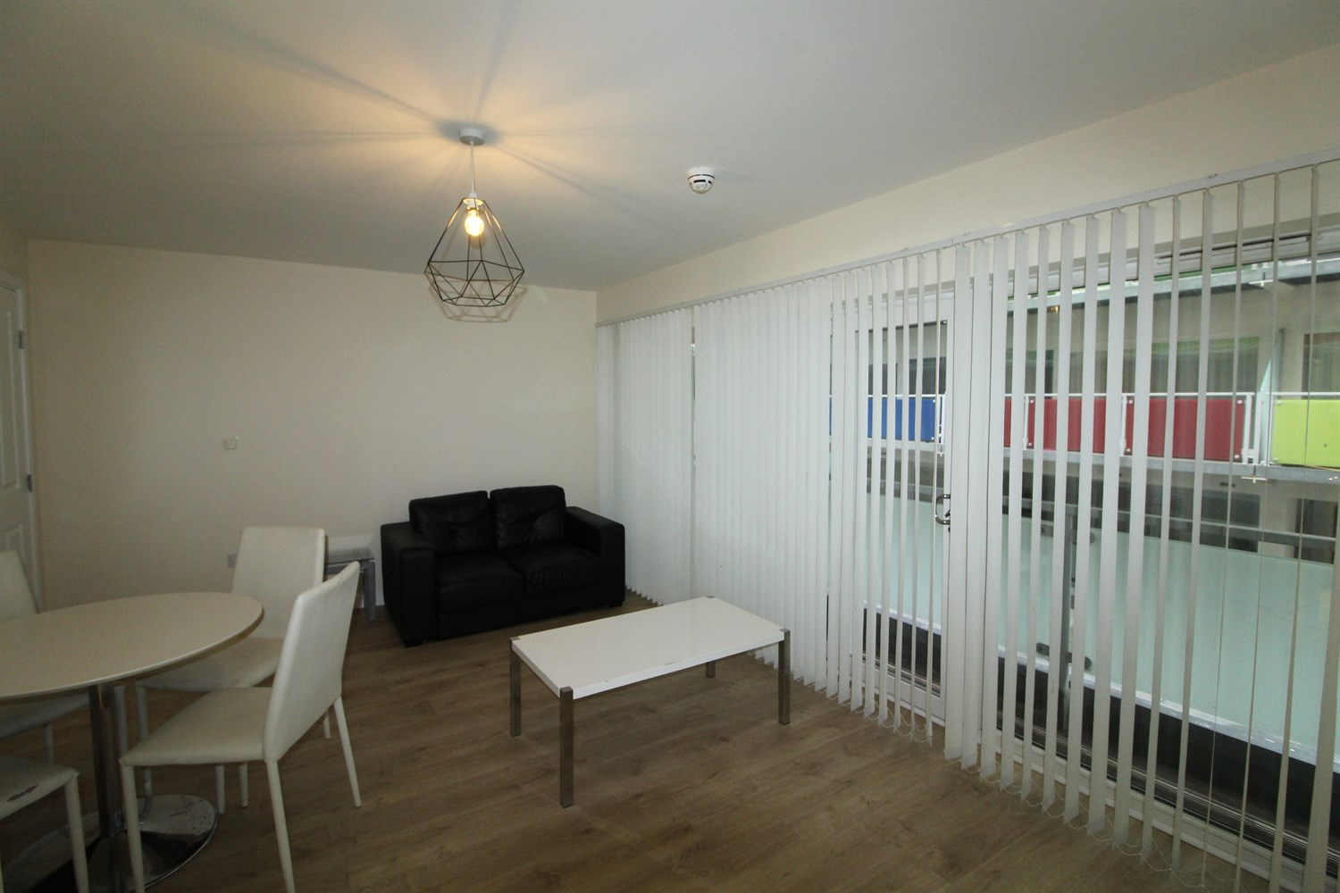

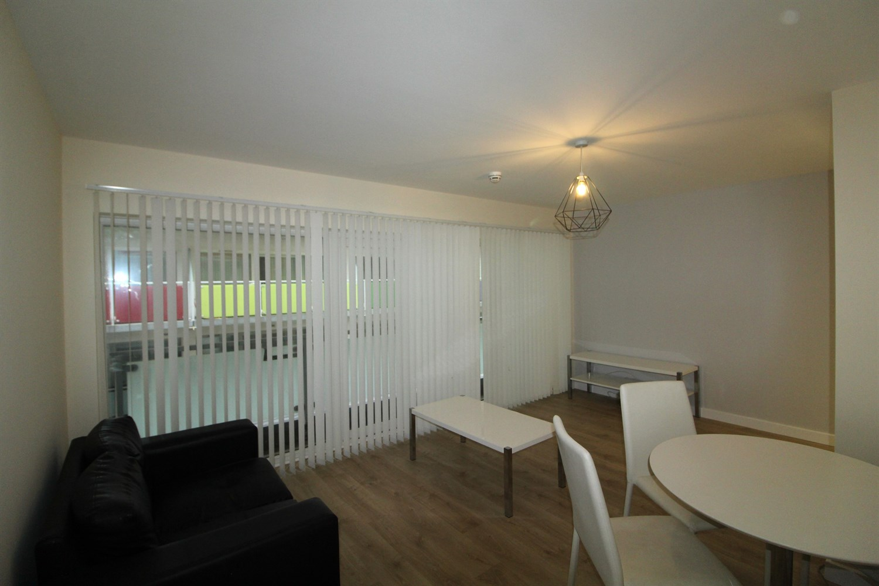

1 Bathroom(s)

1 Reception(s)

1 Bedroom(s)

00

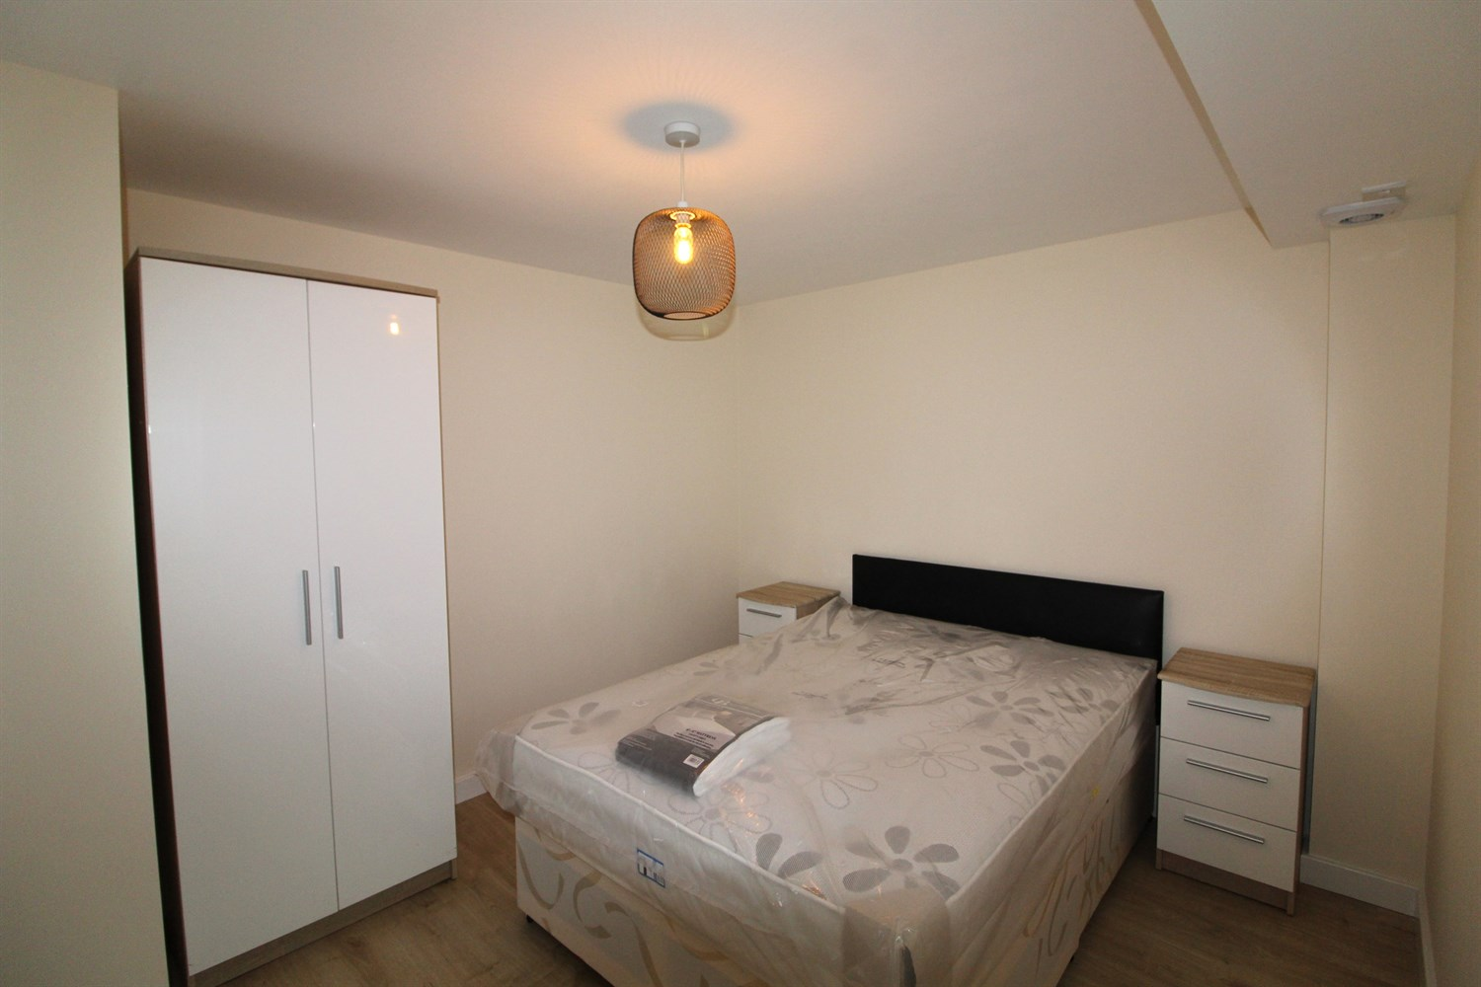

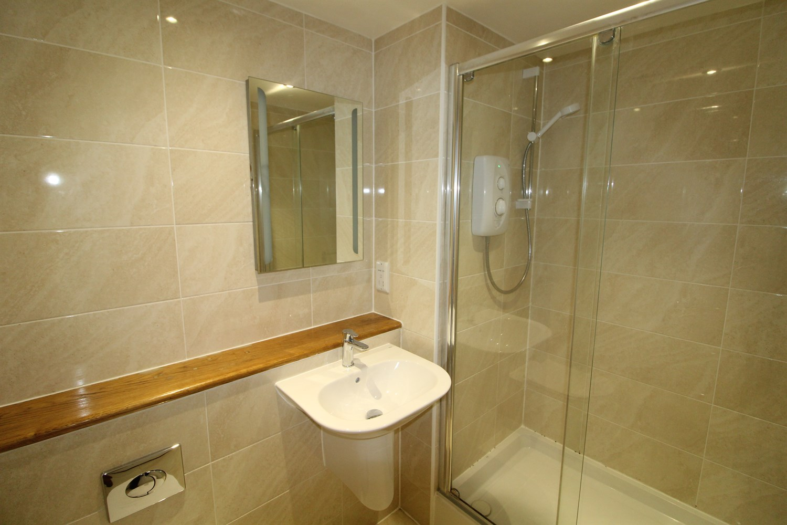

|  |
| --- |
| **Living/Dining**  Spacious open plan living/dining, sliding doors leading to balcony. |
| **Kitchen**  Fitted with a range of wall and base units with work tops over, stainless steel sink with drainer and mixer tap. |
| **Bedroom**  Large double bedroom with uPVC double glazed window facing to the rear of the property, electric wall mounted heater. |
| **Bathroom**  Three piece bathroom suite with large walk in shower, w/c and hand wash basin. larger mirror and electric heater. |
| **Home Information**  COUNCIL TAX BAND: C EPC Rating   Leasehold property   Broadband Virgin media only: Standard 15 Mbps 1 Mbps Good Superfast 80 Mbps 20 Mbps Good Ultrafast 1000 Mbps 1000 Mbps  Mobile availability: EE likely to have good coverage. Three likely to have good coverage. O2 likely to have good coverage. Vodafone limited coverage.  Utilities: Water supplied on standard meters. Electric mains supplied on standard meters. |

|  |  |
| --- | --- |
| These particulars are intended to give a fair description of the property, but their accuracy cannot be guaranteed, and they do not constitute an offer of contract. Intending purchasers must rely on their own inspection of the property. None of the above appliances/services have been tested by ourselves. We recommend purchasers arrange for a qualified person to check all appliances/services before legal commitment.  **Property Ref:** 5078  **For more information, please contact**  0113 258 1150 **|** [lettings@adairpaxton.co.uk](mailto:lettings@adairpaxton.co.uk) **|** www.adairpaxton.co.uk |  |