

**0113 258 1150**

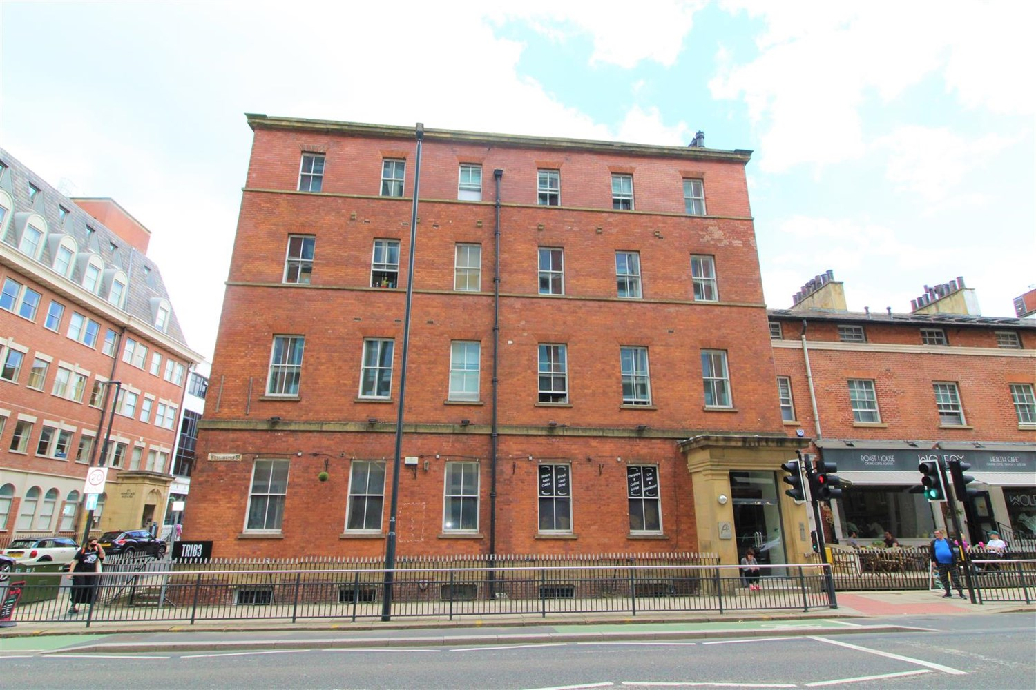



**Available to let £825.00pcm**

**Atlantic Apartments, Leeds,**

Centrally located one bedroom first floor apartment, perfectly positioned within Leeds's business district. A stones throw from Leeds City Station, and having grocery shops, cafes and bars on your doorstep. The property itself is furnished, offering comfortable accommodation, kitchen with built in appliances, bedroom and shower room. Available 13th February 2025 Deposit £950. Council tax band C. EPC Rating D Sorry, no pets.

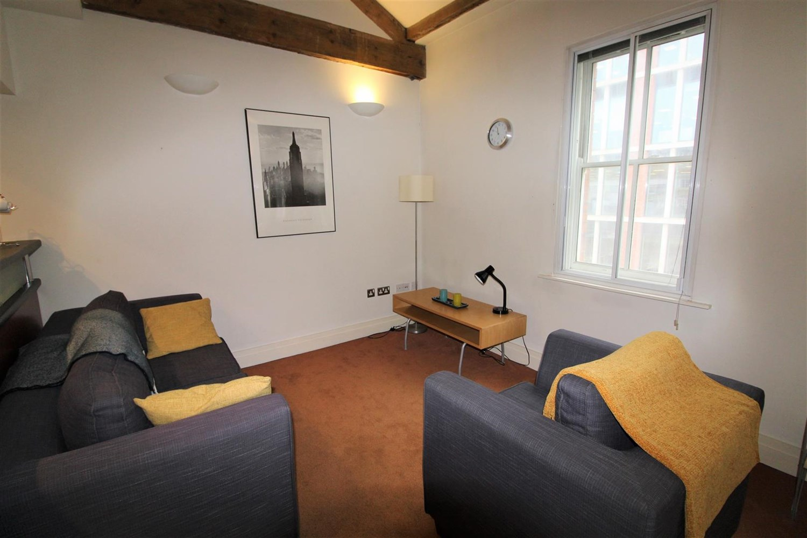

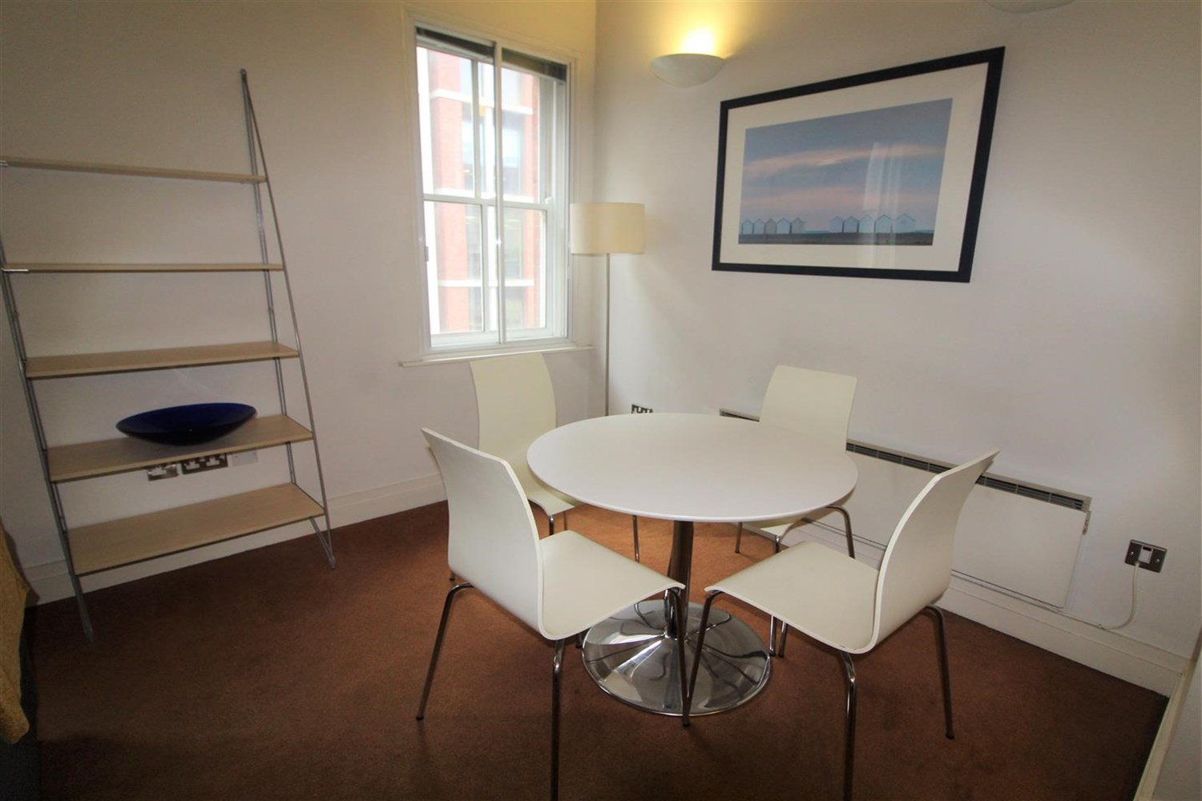

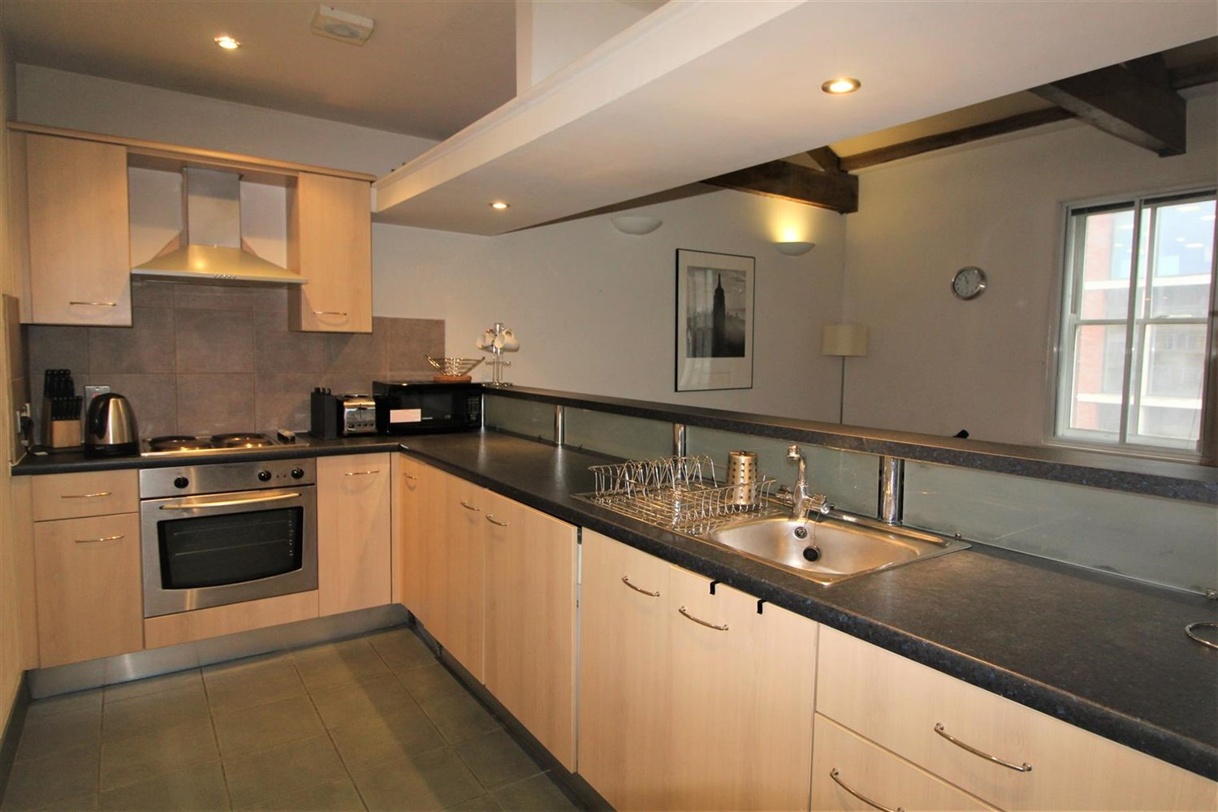

1 Bathroom(s)

1 Reception(s)

0 Bedroom(s)

00

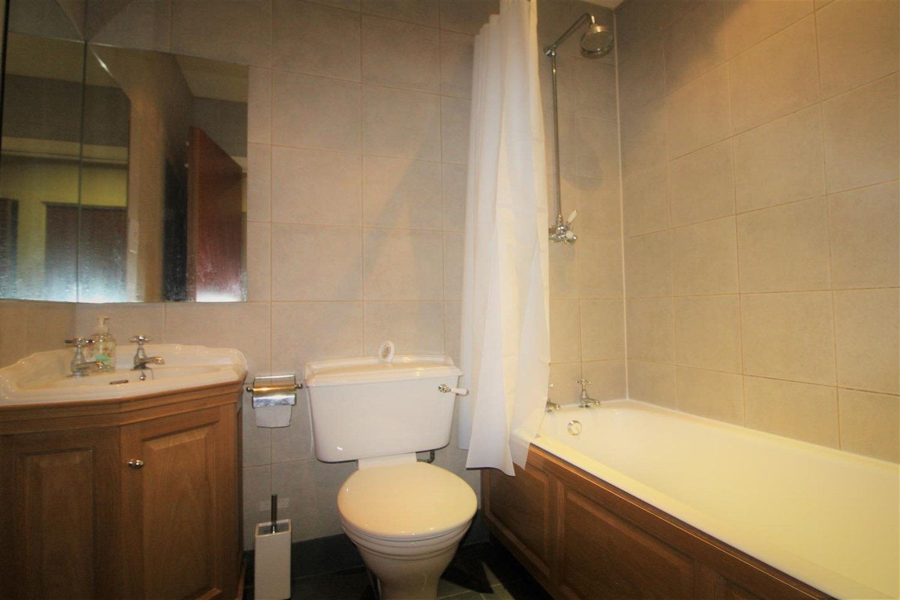

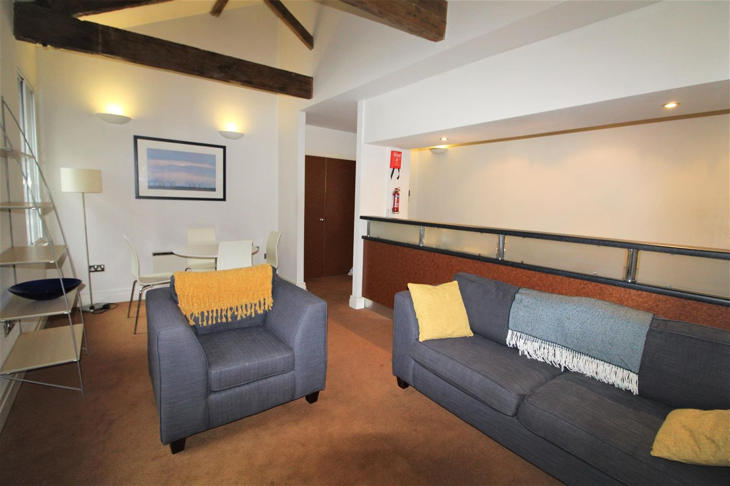

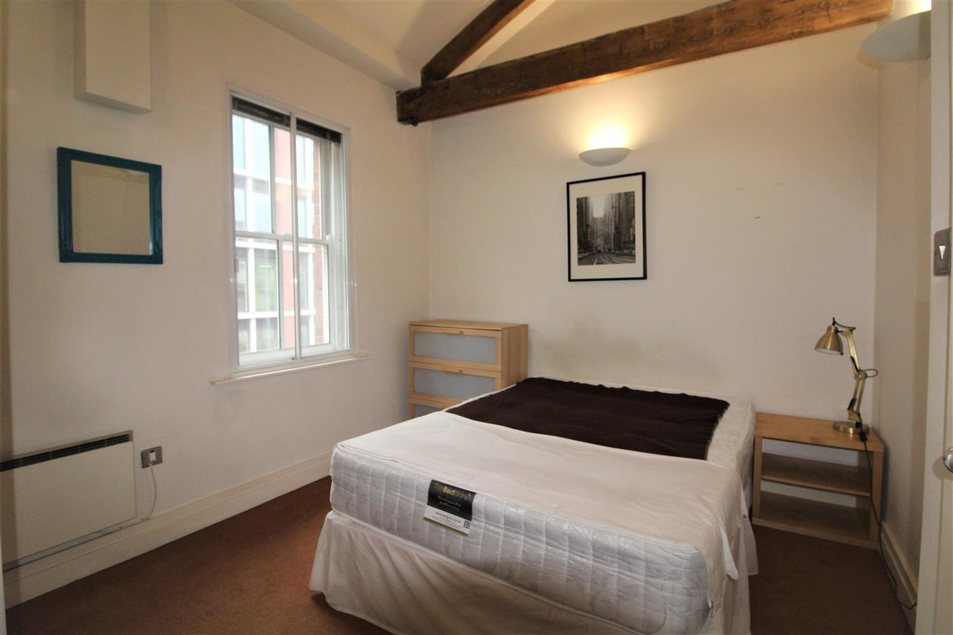

|  |
| --- |
| **Living Room/ Kitchen**  Open plan living/dining room and kitchen with two windows and a wall mounted electric radiator. Kitchen fitted with a range of wall and base units with work tops over, stainless steel sink with mixer tap and drainer. Electric oven and hob with extractor above. |
| **Bedroom**  Double bedroom with a window and a wall mounted electric heater. |
| **Bathroom**  Three piece bathroom suite with a bath and over head shower, W/C, hand wash basin. Tiled walls and floor. |
| **Home Information**  COUNCIL TAX BAND: C EPC Rating D  Leasehold property No Parking  Broadband: Standard 16 Mbps 1 Mbps Good Superfast --Not available --Not available Unlikely Ultrafast --Not available -- Mobile availability: EE Limited Three Limited O2 Likely Vodafone Likely  Electric mains supply, water on mains supply. |

|  |  |
| --- | --- |
| These particulars are intended to give a fair description of the property, but their accuracy cannot be guaranteed, and they do not constitute an offer of contract. Intending purchasers must rely on their own inspection of the property. None of the above appliances/services have been tested by ourselves. We recommend purchasers arrange for a qualified person to check all appliances/services before legal commitment.  **Property Ref:** 4774  **For more information, please contact**  0113 258 1150 **|** [lettings@adairpaxton.co.uk](mailto:lettings@adairpaxton.co.uk) **|** www.adairpaxton.co.uk |  |