

**Crescent Court, The Crescent, Alwoodley**

**For Sale £170,000.00**

***SPACIOUS TWO BEDROOM APARTMENT IN MUCH SOUGHT AFTER ALWOODLEY LOCATION*** Located in this convenient location, just off Alwoodley Lane, this ground floor apartment is offered to the market with NO ONWARD CHAIN and simply MUST BE VIEWED to be appreciated. Boasting generous proportions throughout, the property briefly comprises: private entrance hall, spacious living room, fitted kitchen with integrated appliances, master bedroom with built in wardrobes, second double bedroom and a house shower room. Externally there are attractive communal gardens and a garage. The apartment benefits from a gas central heating, uPVC double glazing and would benefit from cosmetic updating. Enjoying one of North Leeds' most desirable addresses and being one of just four apartments, properties rarely come to the market in this development and early internal viewing is highly recommended.

**0113 258 1150**

**0800 000 000**

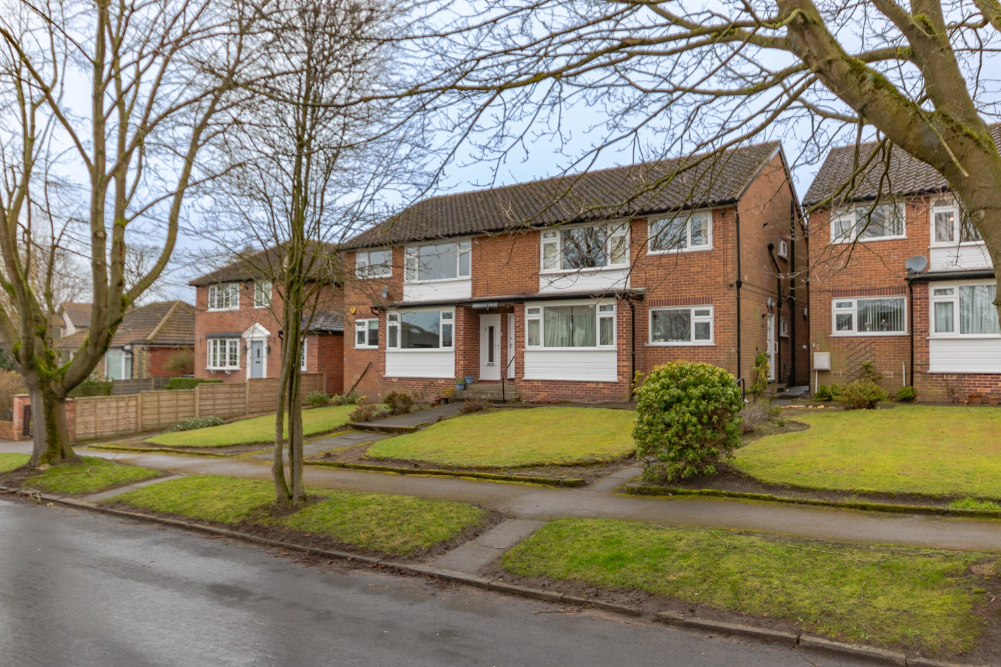

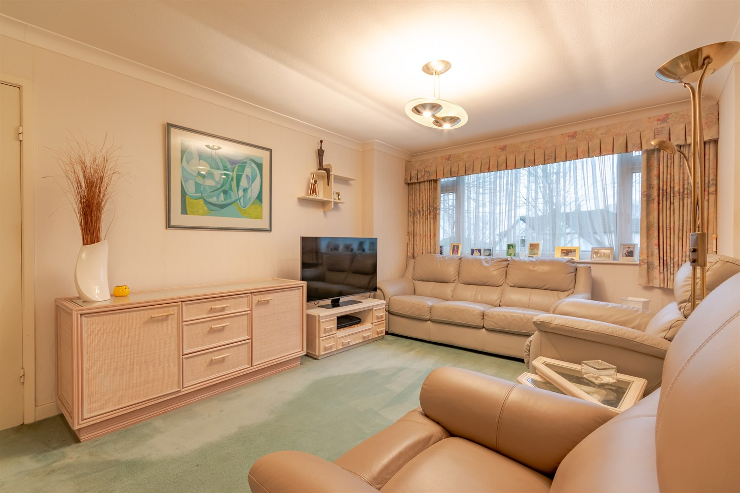

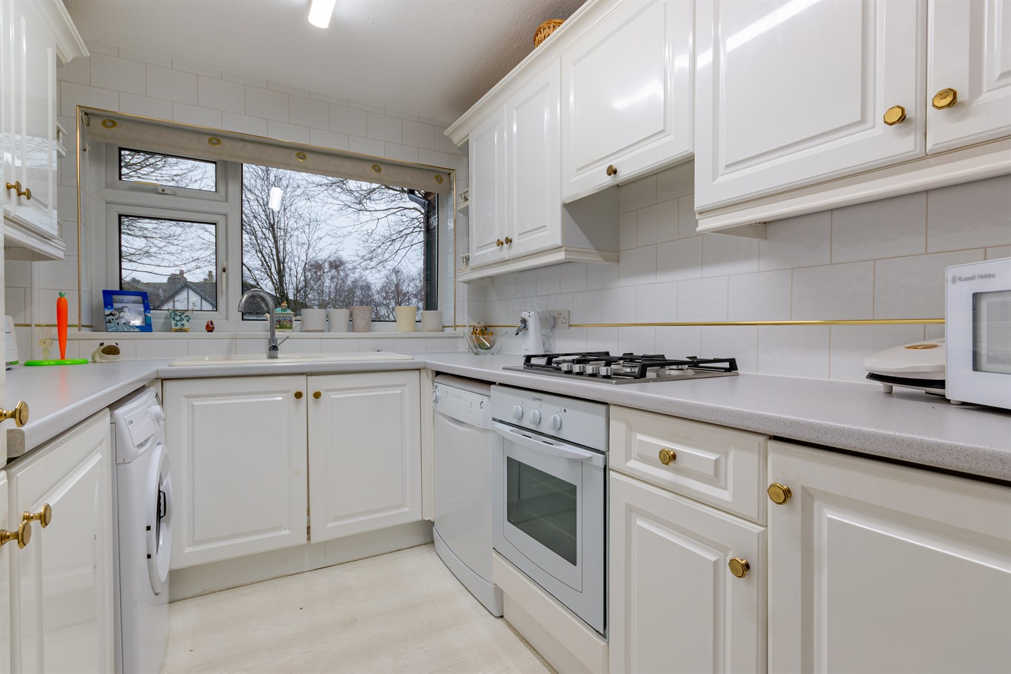

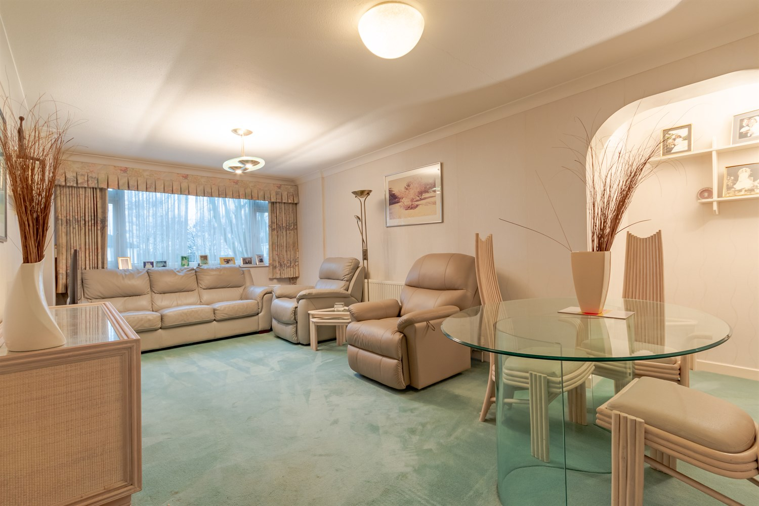

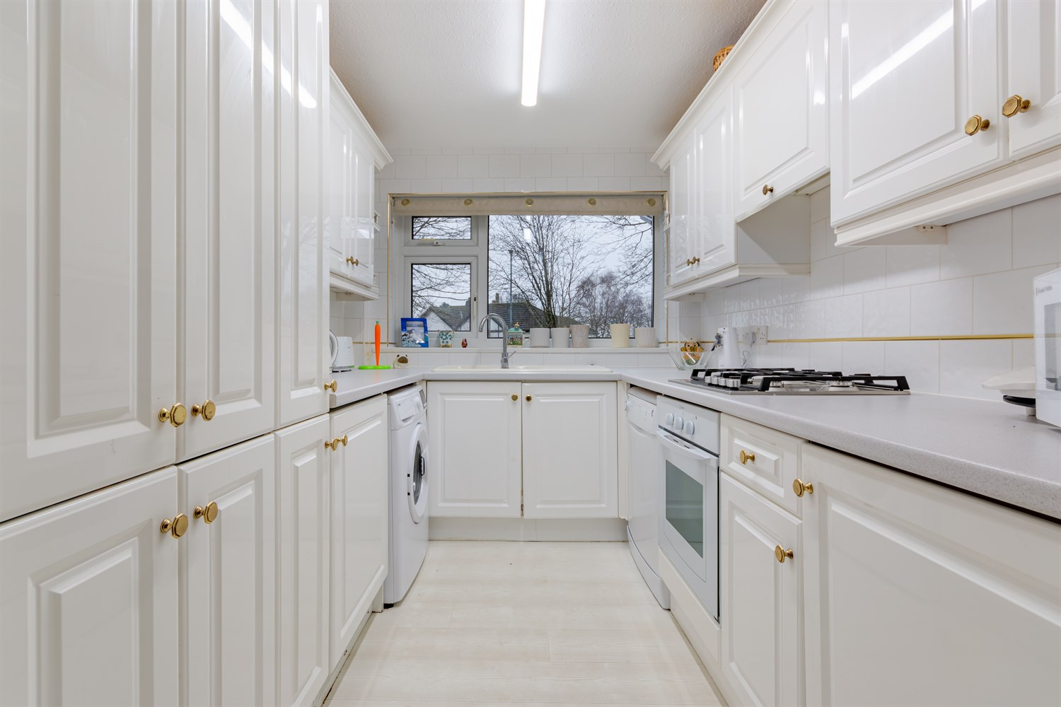

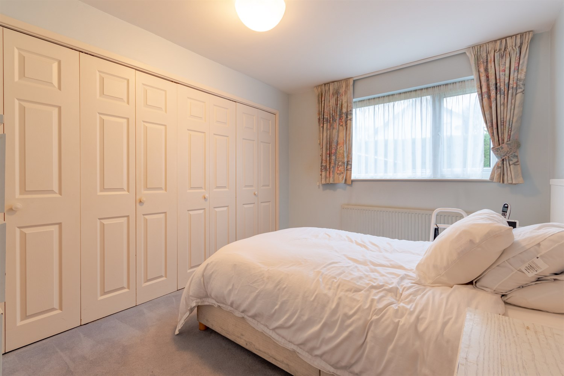

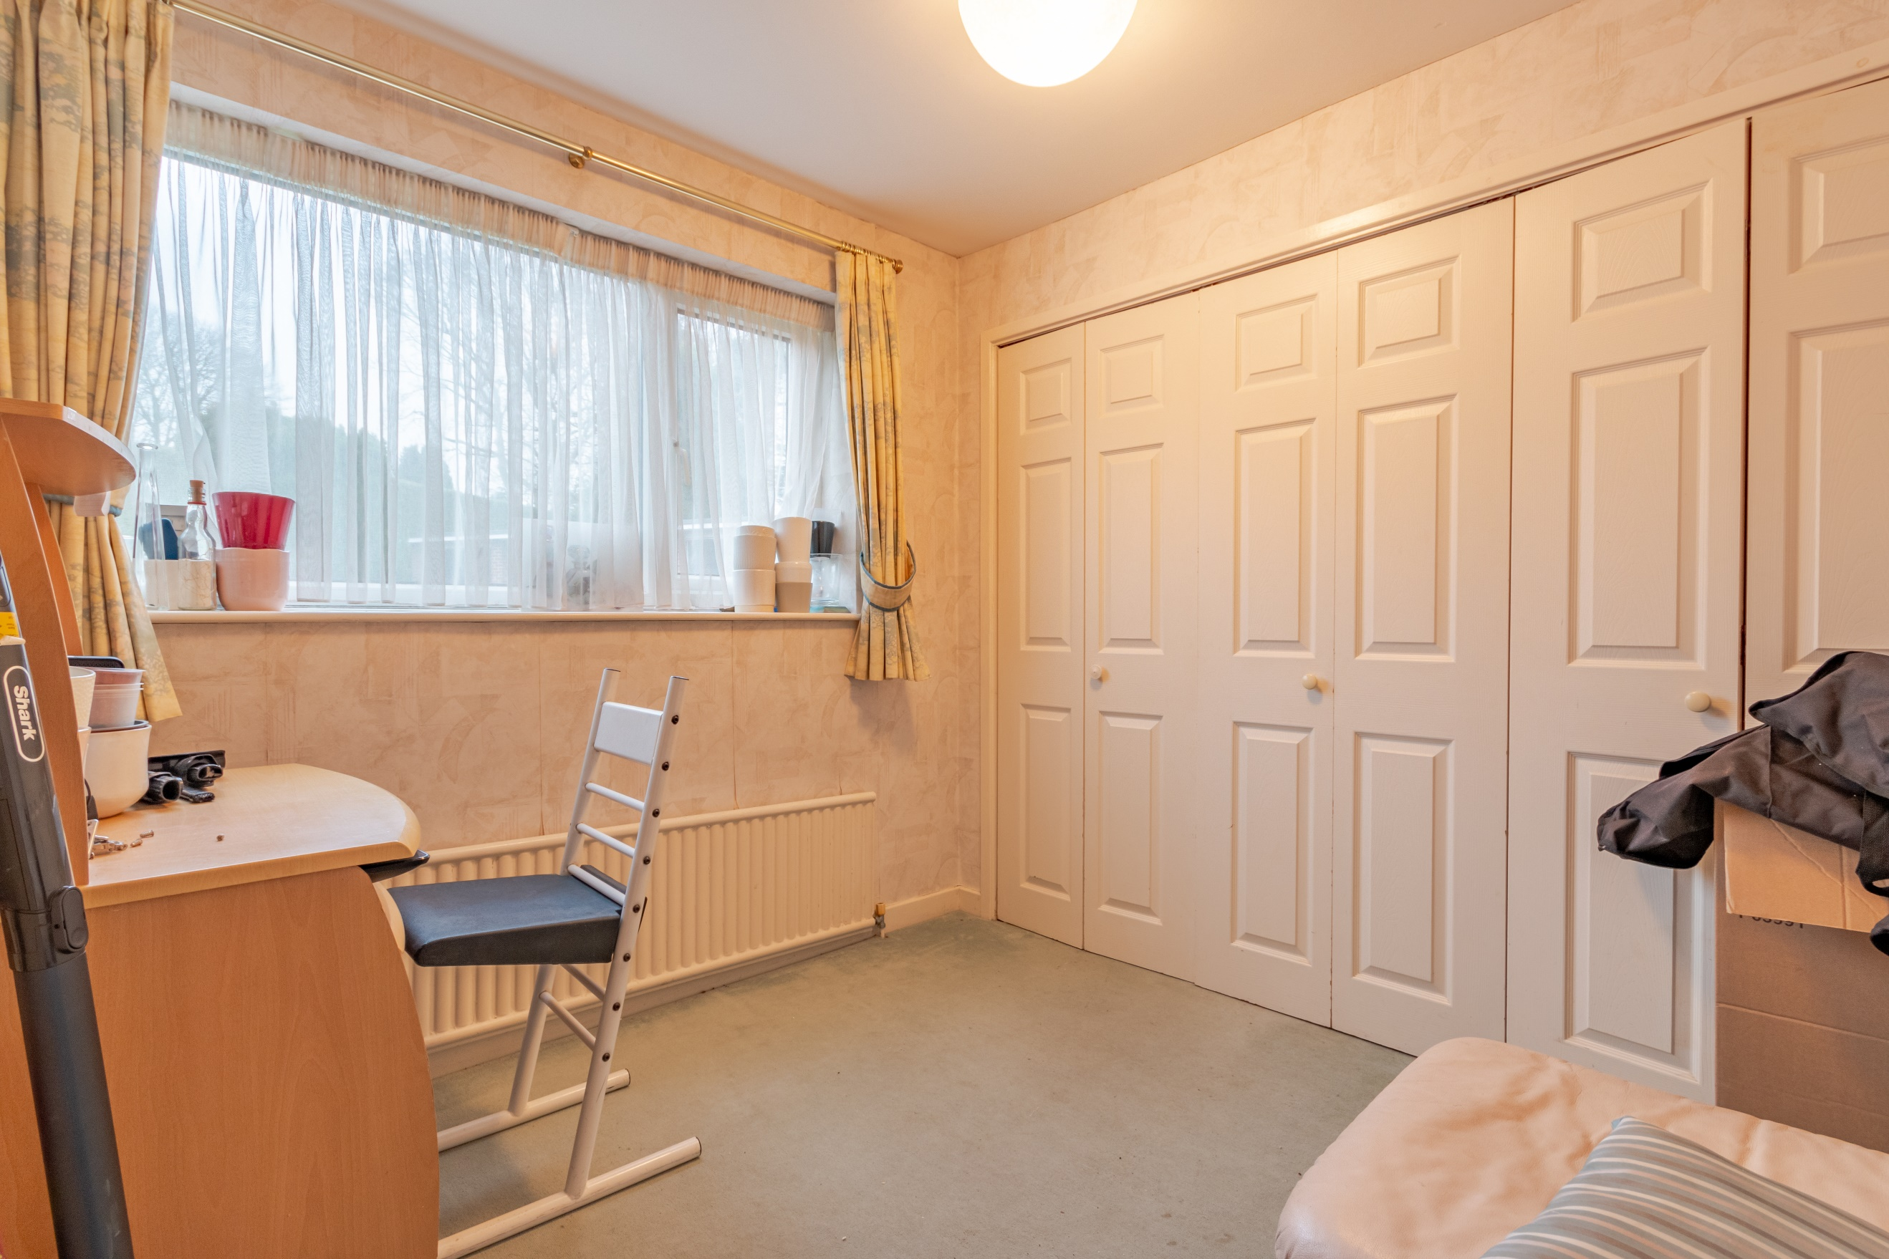

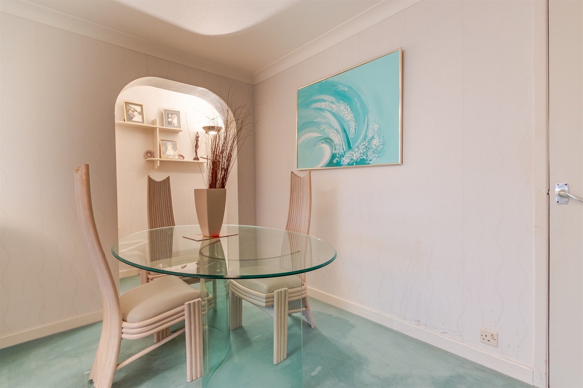

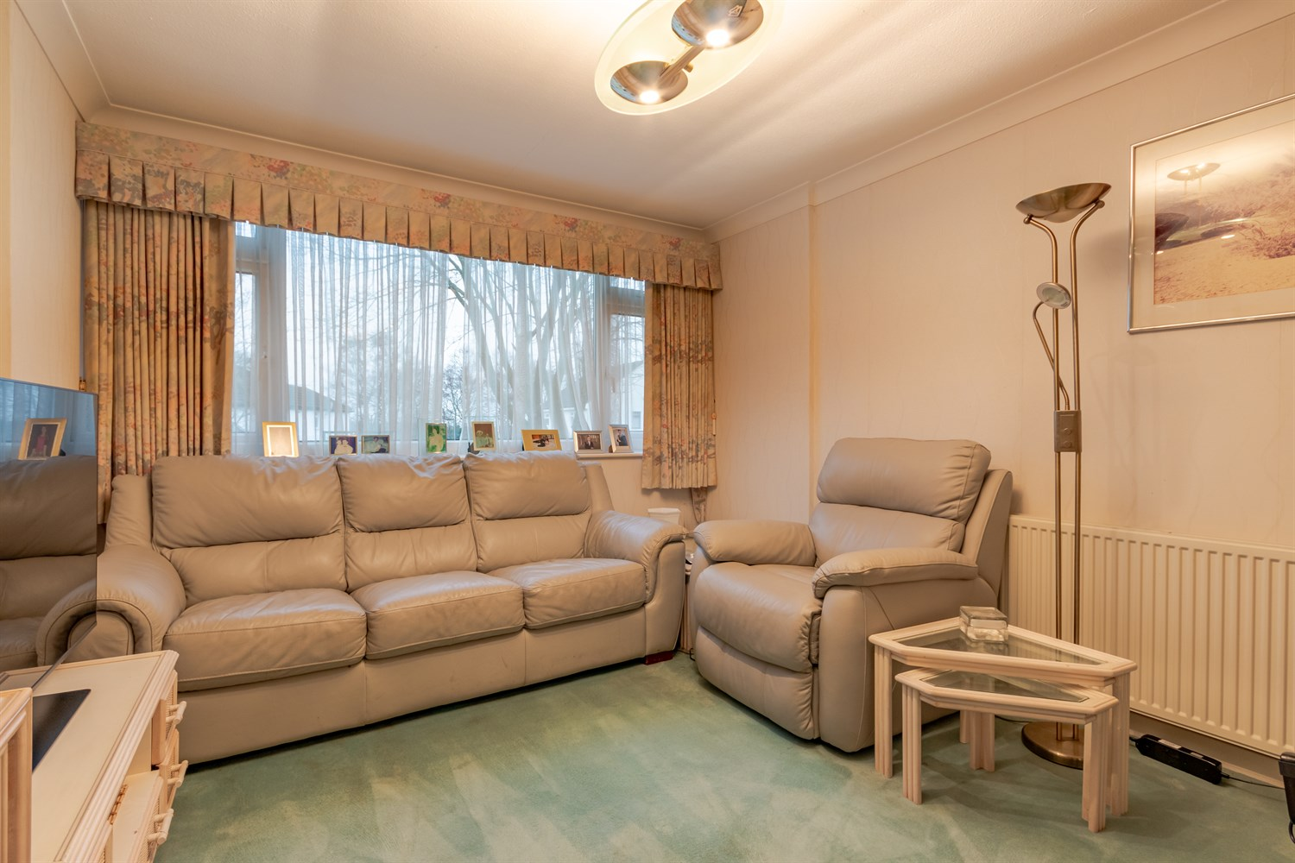

|  |
| --- |
| **Hallway**  Via entrance door. Gas central heating radiator. |
| **Sitting Room 3.31m (10'10) x 5.82m (19'1)**  Light and airy living room with double glazed window to front. Gas central heating radiator. Dining area. |
| **Kitchen 2.31m (7'7) x 3.08m (10'1)**  Fitted kitchen comprising; wall, base and drawer units with worktops over. Integrated fridge and freezer. Integrated oven with 4-ring gas hob and extractor hood over. Space for washing machine and space for dishwasher. Sink with mixer tap and drainer. Tiled walls. Double glazed window to front. |
| **Bedroom 1 3.35m (11') x 3.63m (11'11)**  Double bedroom with double glazed window to rear. Built in wardrobes. Gas central heating radiator. |
| **Bedroom 2 3.29m (10'10) x 2.65m (8'8)**  Second double bedroom with double glazed window to rear. Built in wardrobes. Gas central heating radiator. |
| **Shower Room**  Walk in shower room comprising; walk in shower, WC and wash hand basin. Double glazed window. Part tiled walls. |
| **Communal Garden**  Well maintained communal gardens. |
| **Tenure**  Leasehold - 999 years from 1966 |
| **Service Charge**  £155.00 per annum |
| **Garage** |
|  |

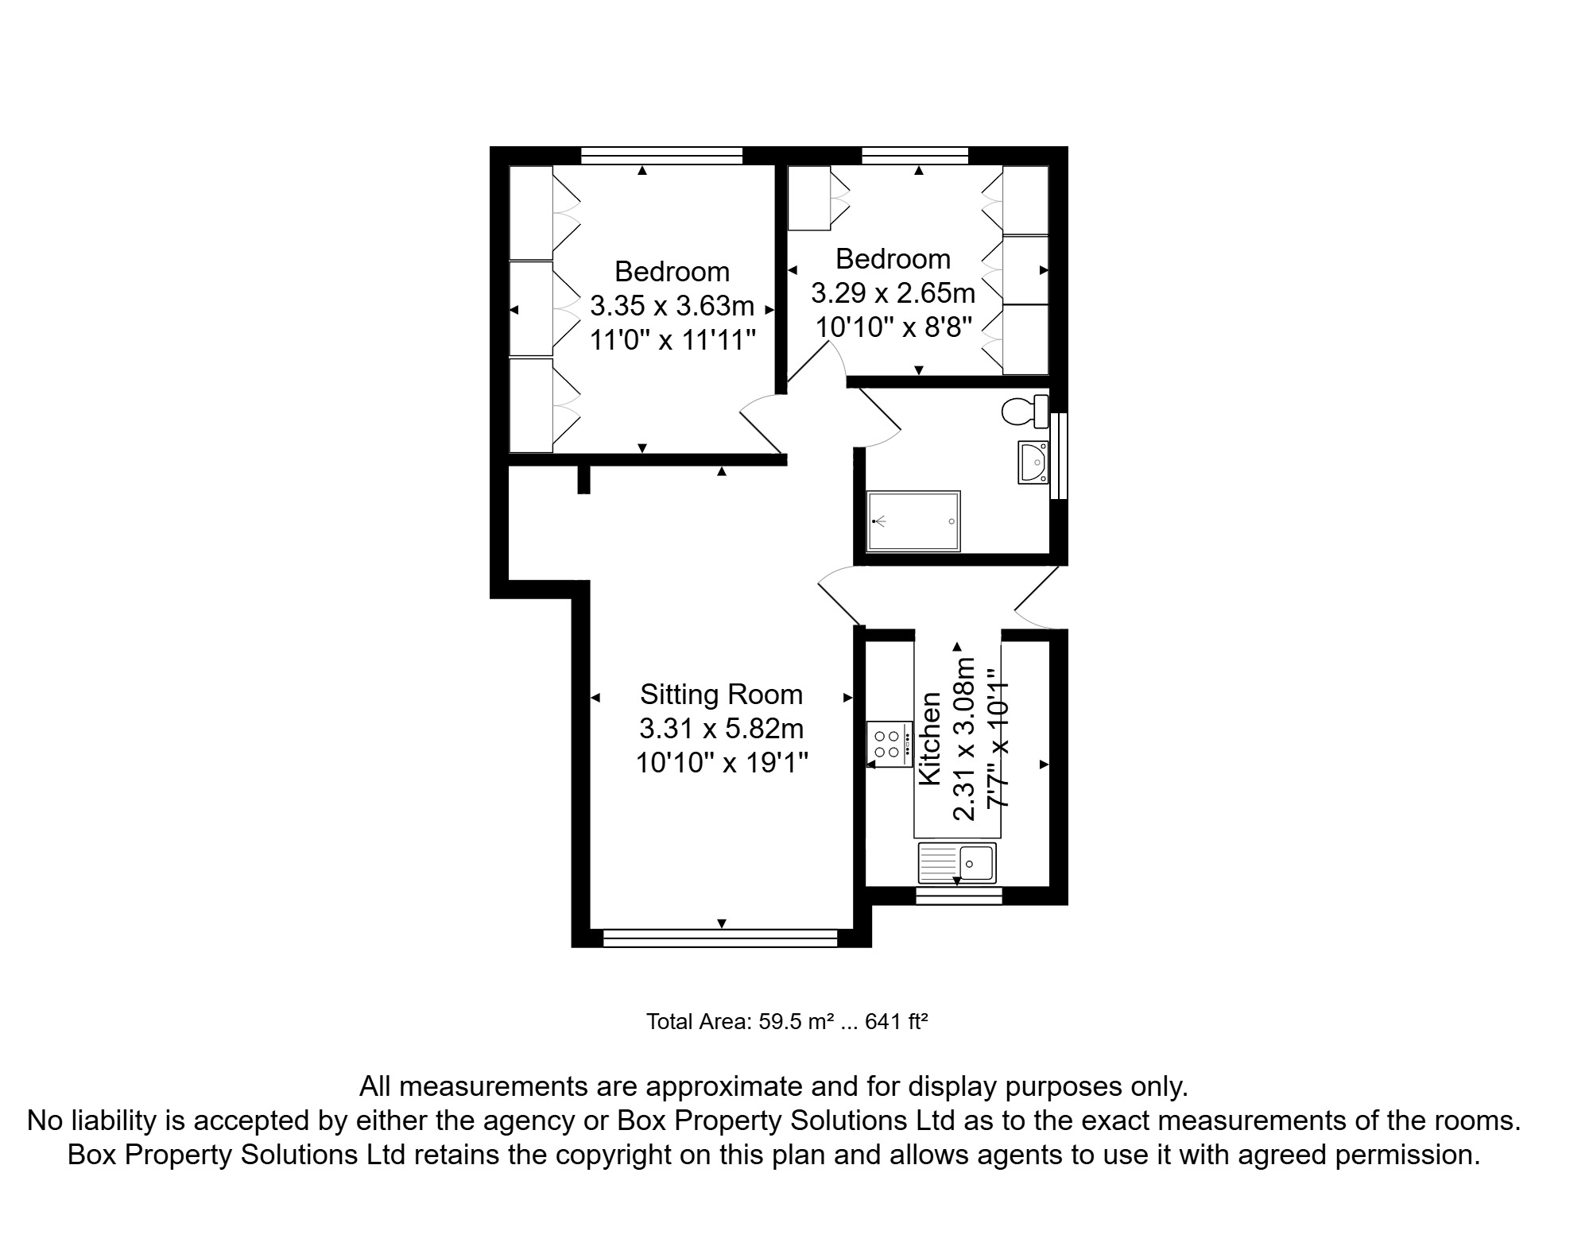

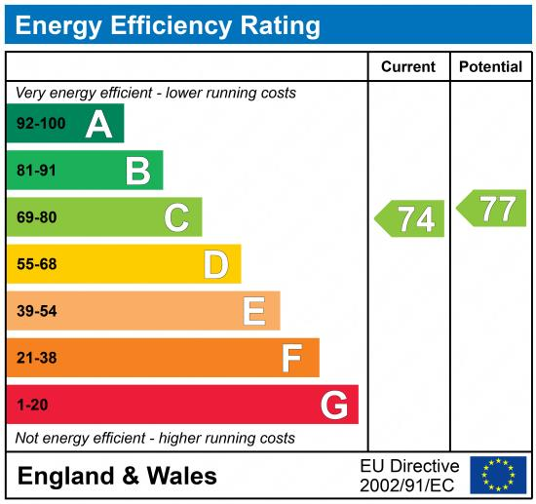

|  |
| --- |
|  |

These particulars are intended to give a fair description of the property, but their accuracy cannot be guaranteed, and they do not constitute an offer of contract. Intending purchasers must rely on their own inspection of the property. None of the above appliances/services have been tested by ourselves. We recommend purchasers arrange for a qualified person to check all appliances/services before legal commitment.

**Property Ref:** 5073

**For more information, please contact**

0113 258 1150 **|** [sales@adairpaxton.co.uk](mailto:sales@adairpaxton.co.uk) **|** www.adairpaxton.co.uk