

**0113 258 1150**

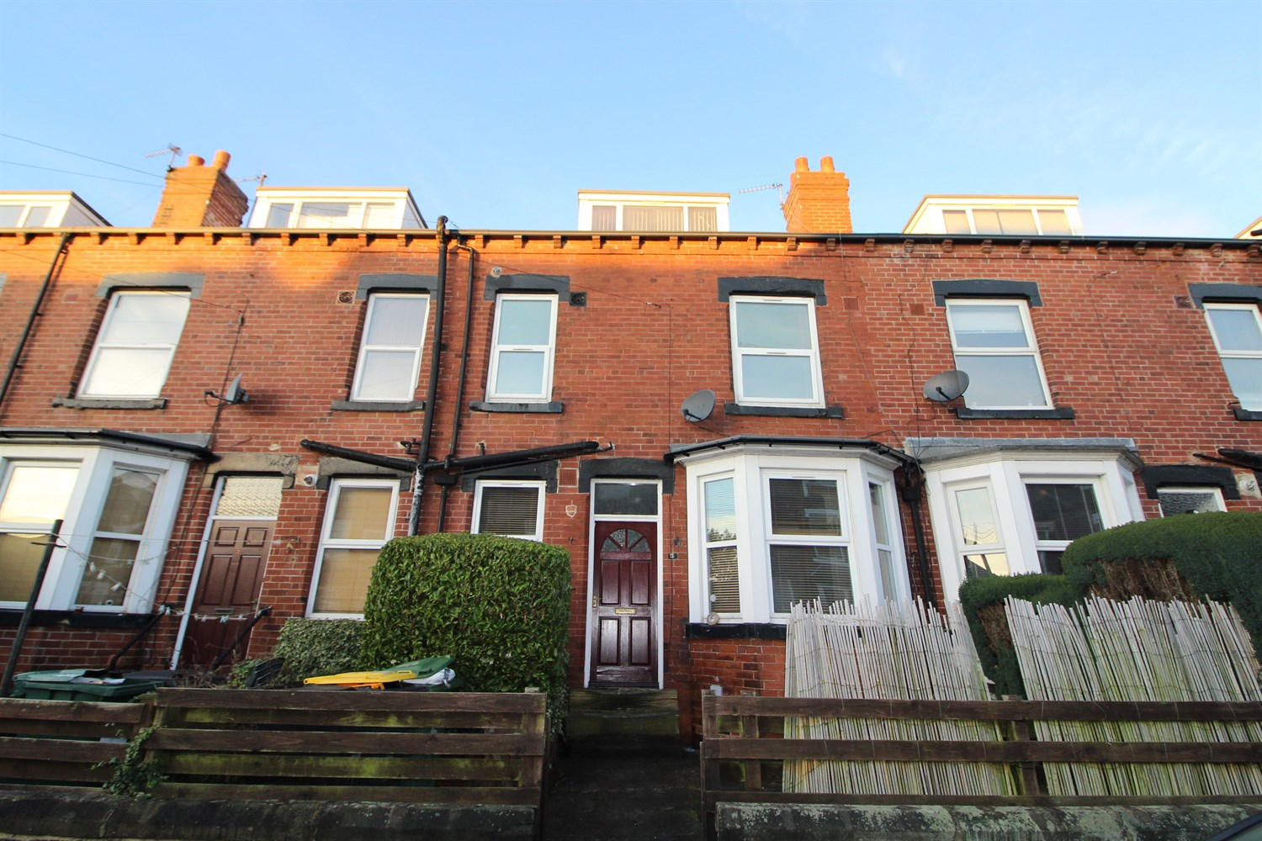



**Available to let £950.00pcm**

**Trelawn Place, Headingley, LS6**

***SPACIOUS TWO DOUBLE BEDROOM PROPERTY IN A FANTASTIC LOCATION*** Newly decorated and carpets, Spacious Mid back-to-back terrace in popular and highly convenient area. Well presented accommodation over three floors & having full gas c/h. Comp: Spacious Lounge, Kitchen, Basement, Double Bedroom & Bathroom to First Floor, Double Bedroom to Second Floor, Forecourt Garden.   
  
Unfurnished. Deposit £, EPC rating E Council tax band B. Available Now SORRY NO PETS.

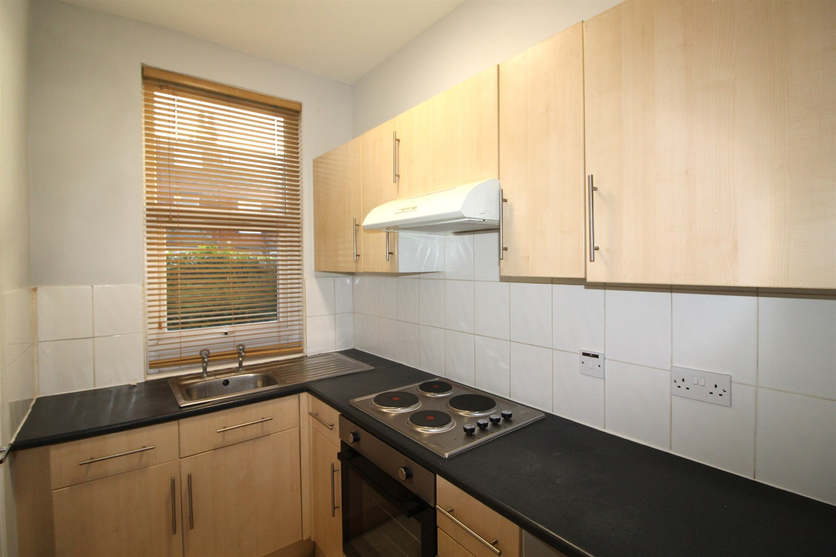

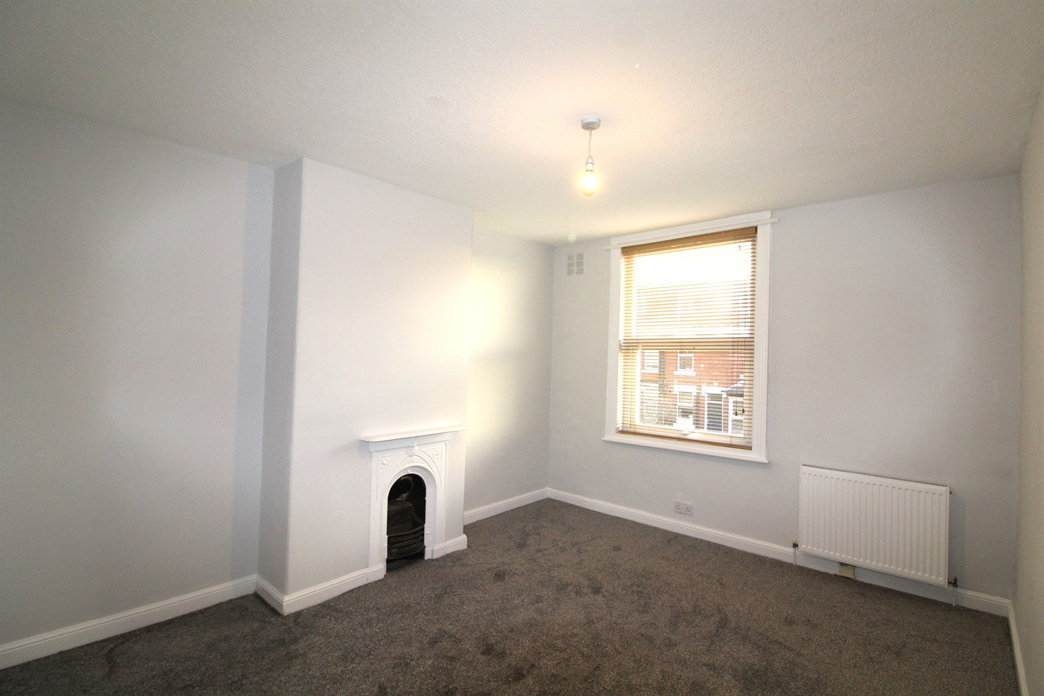

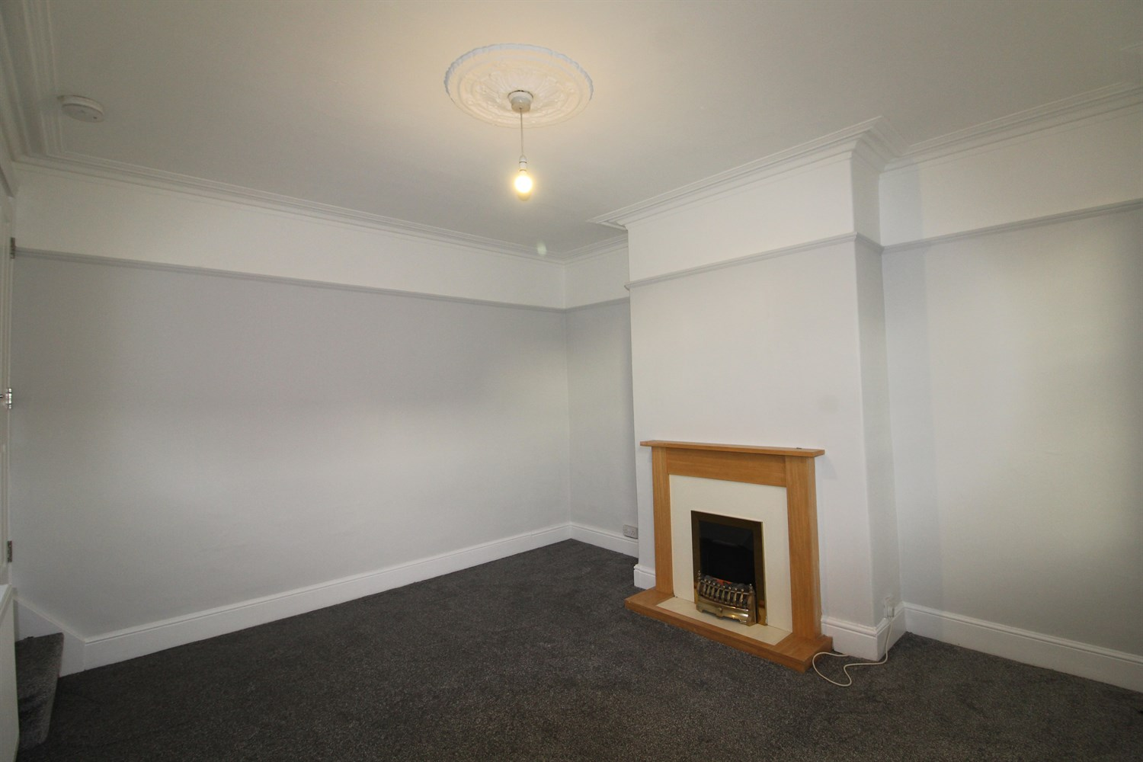

1 Bathroom(s)

1 Reception(s)

0 Bedroom(s)

00

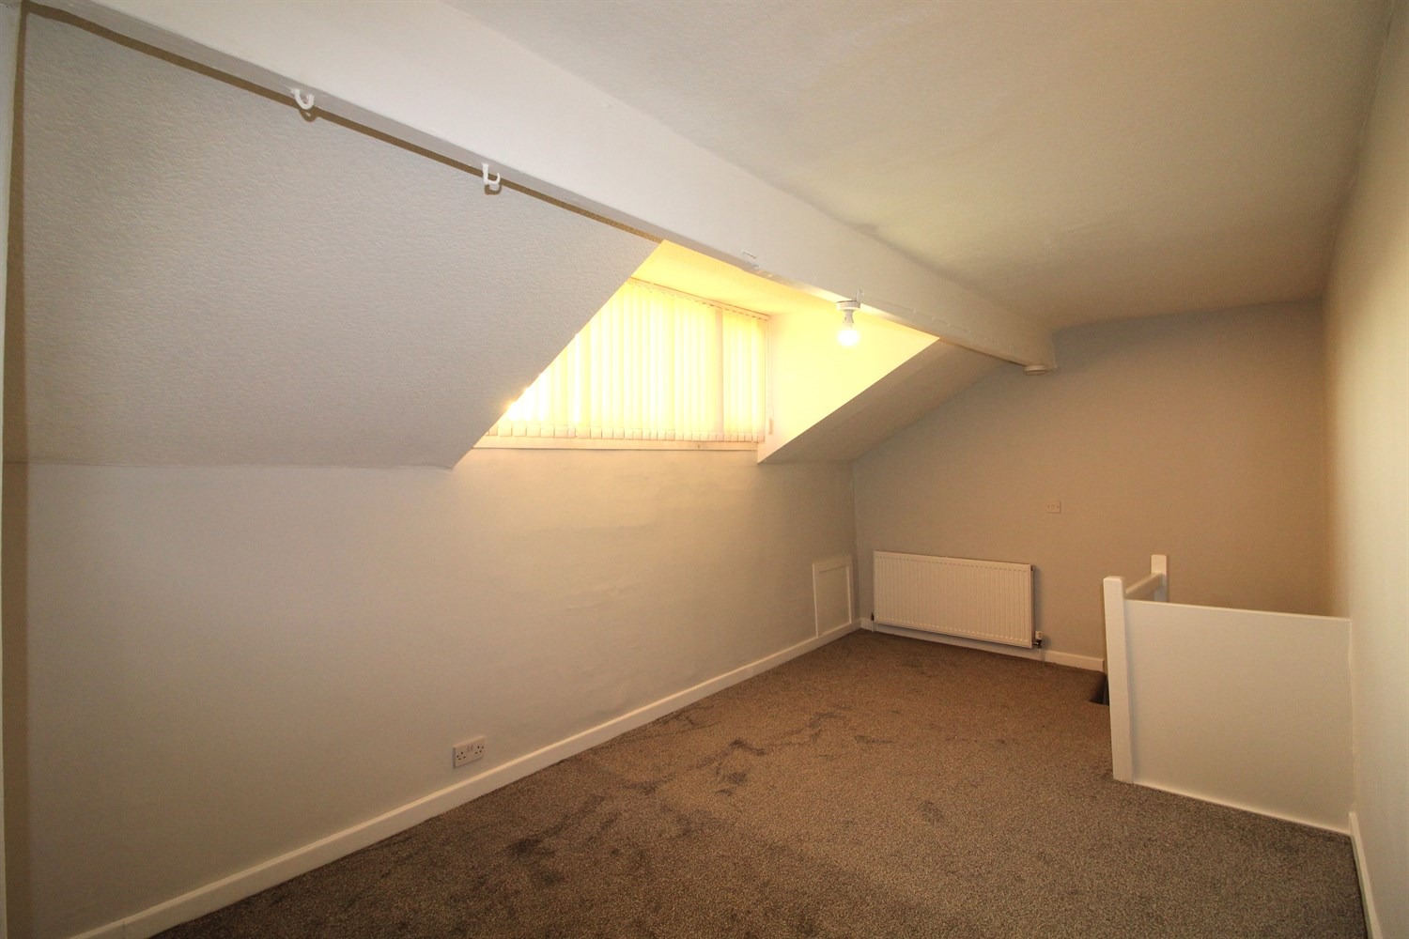

|  |
| --- |
| **Living Room**  Large living area with fire and surround, bay window, gas central heating radiator. |
| **Kitchen**  Fitted with a range of wall and base units with worktops over, stainless steel sink with taps and drainer, electric oven and hob with extractor over head. uPVC double-glazed window to front. |
| **Bedroom 1**  Large double bedroom with uPVC double glazed window to front. gas central heating radiator. |
| **Bedroom 2**  Large double bedroom with uPVC double glazed window. Gas central heating radiator. |
| **Bathroom**  Three piece bathroom suite with shower over head w/c and hand wash basin tiled walls. Towel radiator. |
| **Home Information**  COUNCIL TAX BAND: B EPC Rating D  Freehold property On street parking.  Broadband: Standard 16 Mbps 1 Mbps Good Superfast 80 Mbps 20 Mbps Good Ultrafast 1000 Mbps 1000 Mbps Mobile availability: EE limited coverage. Three limited coverage. O2 likely to have good coverage. Vodafone limited coverage.  Utilities: Water supplied on standard meters. Gas and Electric mains supplied on standard meters. |

|  |  |
| --- | --- |
| These particulars are intended to give a fair description of the property, but their accuracy cannot be guaranteed, and they do not constitute an offer of contract. Intending purchasers must rely on their own inspection of the property. None of the above appliances/services have been tested by ourselves. We recommend purchasers arrange for a qualified person to check all appliances/services before legal commitment.  **Property Ref:** 4851  **For more information, please contact**  0113 258 1150 **|** [lettings@adairpaxton.co.uk](mailto:lettings@adairpaxton.co.uk) **|** www.adairpaxton.co.uk |  |