

**0113 258 1150**

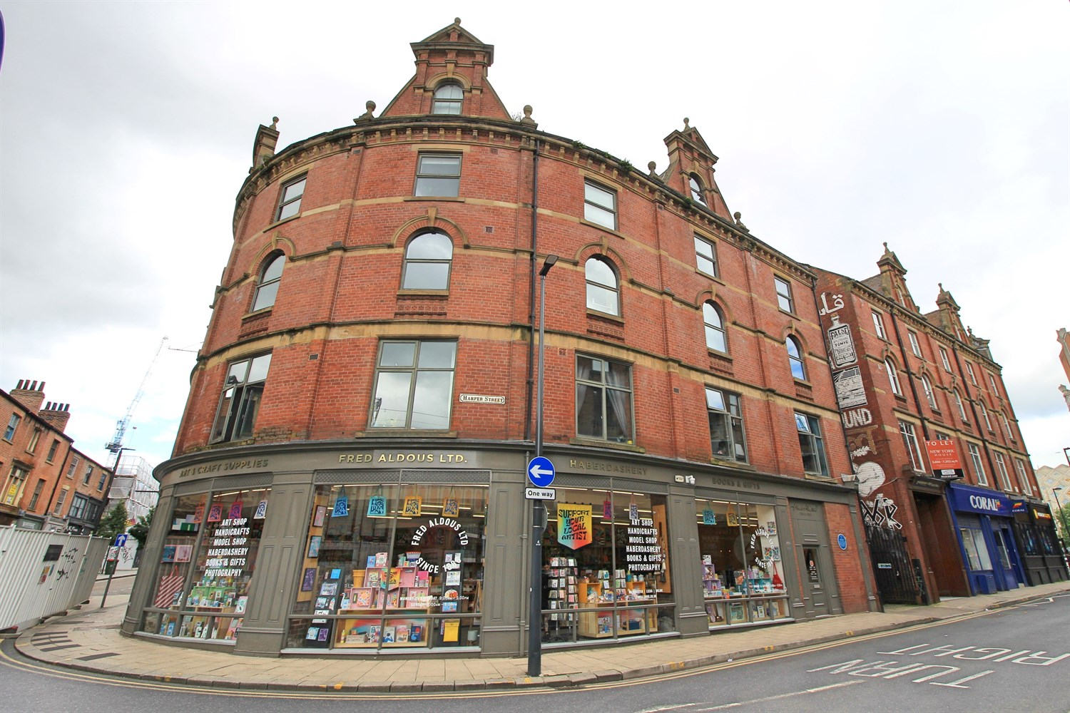



**For Sale £170,000.00**

**Dewhirst Buildings, Kirkgate**

***STUNNING ONE BEDROOM DUPLEX APARTMENT*** This delightful conversion enjoys a rare loft style feel and boasts character and charm. The exposed brickwork and beams create an impressive setting for this city centre apartment. This large one bedroom property briefly comprises: entrance hall, spacious sitting room/kitchen with exposed brick wall and bathroom to the first floor. To the first floor there is a spacious double bedroom with exposed beams and windows to both sides. Located on Leeds' retail doorstep, this conversion is a stones throw from Victoria Gate, Victoria and Queens Arcades, and many more amenities that Leeds has to offer. Ideal for access to local transport links, Leeds City Bus Station and Leeds Train Station, and the motorway networks. Early internal viewing is highly recommended.

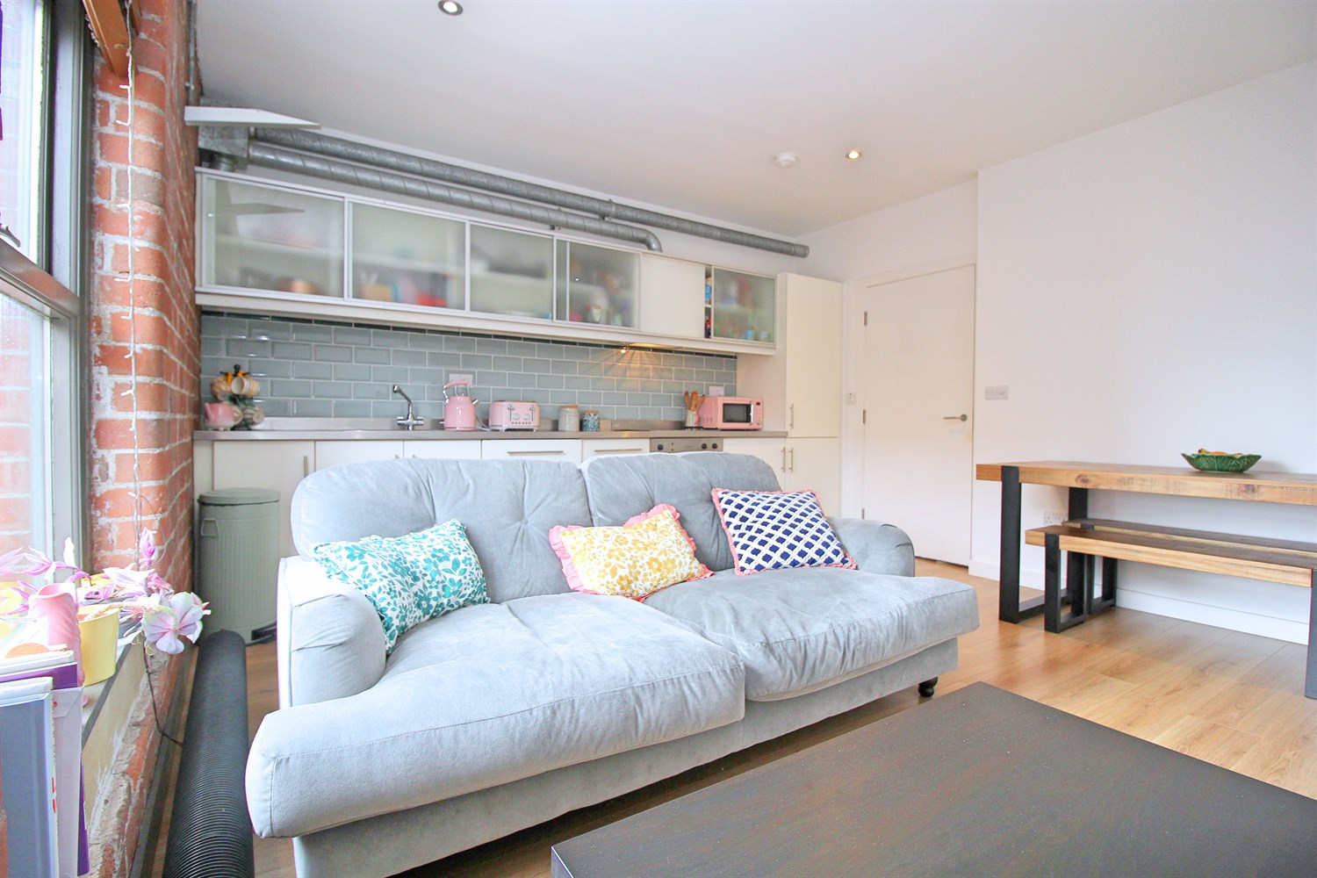

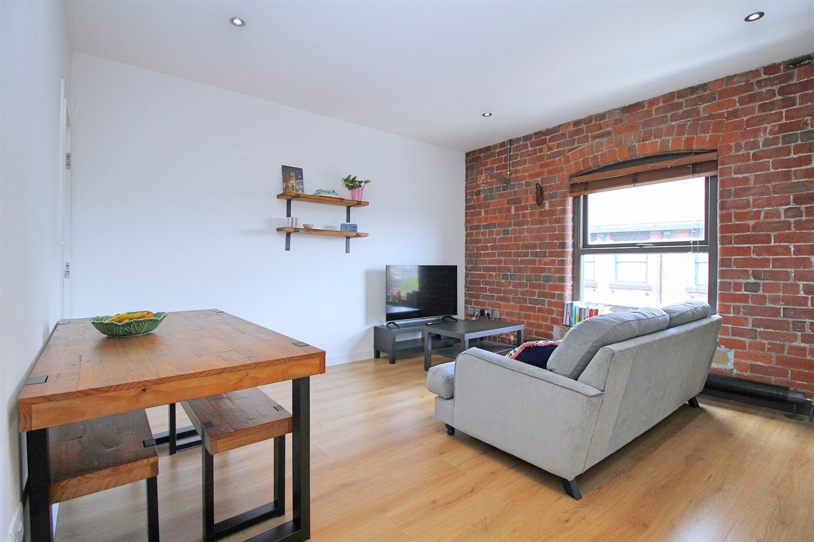

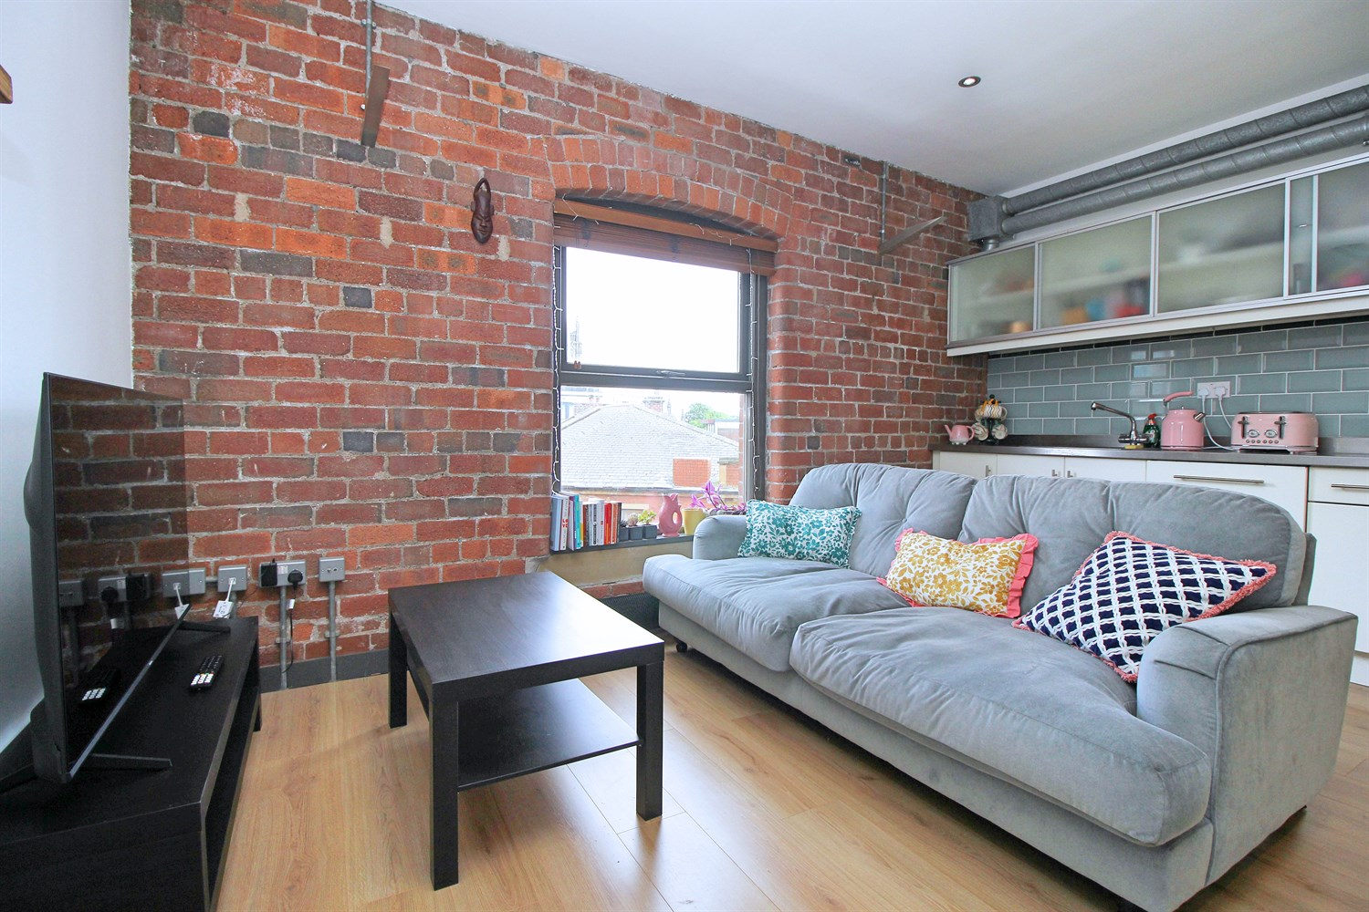

1 Bathroom(s)

1 Reception(s)

1 Bedroom(s)

00

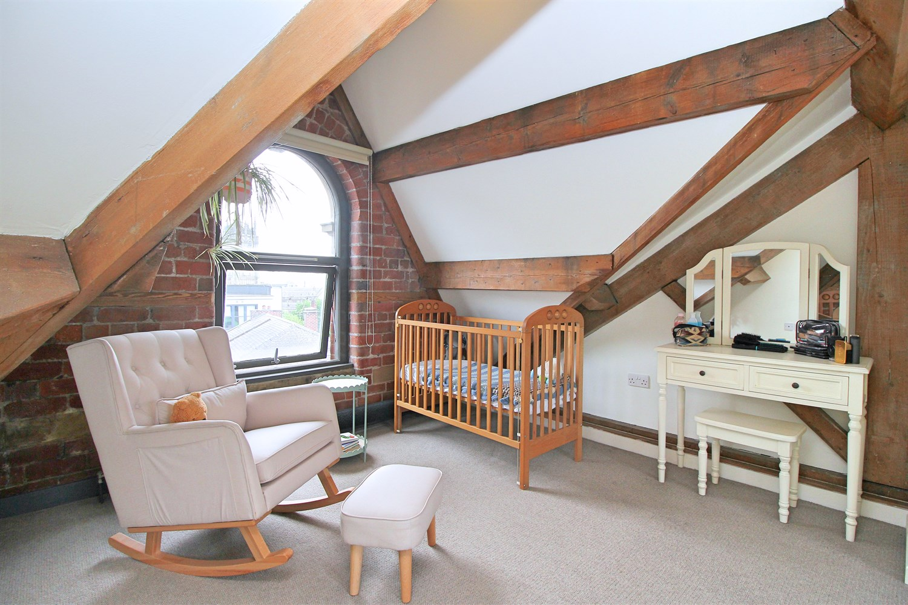

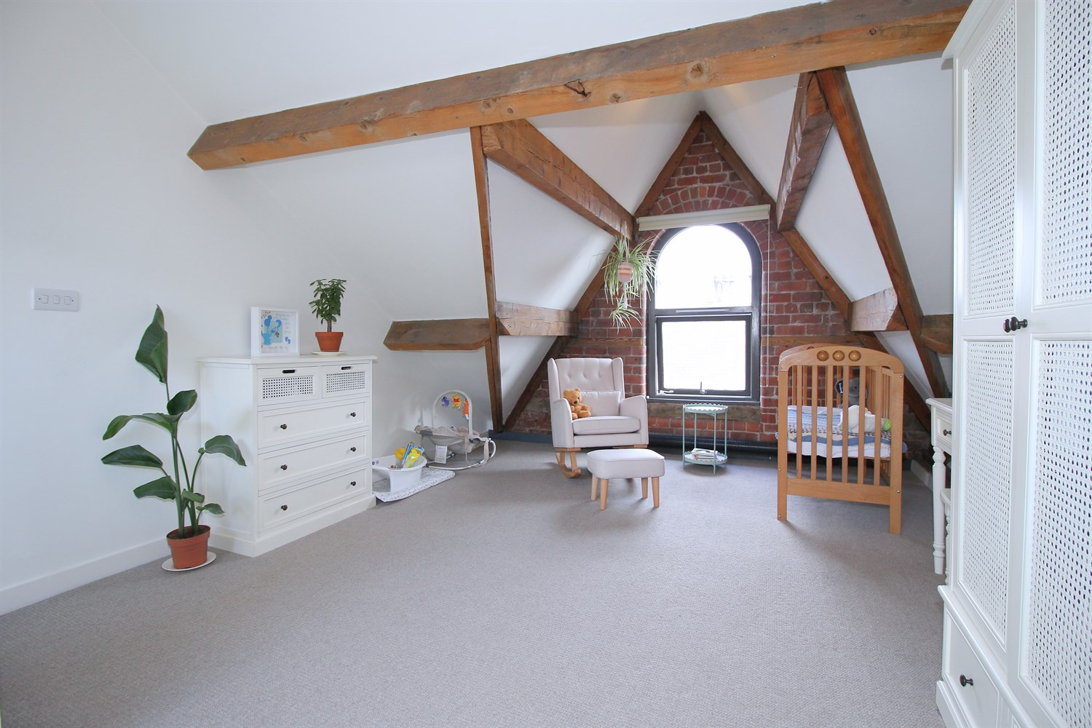

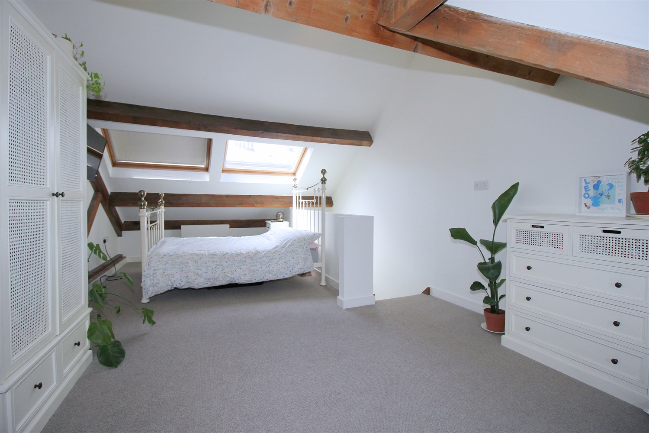

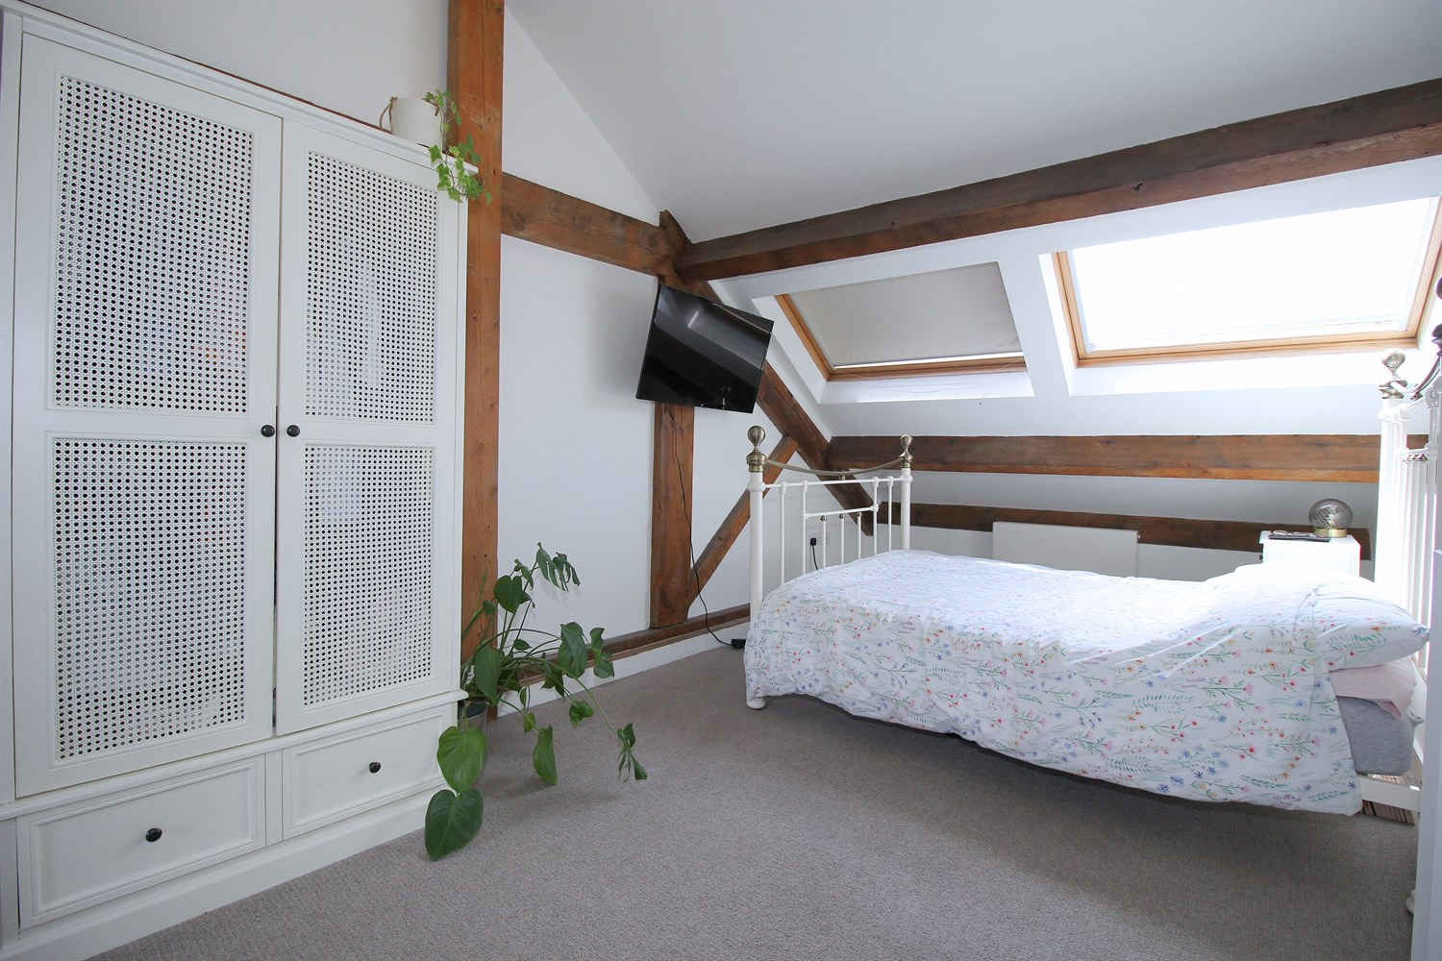

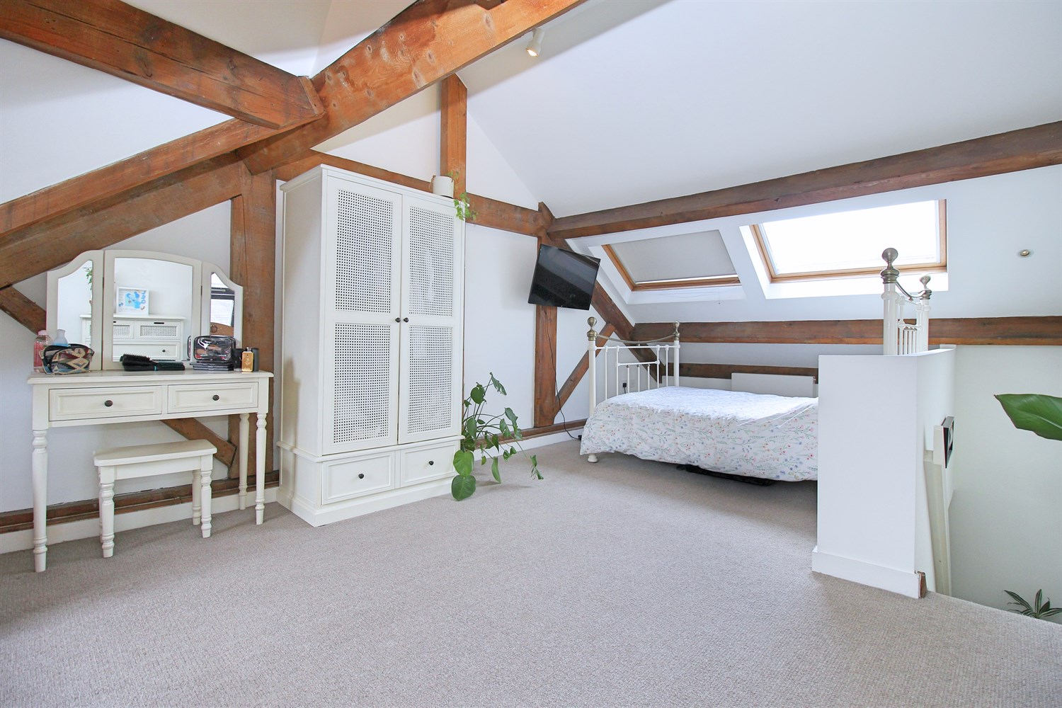

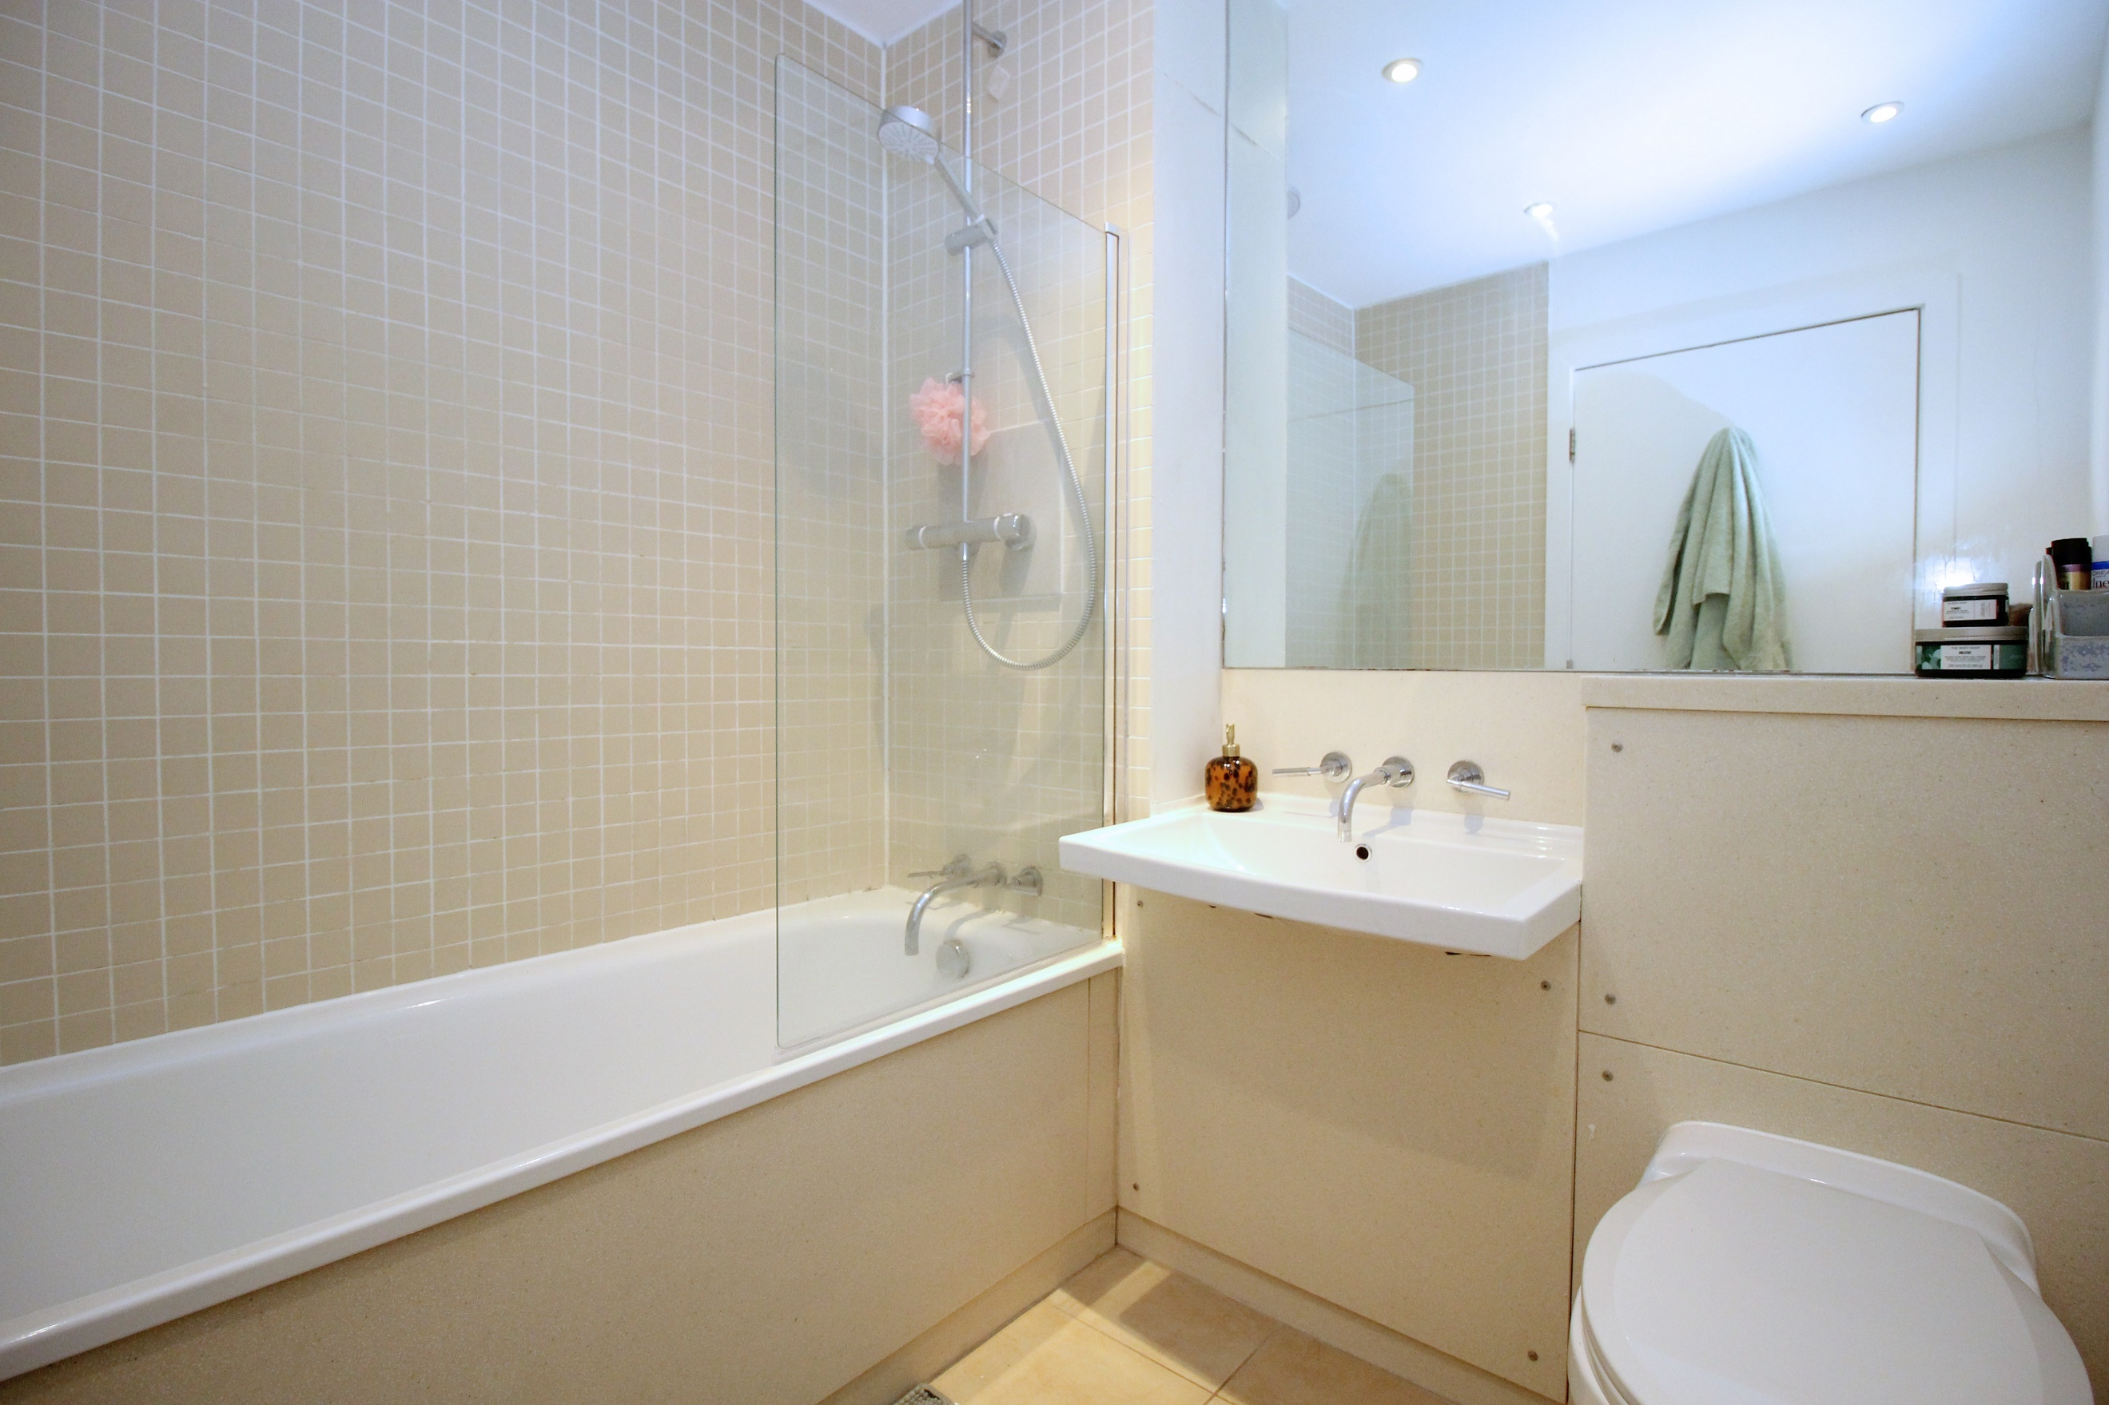

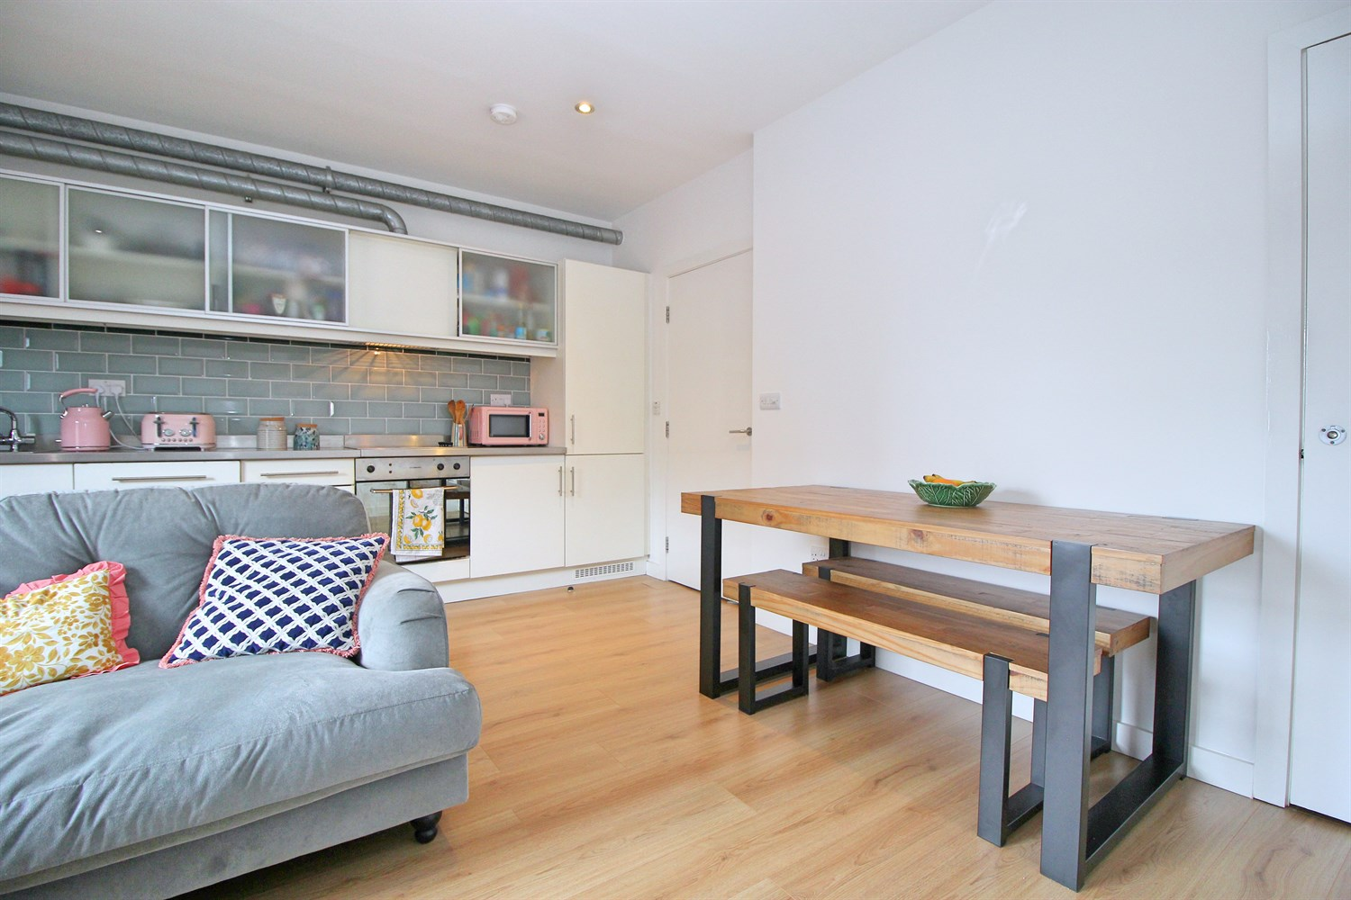

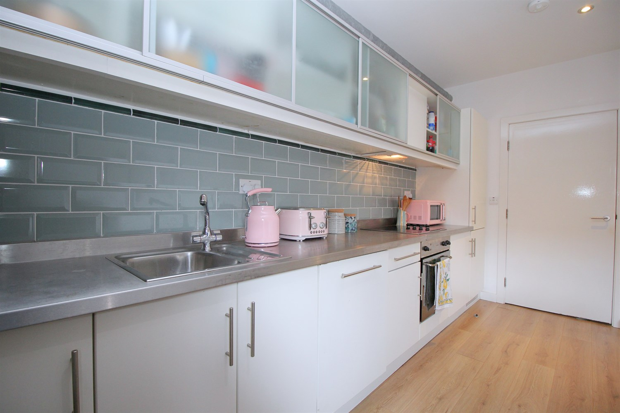

|  |
| --- |
| **Communal Entrance**  Stairs and lift to all floors. Secure entry phone system. |
| **Private Entrance Hall**  Stairs to first floor. Storage cupboard plumbed for washing machine. Entry phone system. |
| **Open Plan Living Room/Kitchen**  Light and Airy living area with exposed brick wall and large window. Storage cupboard. Inset ceiling spotlights. The kitchen is fitted with a range of wall, base and drawer units with worktops over. Integrated fridge/freezer and dishwasher. Integrated oven with 4-ring hob and extractor. Stainless steel sink with mixer tap. tiled wall. |
|  |
| **Bathroom**  Fitted with a three piece white suite comprising; bath with shower over, WC and wash hand basin. Tiled walls. Inset ceiling spotlights. |
| **Bedroom 1**  Spacious double bedroom with exposed beams. Window to front and two Velux windows to the rear. |
| **Tenure**  Leasehold - 125 years from 2002 Ground Rent - £150 per annum |
|  |
| **Service Charge**  The service charge is £178 a month or £534 a quarter. |

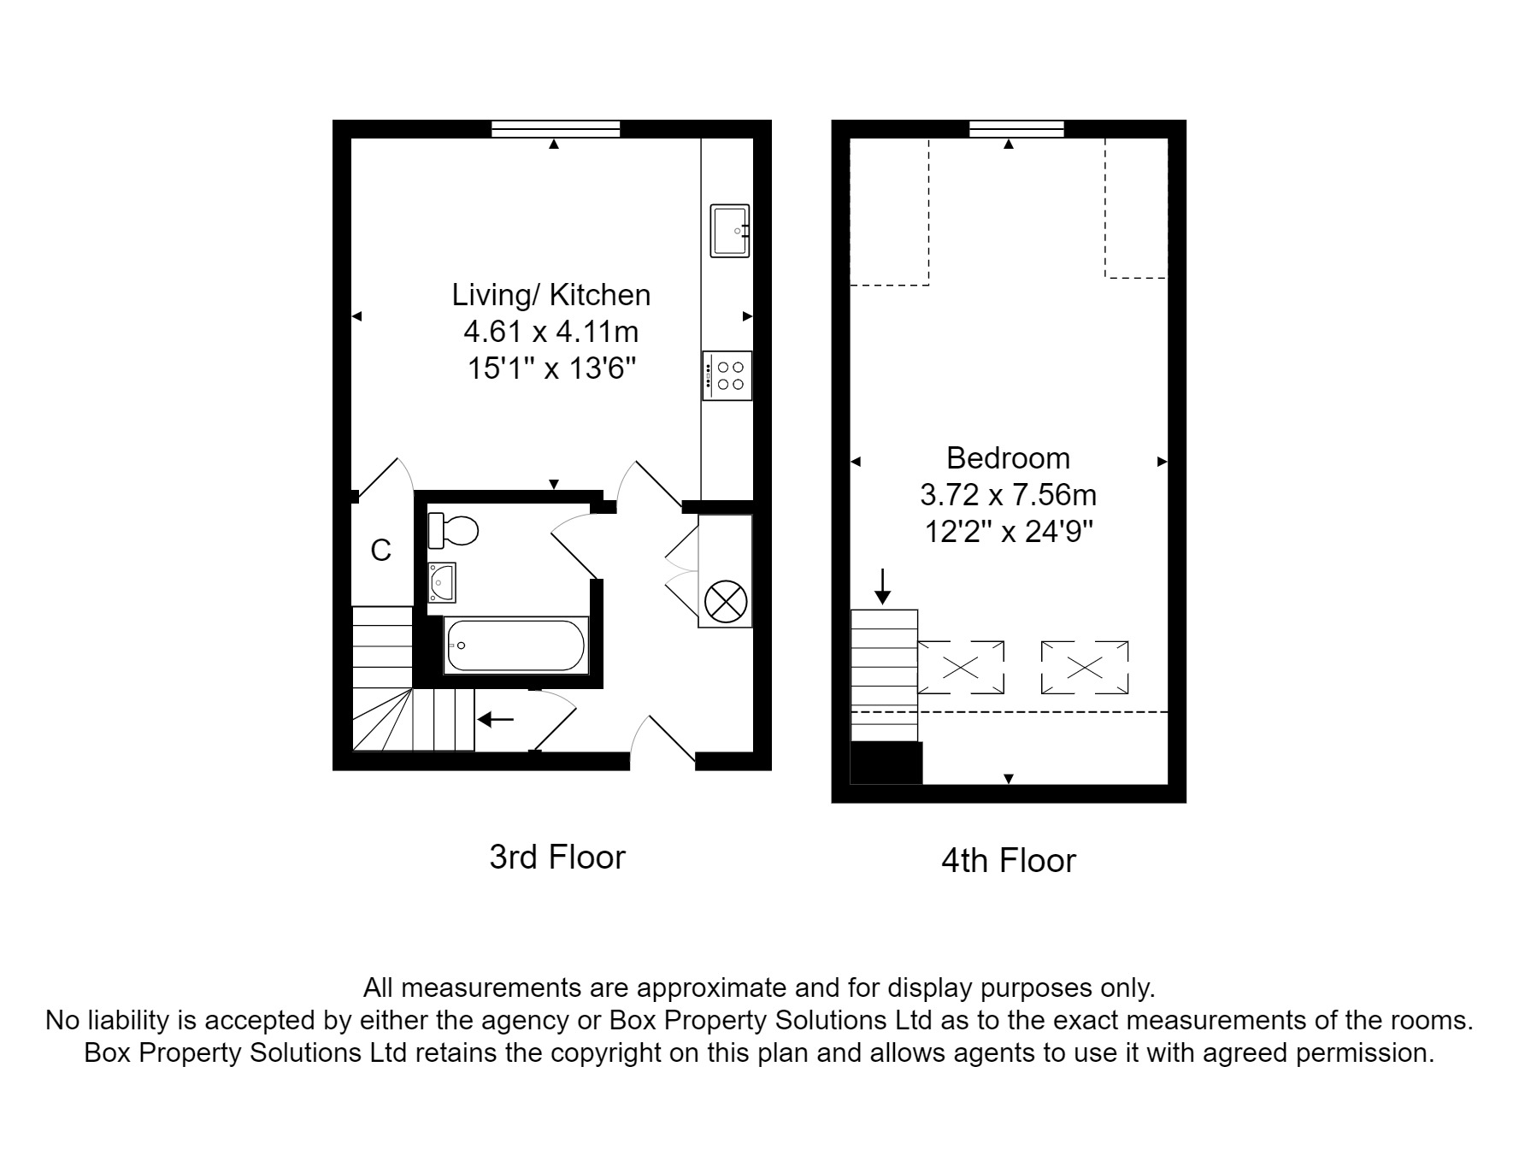

|  |  |
| --- | --- |
| These particulars are intended to give a fair description of the property, but their accuracy cannot be guaranteed, and they do not constitute an offer of contract. Intending purchasers must rely on their own inspection of the property. None of the above appliances/services have been tested by ourselves. We recommend purchasers arrange for a qualified person to check all appliances/services before legal commitment.  **Property Ref:** 2277  **For more information, please contact**  0113 258 1150 **|** [sales@adairpaxton.co.uk](mailto:sales@adairpaxton.co.uk) **|** www.adairpaxton.co.uk |  |