

**0113 258 1150**

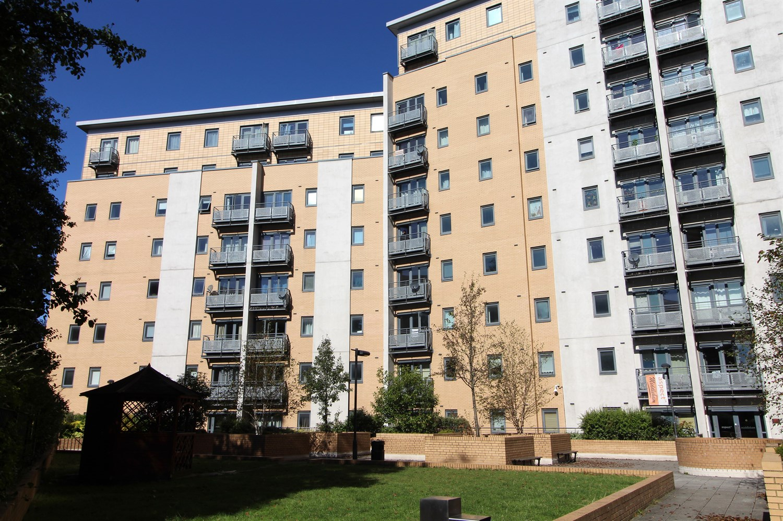



**Available to let £950.00pcm**

**250 Aspect 14, Leeds**

Newly decorated spacious two bedroom apartment in this popular development, located close to Leeds Universities, hospitals and shopping district.  
This unfurnished property is available immediately , with accommodation briefly comprising open plan living kitchen, two double bedrooms and two bathrooms. Benefitting from a balcony with city views. Sorry, no pets. Deposit £1095, Council tax band C. EPC rating B.

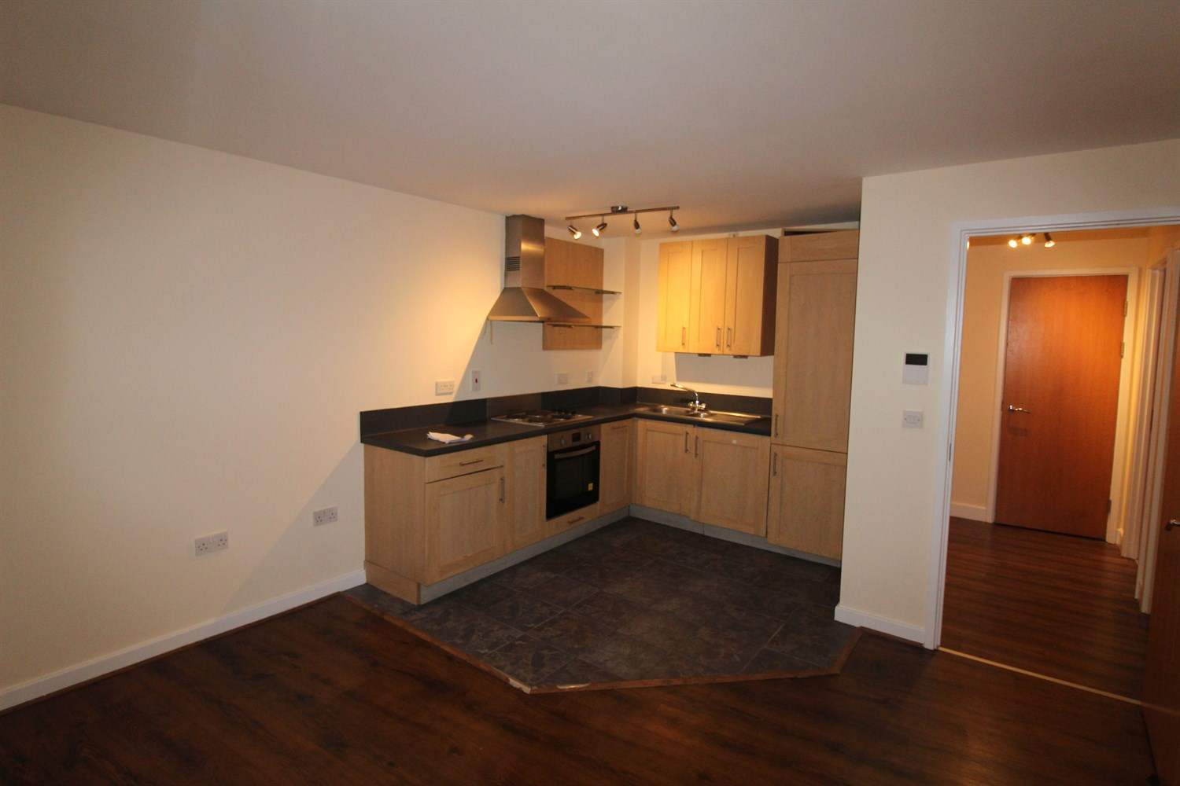

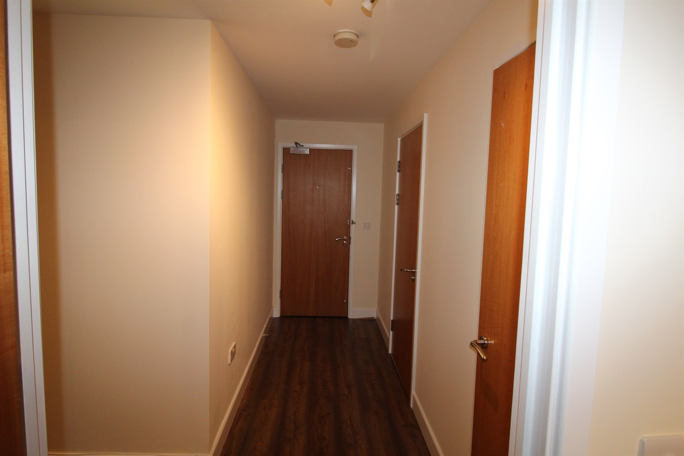

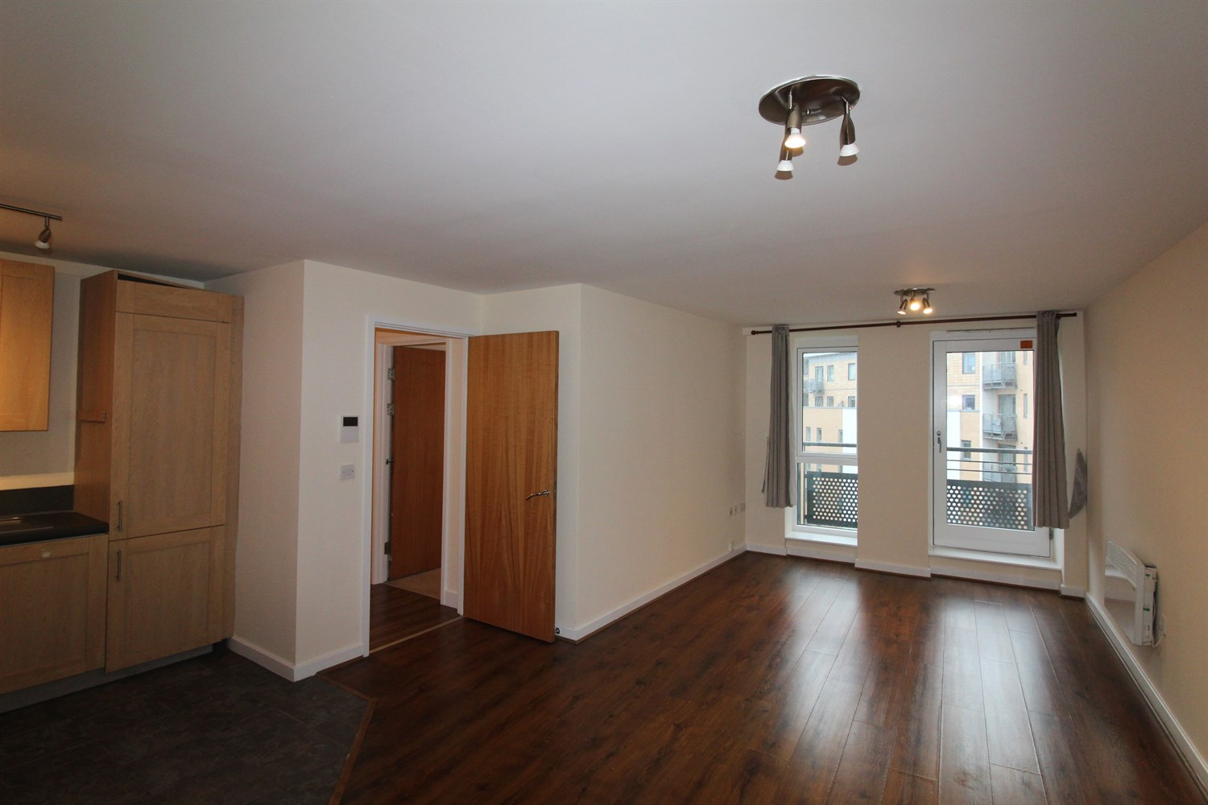

2 Bathroom(s)

1 Reception(s)

2 Bedroom(s)

00

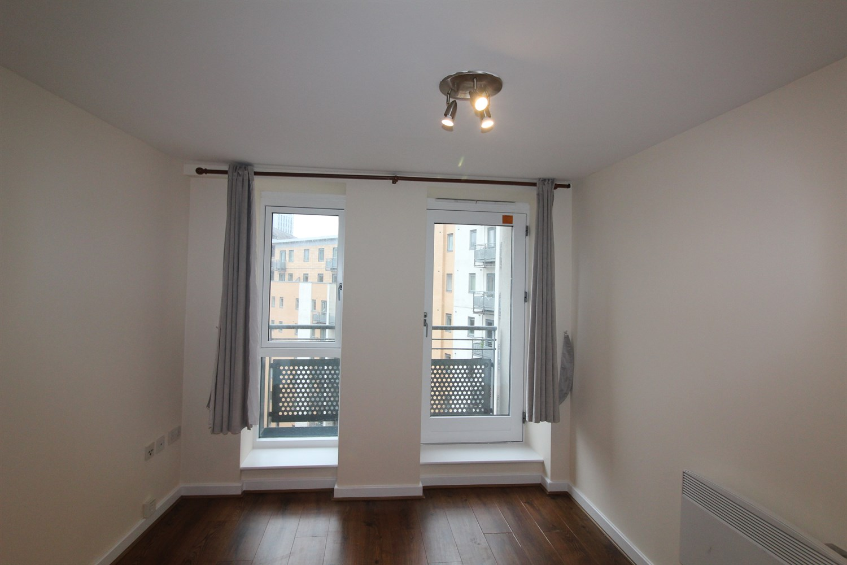

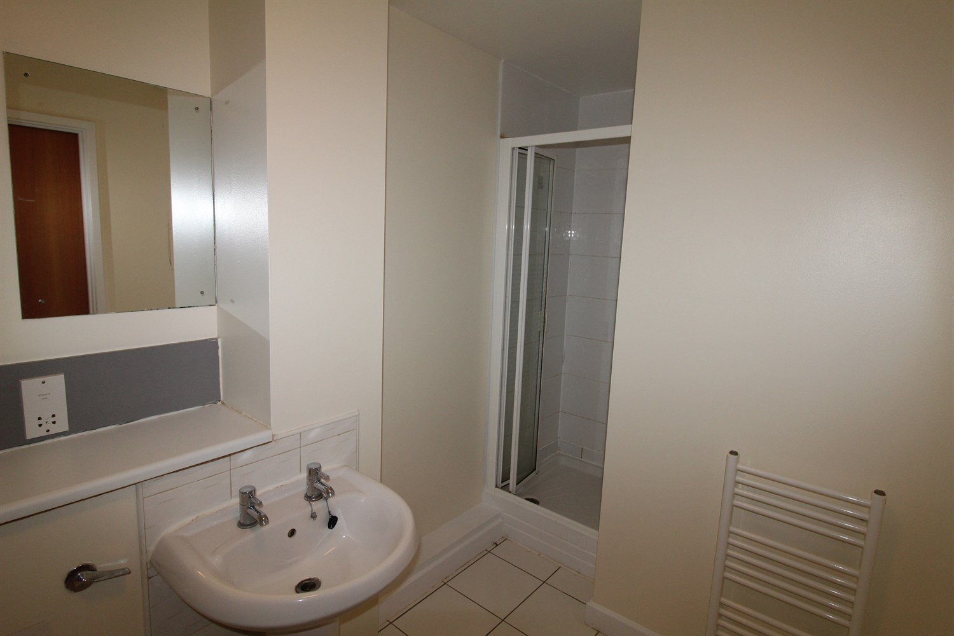

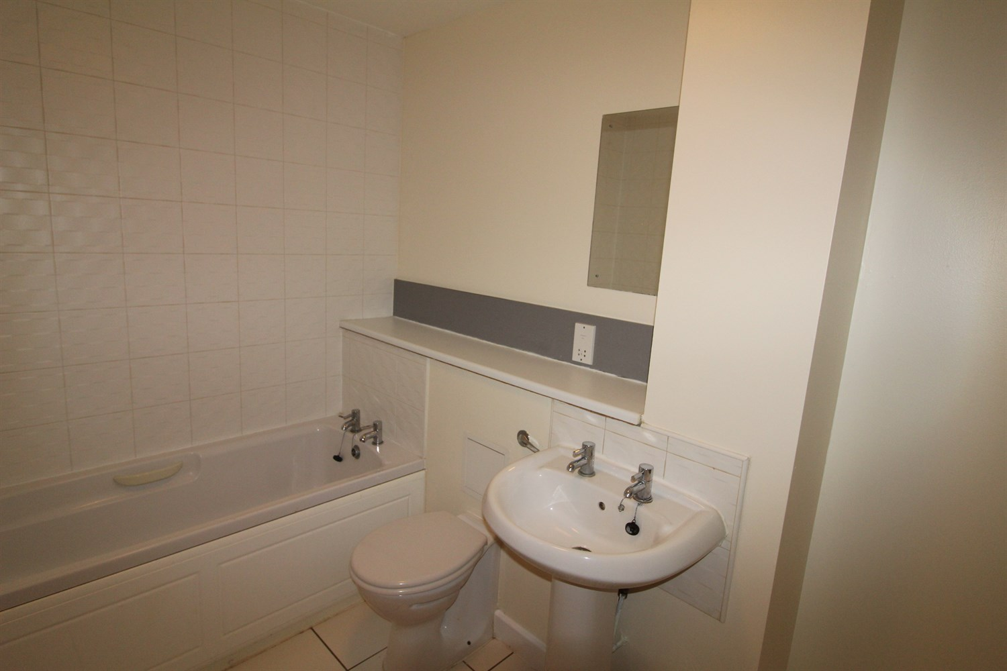

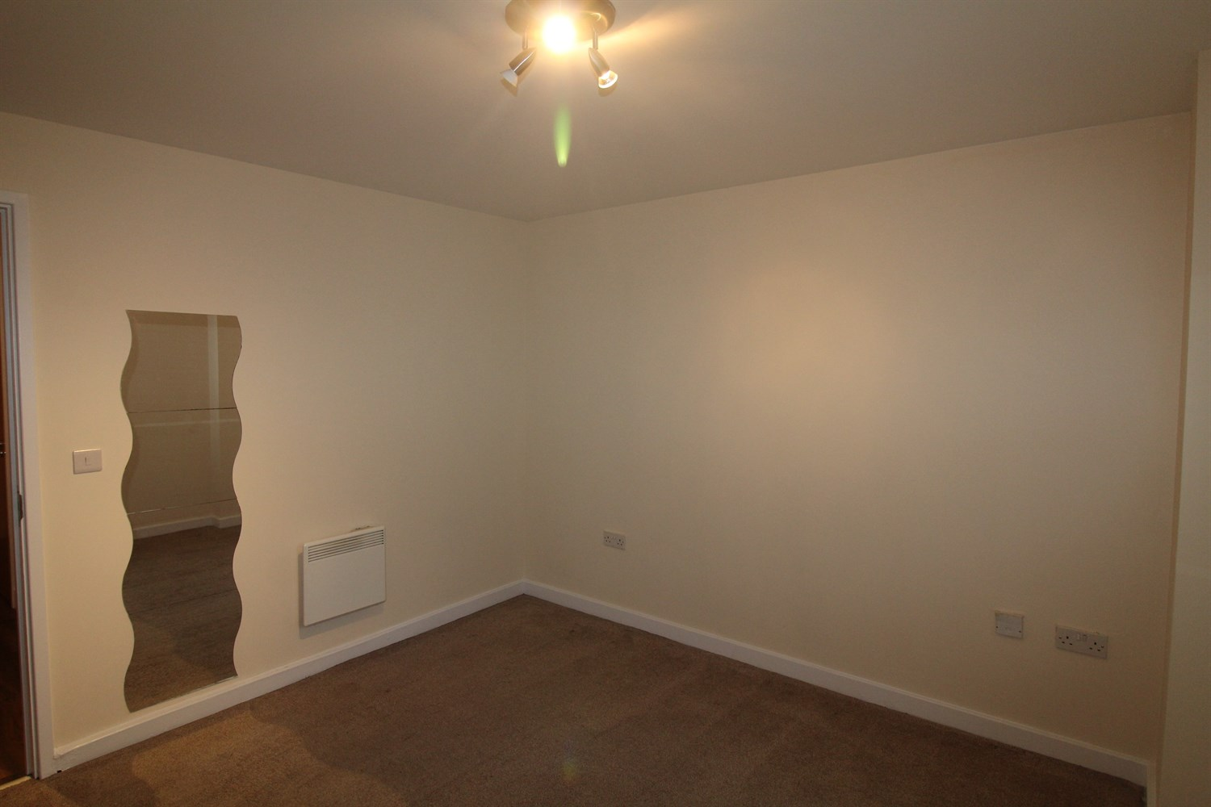

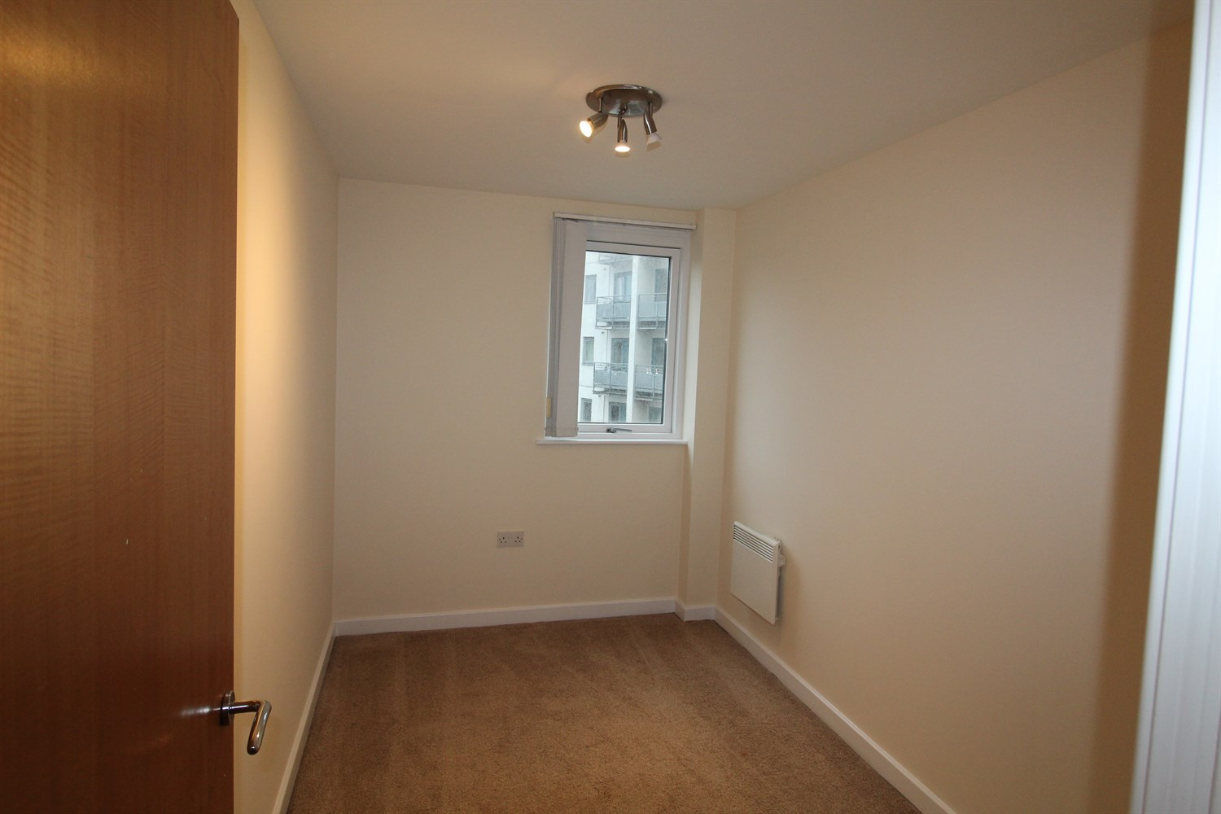

|  |
| --- |
| **Communal Entrance**  Secure entrance with post boxes, video entrance phone and access to all floors via lift and stairs |
| **Hallway**  With laminate flooring, video entrance phone, storage cupboard |
| **Open Plan Kitchen and Living Room**  Open plan living area with access to balcony. Kitchen area having a range of wall, base and drawer units with worktops over. integrated oven, hob and extractor, single drainer stainless steel sink unit with mixer tap, washing machine, fridge freezer and dishwasher. Electric radiator. |
| **Bedroom 1**  Double bedroom with double glazed window. Electric radiator. |
| **En Suite**  En-suite shower room with shower cubicle, low flush w.c and basin. Heated towel rail. |
| **Bedroom 2**  Second bedroom with double glazed window. Electric radiator. |
| **House Bathroom**  A white bathroom suite comprising bath, low flush WC and basin. Heated towel rail. |
| **Home Information**  COUNCIL TAX BAND: C EPC Rating: B  Leasehold property No Parking   Broadband: Standard 16 Mbps 1 Mbps Good Superfast 80 Mbps 20 Mbps Good Ultrafast 1000 Mbps 1000 Mbps Mobile availability: EE likely to have good coverage. Three likely to have good coverage. O2 likely to have good coverage. Vodafone likely to have good coverage.  Utilities: Water supplied on standard meters. Electric mains supplied on standard meters. |

|  |  |
| --- | --- |
| These particulars are intended to give a fair description of the property, but their accuracy cannot be guaranteed, and they do not constitute an offer of contract. Intending purchasers must rely on their own inspection of the property. None of the above appliances/services have been tested by ourselves. We recommend purchasers arrange for a qualified person to check all appliances/services before legal commitment.  **Property Ref:** 4620  **For more information, please contact**  0113 258 1150 **|** [lettings@adairpaxton.co.uk](mailto:lettings@adairpaxton.co.uk) **|** www.adairpaxton.co.uk |  |