

**0113 258 1150**

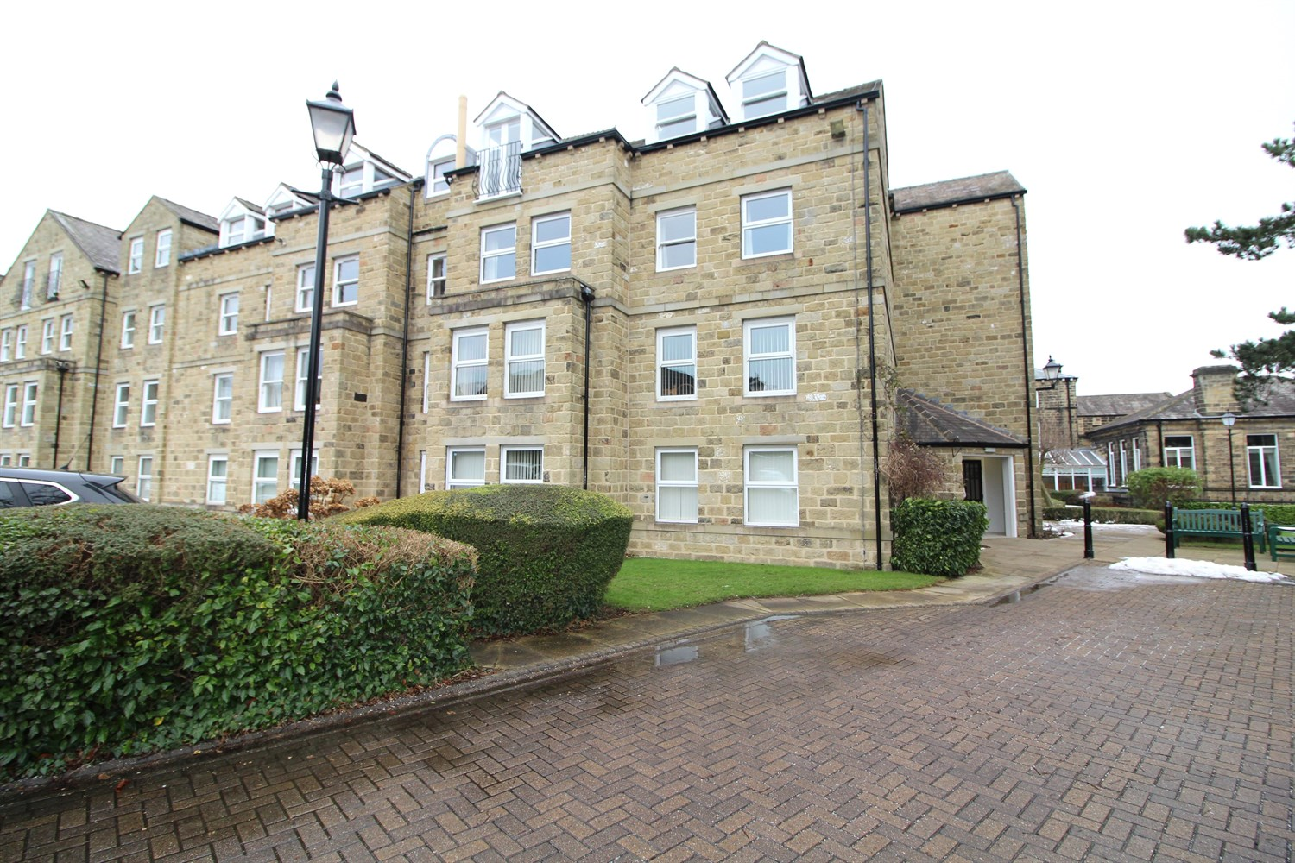



**Available to let £895.00pcm**

**Lister Court, Ilkley**

***A BEAUTIFULLY PRESENTED TWO BEDROOMED RETIREMENT APARTMENT*** Situated on the ground floor of this highly regarded development with access to excellent residents facilities and located with a brief walk of the The Grove. This charming apartment provides easily maintained two bedroomed accommodation within a purpose built development for the over 55s. The accommodation comprises a private entrance hall, sitting room with southerly aspect, smartly presented kitchen, two bedrooms and bath room. Residents have access to a car park, lounge, laundry and smartly maintained communal grounds. Available 14th February 2025. EPC rating C, council tax band

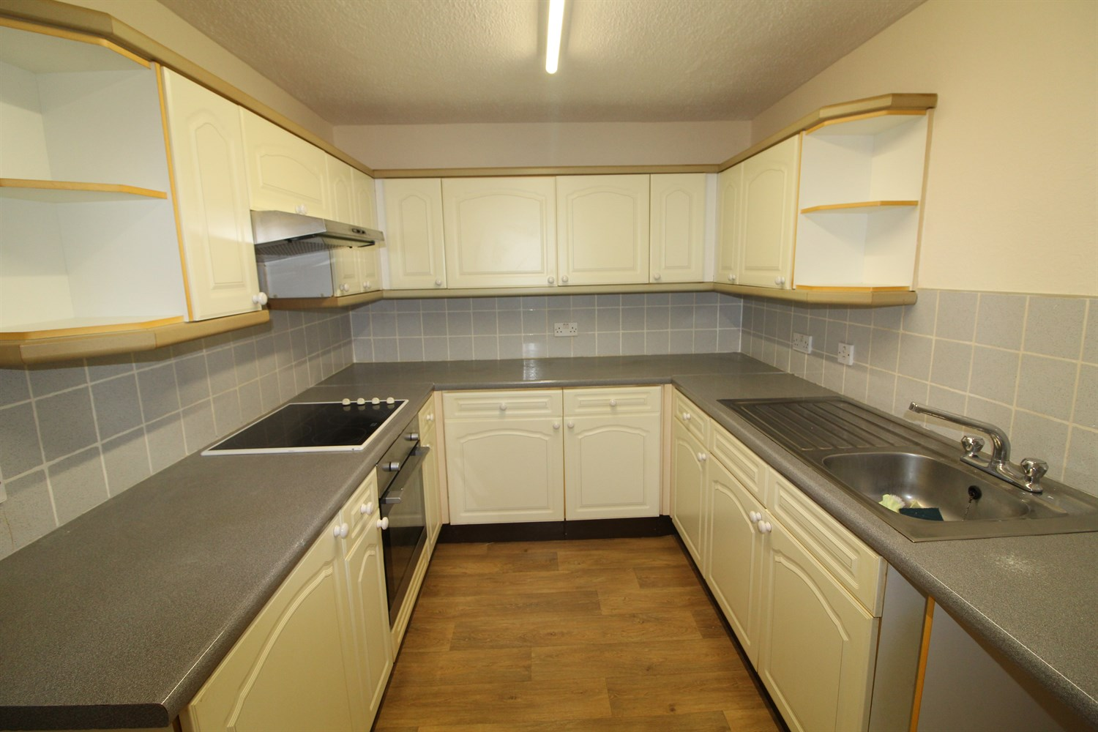

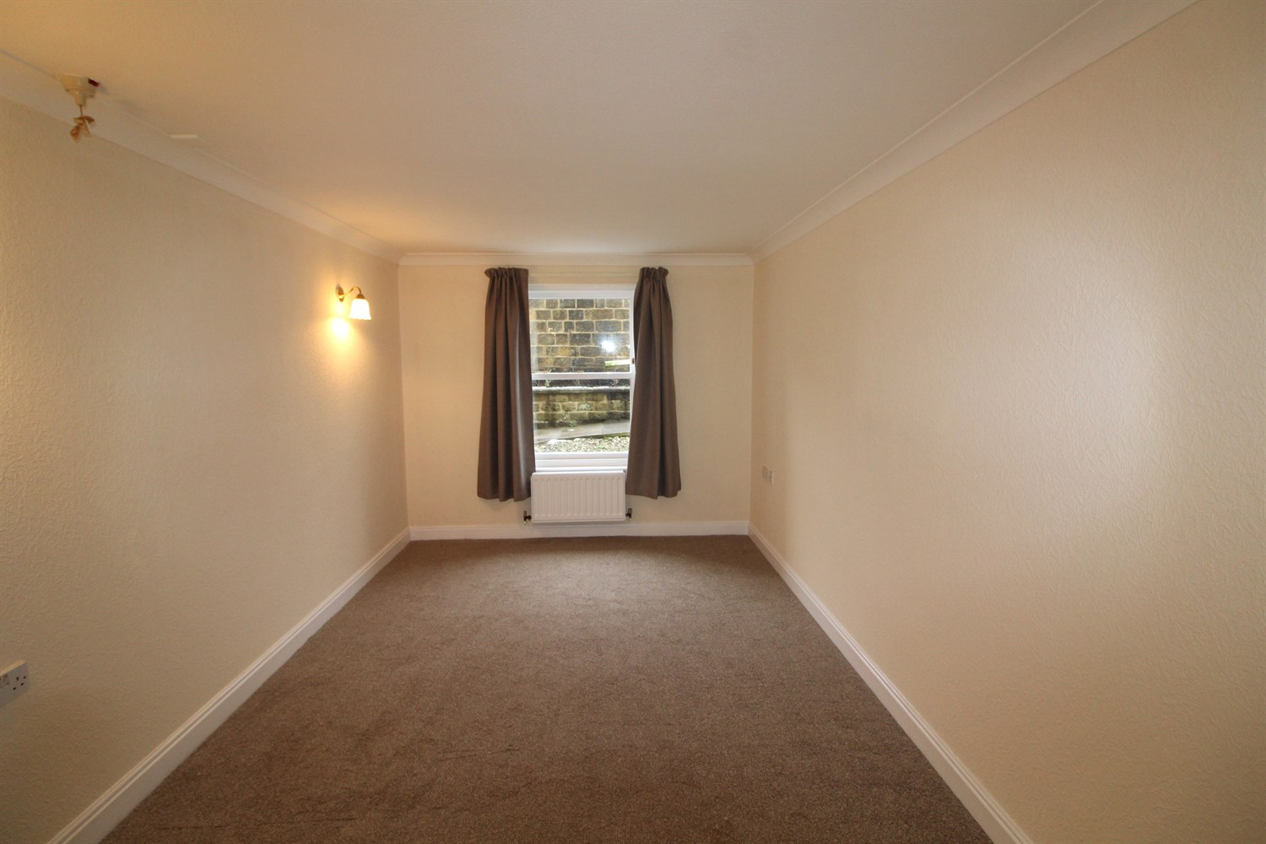

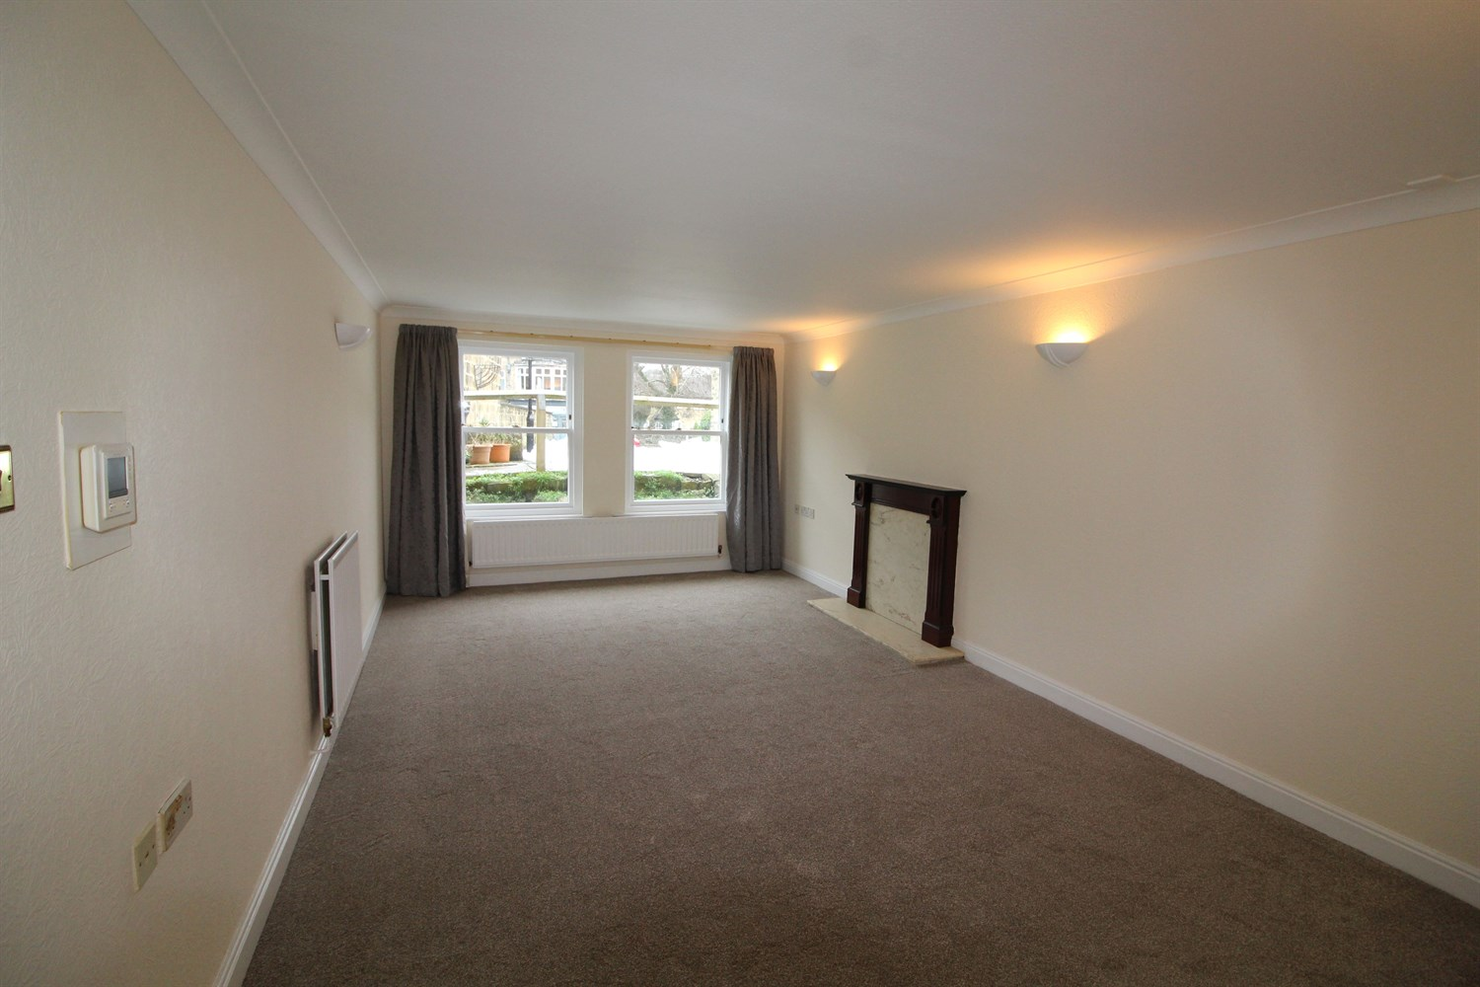

1 Bathroom(s)

2 Reception(s)

2 Bedroom(s)

00

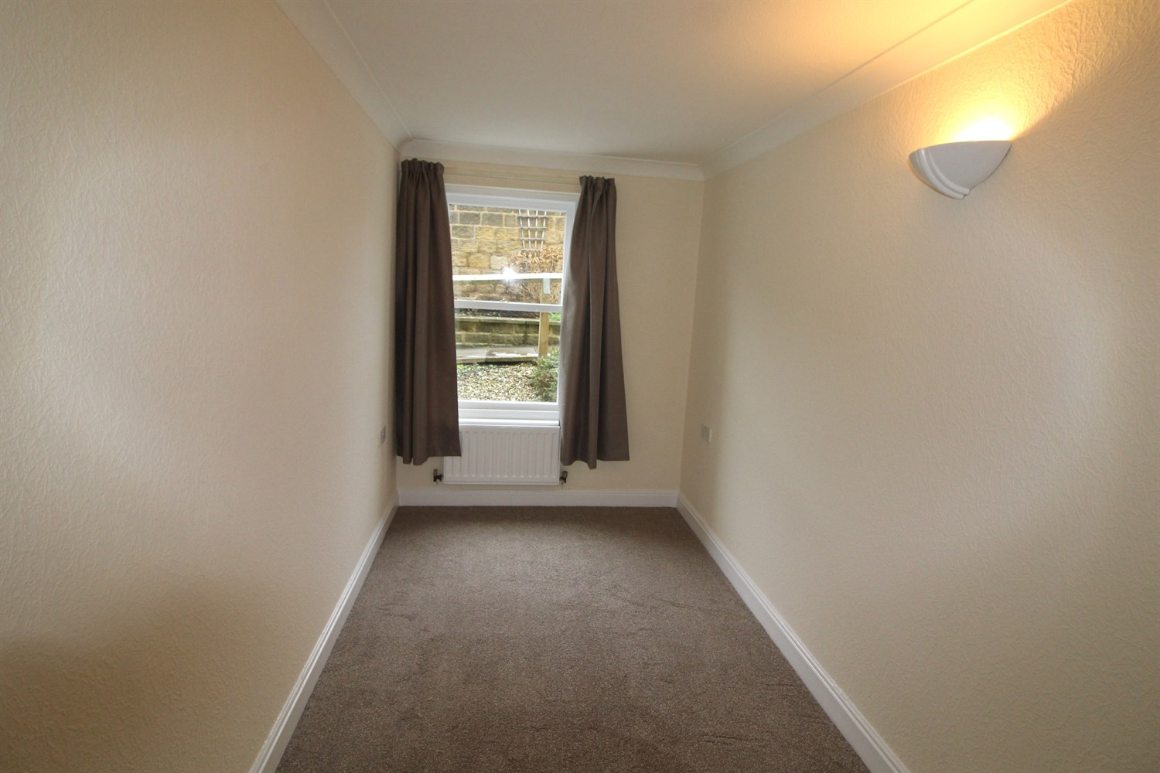

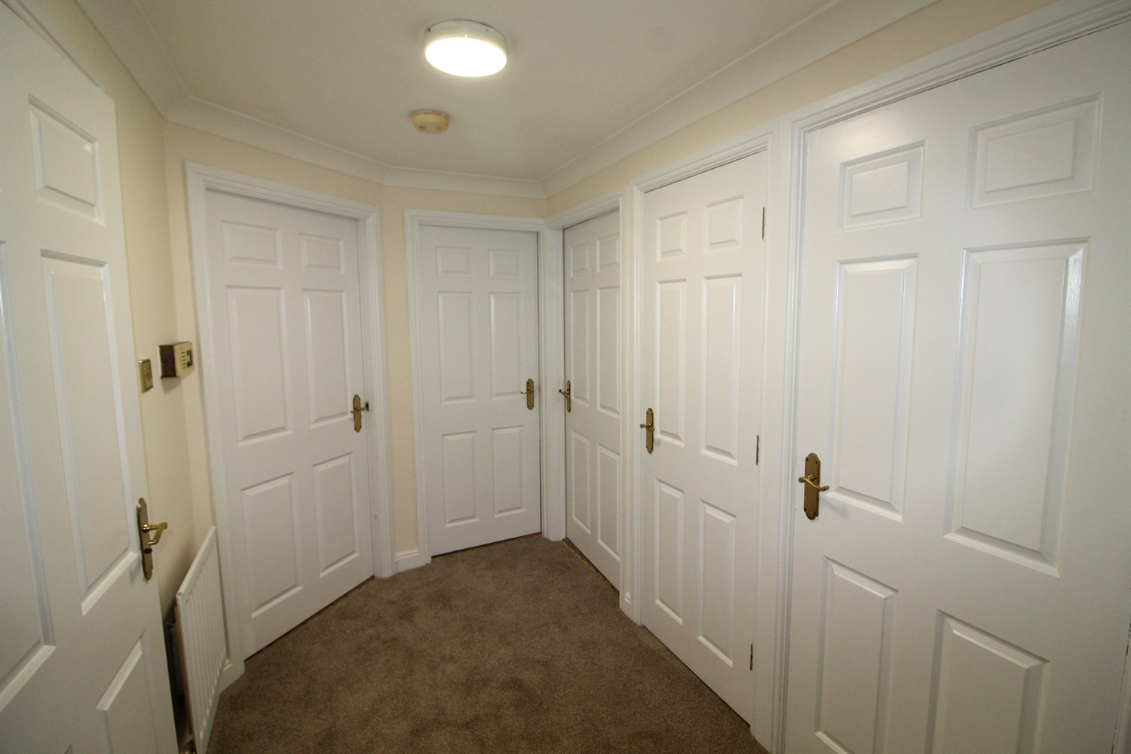

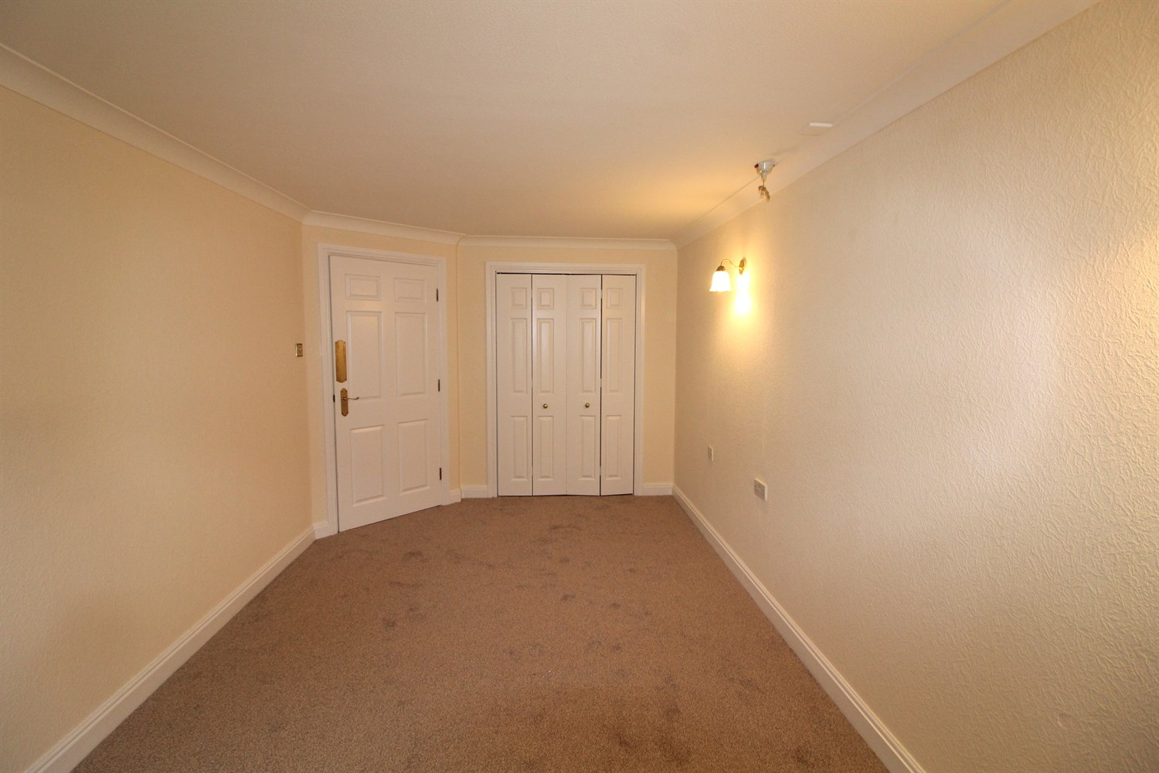

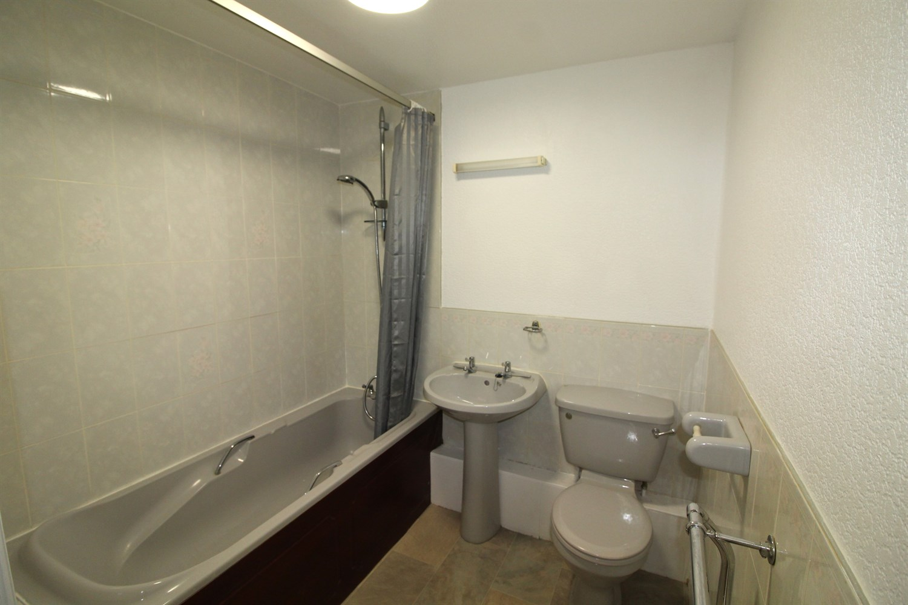

|  |
| --- |
| **Private Entrance Hall**  A welcoming entrance hall with a recessed cloaks cupboard and an additional recessed linen cupboard. |
| **Living Room 6.05m (19'10) x 3.48m (11'5)**  A sizeable sitting room including a feature fireplace with marble hearth, four wall light points and ceiling coving. Window to the rear. Wall mounted video entry system linked to the communal entrance. |
| **Kitchen 3.47m (11'5) x 2.39m (7'10)**  Well presented and comprising an extensive range of soft close base and wall units, co-ordinating work surfaces, tiled splashback and stainless steel sink with mixer tap. Appliances include a electric oven, four ring electric hob, space for a fridge freezer and plumbing for an automatic washing machine. |
| **Bedroom 1 5.1m (16'9) x 2.79m (9'2)**  A spacious double bedroom featuring a recessed wardrobe with sliding doors. Ceiling coving and two wall light points. Window to the rear. |
| **Bedroom 2 4.21m (13'10) x 1.88m (6'2)**  Window to the rear, Ceiling coving and wall light point. |
| **Bathroom 1.91m (6'3) x 1.98m (6'6)**  Three piece bathroom suite with shower over bath, w/c and hand wash basin. Tiled walls. electric heater. |
| **Communal Facilities**  Residents at Listers Court benefit from various communal facilities including a residents lounge, communal washing and drying facilities, a monitored integrated emergency call system and the services of a building manager. |
| **Communal Garden**  Listers Court is set within well maintained communal grounds for the use of the residents. |
| **Parking**  There is a communal car park to the front of Listers Court for the use of residents. |
| **Location**  From Dale Eddison's Ilkley office travel westwards along The Grove. After about 300 metres turn right into Cunliffe Road. Listers Court is towards the bottom of Cunliffe Road on the left hand side. |
| **Home Information** |

|  |  |
| --- | --- |
| These particulars are intended to give a fair description of the property, but their accuracy cannot be guaranteed, and they do not constitute an offer of contract. Intending purchasers must rely on their own inspection of the property. None of the above appliances/services have been tested by ourselves. We recommend purchasers arrange for a qualified person to check all appliances/services before legal commitment.  **Property Ref:** 4947  **For more information, please contact**  0113 258 1150 **|** [lettings@adairpaxton.co.uk](mailto:lettings@adairpaxton.co.uk) **|** www.adairpaxton.co.uk |  |