

**Kirkwood Way, Cookridge**

**For Sale £395,000.00**

## ***FABULOUS EXTENDED THREE/FOUR BEDROOM SEMI-DETACHED HOUSE*** Finished to an IMMACULATE standard throughout, this stunning family home simply MUST BE VIEWED to be appreciated. Situated in a quiet cul-de-sac and enjoying open plan living overlooking gardens to the rear. Having been extended and renovated by the current vendors, this property briefly comprises: entrance hall, living room, study, stunning kitchen/diner, utility room and guest cloakroom to the ground floor. To the first floor there are three double bedrooms and a contemporary house bathroom. The property also benefits from a brand-new boiler with a 10 year warrenty. Externally, the rear garden enjoys a good deal of privacy, to the front is a driveway providing off street parking and leading to a detached garage. Call us now to arrange a viewing! Council tax band - D.

**0113 258 1150**

**0800 000 000**

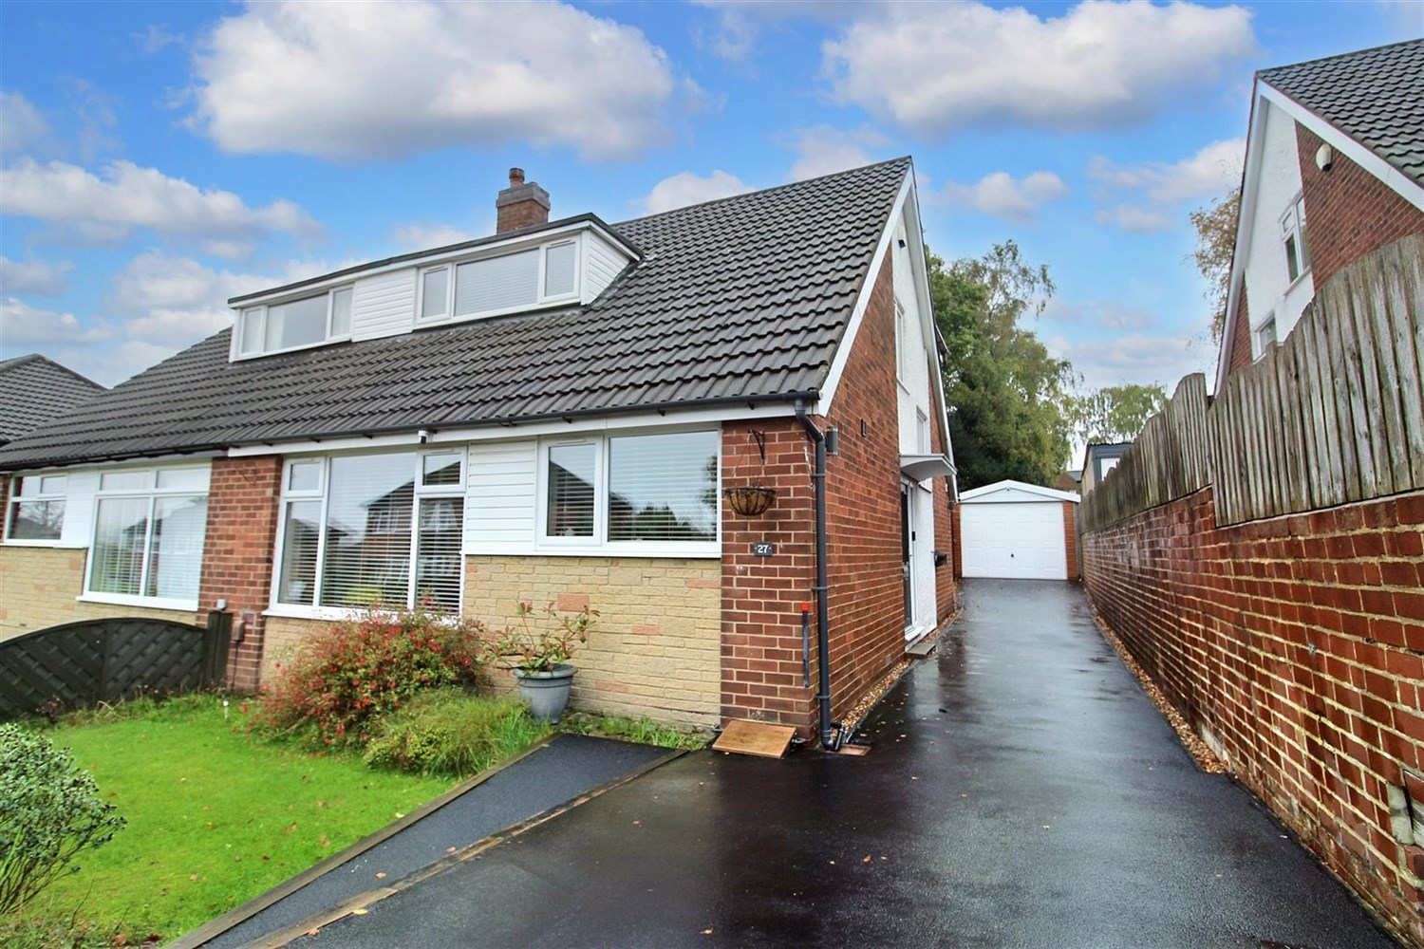



2 Reception

1 Bathroom

3/4 Bedroom

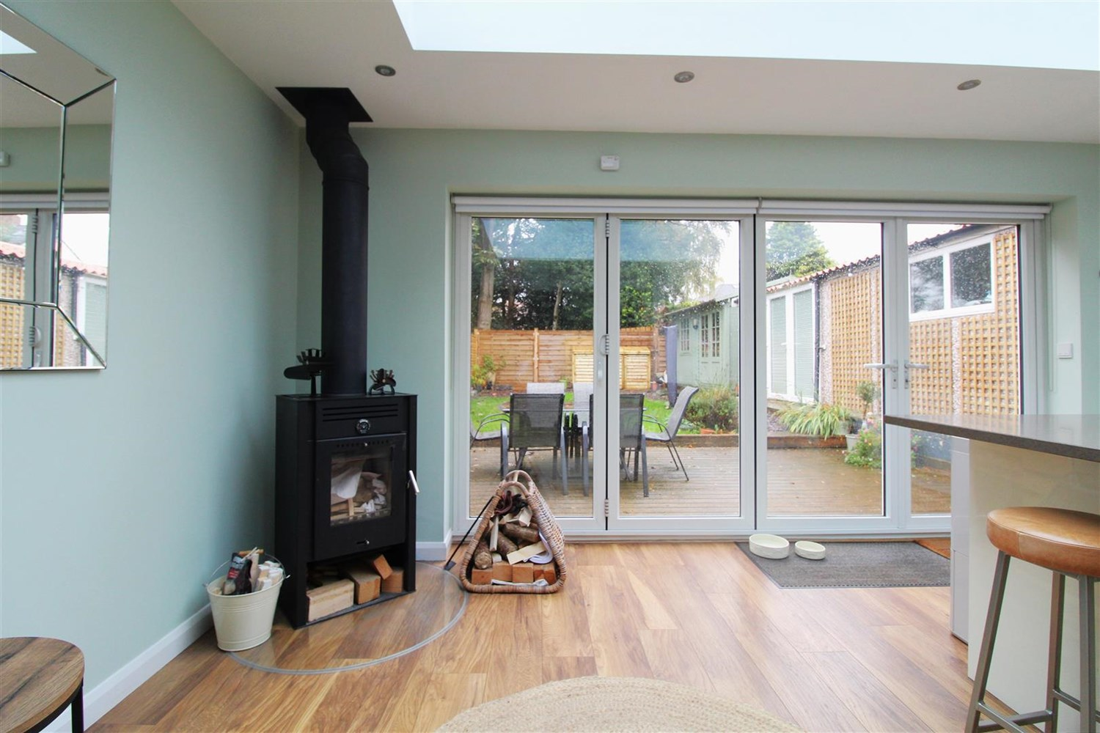

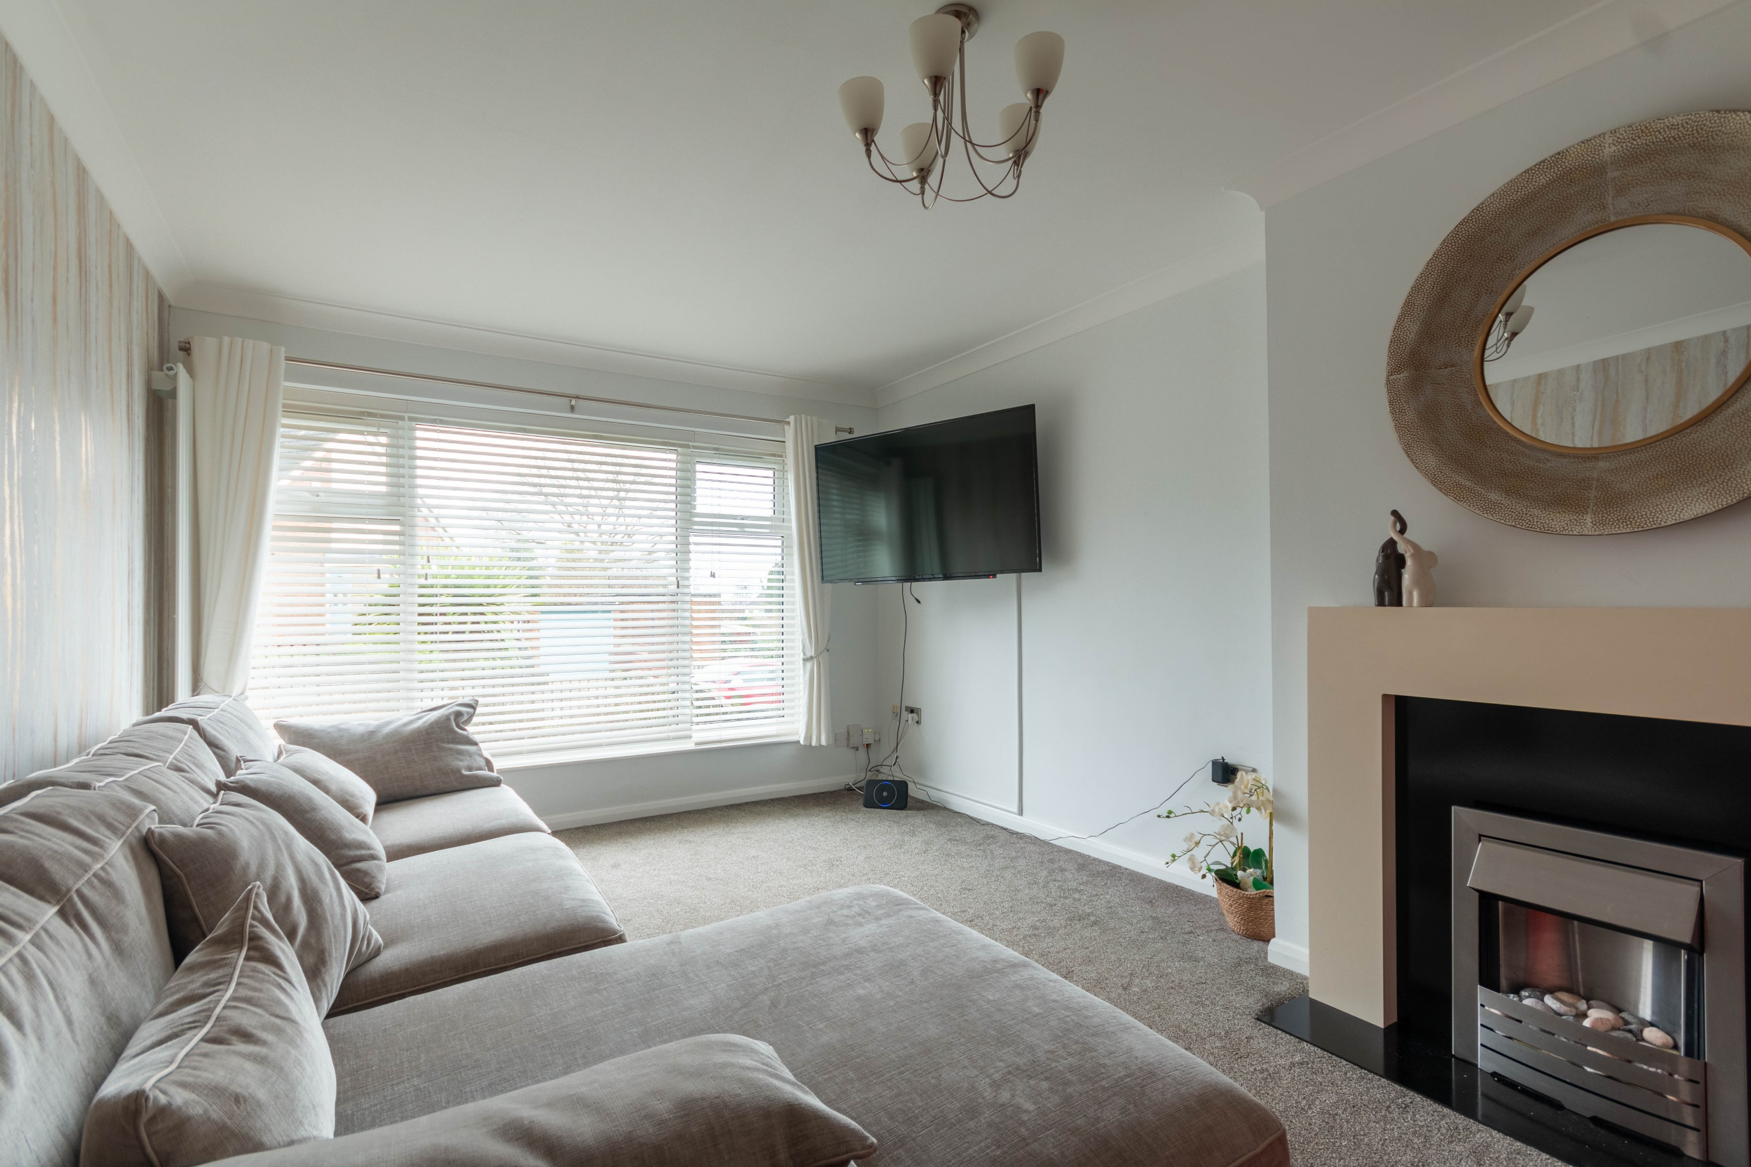

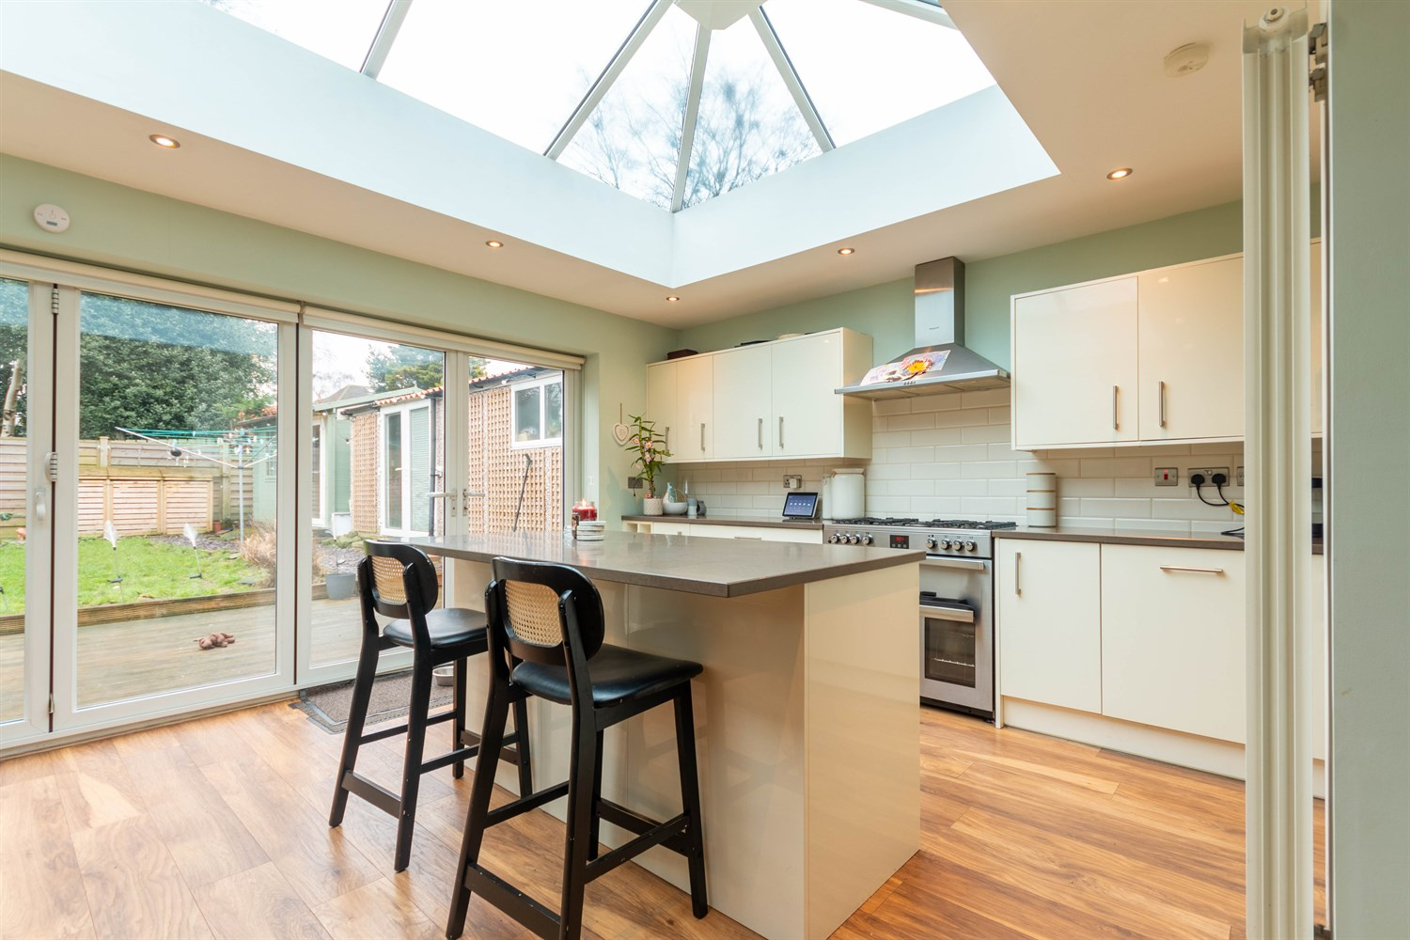

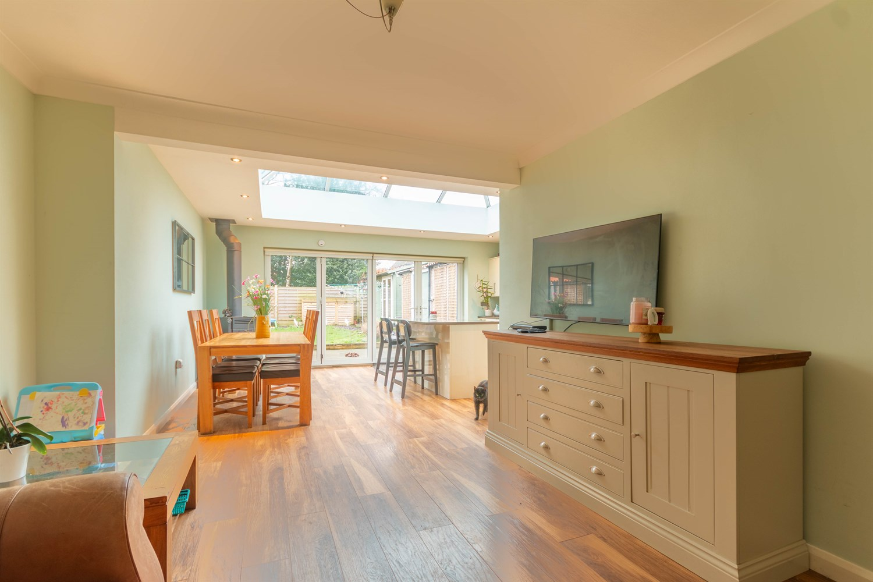

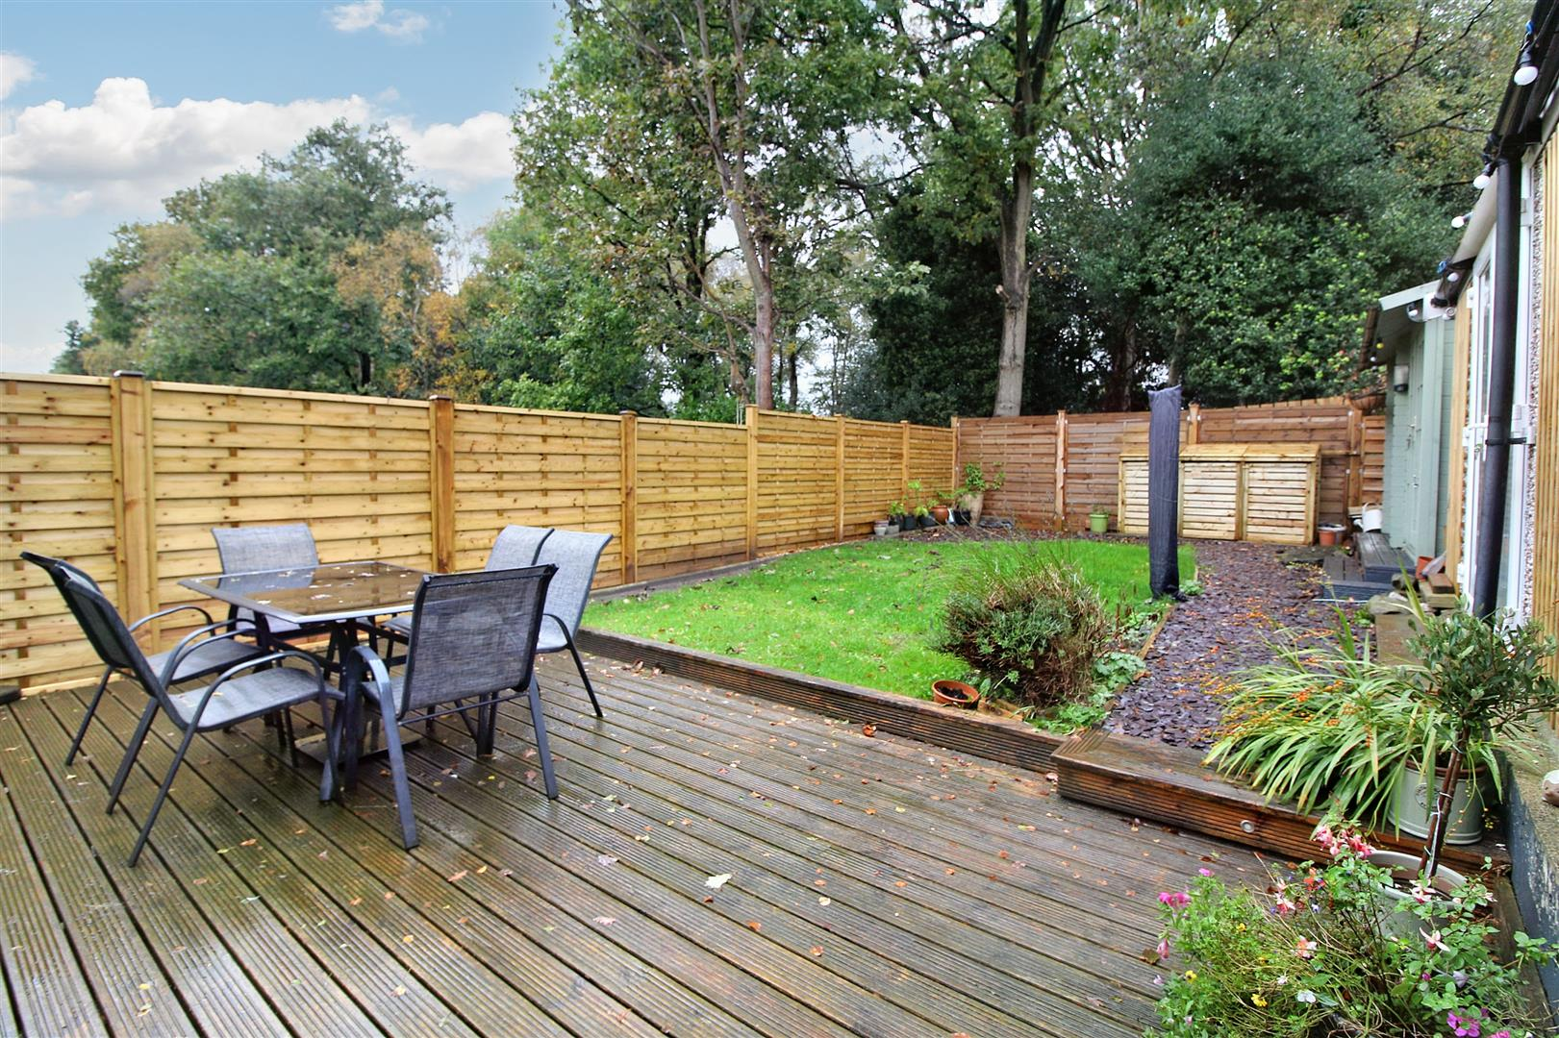

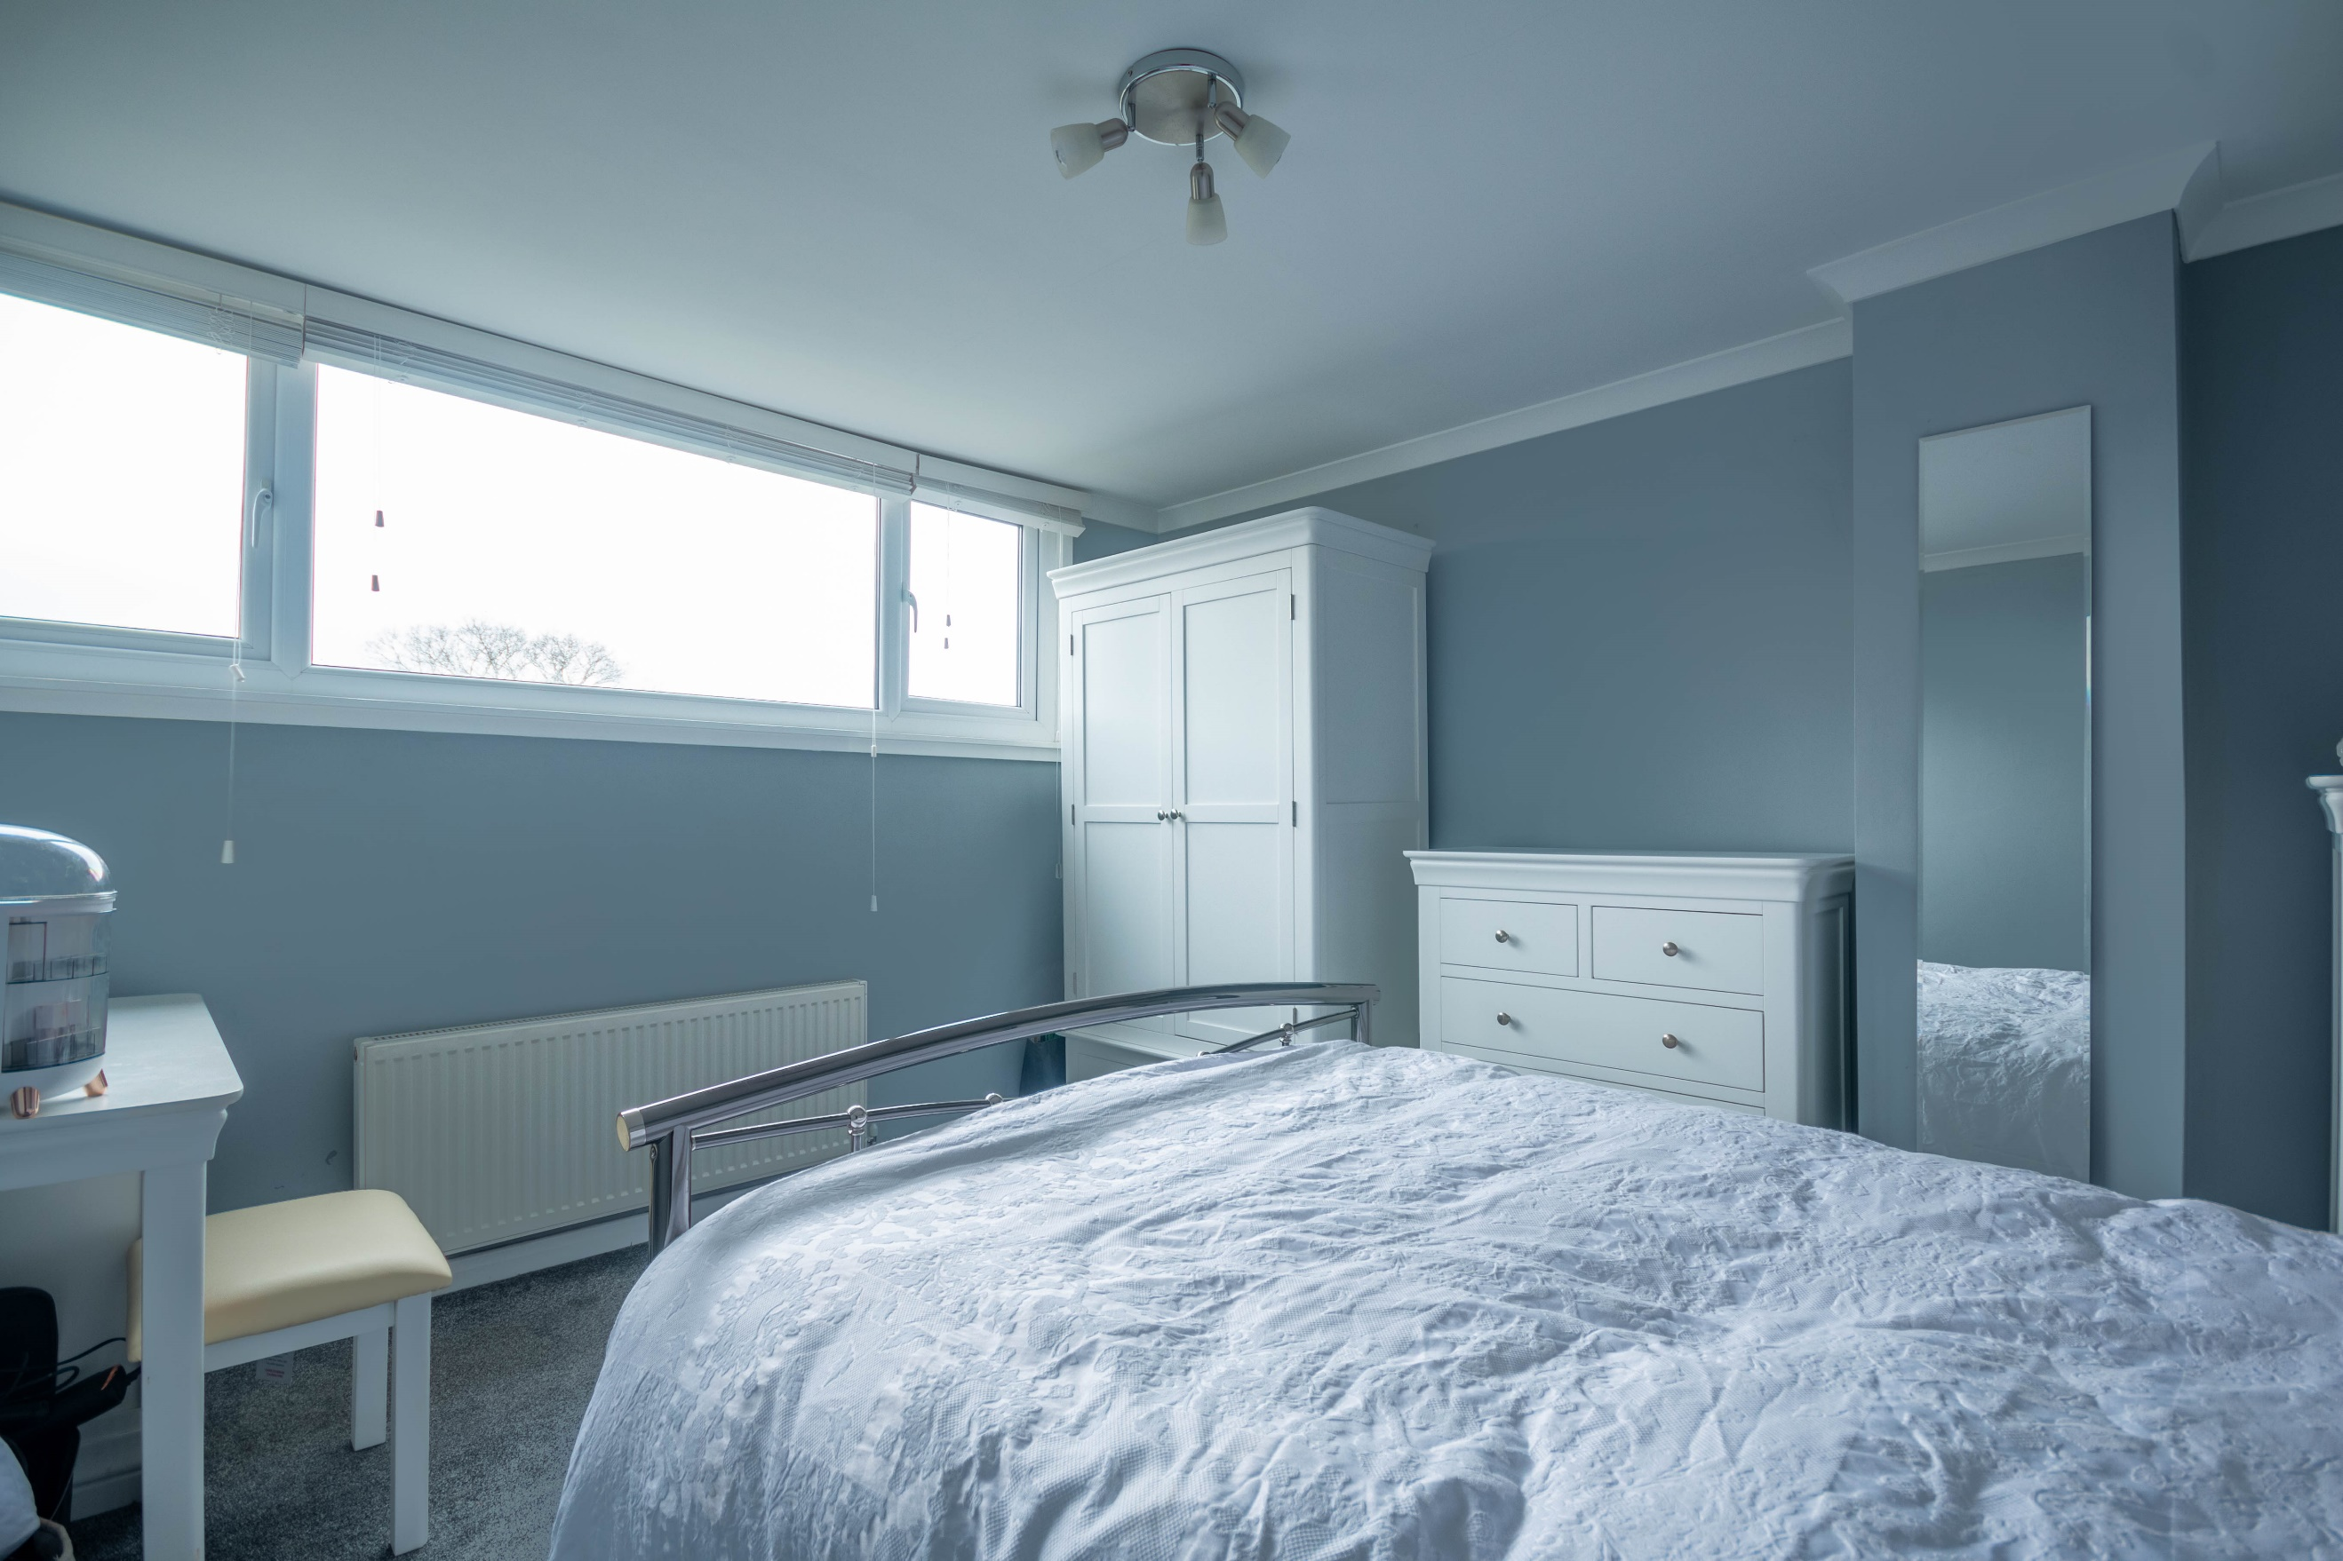

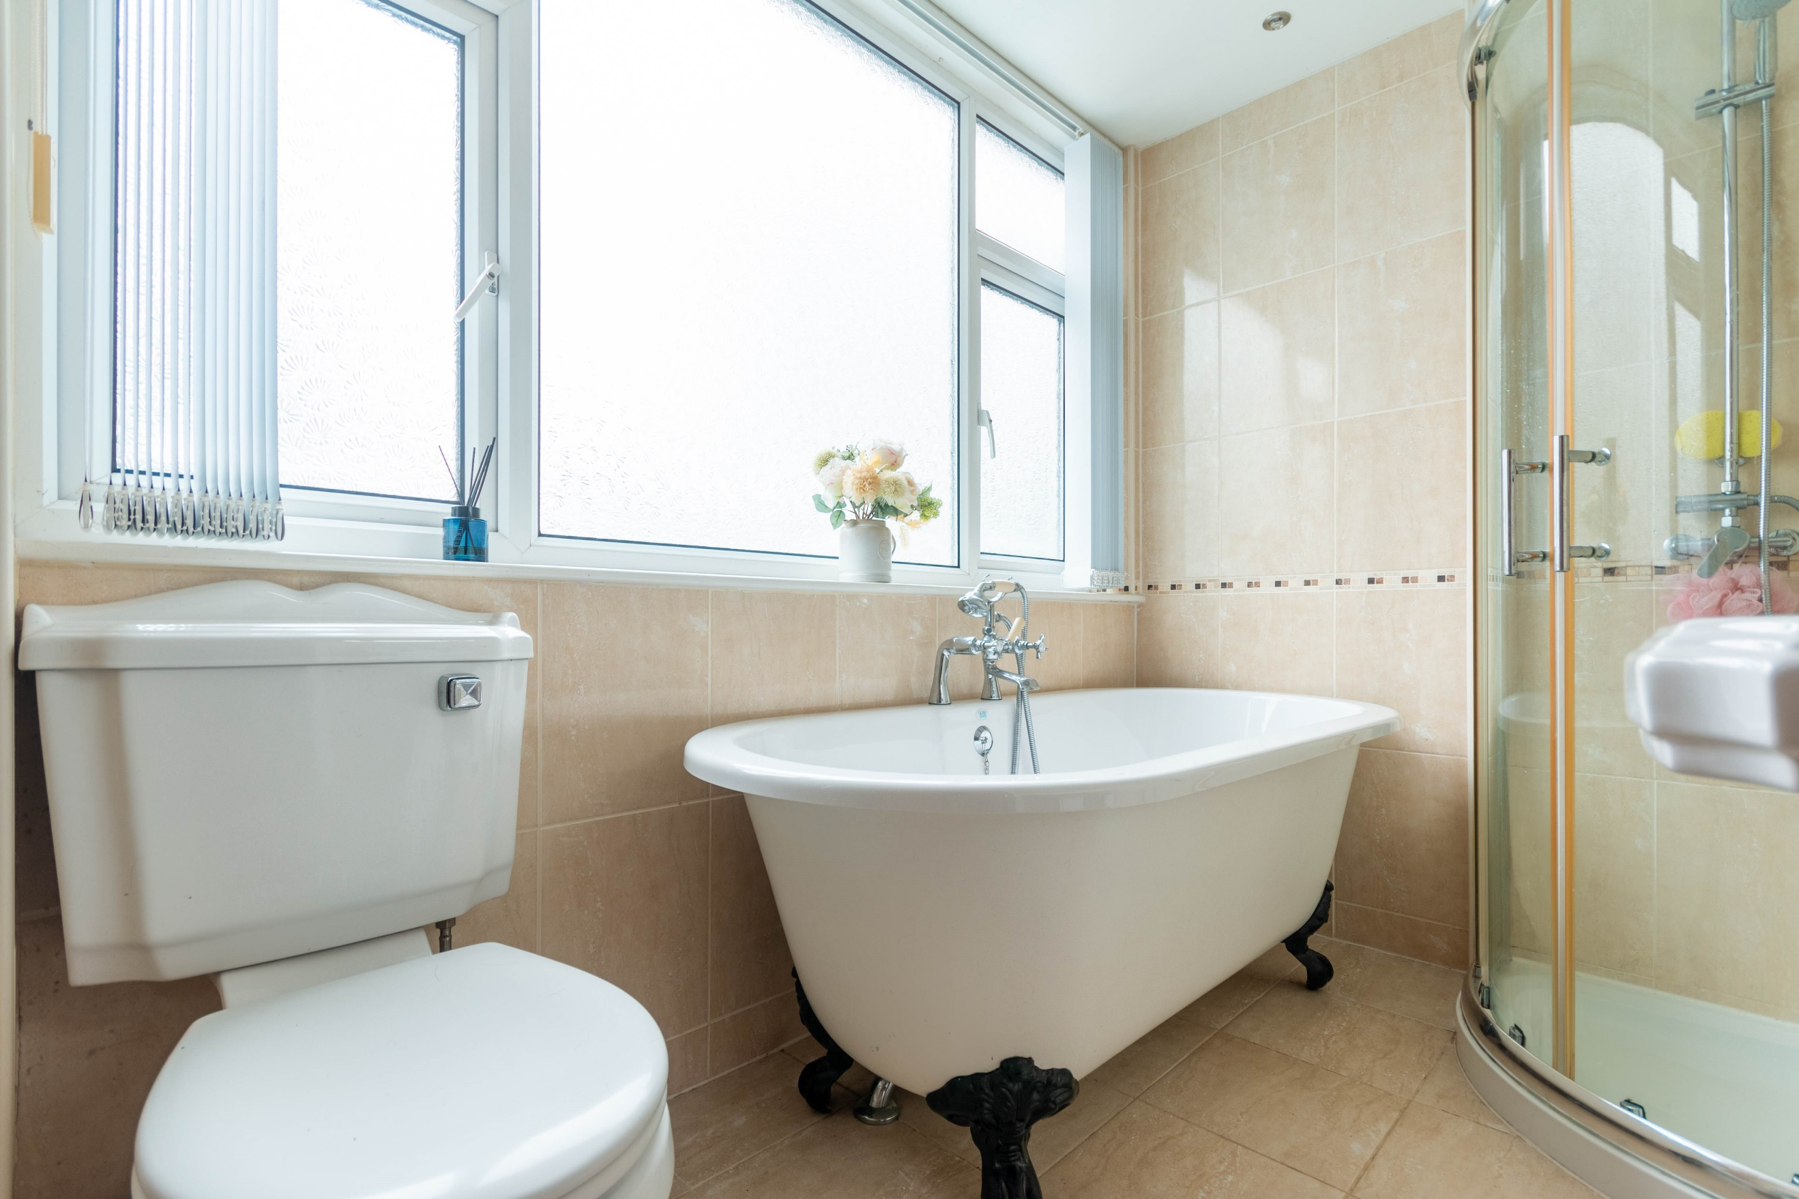

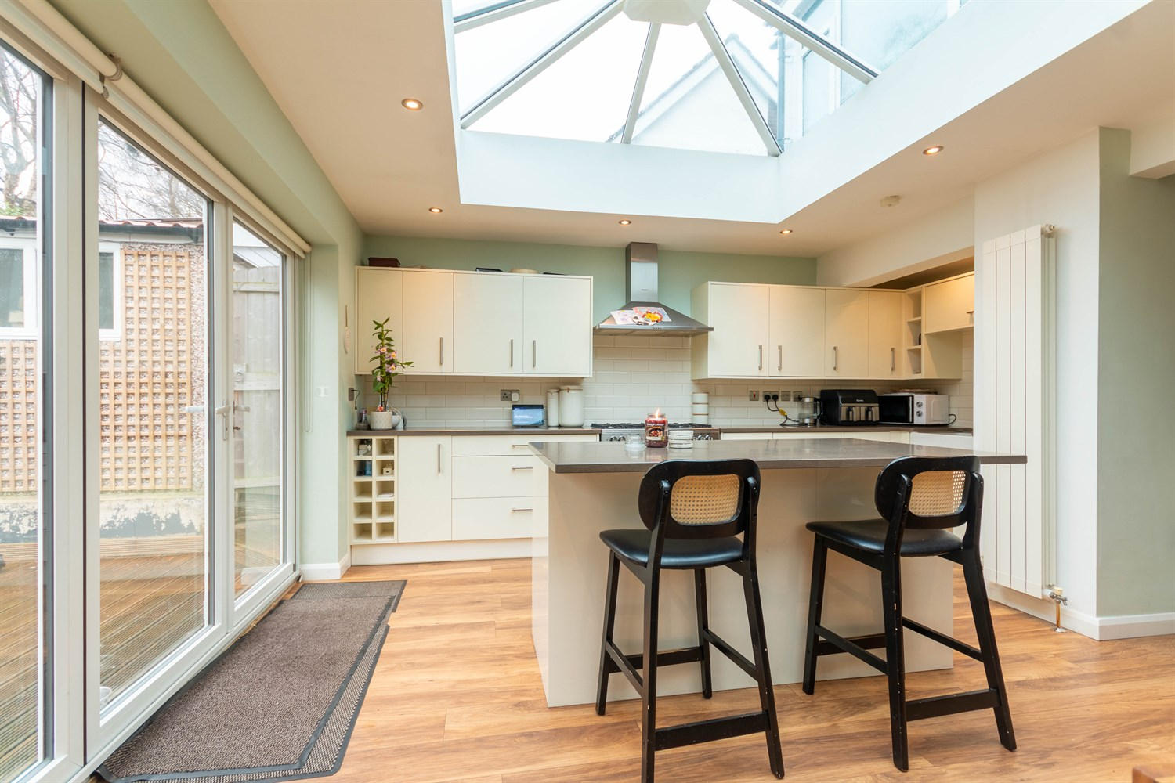

|  |
| --- |
| **Entrance Hall**  Via entrance door. Gas central heating radiator. Stairs to first floor. |
| **Living Room 5.14m (16'10) x 3.35m (11')**  Light and airy living area with uPVC double glazed window to front. Gas central heating radiator. Electric fire set in modern surround. |
| **Open Plan Dining/Kitchen 5.72m (18'9) x 8.86m (29'1)**  A superb entertaining/family space. This luxurious kitchen is fitted with a range of wall, base and drawer units with work surfaces over and led lighting on plinths/cupboards. Central island. White ceramic sink with mixer tap. Integrated dishwasher, fridge and freezer. Space for range style cooker with double extractor hood over. Double glazed bi-folding doors opening out to the rear garden. Skylight. Part tiled walls. Tall Gas central heating radiator. Contemporary wood burning stove. Gas central heating radiator. Inset ceiling spotlights. |
| **Study/Bedroom 4 2.21m (7'3) x 2.7m (8'10)**  uPVC double glazed window to front. Gas central heating radiator. Inset ceiling spotlights. |
| **Utility**  Fitted with wall and base cupboards matching the kitchen. Plumbing for washing machine. |
| **Guest WC**  Fitted with a vanity wash hand basin and WC. Tiled walls. Inset ceiling lights. |
| **First Floor**  Loft access. |
| **Bedroom 1 3.65m (12') x 3.25m (10'8)**  Double bedroom with uPVC double glazed window to front. Gas central heating radiator. |
| **Bedroom 2 2.86m (9'5) x 3.65m (12')**  Second double bedroom with uPVC double glazed window to side. Gas central heating radiator. |
| **Bedroom 3 3.25m (10'8) x 3.85m (12'8)**  Third double bedroom with uPVC double glazed window to rear. Gas central heating radiator. |
| **Bathroom**  Fitted with a four piece white suite comprising WC, wash hand basin, free standing bath and shower cubicle. Tiled walls and floor. uPVC double glazed window. Wall mounted heated towel rail and under floor heating. |
| **Outside**  To the front of the property there is a lawned garden with borders of flowers and shrubs. A driveway provides off street parking for a number of vehicles. The detached garage has power and light with uPVC double glazed doors into the garden. Outside office with uPVC double glazed doors, electric and wi-fi connection. The rear garden is fully enclosed. The rear garden has been mostly laid to lawn with a decked area and gravelled beds with planted shrubs. Log store. |

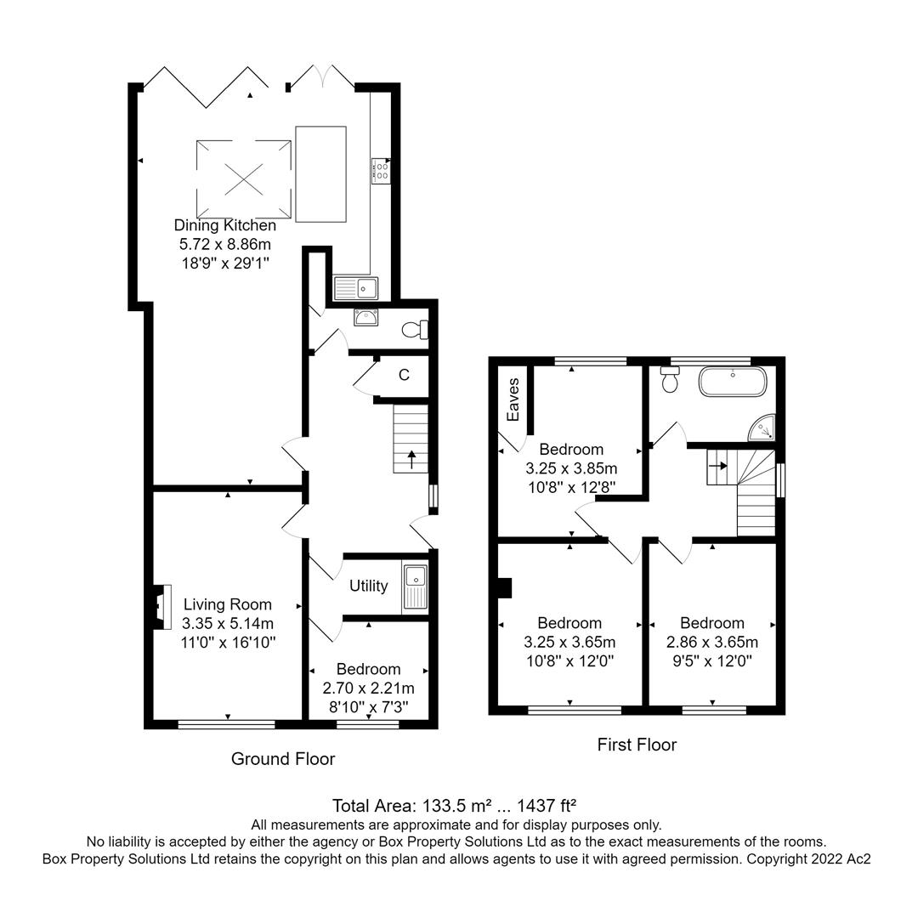

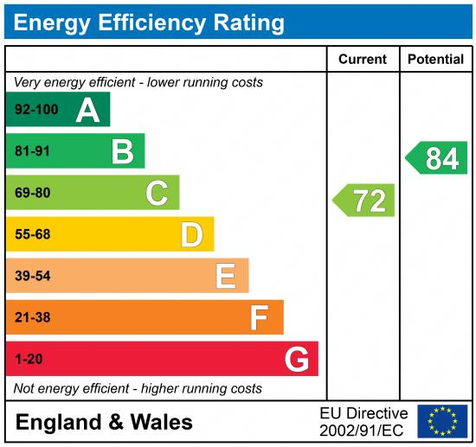

|  |
| --- |
|  |

These particulars are intended to give a fair description of the property, but their accuracy cannot be guaranteed, and they do not constitute an offer of contract. Intending purchasers must rely on their own inspection of the property. None of the above appliances/services have been tested by ourselves. We recommend purchasers arrange for a qualified person to check all appliances/services before legal commitment.

**Property Ref:** 4993

**For more information, please contact**

0113 258 1150 **|** [sales@adairpaxton.co.uk](mailto:sales@adairpaxton.co.uk) **|** www.adairpaxton.co.uk