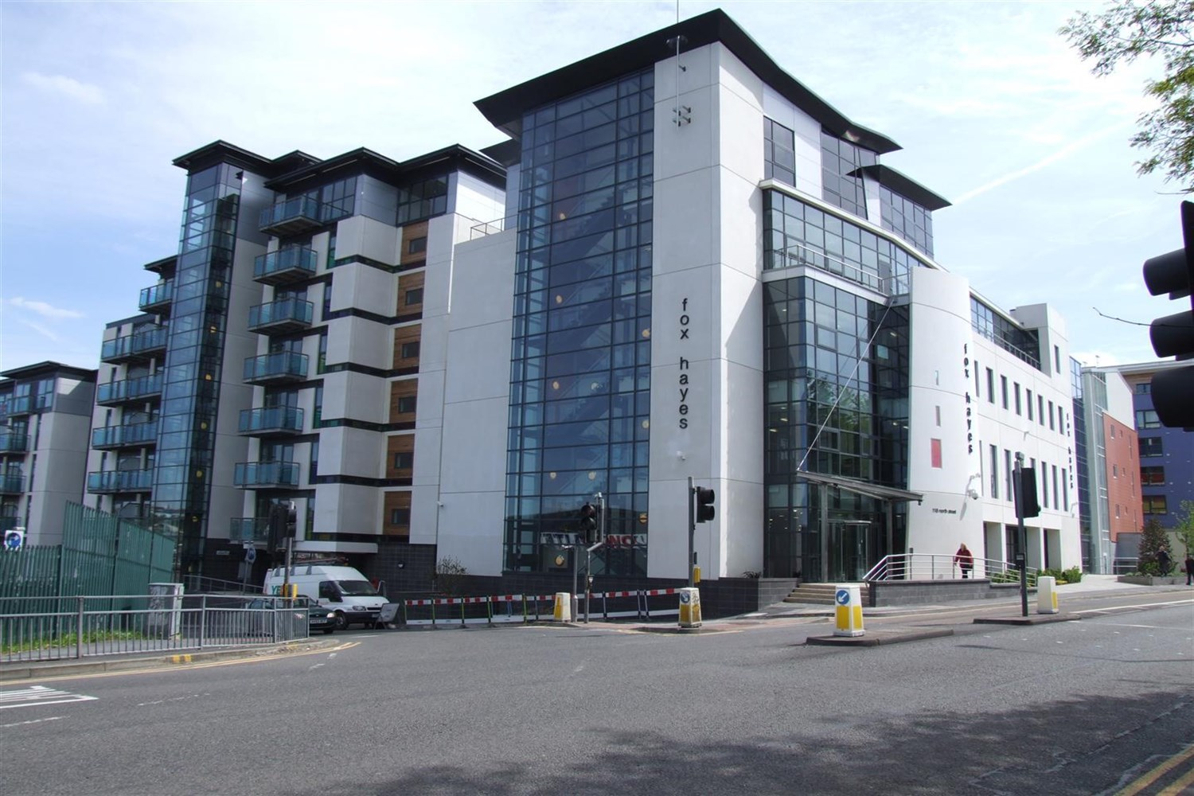



|  |  |
| --- | --- |
| **Lovell House, LS7**  **£795.00pcm**  **Apartment** | |
|  |

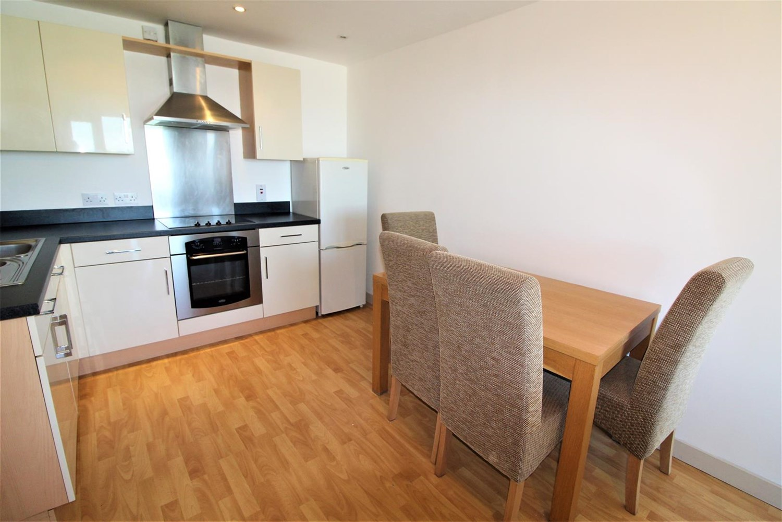

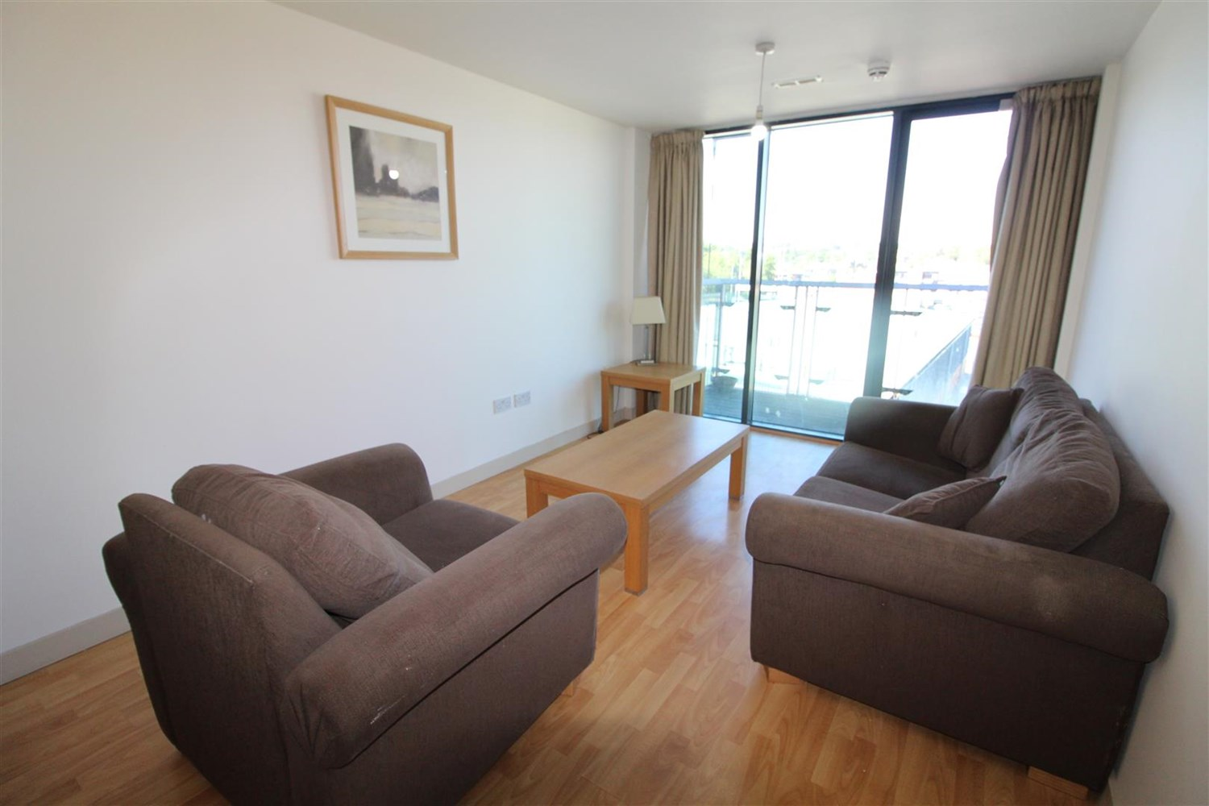

1 Bathroom(s)

1 Reception(s)

0 Bedroom(s)

00

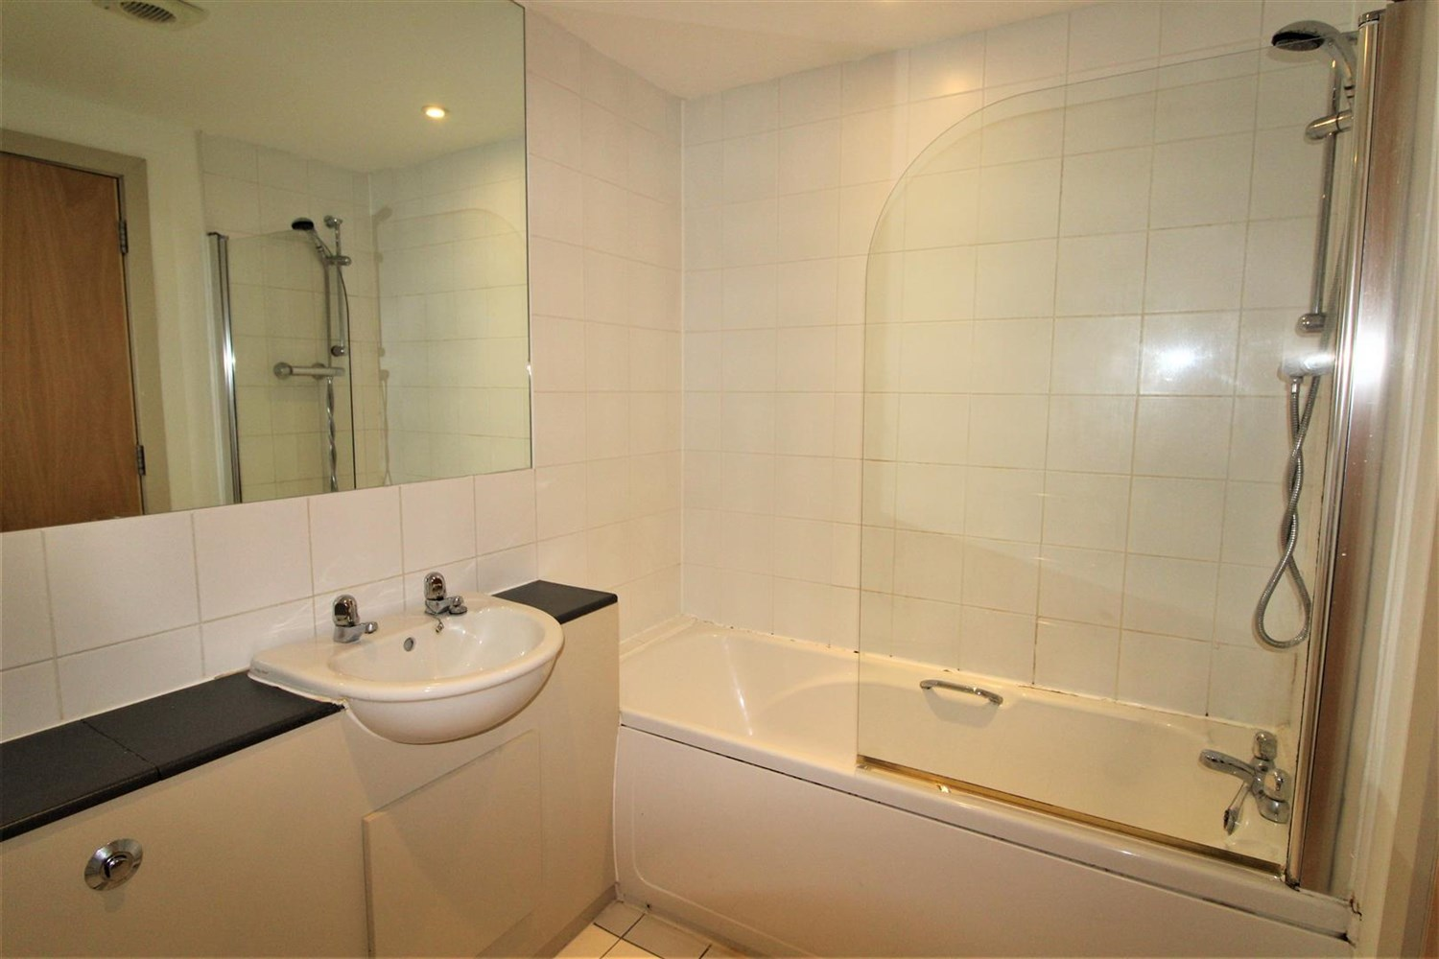

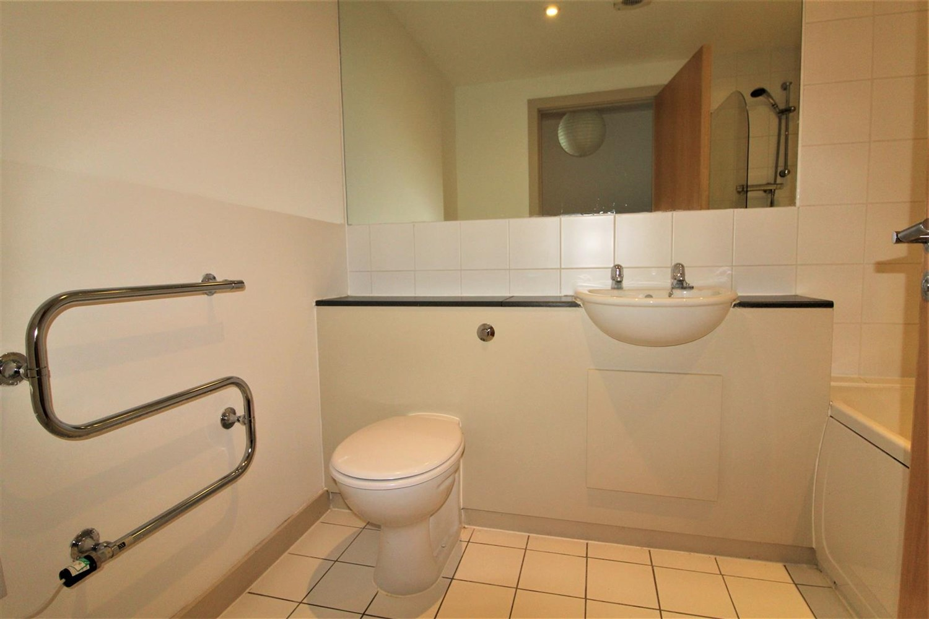

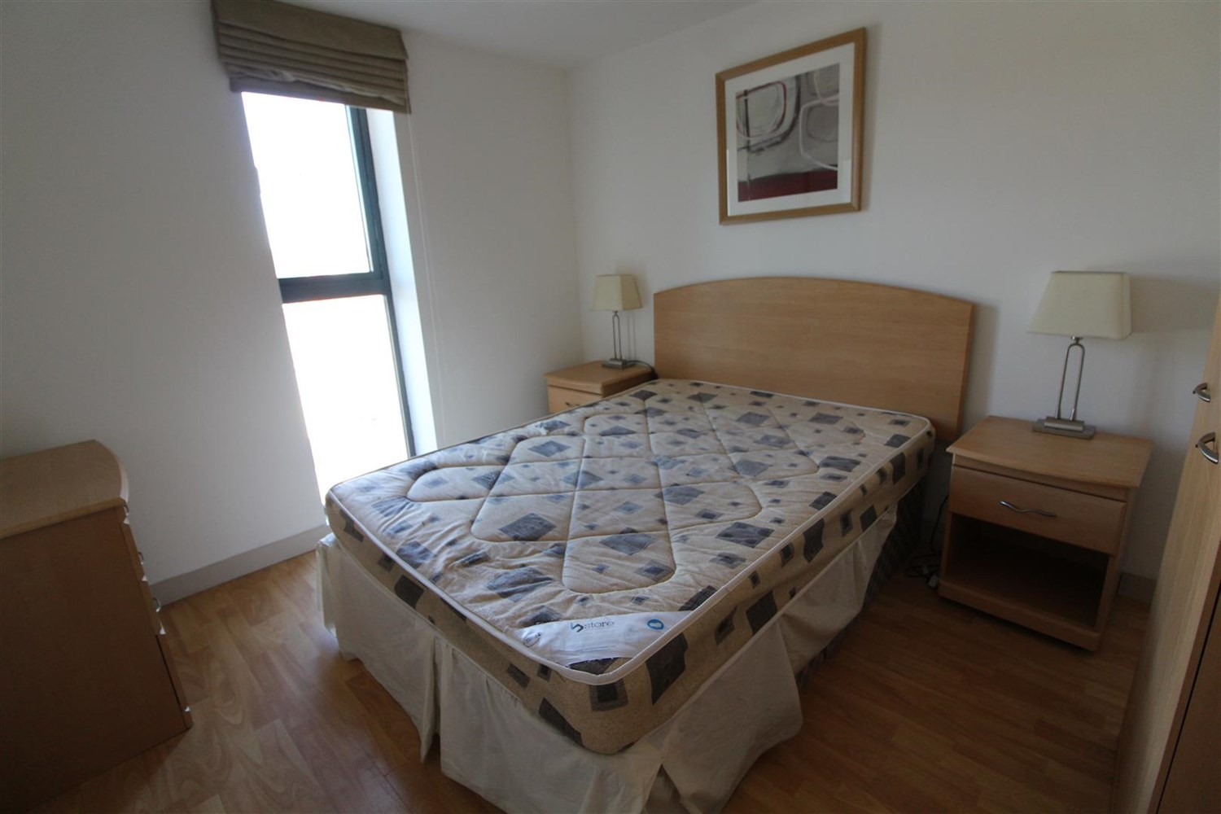

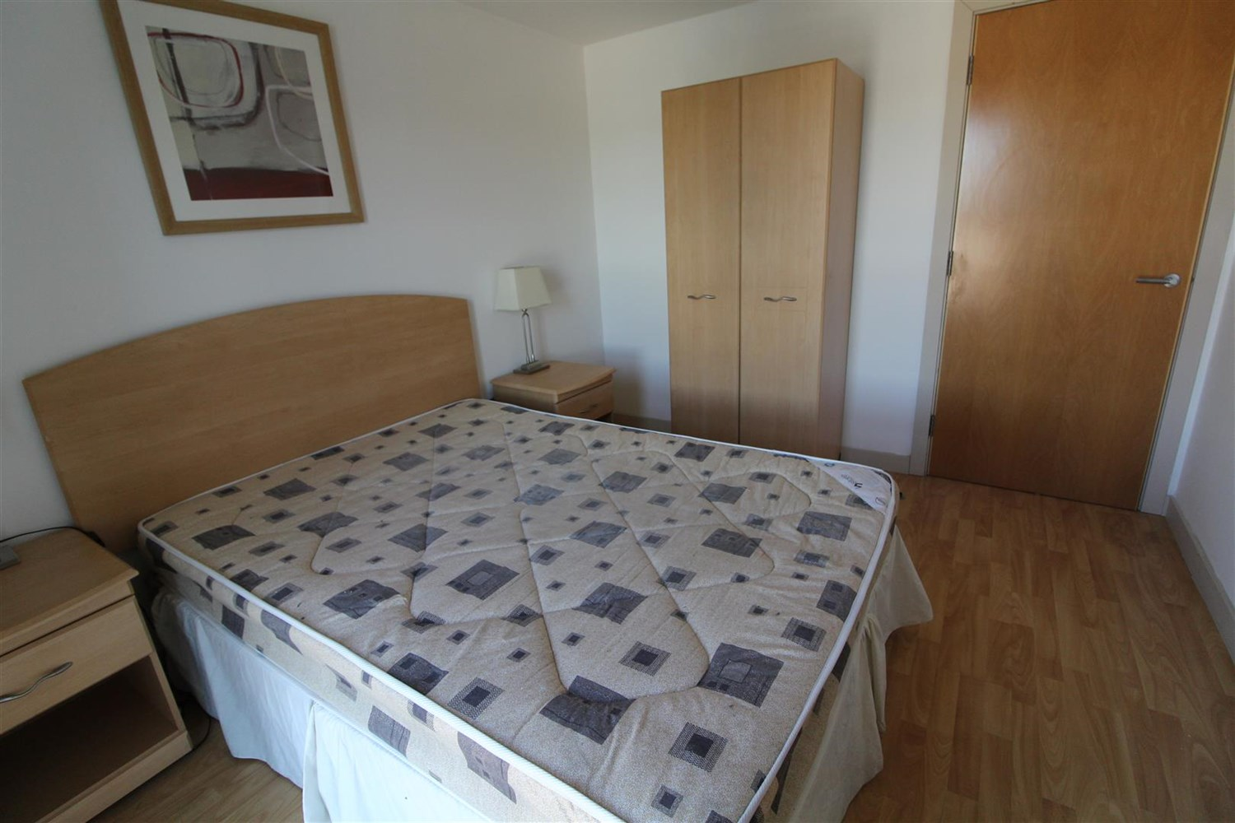

|  |
| --- |
| **Communal Entrance**  Communal entrance with stairs and lift to access all floors and letterboxes. |
| **Living Room**  Spacious living are with double glazed window, electric heater. |
| **Kitchen Area**  Fitted with a range of wall and base units with worktops over, stainless steel sink and mixer tap. |
| **Bedroom**  Double bedroom with electric heater, double glazed window. |
| **Bathroom**  Three piece white bathroom suite with shower over bath, shower screen, w/c and hand wash basin, tiled walls and floor. |
| **Home Information**  COUNCIL TAX BAND: B EPC Rating B  Leasehold property. Currently under going work for cladding. Mobile availability: EE Likely Three Likely O2 Likely Vodafone Limited  Broadband: Standard 15 Mbps Superfast 100 Mbp Ultrafast 1000 Mbps |

|  |  |
| --- | --- |
| These particulars are intended to give a fair description of the property, but their accuracy cannot be guaranteed, and they do not constitute an offer of contract. Intending purchasers must rely on their own inspection of the property. None of the above appliances/services have been tested by ourselves. We recommend purchasers arrange for a qualified person to check all appliances/services before legal commitment.  **Property Ref:** 523  **For more information, please contact**  0113 258 1150 **|** [lettings@adairpaxton.co.uk](mailto:lettings@adairpaxton.co.uk) **|** www.adairpaxton.co.uk |  |