

**0113 258 1150**

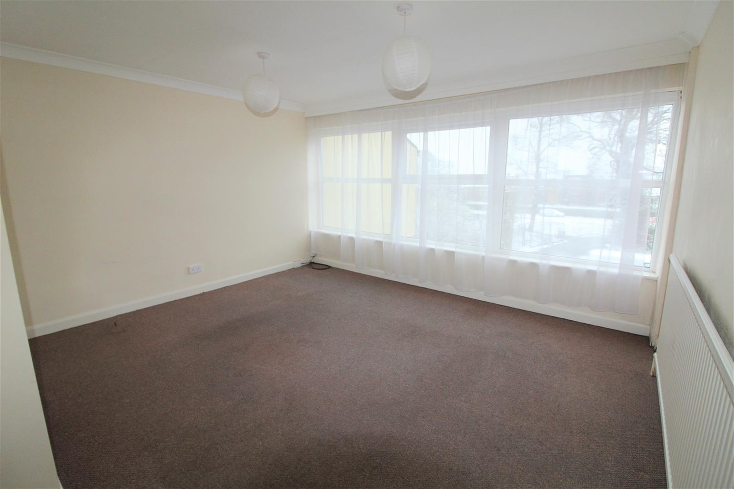



**Available to let £595.00pcm**

**45c Chapeltown, Leeds, LS28**

***ONE BEDROOM FIRST FLOOR APARTMENT *** This spacious one bedroom apartment is situated in the centre of Pudsey with everything you could want on the doorstep. Briefly comprising; Entrance hall, kitchen, bathroom, double bedroom and spacious living area. Gas central heating. Unfurnished. Deposit £685. Available 6th February. EPC Rating E. Council tax band B.

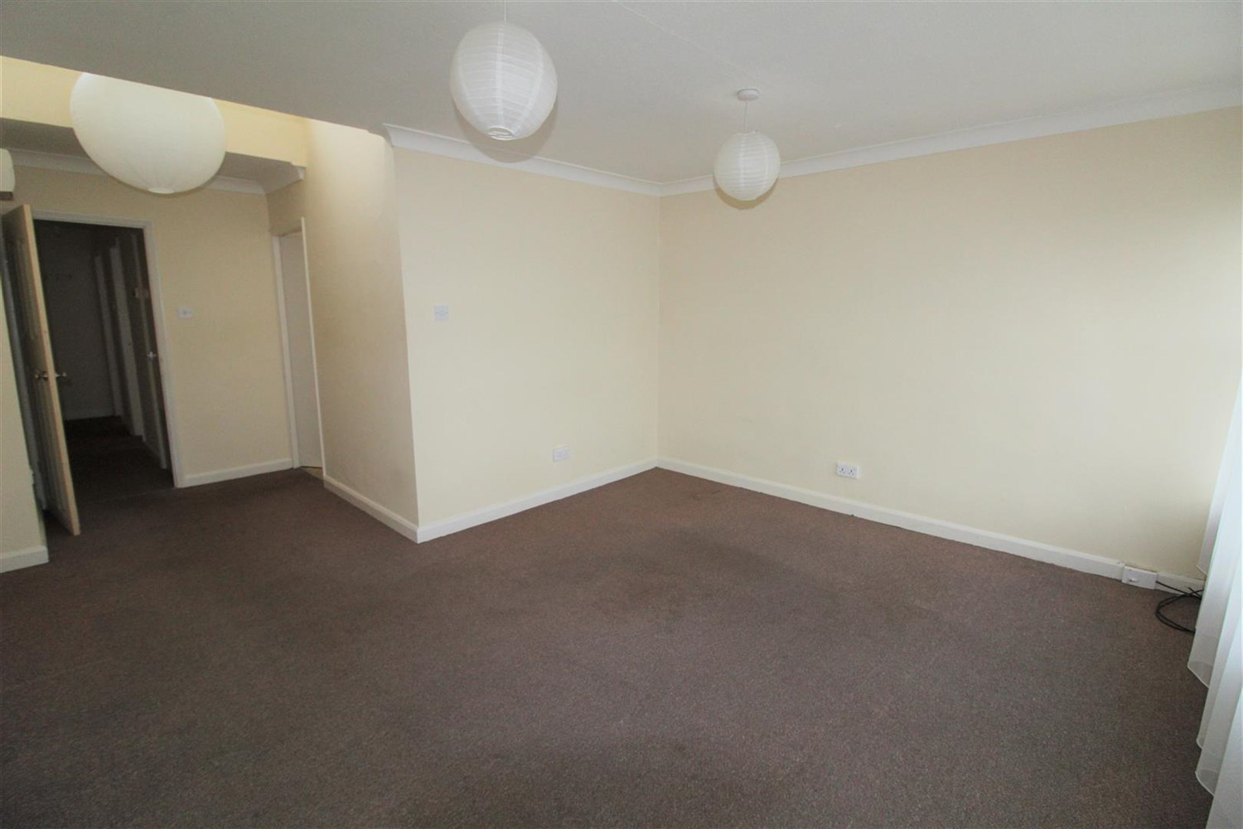

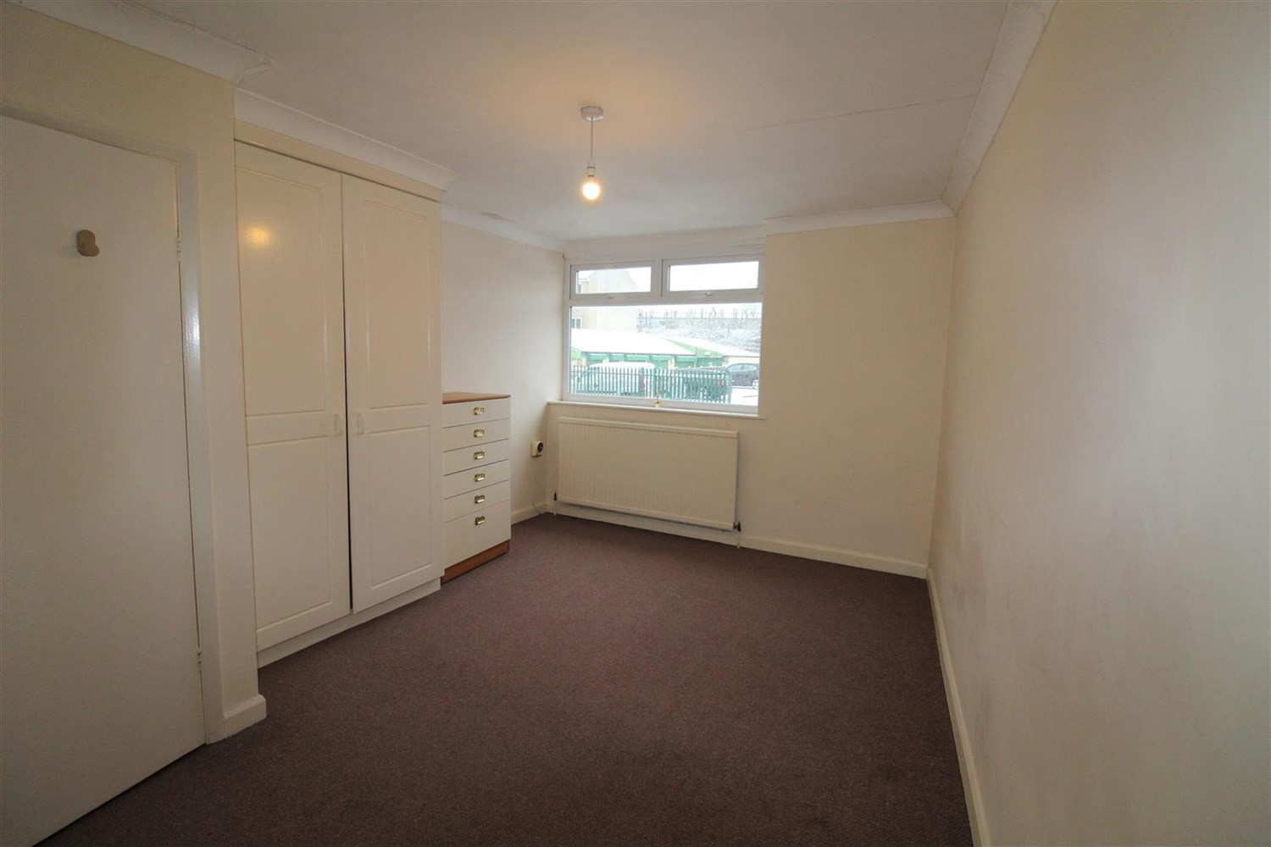

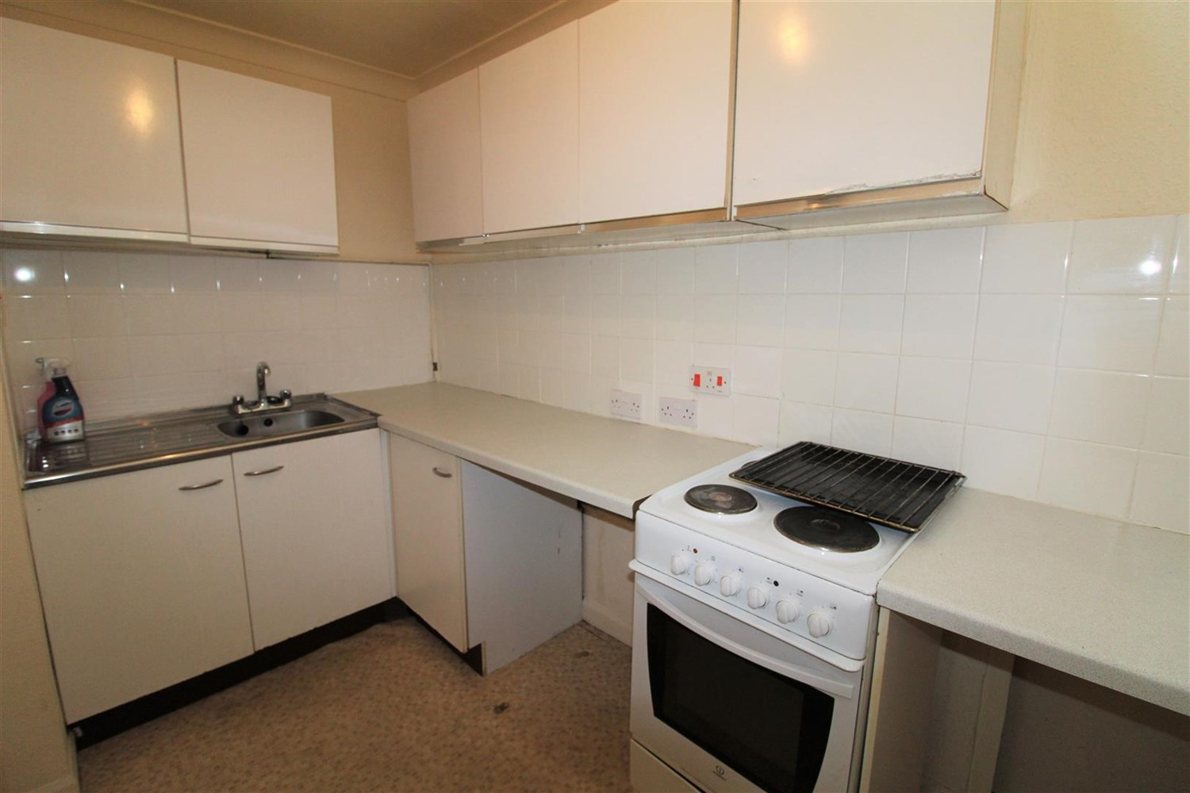

1 Bathroom(s)

1 Reception(s)

0 Bedroom(s)

00

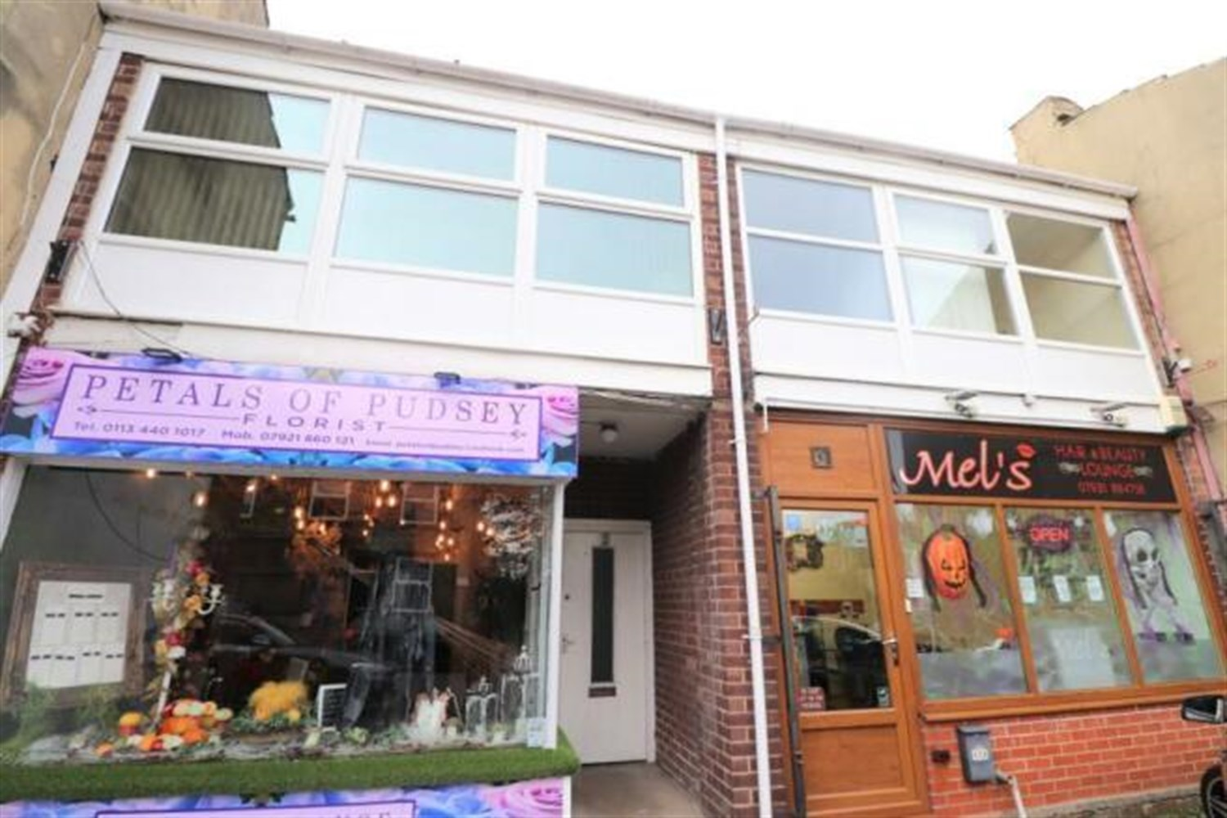

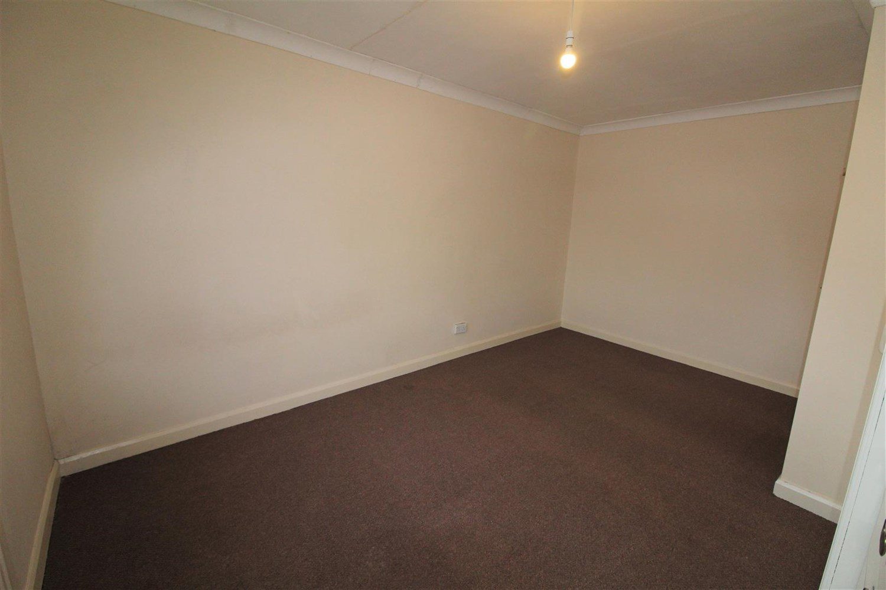

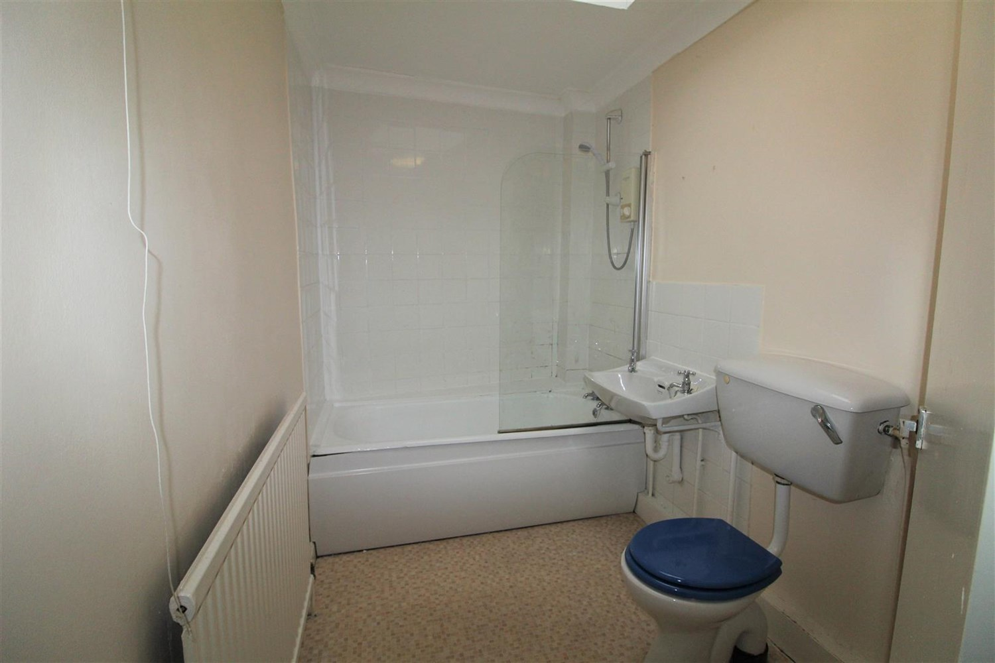

|  |
| --- |
| **Communal Entrance**  Stairs leading to the first floor. |
| **Private Entrance Hall**  Entrance hallway. |
| **Living Room**  Large living room with uPVC double glazed window to front, gas central heating radiator. |
| **Kitchen**  Fitted with a range of wall and base units with worktops over, stainless steel sink with drainer and mixer tap. Electric cooker. |
| **Bedroom**  Large double bedroom with uPVC double glazed window to rear and gas central heating radiator. |
| **Bathroom**  Three piece bathroom with shower over bath, shower screen, w/c and hand wash basin, part tiled round bath. |
| **Home Information**  COUNCIL TAX BAND: B EPC Rating: E  Leasehold property  Mobile availability: EE: Limited coverage Three: Limited coverage. O2: Likely to have good coverage. Vodafone: limited coverage. Broadband:  Standard 8 Mbps 0.9 Mbps Good Superfast 80 Mbps 20 Mbps Good Ultrafast 1800 Mbps 1000 Mbps  Gas and Electric mains supply, water on mains supply. |

|  |  |
| --- | --- |
| These particulars are intended to give a fair description of the property, but their accuracy cannot be guaranteed, and they do not constitute an offer of contract. Intending purchasers must rely on their own inspection of the property. None of the above appliances/services have been tested by ourselves. We recommend purchasers arrange for a qualified person to check all appliances/services before legal commitment.  **Property Ref:** 4975  **For more information, please contact**  0113 258 1150 **|** [lettings@adairpaxton.co.uk](mailto:lettings@adairpaxton.co.uk) **|** www.adairpaxton.co.uk |  |