

**0113 258 1150**

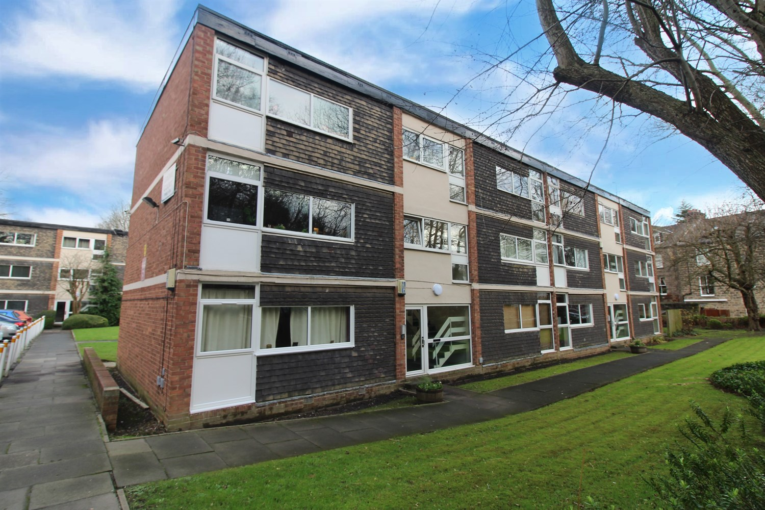



**For Sale £120,000.00**

**Grove Court, Grove Lane, Headingley**

***ONE BEDROOM FIRST FLOOR APARTMENT*** Set in beautiful well maintained grounds and having an excellent central Headingley location in a quiet residential area, this property must be viewed to appreciate the accommodation on offer. The apartment briefly comprises; Hallway, lounge, kitchen, one double bedroom and a house bathroom. Externally the property has well maintained communal gardens and off street parking. The great location benefits from coffee shops, supermarkets, a range of restaurants and popular bars, just a short walk away to Headingley and Meanwood. With Leeds City Centre also nearby, this ideal location has plenty to offer. The apartment is ideal for a first time buyer or investor. Please note the apartment is tenanted until April 2025 at £645pcm.

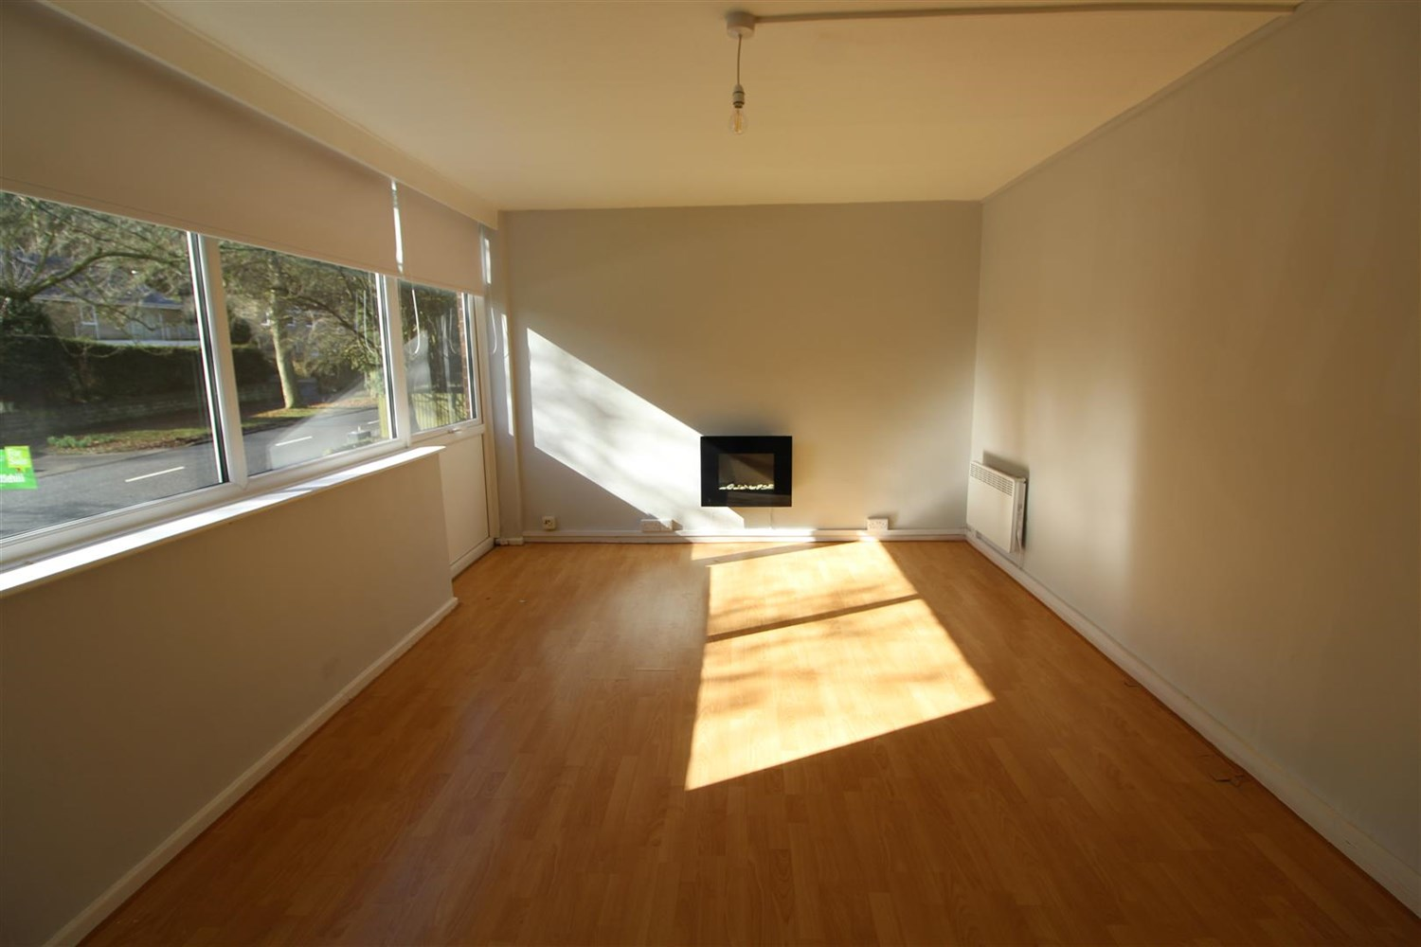

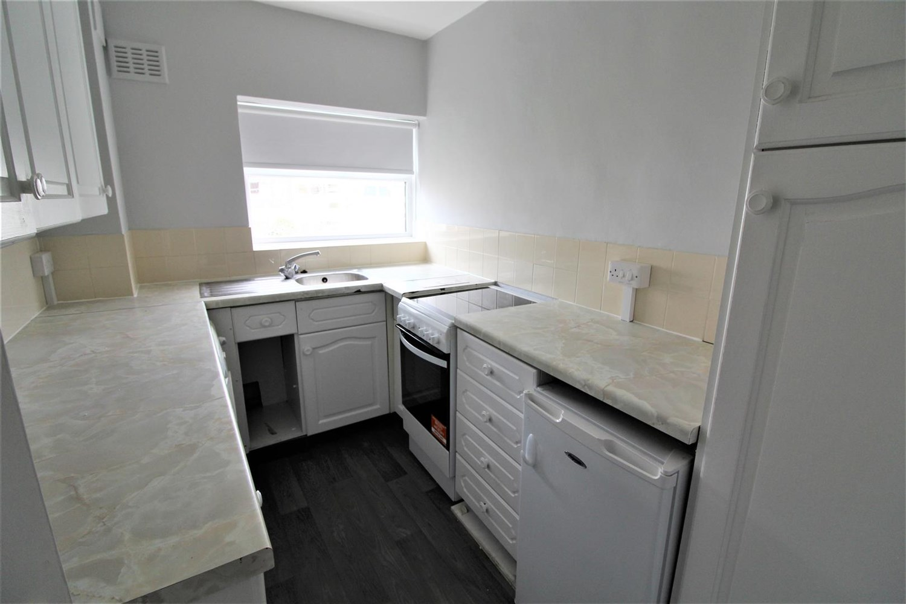

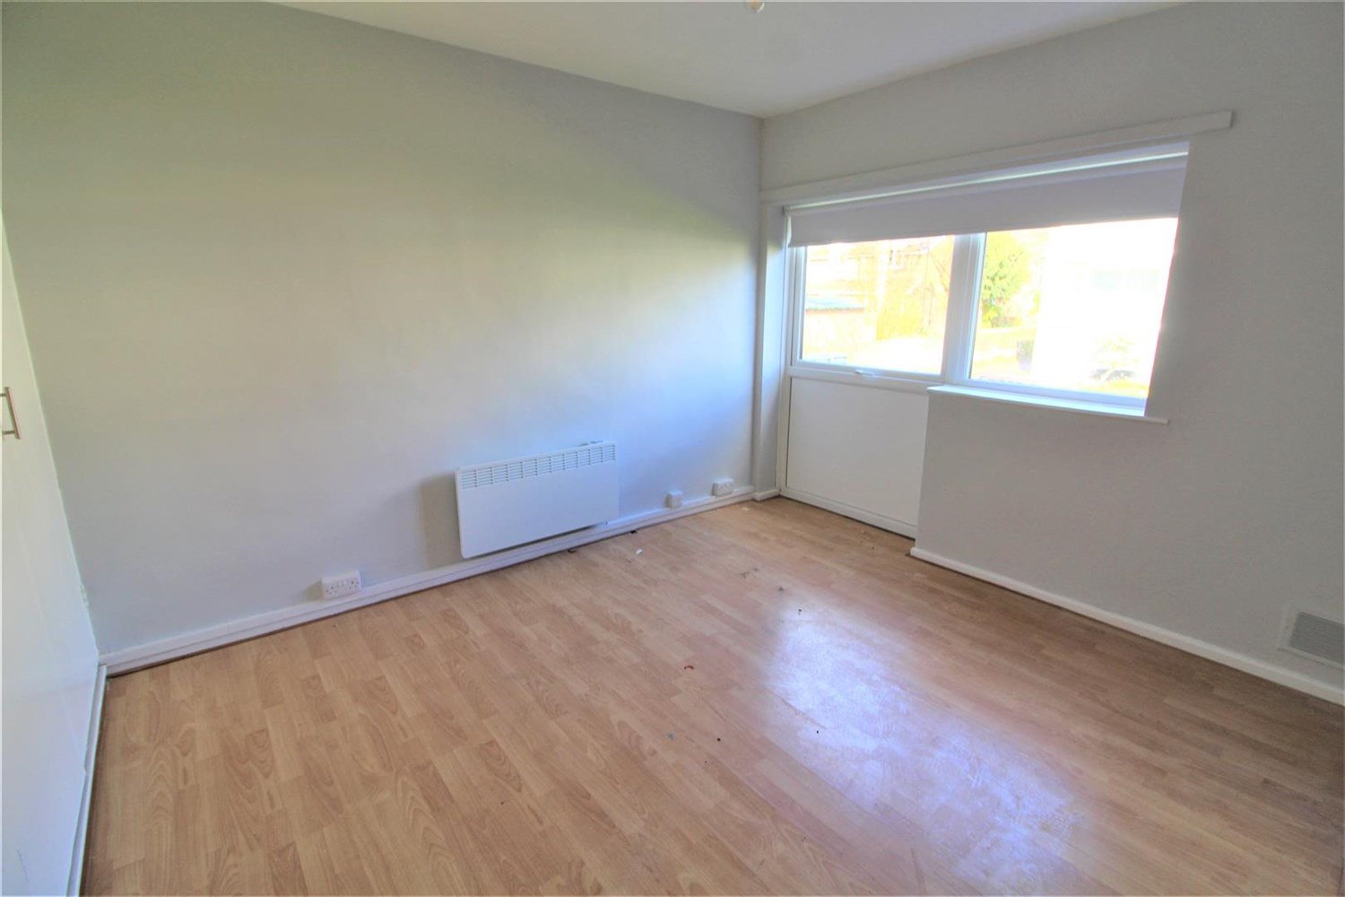

1 Bathroom(s)

1 Reception(s)

1 Bedroom(s)

00

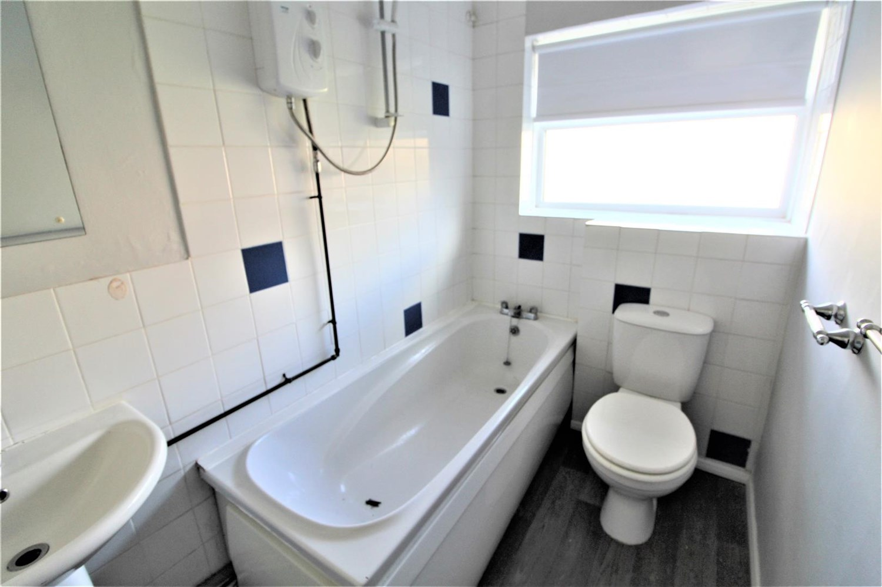

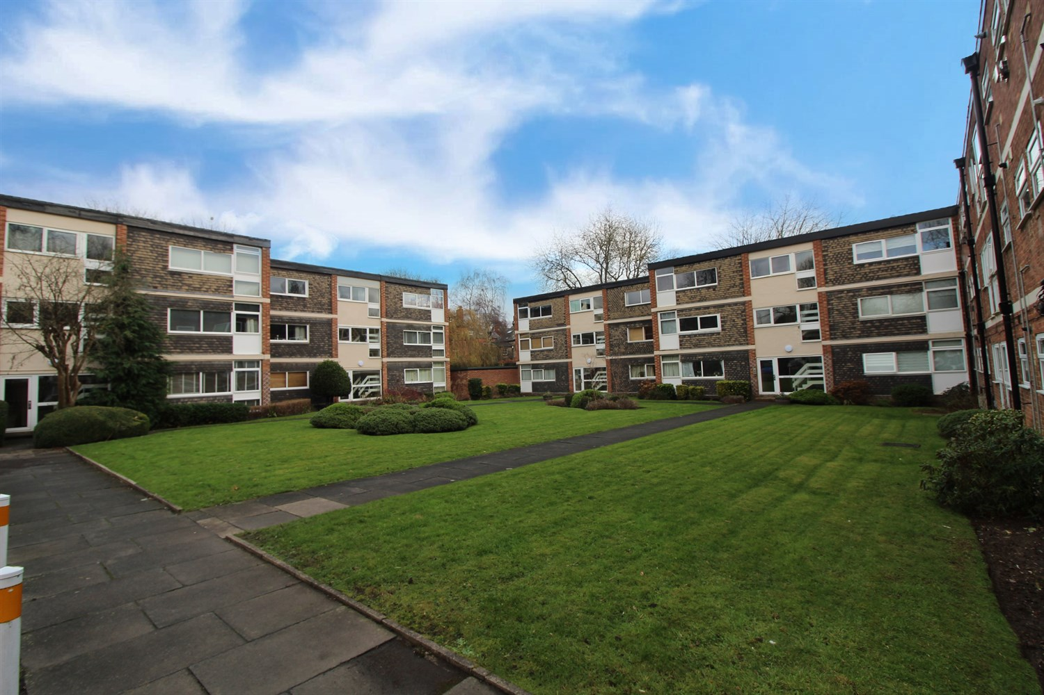

|  |
| --- |
| **Communal Hallway**  Via front entrance door. Secure entry phone system. Stairs to first floor. |
| **Private Hallway**  Via front entrance door. Built in cupboard. |
| **Lounge 3.35m (11') x 5.2m (17'1)**  Light and airy living area with uPVC double glazed windows to front. Wall mounted electric heater. |
| **Kitchen 2.94m (9'8) x 2.06m (6'9)**  Fitted with a range of wall, base and drawer units with worktops over. Stainless steel sink with mixer tap and drainer. Space for fridge, washing machine and cooker. uPVC double glazed window. |
| **Bedroom 3.04m (10') x 3.4m (11'2)**  Double bedroom with uPVC double glazed window. Wall mounted electric radiator. |
| **Bathroom**  Fitted with a three piece white suite comprising; bath with shower over, WC and wash hand basin. Tiled walls. uPVC double glazed window. |
| **Outside**  Communal gardens and parking. |
| **Tenure**  Leasehold - 163 years remaining |
| **Service Charge**  Service charge is £155.41 per month |

|  |  |
| --- | --- |
| These particulars are intended to give a fair description of the property, but their accuracy cannot be guaranteed, and they do not constitute an offer of contract. Intending purchasers must rely on their own inspection of the property. None of the above appliances/services have been tested by ourselves. We recommend purchasers arrange for a qualified person to check all appliances/services before legal commitment.  **Property Ref:** 4697  **For more information, please contact**  0113 258 1150 **|** [sales@adairpaxton.co.uk](mailto:sales@adairpaxton.co.uk) **|** www.adairpaxton.co.uk |  |