

**0113 258 1150**

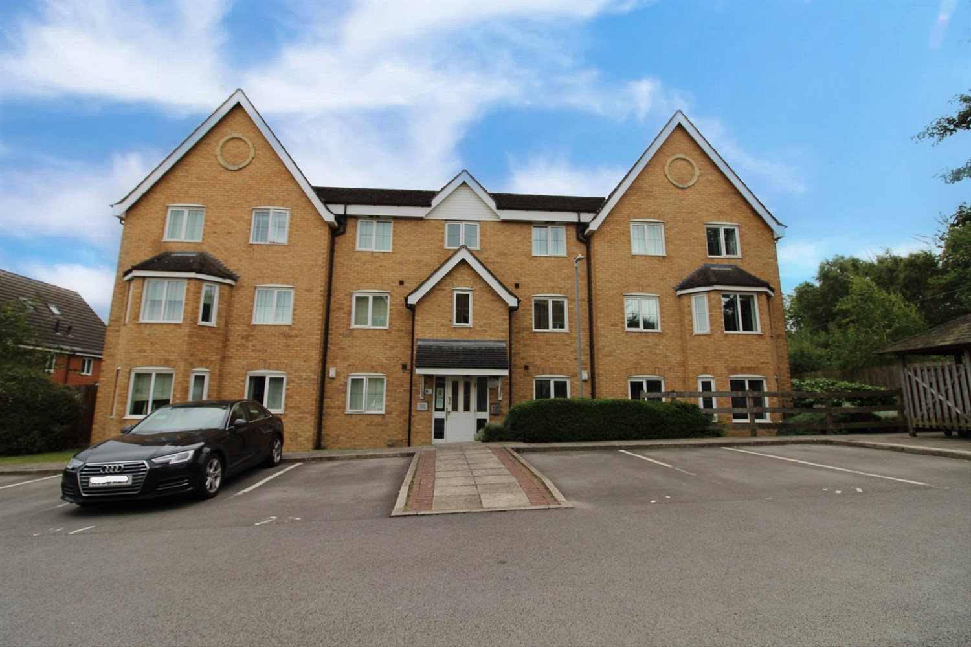



**Available to let £775.00pcm**

**Bracken Green, East Ardsley**

***SPACIOUS TWO BEDROOM, TWO BATHROOM FIRST FLOOR APARTMENT WITH ALLOCATED PARKING SPACE*** Offered to the market is this property which is within easy access to Leeds and Wakefield, close to the motorway networks and handy for all amenities. The apartment briefly comprises; entrance hall, lounge/diner, separate kitchen, two double bedrooms one with en-suite and house bathroom. Externally there are well maintained communal gardens and an allocated parking space. Deposit £890. Council tax band A, EPC rating C.

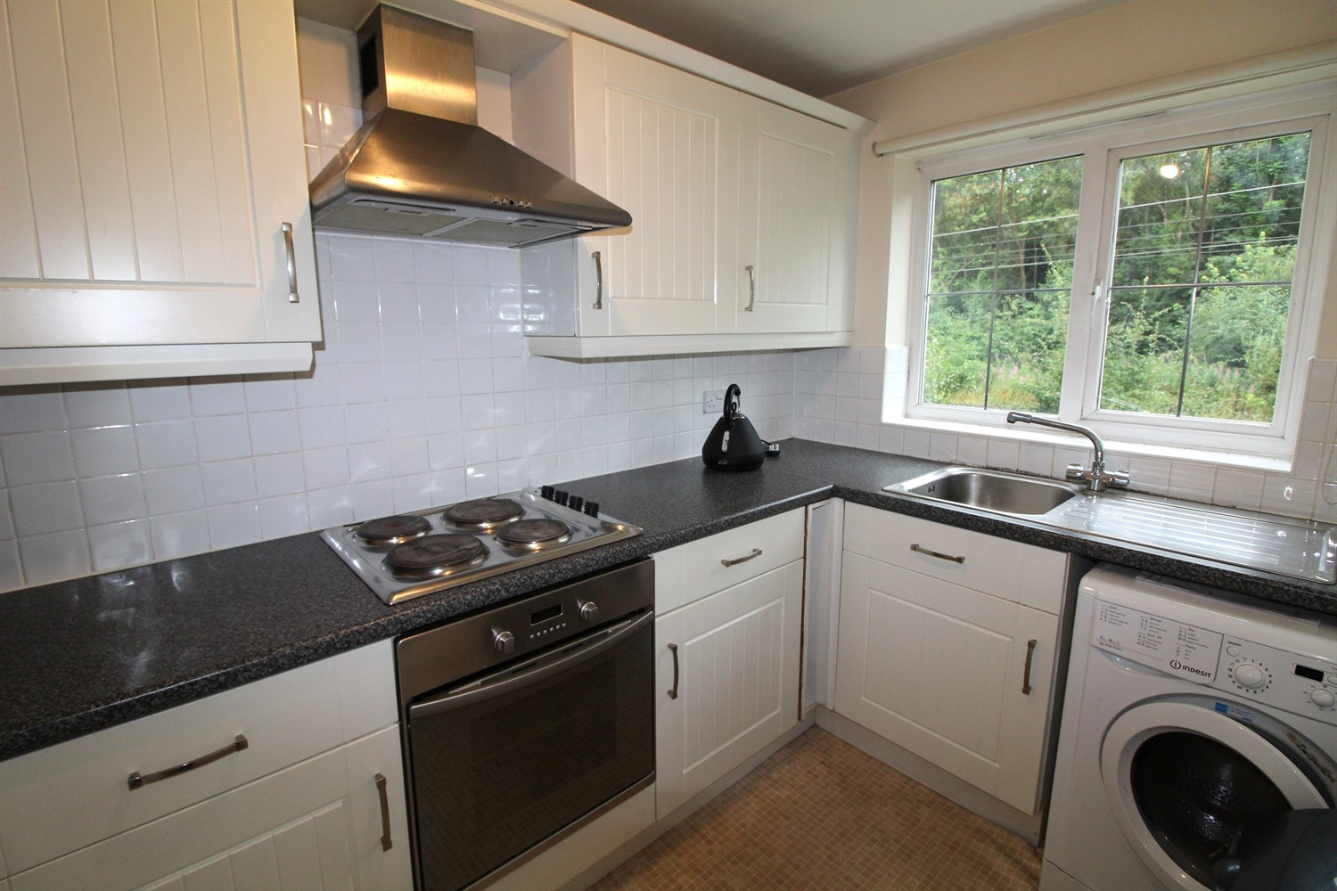

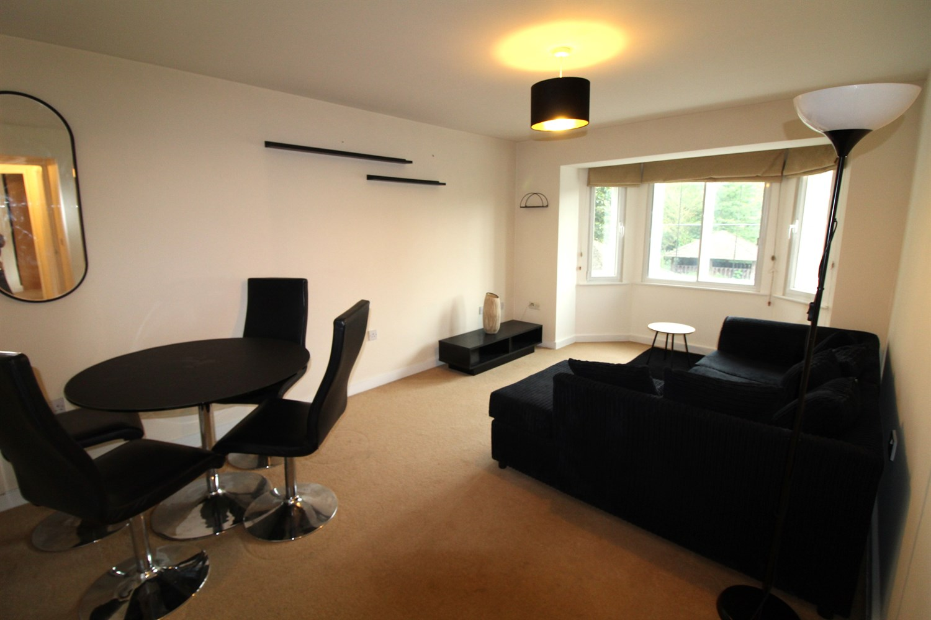

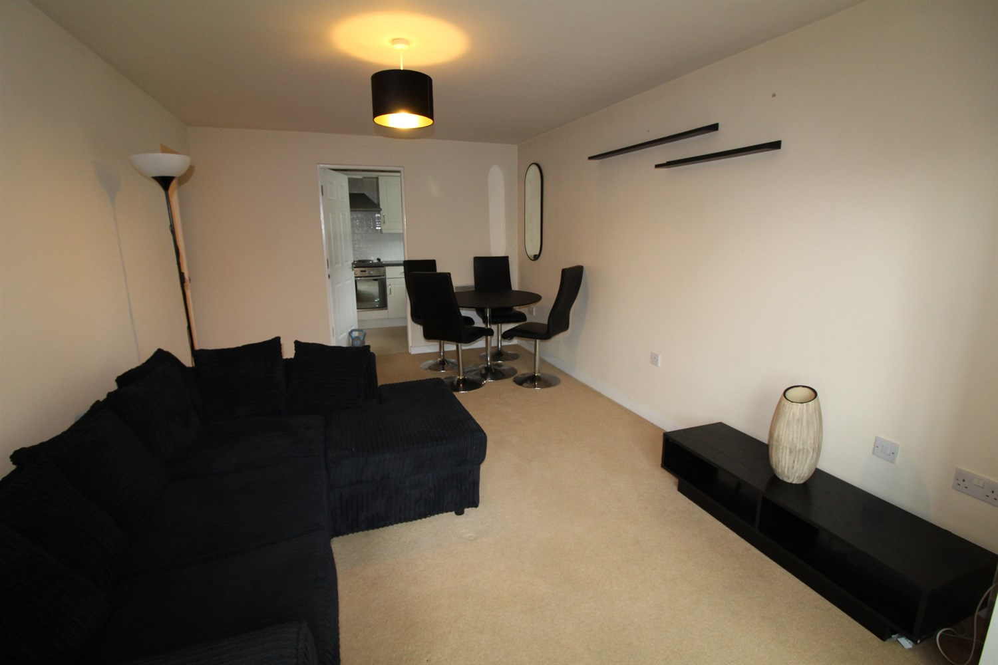

2 Bathroom(s)

1 Reception(s)

2 Bedroom(s)

00

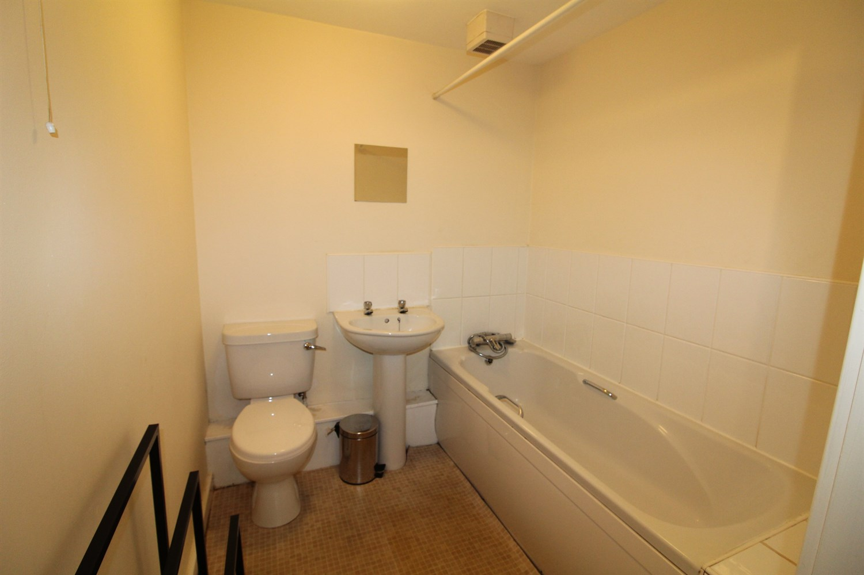

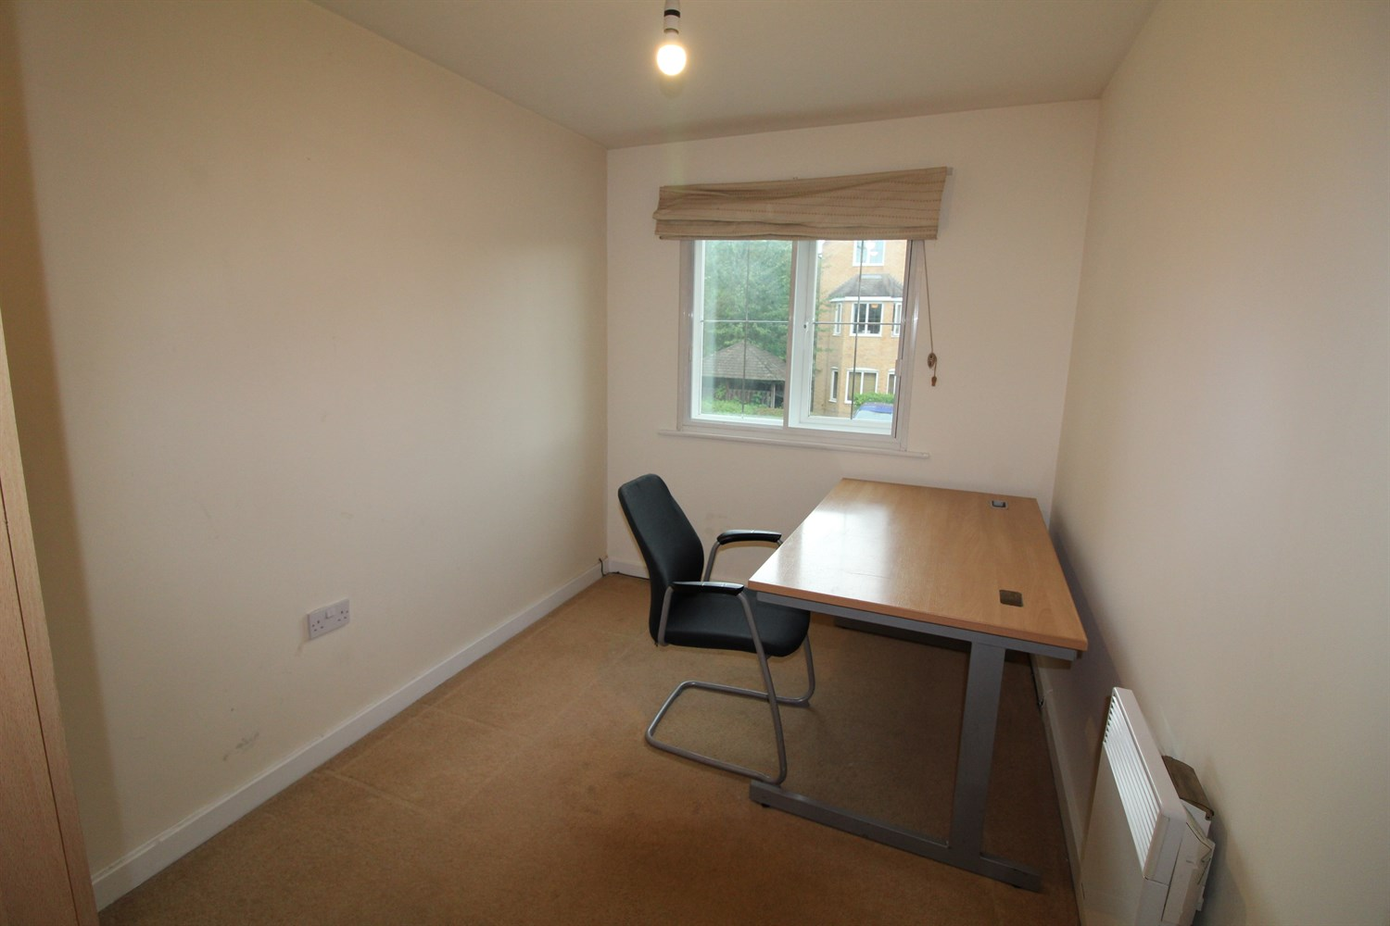

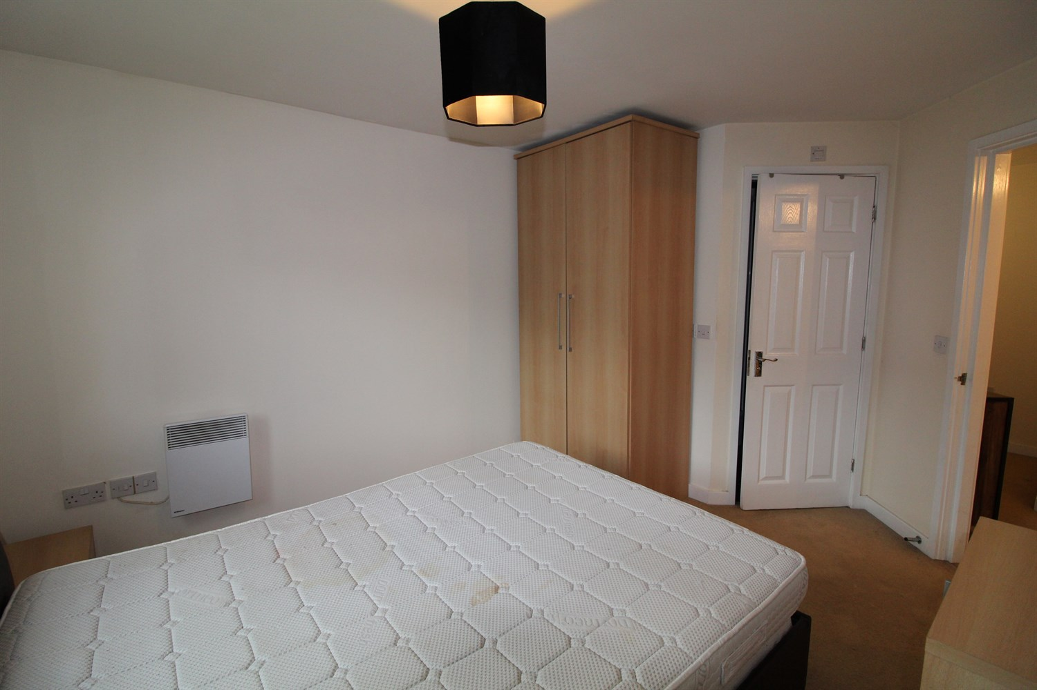

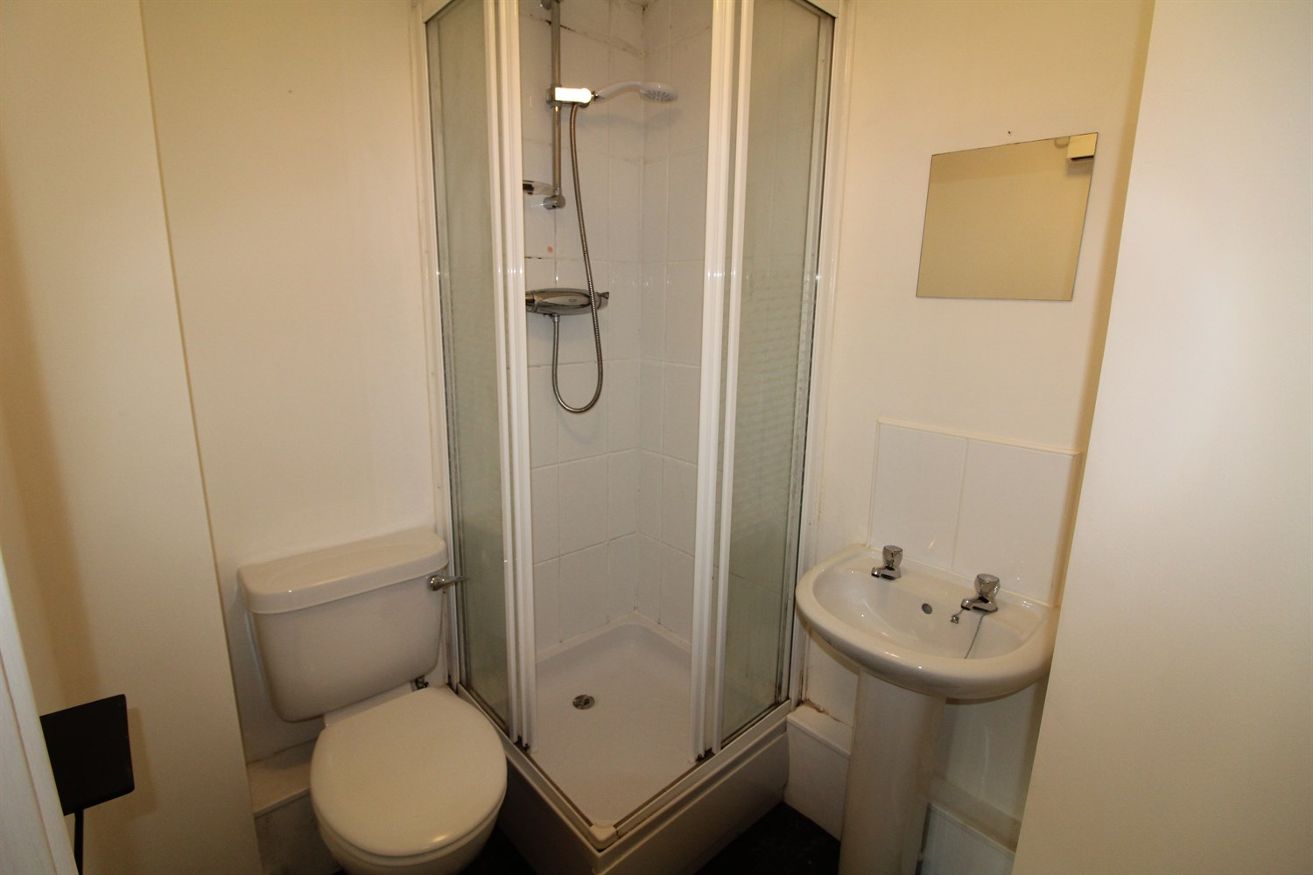

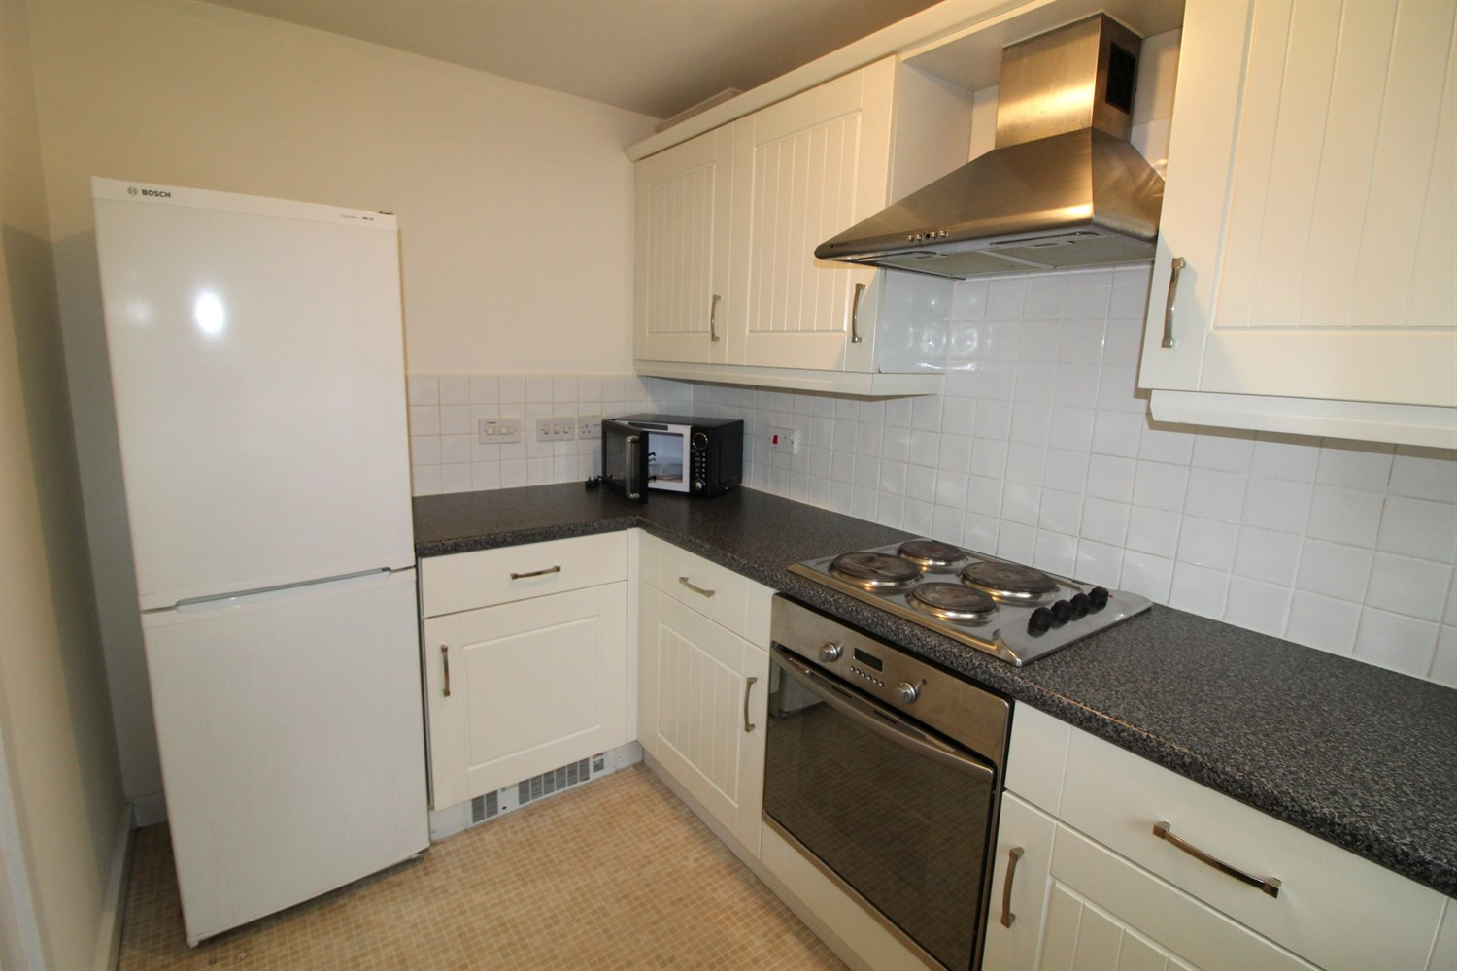

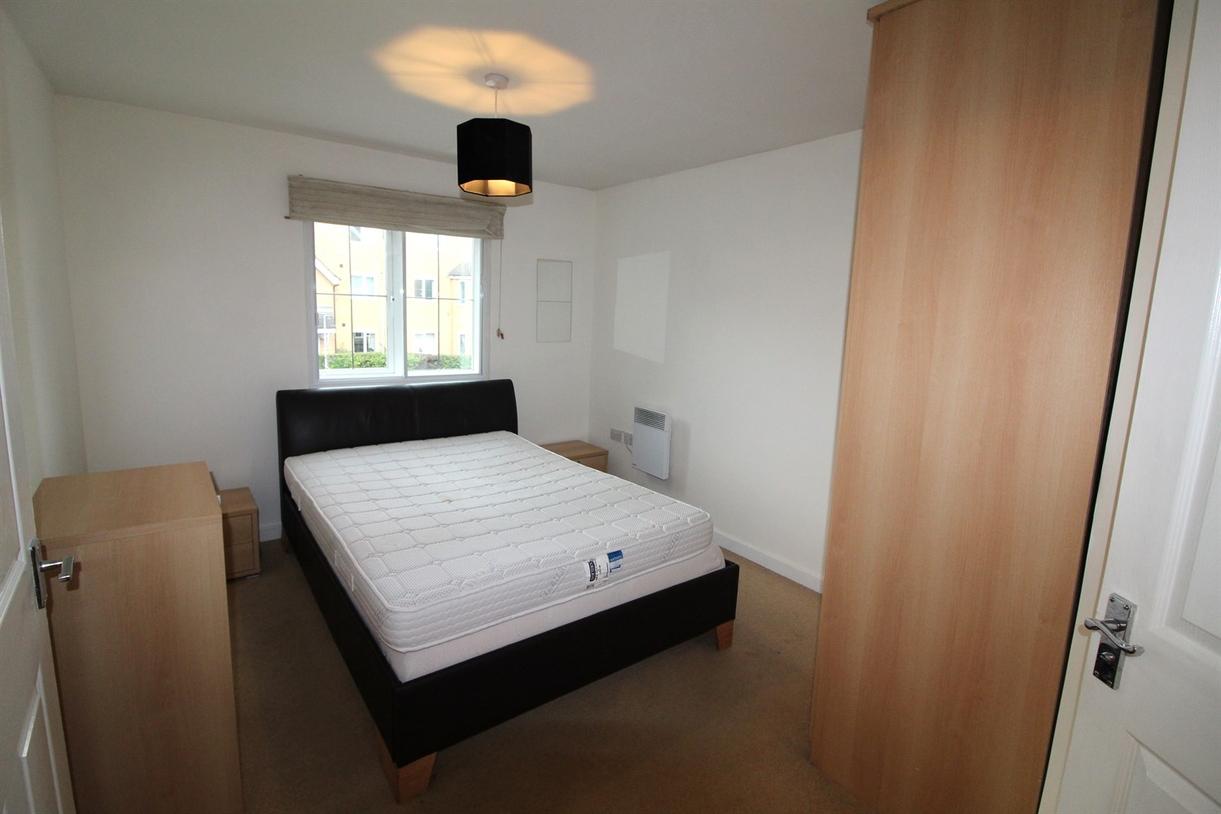

|  |
| --- |
| **Communal Hallway**  Secure communal entrance with stairs to all floors. |
| **Private Entrance Hall**  Entrance hall with storage cupboard. |
| **Lounge/Diner**  Spacious living area with bay window to front. Wall mounted electric radiator. |
| **Kitchen**  Fitted with a range of wall, base and drawer units with worktops over. Single drainer stainless steel sink with mixer tap and drainer. Integrated over with 4-ring hob and extractor above. Plumbed for washing machine. Part tiled walls. Space for fridge freezer. Window to front. |
| **Bedroom 1**  Double bedroom with double glazed window. Wall mounted electric radiator. |
| **En-Suite Shower Room**  Fitted with a three piece suite comprising; shower cubicle, WC and wash hand basin. Tiled walls. |
| **Bedroom 2**  Double bedroom with double glazed window. Wall mounted electric radiator. |
| **House Bathroom**  Fitted with a three piece white suite comprising; bath, WC and wash hand basin. Part tiled wall. Wall mount heated towel rail. |

|  |  |
| --- | --- |
| These particulars are intended to give a fair description of the property, but their accuracy cannot be guaranteed, and they do not constitute an offer of contract. Intending purchasers must rely on their own inspection of the property. None of the above appliances/services have been tested by ourselves. We recommend purchasers arrange for a qualified person to check all appliances/services before legal commitment.  **Property Ref:** 3506  **For more information, please contact**  0113 258 1150 **|** [lettings@adairpaxton.co.uk](mailto:lettings@adairpaxton.co.uk) **|** www.adairpaxton.co.uk |  |