

**Wheatlands Road East, Harrogate**

**For Sale £850,000.00**

***CALLING ALL BUILDERS/INVESTORS*** This substantial detached property is part way through a significant extension and refurbishment project and now requires some investment in order to complete the project. A considerable amount of building and extension work has already been completed and the buyers will have the unique opportunity to complete the work to suit their own requirements. The plans have been well thought out with almost every detail already taken in to consideration. The floorplan represents the finished product and the framework is already there. The property (once finished) will comprise: Entrance hall, sitting room, a tremendous dining kitchen/family room, generous utility room, playroom, office and guest cloakroom to the ground floor. To the first floor there are five double bedrooms (including a master suite with shower room and dressing room and a second en-suite bedroom) and the house bathroom. To the second floor there are two further double bedrooms and a bathroom. Externally, there will be a driveway, carport and garage with a substantial garden to the rear. Located in a much sought after location on a highly regarded road within a short walk of the Stray parkland and backing on to the reputable St Aidan’s school, this will make a wonderful family home for someone with the right vision and appetite to finish the project! Contact us now for more information or to arrange a viewing.

**0113 258 1150**

**0800 000 000**

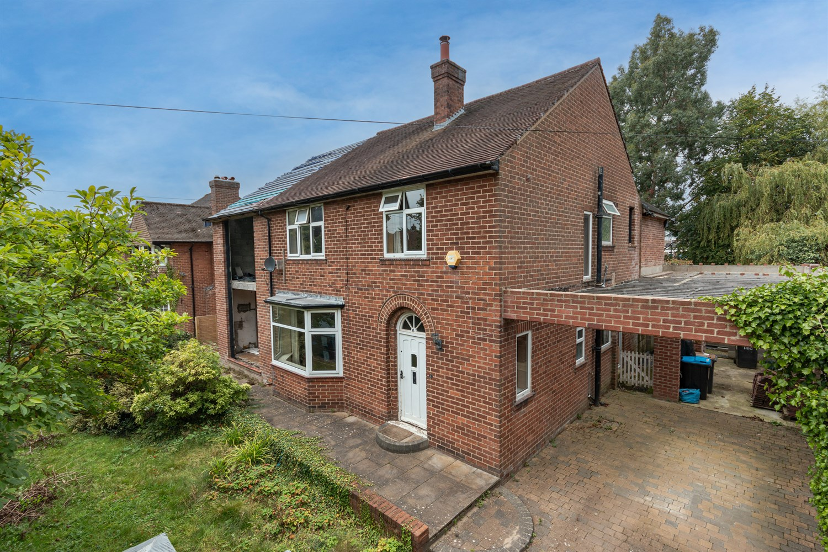

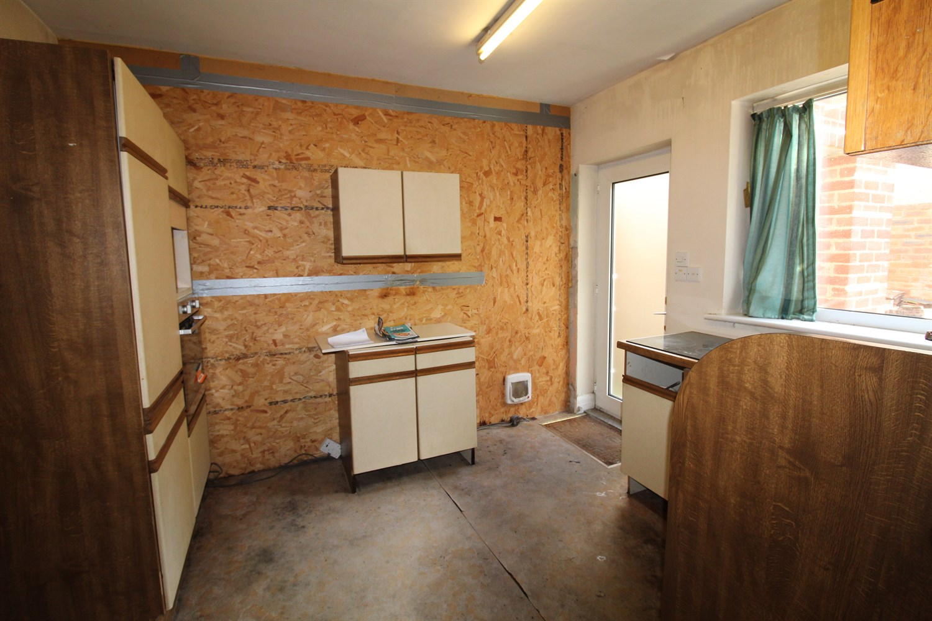

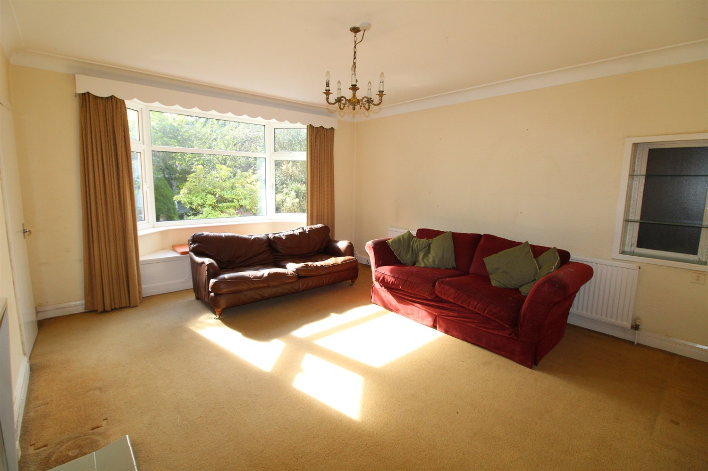

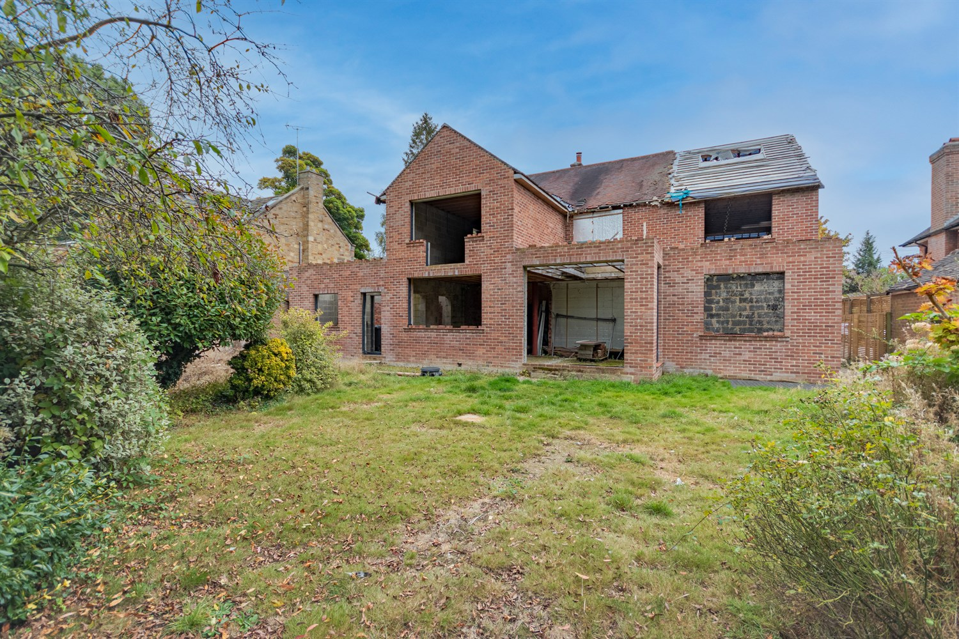

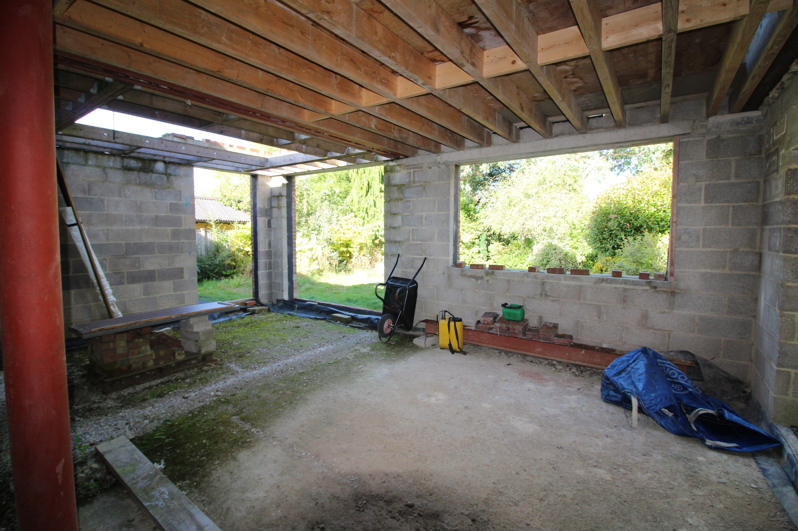

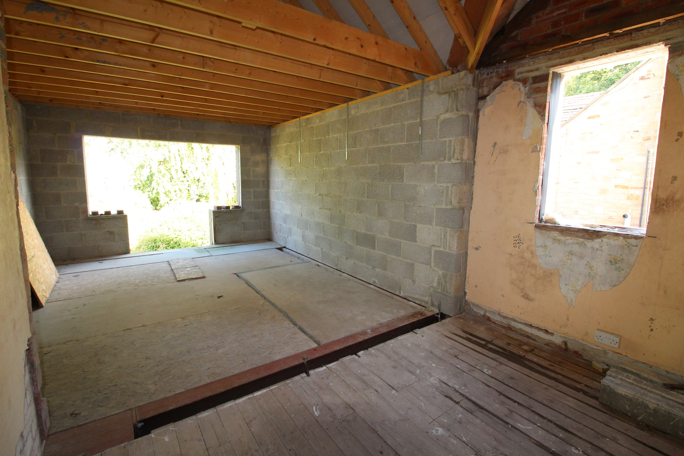

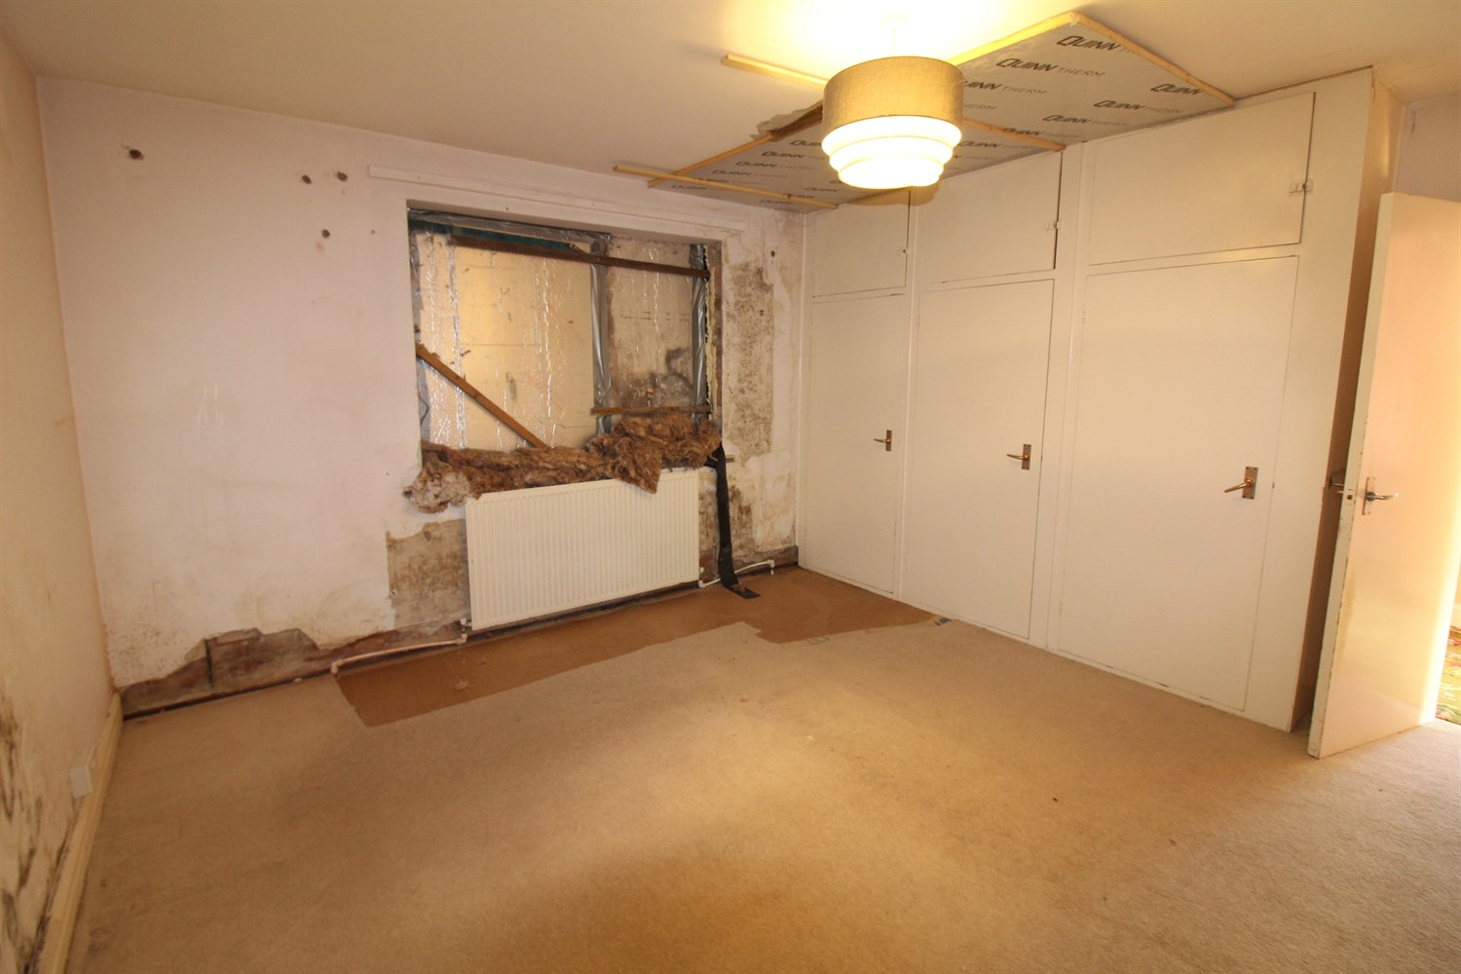

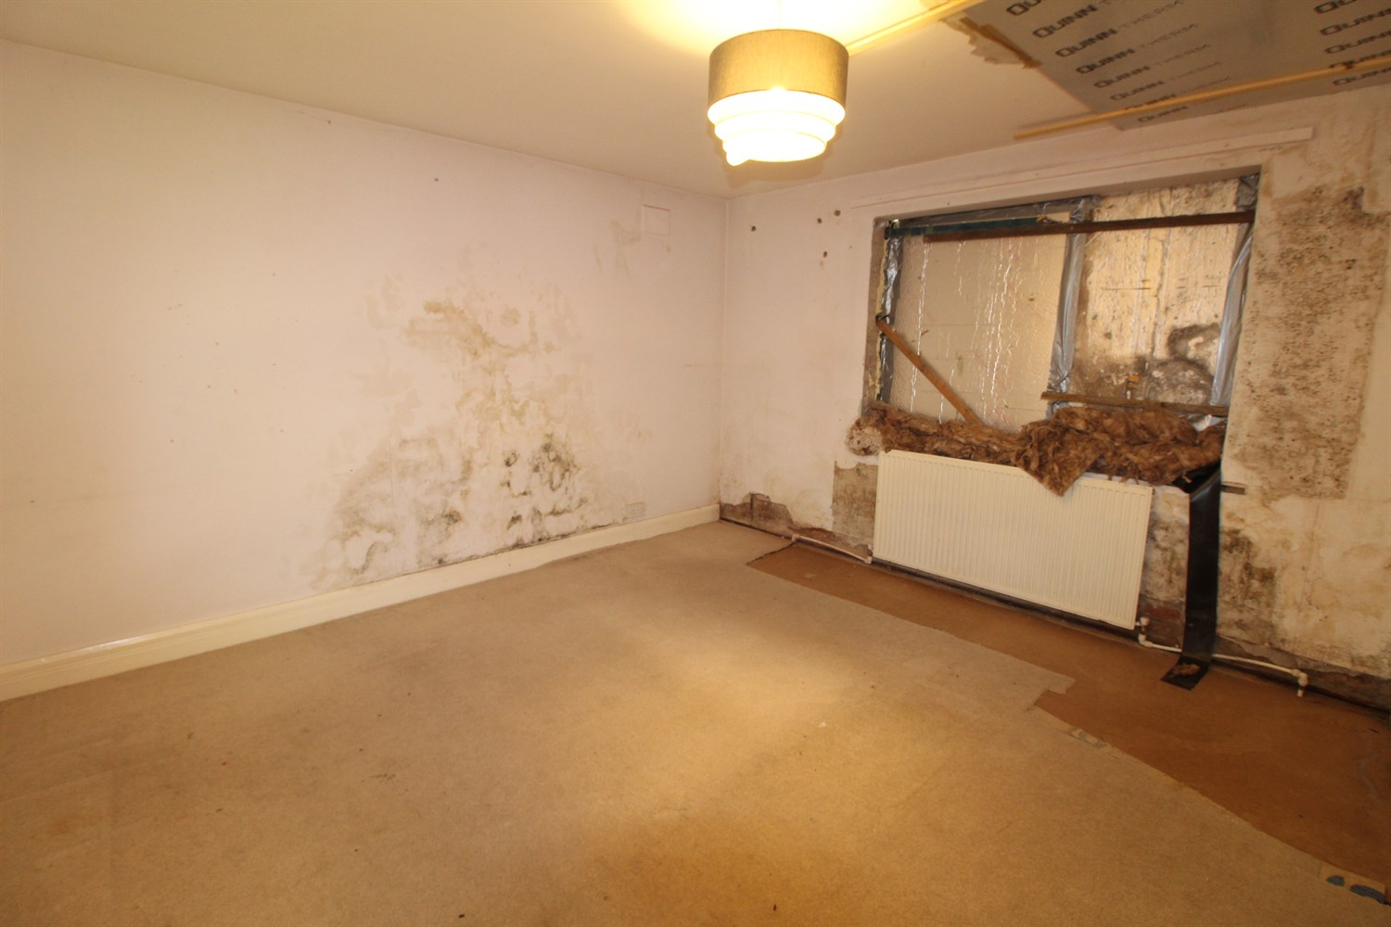

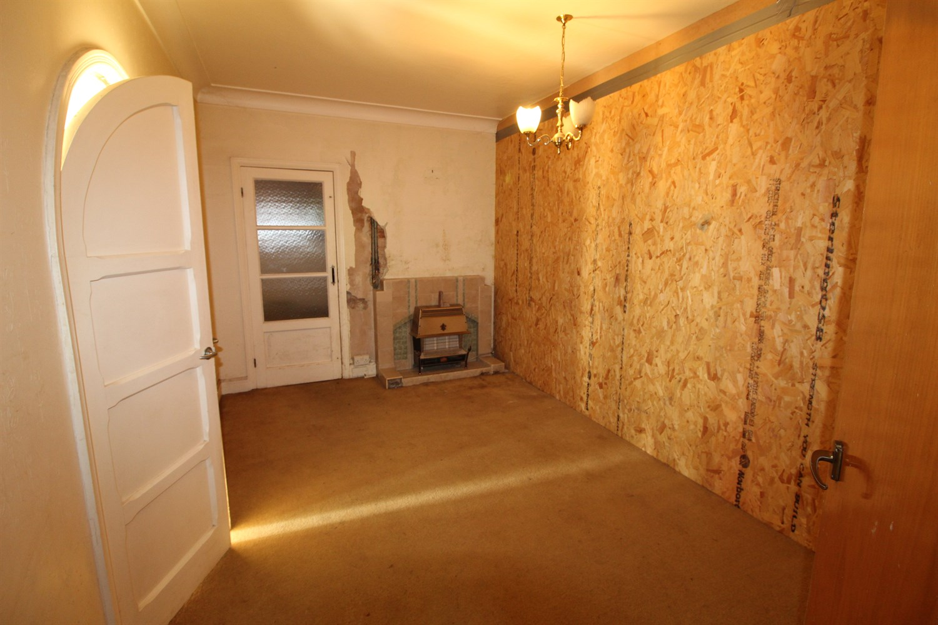

|  |
| --- |
| **Planning Permission**  The various planning consents and approvals for the development can be found on the Harrogate planning portal by searching reference numbers 20/03739 and 18/01750/FUL |
| **Accommodation**  The work carried out so far has been done in accordance with the Planning Permission which has been granted. The works so far consist of a single/double story rear extension and the start of a loft conversation to create two further bedrooms. Upon completion of the works, the accommodation will briefly comprise; Entrance hall, spacious dining/kitchen with snug area, utility, sitting room, family room, study and guest WC to the ground floor. To the first floor there is a master bedroom with a dressing room and en-suite bathroom, a second double bedroom with an en-suite shower room, three further bedrooms and a house bathroom. Externally the property has a driveway to the front leading to a carport and garage. To the rear there is an extensive garden which boasts a lawned garden with borders of flowers, trees and shrubs. The gardens are a particular feature of this fine house and enjoy a good deal of privacy. |
| **Entrance Hall** |
| **Dining Kitchen 7.72m (25'4) x 9.15m (30'0)** |
| **Snug Area 4.24m (13'11) x 4.15m (13'7)** |
| **Utility 4.38m (14'4) x 1.5m (4'11)** |
| **Sitting Room 4.24m (13'11) x 4.78m (15'8)** |
| **Family Room 3.68m (12'1) x 9.09m (29'10)** |
| **Study 3.68m (12'1) x 2.45m (8'0)** |
| **Guest WC** |
| **Landing** |
| **Bedroom 1 3.67m (12'0) x 5.04m (16'6)** |
| **En-suite Bathroom** |
| **Dressing Room** |
| **Bedroom 2 3.87m (12'8) x 5.49m (18'0)** |
| **En-suite shower room** |
| **Bedroom 3 4.24m (13'11) x 3.89m (12'9)** |
| **Bedroom 4 4.24m (13'11) x 4.08m (13'5)** |
| **Bedroom 5 3.33m (10'11) x 3.29m (10'10)** |
| **House Bathroom** |
| **Second Floor** |
| **Bedroom 6** |
| **Bedroom 7** |

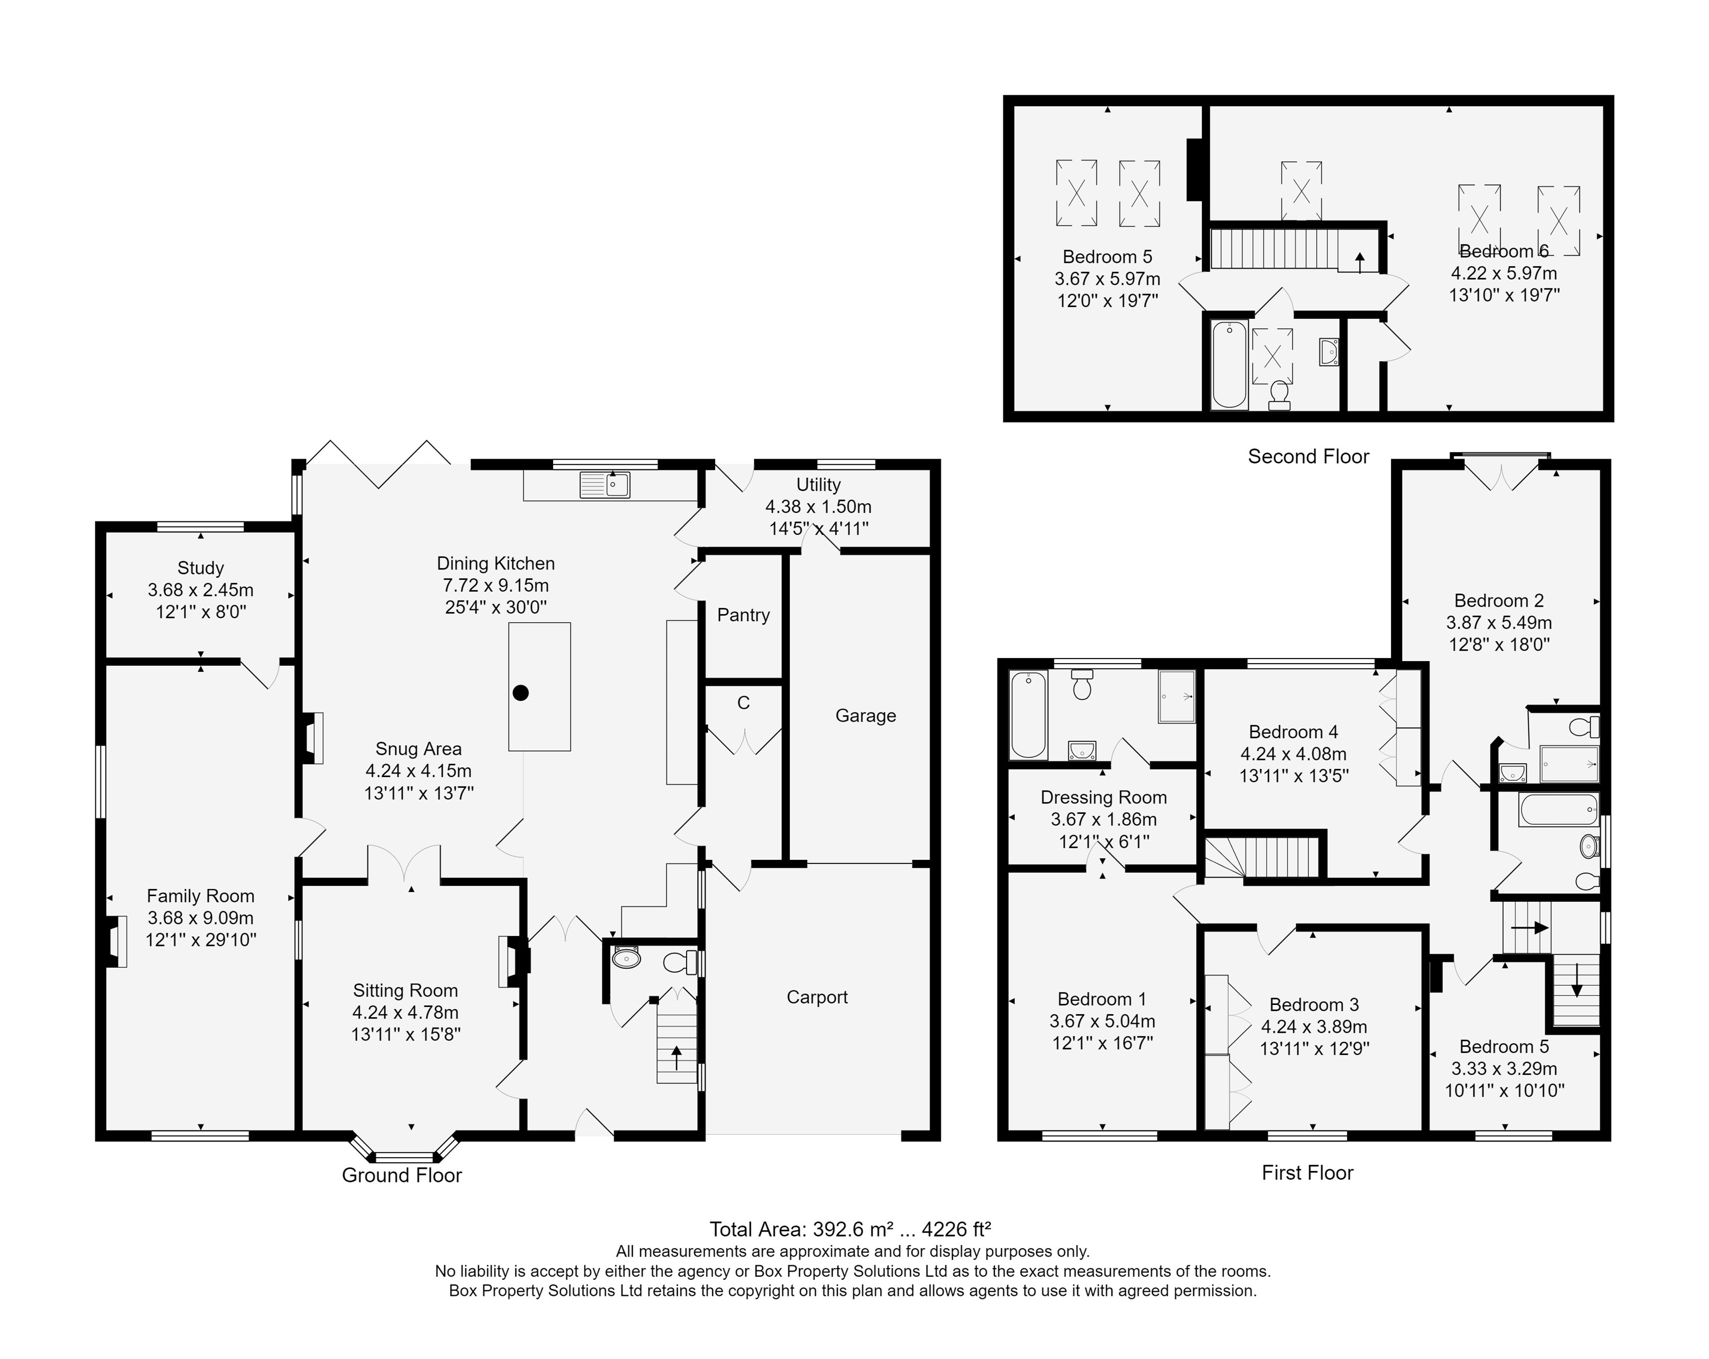

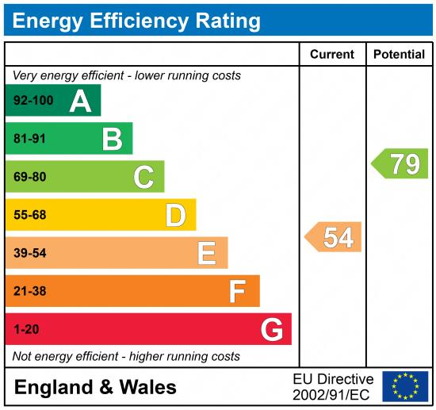

|  |
| --- |
|  |

These particulars are intended to give a fair description of the property, but their accuracy cannot be guaranteed, and they do not constitute an offer of contract. Intending purchasers must rely on their own inspection of the property. None of the above appliances/services have been tested by ourselves. We recommend purchasers arrange for a qualified person to check all appliances/services before legal commitment.

**Property Ref:** 3865

**For more information, please contact**

0113 258 1150 **|** [sales@adairpaxton.co.uk](mailto:sales@adairpaxton.co.uk) **|** www.adairpaxton.co.uk