

**0113 258 1150**

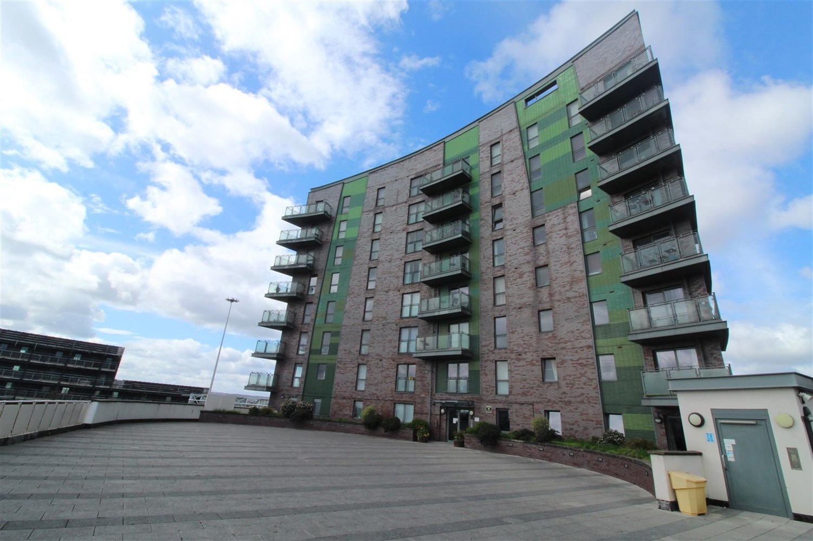



**Available to let £650.00pcm**

**Echo Central 2, Leeds**

Adair Paxton have pleasure in offering a Studio Apartment within the exciting Echo Central Two Development. Only a short walk from Clarence Dock and the City Centre beyond, the apartments offer a superb base for the young professional looking for a high standard of living accommodation. Being FULLY FURNISHED to a contemporary and luxurious style with stylish Kitchens, Bathrooms and Furniture. Internal viewing essential to appreciate the quality of this stunning studio. Council Tax Band A, EPC rating C. Available 21st February 2025. Deposit £750.

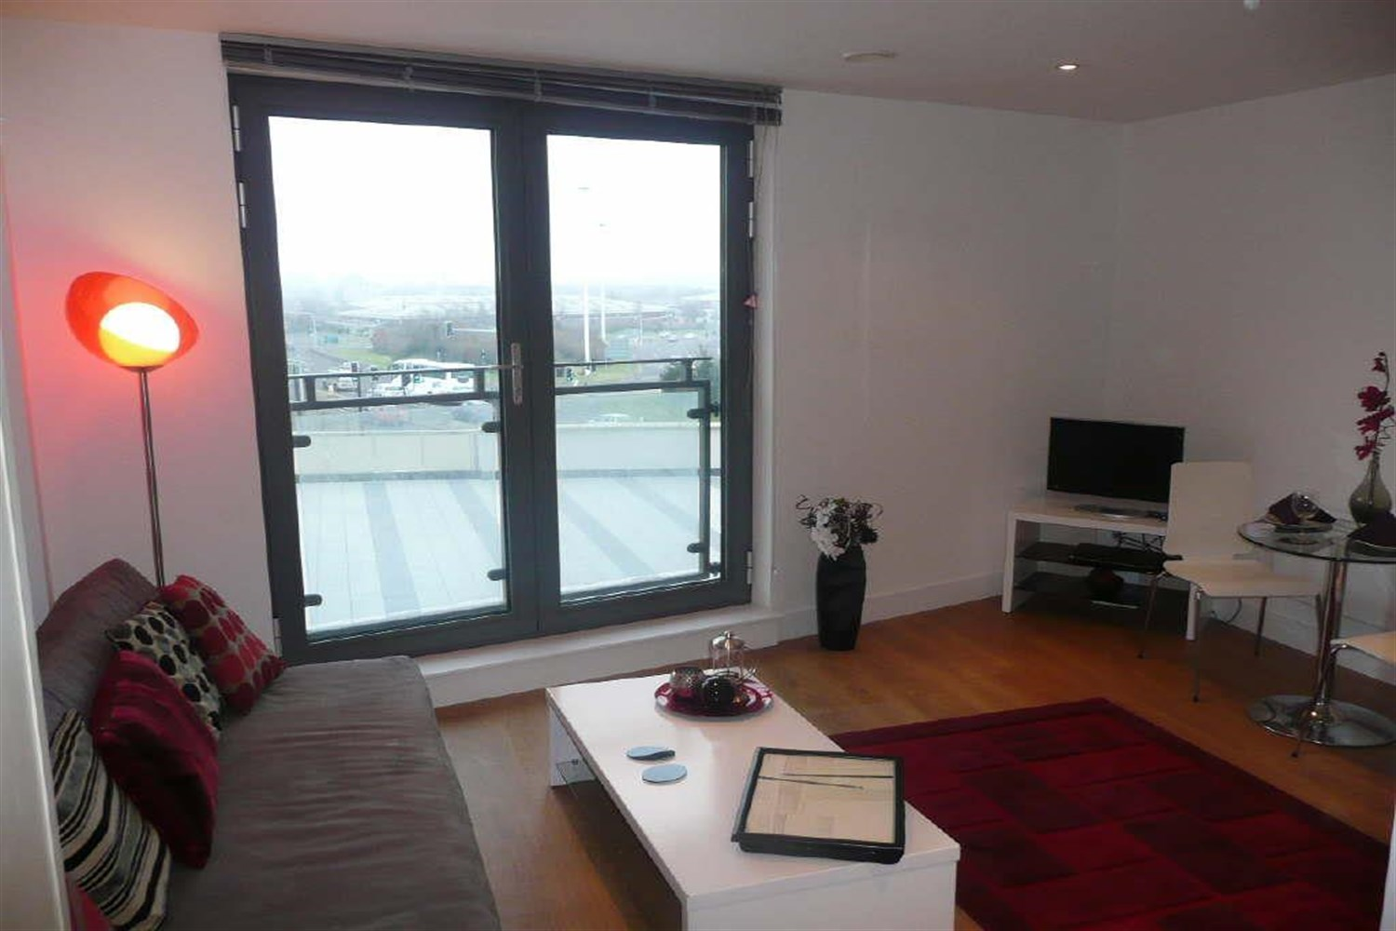

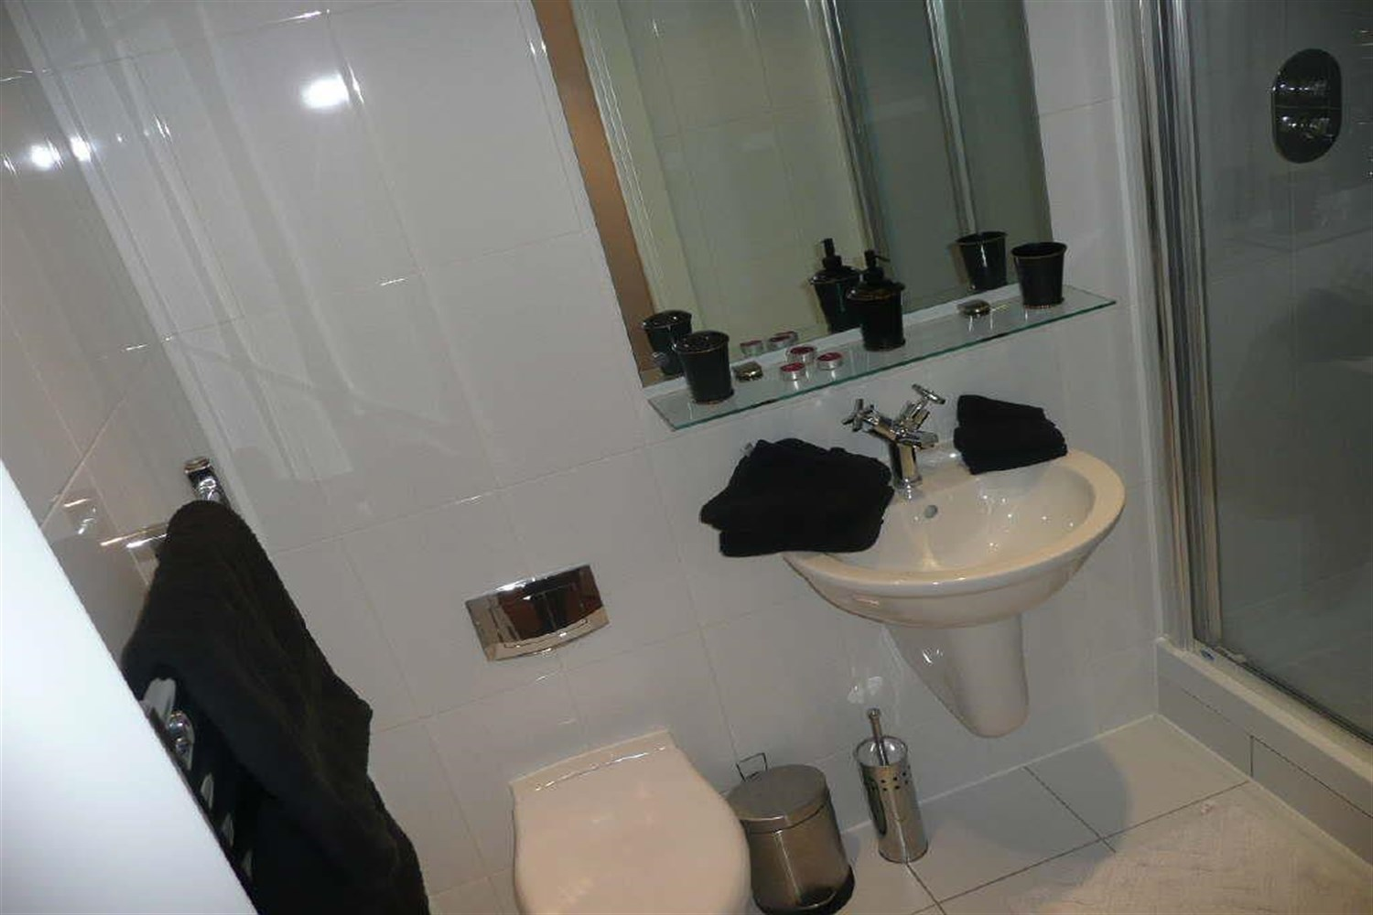

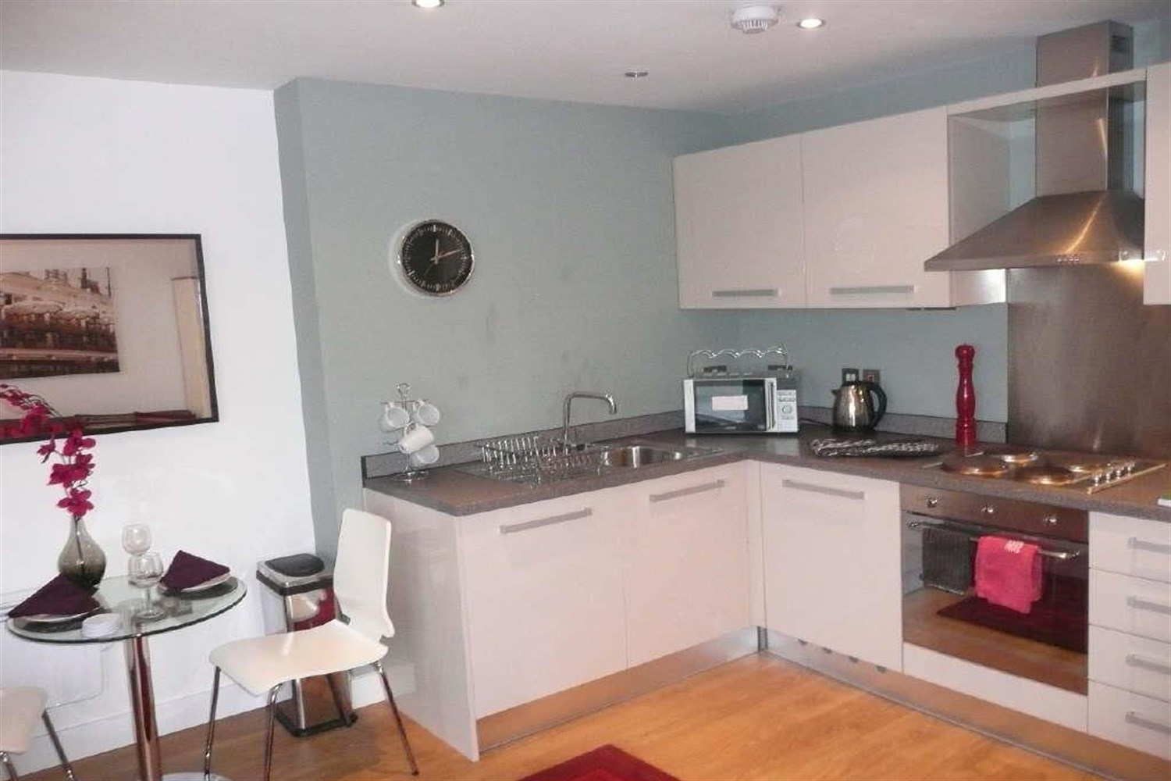

1 Bathroom(s)

1 Reception(s)

0 Bedroom(s)

00

|  |
| --- |
| **Communal Entrance**  Communal entrance with lift to all floors. |
| **Private Entrance Hall**  Hallway with intercom. |
| **Open Plan Kitchen/ Living Room and Bedroom**  Open plan living area, with a pull out sofa bed, dining area and kitchen fitted with a range of wall and base units with work tops over. Electric oven and hob, stainless steel sink with mixer tap. |
| **Shower Room**  Walk in shower, w/c and hand wash basin, large mirror, tiled walls and floor. |
| **Home Information**  COUNCIL TAX BAND: A EPC Rating B  Leasehold property Broadband: Standard 9 Mbps 0.9 Mbps Good Superfast 80 Mbps 20 Mbps Good Ultrafast 1000 Mbps 1000 Mbps  Mobile availability: EE Limited ThreeLikely to have good coverage O2 Likely to have good coverage Vodafone Likely to have good coverage.  Electric mains supply, water on mains supply. |

|  |  |
| --- | --- |
| These particulars are intended to give a fair description of the property, but their accuracy cannot be guaranteed, and they do not constitute an offer of contract. Intending purchasers must rely on their own inspection of the property. None of the above appliances/services have been tested by ourselves. We recommend purchasers arrange for a qualified person to check all appliances/services before legal commitment.  **Property Ref:** 4952  **For more information, please contact**  0113 258 1150 **|** [lettings@adairpaxton.co.uk](mailto:lettings@adairpaxton.co.uk) **|** www.adairpaxton.co.uk |  |