

**0113 258 1150**

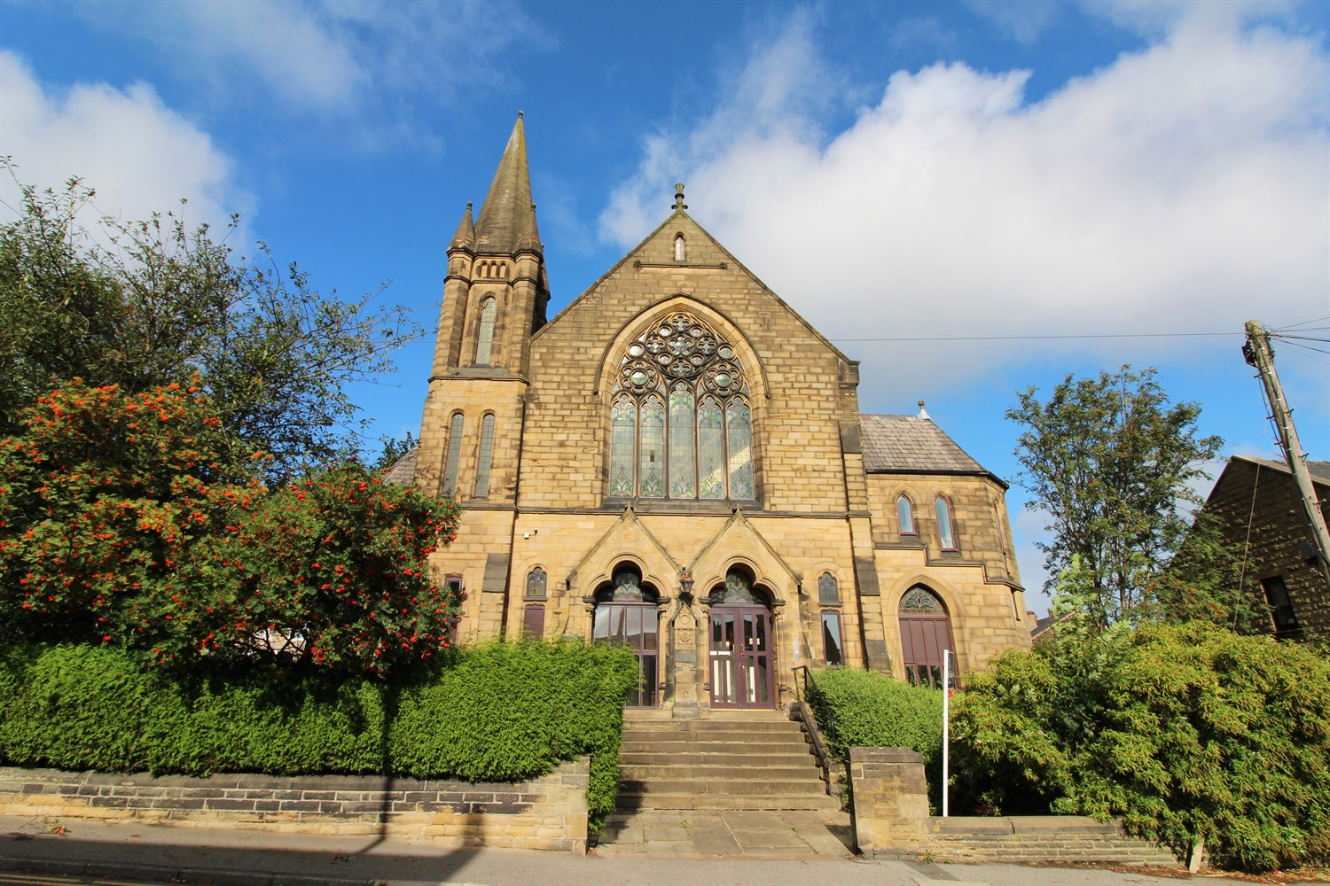



**For Sale £115,000.00**

**Fountain Hall, Morley, LS27**

***TWO BED GROUND FLOOR APARTMENT IN THIS BEAUTIFUL CHAPEL CONVERSION WITH ALLOCATED PARKING***Suitable for the young professional, this property is within walking distance of the Train station and close to the motorway network and all the amenities of Morley Town Centre. The property benefits from electric heating and tasteful decor. Comprising; Entrance hall, spacious L shaped lounge/diner, separate kitchen with oven/hob/extractor, fridge/freezer and washing machine, two bedrooms and house bathroom with shower over the bath. Allocated parking.

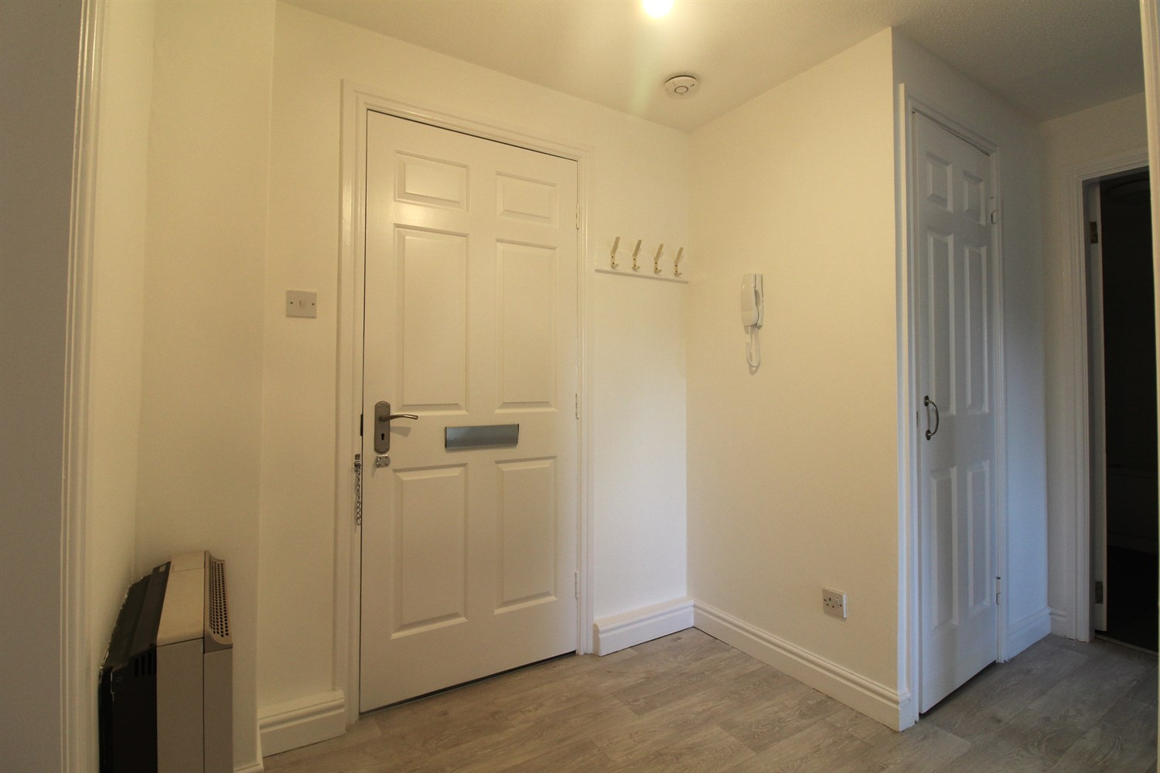

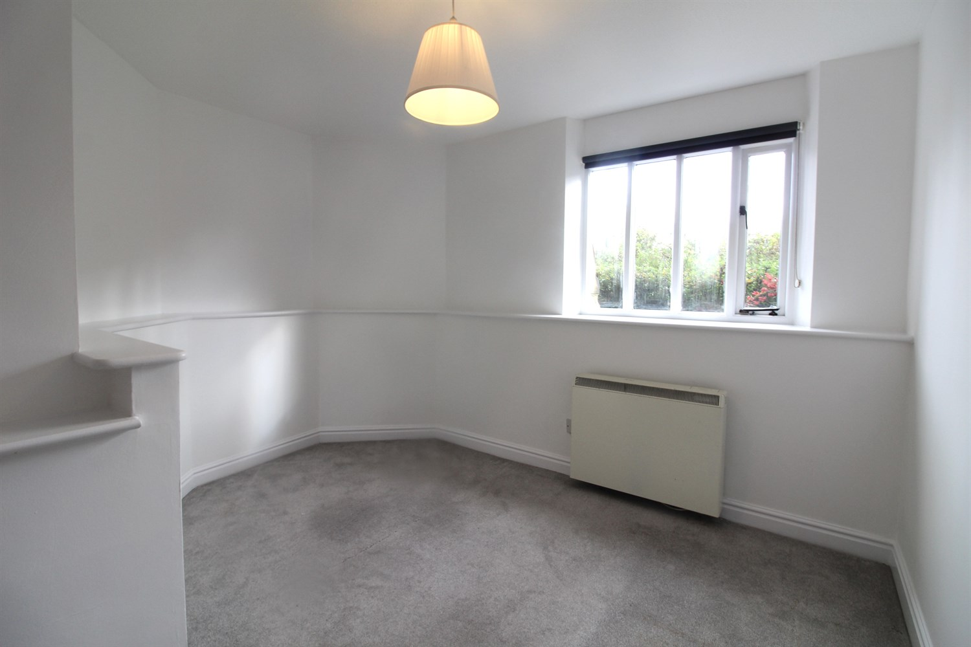

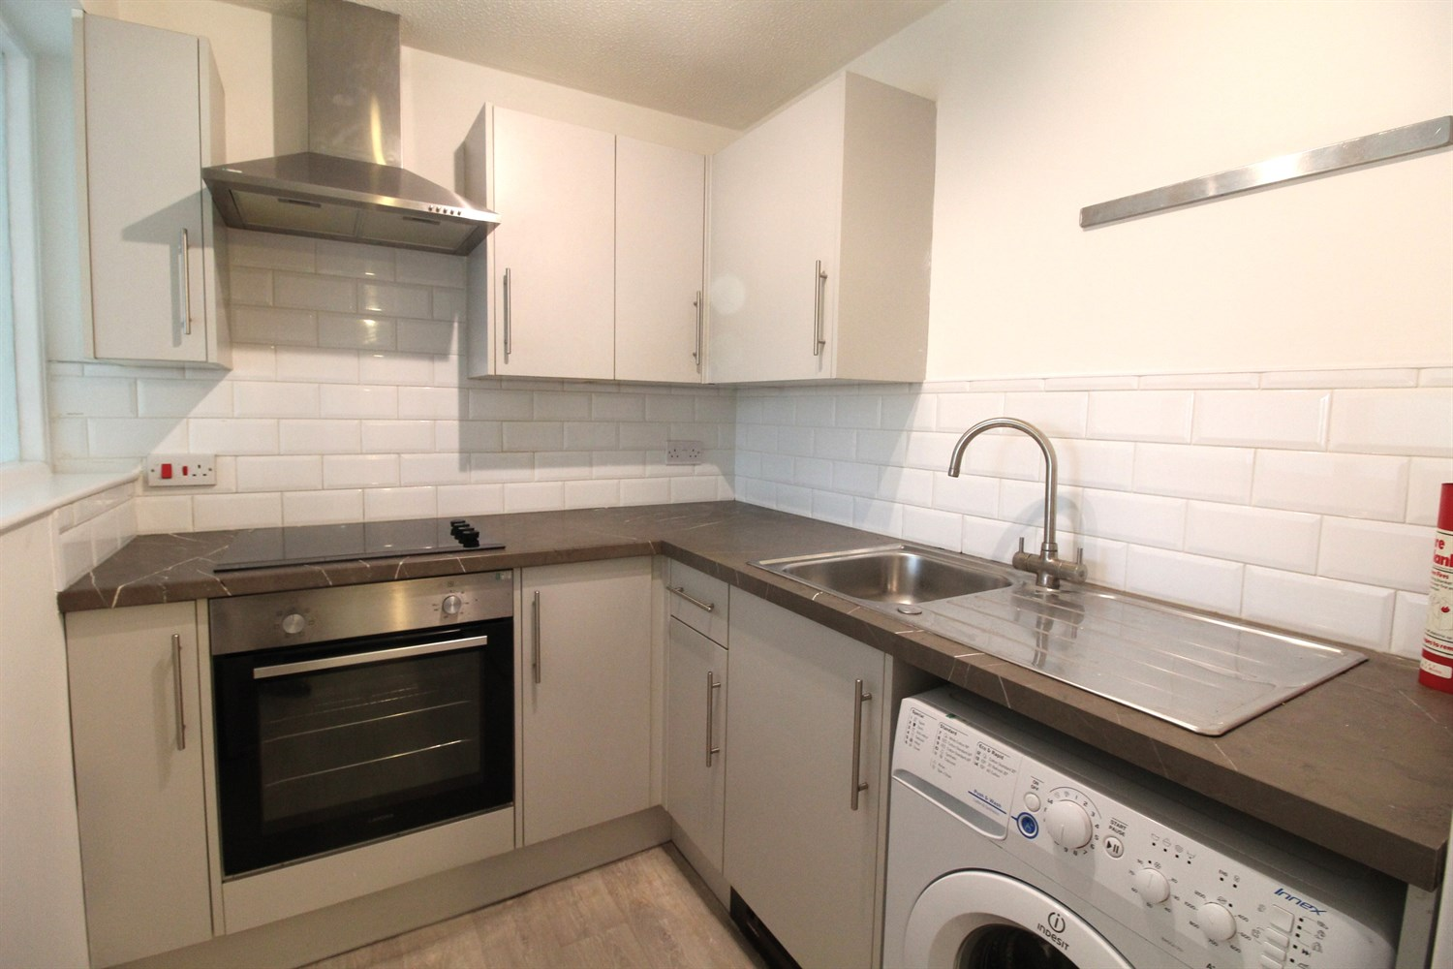

1 Bathroom(s)

1 Reception(s)

2 Bedroom(s)

00

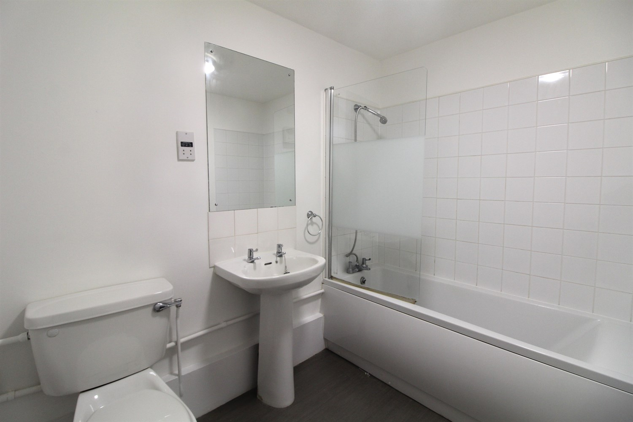

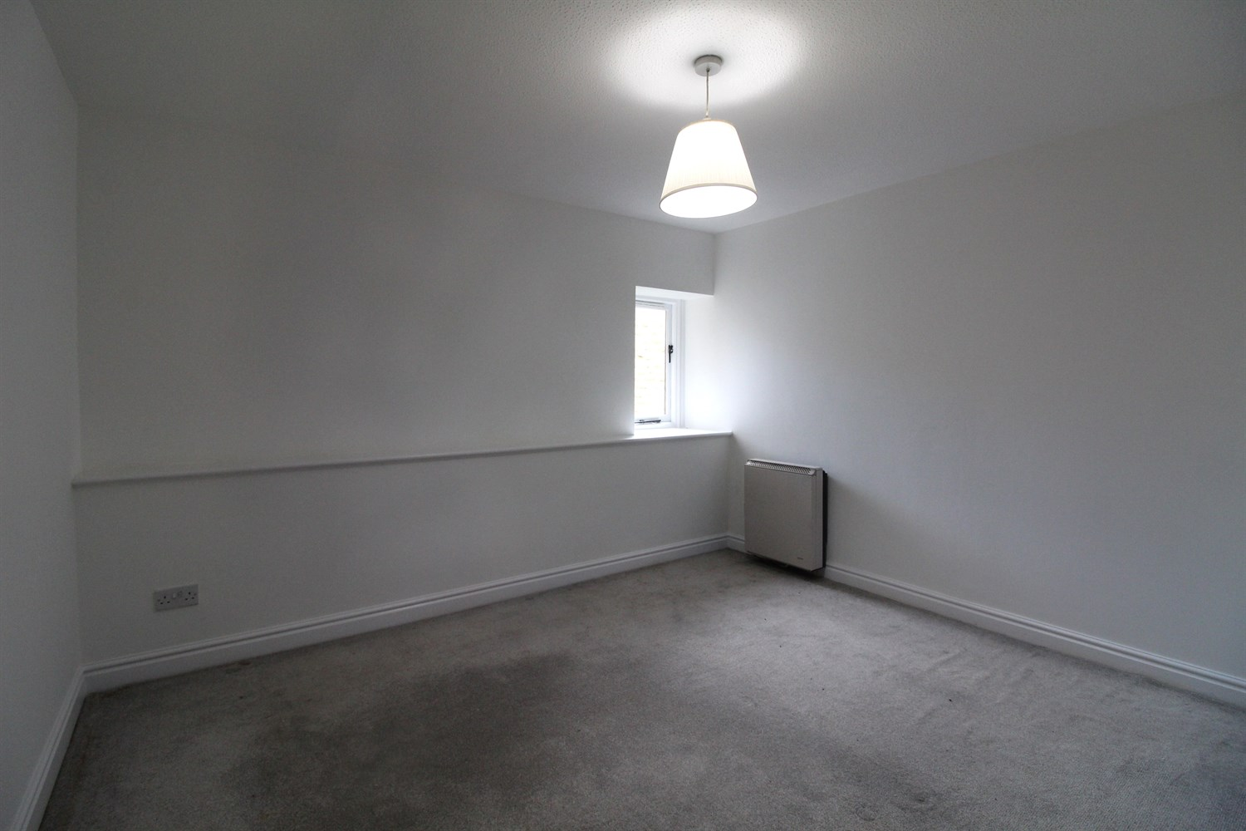

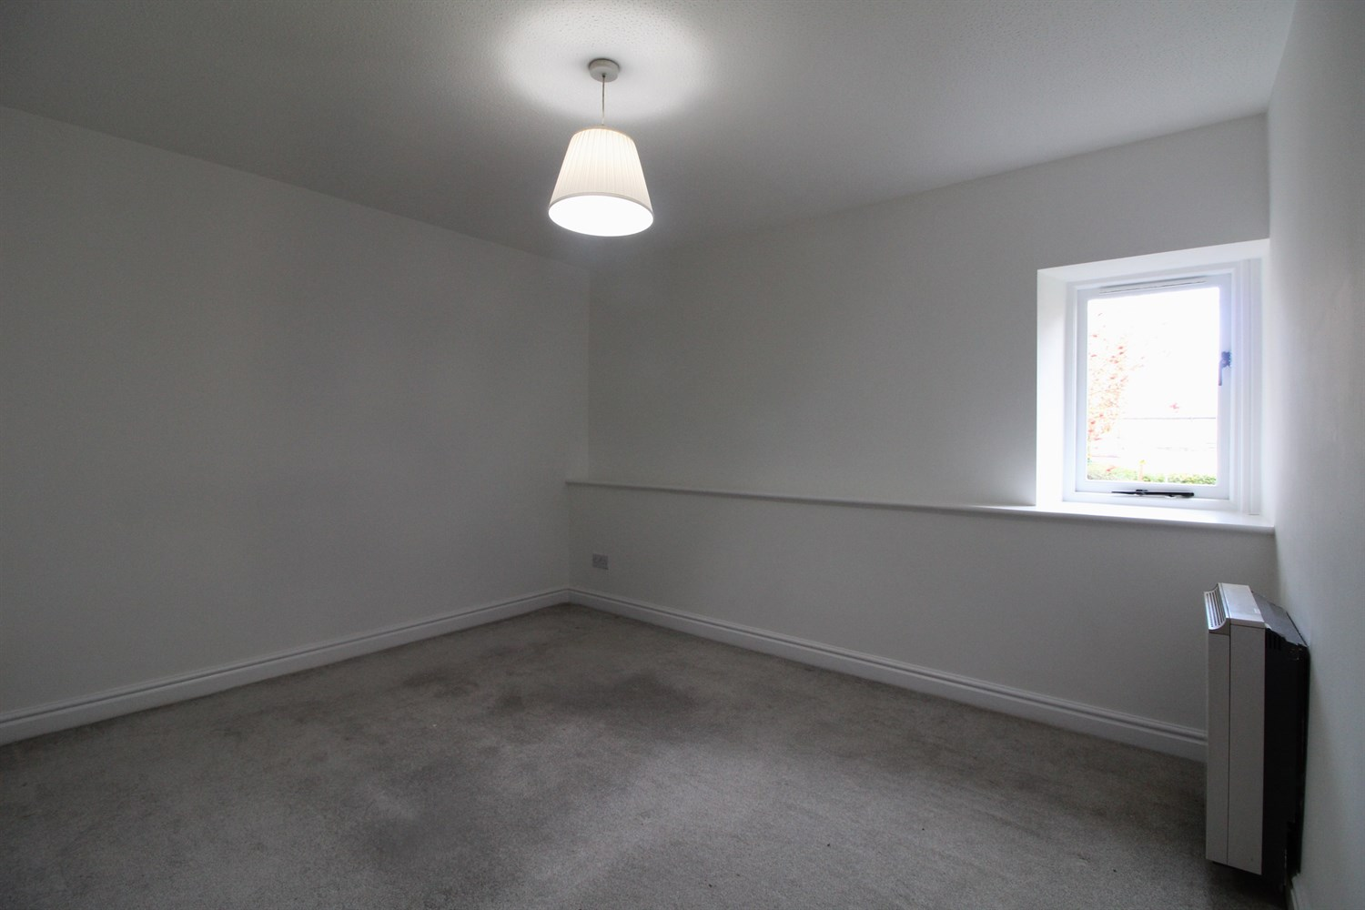

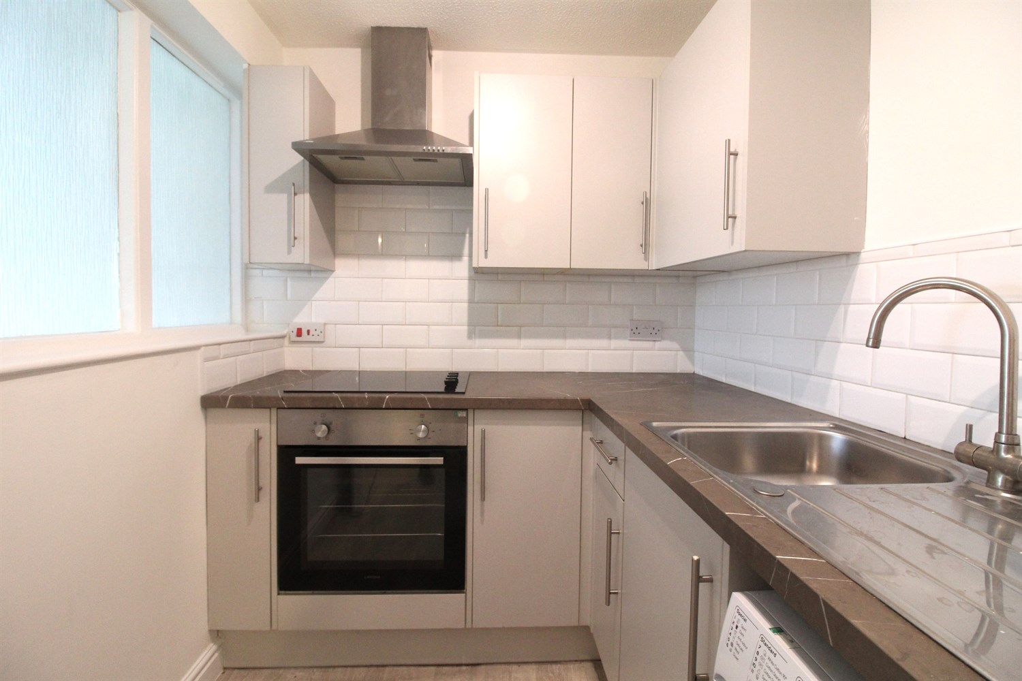

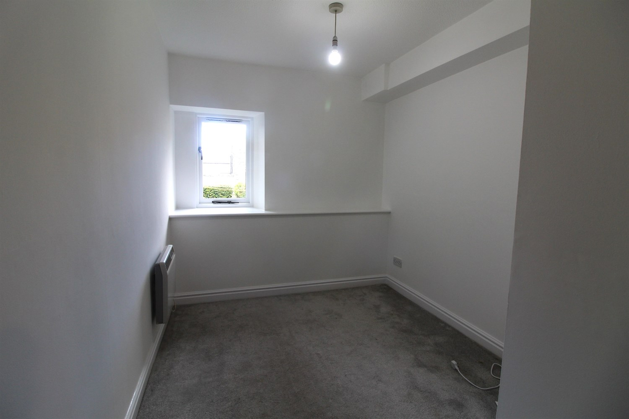

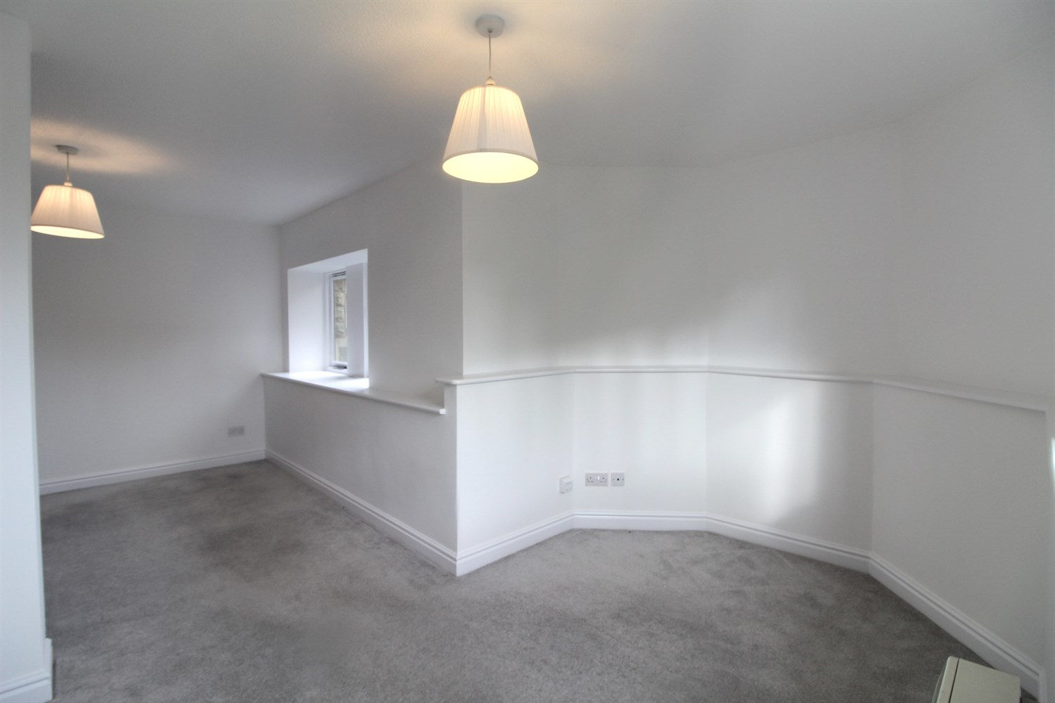

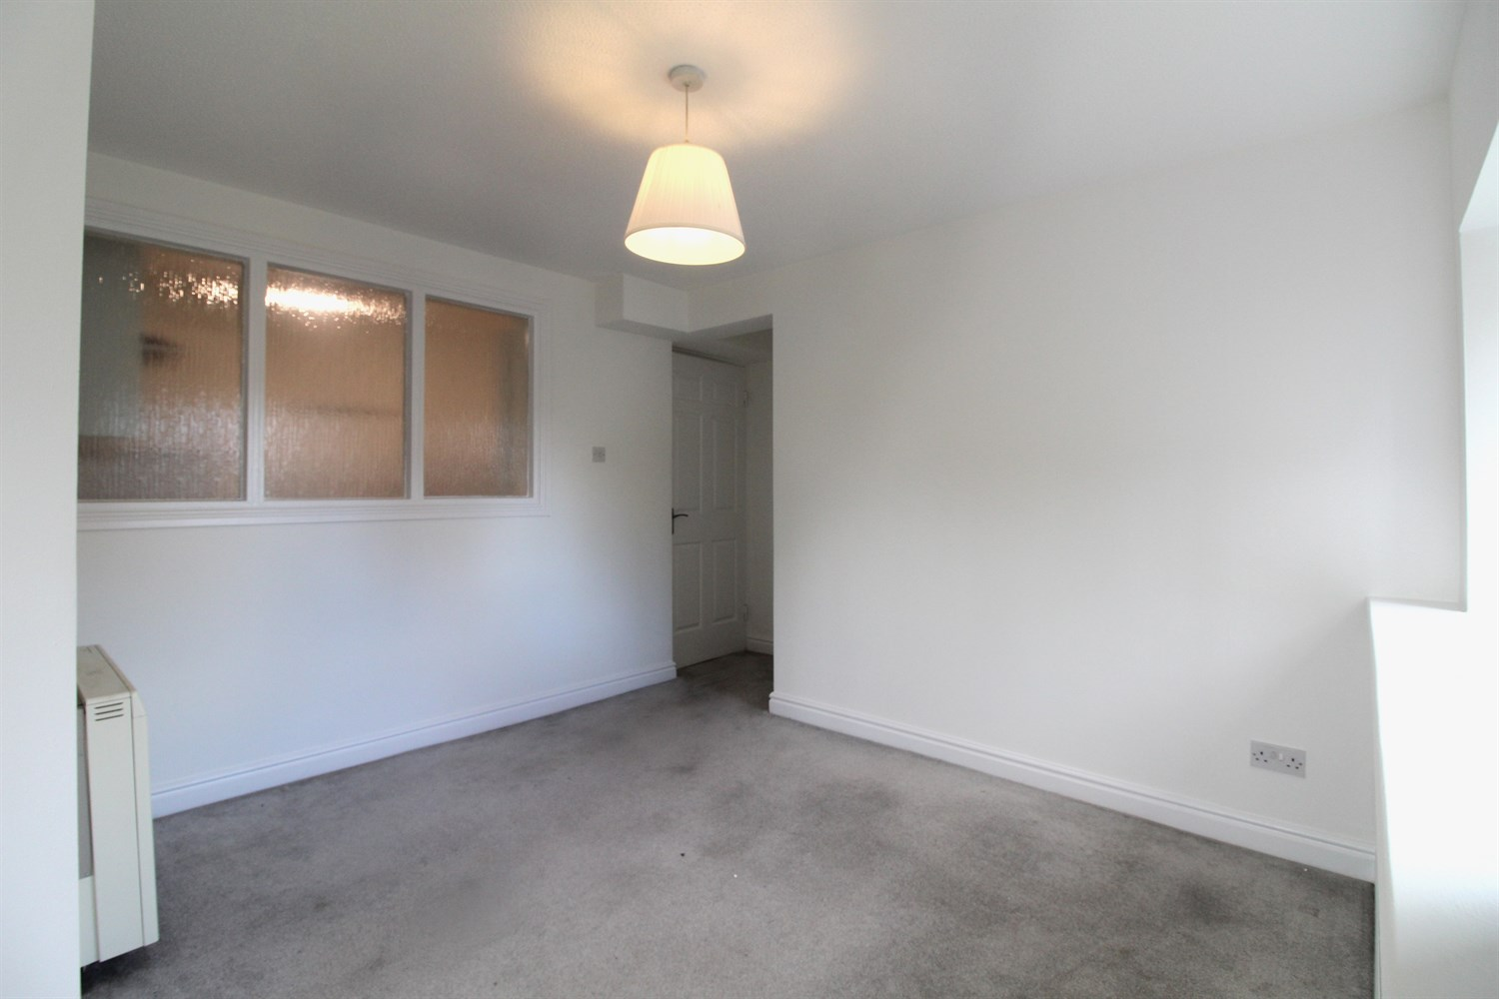

|  |
| --- |
| **Entrance Hall**  Via front Entrance Door. Secure entry phone system. Wall mounted electric heater. |
| **Lounge**  Light and airy living area with two windows. Wall mounted electric heater. |
| **Kitchen**  Fitted with a range of wall, base and drawer units with worktops over. Stainless steel sink with drainer and mixer tap. Integrated electric over with 4-ring electric hob and extractor hood over. Part tiled walls. Space for washing machine and fridge freezer. |
| **Bedroom 1**  Double bedroom with window. Wall mounted electric heater. |
| **Bedroom 2**  Double bedroom with window. Wall mounted electric heater. |
| **Bathroom**  Fitted with a three piece white suite comprising; bath with shower over, wash hand basin and WC. Part tiled walls. |
| **Outside**  Allocated parking and maintained communal gardens. |
| **Tenure**  Leasehold - 99 years from July 1989 (64 years remaining) Ground Rent - £50 |
| **Service Charge**  £1715.73 per annum |

|  |  |
| --- | --- |
| These particulars are intended to give a fair description of the property, but their accuracy cannot be guaranteed, and they do not constitute an offer of contract. Intending purchasers must rely on their own inspection of the property. None of the above appliances/services have been tested by ourselves. We recommend purchasers arrange for a qualified person to check all appliances/services before legal commitment.  **Property Ref:** 3216  **For more information, please contact**  0113 258 1150 **|** [sales@adairpaxton.co.uk](mailto:sales@adairpaxton.co.uk) **|** www.adairpaxton.co.uk |  |