

**0113 258 1150**

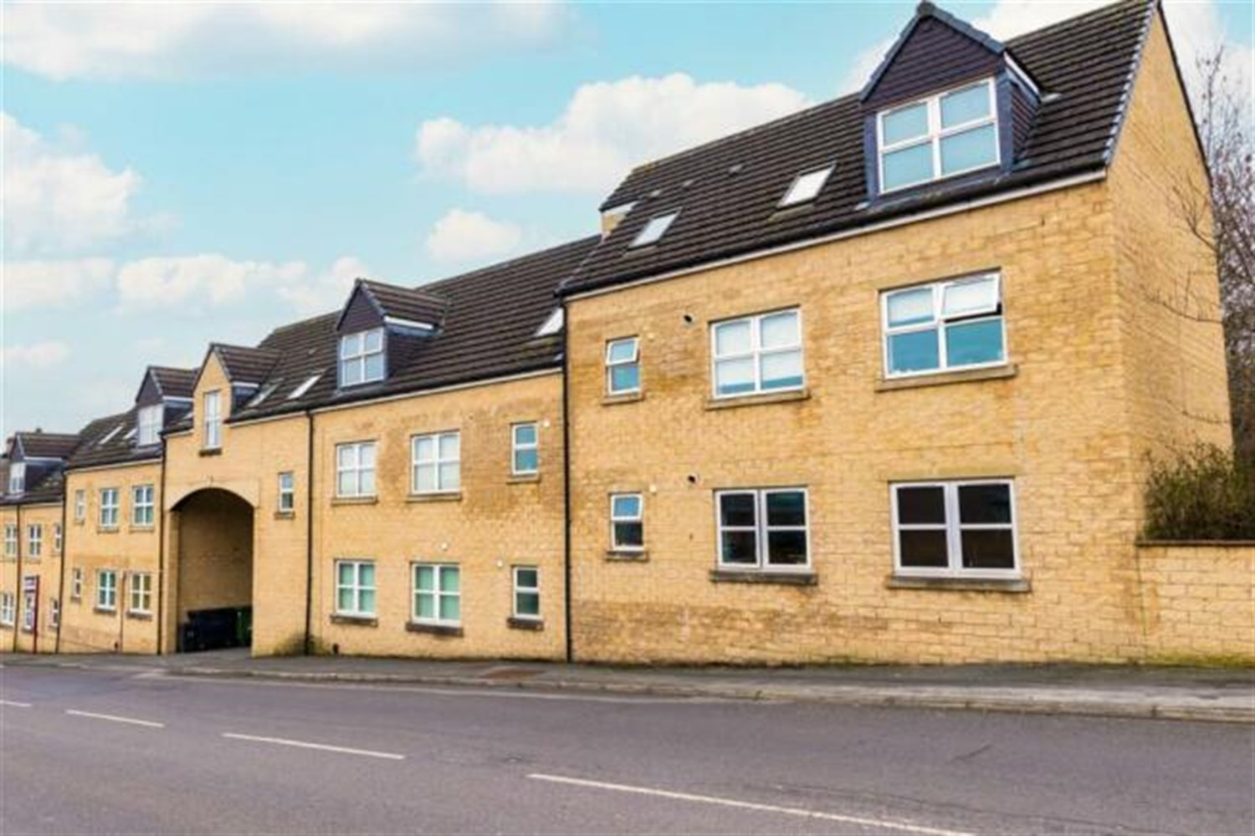



**For Sale £134,950.00**

**Elliott Court, Coal Hill Lane, Rodley**

**TWO BEDROOM FIRST FLOOR APARTMENT - NO ONWARD CHAIN** Elliott Court is situated in the heart of the sought after village of Rodley. This two bedroom apartment is perfect for a first time buyer or investor and briefly comprises; Communal entrance, Entrance hall, open plan living room/kitchen, master bedroom, second bedroom and house bathroom. Externally, there is an allocated parking space. The apartment is ideally located for the shops, bars and restaurants in Rodley as well as useful transport links to both Leeds and Bradford.

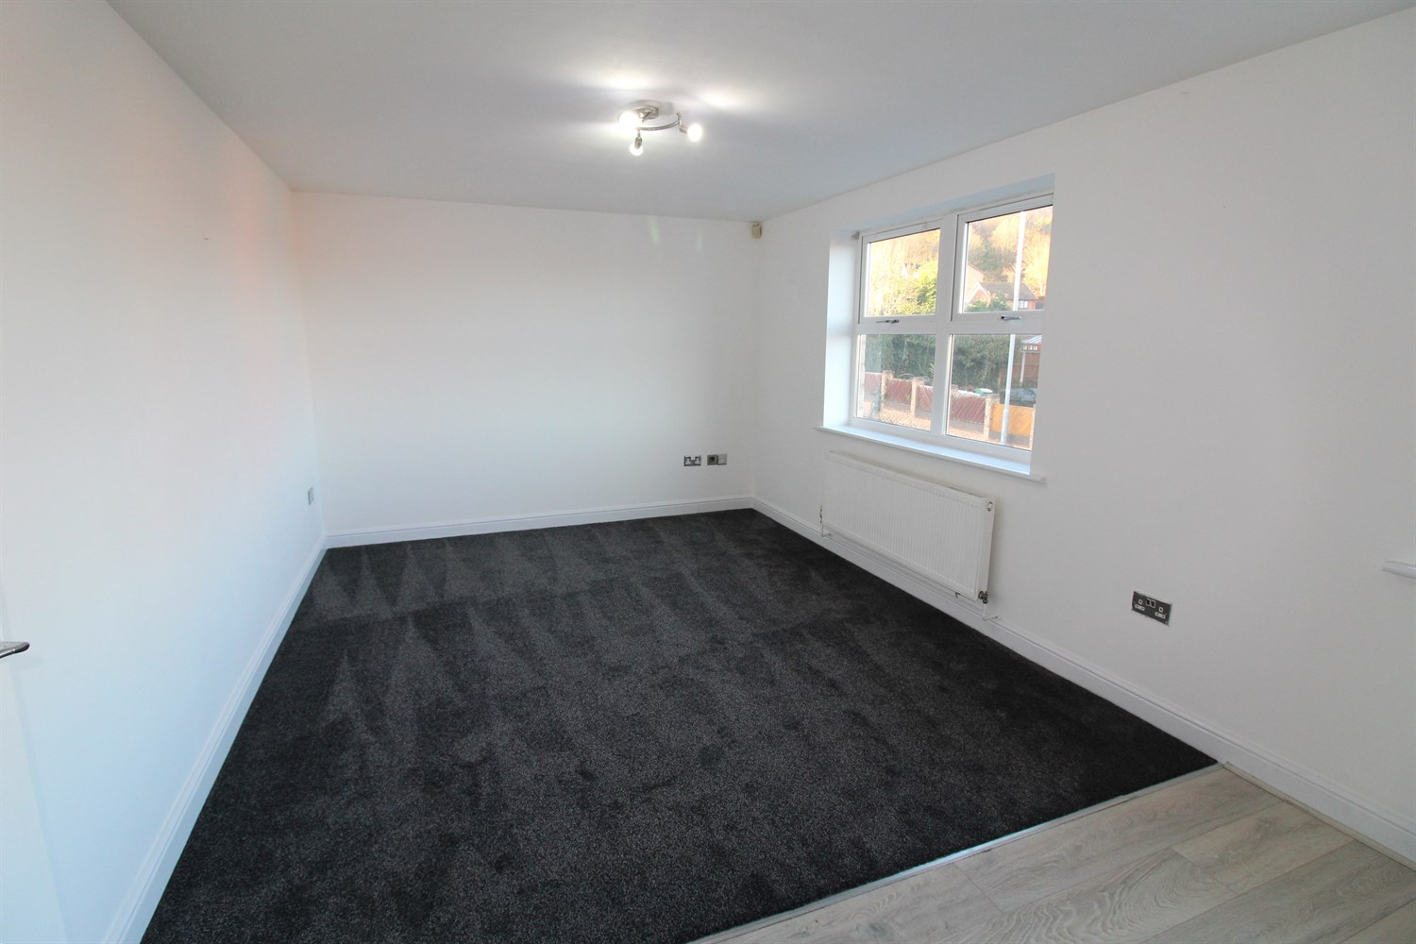

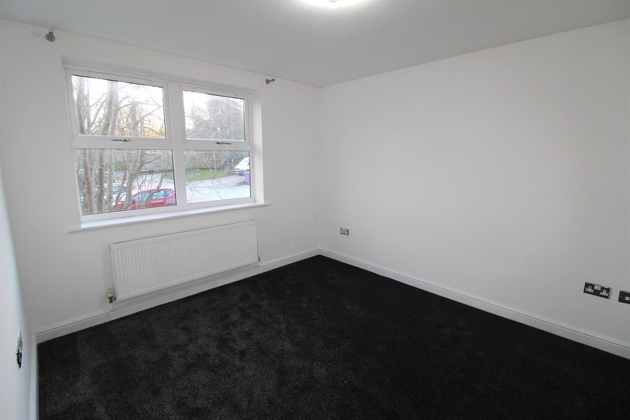

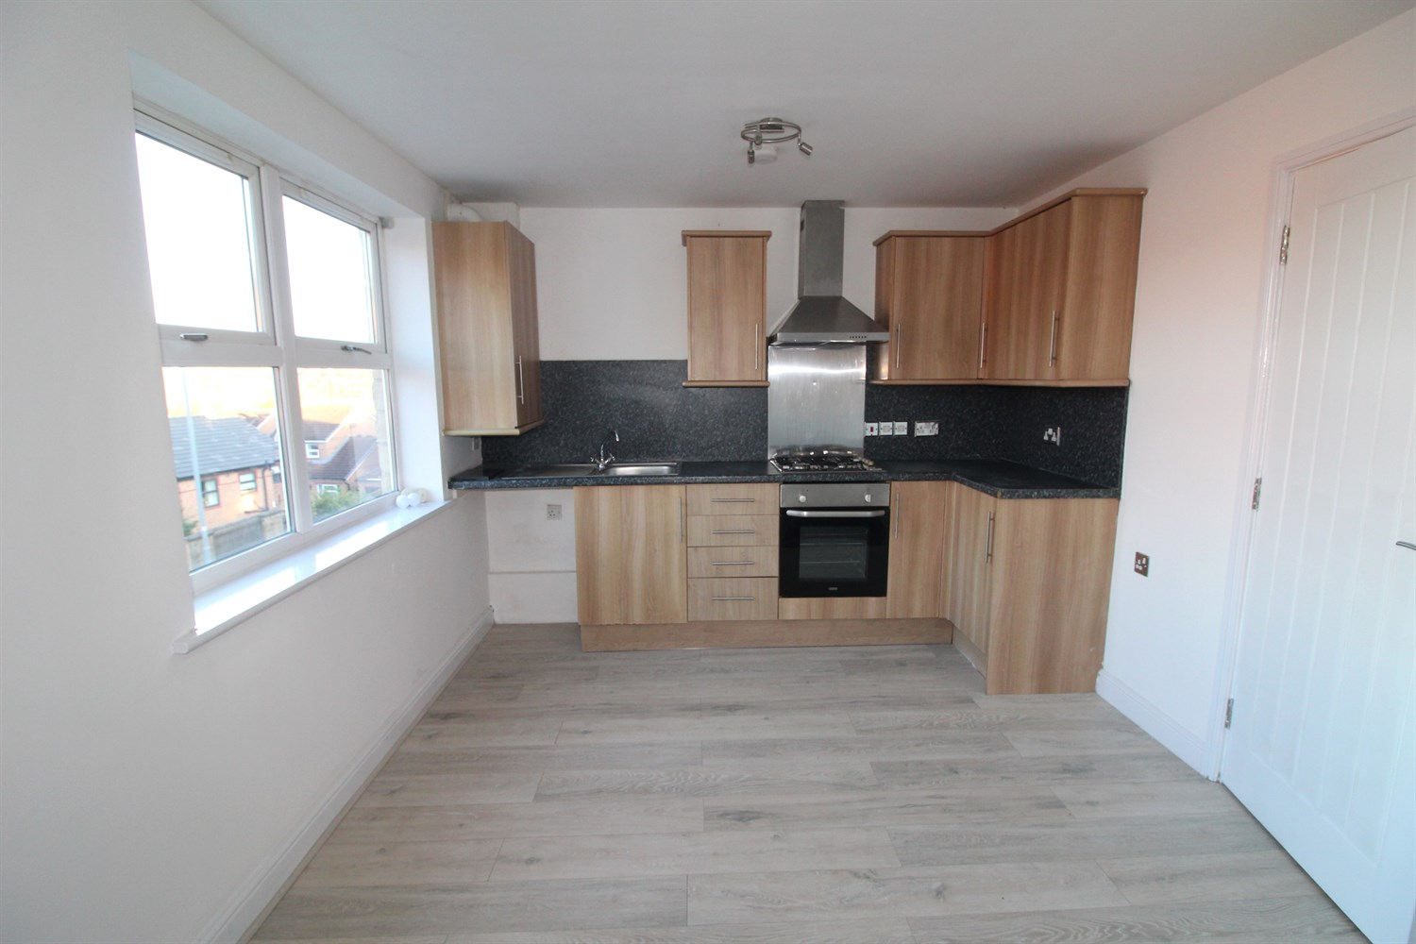

1 Bathroom(s)

1 Reception(s)

2 Bedroom(s)

00

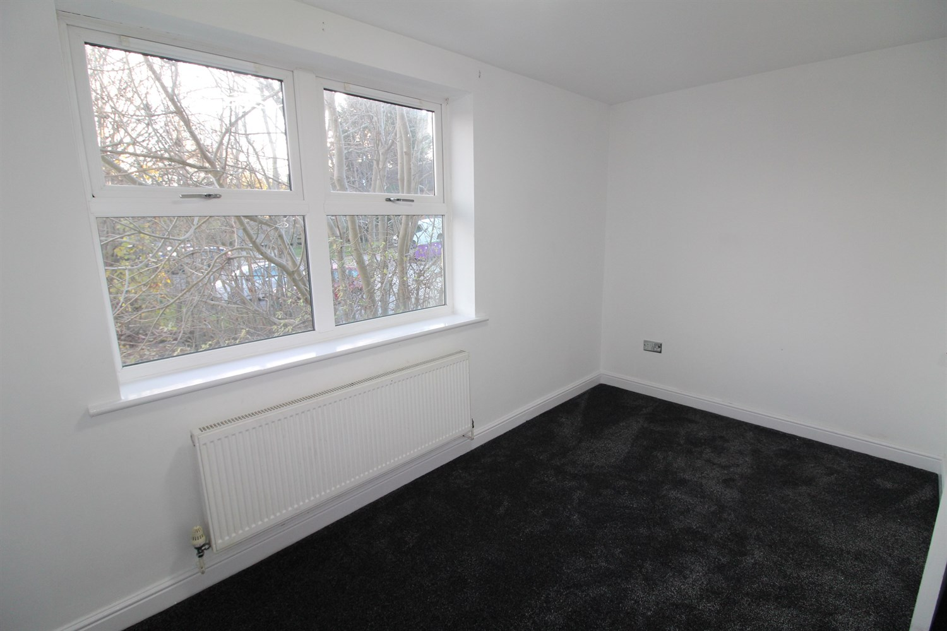

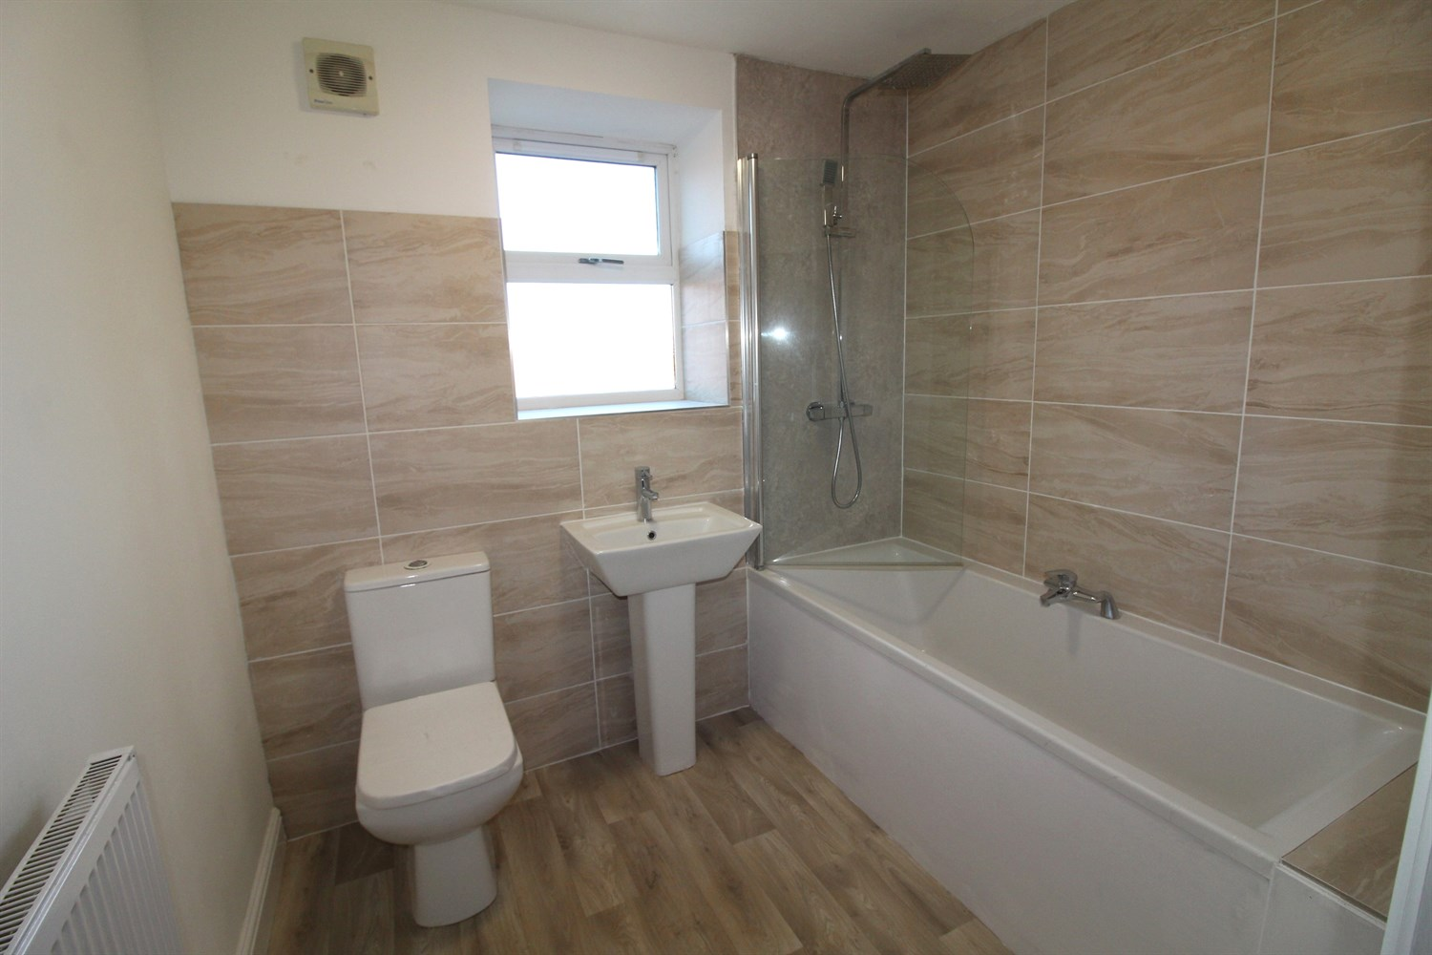

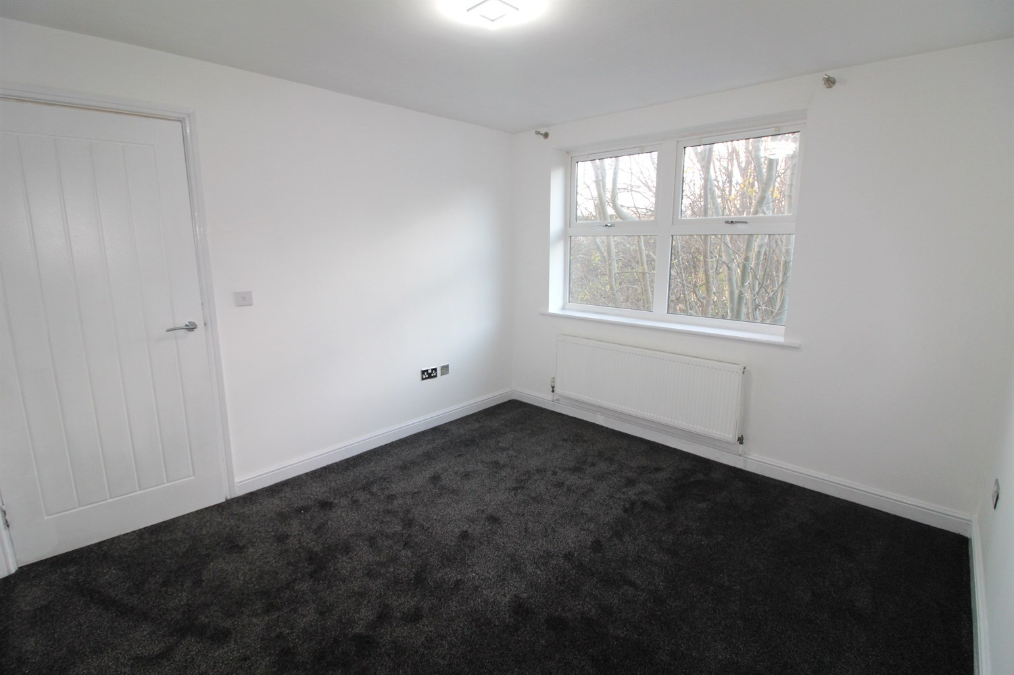

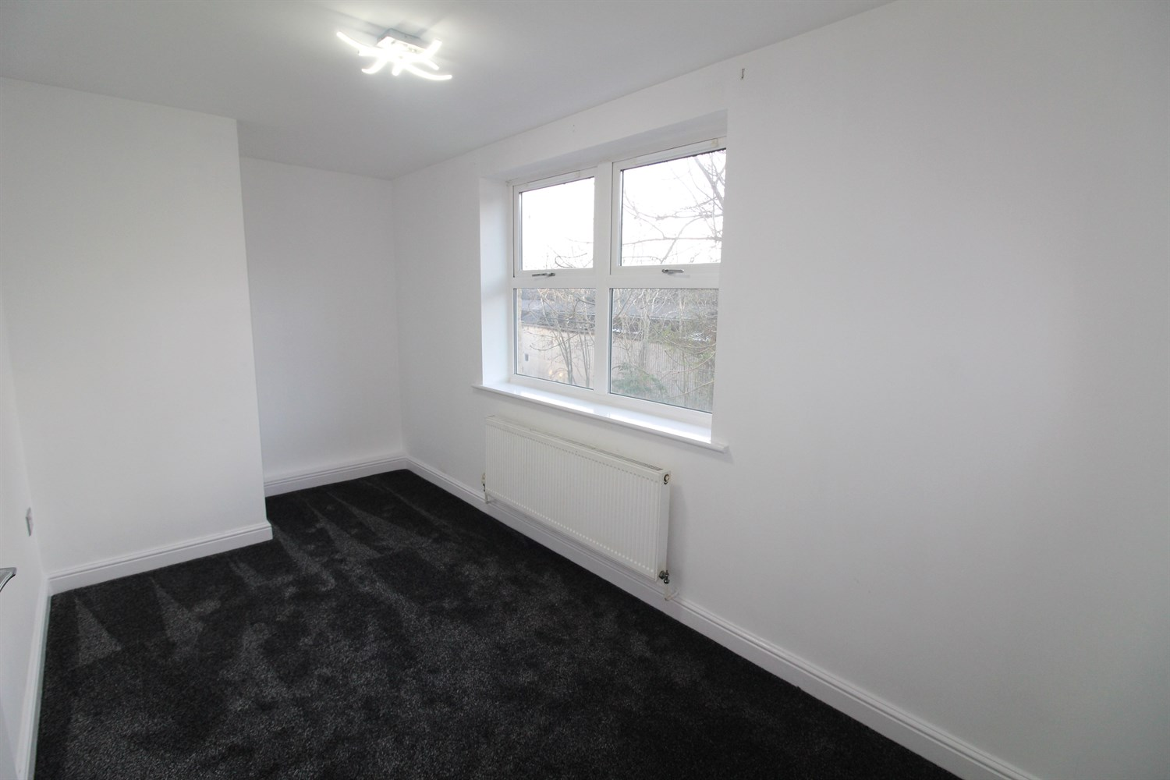

|  |
| --- |
| **Communal Hallway**  Stairs to all floors. |
| **Hallway**  Via front entrance door. Storage cupboard. |
| **Open plan Lounge/Kitchen 6.6m (21'8) x 3.22m (10'7)**  Light and airy living area with uPVC double glazed window. Gas central heating radiator. |
| **Kitchen**  Opening to the lounge area. Fitted with a range of wall, base and drawer units with worktops over. Integrated oven with 4-ring gas hob and extractor hood over. Stainless steel sink with mixer tap and drainer. Space for washing machine. |
| **Bedroom 1 3.08m (10'1) x 3.42m (11'3)**  Double bedroom with uPVC double glazed window. Gas central heating radiator. |
| **Bedroom 2 4.56m (15') x 2.17m (7'1)**  Second bedroom with uPVC double glazed window. Gas central heating radiator. |
| **Bathroom**  Fitted with a three piece suite comprising bath with shower over, WC and wash hand basin. Tiled walls. uPVC double glazed window. Gas central heating radiator. |
| **Tenure**  Leasehold - 125 years from 2006 Ground Rent - £250per annum |
| **Service Charge**  The service charges are £330.00 per quarter. |

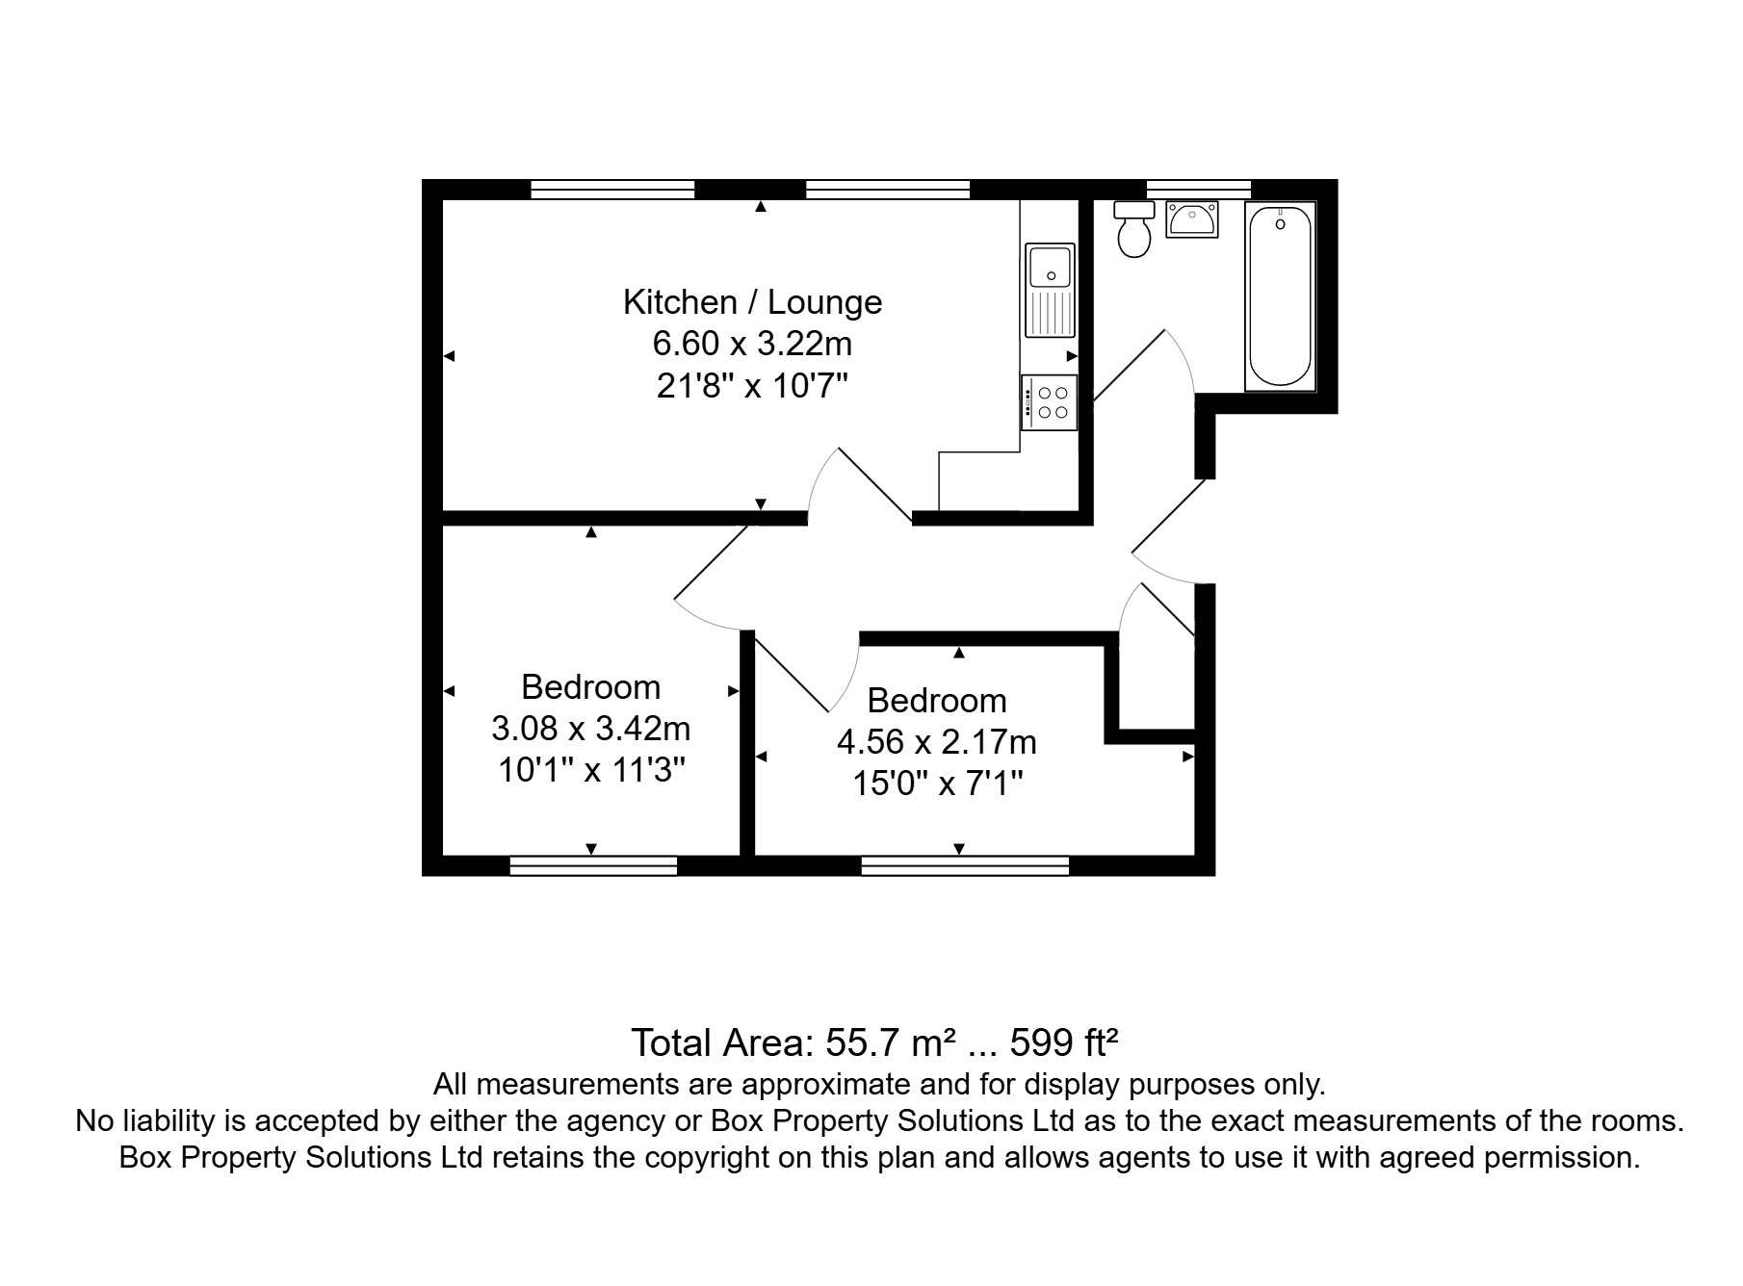

|  |  |
| --- | --- |
| These particulars are intended to give a fair description of the property, but their accuracy cannot be guaranteed, and they do not constitute an offer of contract. Intending purchasers must rely on their own inspection of the property. None of the above appliances/services have been tested by ourselves. We recommend purchasers arrange for a qualified person to check all appliances/services before legal commitment.  **Property Ref:** 4504  **For more information, please contact**  0113 258 1150 **|** [sales@adairpaxton.co.uk](mailto:sales@adairpaxton.co.uk) **|** www.adairpaxton.co.uk |  |