

**Hemingfield Road, Hemingfield**

**For Sale £100,000.00**

# **TWO BEDROOM SEMI-DETACHED HOUSE with NO ONWARD CHAIN** Adair Paxton are pleased to offer to the market this two bedroom semi-detached house, set off the main road in this sought after village location. The property is now in need of cosmetic updating and briefly comprises; Lounge, kitchen and bathroom to the ground floor. To the first floor there are two bedrooms. Externally, the property has a driveway offering off street parking and a garden to the rear.

**0113 258 1150**

**0800 000 000**

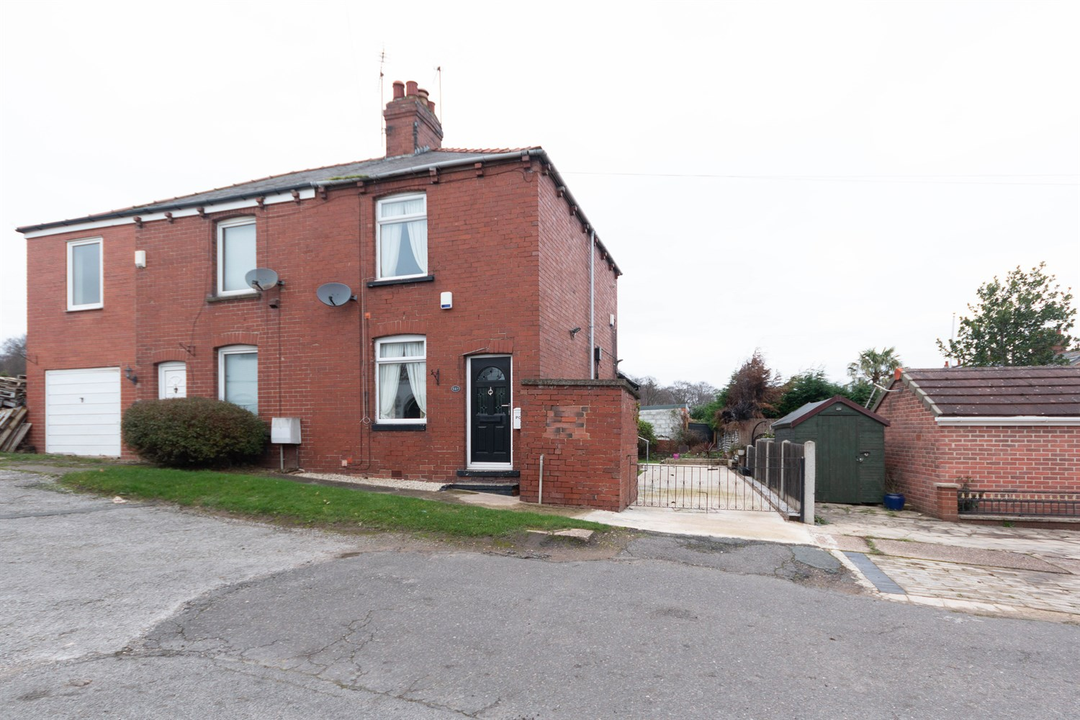

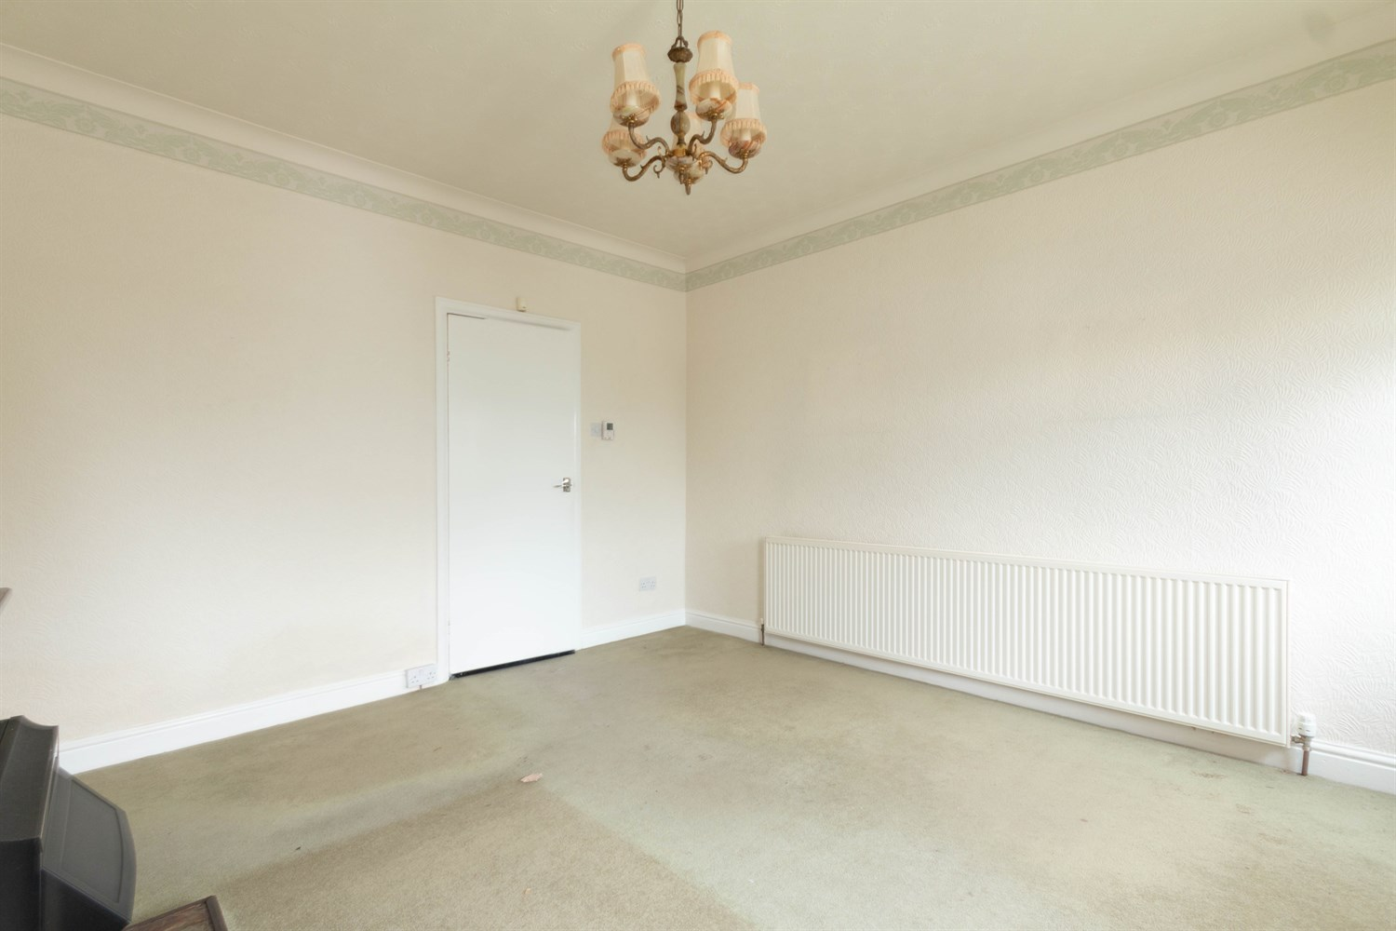

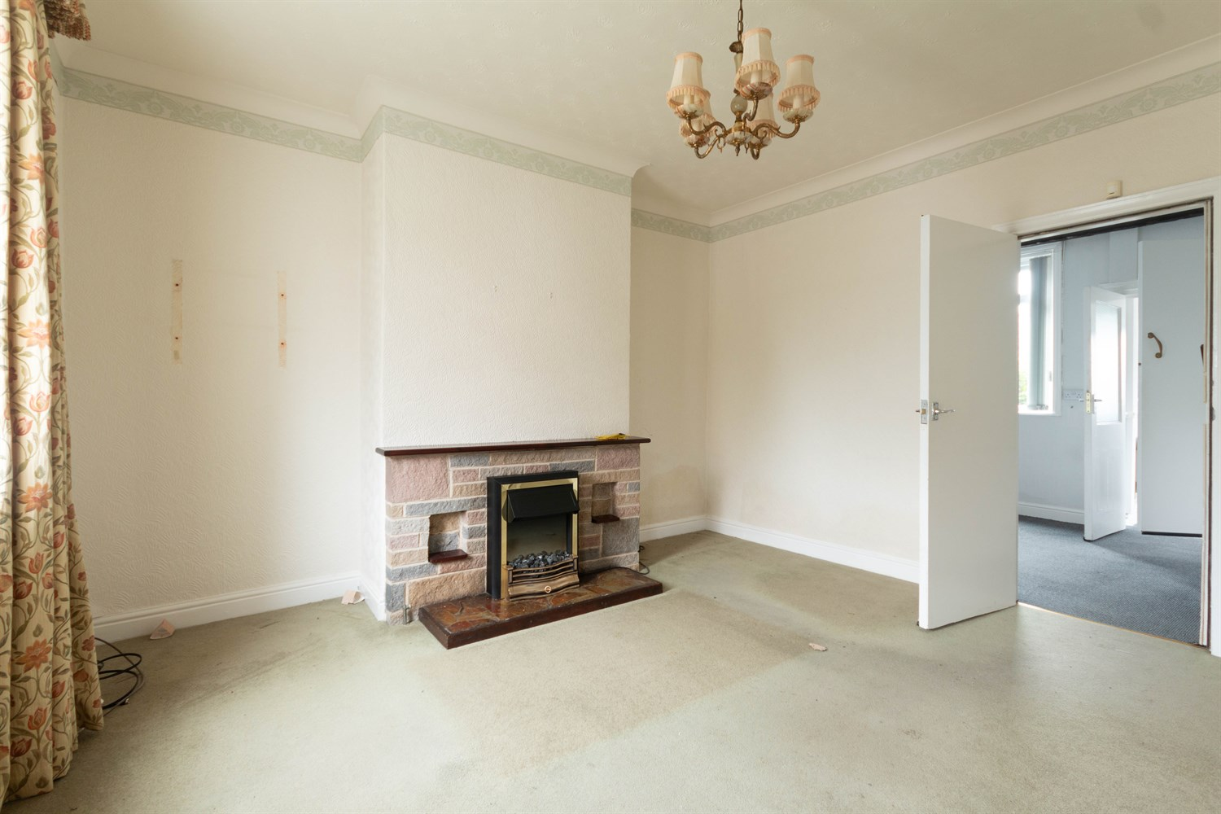

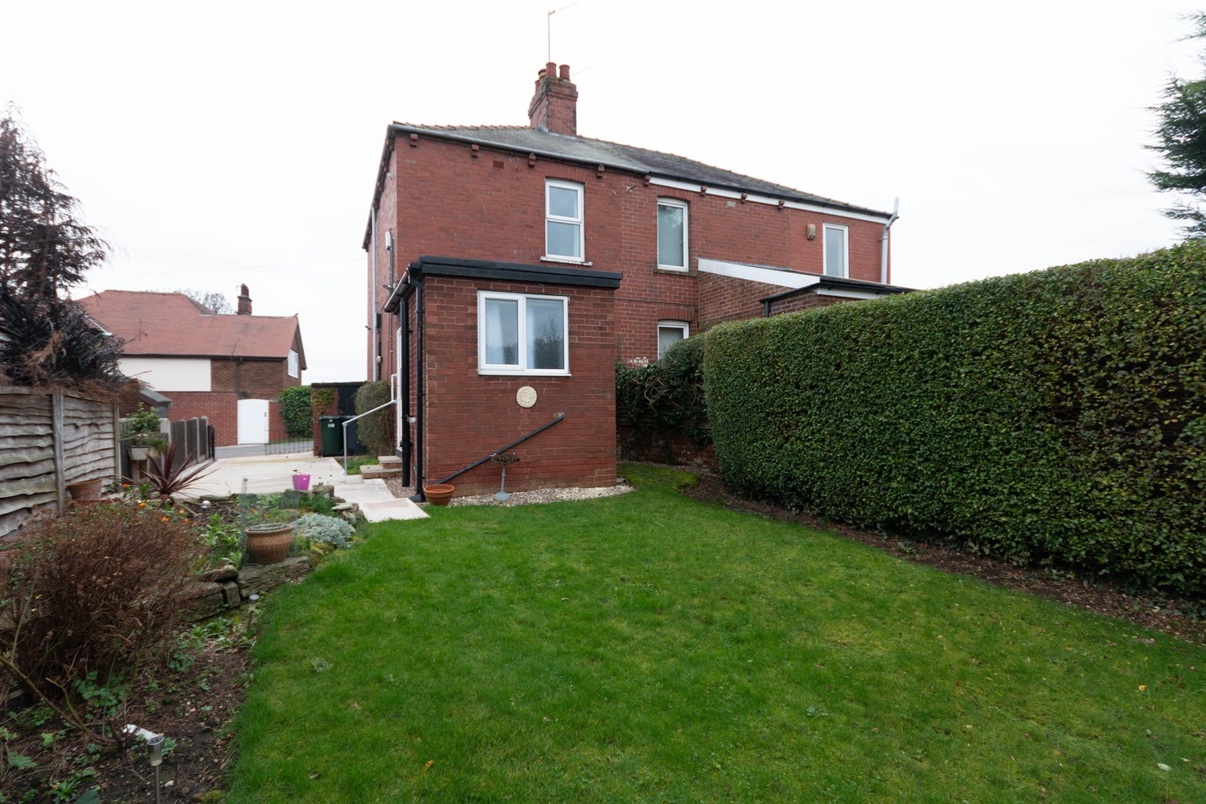

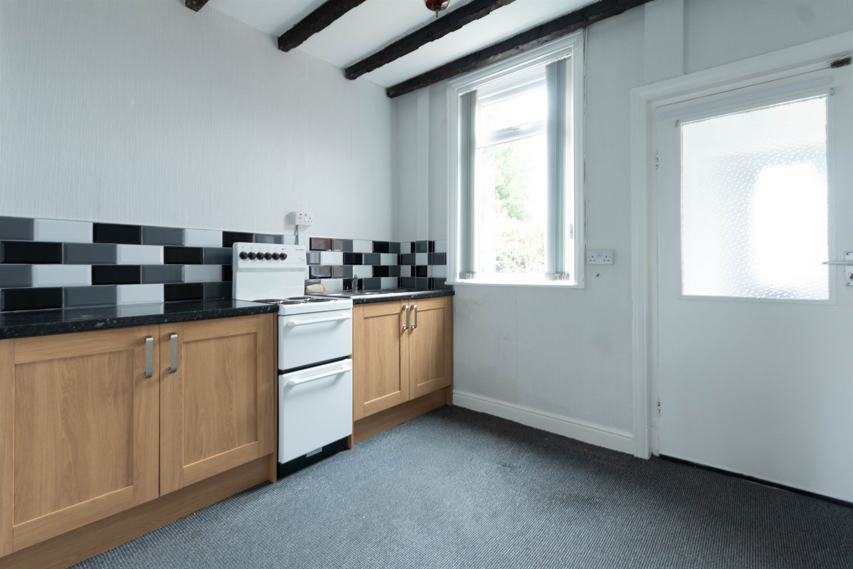

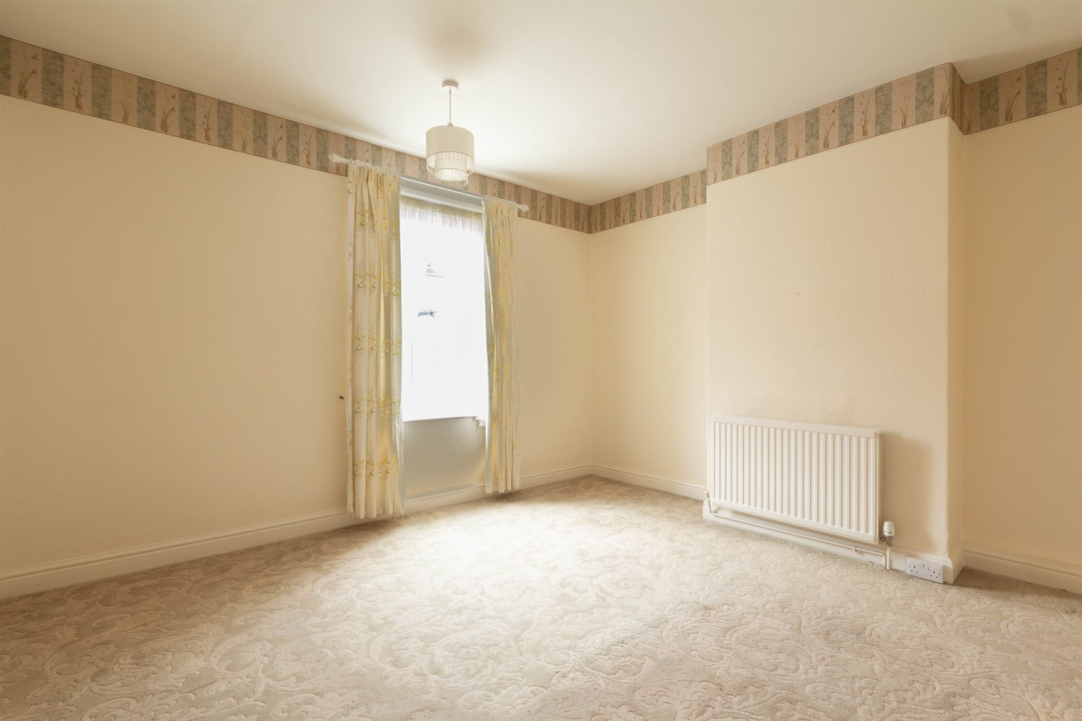

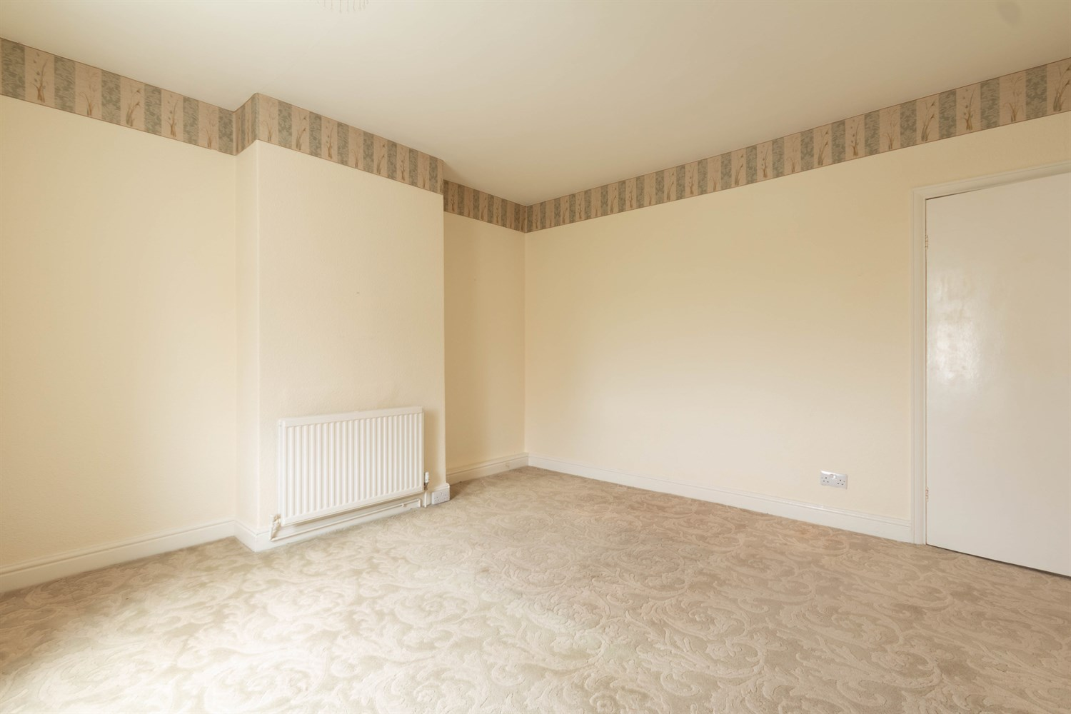

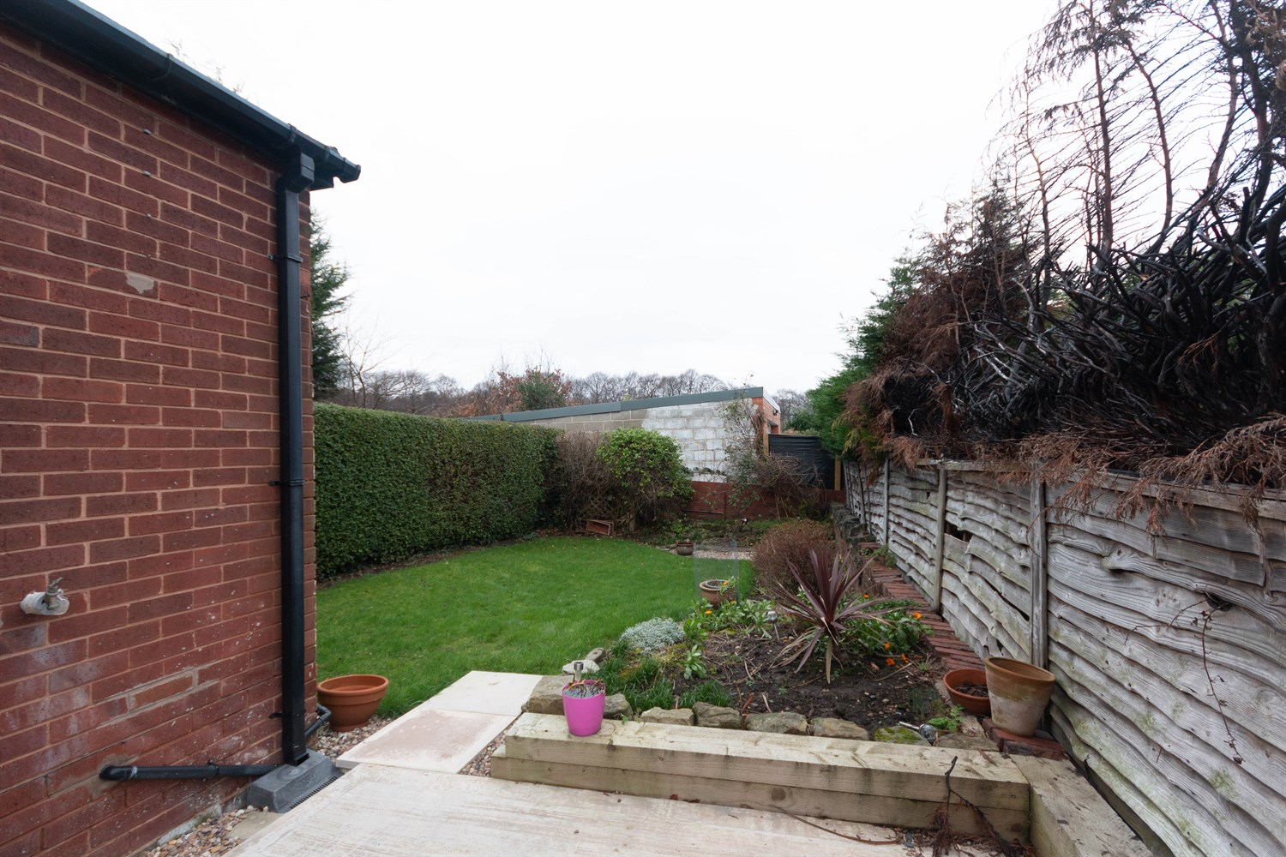

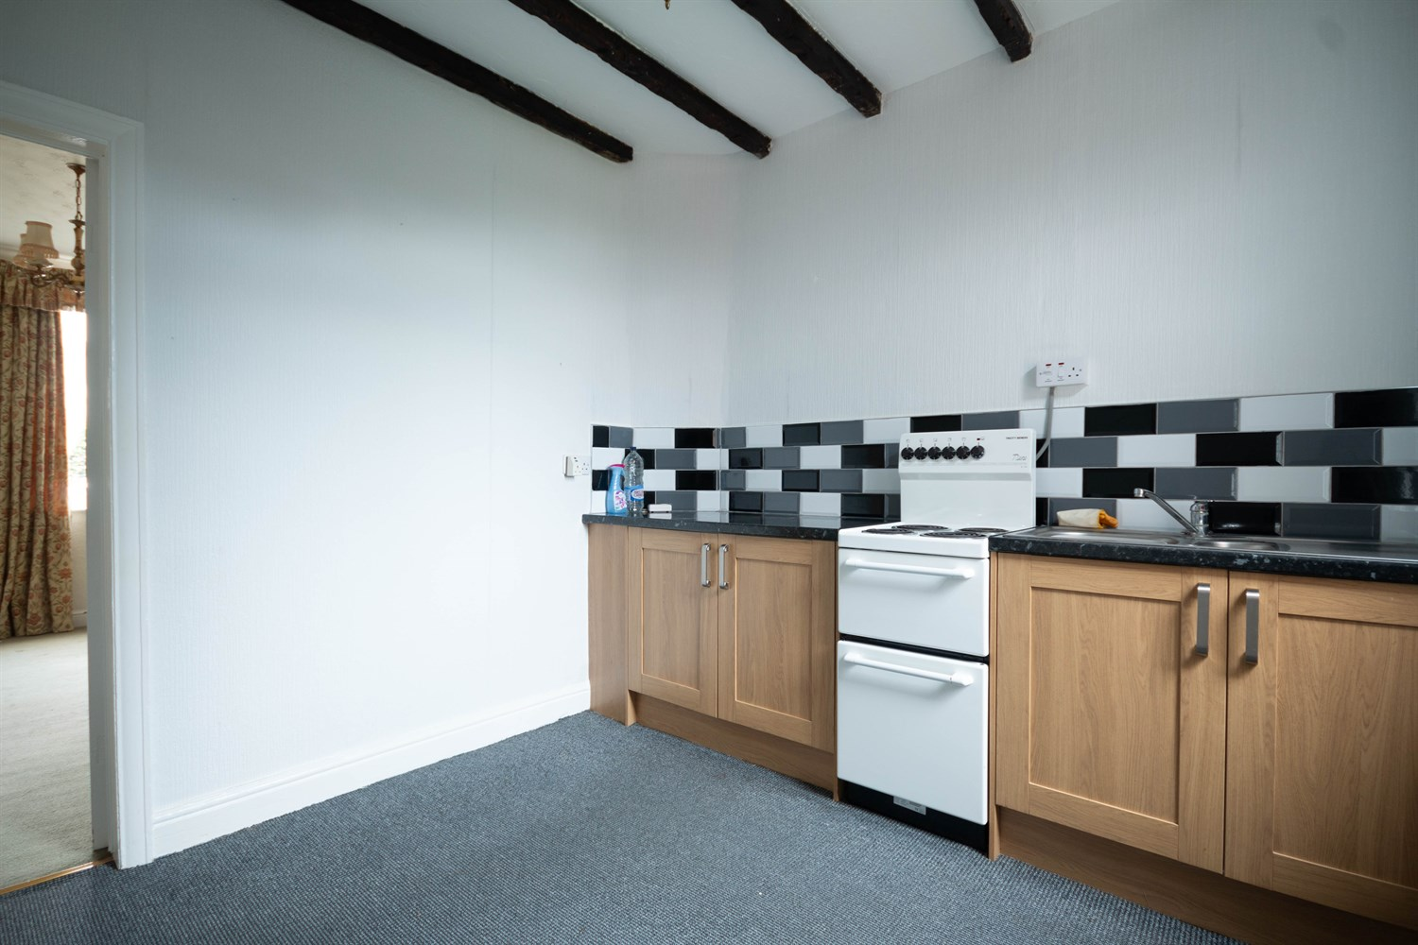

|  |
| --- |
| **Living Room 3.96m (13') x 4m (13'1)**  Via front entrance door. Light and Airy living area with uPVC double glazed window to front. Gas central heating radiator. |
| **Kitchen 2.98m (9'9) x 2.8m (9'2)**  Fitted with a range of wall, base and drawer units with worktops over. 1.5 bowl stainless steel sink with mixer tap and drainer. Space for cooker. Part tiled walls. uPVC double glazed window to rear. Stairs to first floor. |
| **Shower Room**  Walk in shower room with WC and wash hand basin. Tiled walls. uPVC double glazed window. |
| **First Floor** |
| **Bedroom One 3.96m (13') x 4m (13'1)**  Double bedroom with uPVC double glazed window. Gas central heating radiator. |
| **Bedroom Two 3.02m (9'11) x 2.8m (9'2)**  Second bedroom with uPVC double glazed window. Gas central heating radiator. Built in cupboard. |
| **Outside**  The property benefits from a driveway offering off street parking and leading to an enclosed rear garden which has been mainly laid to lawn. |

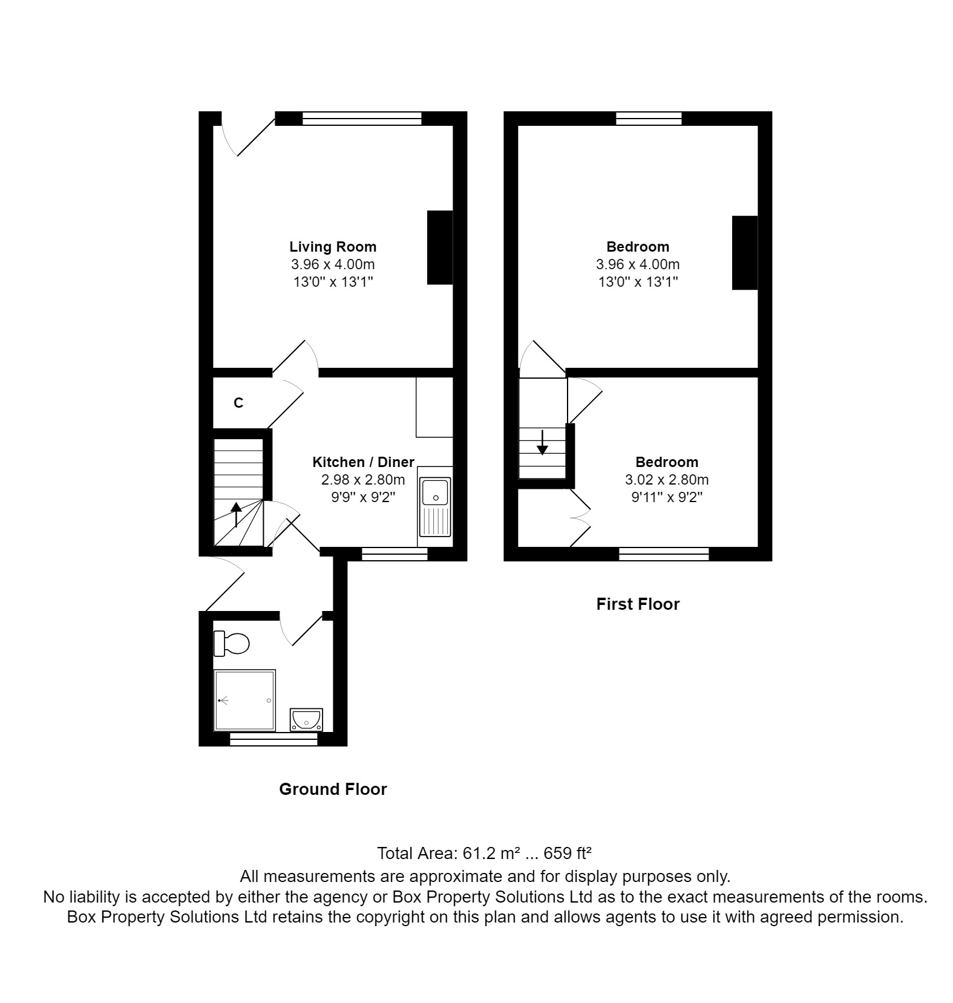

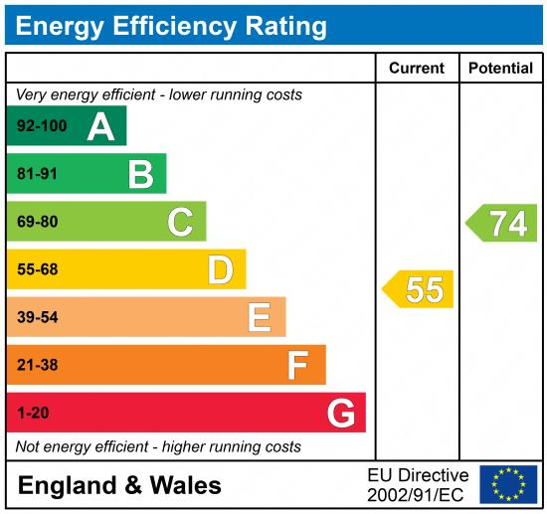

|  |
| --- |
|  |

These particulars are intended to give a fair description of the property, but their accuracy cannot be guaranteed, and they do not constitute an offer of contract. Intending purchasers must rely on their own inspection of the property. None of the above appliances/services have been tested by ourselves. We recommend purchasers arrange for a qualified person to check all appliances/services before legal commitment.

**Property Ref:** 4058

**For more information, please contact**

0113 258 1150 **|** [sales@adairpaxton.co.uk](mailto:sales@adairpaxton.co.uk) **|** www.adairpaxton.co.uk